SPENDWISE
Week 1: Project Planning and Wireframing
Personal Expense & Budget Tracker — Mobile Application
1. Project Overview
SpendWise is a mobile expense and budget tracking application designed to help users record income and expenses, understand their spending habits, and manage a monthly budget from one simple interface. The app focuses on quick transaction entry, clear financial summaries, categorized expenses, and an easy-to-use history screen.
2. Project Objective
The main objective of SpendWise is to provide a simple way for users to monitor daily spending and maintain better control over their personal finances. Instead of manually maintaining notes or spreadsheets, users can record transactions in seconds and view their balance, income, expenses, and category-wise spending in one place.
3. Target Audience
SpendWise is designed for college students, young professionals, and anyone who wants a lightweight personal finance tool. The interface is suitable for users who may have little experience with financial applications and need clear information without complex investment or accounting features.
4. Core Features
- User registration and login.
- Dashboard showing balance, income, expenses, and recent transactions.
- Add income or expense with amount, category, date, and note.
- Transaction history with search and filtering.
- Monthly spending summary and category-wise breakdown.
- Monthly budget setting and progress monitoring.
- Edit or delete transactions.
- Profile and basic application settings.
5. User Flow
Open App → Login/Signup → Dashboard → Add Transaction → Save → Dashboard/History → Monthly Summary → Profile/Settings
6. Wireframes
These low-fidelity wireframes focus on screen structure, information hierarchy, navigation, and primary actions before visual styling and development.
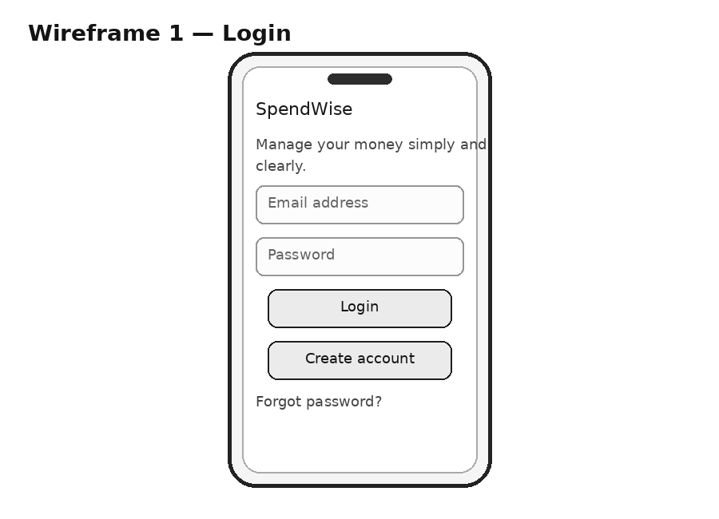
Figure 1: SpendWise mobile screen wireframe
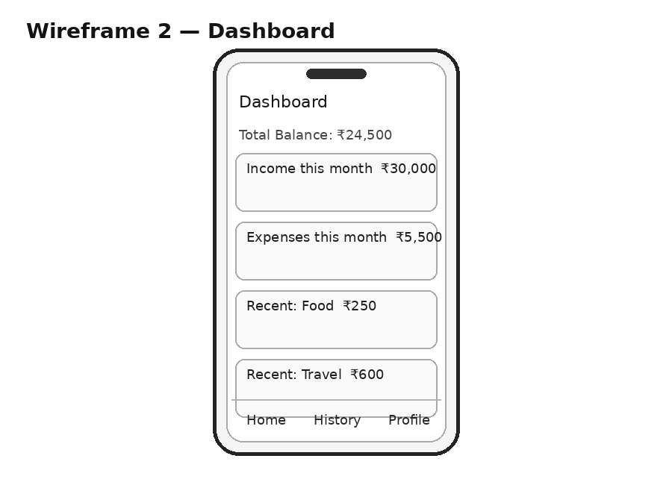
Figure 2: SpendWise mobile screen wireframe
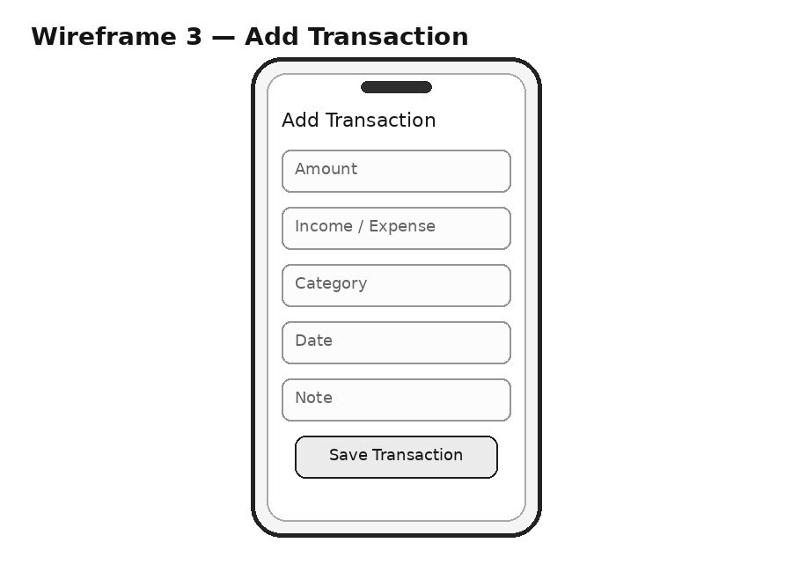
Figure 3: SpendWise mobile screen wireframe
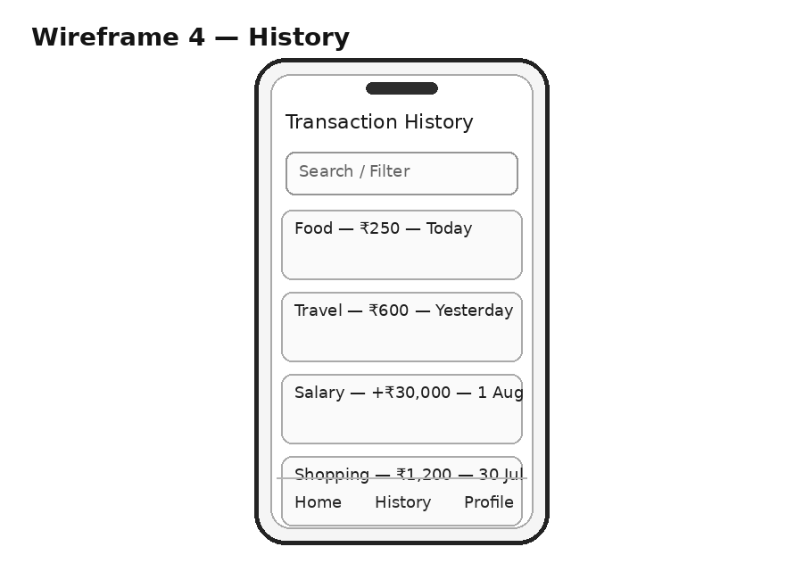
Figure 4: SpendWise mobile screen wireframe
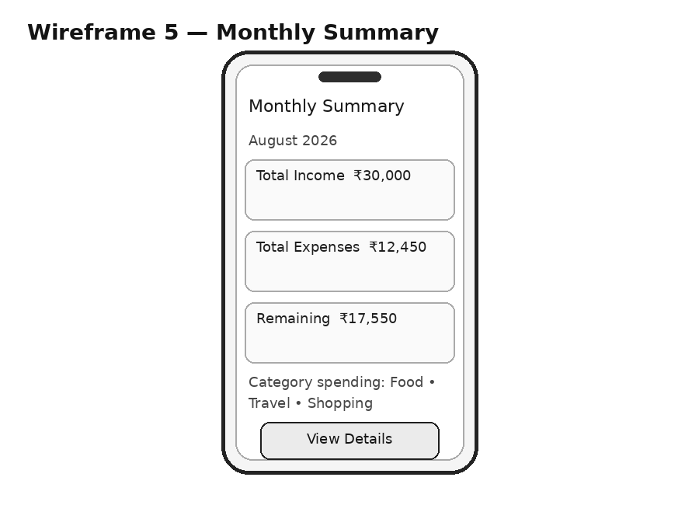
Figure 5: SpendWise mobile screen wireframe
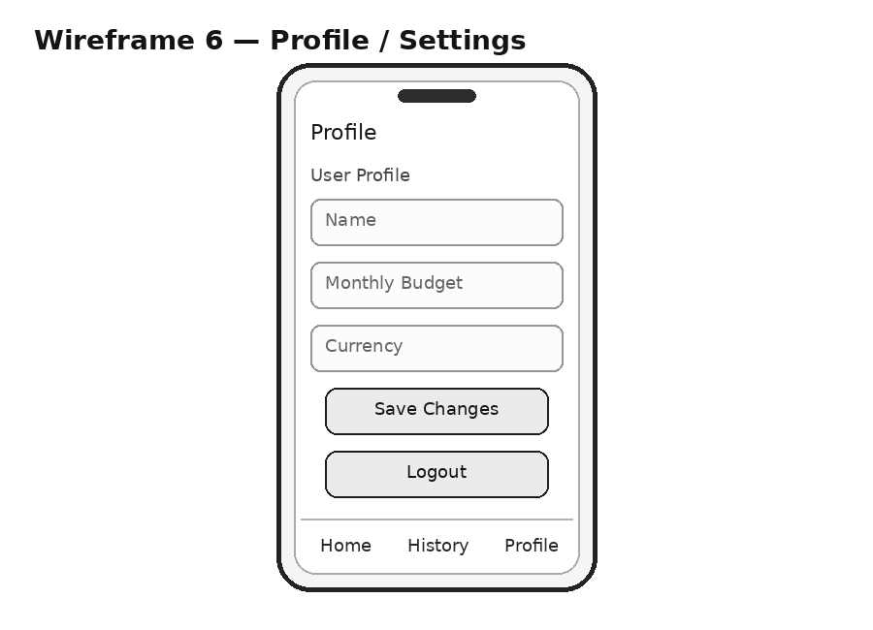
Figure 6: SpendWise mobile screen wireframe
7. Design Decisions and UX Rationale
SpendWise is designed around a simple financial tracking workflow: users open the app, see their current financial summary, record a transaction, and review their spending history. The design intentionally avoids complex financial terminology so that students and first-time users can understand the application immediately.
The login screen is kept minimal because authentication is only the entry point. It contains email and password fields, a login button, and an account creation option. This reduces distraction and allows the user to reach the dashboard quickly.
The dashboard is the most important screen because it provides an overview of the user's financial situation. The total balance is placed prominently, followed by income and expense summaries. Recent transactions are displayed as compact cards so users can quickly recognize where money was spent without opening another screen. This follows the principle of information hierarchy: the most important information appears first.
The Add Transaction screen is designed for speed. Amount, transaction type, category, date, and an optional note provide enough information to make a useful record without creating a long form. A clear Save Transaction button completes the task. In a future version, the app could remember commonly used categories and suggest them automatically.
The Transaction History screen gives users a chronological view of their financial activity. Search and filtering help users locate specific transactions, which becomes important as the number of records grows. Each transaction card contains the category, amount, and date so that users can scan the list quickly.
The Monthly Summary screen helps users understand overall spending rather than looking only at individual transactions. Income, expenses, remaining money, and category-wise spending can support better budgeting decisions. A future high-fidelity design could represent category spending with simple charts while still keeping the screen readable.
The Profile and Settings screen keeps personal preferences separate from financial activity. Users can update their name, monthly budget, and currency and can log out from the same area. Keeping settings away from the dashboard prevents the main experience from becoming cluttered.
The navigation structure is intentionally simple, with Home, History, and Profile as the main destinations. The Add Transaction action can be made prominent on the dashboard because it is a frequent task. The final visual design should use readable typography, sufficient contrast, consistent spacing, and clear labels. Financial amounts should not depend only on color to communicate meaning, which improves accessibility for users with color-vision differences.
Overall, SpendWise follows a task-focused mobile UX approach. Each screen has a clear purpose, the number of required inputs is limited, and important actions are easy to find. This makes the concept suitable for a practical mobile development project while leaving room for future improvements such as notifications, budget alerts, data export, charts, and cloud synchronization.
8. Future Scope
- Budget alerts when spending approaches a monthly limit.
- Interactive charts for category and monthly spending.
- Cloud backup and multi-device synchronization.
- CSV/PDF expense export.
- Recurring income and expense support.
- Optional biometric app lock.
9. Conclusion
SpendWise provides a practical and easy-to-understand concept for a personal expense and budgeting mobile application. The planning defines the users, objectives, features, user journey, and screen structure, while the wireframes provide a clear foundation for high-fidelity UI design and later mobile app development.

