**Docker**

**Assignment 2**

**6th Mar 2024**

Launch 3 EC2 instances named as Jenkins Master, Slave1, Slave2.

Install Java, Docker, Apache tomcat and do all the configuration for Jenkins on Jenkins Master.

Install Git, Java, Docker on Slave1 and Slave2.

Create SSH connection.

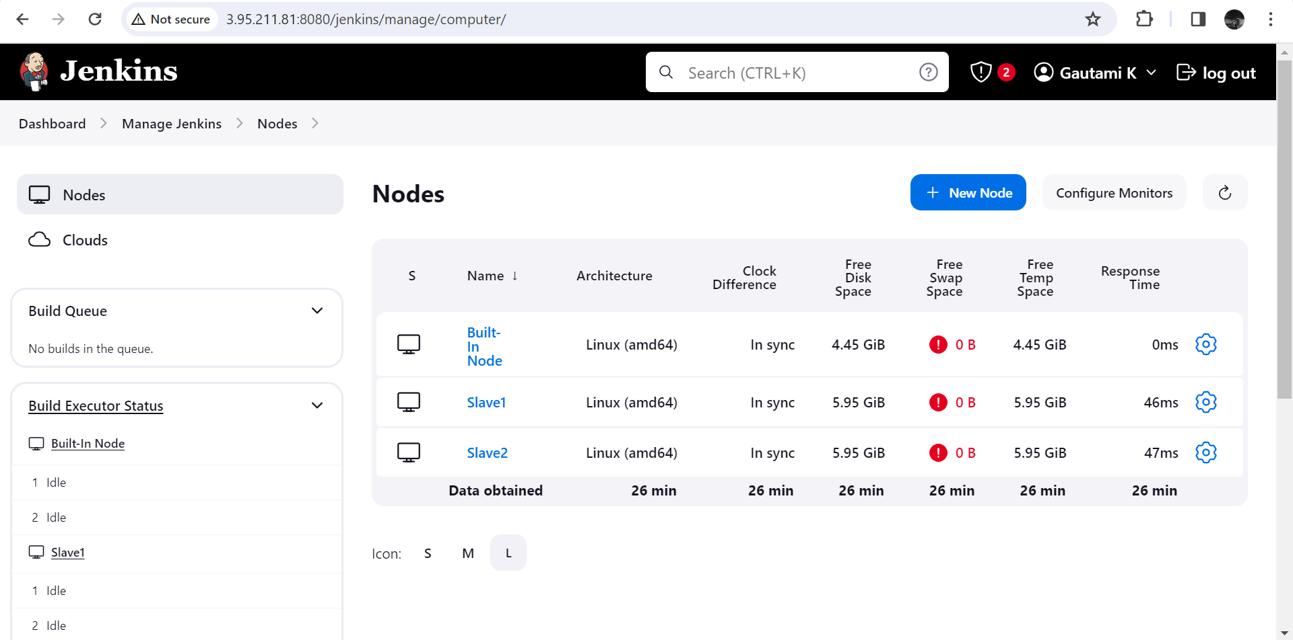

Create two branches named as 2024Q1 and 2024Q2 having index.html on Github repository.

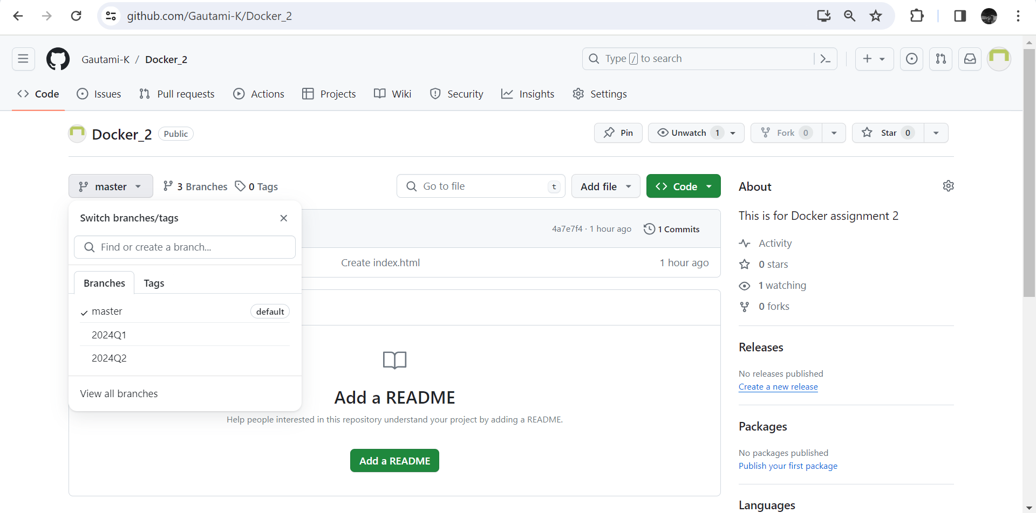

Create One Pipeline Job named as Assignment 2 and do all the required configuration as below.

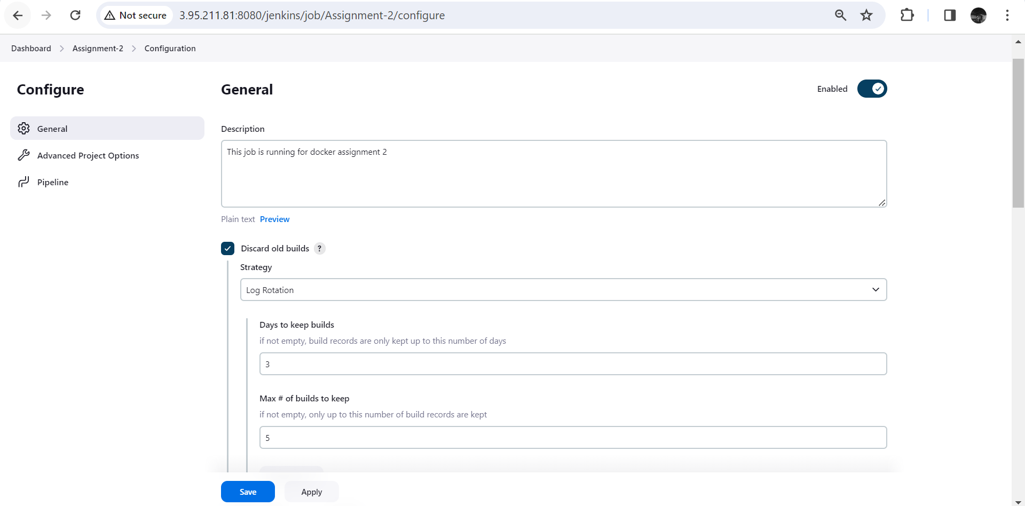

Run the build and build will be successful as below.

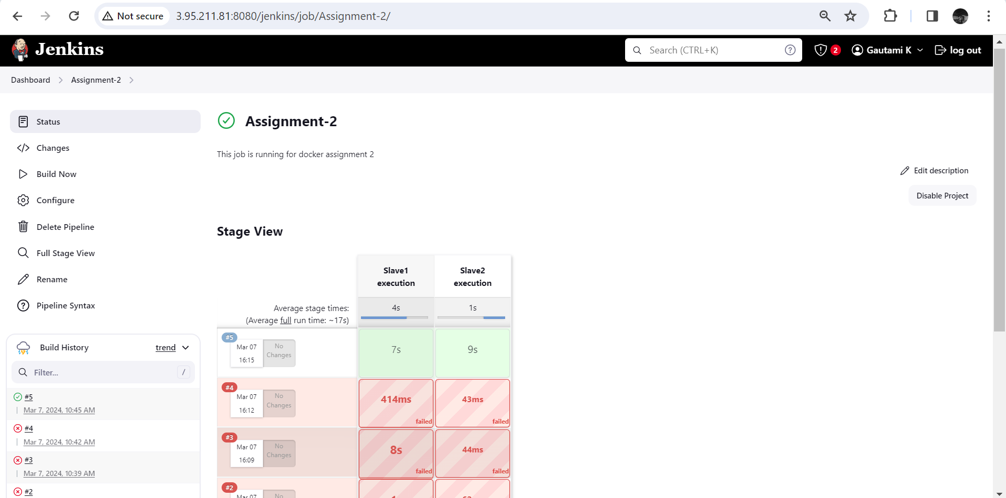

We can see output using Public IP of Slave1 and Slave2 for port 80.

For 2024Q1 branch, HTTPD container on port 80 of Slave1

For 2024Q2 branch, HTTPD container on port 80 of Slave2

