**Jenkins**

**Assignment 2**

**21st Feb 2024**

**Create Repository having 3 branched named as 2024Q1, 2024Q2 and 2024Q3. Install httpd server and deploy index.html file on each branch. Whenever we run particular branch, respective index.html should deploy.**

* Launch a EC2 instance.
* Install java : yum install java-11-amazon-corretto.x86_64 -y
* Create a directory called “servers” in /mnt and install Tomcat in it.
* Go to servers directory ->

wget <https://dlcdn.apache.org/tomcat/tomcat-9/v9.0.86/bin/apache-tomcat-9.0.86.zip>

-> unzip file -> Give full permission to file -> Go to Webapps -> Install Jenkins ->

wget <https://get.jenkins.io/war-stable/2.440.1/jenkins.war> -> Start the tomcat from bin : ./startup.sh -> For accessing the tomcat go to browser - <public ip of instance>:8080/jenkins -> Provide initial admin password, install suggested plugin and give username details to see Jenkins UI

* Meanwhile install git.

Create One repository on GitHub named as Jenkins_repo. Create 3 branches named a 2024Q1, 2024Q2, 2024Q3.

Now create 3 jobs for each branch and do all configuration. Add git repository URL and specify branch to build.

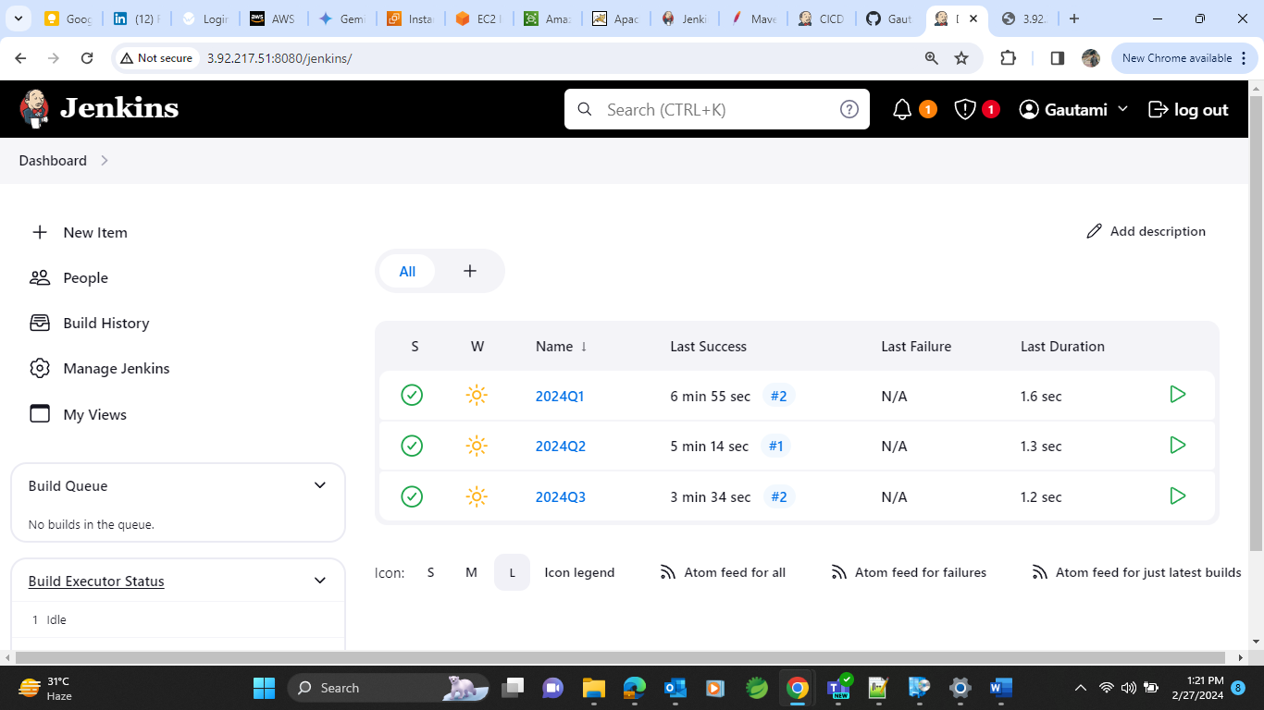

Use execute shell in build step and provide below code.

To access index.html file of particular branch, build that job and paste <public_ip_of_instance> in the browser.

Do all the same process for job 2 i.e. 2024Q2.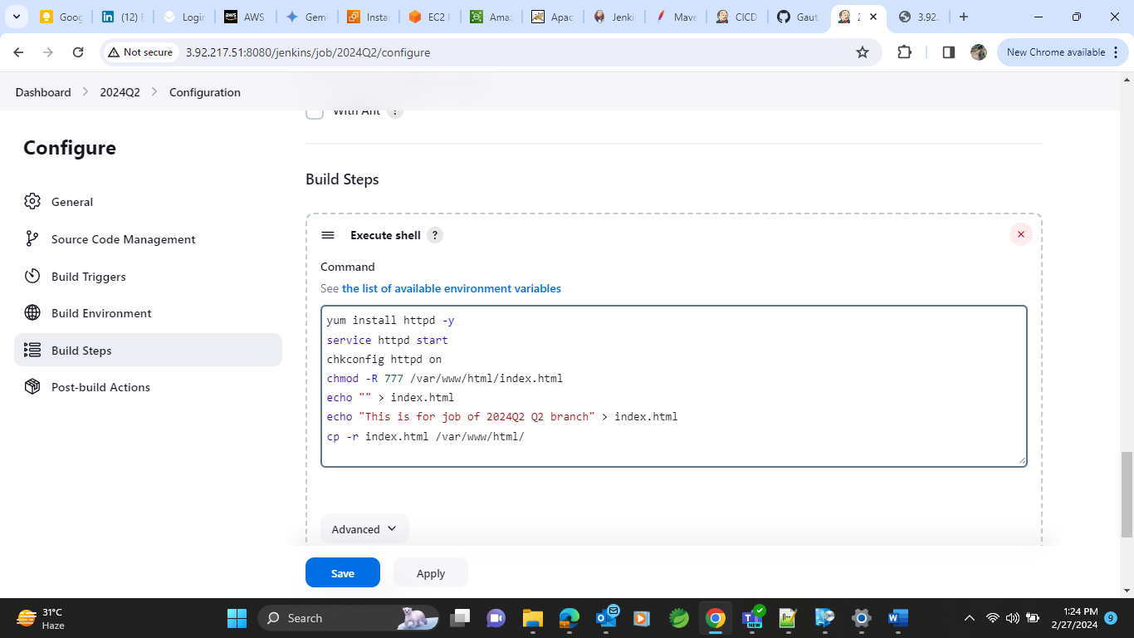

And do same for job 3 i.e. 2024Q3

After that make a build of same and when accessing the public ip we will get output from particular index.html file of job

