**Jenkins**

**Assignment 3**

**21st Feb 2024**

**Build complete CI/CD of project.**

* Launch an EC2 instance.
* Install java : yum install java-11-amazon-corretto.x86_64 -y
* Create a directory called “servers” in /mnt and install Tomcat
* Go to servers directory -> wget <zip link of tomcat folder> -> unzip -> Give full permission to file -> Go to Webapps -> (Install Jenkins) wget <Jenkins WAR file> -> Start the tomcat from bin using ./startup.sh command -> For accessing the tomcat go to the browser : <public ip of instnace>:8080/Jenkins
* Installing maven:

Install required version of maven which is compatible with java 11 version .

Download maven zip in /mnt/build-tools using wget command -> unzip the zip -> we can run mvn command from bin folder only (But in order to run mvn command from anywhere and start maven from anwhere we can use environment variable as follows)

Goto /root/.bash_profile and do the changes as shown below:

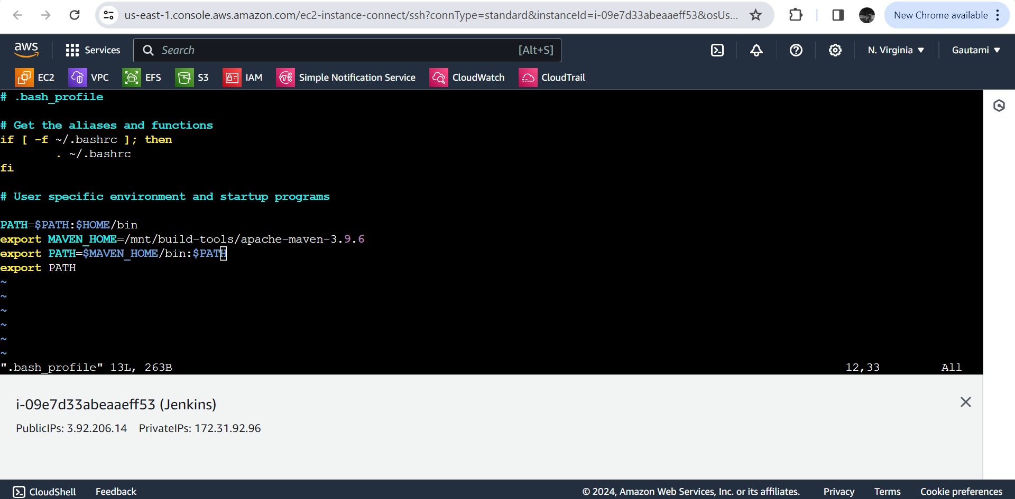

Logout and sudo su – and run mvn command from root. Now you can access maven from anywhere

* Jenkins job building :

Create a job called “Deploy_Project” and do all config as shown below

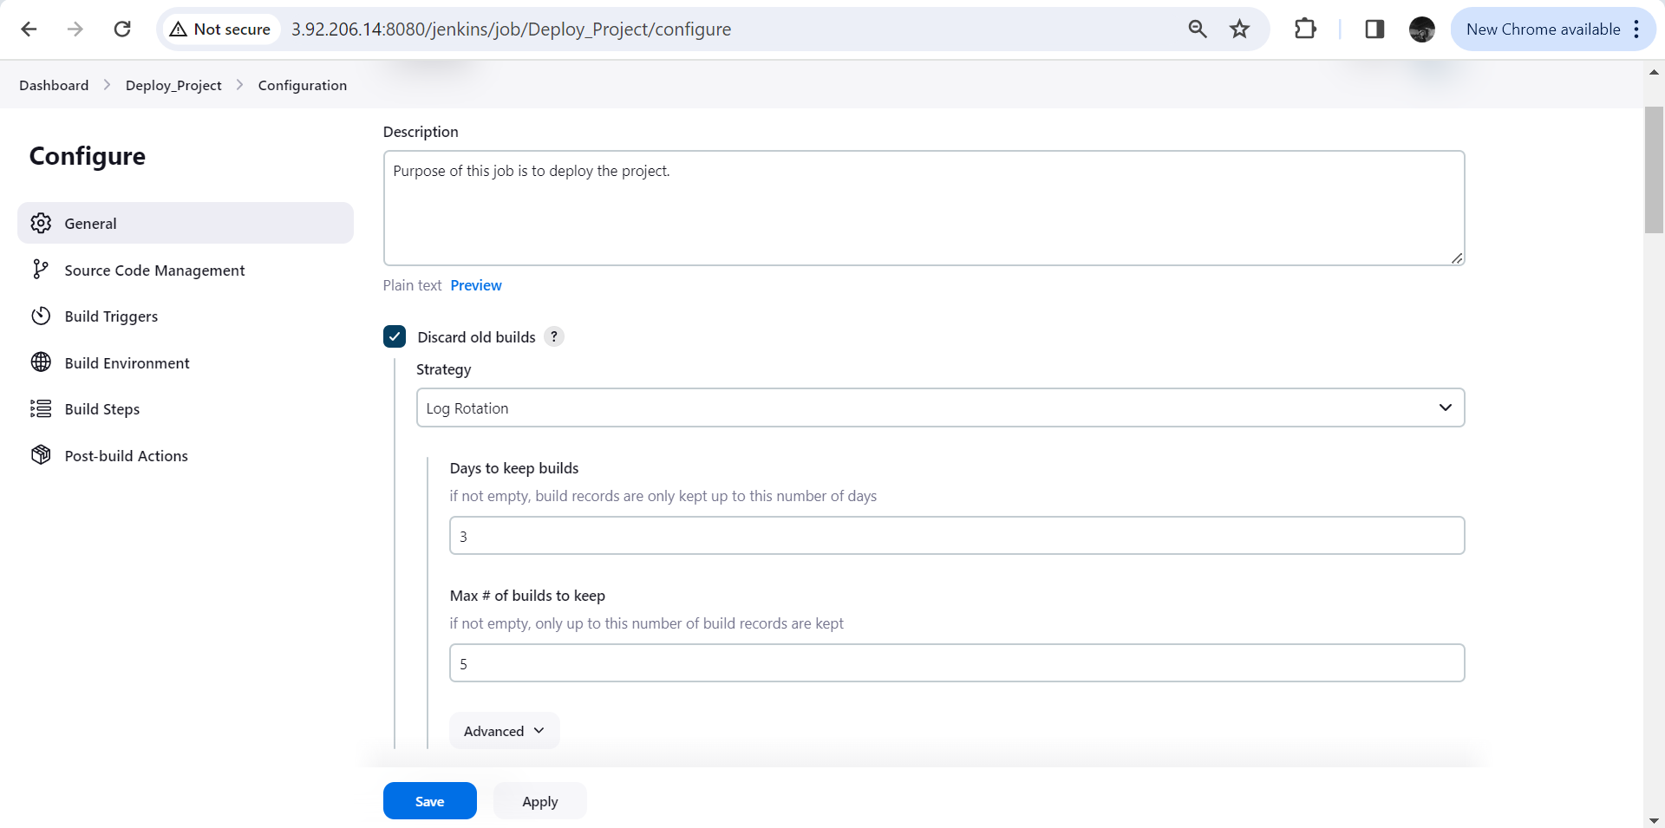

Provide git repository URL

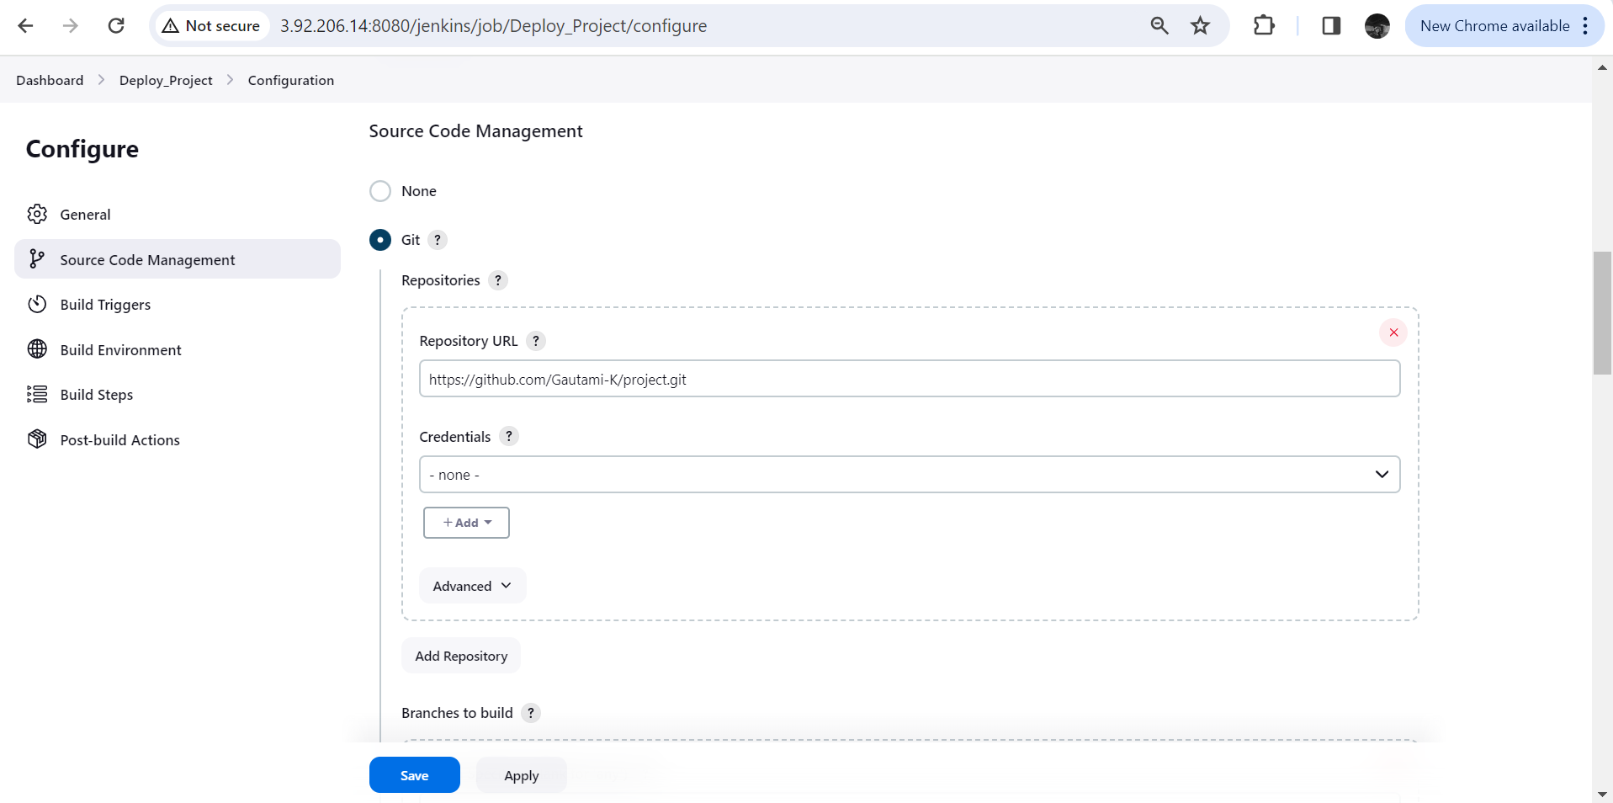

Build step -> Execute shell

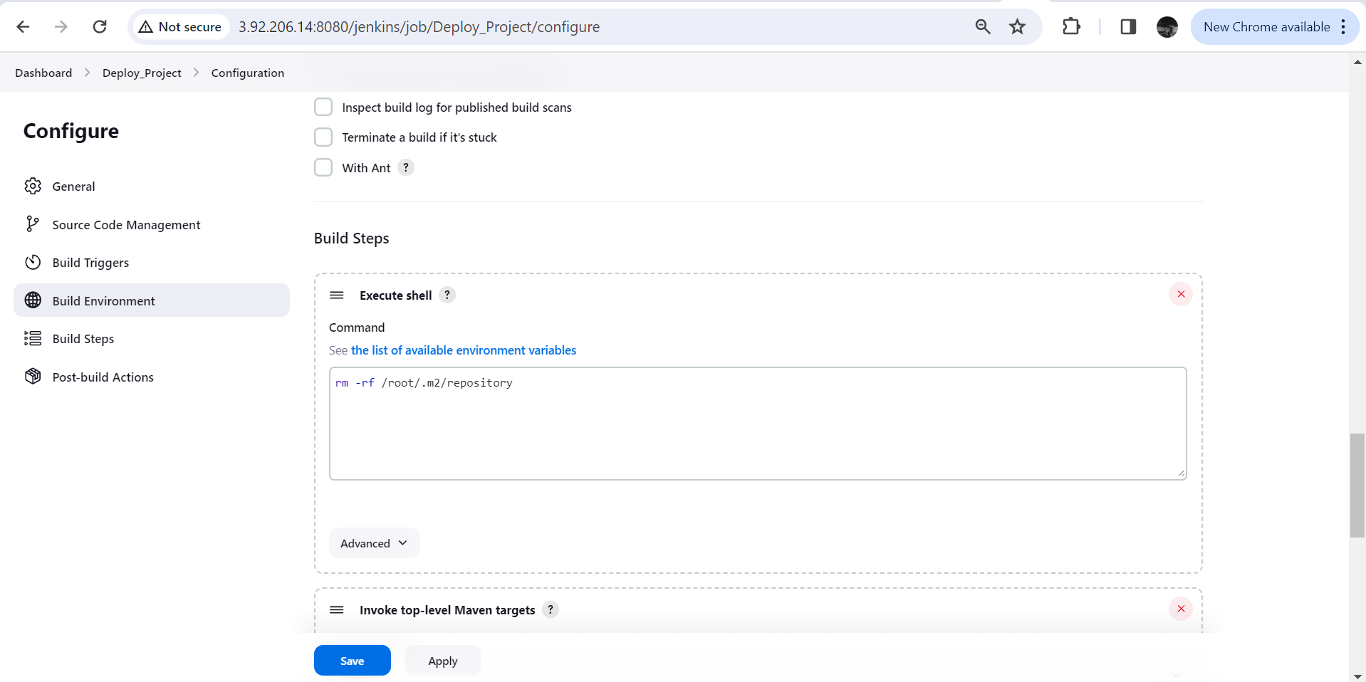

Build step : Invoke Top level maven targets

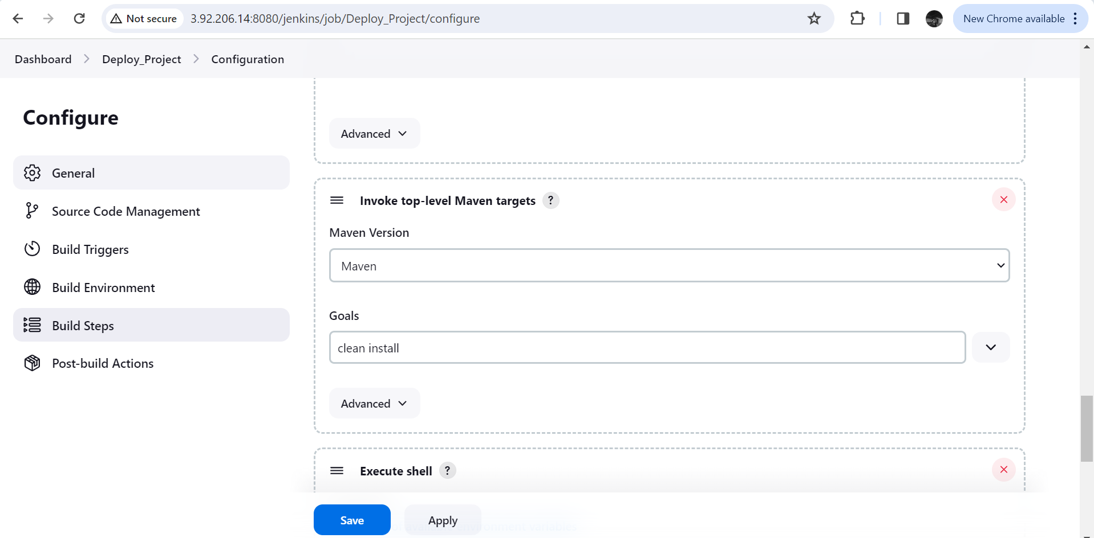

Build step -> Execute shell

Apply and save

Build Now to run latest build

Access the same to see the desired output

