Assignment-1

* Launch a EC2 instance.
* Install java : yum install java-11-amazon-corretto.x86_64 -y
* Create a directory called “Servers” in /mnt and install Tomcat in same
* Go to Servers directory 🡺 wget <tomcat zip link> 🡺 unzip 🡺 Give full permission to file 🡺 Go to Webapps 🡺 (Install Jenkins) wget <Jenkins WAR file > 🡺 Start the tomcat from bin : ./startup.sh 🡺 For accessing the tomcat goto browser : <public ip>:8080/Jenkins 🡺 Provide initial admin password, install suggested plugin and give username details to see Jenkins UI
* Meanwhile install git. (Can be done from Jenkins too)

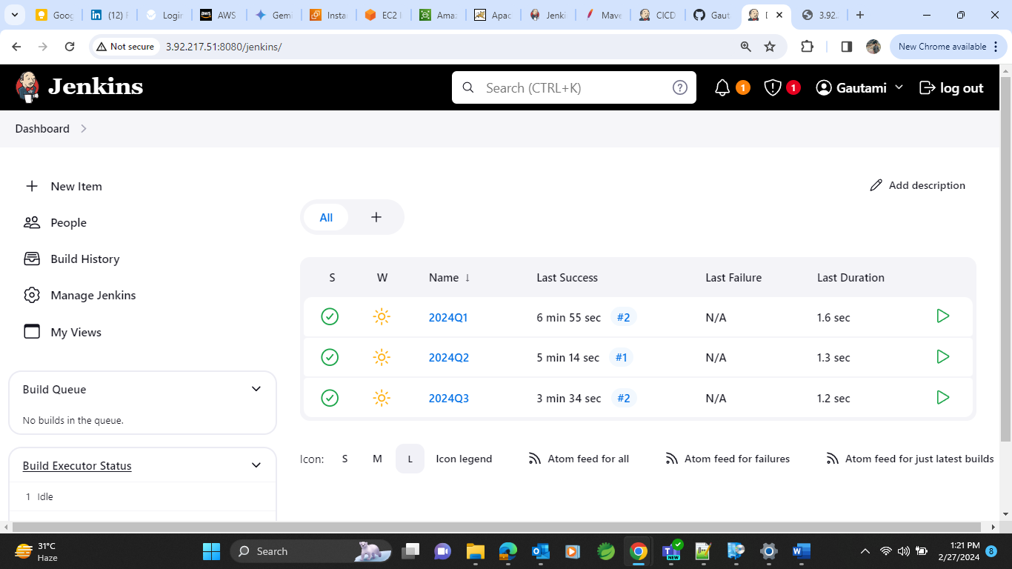

* Create a Job named as 2024Q1. And do All the need configuration of build and workspace.

Use execute shell in build step. And provide lines of code as shown below.

* To access the file take public ip and paste on browser

* Create another Job named as 2024Q2 and do all the same process as did for Job1 except in git configuration, use 2024Q2 branch here for Job2.

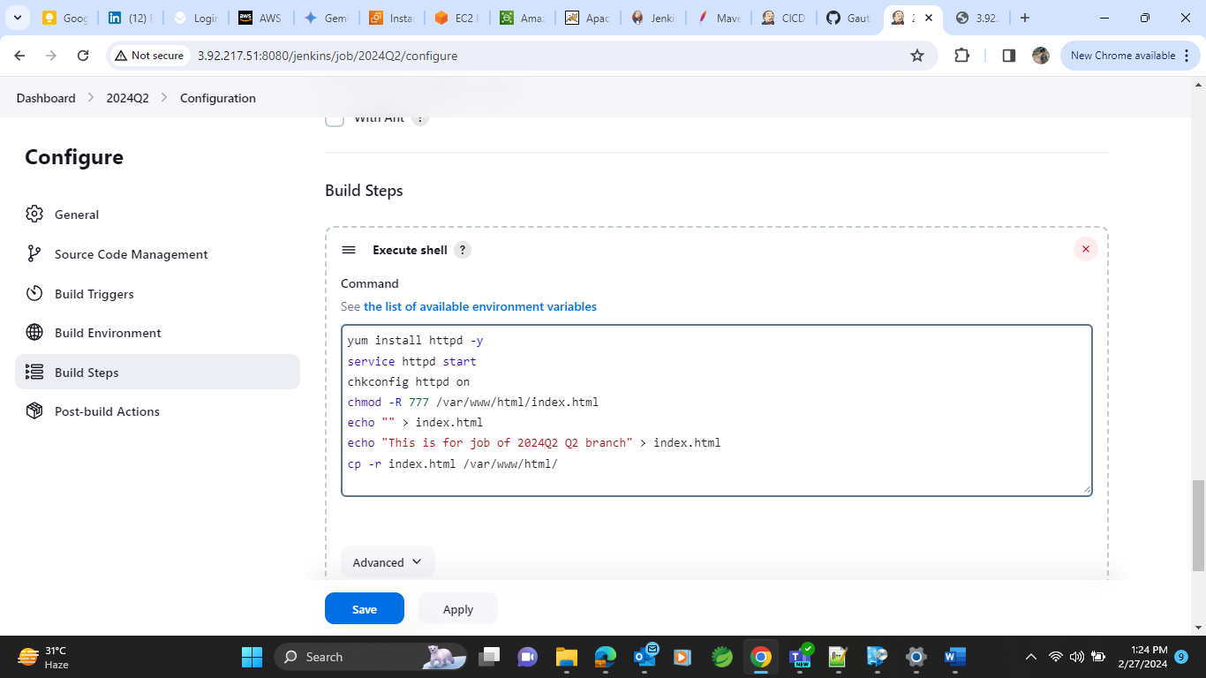

And do same for job 3.

* After that make a build of same and while accessing the public ip we will get result like

So now whenever we click on “Build now” option in any job that jobs Index.html page will hit and give us same content on browser

* For Example:
* Doing build now for JOB3 :

And so on….