**DATABASE MANAGEMENT SYSTEMS**

**REVIEW-III**

**SLOT: D2**

**PROJECT TITLE: ONLINE VEHICLE MANAGEMENT SYSTEM**

**NAME: MINAL MUKTA (REG.NO. 18BCE0826)**

**GAUTAMI MEHTA (REG.NO. 18BCE0855)**

**AIM:**

The project aims to create a webpage where the users can login and enter the data i.e. the starting point and the destination place. The webpage will display the shortest path and the total distance they will travel. This distance will get stored in the database for each particular user. A survey will be conducted after 7 days and here we will use three types of sorting algorithms and then compare as to which one is the best among all these.

Therefore the main aim of the project is to keep a count of all the vehicles that will be used per day by each individual and in the end, a survey will be conducted that will present a proper analysis.

**ABSTRACT:**

The project aims at creating a webpage as a platform for everyone to enter the details of his travel and then display it accordingly whenever he feels like. The person can know how much he used his each particular vehicle in which day. This will create a platform where the particular use of each vehicle and by which person will keep getting updated in the database. The problem is that people nowadays use a lot of vehicles and they themselves are unaware of the fact about the excessive use of their vehicles at times. Here there will be an easy solution for this problem. The entire details can be viewed by a person at once and therefore he can also know which particular vehicle was used by which person in the family. Moreover, this database will have the record for every vehicle which can be used to create an analysis further as to which road is crowded the most and which the least that is, which path is chosen by most people. The algorithms that we will be using here are the dijkstra’s algorithm for shortest path. The administrator will have this facility of viewing all the details of each particular vehicle and each particular person. He will conduct a weekly analysis for the vehciles used the most (number of times) and the vehicle that covered the most distance. The sorting algorithms which we will use here will be of three types and we will compare between them and check which gives the result in the least time. The sorting algorithms that we will be using are merge sort, radix sort and shell sorting techniques.

**INTRODUCTION:**

There are a lot of vehicles in the roads nowadays but they are not properly managed. There is no such platform for each individual to view the use of his vehicle in each particular day and by all people who used it. The people sometimes want to know about all the details of their vehicle but don’t find their vehicle’s papers and therefore it becomes difficult. There is another pertaining problem of traffic. There is a lot of traffic nowadays on the road. Moreover there isn’t record system for every particular vehicle’s individual usage. We talked to several people and found out that they would find it very easy if they would have an online platform where they can enter the each particular usage of their vehicles and can view it whenever necessary. Therefore the project aims at creating such a platform.

The great deal of traffic needs to be dealt with. The information will be entered in the webpage by each particular user and then it will get stored in the database. This will be the source of all oud information for further work on the calculation of distance and sorting. The user can login using the sign-up option and then enter the car number, starting point and then the destination point of his journey. The website after calculation in the backend will display the result.

The project deals with the problem that there are a lot of vehicles on the road nowadays. There will be an administrator who will be responsible for carrying out all the necessary actions. There will be a webpage that will contain all the options (for registered users a login option will be there and for new users, there will be a Sign-up option). There will be an administrator option as well which only the administrator himself will be able to register and use. The user will have the option of entering the vehicle number, his name and the start point of the travel as well as the endpoint of the journey. Immediately after the user enters the necessary details Dijkstra’s algorithm will be used to calculate and display the path which the user must take up and also the distance it is going to cover up in that journey. The administrator will accept the user’s request when they try to create a new account and will be administrating the entire webpage for any bugs. The admin will also have the important task of analysing every 7 days. In the end, the distance for each particular car along with its total distance travelled will also be displayed. The entire objective of the project is to create a platform where the people can get an analysis of the total usage of their vehicles.

The project aims at creating something very different from normal google maps where people can only check the distance from one point to another point whereas using this website people can keep a weekly tracking of all the individual distance it travels for each particular day as well. This is a very convenient method.

In the project, the client will be the user who will login every time and the administrator will have access to the entire database. The algorithm that will be used for the calculation of the shortest path is Dijkstra’s algorithm. In the end, for analysis of how the car was used as a whole in the entire city, we will be using various types of sorting algorithms and comparing which sorting technique is better.

**LITERATURE SURVEY:**

The project aims at creating something very new. We acknowledged that people nowadays have various problems because of traffic. In this project, we will create a website that will interact with the user. The user will begin with a login page where he can enter his login credentials and move to the next page of the website. If the user has forgotten his password then he can go to the forgot password option on the login page and then there will come up a new page where he will have to enter the email id associated with his account. Automatically a mail will be sent to the registered mail id and then the user can change his password. Then, further, the login page will also have the option for new users to sign up. The website will be very user interactive. The user will have the facility to display the usage of his vehicle for the past days. Also, he can display the shortest path which his vehicle will have to travel along with the distance which will get stored in the database.

The administrator will survey the past usage of vehicles for a particular time, say seven days and then will arrange them according to the number of times each particular vehicle is used and the distance travelled by all the vehicles.

The project aims at solving the issues faced by each person who wants to keep a track of the number of times a vehicle will be used and it will also store the starting and destination point of the travel. This will serve to be of convenience to the people. There is no such technology which will store the particular us of each vehicle running on the road in a separate database. If this system is put into action then it can aim at solving a lot of road crimes because the position of any particular vehicle will be easily deciphered.

We implement this project using a webpage which will prove to be a proper way of interacting with each user. The webpage will be interactive and the user will find his way through even if he is an amateur.

Further this project can be made better and implemented in many other ways to be more useful and interactive. For example, the analysis can be made to conclude that which place has the most number of vehicles crossing through it. Steps can be taken to plant more trees in those areas to prevent pollution. This will prove as an easy way of doing the above as we would already be aware of the areas where steps need to be taken and in what ways. As already mentioned, the number of road accidents and crimes can be checked as everything will be checked upon. Further, more and better ideas can be implemented using this concept to solve a lot of society related issues.

**METHODOLOGY:**

**The idea:**

1. User will login using his username and password
2. If the user does not have an account than he can register as a new user
3. The user will enter his vehicle number and starting point and destination point of his journey
4. The back end of the webpage will calculate the shortest path and the distance using the dijkstra’s algorithm
5. After a span of 7 days the administrator will provide an analysis for the total distance covered by each vehicle in those days and the individual usage of each vehicle.

In the back end python will be used to code for the entire actions which the webpage is going to take.

**Algorithm for Dijkstra’s algorithm:**

1. We will mark our initial node with a initial distance of 0 and the other nodes will be infinity.
2. We set the value of the nodes that are not visited with the smallest present distance as the current node .
3. For every neighbour of our current node we add the distance c with the edge connecting the present node and the neighbouring node.
4. If the new calculated distance is smaller than the current distance then we overwrite old value with the new calculated value.
5. We mark the current node as visited.
6. We carry on the same process for all nodes that are not yet visited.

**Algorithm for all the three sorting techniques:**

1. The choice of the technique is made by the administrator using switch case.
2. If the administrator makes the choice of radix sort then the following algorithm is used

* Define 10 queues where each will be a storage representing each digit from 0 to 9
* We consider the least significant digit of each number which is to be sorted.
* We insert each number into their respective queue based on their least significant digit
* Group all the numbers from queue 0 to queue 9 in the order they have inserted into their respective queues.
* Repeat the above steps from 3 for each significant digit
* Repeat from step 2 until all numbers are grouped based on the most significant digit

1. If the administrator makes the choice of shell sort then the following algorithm is used

* Initialize the value of h where h is h=h*3+1 and h starts from 1
* Divide the list into smaller sub list of equal list of equal interval h
* We sort these sub lists using insertion sort
* We repeat the entire process until the list is completely sorted

1. If the administrator makes the choice of merge sort them the following algorithm is used

* We take a variable p and store the starting index of our array in p and we store the last index array in index r.
* The we find the middle of the array using formula (p+r)/2 and mark the middle index as q and then we break the array into two subarrays from p to q from q+1 to r index.
* Now we divide these two subarrays again just like we divided our main and this process we repeat.
* Once we have divide the main array into subarrays with single elements and we merge all the sub arrays.

1. The analysis is conducted which gives the final report for everything.

**User interface:**

1. The first page that appears is the signup page where the user can login using his username and password.
2. If the user has forgotten his password he can select the option that says that forgot password and then a new page will come up which will require two inputs, username and registered email id. A mail will be sent to the registered email id and then the user can change his password.
3. The login page also contains the option for new users to sign up and create a new account.
4. In the signup page for creating a new account the user must enter name, address, phone number, email id, password and confirm password. When the user sign’s up then the data will get stored in the database and then the user can proceed further.
5. When the user has successfully logged in, he can display the shortest distance algorithm(Dijkstra’s algorithm) or display the past usage of the vehicle.
6. Every time the user must enter the vehicle number.

**Comparison between merge sort, radix sort and shell sort**

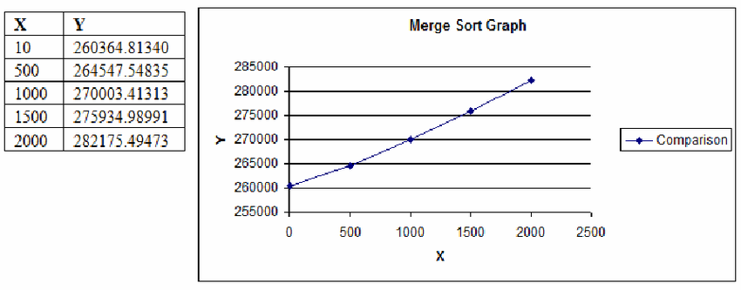

This is graph for merge sort.

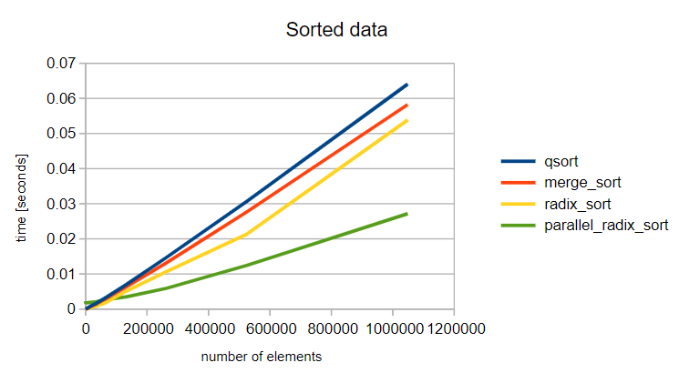

This graph above is the graph for radix sort.

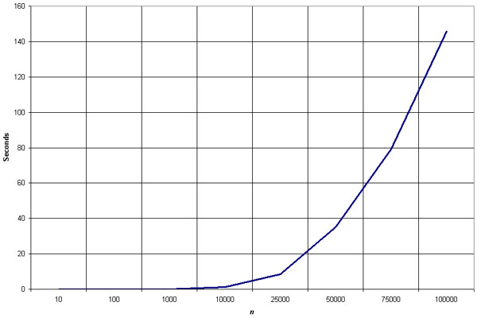

The above graph is for shell sort.

The database for the areas in Delhi is known as **areas_in_delhi.**

The table which has all the information in this database is area.

**DATASET:**

|  |  |  |  |
| --- | --- | --- | --- |
| places | subdiv1 | subdiv2 | subdiv3 |
| New Delhi | Connaught Place | Chanakyapuri | Delhi Cantonment |
| North Delhi | Model Town | Narela | Alipur |
| North West Delhi | Rohini | Kanjhawala | Saraswati Vihar |
| West Delhi | Patel Nagar | Punjabi Bagh | Rajouri Garden |
| South West Delhi | Dwarka | Najafgarh | Kapashera |
| South Delhi | Saket | Hauz Khas | Mehrauli |
| South East Delhi | Defence Colony | Kalkaji | Sarita Vihar |
| Central Delhi | Kotwali | Civil Lines | Karol Bagh |
| North East Delhi | Seelampur | Yamuna Vihar | Karawal Nagar |
| Shahdara | Shahdara | Seemapuri | Vivek Vihar |
| East Delhi | Gandhi Nagar | Preet Vihar | Mayur Vihar |

This table contains information about all the districts in Delhi along with its sub divisions. There will be a new table which will contain the distance from each place to every other place and the shortest path also with it.

There will be a new database which will contain all information about the user which the user will himself enter in the form. This information gets stored directly in the database.