INTELLIGENT PARKING SYSTEM

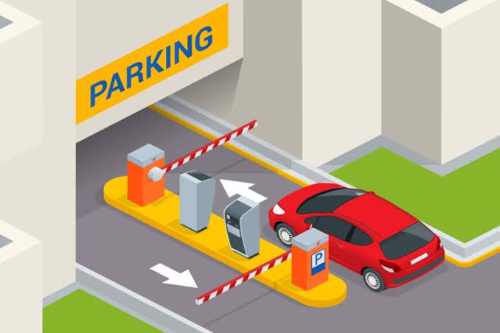

TEAM MEMBERS: GUIDED BY:

Saransh Bhatnagar (lead) Mrs. Richa Jain

Rishabh Dhawad

Gautam Jaiswal

Ojas Khatavkar

**Aim of the project:**

Aim of our project is to provide a quick and hassle free way to find parking spot for your vehicle.

**Components Used:**

* ESP32
* IR sensors
* Servo
* LCD
* Some Passive Components like resistors, capacitors, wires etc

**for further improvement:**

* ESP32-CAM
* UPI Payment gateway

**Optional upgrades:**

* Email Confirmation
* Parking lot safety system
* Carbon monoxide gas sensor etc.

# About the Parts:

# ESP32:

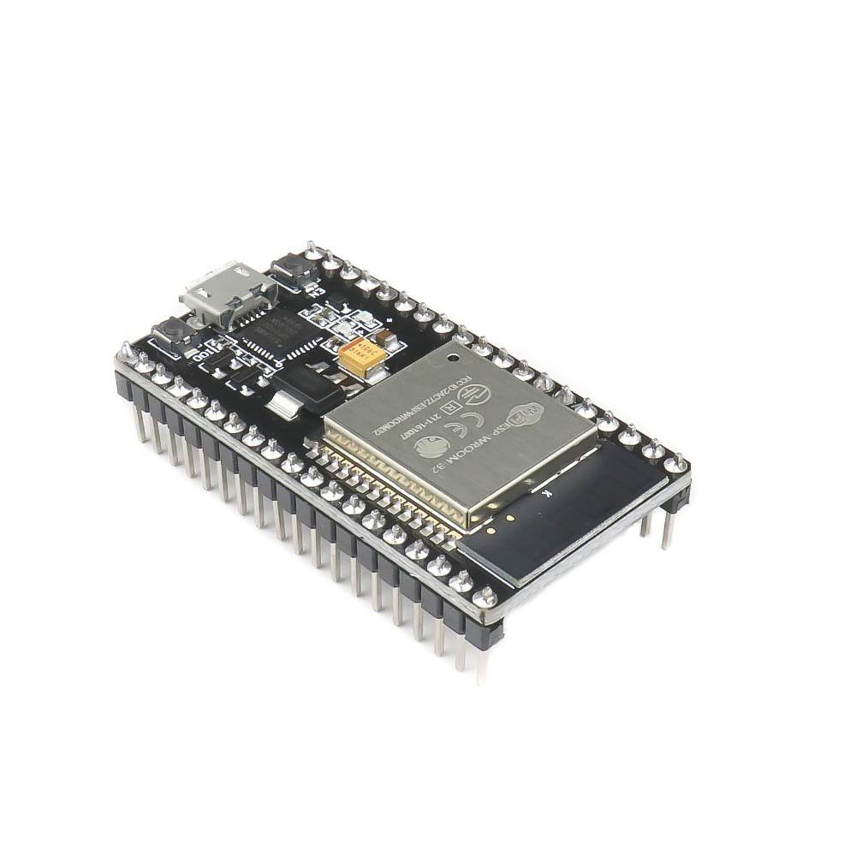

# ESP32 is a highly integrated, low-power, dual-core Wi-Fi Microcontroller SoC, designed to be secure and cost-effective, with a high performance and a rich set of IO capabilities.

# ESP32 implements TCP/IP, full 802.11 b/g/n/e/i WLAN MAC protocol, and Wi-Fi Direct specification. This means ESP 32 can speak to most of the WiFi Routers out there when used in station(client) mode. Also it is able to create an Access point with full 802.11 b/g/n/e/i.

# ESP32 not just supports the latest BLE Bluetooth 4.2, it also supports classic bluetooth. It basically means it can speak to old and new bluetooth phones/tables.

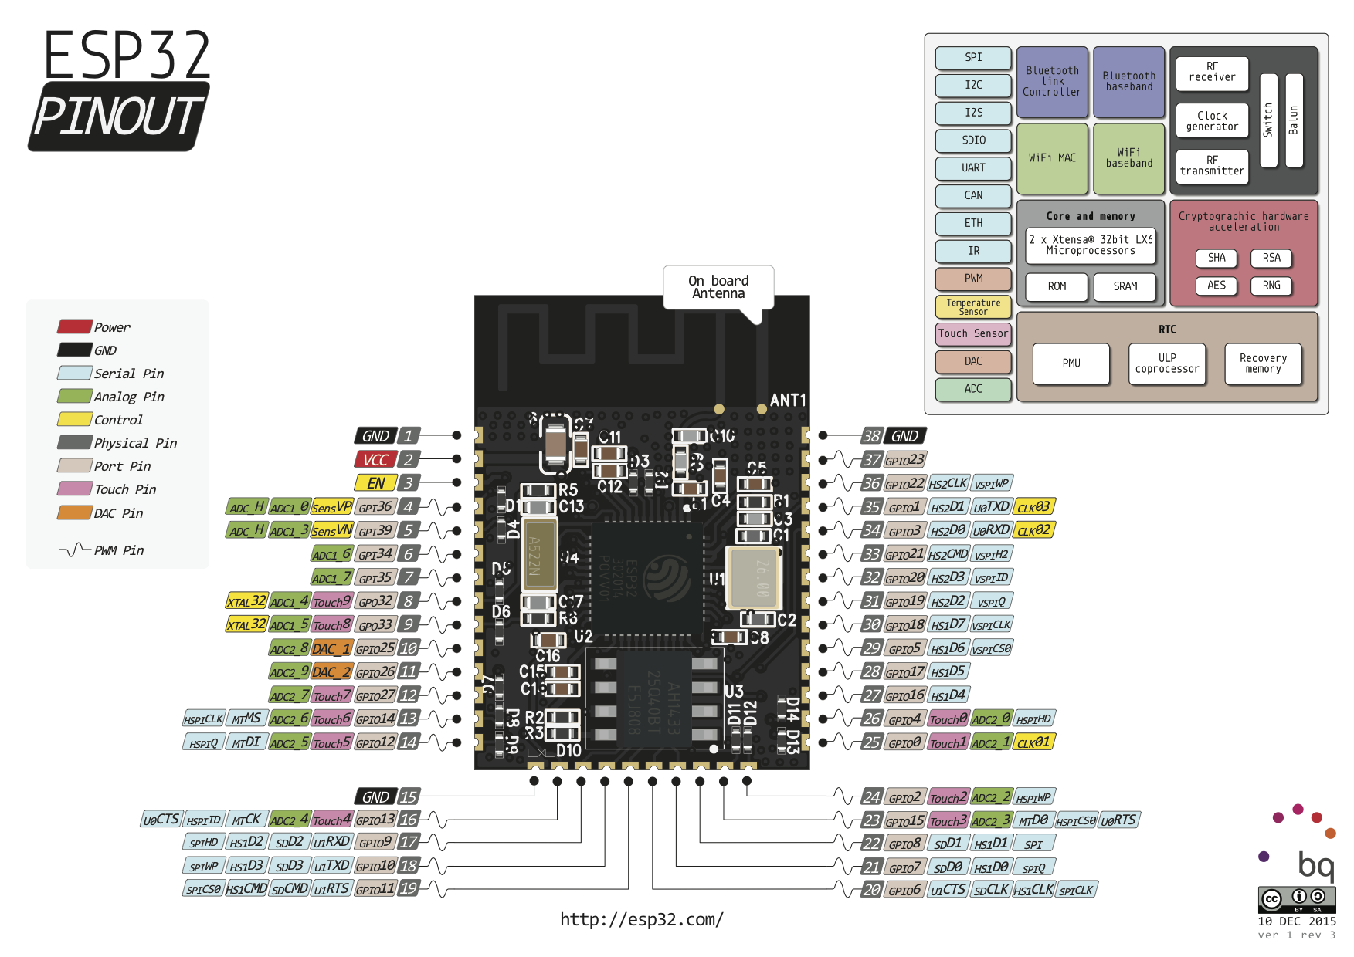

# **IR Sensor:**

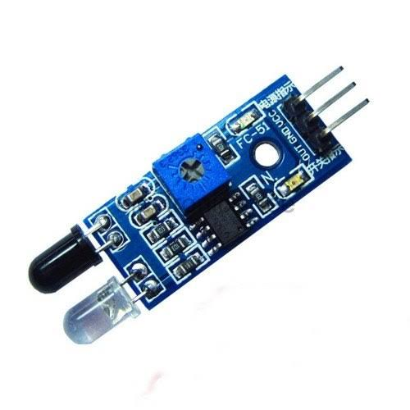

# An infrared sensor (IR sensor) is a radiation-sensitive optoelectronic component with a spectral sensitivity in the infrared wavelength range 780 nm … 50 µm. IR sensors are now widely used in motion detectors, which are used in building services to switch on lamps or in alarm systems to detect unwelcome guests.

# **Servo Motor:**

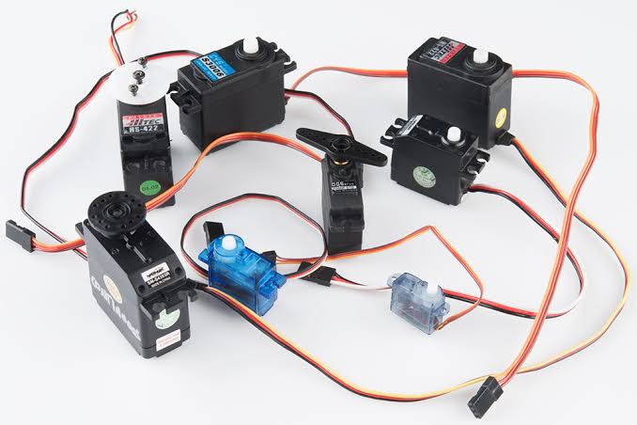

# A servomotor (or servo motor) is a rotary actuator or linear actuator that allows for precise control of angular or linear position, velocity and acceleration.[1] It consists of a suitable motor coupled to a sensor for position feedback. It also requires a relatively sophisticated controller, often a dedicated module designed specifically for use with servomotors.

# **LCD:**

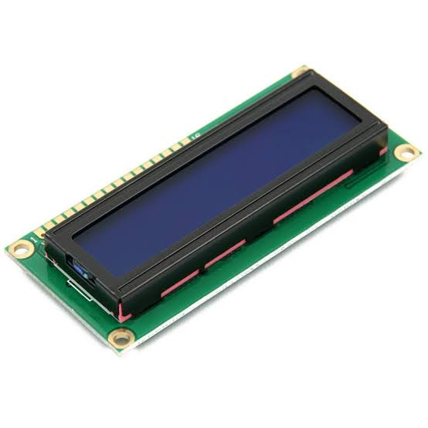

# An LCD is an electronic display module that uses liquid crystal to produce a visible image. The 16×2 LCD display is a very basic module commonly used in DIYs and circuits. The 16×2 translates o a display 16 characters per line in 2 such lines. In this LCD each character is displayed in a 5×7 pixel matrix.

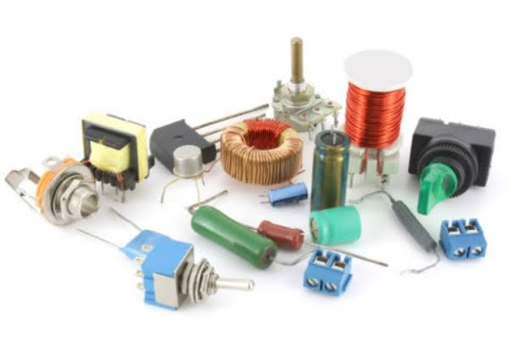

# **Passive Componens:**

# 

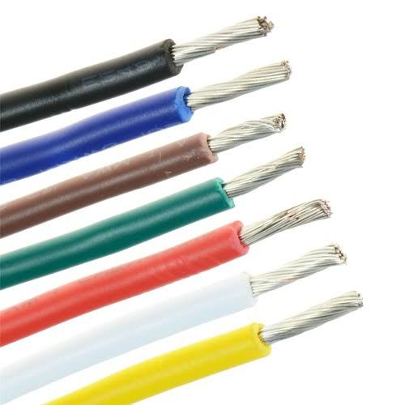

# **About The Project:**

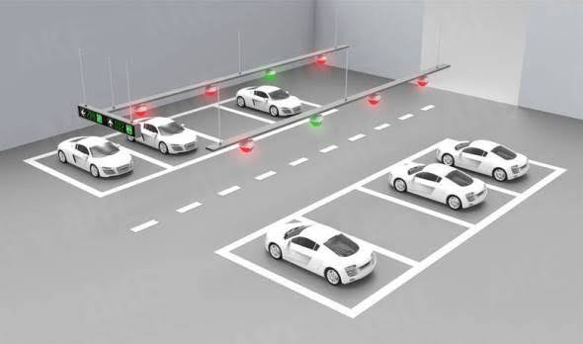

# When a vehicle arrives at the parking lot, at the gate there is checkpoint where he/she will gets allotted a spot for the parking, the barrier will get open and the person can move further for the parking spot, this allocation of spot will be reflected in the database of the system, thus the person can park its vehicle there. At the parking spot there will be a IR sensor that will display the current presence of vehicle and will be used as to sense that whether vehicle is moving out of the parking slot, thus it will mark the slot as vacant.

# As this is a very basic looking project we as well improve it further, by Implementing QR based authorization and Payment system at the Checkpoint. And we can also introduce mobile app to preoccupy your parking slot for more faster parking experience and for the vehicle tracking and SMS/Email confirmation.

# As for the safety of the parking lot we can introduce Carbon Monoxide sensor and fire sensor to prevent CO poisoning and fire hazards to happen.

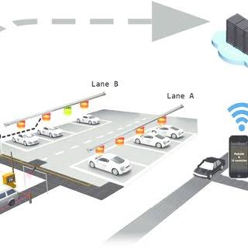

# **The Working:**

# The working of this includes various steps.

# **Step1:** Car will arrive at the checkpoint where the user CAN* pay with a qr code which is being placed there and gets a authentication QR* through the ESP32-CAM module then it will get a parking spot number allocated this authentication QR data will get uploaded to the database server. The barriers (using Servo motor) now opens.

# **Step2:** the car will go to the allocated parking spot and parks the vehicle. Where the IR sensor will detect its presence. As the car goes away form the parking spot the IR sensor detects its absence and marks the spot as unoccupied.

# **Step3:** now the car is again arrive at the checkpoint where it is again authorized by the QR code generated earlier by the ESP32-CAM. After authorization the process is completed.

# **Additional Step:** If there is excess build up of the carbon monoxide gas then the CO sensor will detect it and turns on the exhausts so that the peoples will not suffer from the carbon monoxide poisoning which can be lethal.

# Wee as a team are very ambitious about this project and further improving it. And are all excited to creating and seeing it working to its full potential.

# *This includes further improvements, the actual H/W Might differ from this concept.

# **Reference sites:**

# [www.arduino.cc](http://www.arduino.cc)

# [www.electronoobs.com](http://www.electronoobs.com)

# [www.phonepe.com](http://www.phonepe.com)

# [www.makeuseof.com](http://www.makeuseof.com)