COMP3006 Full-Stack Development CW2 Report

Project Choice | Social Media System
GitHub Link | https://github.com/Plymouth-University/coursework-corey-richardson
YouTube Link | TODO

Requirements

System Design
The system using containerised microservice architecture, separating concerns between the Client, Server and Database. Containers are orchestrated as independent services using Docker.
The application follows a Model-View-Controller (MVC) design pattern:
- Model: A MongoDB database for persistent data storage
- View: A React frontend user interface, using the Context API for state management
- Controller: A Node.js and Express backend to handle logic, authentication and database operations.
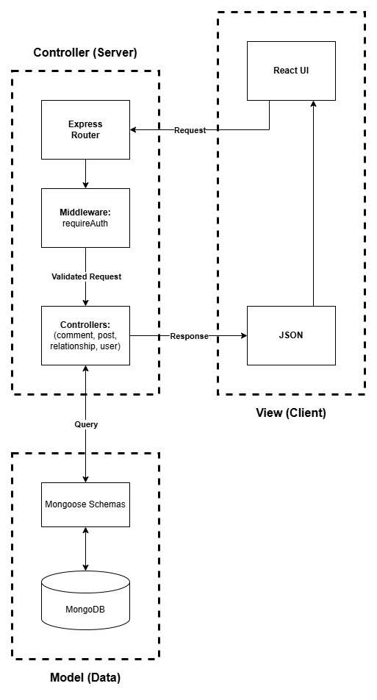
Figure 1: Model-View-Controller

Communications between containers is done through a RESTful API to handle CRUD operations, and a WebSocket channel (via Socket.io) is used with the React Context API to handle real-time UI updates.

Contexts and Reducers to Manage State
To manage the applications global state, I implemented the React Context API with the useReducer hook for managing the state of Authentication, Posts and Relationships.
By using a reducer, state transitions are centralised: a single source of truth. A state transition is triggered by a dispatch action, containing a type and a payload.
This design pattern can be used to encapsulate logic away from the components that consume them. For example, the pages/Login.jsx::handleSubmit method uses the login method provided to it by the useLogin hook. This means that the component itself never needs to know the specific implementation details of the database call.

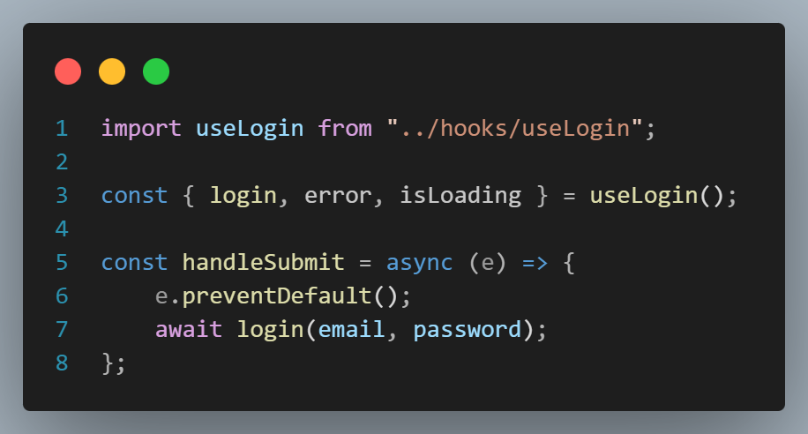
Figure 2: pages/Login.jsx::handleSubmit

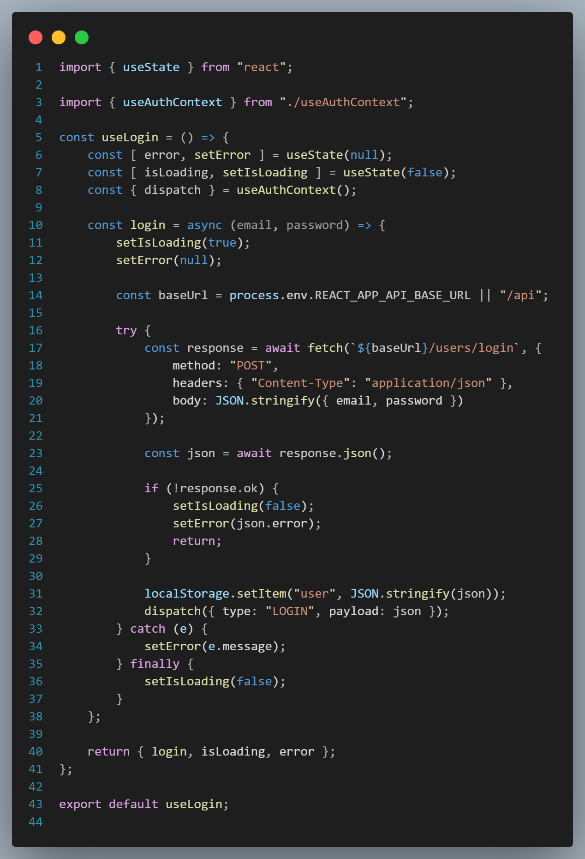
Figure 3: hooks/useLogin.js

The PostContext is another, more complex, example of where this pattern has been implemented. It handles conditional fetching of posts to populate the feed, performing filtering for the “Global” feed, only posts from users the current user is following, or posts from a specific user to show on their profile page.
This pattern also allows for pagination by having actions for SET_POSTS which sets the global post state, and LOAD_MORE_POSTS which instead appends the newly loaded posts to the existing post state.

The WebSocket Lifecycle is managed within the PostContextProvider, by initialising a socket connection from within a useEffect hook to listen to broadcasts emitted by the PostController. These events are dispatched the reducer shown on the next page, ensuring that UI updates occur in real time across connected-clients without a page refresh.

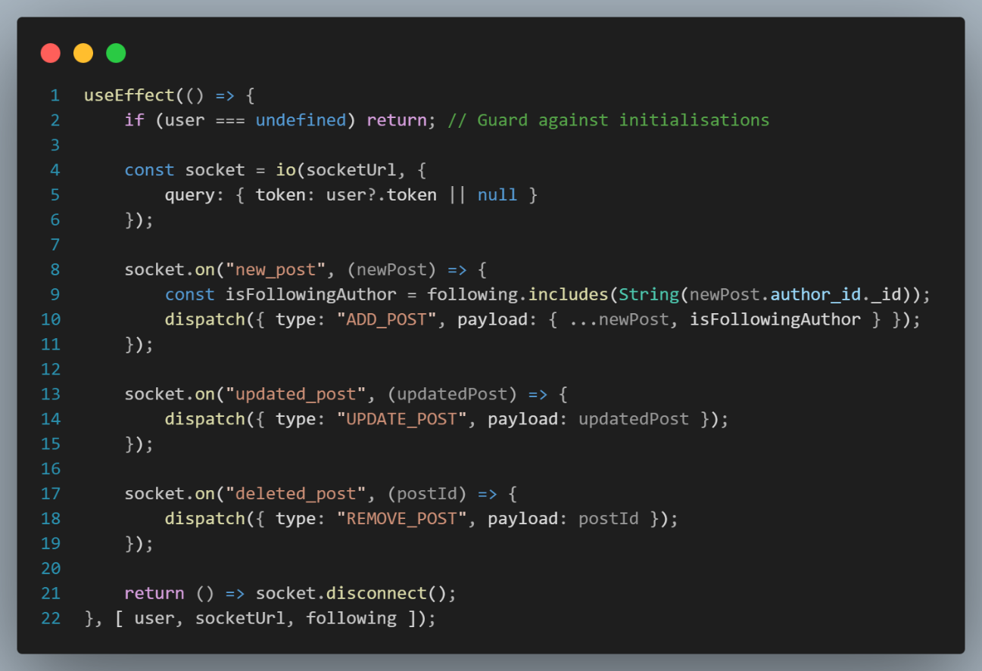
Figure 4: PostContextProvider Socket Management

During a walkthrough test, I found a bug where the newly created post was being added to the context state without checking what feed the user was on - global, following or on a specific user’s profile - causing an error where somebody else’s post could be added to your profile until there was a page refresh. As such, I moved the feedtype state attribute into the PostContext and added a guard to the reducers ADD_POST case to first check if the post was authored by a user that the current user follows, or if you are on their profile page (see Figure 6). This was done using the RelationshipContext and prevents state corruption.
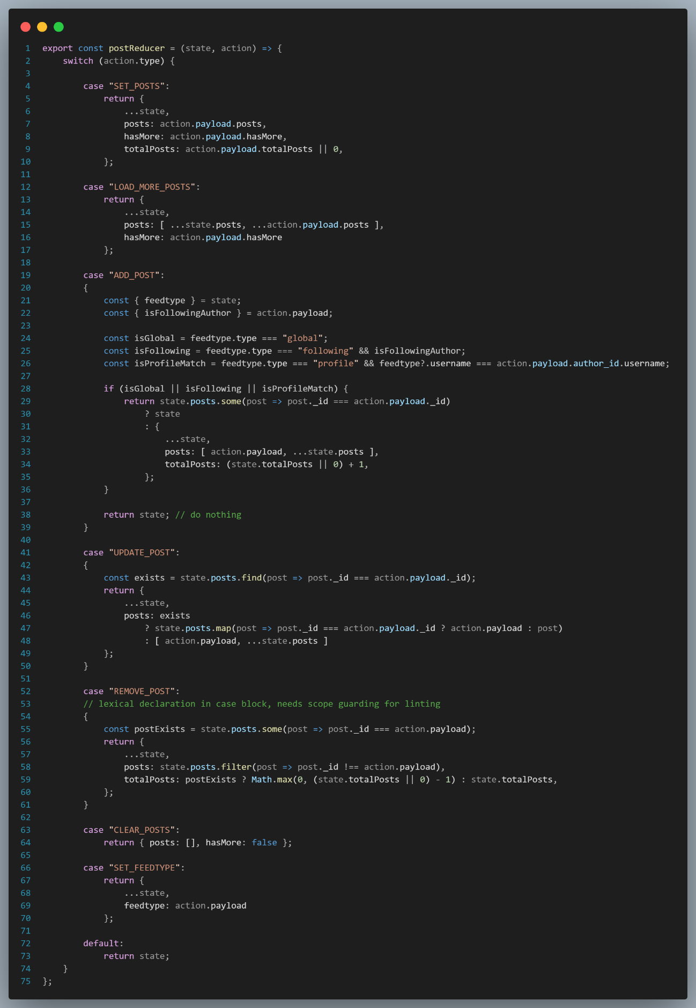
Figure 5: context/PostContext.jsx::postReducer

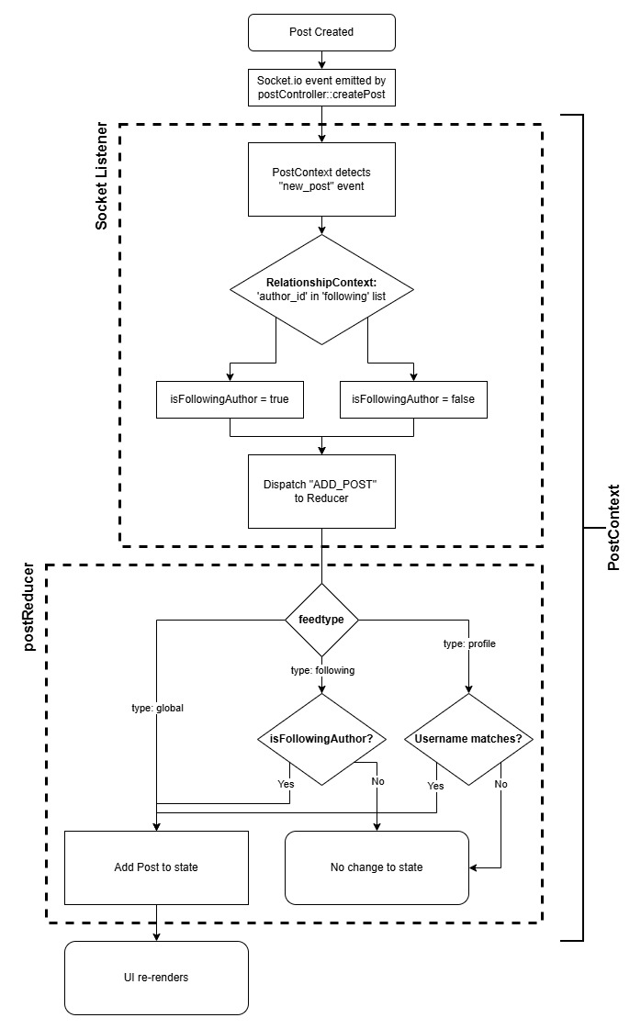
Figure 6: New Post Socket Emit and Context Dispatch

Docker and Containerisation
The system is broken down into three services, orchestrated by a docker-compose file. This file ensures that the database service is always initialised as a dependency before the backend service.

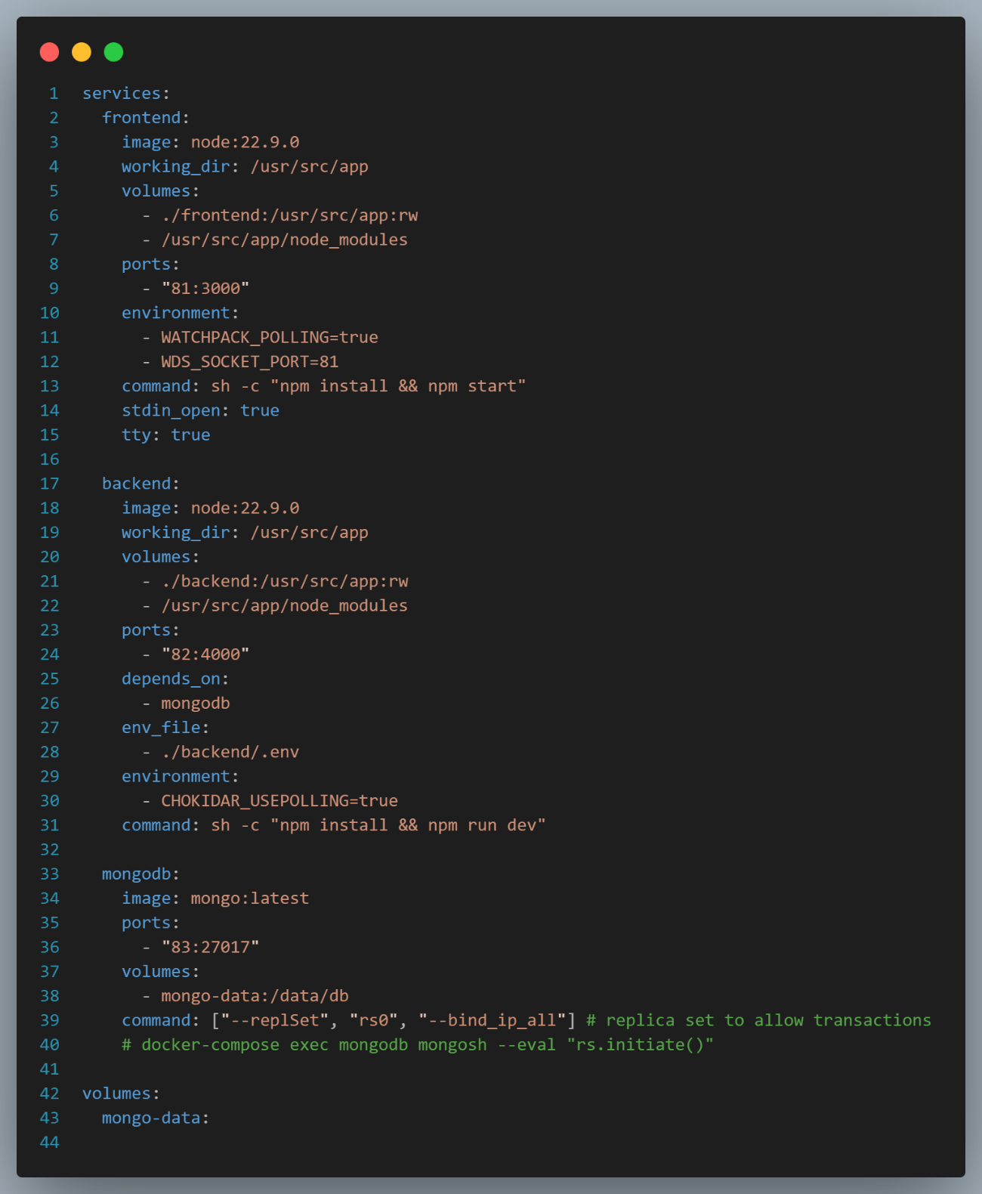
Figure 7: Docker Compose File

The --replSet rs0 --bind_ip_all command turns the MongoDB instance into a replica set, allowing the use of database transactions in my controllers.
This allows for atomic operations, such as deleting a user from the database. Before deleting the user, their posts, comments, likes and relationships must first also be deleted to prevent orphaned items being present in the database. However, if any of these operations fail, all operations as part of that transaction should fail too to prevent inconsistent data.

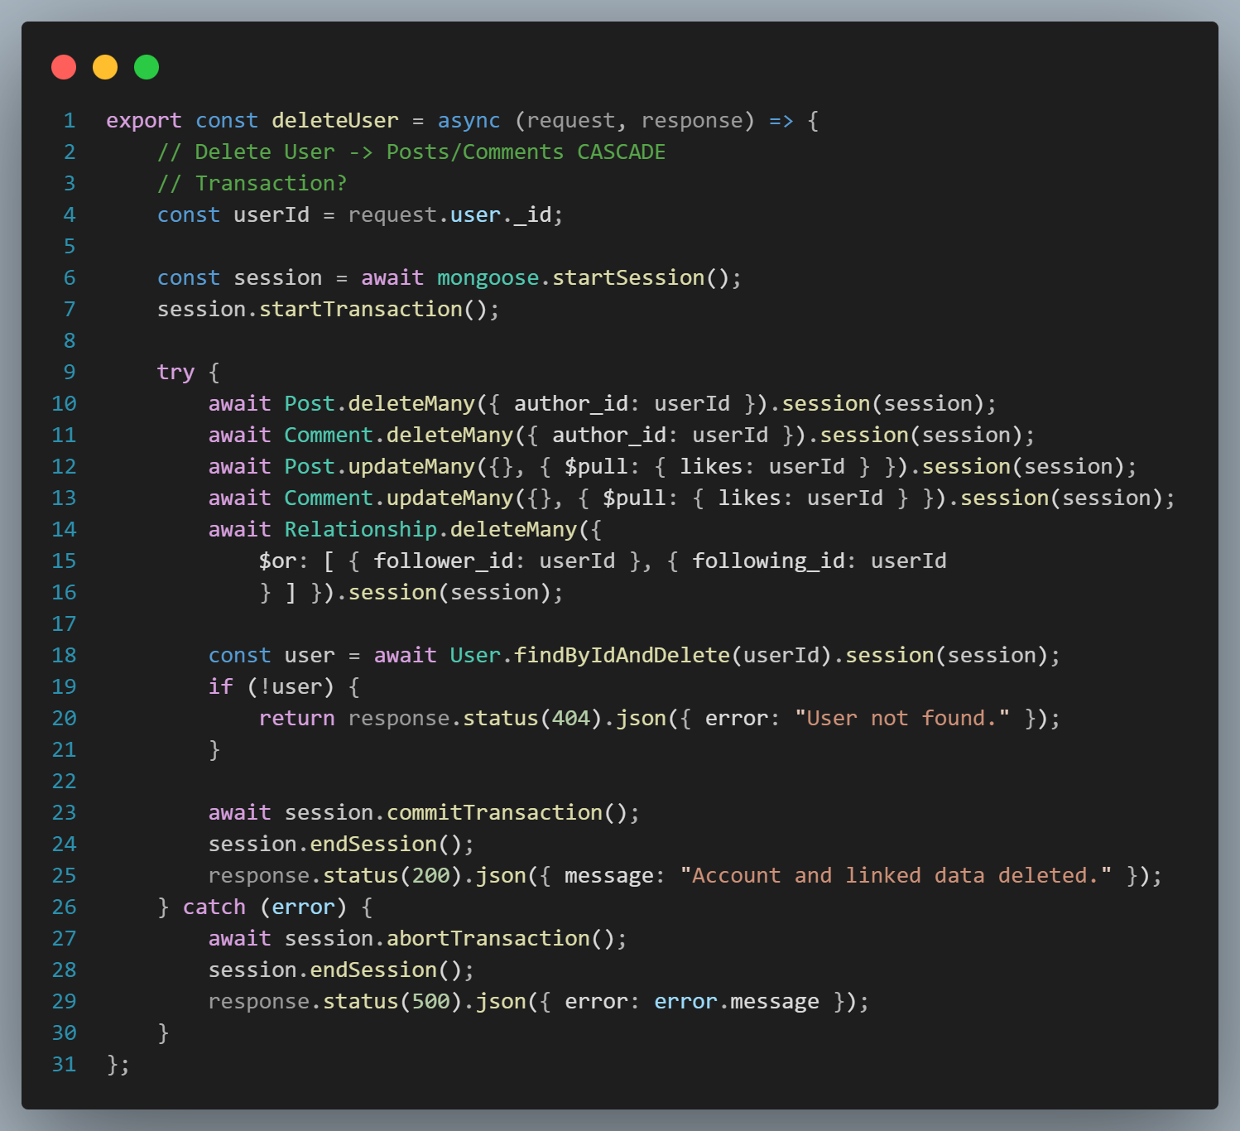
Figure 8: controllers/userController.js::deleteUser

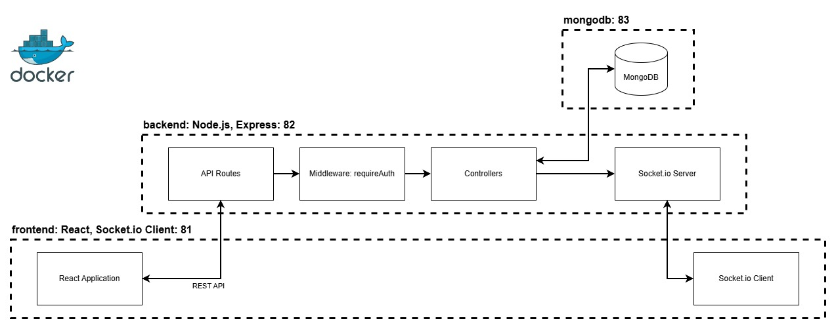
Figure 9: Docker Containerisation Architecture

Service | Host Port | Container Port
frontend | 81 | 3000
backend | 82 | 4000
mongodb (Database) | 83 | 27017

Testing

DevOps Pipeline
Code quality checks are done frequently, and at the earliest point in the development process.
To prevent “untidy” code from being committed to the git repository, I implemented a Husky pre-commit hook which runs lint-staged whenever someone makes a commit in the repository. lint-staged runs static analysis with ESLint on the files which have been changed and staged since the last commit, enforcing style rules defined in SourceCode/eslint.config.mjs. These rules include preventing unused variables from being defined, consistent indentation is used and imports are grouped and sorted alphabetically. Whilst these rules don’t change the effects of the code, they do improve the readability and maintainability of the project by ensuring consistency across files and a high code quality.
The next quality gate is a Continuous Integration pipeline, ran on each push to the main branch of the repository with GitHub Actions. The lint job ensures that code is styled consistently and is a dependency of the following jobs: if this job fails, they don’t run (fail early). After linting passes, backend-tests and frontend-tests run in parallel with coverage metrics. There is a check to see if the workflow is being run from GitHub Local Actions but if not, the upload-artifact step uploads the test coverage reports to the run so that tests can be reviewed.

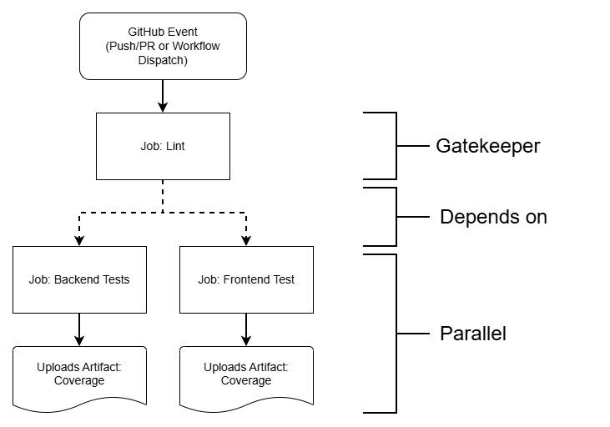
Figure 10: GitHub Actions Workflow

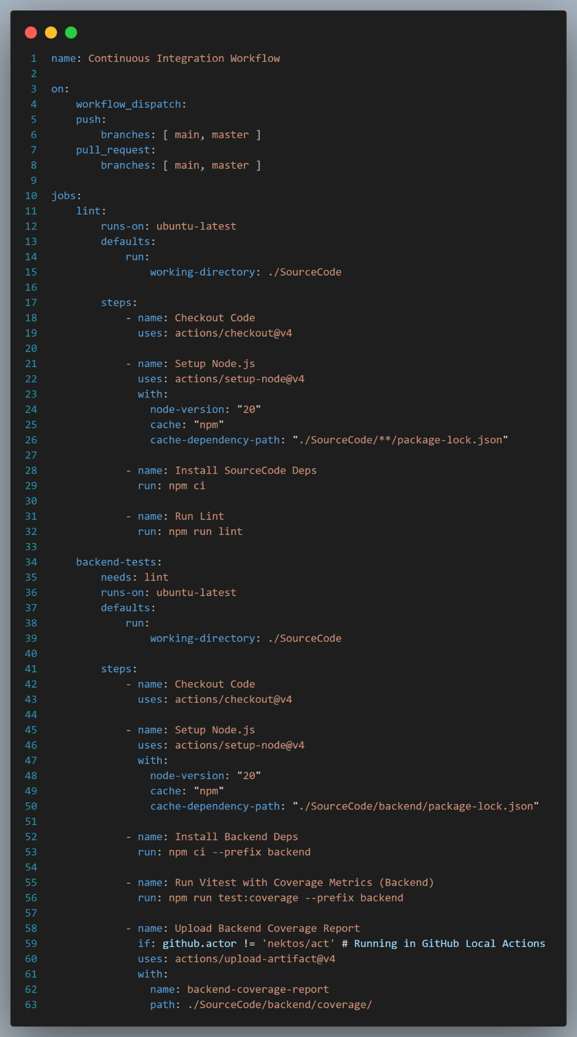
Figure 11: CI Workflow 1
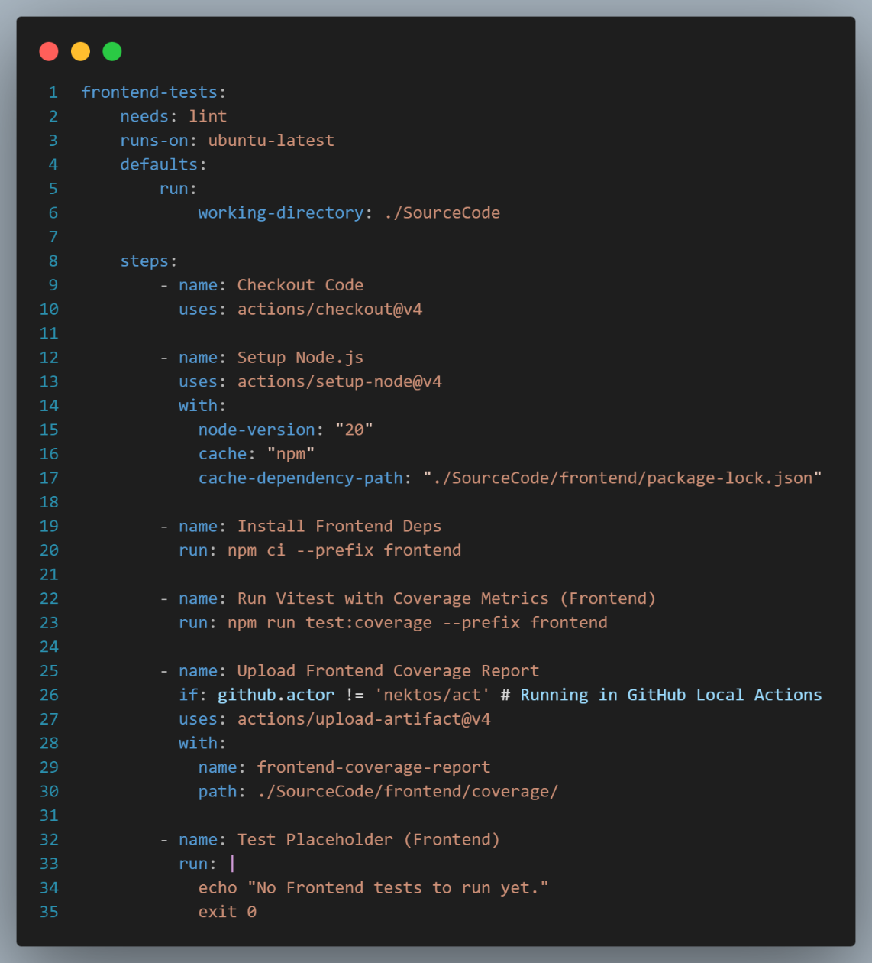
Figure 12: CI Workflow 2

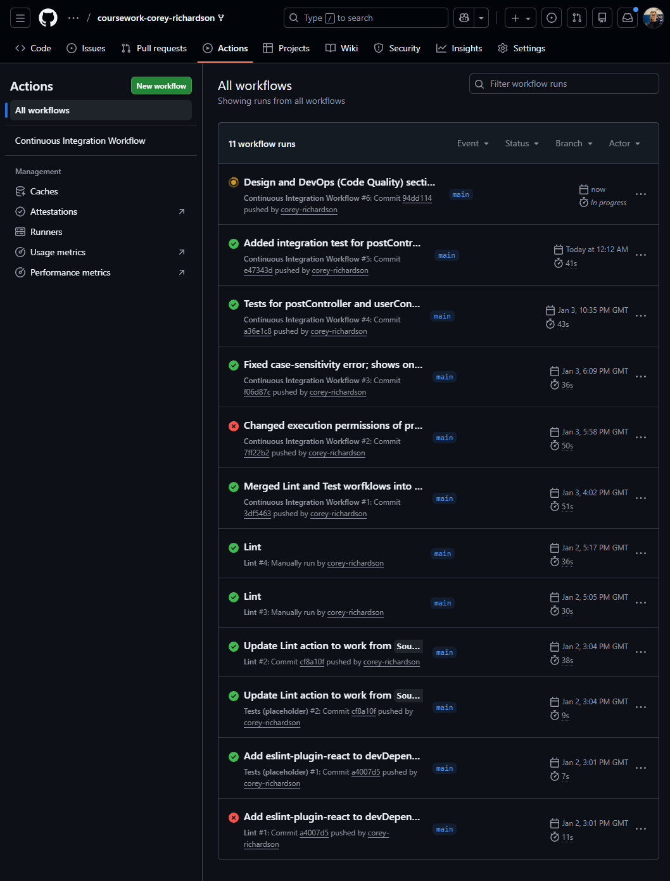
Figure 13: GitHub Actions Page
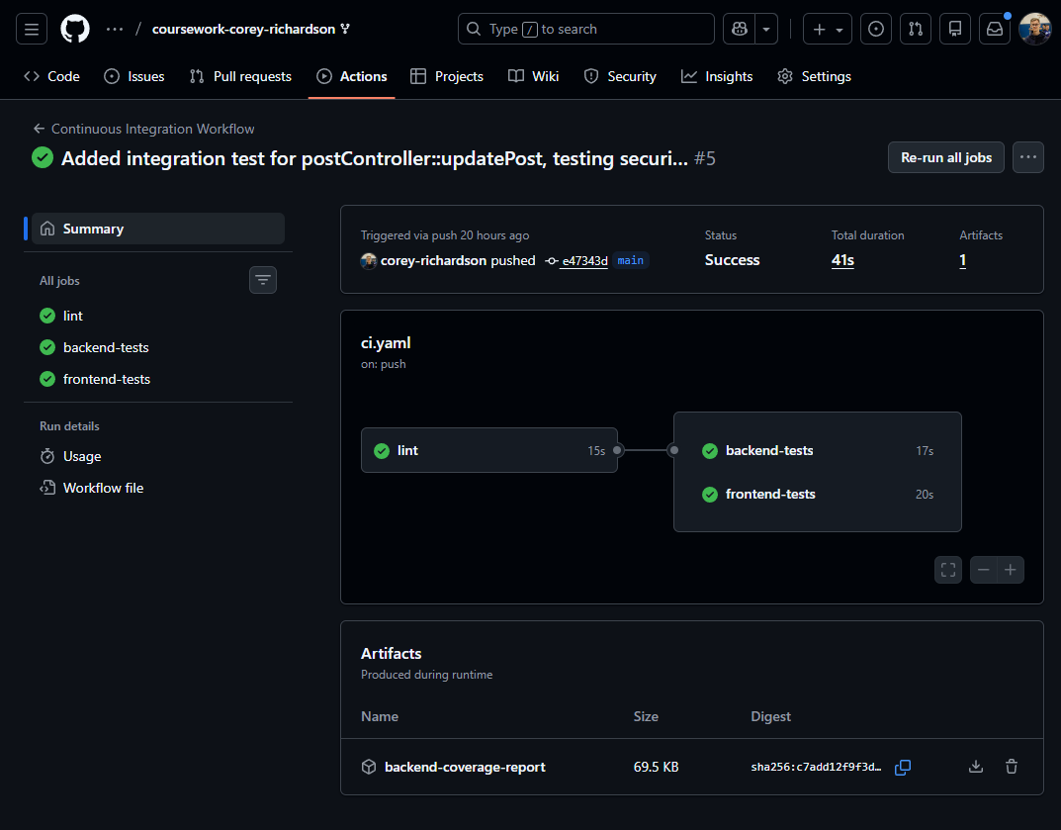
Figure 14: GitHub Actions Page - Coverage Report Artifact

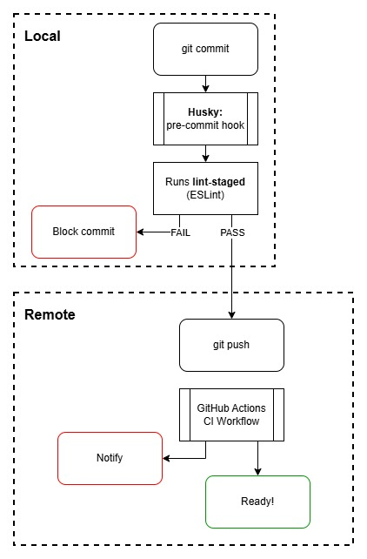
Figure 15: Code Quality Pipeline

The Dockerfile configurations (frontend/Dockerfile and backend/Dockerfile) provide a consistent environment between development, testing, and deployments.
GitHub Actions will use the same node:18-alpine image used during development and deployment, meaning that if the CI pipeline tests pass there, they will pass in a production container too.
npm run lint is also found in the Dockerfiles before exposing the port, providing a final check that below-quality code isn’t being provided to the deployment.

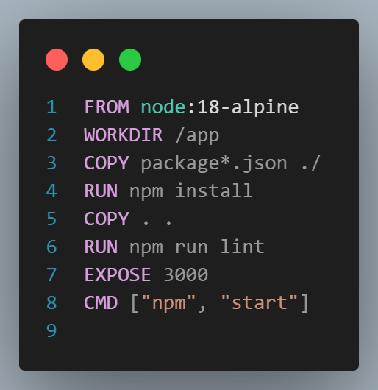  Figure 16: frontend/Dockerfile | 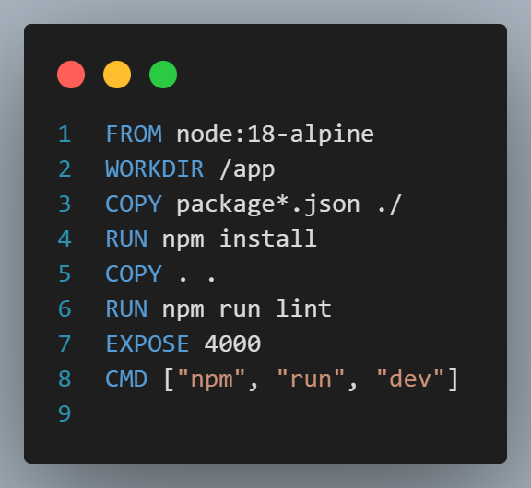  Figure 17: backend/Dockerfile

Code Quality Gates
Stage | Tool | Trigger | Action
Commit | Husky / lint-staged | git commit | Block commit if linting fails.
Push | GitHub Actions | git push | Notifies on lint or test failure.
Build | Docker | docker-compose | Runs npm run lint before EXPOSE.

Evaluation

