|| Jai Sri Gurudev ||
Sri Adichunchanagiri Shikshana Trust ®
SJB INSTITUTE OF TECHNOLOGY

BGS Health & Education City, Kengeri, Bengaluru – 560 060
Department of Information Science & Engineering
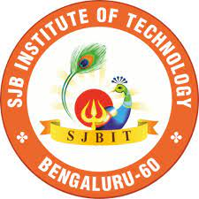
CERTIFICATE

Certified that the project work entitled “HISTOPATHOLOGICAL ANALYSIS USING NEURAL NETWORKS” carried out by Mr. Gagan K P bearing USN 1JB17IS021, Mr. Koodavalli Niranjana Subhodh bearing USN 1JB17IS036 , Mr. Manwel Keithan Monis bearing USN 1JB17IS038 , Mr. Mohammed Faizan Khan bearing USN 1JB17IS044, are bonafide students of SJB Institute of Technology in partial fulfillment for the award of BACHELOR OF ENGINEERING in INFORMATION SCIENCE AND ENGINEERING of the Visvesvaraya Technological University, Belagavi during the Academic Year 2024-25. It is certified that all corrections/suggestions indicated for Internal Assessment have been incorporated in the report deposited in the departmental library. The project report has been approved as it satisfies the academic requirements in respect of Project work prescribed for the said Degree.

Dr/Mr/Mrs Name of the Guide Dr. Shashidhara H R Dr. K V Mahendra Prashanth
Designation Professor & Head Principal
Dept. of ISE Dept. of ISE SJBIT, Bengaluru

External Viva
Name of the Examiners Signature with date
- ……………………………. …………………………
2. …………………………… …………………………

