**GAUTHAM K**

1. Answer all the problems by applying OOP concepts in all places applicable

a. Count the number of vowels in a given string

class Program

{

public static void Main(string[] args)

{

string str;

Console.WriteLine("Enter the string :");

str = Console.ReadLine().ToLower();

Vowels vowels = new Vowels(str);

Console.WriteLine("NUmber of Vowels in the Given String is : "+ vowels.str_vowels());

}

}

using System;

using System.Collections.Generic;

using System.Linq;

using System.Text;

using System.Threading.Tasks;

namespace Assessment

{

internal class Vowels

{

private int count=0;

private string str;

public Vowels(string str)

{

this.Str = str;

}

public int Count { get => count; set => count = value; }

public string Str { get => str; set => str = value; }

public int str_vowels()

{

for (int i = 0; i < Str.Length; i++)

{

if (Str[i] == 'a' || Str[i] == 'e' || Str[i] == 'i' || Str[i] == 'o' || Str[i] == 'u')

{

Count++;

}

}

return Count;

}

}

}

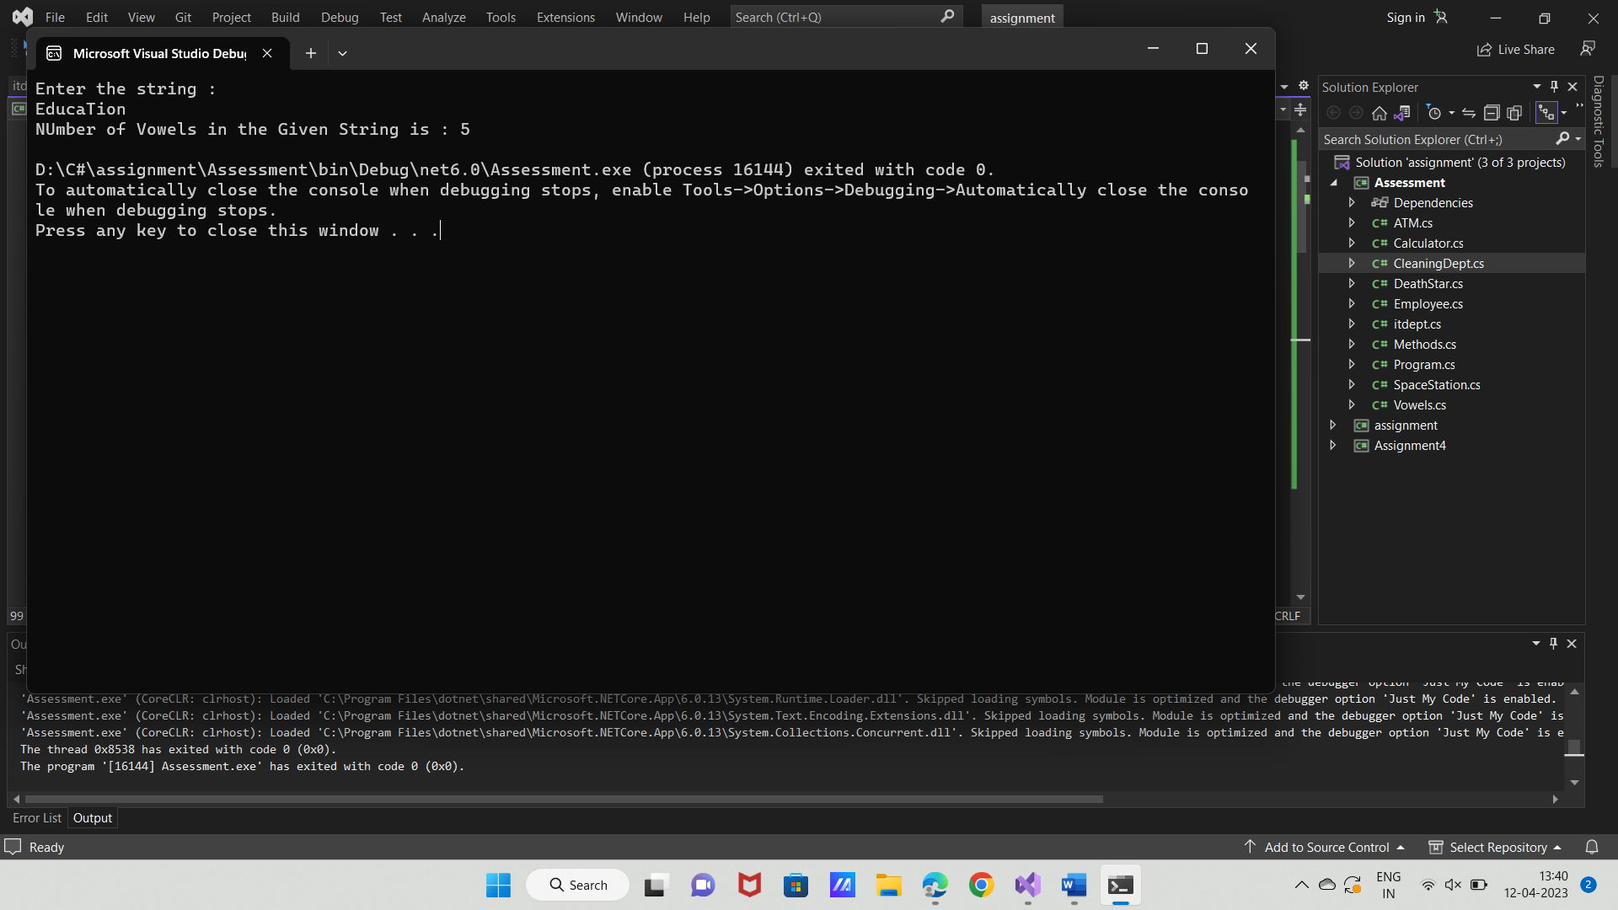

b. Create a ATM class that would allow the end user to perform cash withdrawal and

deposit operations in sequence not by choice and print the balance in the account after

every operation.

class Program

{

public static void Main(string[] args)

{

double balance,withdraw,deposit;

int accountno;

string name;

Console.WriteLine("Enter the account number :");

accountno = Convert.ToInt32(Console.ReadLine());

Console.WriteLine("Enter the Name : ");

name = Console.ReadLine();

Console.WriteLine("Enter the Initial balance : ");

balance= Convert.ToDouble(Console.ReadLine());

ATM atm = new ATM(name, accountno, balance);

Console.WriteLine("Enter the Withdrawal Amount :");

withdraw= Convert.ToDouble(Console.ReadLine());

atm.withdrawal(withdraw);

Console.WriteLine("Enter the Deposit Amount :");

deposit = Convert.ToDouble(Console.ReadLine());

atm.Deposit(deposit);

}

}

using System;

using System.Collections.Generic;

using System.Linq;

using System.Text;

using System.Threading.Tasks;

namespace Assessment

{

internal class ATM

{

private string name;

private double balance;

private int accountno;

public ATM(string name,int accountno, double balance)

{

this.Name = name;

this.Accountno = accountno;

this.Balance = balance;

}

public string Name { get => name; set => name = value; }

public double Balance { get => balance; set => balance = value; }

public int Accountno { get => accountno; set => accountno = value; }

public void withdrawal(double withdraw)

{

if (withdraw < this.Balance)

{

this.Balance = this.Balance - withdraw;

Console.WriteLine("balance after withdrawal : " + this.Balance);

}

else

{

Console.WriteLine("Your balance amount {0} is less than widrawal amount {1}",this.Balance,withdraw);

}

}

public void Deposit(double deposit)

{

this.Balance += deposit;

Console.WriteLine("Total balance after Deposit : " + this.balance);

}

}

}

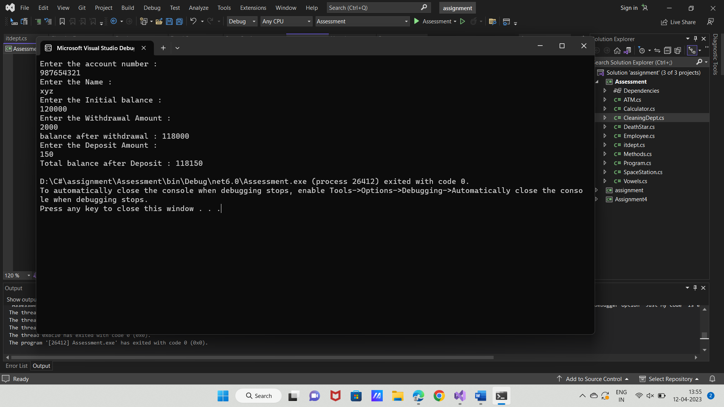

2. Implement hierarchical inheritance in a Company with employees of different departments

segregated in the child classes. Write method to calculate the employees bonus (assume bonus

is different for every department and is calculated from basic salary). (basic = 10000 bonus=10%

bonus amt=10000*10% = 1000)

class Program

{

public static void Main(string[] args)

{

string emp_name;

int emp_id;

double salary;

Console.WriteLine("emp_name");

emp_name = Console.ReadLine();

Console.WriteLine("emp_id");

emp_id = Convert.ToInt32(Console.ReadLine());

Console.WriteLine("Enter i for it department and c for cleaning department");

char ch = Convert.ToChar(Console.ReadLine());

switch (ch)

{

case ('i' or 'I'):

Console.WriteLine("salary :");

salary = Convert.ToDouble(Console.ReadLine());

ItDept itdept = new ItDept(salary, emp_name, emp_id);

Console.WriteLine("The bonus of {0} is {1}", itdept.Emp_name, itdept.salary_bonus());

break;

case ('c' or 'C'):

Console.WriteLine("salary :");

salary = Convert.ToDouble(Console.ReadLine());

CleaningDept cleaningdept = new CleaningDept(salary,emp_name, emp_id);

Console.WriteLine("The bonus of {0} is {1} ", cleaningdept.Emp_name, cleaningdept.salary_bonus());

break;

default:

Console.WriteLine("Enter the correct department name");

break;

}

}

using System;

using System.Collections.Generic;

using System.Linq;

using System.Text;

using System.Threading.Tasks;

namespace Assessment

{

internal class CleaningDept : Employee

{

double salary;

static double bonus=12.4;

public CleaningDept(double salary,string emp_name, int emp_id) : base(emp_name, emp_id)

{

this.Salary = salary;

}

public double Salary { get => salary; set => salary = value; }

public double salary_bonus()

{

return this.Salary * (bonus / 100);

}

}

}

using System;

using System.Collections.Generic;

using System.Linq;

using System.Text;

using System.Threading.Tasks;

namespace Assessment

{

internal class ItDept : Employee

{

double salary;

static double bonus=10;

public ItDept(double salary, string emp_name, int emp_id) : base(emp_name, emp_id)

{

this.Salary = salary;

}

public double Salary { get => salary; set => salary = value; }

public double salary_bonus()

{

return this.Salary * (bonus/ 100); ;

}

}

}

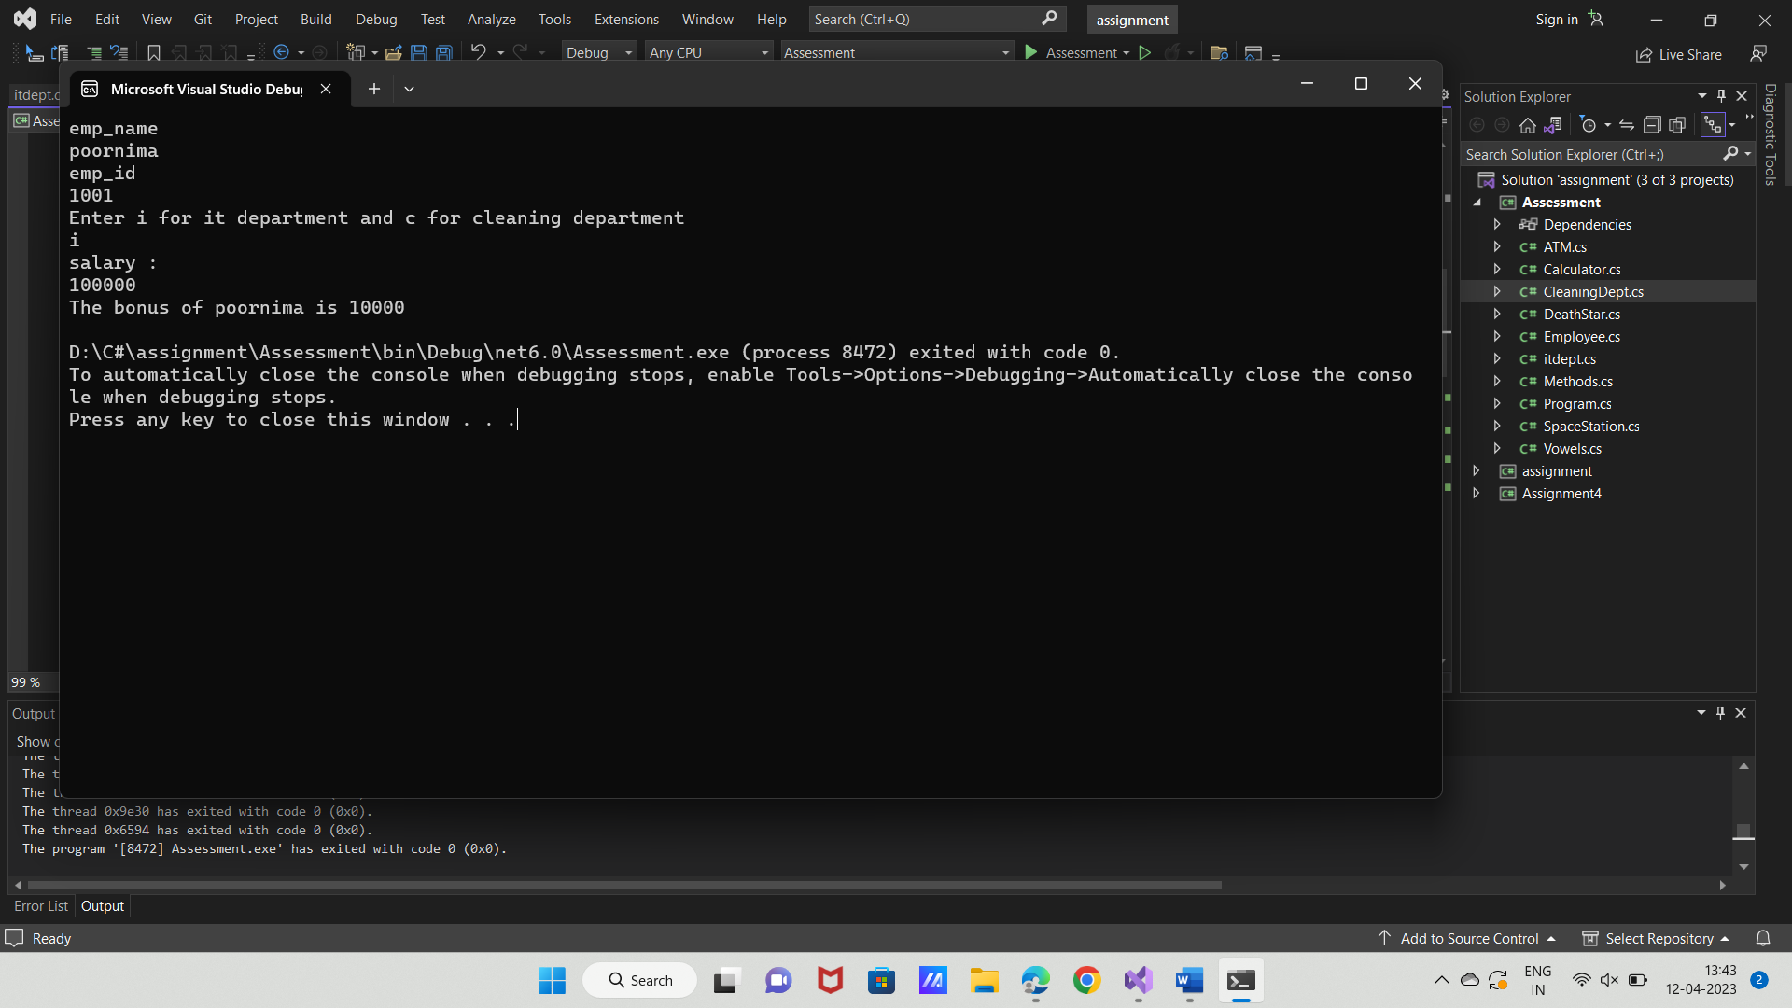

3.

a. Create a class named SpaceStation that is abstract

b. On that abstract class, add a abstract method called FireLaser

c. Create a derived class called DeathStar that implements the FireLaser method to write &quot;Pew

Pew&quot; to the Console followed by a new line

class Program

{

public static void Main(string[] args)

{

DeathStar ds = new DeathStar();

ds.FireLaser();

}

}

using System;

using System.Collections.Generic;

using System.Linq;

using System.Text;

using System.Threading.Tasks;

namespace Assessment

{

abstract class SpaceStation

{

public abstract void FireLaser();

}

}

using System;

using System.Collections.Generic;

using System.Linq;

using System.Text;

using System.Threading.Tasks;

namespace Assessment

{

internal class DeathStar : SpaceStation

{

public override void FireLaser()

{

Console.WriteLine("Pew Pew");

}

}

}

