 | PERSONALIZED DIET-WORKOUT PAIR RECOMMENDATION AND ADAPTIVE FITNESS TRAJECTORY PREDICTION USING USER-CENTRIC DATA | 

A PROJECT REPORT
Submitted by

GAUTHAM R | 720922104024
Harish B | 720922104029
Karthick R | 720922104303
Kishore r V | 720922104305

in partial fulfillment of the requirements for the award degree of

BACHELOR OF ENGINEERING
in
cOMPUTER SCIENCE AND ENGINEERING

JCT COLLEGE OF ENGINEERING AND TECHNOLOGY
(AUTONOMOUS)
COIMBATORE - 641105
April 2026
JCT COLLEGE OF ENGINEERING AND TECHNOLOGY
(AUTONOMOUS)
COIMBATORE - 641105

Bonafide CERTIFICATE
Certified that this project report “HEALTH CHAIN: INTEGRATING MYSQL WITH BLOCKCHAIN FOR RESILIENT HEALTHCARE SYSTEMS” is the bonafide work of students Gautham R (720922104024), Harish B (720922104029), Karthick R (720922104303), Kishore (720922104305) who carried out the project work under my supervision.

Ms. Annal Sheeba Rani E  SUPERVISOR  Department of Computer Science and Engineering  JCT College of Engineering and Technology  Pichanur, Coimbatore - 641105 | Dr. P. D. R. Vijayakumar  HEAD OF THE DEPARTMENT  Department of Computer Science and Engineering  JCT College of Engineering and Technology  Pichanur, Coimbatore - 641105

Submitted for the Viva Voce examination held on ……………………

internal eXAMINER EXTERNAL EXAMNIER

JCT COLLEGE OF ENGINEERING AND TECHNOLOGY
(AUTONOMOUS)
COIMBATORE - 641105

Bonafide CERTIFICATE
We jointly declare that the project report on “ HEATH CHAIN : INTEGRATION MYSQL WITH BLOCKCHAIN FOR RESILIANT HEALTHCARE SYSTEMS ” is the result of original work done by us and best of our knowledge, similar work has not been submitted to “ANNA UNIVERSITY CHENNAI” for the requirement of Degree of Bachelor of Engineering. This project report is submitted on the partial fulfilment of the requirement of the award of Degree of BACHELOR OF ENGINEERING in COMPUTER SCIENCE AND ENGINEERING.
Signature

Place: Coimbatore
Date:
ABSTRACT
Health Chain is a full-stack Electronic Health Record system that combines a relational database workflow with an in-application blockchain ledger to provide tamper-evident clinical data management, designed to retain the benefits of a MySQL-based healthcare system while introducing an integrity layer that detects unauthorized modification of patient records. The implemented architecture consists of a React frontend, an Express-based backend, a normalized MySQL schema, role-based access control with JWT, and a blockchain model persisted to JSON, where during record creation, structured SOAP data is inserted into visit, vitals, diagnoses, and prescriptions tables, then converted into a deterministic clinical text representation, hashed using SHA-256, and appended as a block linked to the previous block hash. Verification endpoints recompute the current hash from database state and compare it against the blockchain hash to identify secure or tampered records. The project also integrates healthcare features such as appointment scheduling, doctor administration, patient timeline retrieval, and audit logging, with security controls including password hashing, role-based authorization, and field-level encryption for sensitive data, demonstrating through experimental walkthroughs that normal workflows remain responsive while direct database tampering is reliably detected by the blockchain verification pipeline, ultimately showing how blockchain-assisted integrity can enhance conventional healthcare systems without replacing the relational model.

ACKNOWLEDGEMENT

We express our sincere gratitude to the management of JCT College of Engineering and Technology for providing us with the opportunity and facilities to successfully complete our undergraduate project.
We are immensely thankful to our esteemed Founder, Thiru. S. A. Subramanian, for his visionary leadership and continuous support towards academic excellence.
We extend our heartfelt thanks to our Chairman, Thiru. R. Arulselvan, Vice Chairman, Thiru. R. Gautaman, and Secretary, Thiru. R. Duga Shankar, for their constant encouragement and for creating a conducive environment for learning and research.
We express our deep sense of gratitude to our respected Principal, Dr. S. Manoharan, for his valuable guidance and support throughout the course of our project work.
We are highly thankful to our Head of the Department, Dr. P. D. R. Vijayakumar, for his continuous support, motivation, and guidance which helped us in completing our project successfully.
We are highly indebted to our Project Coordinator, Dr. T. Rajendran, for his valuable suggestions, motivation, and continuous encouragement which greatly contributed to the successful completion of this project.
We would like to express our sincere thanks to our Project Supervisor, Ms. Annal Sheeba Rani E for his expert guidance, constructive suggestions, and constant support at every stage of the project.
We also extend our gratitude to all the faculty members of CSE department and various departments and the technical staff members for their support and cooperation.
Finally, we express our heartfelt thanks to our parents and friends for their encouragement, moral support, and inspiration throughout the completion of this project.

APARNA P (720922104012)
ARAVIND MOHAN V (720922104013)
BAISIL JOSE (720922104017)
NAKUL DEV M V (720922104304)

TABLE OF CONTENTS

CHAPTER NO. | TITLE | PAGE NO.
 | ABSTRACT | 4
 | ACKNOWLEDGEMENT | 5
 | LIST OF TABLES | 9
 | LIST OF FIGURES | 10
 | LIST OF SYMBOLS AND ABBREVIATIONS | 11
1 | INTRODUCTION | 12
 | 1.1 Background and Need | 12
 | 1.2 Problem Statement | 13
 | 1.3 Objectives of the Project | 14
 | 1.4 Scope of the Work | 14
 | 1.5 Contributions of the Work | 15
 | CHAPTER 2: LITERATURE SURVEY | 17
 | 2.1 Traditional EHR Systems and Integrity Challenges | 17
 | 2.2 Blockchain in Healthcare Data Management | 18
 | 2.3 Hash-Based Tamper Detection Approaches | 19
 | 2.4 Audit Logging and Compliance Perspective | 20
 | 2.5 Research Gap and Motivation | 21
3 | PROBLEM DEFINITION AND REQUIREMENT ANALYSIS | 23
 | 3.1 Problem Definition | 23
 | 3.2 Functional Requirements | 24
 | 3.3 Non-Functional Requirements | 25
 | 3.4 Software and Hardware Requirements | 26
 | 3.5 Feasibility Analysis | 27
4 | SYSTEM ARCHITECTURE AND DESIGN | 30
 | 4.1 Overall Architecture | 30
 | 4.2 Frontend Design | 31
 | 4.3 Backend Node Service Design | 34
 | 4.4 Backend Python Analytics Design | 36
 | 4.5 Module Interaction Overview | 37
5 | DATABASE DESIGN AND DATA FLOW | 38
 | 5.1 Database Overview | 38
 | 5.2 Core Tables and Relationships | 38
 | 5.3 Operational Data Flow | 40
 | 5.4 Prediction and Snapshot Data Flow | 41
 | 5.5 AI Retrieval Data Flow | 42
6 | DATASET PREPARATION AND FEATURE ENGINEERING | 43
 | 6.1 Plan Dataset Preparation | 43
 | 6.2 Reference Data Sources | 45
 | 6.3 Feature Engineering Workflow | 45
 | 6.4 Data Validation and Consistency Checks | 47
7 | PREDICTION ENGINE AND RECOMMENDATION METHODOLOGY | 48
 | 7.1 Calorie Intake and Burn Estimation | 48
 | 7.2 BMR and TDEE Computation | 49
 | 7.3 Weight Projection Logic | 50
 | 7.4 Residual Machine Learning Models | 51
 | 7.5 Deviation Score and Risk Flags | 53
8 | AI COACH AND PERSONALIZATION LOGIC | 54
 | 8.1 AI Coach Module Overview | 54
 | 8.2 Intent Classification | 55
 | 8.3 Multi-Stream Retrieval Pipeline | 56
 | 8.4 Context Synthesis | 57
 | 8.5 Grounded Response Generation | 58
9 | IMPLEMENTATION DETAILS AND API WORKFLOWS | 60
 | 9.1 Authentication and Profile Flow | 60
 | 9.2 Plan Selection and Daily Check-In Flow | 62
 | 9.3 Progress Chart and Summary Flow | 63
 | 9.4 Alternative Plan Workflow | 65
 | 9.5 AI Question-Answer Workflow | 66
10 | TESTING, EVALUATION, AND DISCUSSION | 68
 | 10.1 Unit Testing and Integration Testing | 68
 | 10.2 Prediction Validation | 66
 | 10.3 AI Retrieval and Response Testing | 67
 | 10.4 Experimental Observations | 68
 | 10.5 Discussion of Results | 69
11 | CONCLUSION AND FUTURE ENHANCEMENTS | 70
 | 11.1 Conclusion | 70
 | 11.2 Limitations | 71
 | 11.3 Future Scope | 72
 | APPENDICES | 74
 | A.1 Sample API Payloads | 74
 | REFERENCES | 75

LIST OF TABLES

TABLE NO. | TITLE | PAGE NO.
2.1 | General comparison between diet and workout recommendation systems | 16
4.1 | Major architectural layers and their responsibilities | 28
4.2 | Main responsibilities of the Node backend service | 32
4.3 | Main responsibilities of the Python analytics service | 33
5.2 | Core tables used in the application database | 38
5.4 | Prediction-related data artifacts stored by the system | 39
6.1 | Summary of synthetic plan datasets used in the project | 42
7.1 | Inputs used for calorie-related estimation in the project | 47
7.3 | Prediction outputs supported by the hybrid pipeline | 49
7.4 | Examples of interpretation signals generated by the prediction layer | 51
8.1 | Intent types used in the AI coach module | 54
9.2 | Important plan and daily check-in endpoints | 61
10.2 | Key prediction validation goals in the project | 67
10.3 | Representative AI retrieval and assistant testing concerns | 68
A.1 | Representative Profile Update Payload | 74
A.2 | Representative Daily Check-in Payload | 74

LIST OF FIGURES
FIGURE NO. | TITLE | PAGE NO.
4.1 | Overall System Architecture of the Proposed System | 28
4.2 | Dashboard Interface Showing Aggregated Progress and Plan Information | 30
4.3 | Tracker Interface for Check-in History and Progress Interpretation | 31
5.1 | Database Relationship Overview of the Implemented System | 36
6.1 | Feature Engineering Workflow Used for the Prediction Pipeline | 42
7.1 | Hybrid Prediction Pipeline from Metabolic Baseline to User-Adjusted Projection | 50
8.1 | AI Coach Interface for Personalized Question-Answer Support | 53
8.2 | Multi-Stream Retrieval Workflow Used by the AI Coach | 55
9.1 | User Flow from Registration and Login to Dashboard Access | 59
9.2 | Plan Selection and Daily Check-in Flow in the Implemented System | 61
9.3 | RAG Retrieval and Streaming Pipeline for AI Question-Answer Flow | 64
9.4 | Login and Registration Interface of the System | 59
9.5 | Profile Setup Interface for User Personalization | 60
10.1 | Evaluation Flow Followed in Testing and Discussion | 65

LIST OF SYMBOLS AND ABBREVIATIONS

SYMBOL / ABBREVIATION | EXPANSION
AI | Artificial Intelligence
API | Application Programming Interface
BMR | Basal Metabolic Rate
TDEE | Total Daily Energy Expenditure
ML | Machine Learning
RAG | Retrieval-Augmented Generation
JSON | JavaScript Object Notation
SQL | Structured Query Language
DB | Database
UI | User Interface
UX | User Experience
kcal | Kilocalories
BMR (Male) | 10W + 6.25H − 5A + 5
BMR (Female) | 10W + 6.25H − 5A − 161
Node.js | JavaScript Runtime for Backend
React | Frontend JavaScript Library
FastAPI | Python Framework for APIs
PostgreSQL | Relational Database System
Prisma | ORM for Node.js
SQLAlchemy | ORM for Python
ANALYTIC | User-data driven AI query type
KNOWLEDGE | General information query type
HYBRID | Mixed context AI query type

CHAPTER 1
INTRODUCTION

Background and Need
Healthcare organizations depend on accurate and trustworthy records for diagnosis, treatment planning, legal compliance, insurance processing, and continuity of care. Most hospital information systems are built on centralized relational databases that provide efficient querying and structured storage. However, centralized storage alone does not inherently provide tamper evidence. If records are modified at the database level through unauthorized access, misconfiguration, or insider abuse, the system may not detect the change without an additional integrity mechanism.
Clinical records are highly sensitive and legally significant. A single altered diagnosis or prescription note can affect treatment decisions and patient safety. In this context, record
integrity is not only a technical issue but also an ethical and regulatory requirement. This
motivates a design where routine EHR operations remain practical while data integrity be-
comes independently verifiable.
Health Chain addresses this need by integrating MySQL with blockchain-style hash chaining. The project avoids replacing the relational model; instead, it introduces a complementary verification layer that marks each clinical record with a deterministic SHA-256 hash and stores it as a linked block. Any later mismatch between current record content and blockchain hash is treated as tampering.

Problem Statement
Many existing Electronic Health Record (EHR) systems use relational databases to efficiently store and manage clinical data, but they often lack mechanisms to ensure records remain tamper-proof after entry. While role-based access control and audit logging are commonly used, they do not fully guarantee data integrity, especially when modifications occur outside standard application workflows. This creates a gap between data storage and data trustworthiness in healthcare systems.
The main problem addressed in this project can be stated as follows:
How can a practical doctor-facing EHR platform preserve the efficiency of a normalized MySQL workflow while adding a robust and auditable mechanism to detect post-entry tampering of medical records?
In typical healthcare systems, records are distributed across multiple normalized tables and updated through user interfaces and backend APIs. While this improves scalability and maintainability, it introduces integrity challenges. Record content is fragmented across tables, tampering may occur outside application flows, role-based access does not ensure immutability, and audit logs cannot independently confirm data integrity.
This problem is critical in healthcare, where data integrity directly impacts patient safety and clinical decisions. If records are altered without detection, it can lead to errors and loss of trust. Therefore, the system must not only manage data but also verify its integrity deterministically, clearly identifying secure and tampered records.

Objectives of the Project
The main objectives of the project are listed below:
  - To design and develop a full-stack Electronic Health Record (EHR) system supporting doctors, patients, and administrators.
  - To implement transactional storage of structured SOAP records using normalized MySQL tables.
  - To generate deterministic SHA-256 hashes for clinical records to ensure data consistency.
  - To build an append-only blockchain ledger with previous-hash linking for integrity tracking.
  - To provide record-level and chain-level verification mechanisms for tamper detection.
  - To maintain audit logging for traceability aligned with healthcare compliance requirements.
  - To support real-world workflow features such as appointment scheduling, dashboards, and role-based access control.
These objectives were defined to ensure that the system goes beyond basic data storage. The aim is to create an integrated platform where data management, integrity verification, and operational workflows are combined into a reliable and practical healthcare solution.

Scope of the Work
The scope of this project is limited to the design and development of a software-based Electronic Health Record (EHR) system with integrated data integrity verification. The work mainly focuses on application logic, secure data handling, blockchain-based integrity mechanisms, and audit-supported workflows. The front-end handles user interaction, while the back-end manages APIs, record processing, hashing, and verification operations.
The project includes the following major features within its scope:
- Web-based EHR workflow for managing patient records and appointments,
- Role-based authentication for patient, doctor, and administrator users,
- Deterministic hashing of clinical records and blockchain block creation,
- Verification APIs and blockchain explorer interfaces for tamper detection,
- Audit trail generation for tracking key user actions,
- Field-level encryption for selected sensitive profile attributes.

At the same time, certain areas are outside the current scope of the project. The system does not include public decentralized blockchain deployment or smart contract execution on external chains. It does not aim to achieve full production-level HIPAA certification or integrate with national EHR interoperability standards. Additionally, high-availability cloud deployment and large-scale auto-scaling are not considered, as the project focuses on demonstrating a functional and verifiable prototype.

Contributions of the Work
- A hybrid architecture that combines relational data handling with blockchain-based integrity checking.
- Deterministic record serialization and hash generation strategy for reproducible verification.
- Practical clinical workflow implementation with SOAP entry, timeline access, and scheduling.
- End-to-end tamper detection capability with clear SECURE/TAMPERED outcomes.
- Integrated compliance-minded features including audit logs and access controls.

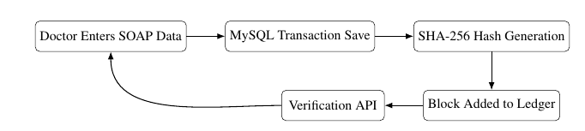

Fig 1.1 Core integrity loop of the Health Chain System

CHAPTER 2
LITERATURE SURVEY

Traditional EHR Systems and Integrity Challenges
Conventional EHR systems are mostly built on centralized database architectures. They are optimized for structured storage, rapid retrieval, and complex clinical reporting through SQL. These systems support high transaction volumes and provide mature tooling for backup and recovery. Despite these strengths, many implementations rely on trust in access controls and administrative governance without embedding cryptographic tamper evidence in the data lifecycle.
Literature on healthcare security repeatedly identifies insider threat and privileged misuse as key risks. Even when role-based controls are present, database-level changes can be difficult to detect unless there is independent integrity instrumentation. This motivates cryptographic verification techniques that complement, rather than replace, mainstream EHR platforms.

Blockchain in Healthcare Data Management
Blockchain-inspired methods have been investigated for medical data provenance, consent traceability, and integrity assurance. Most studies emphasize immutability through linked blocks and cryptographic hashing, where any modification to prior data invalidates down stream chain consistency.
In practical healthcare software engineering, fully decentralized blockchain adoption often faces constraints such as operational complexity, cost, and integration friction with existing DBMS workflows. As a result, hybrid designs are increasingly explored: critical record fingerprints are anchored to a ledger while primary data remains in relational storage.
Health Chain follows this hybrid direction by storing complete clinical records in MySQL and preserving record fingerprints in a local chain. This strategy keeps query efficiency intact and introduces tamper detectability through deterministic hash comparison.It also ensures that existing healthcare workflows remain unaffected while adding a lightweight integrity layer. Furthermore, the approach demonstrates how blockchain concepts can be practically adapted within conventional systems without requiring full decentralization.

System Type | Typical Strength | Common Limitation
Traditional EHR Systems | Efficient structured storage,fast querying, and mature DBMS support for clinical workflows | Lack inherent tamper-evidence; integrity depends on access control and administrative trust
Blockchain-Based Healthcare Systems | Strong immutability through cryptographic hashing and linked blocks ensuring data integrity | High operational complexity, cost, and integration challenges with existing systems
Hybrid EHR + Blockchain Systems (Proposed) | Combines relational efficiency with tamper detection using deterministic hashing,and blockchain linkage | Added implementation complexity and dependence on correct hash generation and synchronization
Table 2.1: General comparison between traditional EHR systems, blockchain-based approaches, and hybrid integrity models in healthcare systems

Hash-Based Tamper Detection Approaches
Cryptographic integrity verification has become important in modern healthcare systems because storing data alone is not sufficient; the system must also ensure that data remains unaltered over time. In Electronic Health Record (EHR) platforms, even small unauthorized changes can have serious consequences, making hash-based integrity mechanisms essential.
Traditional approaches rely on access control and audit logging, which track user actions but do not guarantee that stored data has not been modified. Cryptographic hash functions solve this by generating unique fingerprints of data, where even a minor change produces a completely different output, enabling effective tamper detection.
However, reliable hashing requires deterministic data representation. Since clinical records are distributed across multiple tables, identical logical content must always produce the same hash value. If serialization is inconsistent, verification may fail even without tampering. Therefore, tamper detection depends on the following factors:
- stable canonical representation of record fields,
- consistent ordering of serialized data,
- secure hash function choice,
- reliable mapping between stored records and integrity anchors.
The project implements these principles using structured SOAP-based serialization and a SHA-256 hashing pipeline, ensuring reproducible hashes and accurate detection of unauthorized modifications while maintaining compatibility with the relational database system.

Audit Logging and Compliance Perspective
Healthcare regulation frameworks emphasize accountability and traceability in the handling of sensitive clinical data. Audit logs play a critical role by recording who accessed what data, when actions occurred, and what operations were performed, thereby creating a detailed chronological history of system activity. These logs are essential for compliance, monitoring, and post-incident analysis.
However, audit logs alone do not guarantee that the current record content remains unchanged from its original submission. While they provide visibility into user actions, they do not independently verify whether the stored data has been altered, either intentionally or through unauthorized access. This creates a limitation in relying solely on logging mechanisms for data integrity assurance.
Therefore, best practices in secure system design combine event logging with cryptographic integrity verification. By integrating both approaches, systems can ensure not only traceability of actions but also detect any unauthorized modifications to stored data. Health Chain follows this integrated approach by maintaining detailed action-level audit trails alongside verification endpoints and blockchain-based validation routines, ensuring both compliance and reliable tamper detection within the system.This combined approach strengthens trust in the system by providing both evidence of user activity and proof of data integrity. It also supports easier auditing and verification during security reviews and regulatory evaluations.

Research Gap and Project Positioning
A clear practical gap exists between academic blockchain proposals and deployable student-level healthcare systems. Many research works focus on theoretical aspects such as immutability, decentralization, and cryptographic assurance, but often lack complete end-to-end implementations that can be integrated into real-world healthcare workflows. As a result, there is a disconnect between conceptual models and systems that can actually be used in practice.
Most studies do not provide full-stack implementations that cover essential components required for a functional healthcare application, including:
- normalized healthcare schema,
- transactional clinical inserts,
- role-based APIs,
- blockchain verification endpoints,
- scheduler and dashboard workflows.
These components are critical for demonstrating how integrity mechanisms operate within real application flows rather than in isolated modules. Without such integration, blockchain concepts remain theoretical and difficult to evaluate in practical scenarios.
This project is motivated by this implementation gap. It demonstrates a realistic, full-stack prototype where integrity verification is embedded directly into normal EHR operations, including record creation, retrieval, and validation workflows. By integrating blockchain-based verification with relational database operations, the system provides a practical example of how theoretical integrity concepts can be applied in real healthcare software systems.

CHAPTER 3
PROBLEM REQUIREMENTS AND SPECIFICATIONS

Functional Requirements
Functional requirements describe what the system must do. For this project, the requirements are derived from the real-world workflow of an Electronic Health Record (EHR) system, starting from user authentication and extending to clinical record management, integrity verification, and administrative operations.
The system shall satisfy the following major functional requirements:
- User registration and authentication: The system shall allow users to register, log in, and access the platform with role-specific permissions for patients, doctors, and administrators.
- Clinical record creation: The system shall allow doctors to create complete SOAP-based clinical records for selected patients.
- Data persistence: The system shall store visit data in normalized relational tables using transactional operations to ensure consistency.
- Hash generation: The system shall generate deterministic SHA-256 hashes for every created clinical record.
- Blockchain integration: The system shall append each generated hash as a new block linked to the previous blockchain state.
- Record verification: The system shall provide an endpoint to verify individual records and classify them as SECURE or TAMPERED.
- Chain validation: The system shall provide a chain status endpoint to verify the overall integrity of the blockchain.
- Patient data access: The system shall support retrieval of patient profiles and timeline-based visualization of clinical history.
- Appointment management: The system shall support appointment booking with conflict detection and status updates.
- Audit logging: The system shall capture audit logs for key clinical and security-related actions.
- Administrative control: The system shall provide interfaces for administrators to manage doctor accounts and system access.
These functional requirements ensure that the system is not limited to isolated features. Instead, they define a complete workflow that integrates clinical data management, integrity verification, and operational healthcare processes within a single platform.

Non-Functional Requirements
Non-functional requirements describe how the system performs and the quality attributes it must satisfy. For this project, these requirements focus on ensuring that the system remains secure, reliable, efficient, and suitable for real-world healthcare workflows.
The system shall satisfy the following major non-functional requirements:
- Integrity: The system shall ensure deterministic and repeatable record verification so that identical data always produces the same verification outcome.
- Security: The system shall implement password hashing, role-based authorization, and token-based authentication to protect user data and restrict access.
- Reliability: The system shall use transactional database operations to prevent partial or inconsistent record states during clinical data insertion.
- Performance: The system shall provide responsive API operations to support typical clinic usage without noticeable delays.
- Maintainability: The system shall be designed with modular backend controllers and well-structured frontend components to allow easy updates and extension.
- Usability: The system shall provide a clear and intuitive workflow for doctors and administrators to perform their tasks efficiently.
- Auditability: The system shall maintain immutable-style evidence using blockchain records and audit logs to support traceability and compliance.
These non-functional requirements ensure that the system not only performs its intended functions but also maintains quality, security, and reliability standards suitable for healthcare applications.

Software and Hardware Requirements
The project is implemented using a modern but lightweight software stack that supports full-stack development, analytics processing, and AI-based retrieval. The software requirements are based on the tools and frameworks used in the repository.
Software Requirements
- Operating system: Windows, Linux, or any environment capable of running Node.js and MySQL.
- Frontend technologies: React with Vite for building the user interface and clinical workflows.
- Backend technologies: Node.js with Express for handling APIs, authentication, and business logic.
- Database: MySQL for storing normalized healthcare data including users, patients, visits, and appointments.
- Blockchain layer: JSON-based local ledger for storing block data and hash chains.
- Security libraries: bcrypt for password hashing and JSON Web Tokens (JWT) for authentication and authorization.
- Development tools: npm, Node package manager, MySQL tools, and API testing tools such as Postman.
Based on the implementation, the backend environment includes libraries such as Express, bcrypt, JSON Web Token, and MySQL drivers for database interaction. The frontend environment uses React, Axios for API communication, and Vite for development and build processes. Additional utilities are used for hashing (SHA-256), validation, and middleware-based request handling.

Hardware Requirements
The hardware requirements for development and testing are modest because the project is mainly a software application. A standard laptop or desktop computer is sufficient for local execution and report-level experimentation.
- Processor: Intel i5 / Ryzen 5 or above recommended.
- Memory: Minimum 8 GB RAM recommended for running frontend, Node back- end, Python backend, and database-related tools together.
- Storage: At least 10 GB free space for source code, dependencies, datasets, generated artifacts, and logs.
- Internet connection: Required for package installation, cloud database connectivity, and optional LLM-based integrations.

Feasibility Analysis
Feasibility analysis is important in a final year project as it evaluates whether the proposed system can be realistically developed within the available time, tools, and academic scope. For this project, feasibility is analyzed under three aspects: technical feasibility, economic feasibility, and operational feasibility.
Technical Feasibility
The project is technically feasible as it uses widely adopted and well-supported technologies such as React, Node.js, Express, and MySQL. The implementation of blockchain-based integrity is also manageable since it is designed as an in-application ledger rather than a fully decentralized system. The modular architecture allows independent development of frontend, backend, database, and verification components, reducing complexity and improving maintainability.
Economic Feasibility
The project is economically feasible for academic purposes as it relies entirely on open-source technologies and standard development tools. It does not require expensive infrastructure or external services, and the system can be developed and tested using typical student-level computing resources. This makes the cost of implementation minimal and suitable for a prototype.
Operational Feasibility
The system is operationally feasible because it follows real-world healthcare workflows such as user authentication, clinical record entry, appointment scheduling, and record verification. These processes are intuitive for users like doctors and administrators, making the system practical and easy to use. Additionally, the integration of audit logs and verification mechanisms supports accountability and aligns with healthcare system expectations.
Overall, the project is feasible from an academic perspective as it demonstrates a complete integration of frontend, backend, database, and security concepts. The next chapter presents the system architecture and design used to implement these requirements.

CHAPTER 4
SYSTEM ARCHITECTURE AND DESIGN

Overall Architecture
The proposed system follows a layered full-stack architecture. This design was chosen because the project includes very different kinds of work: user interaction, operational API handling, database persistence, analytics computation, and AI-based retrieval. Keeping all of this inside a single monolithic code path would make the system harder to maintain and harder to explain. By separating responsibilities across layers, the application becomes easier to build, test, and extend.
At a high level, the system contains four main parts:
- the frontend used by the user,
- the Node.js backend that manages application-facing operations,
- the Python backend that handles analytics and AI workflows,
- the PostgreSQL database used for persistent storage.
The frontend interacts with the Node backend through REST APIs. The Node backend performs authentication, profile handling, plan selection, and check-in management. Whenever analytical processing is needed, the Node backend communicates with the Python backend. The Python service calculates intake, burn, prediction curves, summaries, and AI-based answers. Both services share the same PostgreSQL database, which helps maintain continuity between operational data and analytical results.
This architecture is a good fit for the project because it supports both day-to-day transactional actions and heavier analytical processing. For example, login and profile update operations are different in nature from prediction or AI retrieval operations. Splitting them into separate services keeps the design more practical and cleaner.

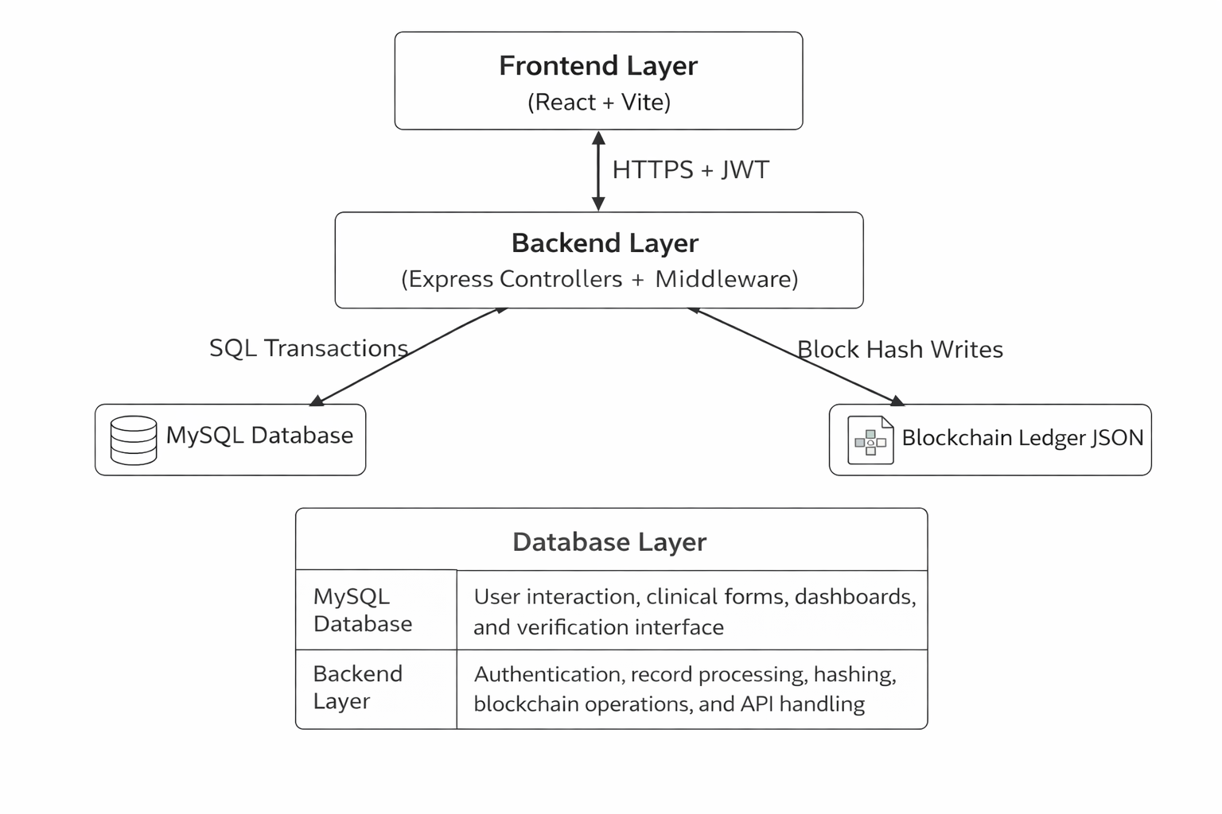
Figure 4.1:High-level architecture of the Health Chain platform

Layer | Main Responsibility
Frontend Layer | User interaction, clinical forms, dashboards, and verification interface
Backend Layer | Authentication, record processing, hashing, blockchain operations, and API handling
Database Layer | Storage of clinical data in MySQL and blockchain metadata in JSON ledger
Table 4.1: Major architectural layers and their responsibilities.

Frontend Design
The frontend of Health Chain is implemented using React and Vite, and serves as the operational interface for doctors, administrators, and patients. Rather than acting as a simple input layer, it coordinates complete healthcare workflows including authentication, dashboard monitoring, clinical documentation, scheduling, blockchain verification, and compliance review.
The interface is organized as role-aware task screens so that each user reaches goal-specific actions with minimal navigation. Doctor and admin users access dashboard metrics, patient records, scheduler operations, integrity verification, and audit monitoring, while patient users are restricted to self-related views. This structure improves usability and enforces security policy at the presentation layer along with backend role checks.
A key frontend contribution is the integration of clinical workflow and integrity workflow on the same UI path. In the clinical workstation, SOAP data entry, patient selection, and historical record context are presented together, and generated records can later be verified from the blockchain explorer or verification actions. This makes tamper detection visible to end users and not only to backend administrators.
The frontend also provides operational transparency through visual summaries such as appointment statistics, recent activities, chain validity indicators, and audit-log tables. By combining workflow-focused forms with compliance and integrity views, the frontend demonstrates how blockchain-backed healthcare verification can remain practical in day-to-day clinical usage.

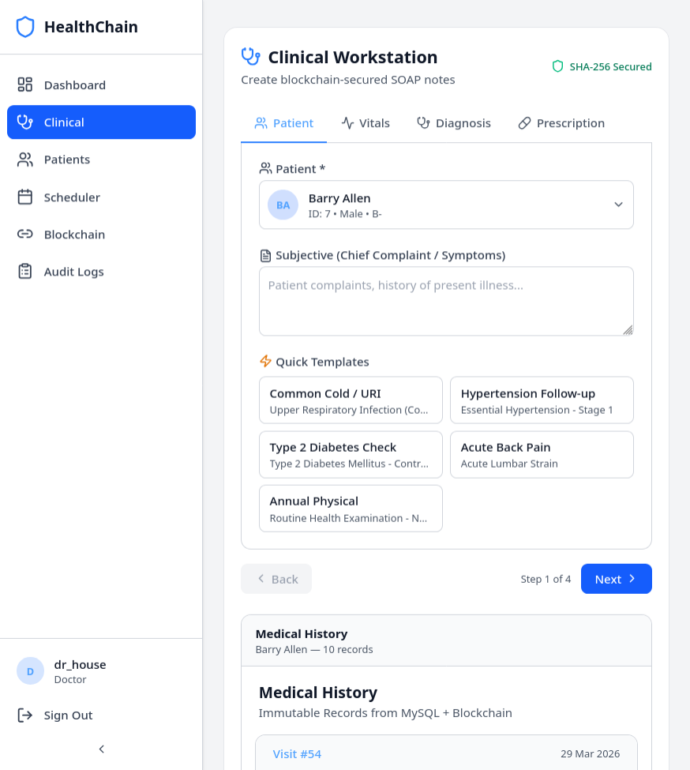

Figure 4.2: Dashboard Interface Clinical Workstation to enter data

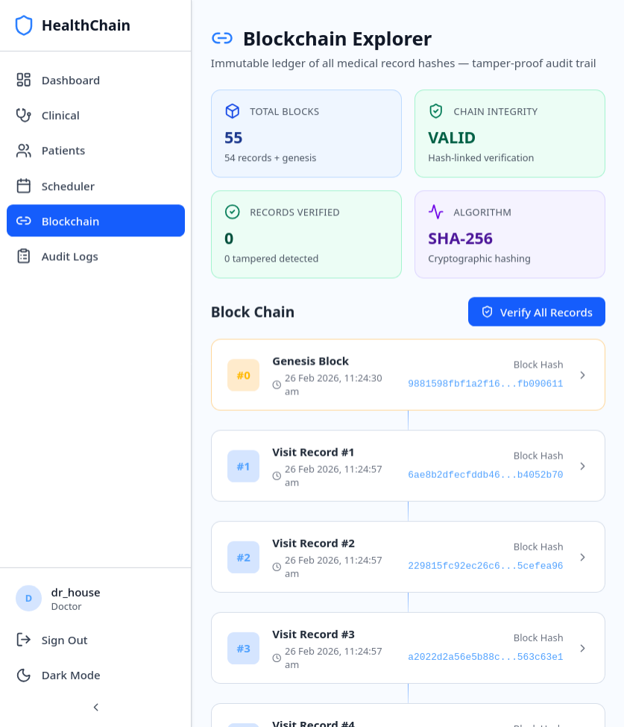
Figure 4.3: Blockchain Interface for \Record Verification

Backend Node Service Design
The backend serves as the core operational layer of the system and is implemented using Node.js and Express. It is responsible for handling application workflows such as authentication, clinical record management, appointment scheduling, and integrity verification. This layer acts as the primary interface between the frontend and the data storage components.
The backend follows a modular design with clear separation of concerns across middleware, controllers, models, and utility modules. Middleware handles JWT-based authentication and role-based access control, ensuring secure access to protected routes. Controllers manage domain-specific operations such as record creation, appointment handling, dashboard aggregation, and administrative functions.
A key responsibility of the backend is integrating blockchain-based integrity verification into normal workflows. During clinical record creation, data is inserted transactionally into normalized MySQL tables, after which a deterministic SHA-256 hash is generated and appended to the blockchain ledger. The system also provides verification endpoints to validate record integrity and detect tampering.
Overall, this architecture ensures that operational logic, data handling, and integrity mechanisms are tightly integrated while remaining modular and maintainable.

Area | Responsibility
Middleware Layer | Handles JWT token verification, extracts user identity, and enforces role-based access control for protected routes
Authentication Controller | Manages user registration, login, password hashing using bcrypt, and JWT token generation
Record Controller | Handles creation of SOAP-based clinical records, transactional inserts across multiple tables, hash generation, blockchain block creation, and integrity verification
Appointment Controller | Manages appointment booking, conflict detection, scheduling, status updates, and calendar-based retrieval
Dashboard Controller | Aggregates system statistics such as appointments, patient counts, and recent activity for dashboard display
Model Layer | Performs database operations including transactional inserts, joins for record retrieval, and structured data access from MySQL
Blockchain Module | Maintains hash-linked blocks, handles block creation, chain validation, and integrity verification logic
Audit Logging Module | Records user actions such as record creation, access, and verification to ensure traceability and compliance  API calls
Utility Layer | Provides SHA-256 hashing, field-level encryption, and helper functions for consistent data processing

Table 4.2: Main responsibilities of the Node backend service.

Record Creation and Verification Flow
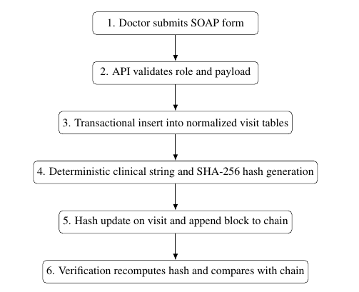
Figure 4.3: Clinical record creation and integrity verification workflow.

The system integrates clinical record management with blockchain-based integrity verification through a structured workflow. This process ensures that every record created by the doctor is securely stored, consistently processed, and later verifiable without ambiguity. By combining transactional database operations with deterministic hashing, the system maintains both data reliability and tamper detection capability.
The following steps outline the operational flow for record creation and verification:
  - Doctor submits SOAP form
  - API validates role and payload
  - Transactional insert into normalized visit tables
  - Deterministic clinical string and SHA-256 hash generation
  - Hash update on visit and append block to chain
  - Verification recomputes hash and compares with chain

Security and Compliance Design
The security and compliance design of the system focuses on protecting sensitive healthcare data while ensuring accountability and controlled access. Since medical records are highly sensitive, the system incorporates multiple layers of security including authentication, authorization, data protection, and auditability. These mechanisms work together to prevent unauthorized access, safeguard stored data, and maintain traceability of all critical operations.
Security design includes authentication, authorization, data protection, and accountability
- Passwords are stored using bcrypt hashes.
- JWT tokens carry user identity and role claims.
- Role checks are enforced per API endpoint.
- Sensitive profile fields can be encrypted at rest.
- Audit logs record critical actions including record creation and verification.

CHAPTER 5
DATABASE DESIGN AND DATA FLOW

Database Overview
The database plays a central role in this project because almost every important system feature depends on stored user and application data. Authentication needs persistent user records, daily logging requires structured check-in tables, progress tracking depends on historical records, and the AI coach needs access to stored profile and knowledge information. For this reason, the project uses PostgreSQL as the main database layer.
PostgreSQL was chosen because it is reliable, flexible, and well suited for a project that combines normal application data with analytical and retrieval-oriented storage. It supports structured relational tables, JSON-based fields, indexing, and extension features such as vector storage. These capabilities are useful because the project does not only store plain user data; it also stores logs, prediction snapshots, summaries, recommendation payloads, and knowledge chunks used in AI-based retrieval.
Another important design decision is that both backend services share the same primary database. The Node backend uses Prisma for operational access, while the Python backend uses SQL Alchemy for analytics and data-processing workflows. This shared- database approach keeps operational and analytical data connected, which is essential for a personalized application. A user’s progress chart, for example, becomes meaningful only when profile data, check-in history, and prediction outputs all relate to the same stored records.

Core Tables and Relationships
The database schema is designed around the real application workflow. Instead of using unrelated generic tables, the schema maps directly to major user and system activities such as login, profile completion, plan selection, daily check-ins, prediction generation, and AI-related retrieval support.
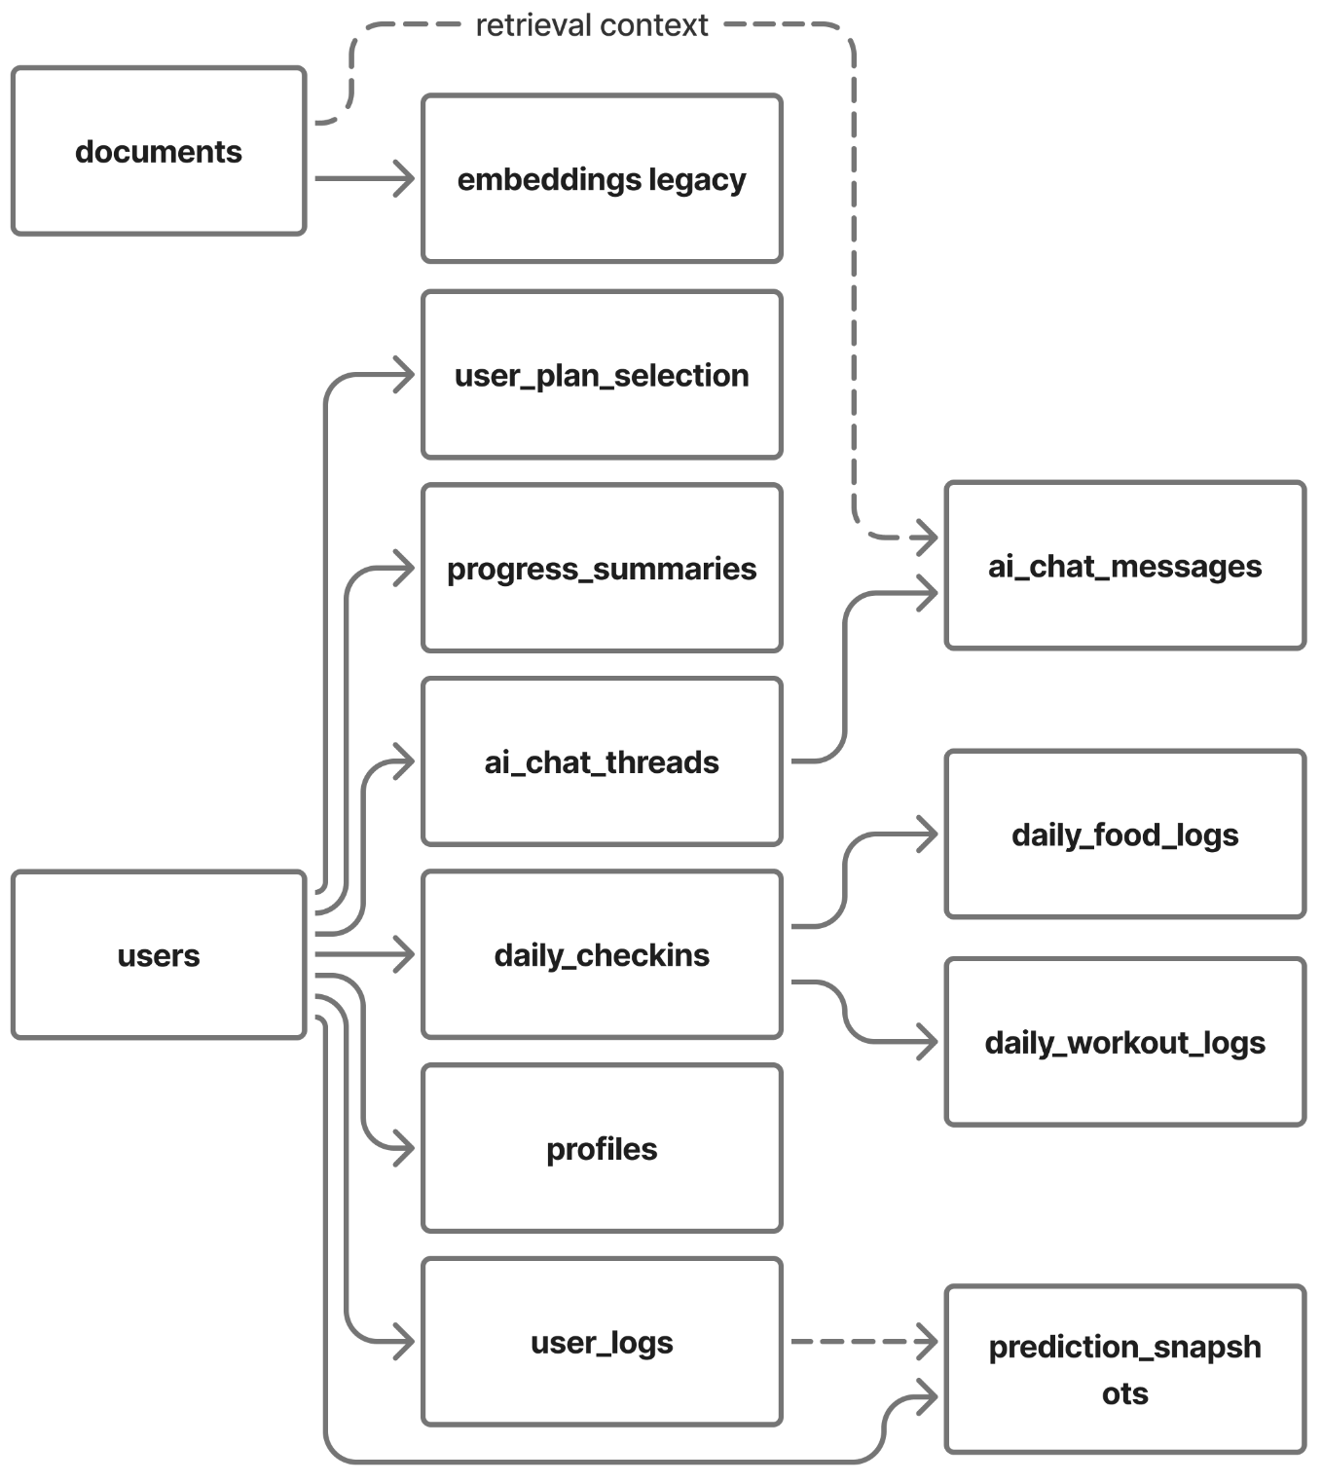
Figure 5.1: Database Relationship Overview of the Implemented System

The user’s table is the core entity, with authentication tables extending it for sessions and verification. The profiles table stores health attributes like age, height, weight, preferences, activity level, and goals for personalization. Plan management is handled through plan catalog and user plan selection, keeping plans reusable and user choices separate. Daily data is organized into check-ins, food logs, and workout logs to maintain structure and simplify analysis. Predictions and recommendations are stored in separate tables to preserve history and improve traceability. For AI retrieval, canonical documents handle knowledge search, while canonical user logs manage user history, ensuring clear separation and effective response generation

Table | Purpose
users | Stores primary user identity information
auth sessions | Stores refresh-session details for authenticated access
profiles | Stores health, goal, and personalization-related profile data
plan catalogue | Stores standard plans available in the application
user plan selection | Stores the active plan selected by each user
daily check-ins | Stores daily progress, adherence, and health measurements
daily food logs | Stores intake mode and food-related daily records
daily workout logs | Stores exercises and calorie-burn-related daily records
prediction snapshots | Stores generated chart lines and risk-related prediction values
progress summaries | Stores summary payloads returned from analytics endpoints
plan recommendations | Stores generated recommendation or alternative-plan outputs
documents | Stores vector-ready knowledge chunks for semantic AI retrieval
user logs | Stores temporal user activity summaries used in retrieval workflows

Table 5.2: Core tables used in the application database.

Operational Data Flow
Operational data flow refers to the normal application flow followed by the user from authentication to daily usage. This is the part of the system that is most visible to the end user. The flow begins with registration and login, then moves to profile setup, plan selection, and daily check-in submission.
When a user logs in or registers, the request is handled by the Node backend, and the related records are stored in authentication and user tables. After that, the user completes the profile. This profile data is important because later recommendation and prediction steps depend on these values. If the profile is incomplete, the personalization quality of the system drops.
Once a plan is selected, the user begins regular interaction through daily check-ins. On each day, the user may submit weight, calorie intake, workout details, sleep, steps, and adherence-related information. These inputs are validated at the API level and then stored in the relevant daily logging tables. This operational flow is the foundation for all later analytics.
What makes the design stronger is that operational data is not treated as static history. It immediately becomes useful for progress generation and AI support. This means the operational data flow is directly connected to the analytical layer rather than being stored passively.

Prediction and Snapshot Data Flow
Prediction data flow begins when the system needs to convert stored user history into meaningful progress output. This usually happens when the user opens the progress chart, requests a summary, or submits new daily check-in data that changes the expected outcome.
The Node backend first checks whether suitable prediction snapshots already exist. If they are available and valid, they can be returned directly to avoid unnecessary recomputation. If not, the Node backend forwards the request to the Python analytics service. The Python service then uses stored profile and check-in data to calculate progress outputs such as ideal line, actual line, deviation score, and risk flags.
After computation, the generated outputs may be stored back into snapshot-oriented tables such as prediction snapshots, progress summaries, or plan recommendations. This step is important because it creates a record of analytical outputs over time. In- stead of treating predictions as temporary values only, the system preserves them in a structured way for later access, comparison, and debugging.
This design improves both usability and engineering quality. From the user side, chart and summary retrieval becomes smoother. From the system side, it supports traceability and repeatability.

Artifact | Stored Content
prediction snapshots | Ideal line, actual line, deviation score, and risk flags
progress summaries | Generated summary payloads and progress interpretation
plan recommendations | Alternative suggestions and recommendation payloads

Table 5.4: Prediction-related data artifacts stored by the system.

AI Retrieval Data Flow
The AI retrieval data flow is one of the most interesting parts of the project because it connects user-specific information with knowledge-based content. When a user sends a question through the AI coach interface, the request first reaches the Node backend. The Node service authenticates the request and forwards it to the Python analytics backend.
The Python backend then performs intent classification to understand what kind of question has been asked. After that, it retrieves context from multiple sources. These typically include profile details, recent user logs, and stored knowledge chunks from a vector-backed document or embedding store. The retrieved information is then merged into a unified context used to generate the final answer.
This flow ensures AI responses are grounded in user data rather than generic, making them more meaningful, explainable, and relevant. This chapter covered the database structure and data flow, while the next focuses on dataset preparation and feature engineering for analytics and prediction.

CHAPTER 6
DATASET PREPARATION AND FEATURE ENGINEERING

Plan Dataset Preparation
The analytical part of this project depends on more than just live user data. To support prediction workflows, model development, and controlled experimentation, the project includes a synthetic dataset generation pipeline. This pipeline creates structured plan- based datasets that imitate realistic diet and workout tracking patterns over time.
The generated datasets are organized at the plan level. In the current implementation, there are six major plan datasets:
- vegan weight gain,
- vegan weight loss,
- non-veg weight gain,
- non-veg weight loss,
- mixed diet weight gain,
- mixed diet weight loss.
Each dataset contains records for 300 synthetic users tracked over 90 days. This gives 27,000 rows per file and a total of 162,000 rows across all six files. The row granularity is one record per user per date, which makes the datasets suitable for time-based feature extraction and horizon-based prediction tasks.
The generation process is deterministic, which is an important design choice. A fixed seed is used so that dataset creation can be repeated reliably. This improves reproducibility and makes the project more suitable for academic analysis. If the generated data changes on every run, then model behavior and output comparison become harder to justify.
Another strong point of the dataset preparation workflow is that it does not generate arbitrary values without logic. The synthetic records are built using health-oriented formulas and safety-aware ranges. For example, BMR and TDEE estimates are used as a basis for calorie planning, goal type influences whether the system models a safe surplus or deficit, and expected versus actual weight is integrated using energy-balance logic. This helps the synthetic data behave more like realistic structured health data rather than random numbers.

Dataset | Users | Rows
vegan-weight-gain.csv | 300 | 27,000
vegan-weight-loss.csv | 300 | 27,000
non-veg-weight-gain.csv | 300 | 27,000
non-veg-weight-loss.csv | 300 | 27,000
mixed-diet-weight-gain.csv | 300 | 27,000
mixed-diet-weight-loss.csv | 300 | 27,000
Table 6.1: Summary of synthetic plan datasets used in the project.

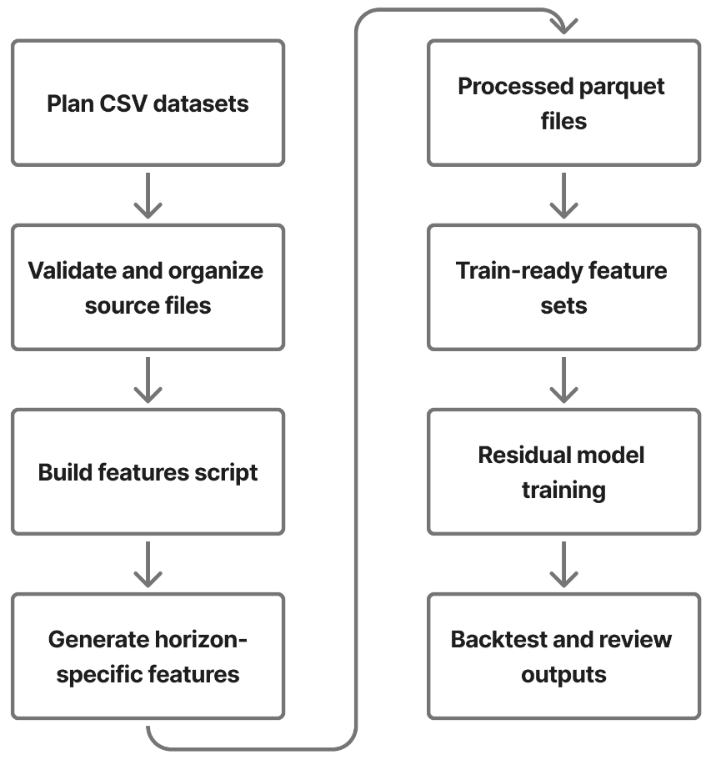
Figure 6.1: Feature Engineering Workflow Used for the Prediction Pipeline

Reference Data Sources
Along with the main plan datasets, the project uses supporting reference datasets that provide domain-level values needed during generation and later analytical processing. These reference files help ensure that food and exercise values remain consistent with the expected logic of the application.
Two important reference files are used in the current workflow:
- Indian food calories.csv, which contains calorie-related information for food items,
- exercise calorie reference.csv, which contains calorie burn rates for different exercises.
These references are especially useful because the project is not limited to abstract calorie numbers. Instead, it tries to connect intake and burn values with more meaningful food and exercise categories. This improves the realism of both the generated datasets and the later feature engineering process.
The project also includes generated plan documents and knowledge documents. Plan documents describe weekly structures, meal patterns, and workout logic for the six supported plans. Knowledge documents cover supporting health topics such as protein guidance, fat loss principles, muscle gain principles, progressive overload, metabolic adaptation, injury prevention, and calorie mathematics. These documents later become useful for AI retrieval workflows through chunking and semantic storage.

Feature Engineering Workflow
Feature engineering is the stage where raw plan-level data is converted into model-ready analytical input. This is one of the most important steps in the project because prediction quality depends not only on the model, but also on whether the features capture the right behavior over time.
The feature-building script standardizes input columns, normalizes plan files, and then computes time-aware derived values. Instead of using only current-day values, the project creates rolling and trend-based features so that the model can understand recent patterns. This is important because human progress in diet and workout routines depends heavily on short-term consistency, not just on isolated daily entries.
Some of the important engineered features used in the project include:
- rolling mean of net calories over 7 and 14 days,
- rolling standard deviation of recent calorie balance,
- rolling average adherence over 7 days,
- short-term weight trend using slope over 14 days,
- average recent steps and sleep duration,
- recent workout-completion behavior,
- day count since plan start,
- day-of-week information,
- physics-based baseline weight for the current date
One strong design choice in the feature pipeline is that it is leakage-safe. Features are computed using shifted historical data so that the model does not accidentally learn from future values while predicting future outcomes. This is especially important in time- series-style health prediction because careless feature construction can make a model appear much better than it actually is.
After the base features are prepared, target residuals are added for different horizons such as 7, 14, and 30 days. These residual targets represent the gap between future observed weight and the physics-based baseline. This allows the machine learning model to learn adjustments on top of a deterministic baseline rather than replacing health logic entirely.

Data Validation and Consistency Checks
Once datasets and engineered features are created, validation becomes necessary. With- out a validation stage, errors in row counts, missing columns, unrealistic values, or inconsistent goal direction could silently affect the quality of predictions and recommendations.
The project includes explicit validation rules for the generated plan datasets. These checks verify that required columns are present, row counts match expectation, dates remain continuous for each user, calorie values are not negative, and nutritional relation- ships remain within acceptable tolerance. Goal-direction consistency is also checked. In other words, weight-gain plans should generally show a positive trend by the end of the horizon, while weight-loss plans should generally show a negative trend.
The project also keeps supporting artifacts such as manifests, data dictionaries, generation summaries, seed files, and consistency reports. These are useful from both an engineering and academic perspective. They make the data pipeline easier to audit and demonstrate that the project is reproducible rather than manually assembled without structure.
Another important part of consistency checking is alignment between plan documents and generated datasets. The project attempts to ensure that the logic described in human- readable plan documents is consistent with the numerical data generated for those plans. This is particularly valuable because the same plan content later contributes to AI retrieval workflows.
This chapter explained how the project prepares synthetic plan data, uses reference sources, builds prediction-ready features, and validates the resulting artifacts.

CHAPTER 7
PREDICTION ENGINE AND RECOMMENDATION METHODOLOGY

Calorie Intake and Burn Estimation
The prediction and recommendation part of the project begins with basic energy-related quantities. Before the system can estimate progress, it must first understand how much energy the user consumes and how much energy the user spends. In this project, these two values are treated as calorie intake and calorie burn.
Calorie intake is derived from user food input. The system supports more than one way of recording intake. A user may provide direct calorie information or enter food items that are then mapped to calorie values through reference data. This flexibility is useful because different users prefer different logging styles. Some want quick direct entry, while others want item-level food records.
Calorie burn is estimated from workout and activity inputs. Exercise-related calorie references, step count, and workout completion details help the system approximate how much energy the user has spent. These values are later combined with profile and metabolic information so that the system can understand whether the user is in a calorie deficit, calorie surplus, or maintenance zone.
The importance of this stage should not be underestimated. If intake and burn values are poor, every later prediction step becomes weaker. For that reason, the project uses structured logging and reference-based support rather than depending only on rough user guesses.
Input Type | Purpose in System
Food Intake Data | Calculates daily calorie intake based on consumed food items
Exercise Entries | Determines calories burned through different workout activities
Steps Count | Reflects overall daily movement and contributes to activity-level estimation
Workout Completion Percentage | Measures adherence to the planned workout routine
Profile Data | Provides user-specific details (age, weight, goals) for personalized estimation
Table 7.1: Inputs used for calorie-related estimation in the project.

BMR and TDEE Computation
After intake and burn inputs are available, the system calculates the user’s baseline metabolic requirement. This is done through BMR and TDEE estimation. These two values form the foundation of the deterministic prediction layer.
BMR, or Basal Metabolic Rate, represents the approximate energy the body needs at rest to maintain essential biological functions. In this project, BMR is calculated using the Mifflin-St Jeor equation. This formula is widely used in health and fitness applications because it is simple, interpretable, and practically useful. The project supports male, female, and other values in a deterministic manner.
TDEE, or Total Daily Energy Expenditure, extends BMR by including the effect of daily activity. The system applies an activity multiplier to the BMR value in order to estimate how much energy the user needs in a normal day. This is important because two users with similar weight and height may still need very different calorie recommendations if one is sedentary and the other is physically active.
In this project, BMR and TDEE are not treated as isolated display values. They directly influence weight projection, net-calorie planning, and later progress interpretation. That is why this step is one of the central parts of the prediction methodology.
The BMR equation used in the code is based on the following logic:

- male: 𝐵𝑀𝑅 = 10𝑊 + 6.25𝐻 − 5𝐴 + 5
- female: 𝐵𝑀𝑅 = 10𝑊 + 6.25𝐻 − 5𝐴 − 161
- other: a neutral deterministic offset is used for stable computation
where 𝑊 is weight in kilograms, 𝐻 is height in centimeters, and 𝐴 is age in years.

Weight Projection Logic
Once BMR and TDEE are available, the system can project future weight based on energy balance. This deterministic projection acts as the baseline prediction line in the project. The central assumption used here is the widely known approximation that 7700 kilocalories correspond to about 1 kilogram of body weight change.
The project uses planned net calories per day to generate an ideal weight trajectory. If the daily net energy is negative, the model expects weight loss over time. If the daily net energy is positive, it expects weight gain over time. By integrating this daily difference over a period of days, the system generates an ideal line that represents what should happen under consistent plan-following conditions.
This baseline is very important because it gives the system a transparent and explainable starting point. Instead of immediately jumping into black-box model outputs, the project first creates a physics-style expectation. This makes it easier to explain why the predicted chart looks the way it does and how real outcomes differ from ideal ones.
The system also uses check-in-calibrated prediction logic. Recent user history is sorted, validated, and analyzed to understand adherence level, trend gap, and net-calorie variation. This means the actual projected line is not just a random modification of the ideal line. It is adjusted using recent user behavior and short-term patterns.

Residual Machine Learning Models
While deterministic weight projection is useful, it does not fully capture the complexity of real user behavior. People do not follow plans perfectly every day. Their adherence varies, daily fluctuations occur, and the same calorie target may affect different users differently. Because of this, the project includes residual machine learning support on top of the deterministic baseline.
The idea behind the hybrid approach is simple: first generate a sensible baseline using health formulas, and then let the machine learning model learn the remaining adjustment. In other words, the model predicts the residual difference between actual future weight and the baseline projection. This is more stable and interpretable than asking the model to predict everything from scratch.
The project uses leakage-safe features and trains residual models for multiple horizons such as 7, 14, and 30 days. Quantile models are also used so that the system can provide not only a median prediction but also lower and upper bands. In the final output, this appears as a predicted median line and an uncertainty interval between p10 and p90. This is a better design than returning one hard number without any notion of confidence.
Another practical strength of this approach is that it supports fallback behavior. If suitable models are unavailable, the system can still return a deterministic baseline instead of failing completely. This improves reliability and makes the prediction engine more robust in a real application setting.

Output | Meaning
Ideal Line | Deterministic physics-based trajectory from energy balance
Predicted Median Line | Hybrid prediction using residual model plus baseline
P10 Line | Lower quantile estimate representing a conservative range
P90 Line | Upper quantile estimate representing an optimistic range
Provenance Metadata | Model version, source, and input-related traceability information

Table 7.3: Prediction outputs supported by the hybrid pipeline.
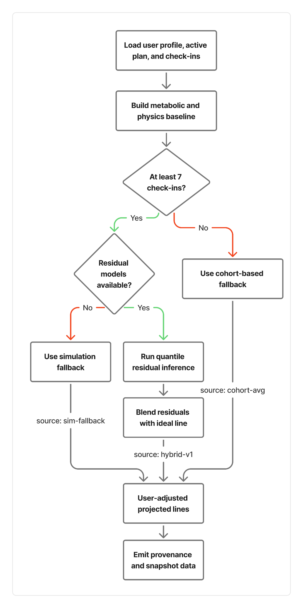
Figure 7.1: Hybrid Prediction Pipeline from Metabolic Baseline to User-Adjusted Projection

Deviation Score and Risk Flags
Prediction becomes much more useful when the system can explain whether the user is close to the expected path or drifting away from it. This is the role of deviation scoring and risk flag generation in the project.
The deviation score is used to measure the gap between the ideal line and the actual projected line. Instead of checking just the final point, the system looks at the difference across recent values and calculates a deviation-oriented metric. This helps identify whether the user is consistently off track, even if the final weight has not yet moved dramatically.
Risk flags provide an additional interpretive layer. These flags are generated when the system notices patterns such as large deviation, too-fast weight change, aggressive calorie planning, or strong drift between actual and ideal end points. These flags are useful because they convert numerical differences into readable warnings that can later be shown in dashboards or used in summaries.
This part of the prediction system is especially valuable from a user perspective. People generally understand labels such as “large deviation” or “aggressive calorie plan” more easily than a raw list of numbers. It also helps the system produce smarter recommendations and better AI explanations.

Signal | Purpose
Deviation Score | Measures how far actual progress deviates from  the expected line
Large Deviation Flag | Highlights strong mismatch between ideal and  actual trends
Too-fast Weight Change Flag | Indicates potentially unrealistic or unsafe rate of  change
Aggressive Calorie  Plan Flag | Warns about extreme planned net-calorie  values
Endline Drift Flag | Shows that actual projection diverges strongly  from the ideal endpoint

Table 7.4: Examples of interpretation signals generated by the prediction layer.

CHAPTER 8
AI COACH AND PERSONALIZATION LOGIC

AI Coach Module Overview
The AI coach module is one of the most user-visible parts of the project. Its purpose is to allow users to ask questions in natural language and receive useful responses related to progress, diet, workout behavior, and overall plan quality. Instead of forcing users to understand charts or raw metrics on their own, the AI coach provides a more conversational way to interpret what is happening.
What makes this module important is that it is not designed as a generic chatbot. A normal chatbot can answer broad health questions, but it cannot always explain the user’s actual situation. In this project, the AI coach is built to combine profile information, recent user history, and stored knowledge content. This makes the final answer more grounded and more personal.
The AI coach workflow begins when a user sends a question from the frontend. That request moves through the Node backend and reaches the Python analytics service. The Python backend then performs routing, retrieval, synthesis, and final response generation. Each of these steps is important because the system is trying to answer not only fluently, but also meaningfully.
Another practical strength of this design is that it supports both general knowledge questions and user-specific questions. A user may ask about calories, protein, weight plateau, workout consistency, or personal progress trends. The module is designed to choose the right type of context before generating the response.
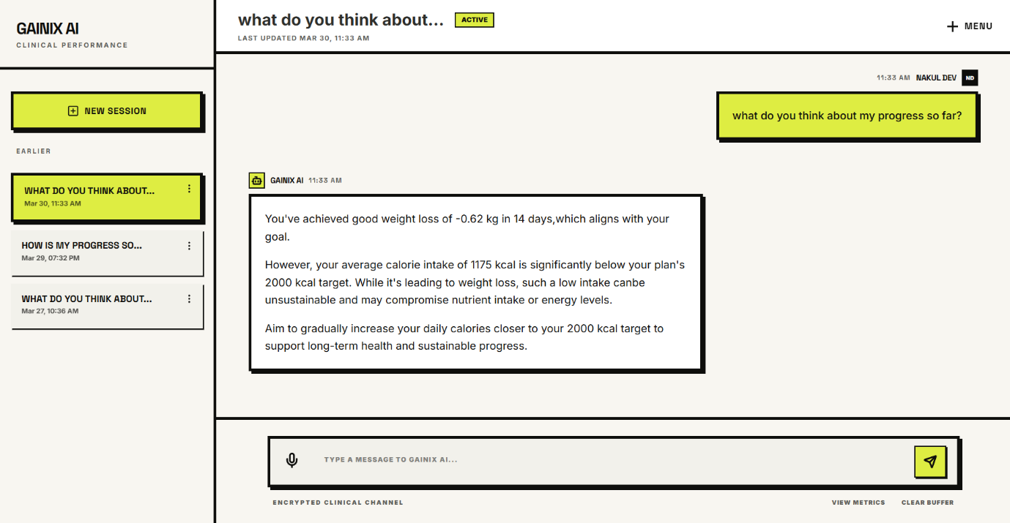
Figure 8.1: AI Coach Interface for Personalized Question-Answer Support

Intent Classification
The first analytical step in the AI workflow is intent classification. Before the system retrieves any context, it tries to understand what type of question the user is asking. In the current design, questions are classified into three broad categories:
- ANALYTIC, when the question is mainly about the user’s own data,
- KNOWLEDGE, when the question is mainly general or educational,
- HYBRID, when the question mixes user context with knowledge-based guidance.
This classification matters because not every question requires the same data source. A purely knowledge-oriented question may depend more on health documents, while an analytic question should depend more on user logs and profile data. A hybrid question often needs both. By making this distinction early, the system avoids unnecessary retrieval and improves the quality of the final answer.
The project uses a rule-based heuristic approach with optional model-assisted routing support. It also extracts entities such as dates, exercise-related terms, and food-related terms from the user question. These extracted signals later help decide which logs or knowledge chunks are most relevant.

Intent Type | Meaning
ANALYTIC | The question focuses mainly on user  logs, trends, or recent performance
KNOWLEDGE | The question focuses mainly on general health or fitness explanation
HYBRID | The question needs both domain  knowledge and user-specific context

Table 8.1: Intent types used in the AI coach module.

Multi-Stream Retrieval Pipeline
After intent classification, the system enters a retrieval phase that uses a multi-stream design instead of a single context source, which is especially effective for health-related queries. It combines three streams: a semantic stream that pulls relevant information from stored documents for general guidance, a temporal stream that analyzes recent user logs (typically the last 14 days) to summarize activity and trends, and a profile stream that incorporates user goals, preferences, and health conditions.
By merging these streams, the system produces responses grounded in both knowledge and personal context, making them far more meaningful than generic answers generated from model memory alone.
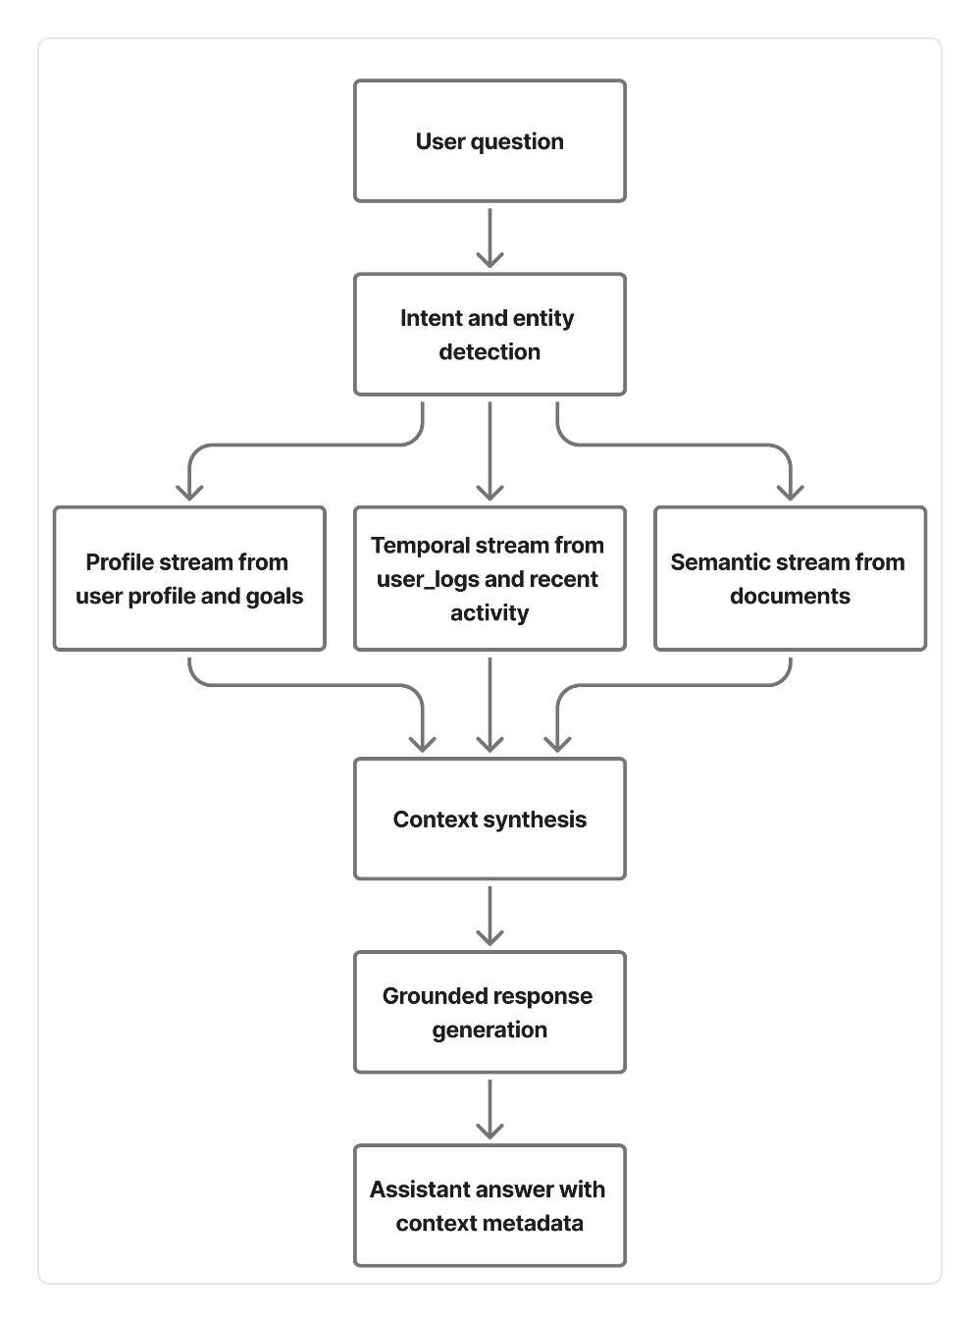

Figure 8.2: Multi-Stream Retrieval Workflow Used by the AI Coach

Context Synthesis
Retrieval alone does not solve the problem. The system still needs to transform multiple pieces of evidence into one clean and usable context for the generation step. This is the purpose of context synthesis.
In this project, the retrieved content is merged into a single unified context string. The unified format combines three major elements: research base, user performance, and profile. The research base comes from retrieved knowledge chunks, user performance comes from temporal summaries of recent logs, and profile comes from goal and preference information.
The system also checks whether enough user data is available. If logs are missing or insufficient, the system explicitly marks user data sufficiency as low. This is a very important feature because it prevents the AI coach from pretending to know details that are not actually available. Instead, it can shift toward giving a more general but still useful answer.
Another interesting part of context synthesis is the calorie delta logic. If the system finds a target calorie value in retrieved research content and also has usable user log data, it calculates the difference between target calories and actual average calories. This gives the final response a more practical and personalized explanation.
The synthesis stage therefore acts as the bridge between retrieval and generation. Without it, the AI coach would only have a loose collection of facts instead of a structured understanding of the user’s situation.

Grounded Response Generation
The final stage of the AI coach pipeline is response generation. After the unified context is created, the system sends the user question and the synthesized context to the language model layer. The response is then cleaned, validated, and returned through the API.
One of the strongest aspects of this design is that generation happens only after retrieval and synthesis. This means the model is not encouraged to answer freely without context. Instead, it is guided by structured evidence. In health-related applications, this is an important safety and quality consideration because users may rely on the answer to make decisions about diet or exercise.
The project also includes response-guard behavior. If model output is incomplete or if a problematic finish reason occurs, the system can retry with a more controlled configuration. It also sanitizes forbidden internal terms and ensures that the final response ends like a complete sentence. These small details improve professionalism and help the user experience feel more polished.
Another useful part of the design is the metadata returned with the response. The API stores or returns information such as request ID, question intent, grounding mode, user data sufficiency, finish reason, recovery usage, and output validation status. These metadata fields are valuable for debugging, evaluation, and future improvement of the AI module.
Overall, the AI coach in this project is not simply an added chatbot feature. It is a structured personalization layer built on top of profile data, log summaries, and
knowledge retrieval. This makes it more consistent with the overall goal of the system to provide meaningful, explainable, and user-centered digital health support.

CHAPTER 9
IMPLEMENTATION DETAILS AND API WORKFLOWS

Authentication and Profile Flow
The implementation of the system begins with user identity and profile management. These two parts are fundamental because almost every personalized feature depends on them. Without proper authentication, the system cannot safely associate logs and pre- dictions with the correct user. Without profile data, the recommendation and prediction quality becomes limited.
The authentication layer is implemented in the Node backend using Express routes and controller-based logic. The project supports registration, login, token refresh, logout, and user-detail retrieval. Authentication requests are validated using JSON schema validation before they reach the business logic. This improves reliability because malformed or incomplete payloads are rejected early.
Once a user is authenticated, profile management becomes the next important workflow. The frontend collects profile data such as age, height, weight, activity level, goal, food preference, and related fields. This data is then sent to the Node backend through protected routes. The backend validates the payload and updates the corresponding profile record in the database.
This flow is very important because later features such as plan selection, progress prediction, and AI guidance all depend on profile completeness. In fact, the project design intentionally links profile quality with downstream usefulness. A better profile leads to better personalization.

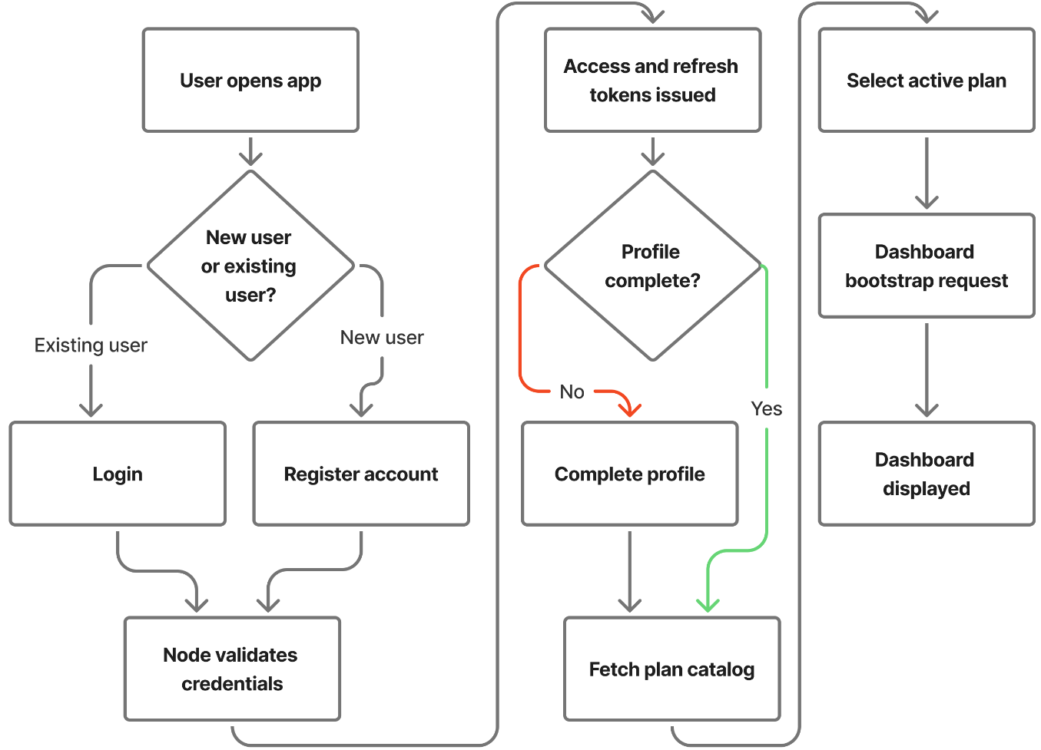

Figure 9.1: User Flow from Registration and Login to Dashboard Access



Figure 9.4: Login and Registration Interface of the System
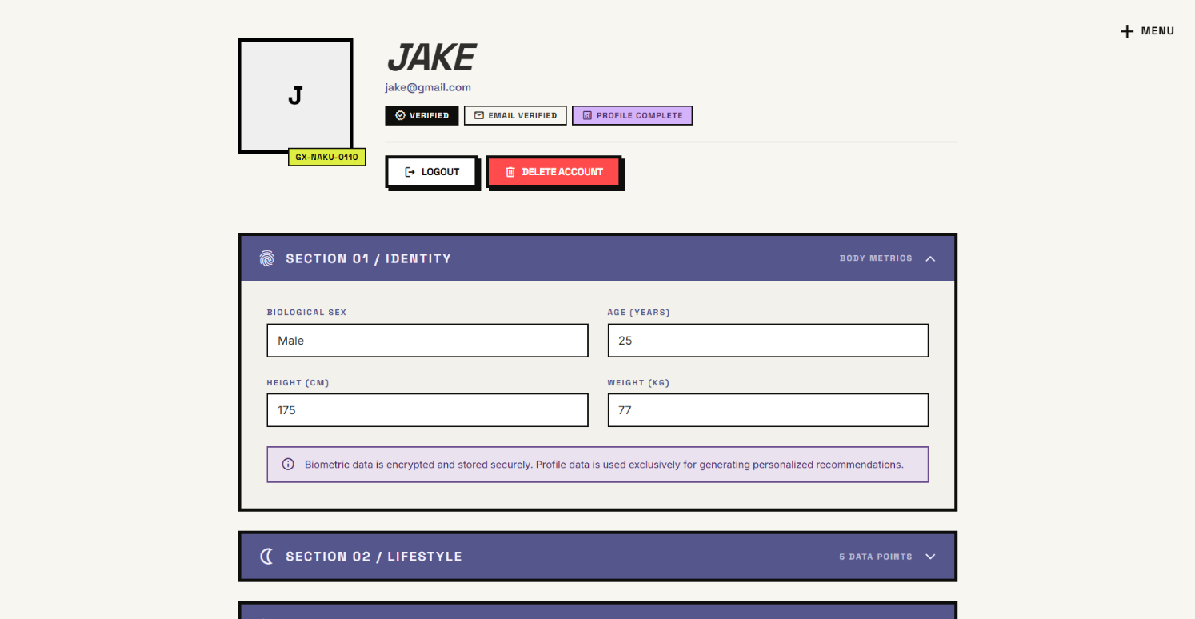

Figure 9.5: Profile Setup Interface for User Personalization

Plan Selection and Daily Check-In Flow
After authentication and profile setup, the user moves into the actual health-management workflow. This begins with plan selection and continues through daily check-ins. These two steps are closely connected because the selected plan gives the system a baseline structure, while the daily check-ins show how the user is really behaving.
The plan flow works by exposing plan data through the backend and storing a user’s active selection in the database. This allows the system to know which plan the user is currently following. Plan identity later becomes important for summary generation, prediction support, and recommendation adjustments.
The daily check-in workflow is one of the most important implemented flows in the project. A check-in may include weight, height, sleep, steps, workout completion, intake details, and workout information. The Node backend validates the payload and writes the data into structured daily tables. Depending on the request path and system needs, these records can later be used for calorie calculations, prediction updates, and progress summary generation.
From an implementation perspective, this flow is well structured because it separates intake data, workout data, and overall daily check-in records. That makes the stored information easier to query and reuse later in analytics.
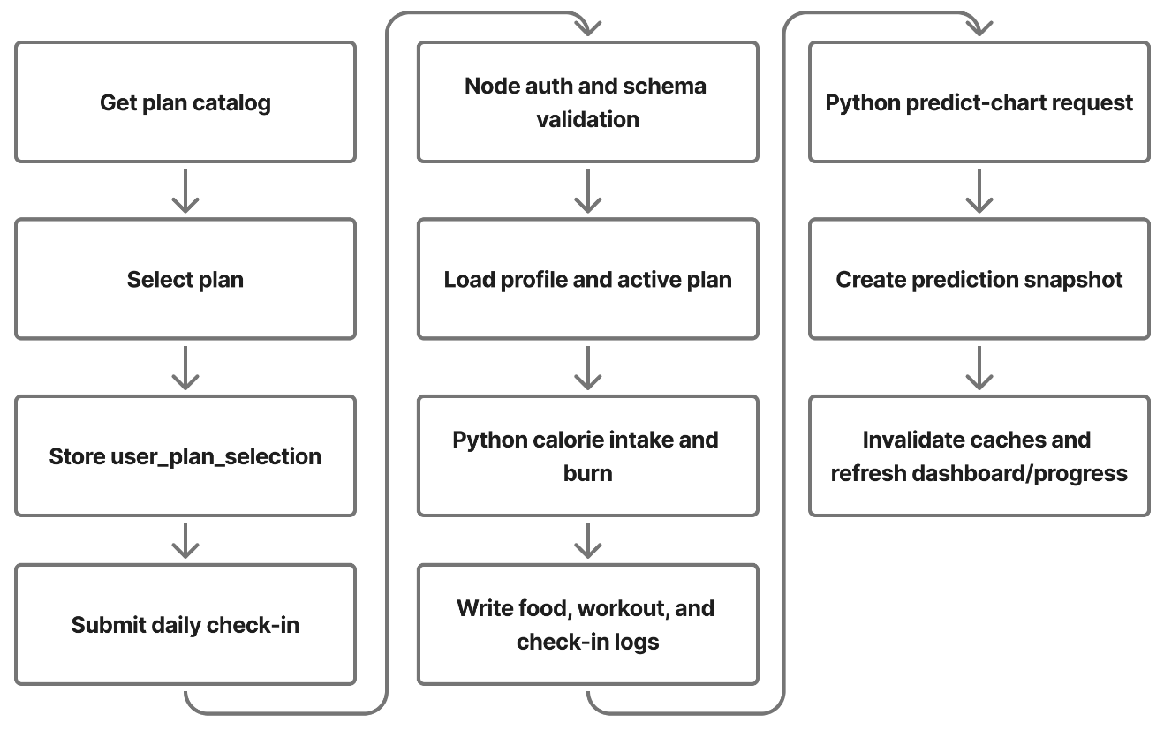
Figure 9.2: Plan Selection and Daily Check-in Flow in the Implemented System

Endpoint | Method | Purpose
/api/plans | GET | Fetch available plans from the catalogue
/api/checkins/daily | POST | Submit a daily health and activity check-in
/api/checkins/{date} | GET | Retrieve the stored daily check-in for a given  date

Table 9.2: Important plan and daily check-in endpoints.

Progress Chart and Summary Flow
Progress review is one of the most meaningful features of the system because it converts stored user history into visible insight. The user should not only be able to log daily data but also understand what that data is leading to. For this reason, the project includes chart generation, summary generation, and predictive flow integration.
In the current implementation, the frontend does not depend only on isolated progress endpoints. The dashboard first calls a bootstrap route that aggregates current plan selection, weekly action-plan content, profile completeness, recent check-ins, and progress chart information into one response. This reduces the number of separate initial requests needed by the frontend and keeps the main dashboard screen faster and more coherent.
When the user requests progress-related output, the Node backend acts as the coordinator. It checks stored information and either returns available values or calls the Python analytics service for heavier computation. The Python side may generate predicted chart data, progress summaries, or deviation-related outputs. These results are then stored or returned back through the Node backend to the frontend.
One useful implementation detail is the presence of snapshot logic. If a valid prediction snapshot already exists, the system can reuse it instead of recomputing everything. This improves efficiency and provides a more stable user experience. If no valid snapshot exists, the backend triggers the necessary analytics workflow and then persists the result.
Another useful implementation detail is route-level caching in the Node service. The dashboard bootstrap endpoint uses a short-lived cache so that repeated dashboard refreshes within a short time window do not repeatedly reconstruct the same payload. This is a practical engineering decision because dashboard data is read often, but it does not need to be recomputed on every single request.
The summary flow is especially important because it transforms raw history into readable insights. Instead of only showing a weight line, it can also provide average adherence, total calories burned, net calorie trend, weight change, and flags that describe the user’s current status more clearly.

Alternative Plan Workflow
Not every user will continue progressing well under the first selected plan. Because of this, the project includes support for alternative plan generation. This workflow is useful when the current plan is not producing the expected trend or when the user explicitly requests alternatives.
In the implementation, the alternative-plan workflow depends on user context, recent metrics, and the available plan catalog. The Node backend provides the route that the frontend consumes, while the Python analytics service handles the logic required to generate recommendation candidates. The resulting alternatives may also be stored in the database for later reuse or comparison.
This workflow is an important addition because it makes the system more adaptive. Instead of assuming that one chosen plan is always correct, the application can respond to changing user outcomes and propose more suitable options. From a project perspective, this improves the practical value of the recommendation engine.

AI Question-Answer Workflow
The AI question-answer flow connects the frontend user experience with the retrieval and generation logic explained in the previous chapter. From the implementation point of view, this workflow begins in the frontend when the user submits a question through the AI coach interface. The request is then sent to the Node backend route dedicated to AI interaction.
The Node backend performs several important checks before forwarding the question. It validates that a usable user ID is available, ensures that the question length is acceptable, and applies rate limiting to protect the service. Once the request passes validation, it is forwarded to the Python analytics backend, where the multi-stream retrieval and grounded generation process takes place.
After the Python service completes the orchestration, the generated answer and related metadata are returned through the Node backend and then displayed in the frontend. The workflow also includes feedback support, which allows the application to record user opinion about the AI response. This is useful from an engineering standpoint because it creates a path for future monitoring and improvement.
This implemented flow is valuable because it demonstrates how a conversational feature can be integrated into a structured health application without making it feel disconnected from the rest of the system.
This chapter described how the system is implemented in practice through authentication, profile handling, plan selection, daily check-ins, progress workflows, alternative-plan generation, and AI question answering. The next chapter evaluates the system through testing, validation, observations, and discussion of results.
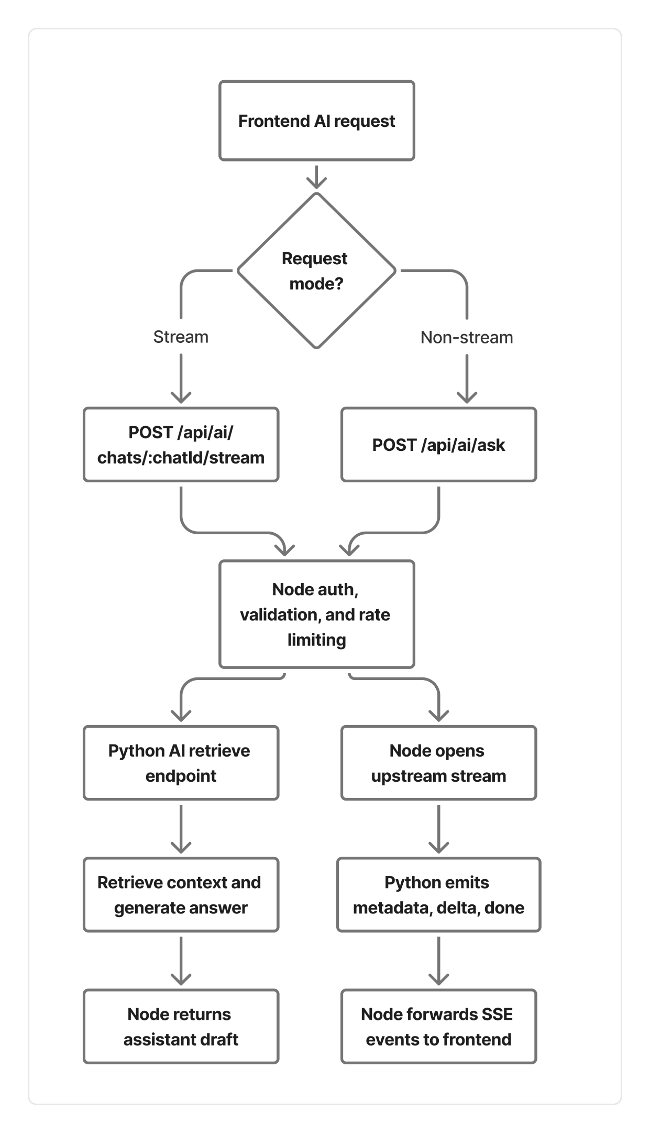
Figure 9.3: RAG Retrieval and Streaming Pipeline for AI Question-Answer Flow

CHAPTER 10
TESTING, EVALUATION, AND DISCUSSION

Unit Testing and Integration Testing
Testing is an important part of this project because the application combines multiple layers: frontend interaction, Node API logic, Python analytics, prediction workflows, and AI-based retrieval. In such a system, correctness cannot be checked only by visual output. It is necessary to test smaller modules independently and also verify whether the major workflows work together correctly.

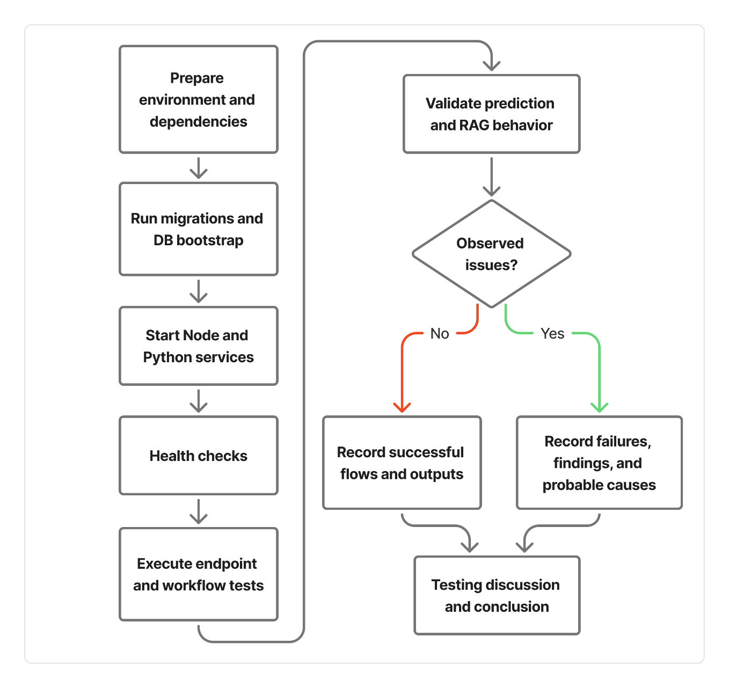
Figure 10.1: Evaluation Flow Followed in Testing and Discussion

The project includes both unit-level and integration-level testing. Unit tests focus on the behavior of individual services or helper functions. Integration tests focus on whether different layers of the application connect properly, especially in the backend flow.
The Python backend contains a broad set of tests for prediction, physics logic, inference, feature engineering, RAG support, schema handling, snapshot behavior, AI retrieval routing, and training-related utilities. This gives good coverage for the analytical side of the system. The Node backend also includes integration-style checks that verify the presence of critical route guards and controller hooks.
From a final-year project perspective, this is a strong testing setup because it does not test only surface-level functionality. It checks both numerical logic and workflow structure. That makes the project easier to trust and easier to improve later.

Prediction Validation
Prediction validation in this project focuses on reliability, shape correctness, and deterministic behavior rather than on one single accuracy metric alone. This is a sensible approach because the project combines formula-based logic with hybrid inference, and the objective is to ensure stable and meaningful behavior under realistic inputs.
The prediction tests verify that:
- generated ideal and actual chart lines have the expected length,
- the same seed produces the same output under the same input conditions,
- different user trends lead to meaningfully different prediction outputs,
- metadata such as seed and calibration information are preserved correctly.

Validation Goal | Why It Matters
Correct Chart Length | Ensures progress outputs are aligned with the  requested horizon
Deterministic Output for  Fixed Seed | Supports reproducibility and debugging
Sensitivity to User Trend  Changes | Confirms that predictions react to different user behavior
Metadata Integrity | Preserves traceability of prediction generation logic

Table 10.2: Key prediction validation goals in the project.

AI Retrieval and Response Testing
The AI coach is one of the most complex parts of the project because it depends on retrieval logic, profile context, user history, and final response generation. For this reason, the project includes tests that focus specifically on RAG behavior and assistant output quality.
These tests cover areas such as deterministic embeddings, fallback retrieval behavior,
intent-sensitive assistant drafting, output validation, and the use of user metrics when the
question requires them. This is especially important because an AI module can appear to work well in casual usage while still producing weak or poorly grounded responses in edge cases.
The tests also verify fallback behavior when real embeddings are not available or when provider-level operations fail. This matters in production-style systems because AI support should degrade gracefully instead of breaking entirely. The project design handles this through deterministic fallback retrieval and validation checks around output completeness.
Another useful testing aspect is response quality validation. The assistant is checked for conditions such as minimum completeness and sentence termination. While these are simple checks, they improve professionalism and prevent obviously poor responses from being treated as acceptable.

Concern | Test Purpose
Deterministic Embedding Stability | Ensure repeated embedding calls remain consistent for  the same input
Fallback Retrieval Behavior | Confirm the system still works when real embedding  mode is unavailable
Intent-aware Assistant  Behavior | Ensure user-data questions trigger context-aware  drafting
Output Validation | Reject incomplete or low-quality generated  responses
Route Orchestration  Correctness | Verify that AI retrieval endpoints trigger the  expected workflow

Table 10.3: Representative AI retrieval and assistant testing concerns.

Experimental Observations
The project is not evaluated only through isolated tests. It also includes practical observations based on how the full workflow behaves across data logging, prediction, and AI assistance.
One important observation is that the architecture supports smooth separation between operational and analytical tasks. The Node backend handles user-facing flows cleanly,
while the Python backend remains focused on data-intensive and AI-intensive logic. This makes the project easier to debug and extend.
Another observation is that the hybrid prediction approach is more practical than using either formulas alone or models alone. Formula-based baseline logic keeps the system understandable, while residual modeling allows the system to react to actual user trends more realistically. This balance improves the usefulness of the generated progress charts.
The AI module also shows a useful pattern: responses become more meaningful when the system has sufficient recent logs. When user-data sufficiency is low, the module can still provide a general answer, but it is naturally less personalized. This is a good sign because it shows that the system is sensitive to context quality rather than pretending to know more than it actually does.
The available end-to-end report in the repository also highlights a realistic engineering lesson: infrastructure or setup issues can break a broader validation harness even when many module-level tests exist. This is valuable to mention because real software systems are affected not only by logic errors but also by integration and environment readiness.

Discussion of Results
From the testing and evaluation activities, it can be said that the project demonstrates good internal consistency across its major modules. The prediction layer is designed with determinism and traceability in mind. The AI layer includes both retrieval grounding
and fallback handling. The backend routes contain validation and protective checks. Together, these aspects show that the system was implemented as an engineering solution rather than as a collection of disconnected features.
At the same time, the evaluation also reveals the realistic limitations of the current stage. The project already contains many module-level and workflow-level validations, but full environment-dependent harness execution can still fail due to setup or infrastructure-related issues. This is not unusual in multi-service systems, and it high- lights the importance of deployment discipline, test environment stability, and controlled initialization steps.
Overall, the results suggest that the project succeeds well as a final-year engineering system. It integrates personalization, predictive analytics, and AI-assisted support in a structured way. The testing evidence supports the claim that the system is modular, reproducible, and extendable. The next chapter concludes the report by summarizing the work, discussing limitations, and identifying future improvements.

CHAPTER 11
CONCLUSION AND FUTURE ENHANCEMENTS

Conclusion
This project set out to build a health and fitness platform that goes beyond basic calorie tracking or static workout suggestions. The main goal was to create a system that could understand user profile information, support daily logging, estimate calorie intake and calorie burn, predict progress over time, and answer questions through an AI-assisted module. Based on the design and implementation presented in the earlier chapters, that goal has been achieved in a meaningful and structured way.
One of the strongest outcomes of the project is that it brings multiple important features into a single connected workflow. The user is not forced to use one application for logging, another for prediction, and another for guidance. Instead, profile setup, plan selection, daily check-ins, progress tracking, and AI-based support are all connected through the same platform. This makes the system more practical and also gives the report a stronger engineering foundation, because each module contributes to a larger end-to-end flow.
Another important contribution of the project is the architectural separation between operational logic and analytical logic. The Node.js backend handles authentication, user-facing routes, plan flows, dashboard aggregation, and request coordination, while the Python service handles calorie analytics, prediction logic, progress summaries, alternative plans, and AI retrieval orchestration. This separation keeps the design maintainable and mirrors the different strengths of the two technology stacks.
The project also demonstrates that personalization becomes more useful when it is grounded in actual user behavior. The progress module does not only show stored values; it interprets how current behavior compares with the expected path. The AI coach does not answer only from generic text generation; it builds its response using profile information, recent logs, and knowledge documents. These aspects make the system more credible and much more relevant than a generic fitness dashboard.
From an academic and implementation point of view, the completed work can therefore be seen as a successful final-year project. It combines full-stack development, data modeling, analytical logic, prediction design, retrieval-based AI support, and testing in one system. The final product is not just a visual prototype. It is a working multi-service application with a realistic architecture and clear scope for extension.

Limitations
Even though the system performs well within the defined scope, it also has a number of practical limitations that should be stated clearly.
The first limitation is that the platform is still a software guidance system, not a clinical medical system. It can estimate trends, suggest plans, and provide useful summaries, but it should not be treated as a replacement for a doctor, certified dietitian, or professional fitness trainer. The recommendations are helpful for guidance and monitoring, but they are not medical prescriptions.
The second limitation is that progress prediction still depends strongly on the quality of user-entered data. If the user skips check-ins, enters inaccurate calorie values, or fails to log workouts correctly, then the resulting progress interpretation will naturally become less reliable. In other words, the quality of personalization depends on the quality of the available data.
Another limitation is that the AI coach is retrieval-grounded but still bounded by the knowledge and logs available to it. If recent user data is missing or if the question goes beyond the stored knowledge base, the assistant may respond in a more general way instead of a deeply personalized way. This is better than hallucinating unsupported details, but it still limits how precise the guidance can be in some cases.
The project also inherits the normal deployment complexity of a multi-service application. Since the frontend, Node backend, Python backend, PostgreSQL database, and optional Redis cache all work together, setup and environment consistency become important. As seen in testing and validation discussions, some broader workflows can fail when infrastructure or initialization is not handled correctly, even if the code logic itself is sound.
Finally, the current system is limited in personalization depth when compared with large- scale commercial health platforms. It does not yet include wearable-device integration, live sensor streaming, long-term adaptive coaching based on months of behavior, or advanced clinical screening logic. These areas remain open for future improvement.

Future Scope
The current project already provides a strong base, but it also opens several useful directions for future work.
One natural extension is deeper personalization. The system can be improved to learn more dynamically from long-term user behavior and not only from short-term recent logs. For example, future versions could adapt plans based on repeated adherence patterns, missed workouts, sleep irregularity, or sustained deviation trends. This would make the recommendation engine more proactive.
Another useful enhancement is wearable and device integration. If the platform can connect to smartwatches, fitness bands, or phone health APIs, it could capture steps, heart rate, workout duration, and sleep data automatically. This would reduce manual entry effort and improve the reliability of the data used by the prediction engine.
The AI coach can also be extended further. At present, it combines retrieval from profile data, recent logs, and knowledge documents. In future versions, it could support memory of longer-term user milestones, better conversational continuity, richer explanation formats, and possibly personalized weekly coaching summaries generated automatically from progress trends.
From the system side, future work could also improve deployment maturity. Containerized orchestration, stronger environment validation, CI-based service integration checks, and production-grade monitoring would make the platform easier to run and maintain beyond an academic setting.
There is also room for richer plan intelligence. The current project already supports alternative plans, but future versions could include finer plan ranking, condition-aware suggestions, vegetarian and non-vegetarian substitution logic at a more detailed level, and adaptive calorie cycling strategies based on recent user adherence and goal progress.
Overall, the project forms a solid foundation for future development. What has been built here is enough to demonstrate a meaningful, practical, and technically coherent health recommendation platform. With more data, stronger integration, and extended analytics, the same system can grow into a much more advanced personalized digital fitness assistant.

CHAPTER A
APPENDICES

Sample API Payloads

This appendix provides short representative payload examples used across the application. These are included to show the kind of structured data exchanged between the frontend, Node backend, and Python analytics service.

Field | Example Value
name | "Jake"
age | 21
sex | "male"
height (cm) | 172
weight (kg) | 78.5
goal type | "weight loss"
diet type | "veg"
activity level | "moderate"

Table A.1: Representative Profile Update Payload

Field | Example Value
date | "2026-03-20"
weight (kg) | 77.9
sleep hours | 7.5
water (liters) | 2.8
calorie consumed (kcal) | 1920
calorie burned (kcal) | 430
steps | 9450
workout completion (%) | 85

Table A.2: Representative Daily Check-in Payload

REFERENCE

- M. D. Mifflin, S. T. St Jeor, L. A. Hill, B. J. Scott, S. A. Daugherty, and Y. O. Koh, “A new predictive equation for resting energy expenditure in healthy individuals,” The American Journal of Clinical Nutrition, vol. 51, no. 2, pp. 241–247, 1990.
- K. D. Hall, G. Sacks, D. Chandramohan, C. C. Chow, Y. C. Wang, S. L. Gortmaker, and B. A. Swinburn, “Quantification of the effect of energy imbalance on bodyweight,” The Lancet, vol. 378, no. 9793, pp. 826–837, 2011.
- P. Lewis, E. Perez, A. Piktus, F. Petroni, V. Karpukhin, N. Goyal, H. Küttler, M. Lewis, W.-T. Yih, T. Rocktäschel, S. Riedel, and D. Kiela, “Retrieval-augmented generation for knowledge-intensive NLP tasks,” in Advances in Neural Information Processing Systems (NeurIPS), vol. 33, pp. 9459–9474, 2020.
- G. Ke, Q. Meng, T. Finley, T. Wang, W. Chen, W. Ma, Q. Ye, and T.-Y. Liu, “LightGBM: A highly efficient gradient boosting decision tree,” in Advances in Neural Information Processing Systems (NeurIPS), vol. 30, pp. 3146–3154, 2017.
- T. Chen and C. Guestrin, “XGBoost: A scalable tree boosting system,” in Proc. 22nd ACM SIGKDD International Conference on Knowledge Discovery and Data Mining, San Francisco, CA, USA, pp. 785–794, 2016.
- B. Sarwar, G. Karypis, J. Konstan, and J. Riedl, “Item-based collaborative filtering recommendation algorithms,” in Proc. 10th International Conference on World Wide Web (WWW), Hong Kong, pp. 285–295, 2001.
- D. Zeevi, T. Korem, N. Zmora, D. Israeli, D. Rothschild, A. Weinberger, O. Ben-Yacov, D. Lador, T. Avnit-Sagi, M. Lotan-Pompan, J. Suez, J. A. Mahdi, E. Matot, G. Malka, N. Kosower, M. Rein, G. Zilberman-Schapira, L. Dohnalova, M. Pevsner-Fischer, R. Bikovsky, Z. Halpern, E. Elinav, and E. Segal, “Personalized nutrition by prediction of glycemic responses,” Cell, vol. 163, no. 5, pp. 1079–1094, 2015.
- S. Zhang, L. Yao, A. Sun, and Y. Tay, “Deep learning based recommender system: A survey and new perspectives,” ACM Computing Surveys, vol. 52, no. 1, pp. 1–38, 2019.
- H. Wang, N. Wang, and D.-Y. Yeung, “Collaborative deep learning for recommender systems,” in Proc. 21st ACM SIGKDD International Conference on Knowledge Discovery and Data Mining, Sydney, Australia, pp. 1235–1244, 2015.
- F. Ricci, L. Rokach, and B. Shapira, Eds., Introduction to Recommender Systems Handbook. New York, NY, USA: Springer, 2011.
- A Vaswani, N. Shazeer, N. Parmar, J. Uszkoreit, L. Jones, A. N. Gomez, Ł. Kaiser, and I. Polosukhin, “Attention is all you need,” in Advances in Neural Information Processing Systems (NeurIPS), vol. 30, pp. 5998–6008, 2017.
- J. Devlin, M.-W. Chang, K. Lee, and K. Toutanova, “BERT: Pre-training of deep bidirectional transformers for language understanding,” in Proc. 2019 Annual Conference of the North American Chapter of the Association for Computational Linguistics: Human Language Technologies (NAACL-HLT), Minneapolis, MN, USA, pp. 4171–4186, 2019.
- C. Trattner and D. Elsweiler, “Food recommender systems: Important contributions, challenges and future research directions,” arXiv preprint, arXiv:1711.02760, 2017.
- D. Elsweiler, C. Trattner, and M. Harvey, “Exploiting food choice biases for healthier recipe recommendation,” in Proc. 40th International ACM SIGIR Conference on Research and Development in Information Retrieval, Shinjuku, Tokyo, Japan, pp. 575–584, 2017.
- D. C. Nieman and L. M. Wentz, “The compelling link between physical activity and the body’s defense system,” Journal of Sport and Health Science, vol. 8, no. 3, pp. 201–217, 2019.
- K. Guu, K. Lee, Z. Tung, P. Pasupat, and M.-W. Chang, “REALM: Retrieval-augmented language model pre-training,” in Proc. 37th International Conference on Machine Learning (ICML), Vienna, Austria, pp. 3929–3938, 2020.

