**ECEN 602 Assignment 1 Test Cases**

Following are the use cases tested:

**Note:** We have implemented the server and client which can handle both **IPv4 and IPv6** addresses (bonus feature) but as said in the manual, it cannot be tested.

1. Chatting with three clients

Following pictures shows the chatting of 3 clients – gautham, amit and arun. Later, they become idle and amit left the chat.

**BONUS FEATURE:**

**ACK:** When the client connects to the server, the server sends an ACK message stating the total number of clients connected and the user name of existing clients exclusive of the requestor.

In this example (Fig.1.c), when amit (client 3) connects to the server, the server sends an ACK with message “**3, gautham, arun**”, where 3 indicates total number of clients connected inclusive of the requestor and the server provides the two other clients names which have joined the chat room.

**ONLINE:** When the client connects to the server, the server informs other clients that a new client is online and has joined the chat.

In this example (Fig.1.c), when amit (client 3) connects to the server, the server informs gautham (client 1) and arun (client 2), that amit has joined the chat.

**OFFLINE:** When the client disconnects to the server, the server informs other client that a new client is offline and has left the chat.

In this example (Fig.1.a and Fig1.b), when amit (client 3) disconnects to the server, the server informs gautham (client 1) and arun (client 2), that amit has left the chat.

**IDLE:** When the client does not send any messages for 10 seconds, it informs the server and the server broadcast this message to other clients.

In this example, after some time, all the clients become idle and the server broadcast this message to other clients.

Fig 1.a: Client 1

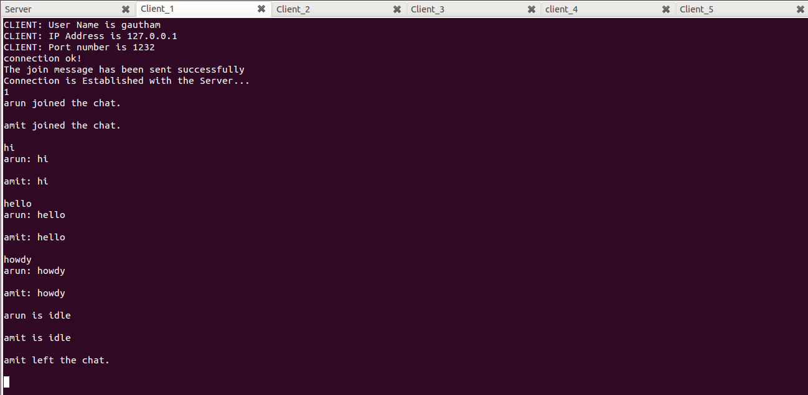

Fig 1.b: Client 2

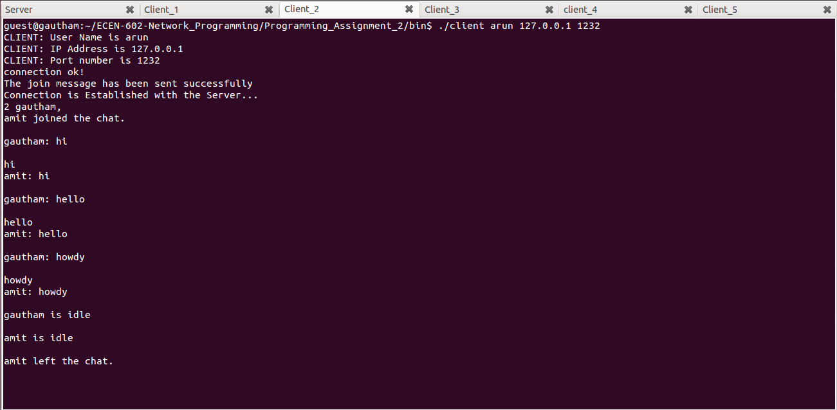

Fig 1.c: Client 3

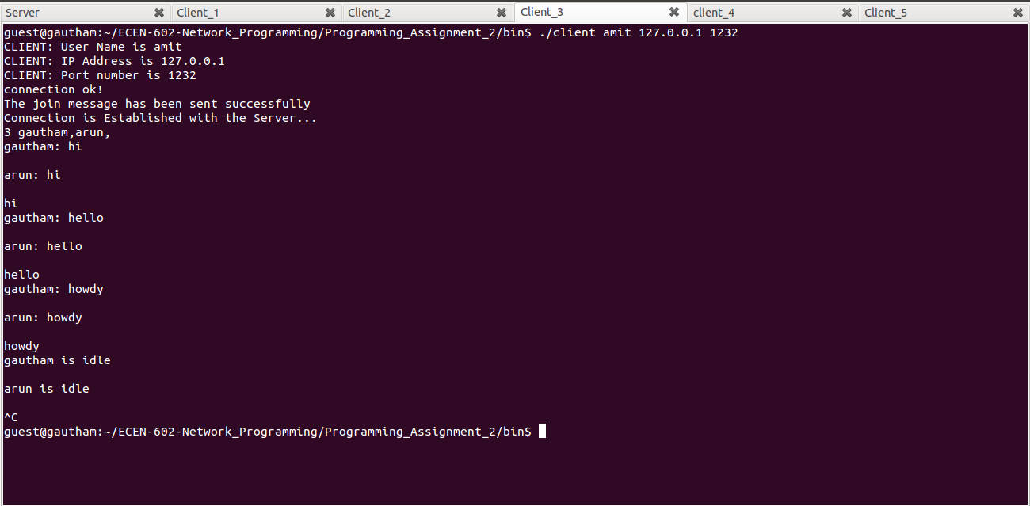

Fig 1.d: Server

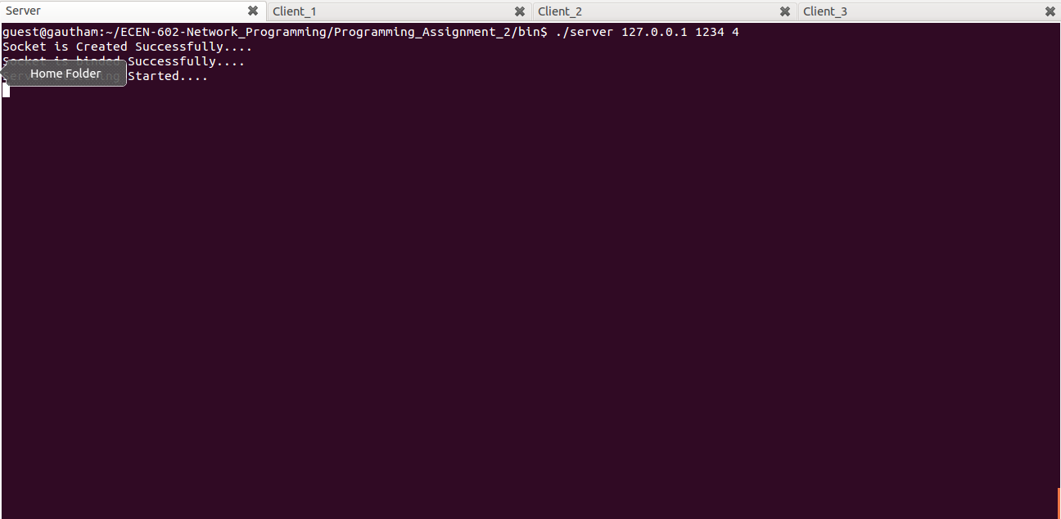

1. The following picture depicts that the server rejects the client with the same user name.

**NAK BONUS FEATURE:**

In the chat room, already 3 clients named: gautham, amit and arun are connected. When the 4th client connects with the name “gautham”, the server rejects the client stating it’s a duplicate user name.

Fig. 2. Server sending NAK message to the client

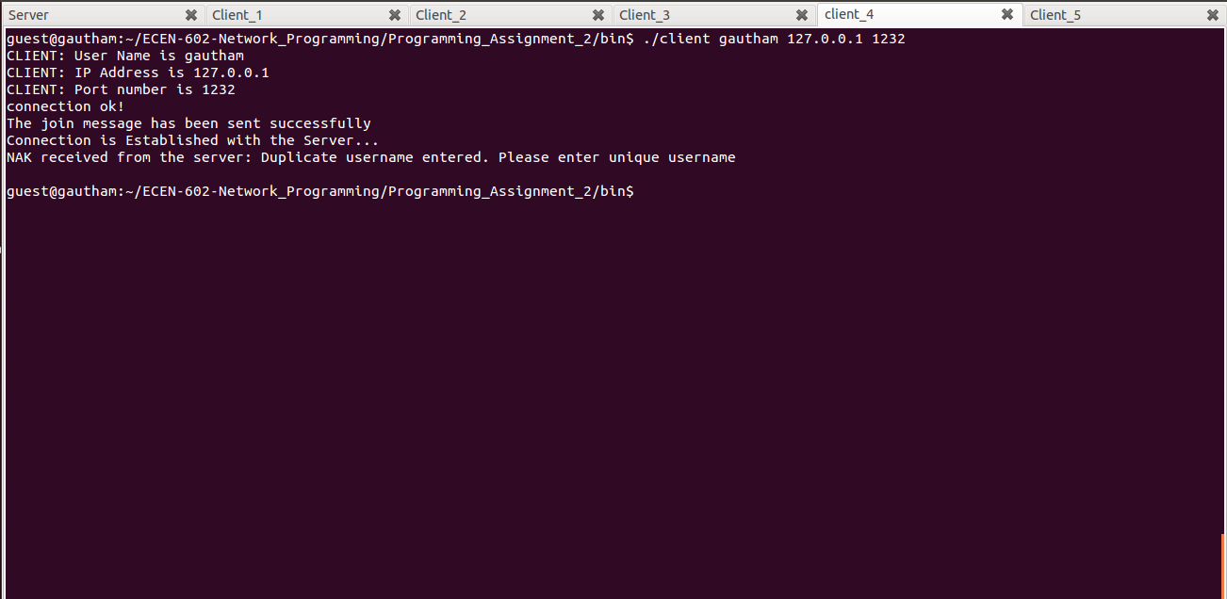

1. Server allows previously used username to be reused

In this picture, when client 4 connects with the username as **gautham**, it gets rejected by the server. Later when gautham (client 1) leaves the chat room, and client 4 connects with the username as **gautham**, it gets accepted by the server.

Fig.3.a: Client 1 leaves the chat

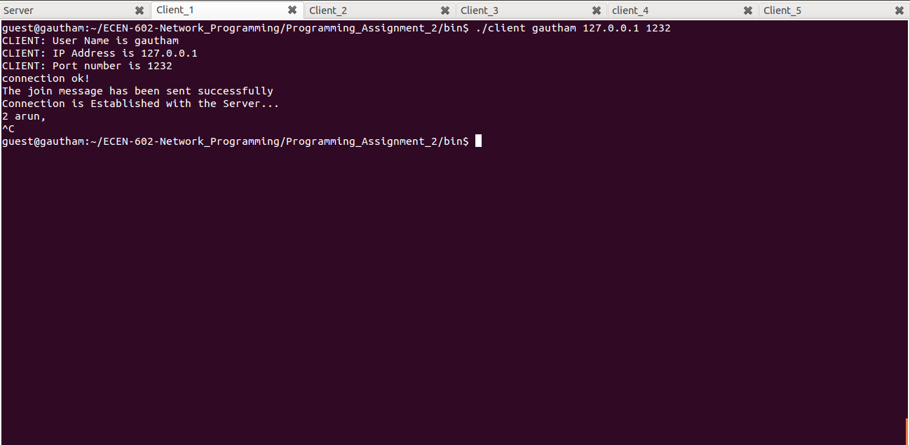

Fig.3.b: Client 4 initially rejected by server and later accepted by the server

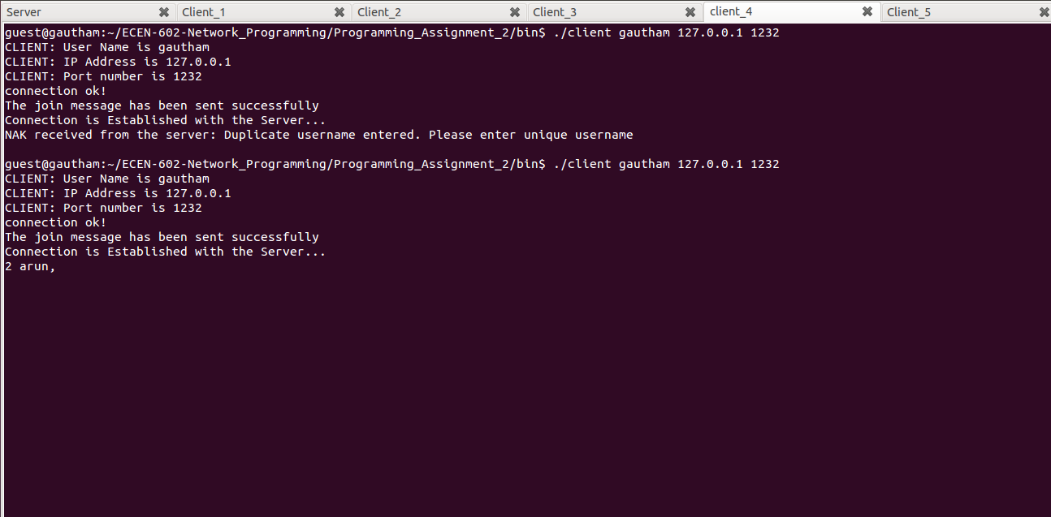

1. Server rejects client when max clients are already present.

In this picture, the server rejects client 5, as in the chat room already 4 clients are present and the server can take maximum of 4 clients.

Fig.4: Server rejects client 5

