**ECEN 602 Assignment 4 Test Cases**

Following are the test cases executed:

1. a cache hit returns the saved data to the requester

Initially the client requests a file to the server. The server proxies the request to the web server, caches it and send it to the client. Next time the client request the same file, the server returns the file from the cache instead of sending a request to the web server.

Server proxies the request to the web server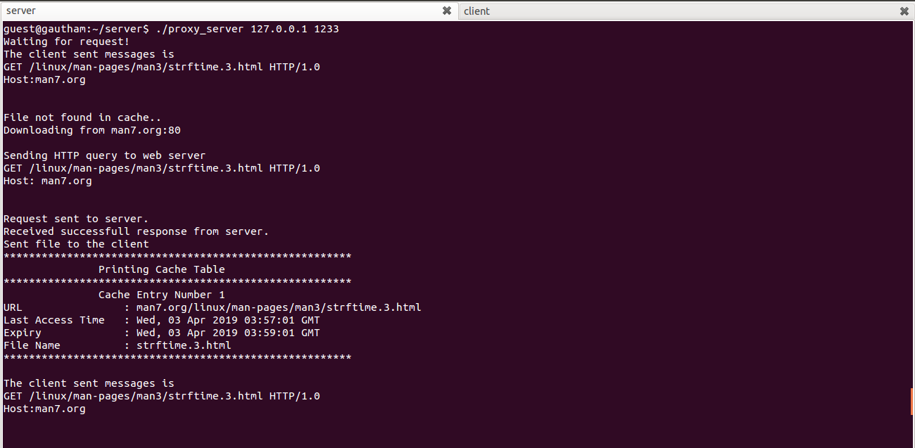

Server sends from cache subsequent time

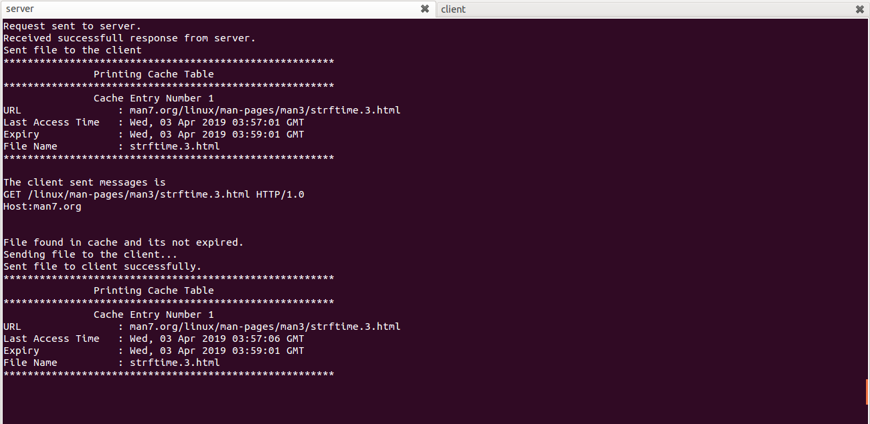

Client requests server two times

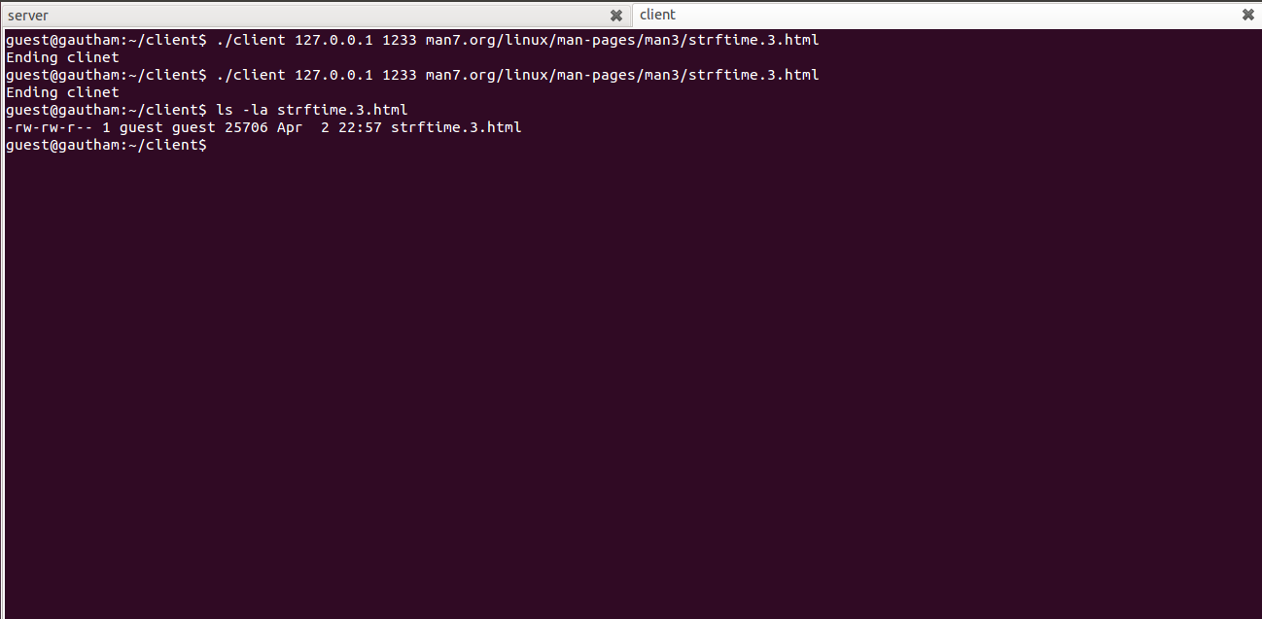

1. a request that is not in the cache is proxied, saved in the cache, and returned to the requester

Initially the client requests a file to the server. The server proxies the request to the web server, caches it and send it to the client.

Server

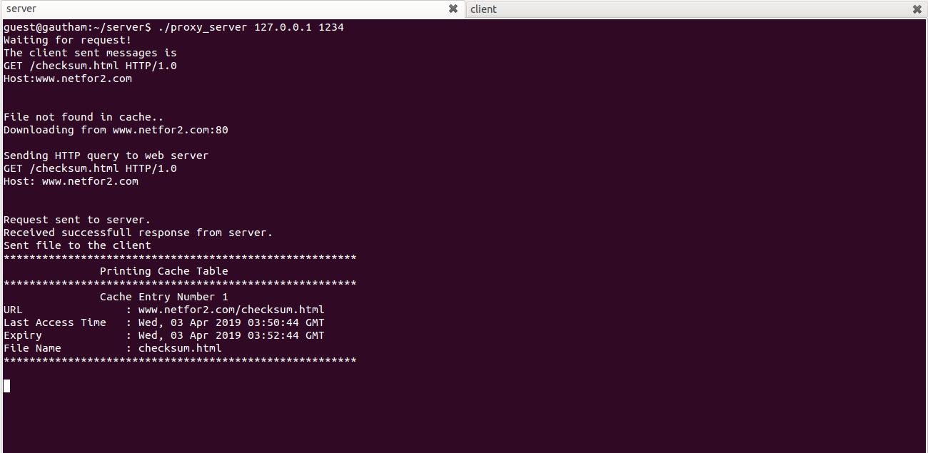

Client

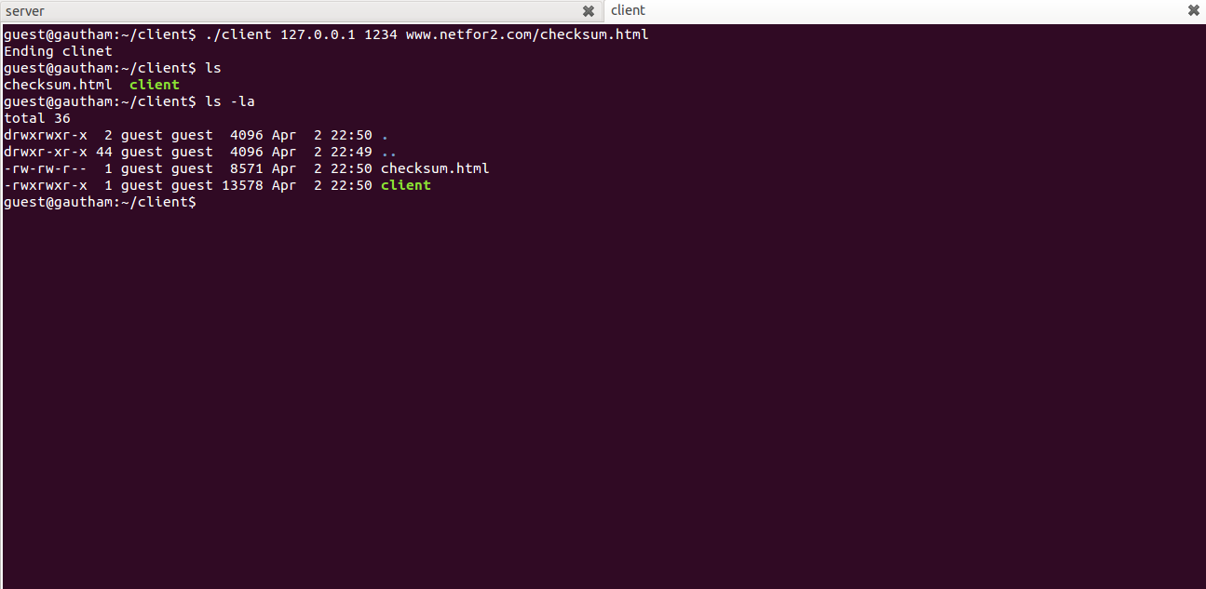

1. a cache miss with 10 items already in the cache is proxied, saved in the LRU location in cache, and the data is returned to the requester

It is assumed that the client has already requested 10 files and now if the client request another file, it will be caches in the LRU entry.

Server Cache table with 10 entries

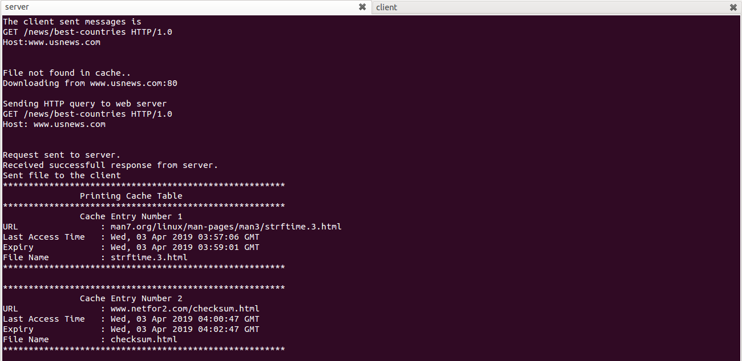

Server cache table with 10 entries

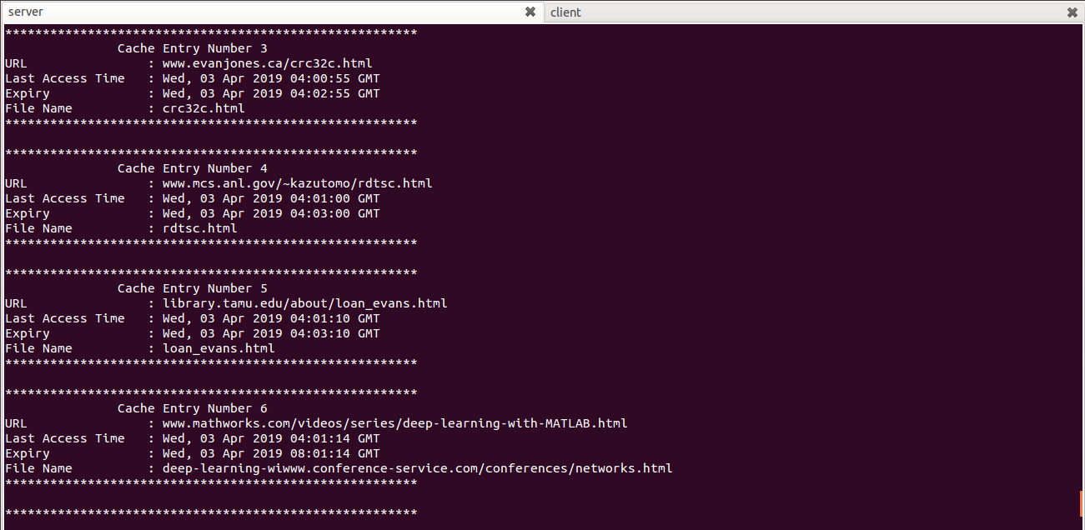

Server cache table with 10 entries

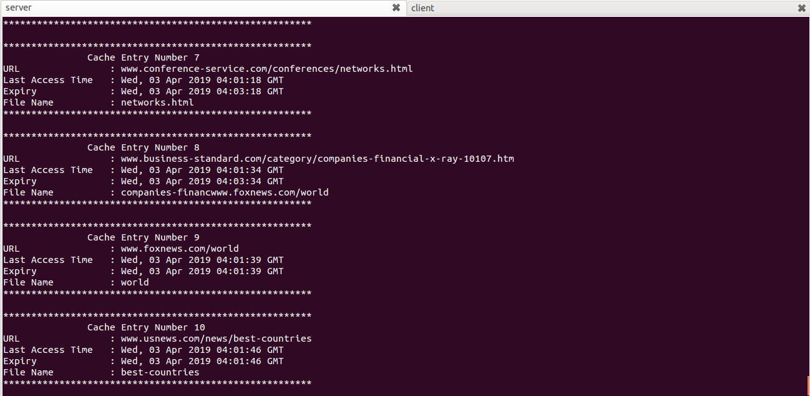

Client requests 11th file

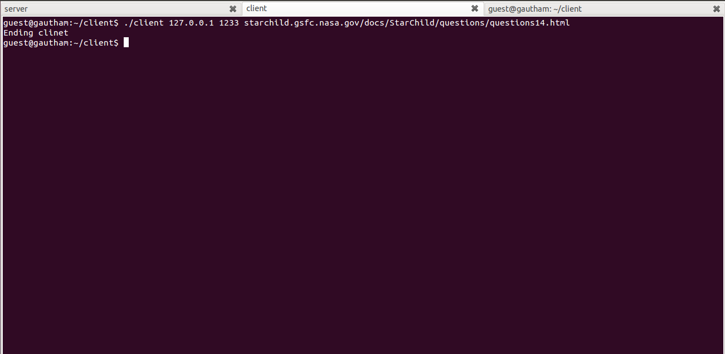

Server puts the 11th file in LRU entry. In our case, it’s the first entry

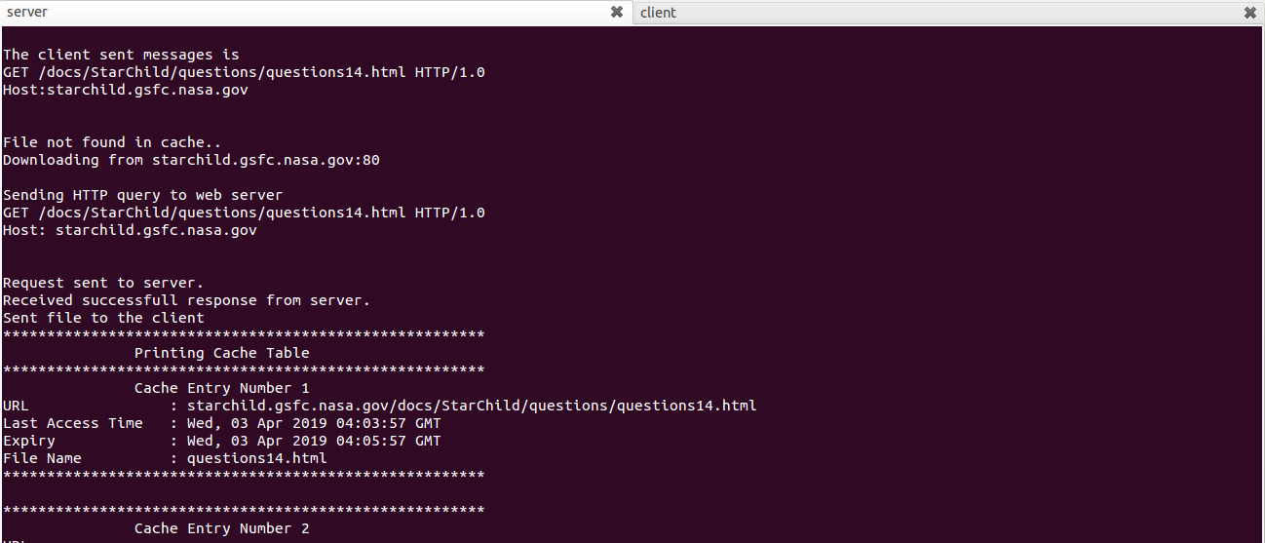

1. a stale Expires header in the cache is accessed, the cache entry is replaced with a fresh copy, and the fresh data is delivered to the requester (**Bonus feature Included)**

When the file is present in the cache and it is expired, the proxy server sends “If-Modified-Since:” request to the web server. The web server responds with a message stating that the file is modified or not. If modified, the proxy server request the file from web server, else the proxy server sends the file from its cache.

Server sends the file for the first time

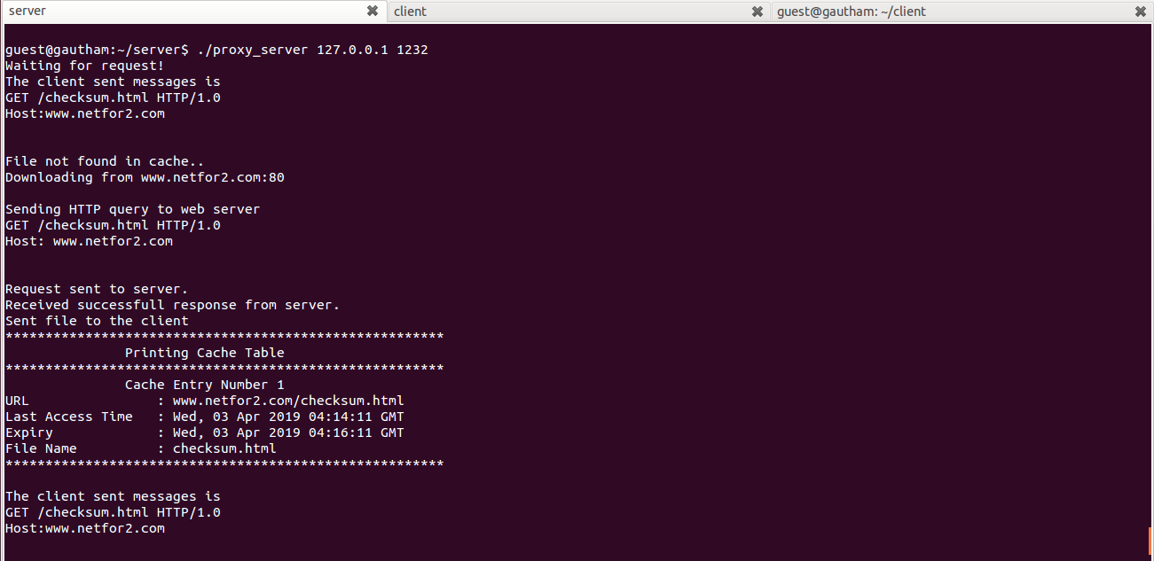

Server finds the expired file, sends If-Modified-Since: request to web server. The web server returns 304 indicating the file has not been modified. Hence, the proxy server returns the file from its cache.

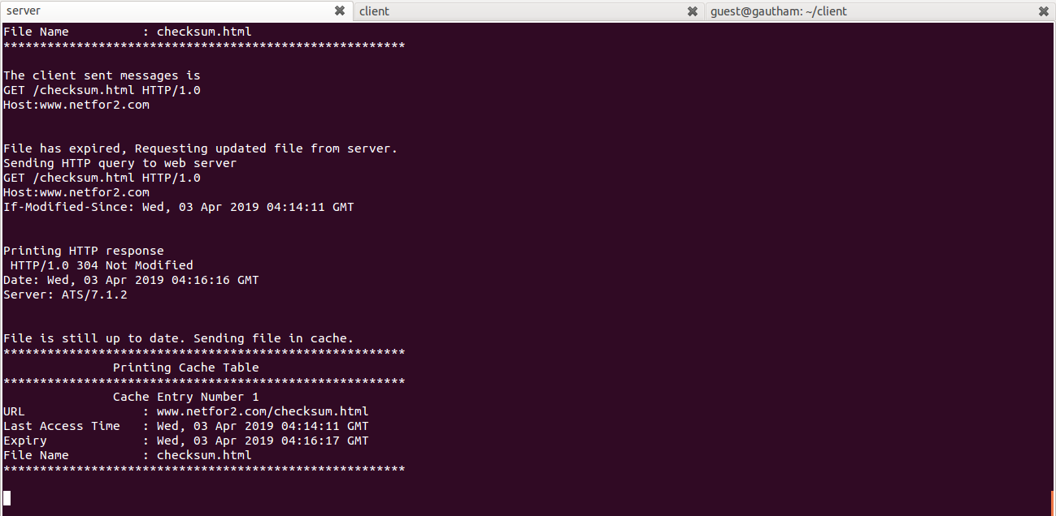

Client requesting file after expired time

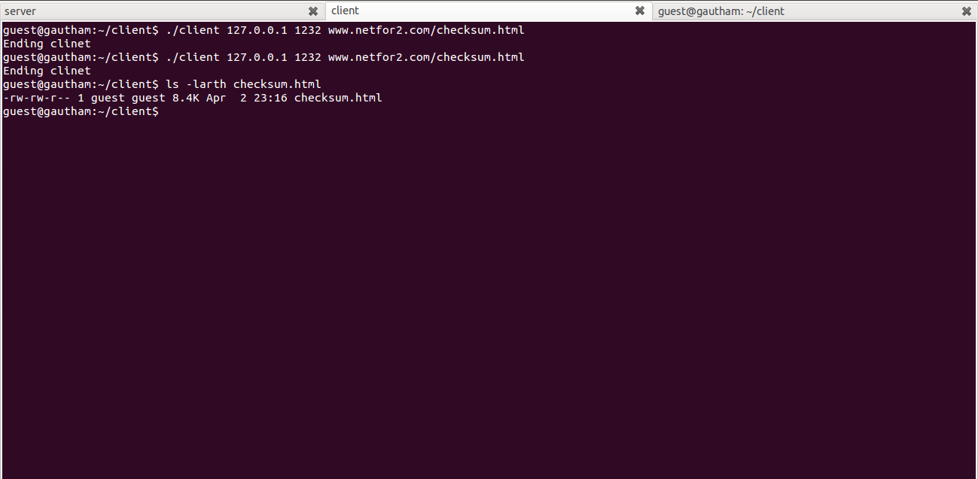

1. three clients can simultaneously access the proxy server and get the correct data

Three clients request data at the same time and the server process it and sends the file

Multiple clients and server

