How Multi-Factor Authentication (MFA) Secures Email Accounts Against Cyber Attacks

What is MFA

MFA stands for Multi-Factor Authentication. When used in the context of an "MFA email," it refers to a security notification or a verification message (usually containing a one-time code) sent to your inbox to confirm your identity when you attempt to log into an account or app.

How it Works

Instead of just asking for a password, this method requires two or more pieces of evidence (factors) to gain access:
- Factor 1 (What you know): Your username and password.
- Factor 2 (What you have/receive): The verification code automatically sent to your email.

Why it is Used

Enhanced Security: Even if a hacker discovers your password, they cannot access your account without having access to your email to retrieve the second code.
Data Protection: It acts as a digital checkpoint to secure sensitive personal, financial, or corporate information.

How MFA Strengthens Email Security

When you use Multi Factor Authentication with your email account, no threat actor can easily access your email by stealing your password. Even if you become a victim of a Phishing attack and enter your password on a fake web page or interface, the adversaries will not be able to compromise your email account.

They cannot pass additional authentication checks like a fingerprint scan, facial scan, or OTP verification. Thus, MFA can be an invaluable tool that can provide you with robust email security.

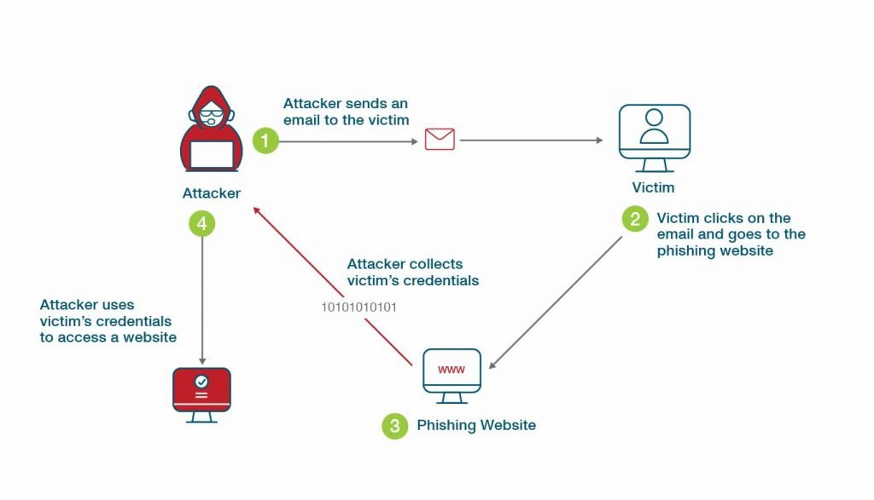

Recent MFA-Related Attacks

1. Kali365 Microsoft 365 MFA Bypass (2026)
A phishing-as-a-service toolkit called Kali365 was reported by the FBI. Attackers trick users into entering a Microsoft device code on a legitimate Microsoft login page. This allows attackers to steal OAuth tokens and access Outlook, Teams, and OneDrive accounts without needing the password or MFA again.

https://nypost.com/2026/05/28/business/fbi-sounds-alarm-on-phishing-tool-that-steals-microsoft-365-accounts

2. Apple MFA Fatigue Attacks (2024)
Attackers abused Apple's password recovery system by repeatedly sending MFA requests and notifications to users. The goal was to overwhelm victims until they accidentally approved a request or interacted with attackers posing as support staff.

https://krebsonsecurity.com/2024/03/recent-mfa-bombing-attacks-targeting-apple-users

3. Payroll Pirates Campaign (2025)

Microsoft warned about attackers targeting university employees through phishing campaigns. The attackers stole MFA codes and used social engineering techniques to gain access to payroll and HR systems.

https://www.itpro.com/security/payroll-pirates-target-us-universities-microsoft-warns

4. SonicWall VPN MFA Bypass Attacks

Researchers reported cases where attackers bypassed MFA by stealing OTP seeds from compromised systems. This allowed them to generate valid authentication codes and access VPN accounts.

https://www.techradar.com/pro/security/sonicwall-vpn-accounts-breached-by-akira-ransomware-even-those-using-mfa

Common Email Security Threats

Hackers are always learning and evolving to ensure they are not detected while seeking opportunities to exploit weak links. As the specific nature of threats changes, some tendencies stay the same and are still rather worrisome.
Knowing these threats makes it possible to plan for them in advance. Here are some common email security threats:

- Phishing & Social Engineering: Phishing emails are fake messages that appear as coming from a legitimated company or a friend to get the user to provide his credentials or click on a link. There are numerous examples of email security where an entire department can be caught in a net cast by a skilled phisher. Real time scanning for suspicious language or links is another element of email security solutions that reduces the rate of successful infiltration.

- Malware & Ransomware: Files such as PDFs, Word documents, or executable files can contain malicious content. Malware, once activated, may get data, monitor the user’s actions or even hold the systems hostage. Sophisticated email security solutions isolate suspicious files and open them in quarantine mode, analyzing their behavior. Some examples of email security show that an entire corporate network can be locked down if a single infected file gets through the wrong filter settings.

- Business Email Compromise (BEC): BEC is a type of phishing attack where the attackers mimic the CEO, other executives, or business partners to get the employees to send money or data. At the same time, BEC does not involve phishing links or attachments, which are usually blocked by most spam filters. To counter this threat, DMARC, SPF, and DKIM, which are some methods of email authentication, are needed.

- Spam and Spoofing: Spam emails are unwanted messages that fill up inboxes and can also contain malicious software. Phishing, on the other hand, is the process of disguising a fake email sender by altering the email header. Anti-spoofing technologies and filters for spam minimize the number of messages and identify fraudulent messages.
- Credential Harvesting: Phishing mostly targets the acquisition of login credentials from users through fake websites. The hackers gain entry into systems through stolen credentials and then move further to achieve a higher level of control. MFA and email link scanning are two other measures that greatly minimize the chances of credential theft.

- Zero-Day Exploits: Some of the email attachments contain zero-day vulnerabilities that are capable of exploiting unknown software flaws. These threats need to be addressed quickly, otherwise they can result in serious infringements. Preventing the execution of attachments and implementing advanced threat protection (ATP) reduce the threat from zero-day threats.

How does Email Security Work?

In practice, email security is a complex system of tools, policies and user awareness measures that work together at different stages of the email process. The moment a message is sent to the time it reaches the recipient’s inbox, there are layers of protection in place. So, let’s understand how email security works, by learning about various layers of defenses:

- Multi-Layered Defense: Email security consists of a strong configuration that uses spam filters, URL protection, and enhanced attachment scanning. These layers support each other in a way that if one layer fails to identify a threat, the other layer can identify it. For instance, if the spam filter approves a message as safe, the advanced scanning tool can detect a virus that has not been flagged by the spam filter.

- Real-Time Analysis: Contemporary email security software uses behavioral analysis to analyze traffic in real time. Machine learning models identify malicious attachments or links by comparing them with a large number of samples of threats. When there are new or unidentified categories, these systems isolate messages for further review. This approach allows security solutions to respond to new phishing attacks or unknown vulnerabilities in a short time.

- Email Authentication Protocols: Email authentication technologies, such as DMARC, SPF, and DKIM, help in confirming the identity of a sender and, therefore, ban the use of fake domain names. These protocols check the authenticity of incoming communication and discard emails that do not meet authentication standards, thus providing an added layer of protection against impersonation scams.

- Encryption of Sensitive Data: Email encryption guarantees that the content of the emails is delivered to the right people only. This avert data interception during transmission. Most of the email security software contains encryption to enhance the security of the communication and prevent leakage of information.
- Quarantine and Threat Isolation: Some suspicious emails are blocked or isolated and sent to a special folder for further examination. This way, users cannot engage in the interaction with the hazardous messages. Quarantine management enables administrators to view the quarantined emails and release them in case they are safe, thus boosting protection without interfering with the workflow.

- User Behavior Monitoring: Behavioral analytics monitors the behavior of email use and looks for anything abnormal that may suggest that an account has been hacked. When an employee starts to send many emails with attachments, security tools can prevent such activity and inform the administrators about it.

MFA weakness

While Multi-Factor Authentication (MFA) is critical, weak implementations like SMS codes or push notifications expose systems to interception and social engineering. To truly secure accounts against modern bypass techniques, organizations must transition to robust, phishing-resistant methods like FIDO2/WebAuthn hardware security keys.

Common MFA Vulnerabilities

1. SMS and Voice Interception (SIM Swapping)
- The Flaw: SMS and voice One-Time Passcodes (OTPs) are sent over unencrypted telecom networks.
- The Exploit: Hackers use social engineering or insider access to port your phone number to their own device (SIM swapping), capturing your OTP instantly.

2. MFA Fatigue
- The Flaw: Push notifications send a simple "Approve" or "Deny" prompt to your mobile device.
- The Exploit: Attackers flood you with hundreds of these prompts late at night. Eventually, exhausted or confused users accidentally tap "Approve," allowing the hacker in.

3. Man-in-the-Middle (AiTM) Phishing
- The Flaw: Traditional MFA only validates the user during the initial login.
- The Exploit: Hackers use proxy servers to trick users into entering their credentials and MFA codes on a cloned, fake login page. The hacker steals the active session cookie to bypass all future checks.

4. Email-Based MFA
- The Flaw: Verification codes sent to email inboxes can be intercepted if the email account is compromised.
- The Exploit: If an attacker gains access to your credentials, they usually have access to your email, allowing them to read the MFA code and bypass the secondary factor easily.

5. Flawed Recovery Processes
- The Flaw: Over-reliance on knowledge-based security questions ("What is your mother's maiden name?") to reset lost MFA devices.
- The Exploit: Attackers frequently bypass primary MFA simply by exploiting weak, easily researched account recovery workflows.

How Attackers Bypass Biometrics

While biometric authentication (like FaceID) is highly secure, attackers can still defeat it via:

- Deepfakes & Spoofing: Using high-resolution photos, 3D-printed masks, or AI-generated deepfake videos to trick camera sensors.
- Malware: Injecting malicious software (like remote access trojans) into the device to hijack the authentication stream after you have successfully unlocked your device.

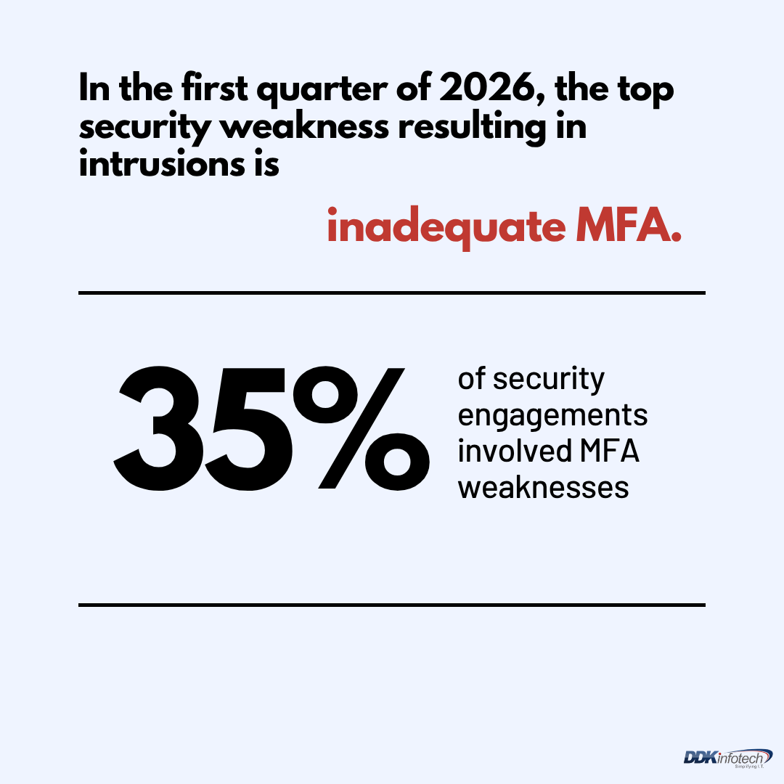

To keep your Multi-Factor Authentication (MFA) secure, prioritize the strongest methods and practice safe habits: upgrade to phishing-resistant FIDO2 hardware keys (like a YubiKey) or Passkeys, use standalone authenticator apps over vulnerable SMS codes, and never approve unrequested push notifications

Choose the Right Factors

- Best: Hardware security keys (like a YubiKey) offer the highest level of protection against phishing.

- Better: Authenticator apps (like Google Authenticator or Microsoft Authenticator) generate offline, time-based codes.

- Least Secure: SMS (text message) MFA. Texts can be intercepted or diverted via SIM-swapping. Use it only if no other options exist.

Manage Your Backups and Recovery
- Secure your recovery codes: When you set up MFA, platforms provide a list of one-time backup codes. Print these out and store them in a secure, physical location like a fireproof box or safe.

- Protect your recovery methods: Make sure the email addresses and phone numbers attached to your accounts for recovery purposes are kept up to date and secured with their own strong passwords.

Update Security Habits

- Check connected devices: Periodically review the "Device" or "Login History" settings on critical accounts (like your Google, Apple, or Microsoft accounts) to ensure no unrecognized devices have trusted access.

- Enable Number Matching: For apps that use push notifications, always turn on "number matching" (if the service offers it) so you are forced to type in a specific number shown on the login screen before you can approve access.

https://www.cisa.gov/news-events/news/4-things-you-can-do-keep-yourself-cyber-safe

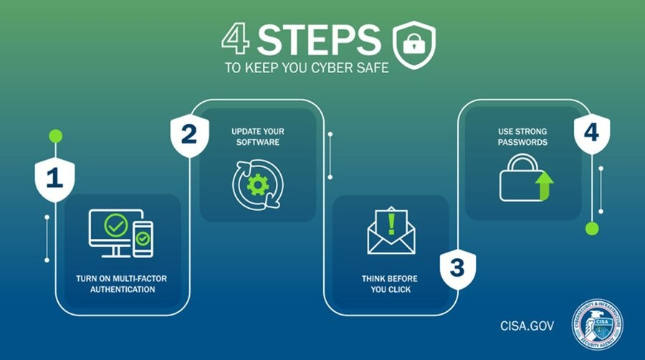

Based on assessment findings, security teams typically recommend:

- Enabling MFA for all critical systems.
- Replacing SMS-based MFA with authenticator applications or hardware security keys.
- Implementing number matching for push notifications.
- Monitoring suspicious login attempts and MFA abuse.
- Adopting phishing-resistant authentication technologies such as FIDO2 and Passkeys.

Importance of MFA Testing

Regular VAPT assessments help organizations identify authentication weaknesses before attackers can exploit them. By continuously evaluating MFA implementations, organizations can strengthen email security, reduce the risk of account compromise, and improve their overall cybersecurity posture.

MFA remains one of the most effective controls for protecting email accounts against cyberattacks. However, attackers continue to develop techniques such as MFA fatigue, SIM swapping, and adversary-in-the-middle phishing. Organizations should adopt phishing-resistant MFA solutions, educate users, and regularly assess authentication controls through VAPT exercises.

