Aim: Basic commands of linux and hadoop

Commands for Linux

1. **sudo**: Used to perform tasks that requires root permissions.

2. **pwd**: It shows the present working directory.



3. **cd:** It is use to come back in the root directory.



4. **ls:** It list down all the directories and folders present.



5. **cat:** Displays the content of the file.

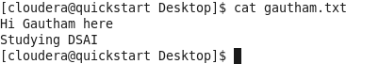

6.**cp:** Copy one file from current directory to another directory.



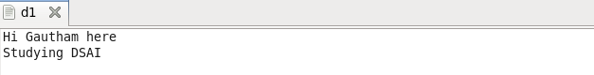

7.**mv**: Used to move and rename files and directories.

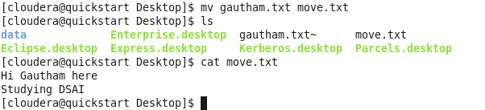

8.**mkdir:** Creates a new directory.

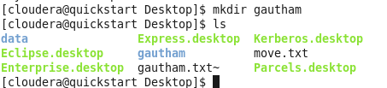

9. **rmdir:** Deletes the directory.



10.**rm:** Removes/ Deletes the file from a directory.



11.**touch:** Creates an empty file.

12.**stat:** Detail view of the file.

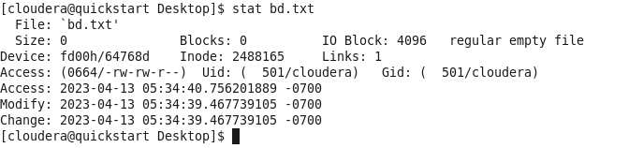

13. **vi:** Creates and open the file.



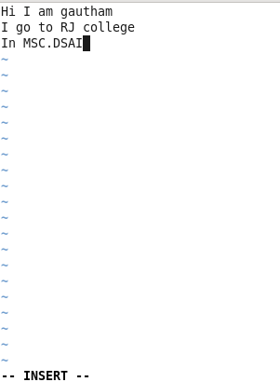

14.**head:** Displays the first 10 lines of a text file.

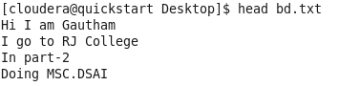

15.**tail:** Displays the last 10 lines of a text file.

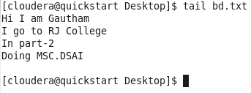

**Commands for Hadoop**

1. hadoop version : Gives the version of the hadoop.

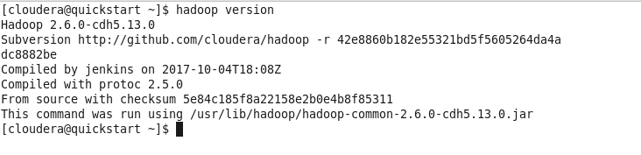

1. ls : List down all the files in hadoop.



1. mkdir: Create a directory

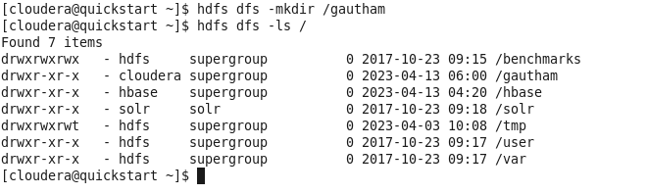

1. touchz : Creates a new file.



1. put : Copy files/folders from local file system to HDFS.



1. cat : Prints the file contents.



1. cp:Use to copy files within HDFS

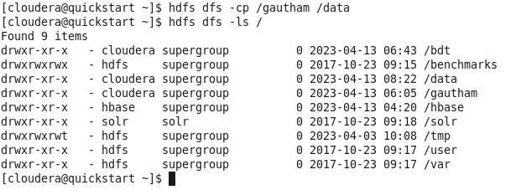

1. rm : Deletes a file from the HDFS.

