

**PES UNIVERSITY**

**(Established under Karnataka Act No. 16 of 2013)**

**100-ft Ring Road, Bengaluru – 560 085, Karnataka, India**

***Report on***

**‘Home Automation’**

***Submitted by***

**Kalakota Kiran Reddy ( PES1UG20EC090)**

**Gautham G Mulay (PES1UG20EC070)**

**Abhishek M S (PES1UG20EC280)**

**Aug - Dec 2021**

**under the guidance of**

***Internal Guide***

**Prof. Prajeesha**

**Assistant Professor**

**Department of ECE**

**PES University**

**Bengaluru -560085**

**FACULTY OF ENGINEERING**

**DEPARTMENT OF ELECTRONICS AND COMMUNICATION ENGG**

**PROGRAM B.TECH**



**CERTIFICATE**

*This is to certify that the Report entitled*

**‘Home Automation’**

*is a bona fide work carried out by*

**Kalakota Kiran Reddy (PES1UG20EC090)**

**Gautham G Mulay (PES1UG20EC070)**

**Abhishek M S (PES1UG20EC280)**

In partial fulfillment for the completion of course work in the Program of Study B.Tech in Electronics and Communication Engineering, under rules and regulations of PES University, Bengaluru during the period Aug- Dec 2021. It is certified that all corrections/suggestions indicated for internal assessment have been incorporated in the report. The report has been approved as it satisfies the academic requirements in respect of IED project work.

*Signature with date & Seal*

*(Dr/ Prof …..)*

*Internal Guide*

Name and signature of the examiners:

1.

**DECLARATION**

We, **Kiran Reddy, Gautham G, Abhishek M S,** hereby declare that the report entitled, ‘Home Automation***’,*** is an original work done by us under the guidance of **Prof. Prajeesha**, *Assistant Professor*, ECE Department and is being submitted in partial fulfillment of the requirements for completion of course work in the Program of Study, B.Tech in Electronics and Communication Engineering.

**PLACE:**

**DATE:**

**NAME AND SIGNATURE OF THE CANDIDATES**

1.Kalakota Kiran Reddy

2.Gautham G Mulay

3.Abhishek MS

Circuit Diagram:

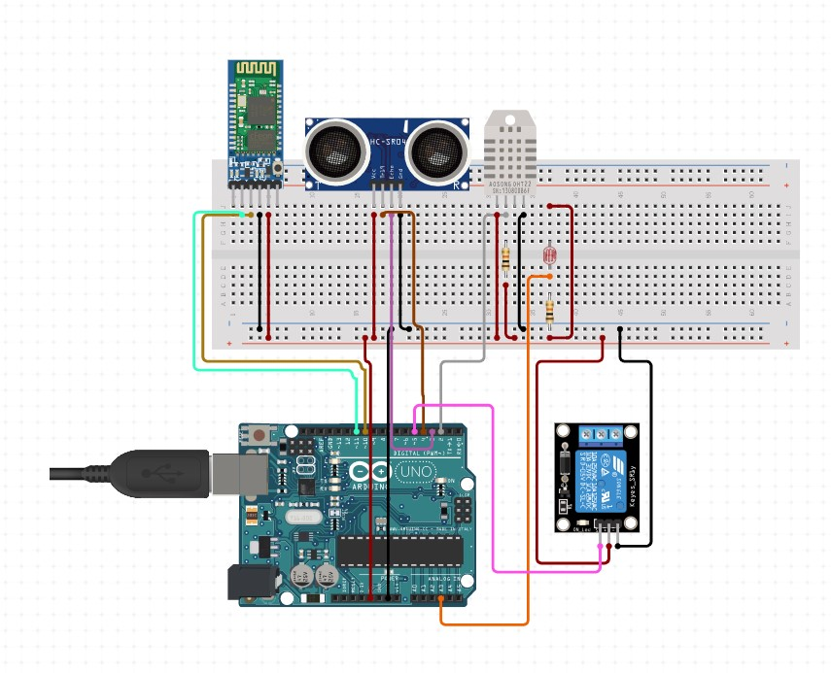

The proposed home automation system represents a connection of hardware devices and software application to control and manage devices in a home.

It allows the control of the house with via sensors and Bluetooth connectivity. The home automation uses the following sensors:

1. Ultrasonic sensor.
2. Temperature and Humidity sensor.
3. LDR sensor.

The data from the sensors are read with the help of the Arduino UNO controller.

One of the essential sensors in a smart home is the temperature and humidity sensor. They are useful both in summer and winter ones because it helps maintain a constant temperature inside the house throughout the day, regardless of the outside temperature.

In this system, the temperature sensor senses the temperature and humidity of the surroundings and if they passes through the threshold value specified, it will automatically switch on a fan which is connected through a relay.

Likewise, the LDR sensor senses the amount of light in the surrounding and switched the bulb depending on the amount of light in the room but this only if there is someone in the room which is detected by the ultrasonic sensor.

This values can we controlled via Bluetooth with the help of the app which was designed with MIT app inventer.

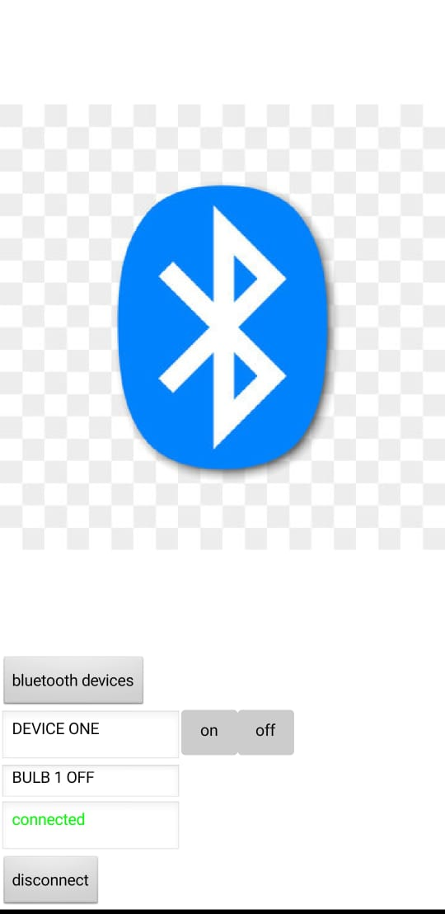

Conclusion:

In this paper, a reliable, compact, fast and low cost smart home system using Arduino and Android app. has been proposed, implemented and tested. The proposed system utilizes Bluetooth module for fast and reliable communications in between the remote user and home devices