Restaurant Cuisine/Location Selector

# INTRODUCTION

Venturing into the restaurant business is always risky. The risk is usually higher than other businesses. A crucial step in this business is to select the right location and to select the right cuisine.

Not every available space is right for a restaurant. A good restaurant location is harder to find than some people think. What may look like the perfect spot- say a busy pedestrian street in the heart of city- may turn out to be a dud. The location is an essential factor to consider while discussing how to start a restaurant business, as it can determine the success of your restaurant. While choosing your restaurant’s location, it is a good idea to identify your competitor in that area and gauge their progress and understand their business model.

It is also very essential to select the right cuisine to ensure success in the business. A thorough examination of the competitors around a selected location should give a fair idea of the cuisine to select. Higher the competition, higher the risk.

# AIM

The aim of this project is to help those venturing into this business to select the right location and cuisine for their restaurant in San Jose, the tech hub in California's Bay Area.

# TARGET AUDIENCE

A important step in a restaurant business is choosing the location and cuisine. Anyone who is willing to step into the restaurant business but unclear about the location and cuisine to choose can use this project to come to a conclusion about the same.

# DATA FOR RESTAURANT CUISINE/LOCATION SELECTOR

The sources data for the project are:

* FourSquareAPI for data on restaurants
* Geopy for translating address to coordinates

First, I used the Geopy to fetch the coordinates of the city (San Jose, CA)

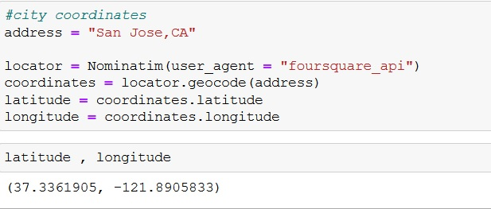

Then using the category code for each cuisine, I fetched the data for restaurants of each cuisine type.

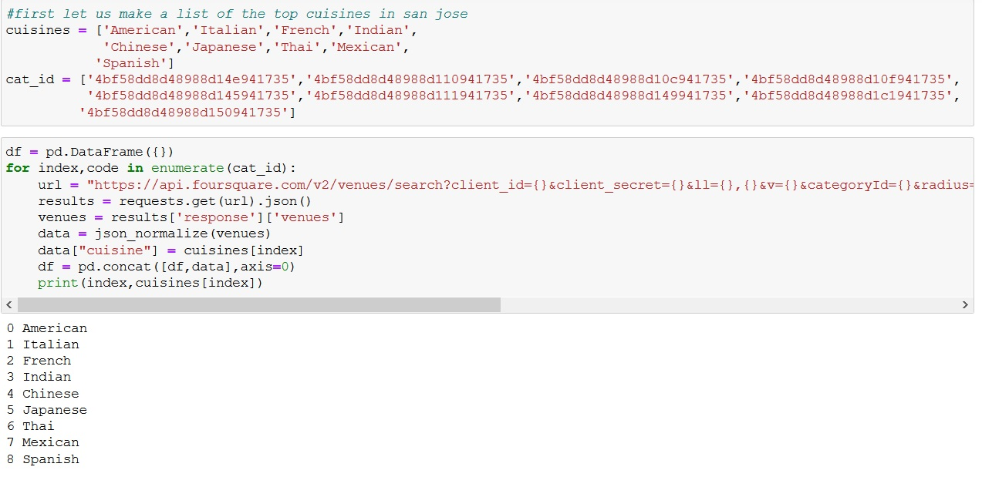

Then I convert the json file to a DataFrame and filter out the required data from the data fetched.

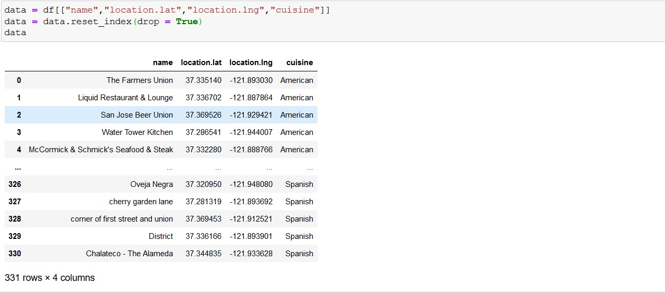

I then plot a map of the restaurants categorised based on the cuisines

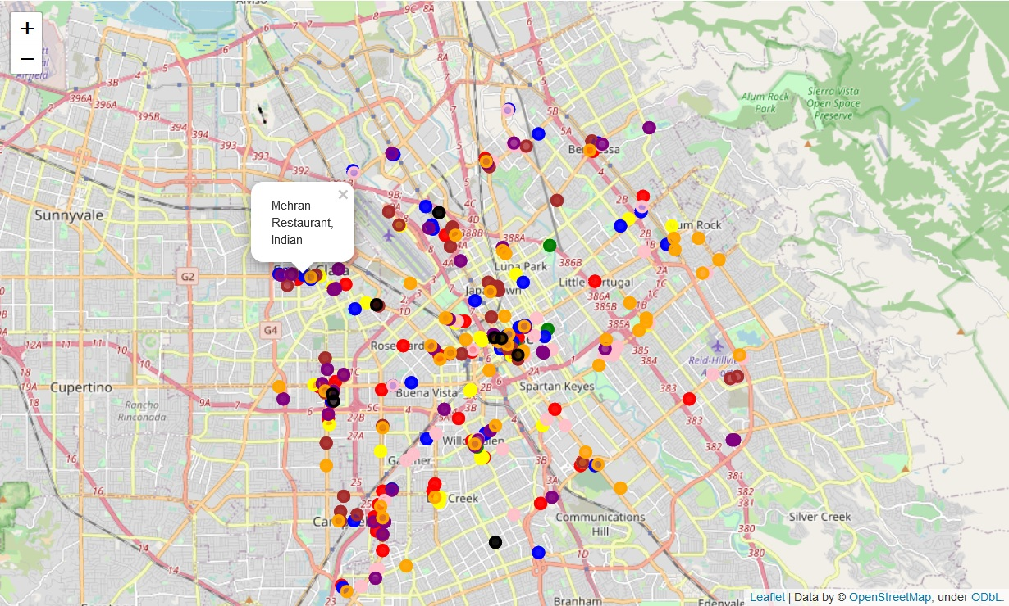

Choose the right number of clusters using the elbow method

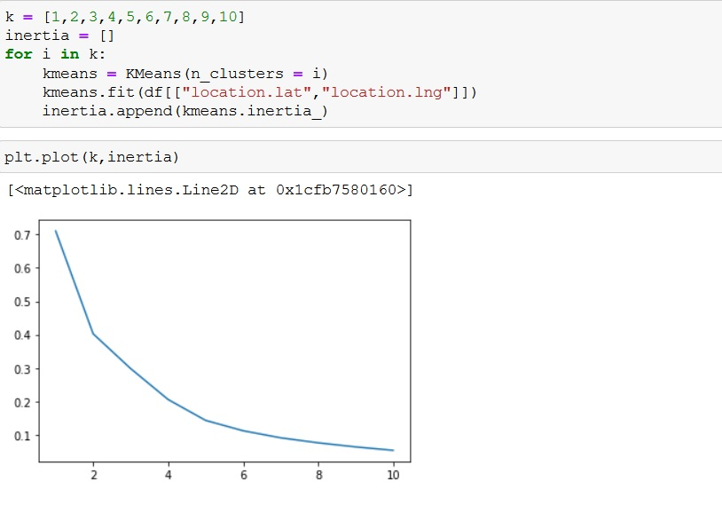

Choosing 5 clusters, plot a map of all the clusters

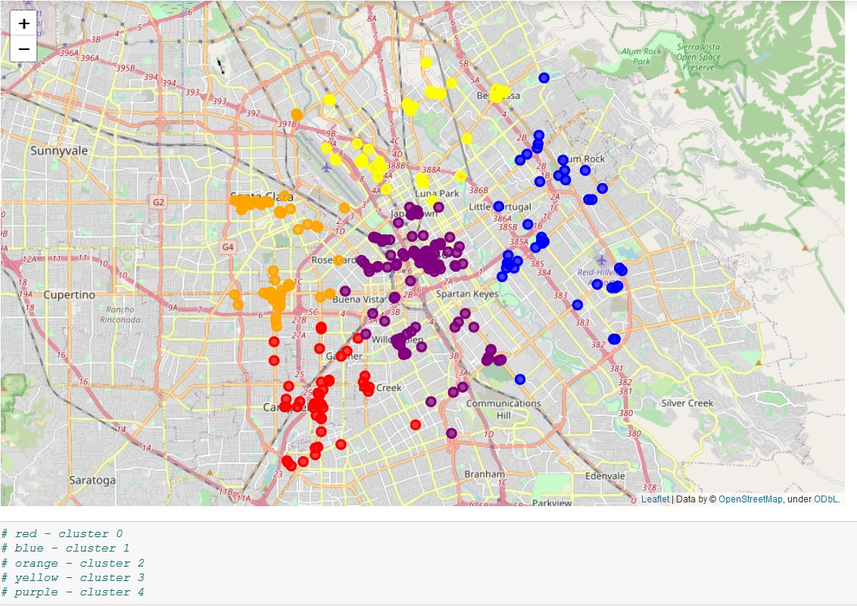

Information about cuisines per cluster

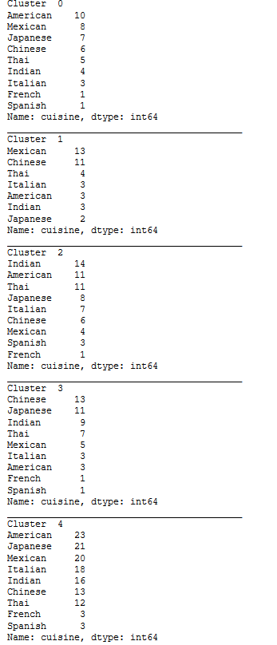

We can select the least common cuisine and the cluster with lowest ratio of cuisine(x) restaurants : total restaurants.