# DATA FOR RESTAURANT CUISINE/LOCATION SELECTOR

The sources data for the project are:

* FourSquareAPI for data on restaurants
* Geopy for translating address to coordinates

First, I used the Geopy to fetch the coordinates of the city (San Jose, CA)

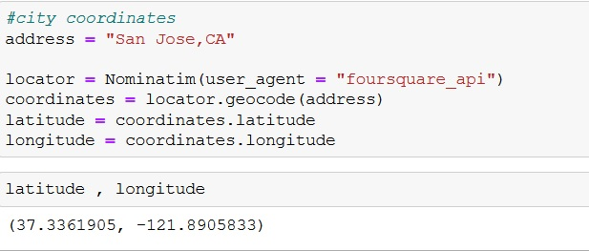

Then using the category code for each cuisine, I fetched the data for restaurants of each cuisine type.

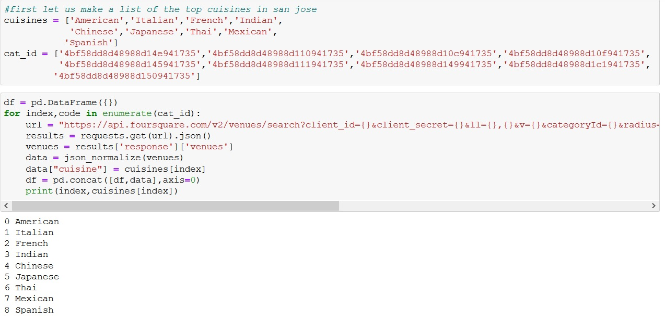

Then I convert the json file to a DataFrame and filter out the required data from the data fetched.

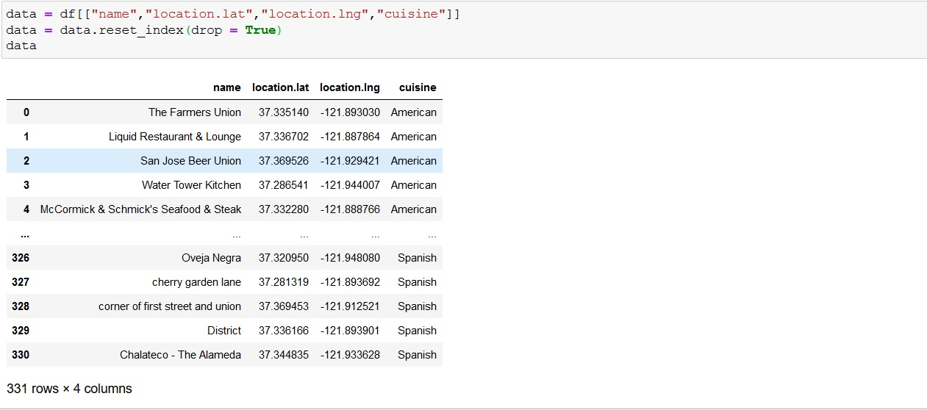

I then plot a map of the restaurants categorised based on the cuisines

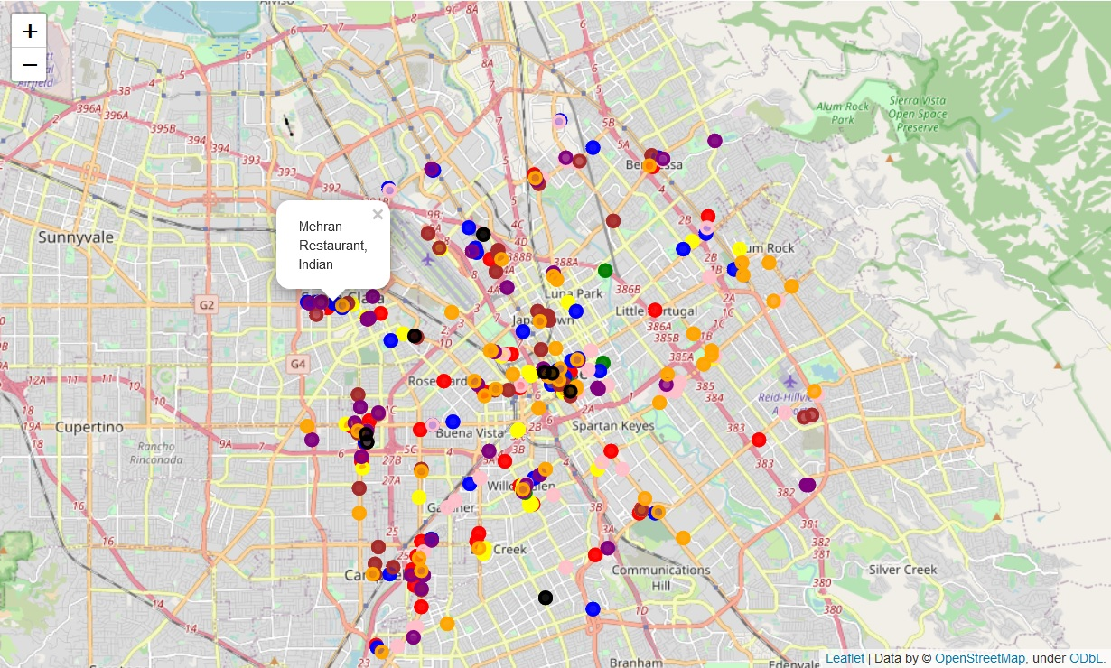

Choose the right number of clusters using the elbow method

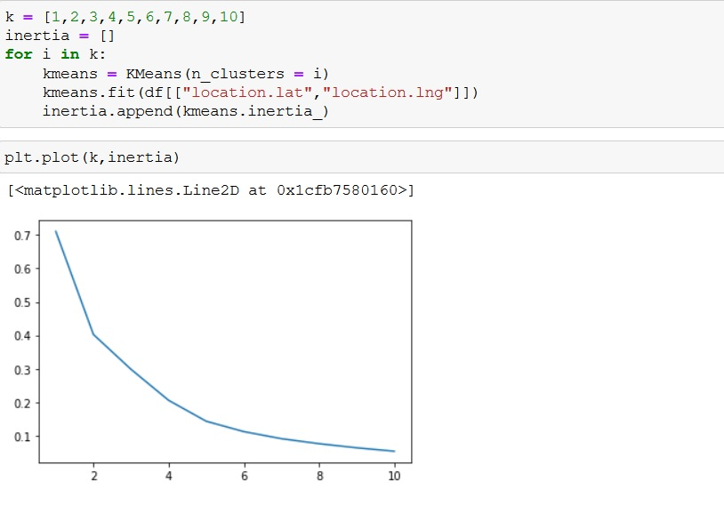

Choosing 5 clusters, plot a map of all the clusters

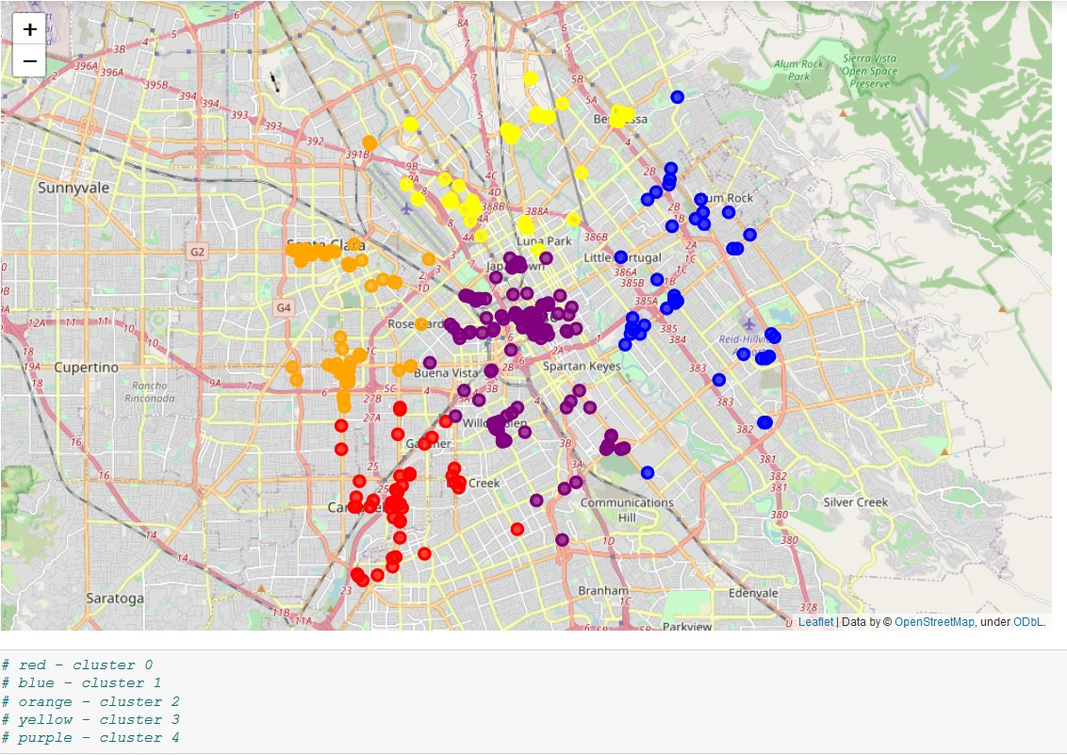

Information about cuisines per cluster

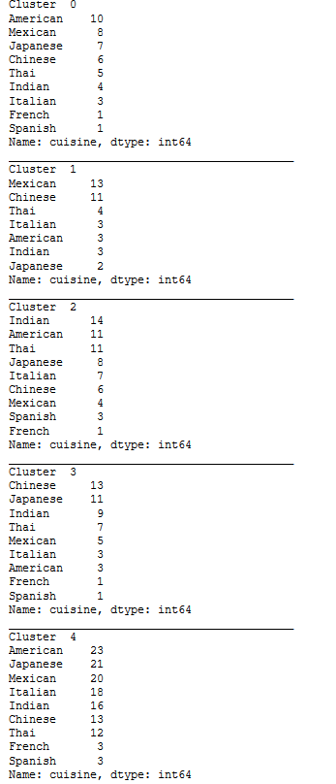

We can select the least common cuisine and the cluster with lowest ratio of cuisine(x) restaurants : total restaurants.