BENCHMARKING TENSOR-NETWORK ANSÄTZE FOR QUANTUM ALGORITHMS AND MANY-BODY GROUND STATES: MPS/TT, PEPS AND MERA
A Practice School Report submitted to
Manipal Academy of Higher Education
in partial fulfilment of the requirement for the award of the degree of

BACHELOR OF TECHNOLOGY
in
Computer Science & Engineering/ Computer Science & Engineering (Artificial Intelligence)

Submitted by
<Student Name>
<Registration Number>
Under the guidance of

Name of the Internal Guide

Designation

Department

Manipal Institute of Technology



DEPARTMENT OF COMPUTER SCIENCE & ENGINEERING

<May/June/July> 2025

DEPARTMENT OF COMPUTER SCIENCE & ENGINEERING

Bengaluru
< Date >

CERTIFICATE

This is to certify that the project titled Benchmarking Tensor-Network Ansätze for Quantum Algorithms and Many-Body Ground States: MPS/TT, PEPS and MERA is a record of the bonafide work done by <STUDENT NAME> (Reg. No. <Register No>) submitted in partial fulfilment of the requirements for the award of the Degree of Bachelor of Technology (B.Tech.) in COMPUTER SCIENCE & ENGINEERING/ COMPUTER SCIENCE AND ENGINEERING (ARTIFICIAL INTELLIGENCE) of Manipal Institute of Technology, Bengaluru, Karnataka, (A Constituent Institute of Manipal Academy of Higher Education), during the academic year 2024-2025.

<Name of Internal Guide>  <Designation>  CSE Dept. M.I.T, BENGALURU | Dr. Coordinator Name  Program Coordinator, SOCE  M.I.T, BENGALURU

Dr. Dean Name
Dean, SOCE
M.I.T, BENGALURU

ACKNOWLEDGMENTS

We express our sincere gratitude to <Director Name>, Director, Manipal Institute of Technology, Bengaluru, and to <HOD Name>, Head of the Department of Computer Science & Engineering, for providing the facilities and the encouraging environment in which this work was carried out.
We are deeply thankful to our internal guide, <Name of Internal Guide>, <Designation>, for the continuous guidance, critical feedback and patience that shaped this project from the first literature study to the final report. We also thank the project coordinators and the faculty members of the department whose suggestions during the review meetings improved the work, and the laboratory staff who supported our computing needs.
Finally, we thank our families and friends for their constant support.
ABSTRACT

Simulating quantum algorithms and quantum many-body systems on classical hardware is limited by the exponential size of the state vector: a 50-qubit state needs about 18 petabytes. Tensor networks overcome this by writing the state as a network of small tensors whose cost is set by a bond dimension, and the best network depends on the entanglement structure of the problem. This project benchmarks three representative families on a CPU: matrix product states (MPS) and tensor trains (TT) for circuit simulation, projected entangled pair states (PEPS) for two-dimensional lattices, and the multiscale entanglement renormalization ansatz (MERA) for critical systems.
Three studies were carried out, each measured against an exact reference. In Study 1 the Deutsch–Jozsa algorithm (10 to 30 qubits) and a controlled modular-exponentiation kernel of Shor’s algorithm (8 to 13 qubits) were simulated on MPS/TT with bond caps of 4 to 32. In Study 2 the ground state of the two-dimensional Heisenberg model on 2×2, 3×3 and 4×4 lattices was computed with PEPS by imaginary-time simple update and by a layered variational quantum eigensolver (VQE) whose gates are applied with truncation and whose truncated energy is optimized directly. In Study 3 a binary MERA was built and optimized for the critical transverse-field Ising chain, validated against a state-vector evaluation and finite differences.
The Deutsch–Jozsa MPS stayed at bond rank 1 with zero error up to 30 qubits, and the Shor kernel reached machine precision (about 10⁻¹⁵) once the bond cap equalled the true rank of 8 to 16. For PEPS, optimizing the VQE through the truncation reduced the error by a factor of 2 to 6, reaching 3.0×10⁻³ on 3×3 at D = 6 and 1.1×10⁻² on 4×4 at D = 4 relative to exact diagonalization. The MERA reached a relative energy error of 1.0×10⁻³ at L = 16 and χ = 4, with the largest-χ run not yet converged.
The work was implemented in Python (NumPy, SciPy, opt_einsum, quimb) and the results are collected in an interactive Streamlit dashboard. The limits are stated plainly: the PEPS study covers the Heisenberg model on lattices up to 4×4, the Shor kernel is a simplified surrogate, the MPS/TT memory measurement is unreliable, and the MERA benchmark grid over system size is not yet complete. Extensions to fermionic models, larger lattices and the full MERA campaign are identified as future work.

Table of
Contents
 |  |  |  |  | Page No
Acknowledgement |  |  |  |  | i
Abstract |  |  |  |  | ii
List Of Tables |  |  |  |  | v
List Of Figures |  |  |  |  | vii
Chapter 1 |  |  | INTRODUCTION |  | 1
 | 1.1 | Introduction |  |  | 1
 | 1.2 | Motivation |  |  | 1
 | 1.3 | Objectives |  |  | 2
 | 1.4 | Target Specifications |  |  | 2
 | 1.5 | Project Work Schedule |  |  | 2
 | 1.6 | Organization of the Report |  |  | 3
Chapter 2 |  |  | BACKGROUND THEORY and/or LITERATURE REVIEW |  | 4
 | 2.1 | Introduction |  |  | 4
 | 2.2 | Tensor Networks and Bond Dimension |  |  | 4
 | 2.3 | Matrix Product States and Tensor Trains |  |  | 4
 | 2.4 | Projected Entangled Pair States |  |  | 5
 | 2.5 | Multiscale Entanglement Renormalization Ansatz |  |  | 5
 | 2.6 | Literature Survey |  |  | 5
 | 2.7 | Summarized Outcome of the Literature Review |  |  | 6
 | 2.8 | Conclusions |  |  | 6
Chapter 3 |  |  | METHODOLOGY |  | 7
 | 3.1 | Introduction |  |  | 7
 | 3.2 | Common Conventions and Metrics |  |  | 7
 | 3.3 | Study 1: MPS and TT Circuit Simulation |  |  | 7
 | 3.4 | Study 2: PEPS on Two-Dimensional Lattices |  |  | 8
 | 3.5 | Study 3: MERA for the Critical Ising Chain |  |  | 9
 | 3.6 | Assumptions Made |  |  | 9
 | 3.7 | Tools Used |  |  | 10
 | 3.8 | Validation of the Implementations |  |  | 10
 | 3.9 | Conclusions |  |  | 10
Chapter 4 |  |  | RESULT ANALYSIS |  | 11
 | 4.1 | Introduction |  |  | 11
 | 4.2 | Study 1: MPS and TT |  |  | 11
 | 4.3 | Study 2: PEPS on the Heisenberg Lattice |  |  | 12
 | 4.4 | Study 3: MERA for the Critical Ising Chain |  |  | 14
 | 4.5 | Results Dashboard |  |  | 15
 | 4.6 | Significance and Deviations from Expectations |  |  | 15
 | 4.7 | Environmental and Societal Impact |  |  | 16
 | 4.8 | Conclusions |  |  | 16
Chapter 5 |  |  | CONCLUSION AND FUTURE SCOPE |  | 17
 | 5.1 | Contribution Summary |  |  | 17
 | 5.2 | Environmental and Societal Impact of the Project Work |  |  | 17
 | 5.3 | Summary of the Work |  |  | 17
 | 5.4 | Conclusions |  |  | 17
 | 5.5 | Future Scope |  |  | 18
REFERENCES |  |  |  |  | 19
ANNEXURES (OPTIONAL) |  |  |  |  | 24
PLAGIARISM REPORT
PROJECT DETAILS |  |  |  |  | 25

LIST OF TABLES

Table No | Table Title | Page No
1.1 | Project work phases | 3
2.1 | Selection matrix and status in this project | 4
2.2 | Summary of the literature used | 5
3.1 | Software and hardware used | 10
4.1 | Deutsch–Jozsa on MPS: wall time (first run excluded) | 11
4.2 | Shor kernel: truncation error |1 − ‖ψ‖²| versus bond cap | 12
4.3 | Heisenberg simple update: relative energy error versus D | 12
4.4 | VQE on PEPS: relative energy error versus ED | 13
4.5 | Exact reference for the critical Ising chain | 14
4.6 | MERA optimization results, critical Ising, L = 16 | 15
4.7 | Time of one energy evaluation of a random, untied MERA | 15
5.1 | Contribution summary | 17

LIST OF FIGURES

Figure No | Figure Title | Page No
3.1 | Overall methodology of the project | 7
3.2 | Pipeline of the PEPS variational study | 9
4.1 | Deutsch–Jozsa wall time versus number of qubits for each bond cap | 11
4.2 | Shor kernel on a tensor train: (a) truncation error and (b) measured maximum bond rank versus the bond cap | 12
4.3 | Relative energy error versus PEPS bond dimension for the simple update, the exact-circuit angles on the truncated PEPS, and the PEPS-aware VQE | 13
4.4 | Convergence of the PEPS-aware optimization on the 3×3 lattice (best relative error so far) | 14
4.5 | MERA energy error per site versus optimizer iteration for L = 16 (snapshots every 40 iterations) | 15

CHAPTER 1
INTRODUCTION

1.1 Introduction
This chapter introduces the area of the project, explains why a systematic comparison of tensor-network methods is useful, states the objectives and target specifications, outlines the work schedule and describes how the rest of the report is organized.
A quantum state of N two-level systems is described by 2^{N} complex amplitudes. Storing a 50-qubit state at 16 bytes per amplitude needs about 1.8×10¹⁶ bytes, roughly 18 petabytes, which is far beyond any computer. Yet many states that matter in practice are only weakly entangled, and for such states most of the amplitudes carry redundant information. Tensor networks exploit this: the state is written as a network of small tensors connected by bonds of dimension χ, and the memory and run time grow polynomially in χ instead of exponentially in N [1].
The structure of the network must match the structure of the entanglement. A one-dimensional chain with area-law entanglement is naturally represented by a matrix product state (MPS), also called a tensor train (TT) [2], [3]. A two-dimensional lattice calls for projected entangled pair states (PEPS) [4], and a critical system, whose entanglement grows logarithmically with the size of a block, is represented well by the multiscale entanglement renormalization ansatz (MERA) [5].
Today tensor-network simulators are widely used both to study many-body physics and as classical baselines against which quantum hardware and quantum algorithms are verified. Mature open-source libraries exist [8], but they are usually applied to one family of states at a time, with metrics and conventions that differ between publications.
1.2 Motivation
The motivation of this project is to obtain a like-for-like, measured picture of what MPS/TT, PEPS and MERA can and cannot do on ordinary hardware. A project proposal had summarized the expected behaviour in a selection matrix that lists, for each problem class, a recommended network, a key metric and a complexity, together with headline numbers for a 50-qubit simulation and for GPU acceleration. Some of those statements were illustrative rather than measured, and some (such as the memory of a 50-qubit state vector, or the suitability of a VQE circuit for a PEPS) needed to be checked against the literature and against experiments.
The shortcomings of existing work that motivate this study are the following. Published benchmarks tend to cover one network family only; accuracy is reported against different references and with different metrics; run time and memory are rarely reported together with a bond-dimension sweep; and validation of the implementation (for example against a brute-force state vector) is not always documented. For a practitioner choosing a method, a single set of validated experiments with exact references is more useful than isolated numbers.
The methodology is unique in three ways: every study is validated against an exact reference (exact diagonalization, a state-vector evaluation, or the free-fermion solution); every study is expressed as error versus bond dimension and run time; and all results are collected in one dashboard so that the three families can be inspected side by side. The significance of the result is a defensible, reproducible statement of which bond dimensions are needed for which problem, and an honest list of the limits of the experiments.
1.3 Objectives
Main objective. To benchmark three tensor-network families (MPS/TT, PEPS and MERA) on representative problems on a CPU, measuring accuracy against an exact reference, wall time and bond rank as functions of the bond dimension.
Secondary objectives. (i) To build validated reference implementations of the PEPS and MERA pipelines and to validate them against brute-force calculations. (ii) To develop a variational quantum eigensolver on a PEPS that remains accurate after truncation. (iii) To collect all results in an interactive dashboard and to document the limitations of every study.
1.4 Target Specifications
- MPS/TT: simulate Deutsch–Jozsa on 10 to 30 qubits and a Shor modular-exponentiation kernel on 8 to 13 qubits, bond caps 4, 8, 16, 32.
- PEPS: ground state of the two-dimensional Heisenberg model on 2×2, 3×3 and 4×4 lattices with bond dimension D = 2 to 6, compared with exact diagonalization.
- MERA: critical transverse-field Ising chain with L = 16 sites and χ = 2, 4, 8, compared with the exact free-fermion energy.
- Every implementation validated to numerical round-off against an independent calculation where one exists.
- All studies runnable on a CPU-only laptop with less than 8 GB of RAM, with scripts and logs retained for reproducibility.
The importance of the end result lies in showing, with measured data, how accuracy depends on bond dimension for each family, and which of the proposal’s expectations were confirmed, adjusted or not tested.
1.5 Project Work Schedule
The work was organized in phases that follow the structure of the project. Table 1.1 lists the phases and the output of each; the dates and durations are to be entered according to the project calendar.
Table 1.1: Project work phases
Phase | Activity | Output
1 | Literature study and selection matrix | Problem classes, networks, metrics
2 | Environment setup, reference calculations | Exact diagonalization and free-fermion references
3 | Study 1: MPS/TT circuit simulation | Bond-cap sweeps (CSV)
4 | Study 2: PEPS simple update and VQE | Error vs D, logs, optimizer
5 | Study 3: MERA energy and optimizer | Validated MERA, L = 16 runs
6 | Integration: dashboard and analysis | Combined Streamlit dashboard
7 | Report writing | This report

1.6 Organization of the Report
Chapter 2 gives the background theory and a survey of the literature. Chapter 3 describes the methodology of the three studies, the tools and the validation procedure. Chapter 4 presents and analyses the results, including deviations from expectations. Chapter 5 summarizes the contributions, the societal and environmental impact, the conclusions and the future scope. References, the course-outcome mappings, annexures and project details follow.

CHAPTER 2
BACKGROUND THEORY / LITERATURE REVIEW

2.1 Introduction
This chapter introduces tensor networks and the three families studied, summarizes the quantum algorithms and models that serve as test cases, and surveys the literature on which the implementations are based. It closes with a summary of the survey and of the conclusions that guide the methodology of Chapter 3.
2.2 Tensor Networks and Bond Dimension
Any state of N qudits can be written by repeatedly applying the singular value decomposition (SVD) across bipartitions. Keeping only the largest χ singular values at each cut gives a controlled approximation, and the discarded weight measures the error. The number χ is the bond dimension. The entanglement entropy across a cut is bounded by log χ, so χ limits how much entanglement a network can represent. States with area-law entanglement, typical for gapped ground states, need a χ that does not grow with system size, which is why networks can be efficient [1].
For any family, three quantities are useful in practice: the error of an observable against an exact reference, the run time, and the memory. Their dependence on χ is the central object of this project. The proposal’s selection matrix (Table 2.1) lists the network, key metric and quoted complexity for each problem class; the complexity figures are taken from the proposal and were not independently verified here.
Table 2.1: Selection matrix and status in this project
Problem class | Network | Key metric | Quoted cost | Status
DJ and QFT (linear) | MPS | Fidelity vs bond dim. | O(χ³) | DJ measured
2D lattice / VQE | PEPS | Ground-state energy | O(χ¹⁰) | Measured (Heisenberg)
Critical systems / QAE | MERA / TTNS | Scale invariance | O(χ¹⁶) | MERA energy measured
Shor / image recognition | TT | Feature correlation | O(χ⁴) | Shor kernel measured

2.3 Matrix Product States and Tensor Trains
An MPS writes the amplitude of a basis state of N sites as a product of N matrices, one per site, with bond dimension χ. Vidal showed that a quantum computation that generates only a small amount of entanglement can be simulated efficiently by tracking the Schmidt decomposition across the bonds and truncating small Schmidt coefficients after each gate [2]. The tensor-train (TT) format of Oseledets expresses a high-dimensional array in the same way and is widely used for function approximation and for structured operators [3]. The two formats are mathematically equivalent, and the term “bond rank” used in this report is the TT rank.
The Deutsch–Jozsa algorithm decides with one oracle query whether a function is constant or balanced [6]. For the standard balanced oracle built from CNOT gates the state remains a product state throughout, so an MPS of bond rank 1 suffices. Shor’s algorithm factors integers through period finding, and its bottleneck is the controlled modular exponentiation [7]; this operation entangles the counting and target registers and is a demanding test for a tensor train.
2.4 Projected Entangled Pair States
PEPS generalize MPS to two dimensions: each lattice site holds a tensor with one physical leg and four virtual legs of bond dimension D [4]. Exact contraction of a PEPS is exponentially hard in the lattice width, so practical algorithms use approximate boundary contraction or, for small systems, exact contraction to a dense state vector. The simple update of Jiang, Weng and Xiang [9] performs imaginary-time evolution by applying two-site gates and truncating each bond using only local information stored as bond weights λ, which makes it cheap, at the price of a mean-field treatment of the environment.
The test model is the spin-1/2 Heisenberg model, H = Σ S_{i}·S_{j} over nearest-neighbour pairs. It is the standard benchmark for two-dimensional tensor-network methods and has an exact solution by diagonalization for the small lattices considered here. The variational quantum eigensolver (VQE) [10] minimizes the energy of a parameterized state; in this project the parameterized state is a layered circuit applied to a PEPS.
2.5 Multiscale Entanglement Renormalization Ansatz
MERA, introduced by Vidal [5], organizes tensors in layers of disentanglers (unitaries that remove short-range entanglement) and isometries (that coarse-grain two sites into one), forming a hierarchy that represents the logarithmic entanglement scaling of critical states. Evenbly and Vidal [13] gave optimization algorithms in which the environment of each tensor is contracted and the tensor is replaced by the polar factor of its SVD. The test model is the transverse-field Ising chain at its critical point, whose ground-state energy follows exactly from the Jordan–Wigner free-fermion solution [12]: E₀ = −Σ_{k} √(2 − 2 cos k), with k = π(2m+1)/L for the even-parity sector with periodic boundaries, and E₀/L → −4/π as L → ∞.
2.6 Literature Survey
Table 2.2 summarizes the references that the implementations rely on.
Table 2.2: Summary of the literature used
Ref. | Contribution | Use in this project
[1] | Review of MPS and PEPS | Conceptual basis, Studies 1 and 2
[2] | Simulation of slightly entangled computations | MPS circuit simulation
[3] | Tensor-train decomposition | TT format for the Shor kernel
[4] | PEPS for 2D quantum systems | PEPS ansatz
[5] | Entanglement renormalization | MERA ansatz
[6], [7] | Deutsch–Jozsa and Shor algorithms | Study 1 circuits
[8] | quimb library | MPS/TT simulation engine
[9] | Simple update for PEPS | Imaginary-time evolution
[10] | Variational eigensolver | Study 2 VQE
[11] | Adam optimizer | PEPS-aware optimization
[12] | Transverse-field Ising chain | Exact reference, Study 3
[13] | Algorithms for entanglement renormalization | MERA optimizer

2.7 Summarized Outcome of the Literature Review
The literature establishes that matching the network to the entanglement structure is the key design decision, that MPS/TT simulation of circuits is controlled by truncated Schmidt coefficients, that PEPS ground states can be obtained by imaginary-time evolution with local truncation, and that MERA energies can be optimized with environment-based updates. It does not provide a single like-for-like measurement of the three on common footing, which is the gap this project addresses.
2.8 Conclusions
The background shows that error versus bond dimension, together with run time, is the right common description of all three families, and that each study needs an exact reference to be meaningful. These two principles determine the methodology described next.

CHAPTER 3
METHODOLOGY
3.1 Introduction
This chapter describes how each study was set up, the assumptions made, the tools and hardware used, and how the implementations were validated. Figure 3.1 summarizes the overall method: the selection matrix assigns a network to each problem class, each study produces error, run time and bond rank against an exact reference, and the results are combined in a dashboard.
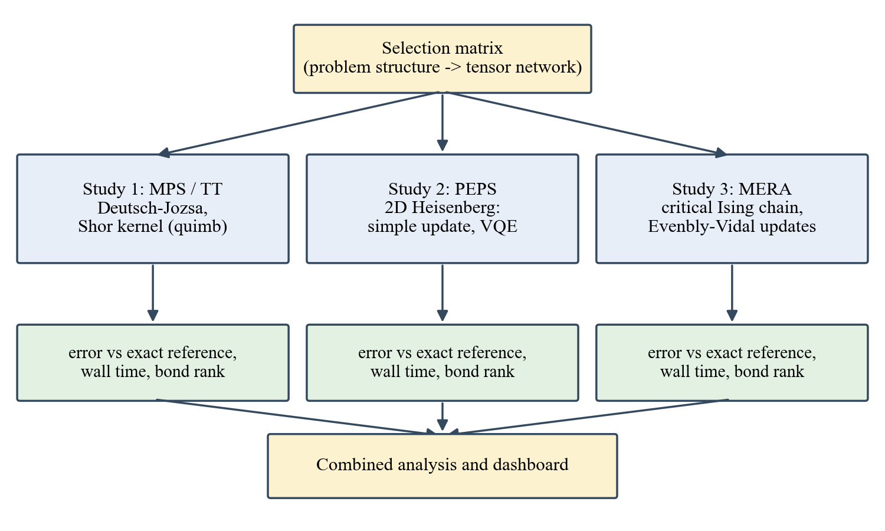
Fig. 3.1: Overall methodology of the project
3.2 Common Conventions and Metrics
The bond dimension is denoted χ for MPS, TT and MERA and D for PEPS. Accuracy is measured against an exact reference, and the metric is defined per study. For the energy studies the relative energy error is
δE = |E − E₀| / |E₀|
where E is the energy of the approximate state and E₀ the exact ground-state energy. Because the metrics differ between studies, error values should not be compared numerically across studies. All runs are CPU-only.
3.3 Study 1: MPS and TT Circuit Simulation
Circuits were simulated with the CircuitMPS class of quimb [8], with the bond dimension capped at χ = 4, 8, 16 and 32 and a singular-value cutoff of 10⁻¹² applied after two-qubit gates. For Deutsch–Jozsa, a balanced oracle (a CNOT from every input qubit to the ancilla) was simulated on n = 9, 15, 19 and 29 input qubits plus one ancilla, i.e., 10, 16, 20 and 30 qubits. The error is the squared amplitude of the all-zeros input outcome, which must vanish for a balanced function.
For the Shor kernel, a tensor train with a counting register of n_{c} qubits and a target register of n_{t} qubits was used for (n_{c}, n_{t}, a, N) = (4, 4, 7, 15), (6, 4, 7, 15) and (8, 5, 2, 21), i.e., 8, 10 and 13 qubits. For each counting qubit k the kernel applies CNOT and controlled-R_{x} gates conditioned on the bits of a^(2^k) mod N. It is a simplified surrogate for modular exponentiation. Its error is the norm lost to truncation, |1 − ‖ψ‖²|. Each trial records the wall time, the measured maximum bond rank and the change in process memory (RSS).
3.4 Study 2: PEPS on Two-Dimensional Lattices
The model is H = Σ S_{i}·S_{j} on open L_{r}×L_{c} lattices (2×2, 3×3, 4×4). Energies are evaluated by contracting the PEPS exactly to a dense state vector, which is feasible up to roughly 4×5 sites, and compared with exact diagonalization by the Lanczos method. Because the contracted state is a genuine state, its energy upper-bounds the true ground-state energy.
Simple update. Starting from a Néel product state, exp(−τH) is applied bond by bond in the Γ–λ form with truncation to D [9], using τ = 0.1, 0.03 and 0.01 with 100 sweeps each.
Layered VQE. The ansatz (Fig. 3.2) starts from a covering of singlet dimers (a pinwheel with a free central spin on 3×3) and applies P layers. In each layer every bond b receives exp[−i(a_{b} XY_{b} + c_{b} ZZ_{b})] with its own two angles, giving 42, 96 and 144 parameters for 2×3 (P = 3), 3×3 (P = 4) and 4×4 (P = 3). Without truncation the circuit is optimized on a state vector with an exact reverse-mode (adjoint) gradient, which was checked against finite differences to 10⁻⁹, and the L-BFGS-B optimizer.
Truncation and PEPS-aware optimization. The optimized angles are applied gate by gate to a PEPS with truncation to D. Because the truncation has no cheap exact gradient, the truncated-PEPS energy itself is then minimized with Adam [11] using central finite-difference gradients evaluated in parallel on 10 processes, a cosine-decayed step from 0.03 to 0.003, and a warm start from the exact-circuit angles. 200 steps were used for 3×3 and 60 for 4×4.
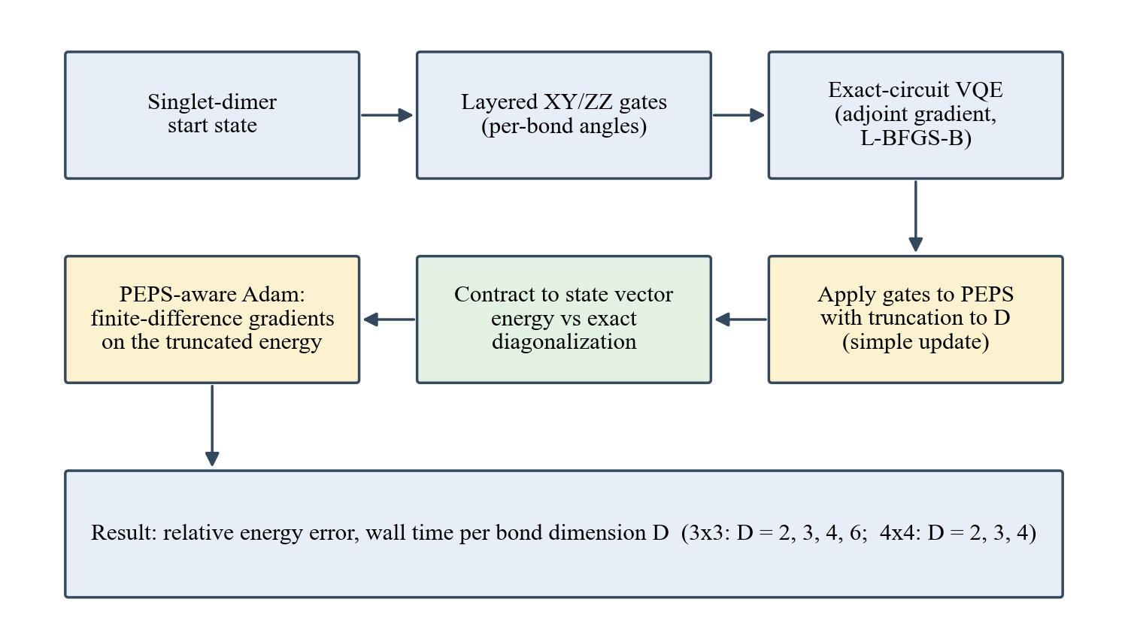
Fig. 3.2: Pipeline of the PEPS variational study
3.5 Study 3: MERA for the Critical Ising Chain
The model is H = −Σ Z_{i}Z_{i+1} − Σ X_{i} with periodic boundaries and L = 2^{n} sites. The exact energy was computed from the free-fermion formula and checked against sparse exact diagonalization for L ≤ 12. The finite binary MERA places isometries on sites (2j, 2j+1) and disentanglers on (2j+1, 2j+2), caps the site dimension at χ, and coarse-grains from L sites to two. The energy is obtained by ascending every Hamiltonian term through the layers (contractions found once with opt_einsum and cached) and diagonalizing the two-site top Hamiltonian.
Tensors are optimized with Evenbly–Vidal updates [13]: the environment of each tensor is obtained by back-propagating through the same coarse-graining network, and the tensor is replaced by −AB^{T}, where Γ = ASB^{T} is the SVD of its environment. A step is accepted only if it lowers the energy. One layer is updated per iteration, cycling through the layers. Runs used L = 16 and χ = 2, 4 and 8 for 200, 200 and 120 iterations.
3.6 Assumptions Made
- Real tensors and real Hamiltonians are used for the MERA study; the PEPS VQE uses complex gates on complex tensors.
- Open boundaries are used for PEPS and periodic boundaries for MERA, so that exact references are available.
- The Shor modular-exponentiation kernel is a surrogate that preserves the entangling structure but is not a verified implementation of the arithmetic.
- Run times from different studies were measured on different machines and are compared only within a study.
3.7 Tools Used
Table 3.1: Software and hardware used
Item | Role
Python 3.13, NumPy 2.2, SciPy 1.15 | Numerics, sparse exact diagonalization, optimizers
opt_einsum | Contraction-path optimization for MERA
quimb | MPS/TT circuit simulation
psutil | Process-memory measurement (MPS/TT)
Matplotlib 3.10 | Figures
Streamlit 1.66, Altair, pandas | Interactive results dashboard
PEPS hardware | Intel Core i5-1235U (10 cores, 12 threads), 7.7 GB RAM, Windows 11, CPU only
MPS/TT and MERA hardware | CPU only; machine not recorded

3.8 Validation of the Implementations
Validation was treated as part of the methodology. The PEPS energy was compared with an exact state-vector simulation of the same circuit and agreed to about 10⁻⁷ when the bond dimension was not limiting. The adjoint gradient of the VQE was compared with finite differences and agreed to 10⁻⁹. For MERA the free-fermion energy was checked against exact diagonalization, the coarse-grained energy against a brute-force state-vector evaluation of random MERAs (agreement to 1.2×10⁻¹⁴), and the environments against finite differences (agreement to 2.0×10⁻⁹).
3.9 Conclusions
The methodology applies the same principles to all three families: an exact reference, a bond-dimension sweep, and measured run time. The validation steps give confidence that differences seen in Chapter 4 reflect the methods and not implementation errors.

CHAPTER 4
RESULT ANALYSIS
4.1 Introduction
This chapter presents the results of the three studies in tabular and graphical form, explains them, discusses their significance and the deviations from expectation, and evaluates the environmental and societal impact of the work.
4.2 Study 1: MPS and TT
Deutsch–Jozsa. For all 16 combinations of size and bond cap the measured bond rank was 1 and the error was exactly 0, so the cap has no effect on accuracy. Excluding the first run, which includes start-up cost (8.35 s), the wall time grows roughly linearly with the number of qubits and is independent of χ (Table 4.1, Fig. 4.1).
Table 4.1: Deutsch–Jozsa on MPS: wall time (first run excluded)
Qubits | Wall time (s) | Bond rank | Error
10 | 0.013 – 0.016 | 1 | 0
16 | 0.031 – 0.034 | 1 | 0
20 | 0.047 – 0.051 | 1 | 0
30 | 0.099 – 0.103 | 1 | 0

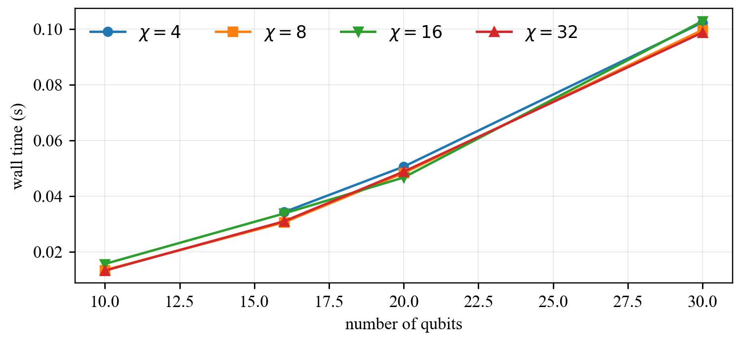
Fig. 4.1: Deutsch–Jozsa wall time versus number of qubits for each bond cap
Shor kernel. The kernel entangles the registers, so accuracy depends strongly on the cap (Table 4.2, Fig. 4.2). The truncation error falls from order 10⁻¹ at χ = 4 to about 10⁻¹⁵ once the cap reaches the true rank, after which the measured rank saturates at 12, 16 and 8 for 8, 10 and 13 qubits. The wall time after the first run was 0.016 to 0.038 s.
Table 4.2: Shor kernel: truncation error |1 − ‖ψ‖²| versus bond cap
Qubits | χ = 4 | χ = 8 | χ = 16 | χ = 32
8 | 4.2e−1 | 5.1e−2 | 2.7e−15 | 2.7e−15
10 | 5.8e−1 | 6.7e−2 | 2.0e−15 | 2.0e−15
13 | 1.4e−1 | 6.7e−15 | 6.7e−15 | 6.7e−15

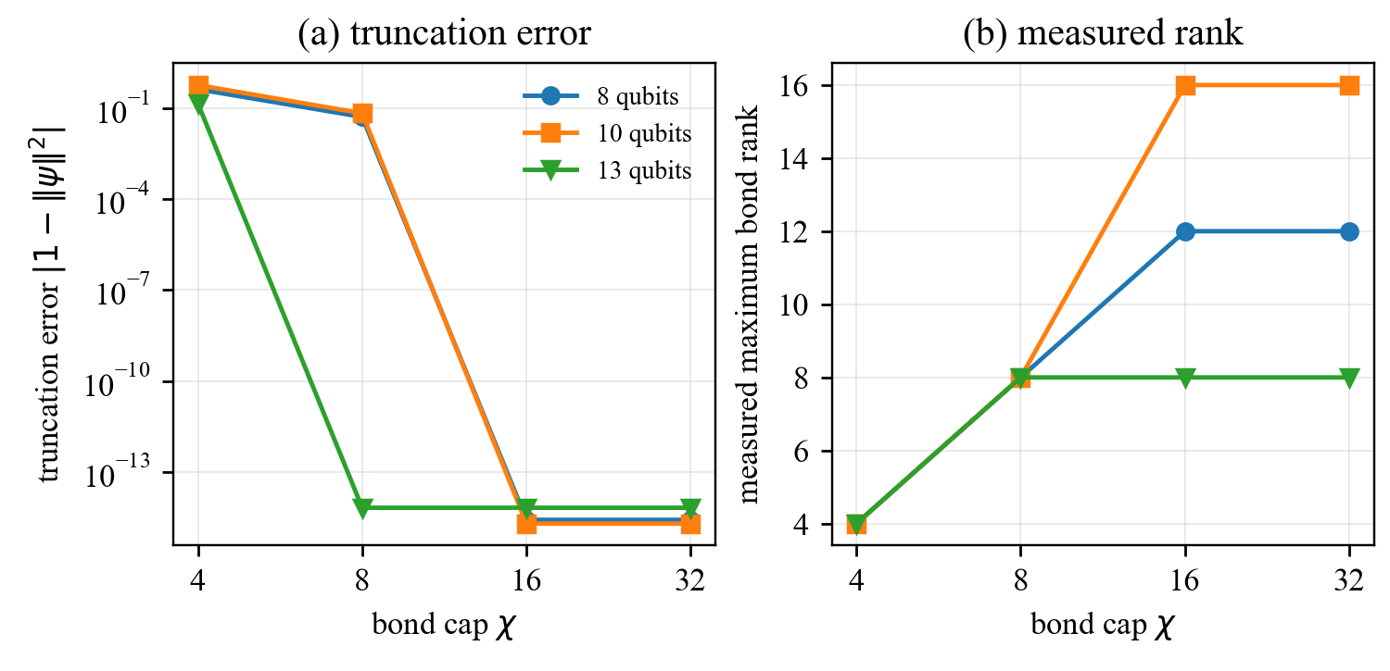
Fig. 4.2: Shor kernel on a tensor train: (a) truncation error and (b) measured maximum bond rank versus the bond cap
The result confirms that the benefit of larger χ stops once the cap exceeds the true rank of the state; beyond that point extra bond dimension only costs time.
4.3 Study 2: PEPS on the Heisenberg Lattice
Simple update. Table 4.3 lists the relative energy error against exact diagonalization. The error generally falls as D grows: on 3×3 from 4.3×10⁻² at D = 2 to 9.6×10⁻⁴ at D = 6. On 2×2 the error at D = 6 (2.2×10⁻³) is larger than at D = 4 (1.5×10⁻⁴); this was not investigated. Runs above D = 4 on 4×4 were not completed.
Table 4.3: Heisenberg simple update: relative energy error versus D
Lattice | D = 2 | D = 3 | D = 4 | D = 6
2×2 | 8.1e−2 | 1.3e−2 | 1.5e−4 | 2.2e−3
3×3 | 4.3e−2 | 2.0e−2 | 4.1e−3 | 9.6e−4
4×4 | 5.3e−2 | 3.5e−2 | 2.0e−2 | —

Variational circuit. With the singlet-dimer start the untruncated circuit reaches a relative error of 10⁻⁹ on 2×3, 6×10⁻⁴ on 3×3 (best of four seeds) and 6.8×10⁻³ on 4×4 (best of two). A Néel start stalled for every seed and depth tried (13% error on 2×3, and an energy of −1.5 instead of −2.0 on 2×2), so the dimer covering was essential.
Truncation and PEPS-aware optimization. Evaluating the exact-circuit angles on a truncated PEPS loses accuracy at small D (Table 4.4). Re-optimizing through the truncation reduces the error by a factor of 2 to 6 in every case. The best results are 3.0×10⁻³ on 3×3 at D = 6 and 1.1×10⁻² on 4×4 at D = 4 (Fig. 4.3). Optimization wall time on the laptop was 346 to 491 s per D on 3×3 (200 steps) and 473 s, 1612 s and 2218 s for D = 2, 3, 4 on 4×4 (60 steps).
Table 4.4: VQE on PEPS: relative energy error versus ED
Lattice | D | Exact angles, truncated | PEPS-aware
3×3 | 2 | 1.9e−1 | 7.4e−2
3×3 | 3 | 1.4e−1 | 5.0e−2
3×3 | 4 | 2.2e−2 | 3.6e−3
3×3 | 6 | 1.3e−2 | 3.0e−3
4×4 | 2 | 3.1e−1 | 1.6e−1
4×4 | 3 | 2.6e−1 | 8.6e−2
4×4 | 4 | 6.3e−2 | 1.1e−2

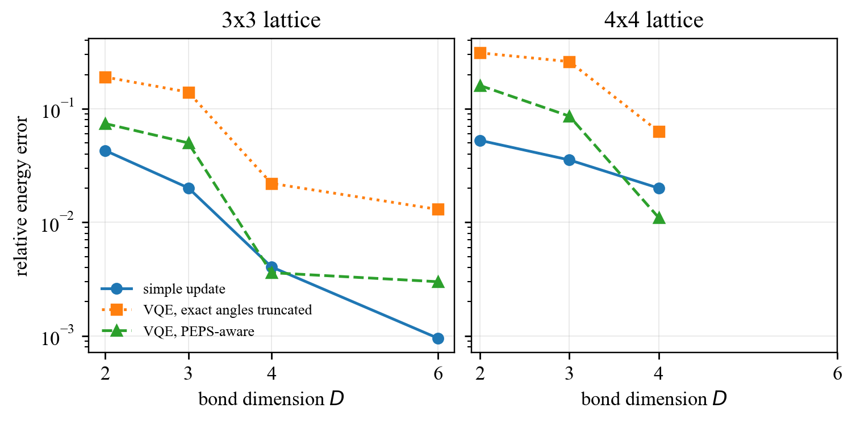
Fig. 4.3: Relative energy error versus PEPS bond dimension for the simple update, the exact-circuit angles on the truncated PEPS, and the PEPS-aware VQE
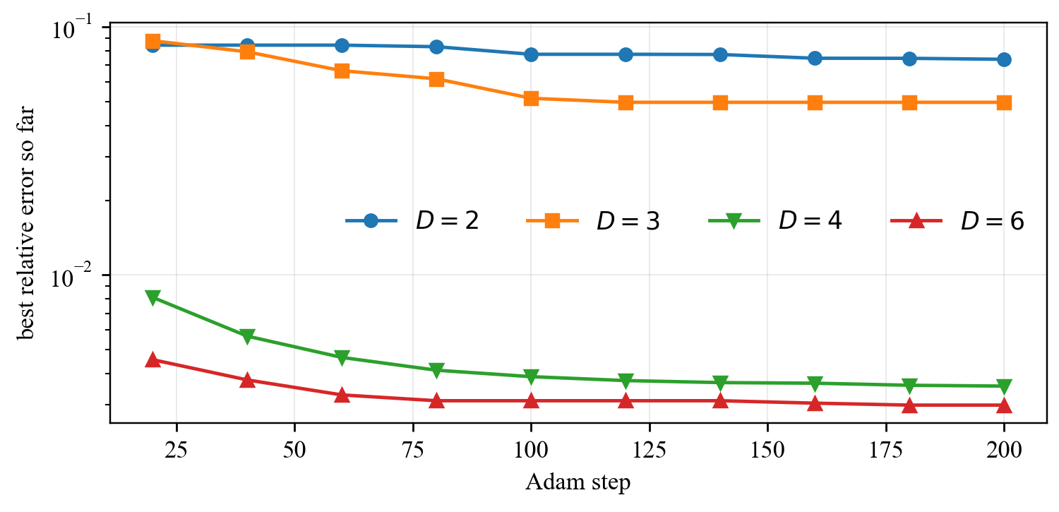
Fig. 4.4: Convergence of the PEPS-aware optimization on the 3×3 lattice (best relative error so far)
The 3×3 runs at D = 2 and 3 were still improving at 200 steps and are probably not converged, and all PEPS-aware runs used a single seed. The 3×3 results at D ≥ 4 are within a few per mille of the exact energy, whereas on 4×4 the accuracy at the same D is lower, which is consistent with the larger entanglement of the bigger lattice.
4.4 Study 3: MERA for the Critical Ising Chain
The free-fermion energy matched exact diagonalization to about 10⁻¹⁴ for L = 4 to 12, and E₀/L approaches −4/π = −1.27324 (Table 4.5). The coarse-grained MERA energy agreed with the state-vector energy to 1.2×10⁻¹⁴ over 24 random MERAs (L = 4, 8, 16 and χ = 2, 3, 4, 6), the environments agreed with finite differences to 2.0×10⁻⁹, and random MERAs lay above the exact ground state, as required for a variational ansatz.
Table 4.5: Exact reference for the critical Ising chain
L | E₀/L (exact) | −4/π
16 | −1.27528715 | −1.27323954
64 | −1.27336739 | −1.27323954
256 | −1.27324753 | −1.27323954
1024 | −1.27324004 | −1.27323954

The optimizer lowered the energy monotonically (Fig. 4.5, Table 4.6). The exact value at L = 16 is E₀/L = −1.27528715. At χ = 2 the error plateaus near 9.6×10⁻³ per site, which indicates a bond-limited ansatz. At χ = 4 the error was 1.3×10⁻³ per site and still decreasing after 200 iterations. The χ = 8 run was stopped at 120 iterations (104 s), so its value of 1.6×10⁻³ is not converged and must not be read as worse than χ = 4.
Table 4.6: MERA optimization results, critical Ising, L = 16
χ | Iterations | Error per site | Relative error | Time (s)
2 | 200 | 9.6e−3 | 7.6e−3 | 33
4 | 200 | 1.3e−3 | 1.0e−3 | 40
8 | 120 | 1.6e−3 | 1.2e−3 | 104

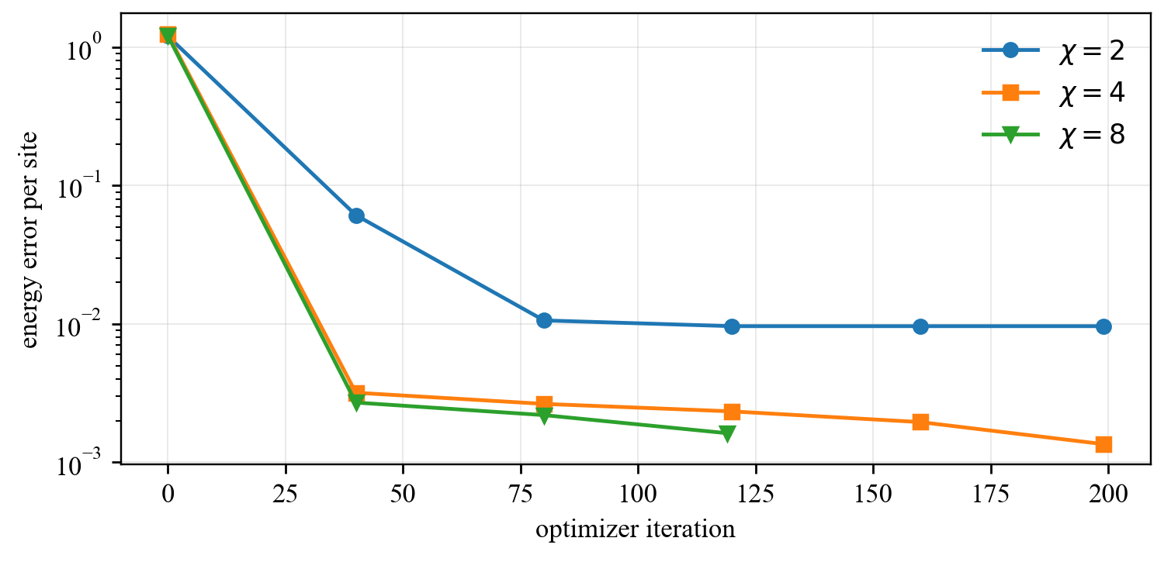
Fig. 4.5: MERA energy error per site versus optimizer iteration for L = 16 (snapshots every 40 iterations)
Table 4.7: Time of one energy evaluation of a random, untied MERA
L | χ | Time (s)
32 | 4 | 0.09
64 | 4 | 0.20
32 | 8 | 0.58
64 | 8 | 1.54

The cost grows steeply with χ and with L until tensors are tied across sites. A benchmark harness with translation-tied tensors, tolerance-based stopping and a scaling-dimension diagnostic is implemented, but its results over a grid of system sizes are not yet available, so only L = 16 is reported.
4.5 Results Dashboard
All results were collected in an interactive Streamlit dashboard with sections for the three studies and a combined overview that plots error and run time against bond dimension for every method and states the status of each part of the plan. The dashboard reads the saved logs and notebook outputs, so the figures in it match the data in this report.
4.6 Significance and Deviations from Expectations
The results show the matching principle concretely: a product-like state (Deutsch–Jozsa) needs rank 1; an entangling kernel (Shor) needs a cap equal to its true rank; a two-dimensional lattice needs a substantial D and is considerably less accurate at a given D than a one-dimensional problem; and a critical chain needs only a modest χ in a MERA to reach per-mille accuracy.
Several deviations from the expectations in the proposal should be noted. The simple-update error on 2×2 does not decrease monotonically with D. A Néel start for the VQE does not converge, whereas a singlet-dimer start does. The standard L-BFGS optimizer stopped after a few iterations on the truncated-PEPS energy, probably because that landscape is not smooth (the retained subspace can jump when singular values are nearly degenerate, as they are for a dimer start; this explanation was not verified), and Adam was used instead. The MPS/TT memory column reads 0.0 for most runs because it measures a difference in process memory, so memory is not compared. The proposal’s illustrative run-time and memory figures were replaced by measured values, and GPU acceleration was not available on the hardware used.
4.7 Environmental and Societal Impact
All computations were CPU-only on a laptop, with run times from seconds to about 40 minutes per configuration, so the energy used is small. By making large simulations feasible without specialized hardware, tensor-network methods reduce the need for energy-intensive high-performance computing and give an inexpensive way to verify quantum algorithms and devices, which supports trustworthy quantum technology. The main societal risk is over-interpretation of limited benchmarks; this is mitigated by stating the limitations of each study explicitly. No personal data, hazardous materials or other environmental burdens are involved.
4.8 Conclusions
The measured results confirm the expected qualitative behaviour of all three families, provide quantitative data on the bond dimension needed, and identify the limits of the experiments. They also show that optimizing a PEPS-based VQE through its truncation is worth a factor of 2 to 6 in error.

CHAPTER 5
CONCLUSION AND FUTURE SCOPE

5.1 Contribution Summary
The project was carried out as a group project. Table 5.1 lists the work packages; the responsible student is to be entered for each.
Table 5.1: Contribution summary
Work package | Responsible student
Study 1: MPS/TT circuit simulation (Deutsch–Jozsa, Shor kernel) | <Student name, Reg. No.>
Study 2: PEPS on 2D lattices (simple update, VQE, PEPS-aware optimization) | <Student name, Reg. No.>
Study 3: MERA for the critical Ising chain | <Student name, Reg. No.>
Combined dashboard and report integration | <Student name, Reg. No.>

5.2 Environmental and Societal Impact of the Project Work
The project is a computational study with a small energy footprint. Its societal value is indirect: reliable classical baselines are needed to verify quantum hardware and algorithms, and a clear statement of what tensor networks can and cannot simulate informs research and investment decisions. The work has no adverse environmental impact; the main responsibility is honest reporting, which the explicit limitations in Chapters 3 and 4 are meant to serve.
5.3 Summary of the Work
The problem addressed was the lack of a common, validated, measured comparison of tensor-network families on ordinary hardware. Three studies were carried out with exact references: MPS/TT simulation of Deutsch–Jozsa and a Shor kernel, PEPS ground states of the 2D Heisenberg model by simple update and by a PEPS-aware VQE, and a binary MERA for the critical Ising chain. The work was implemented in Python with validation against brute-force calculations and collected in a dashboard.
5.4 Conclusions
The Deutsch–Jozsa MPS stays at rank 1 with zero error up to 30 qubits; the Shor kernel reaches machine precision once the bond cap reaches its true rank of 8 to 16; the PEPS VQE reaches 3.0×10⁻³ (3×3, D = 6) and 1.1×10⁻² (4×4, D = 4) after optimizing through the truncation; and the MERA reaches 1.0×10⁻³ at L = 16 and χ = 4. These results are significant because they replace illustrative numbers with measured ones and show how the required bond dimension depends on the structure of the problem. Their scope is limited to the models, sizes and hardware stated in Chapter 3.
5.5 Future Scope
Fermionic models and larger lattices. The PEPS study should be extended from the Heisenberg model to the Hubbard model, which requires fermionic swap gates or a Jordan–Wigner ordering with correct signs, validated against exact diagonalization on small lattices. Approximate boundary-MPS contraction would remove the limit of about 4×5 sites imposed by exact contraction, and exact or automatic differentiation through the truncation would replace finite-difference gradients and allow more seeds and longer runs.
Completing the MERA campaign. The translation-tied MERA harness should be run over the planned grid of system sizes (for example L = 8, 16, 32) and bond dimensions (2, 4, 8), with convergence to a tolerance and with the scaling-dimension diagnostic, whose identity check and the comparison with the Ising dimensions 1/8 and 1 are implemented but not yet evaluated.
Higher-fidelity circuit studies and common infrastructure. The Shor kernel should be replaced by a verified modular-exponentiation operator and extended to the quantum Fourier transform, with a correct memory measurement and a recorded hardware description. All studies should write results in a shared schema (method, model, size, bond dimension, error, time, memory, device) so that the dashboard can compare them directly, and GPU acceleration could be evaluated on suitable hardware.

REFERENCES

Journal / Conference Papers
[1] R. Orús, “A practical introduction to tensor networks: Matrix product states and projected entangled pair states,” Ann. Phys., vol. 349, pp. 117–158, 2014.
[2] G. Vidal, “Efficient classical simulation of slightly entangled quantum computations,” Phys. Rev. Lett., vol. 91, no. 14, Art. no. 147902, 2003.
[3] I. V. Oseledets, “Tensor-train decomposition,” SIAM J. Sci. Comput., vol. 33, no. 5, pp. 2295–2317, 2011.
[4] F. Verstraete and J. I. Cirac, “Renormalization algorithms for quantum many-body systems in two and higher dimensions,” arXiv:cond-mat/0407066, 2004.
[5] G. Vidal, “Entanglement renormalization,” Phys. Rev. Lett., vol. 99, no. 22, Art. no. 220405, 2007.
[6] D. Deutsch and R. Jozsa, “Rapid solution of problems by quantum computation,” Proc. R. Soc. Lond. A, vol. 439, pp. 553–558, 1992.
[7] P. W. Shor, “Polynomial-time algorithms for prime factorization and discrete logarithms on a quantum computer,” SIAM J. Comput., vol. 26, no. 5, pp. 1484–1509, 1997.
[8] J. Gray, “quimb: A python package for quantum information and many-body calculations,” J. Open Source Softw., vol. 3, no. 29, Art. no. 819, 2018.
[9] H. C. Jiang, Z. Y. Weng, and T. Xiang, “Accurate determination of tensor network state of quantum lattice models in two dimensions,” Phys. Rev. Lett., vol. 101, no. 9, Art. no. 090603, 2008.
[10] A. Peruzzo et al., “A variational eigenvalue solver on a photonic quantum processor,” Nat. Commun., vol. 5, Art. no. 4213, 2014.
[11] D. P. Kingma and J. Ba, “Adam: A method for stochastic optimization,” in Proc. Int. Conf. Learn. Represent. (ICLR), 2015.
[12] P. Pfeuty, “The one-dimensional Ising model with a transverse field,” Ann. Phys., vol. 57, no. 1, pp. 79–90, 1970.
[13] G. Evenbly and G. Vidal, “Algorithms for entanglement renormalization,” Phys. Rev. B, vol. 79, no. 14, Art. no. 144108, 2009.

Reference / Hand Books
[14] M. A. Nielsen and I. L. Chuang, Quantum Computation and Quantum Information, 10th Anniversary ed. Cambridge, U.K.: Cambridge Univ. Press, 2010, ISBN 978-1-107-00217-3.

Web
[15] quimb documentation, quimb.readthedocs.io
[16] Streamlit documentation, docs.streamlit.io
CO and PO Mapping

*[The COs for project work and the UG POs and PSOs are listed below. With respect to your project, map the COs to the POs and PSO’s with the correlation levels as below in consultation with your college guide:
3 (if the CO has HIGH EMPHASIS to the POs and PSOs)
2 (if the CO has MODERATE EMPHASIS to the POs and PSOs)
1 (if the CO has LOW EMPHASIS to the POs and PSOs)
Put ‘–‘ (hyphen) if the CO is not related to the POs and PSOs]

NBA:

Table A1.1 Course Articulation Matrix
CO |  | PO1 | PO2 | PO3 | PO4 | PO5 | PO6 | PO7 | PO8 | PO9 | PO10 | PO11 | PO12 | PSO1 | PSO2 | PSO3 | PSO4
CSE  4191.1 | Apply mathematics, science and engineering skills to identify, formulate, synthesize and solve the problems from various areas of computer science engineering.
CSE  4191.2 | Have knowledge of new trends in engineering/technology by developing programmable coding in various computer programming languages.
CSE  4191.3 | Use the industry standard tools to analyze, design, develop and test software engineering based applications.
CSE  4191.4 | Apply theoretical knowledge to real-world engineering problems and manage complex engineering projects.
CSE  4191.5 | Acquire skills of collaboration and independent learning.
CSE 4191 (Avg. correlation level)

PROGRAM OUTCOMES (PO)

Engineering Graduates will be able to:
1. Engineering knowledge: Apply the knowledge of mathematics, science, engineering fundamentals, and an engineering specialization to the solution of complex engineering problems.

2. Problem analysis: Identify, formulate, review research literature, and analyze complex engineering problems reaching substantiated conclusions using first principles of mathematics, natural sciences, and engineering sciences.

3. Design/development of solutions: Design solutions for complex engineering problems and design system components or processes that meet the specified needs with appropriate consideration for the public health and safety, and the cultural, societal, and environmental considerations.

4. Conduct investigations of complex problems: Use research-based knowledge and research methods including design of experiments, analysis and interpretation of data, and synthesis of the information to provide valid conclusions.

5. Modern tool usage: Create, select, and apply appropriate techniques, resources, and modern engineering and IT tools including prediction and modeling to complex engineering activities with an understanding of the limitations.

6. The engineer and society: Apply reasoning informed by the contextual knowledge to assess societal, health, safety, legal and cultural issues and the consequent responsibilities relevant to the professional engineering practice.

7. Environment and sustainability: Understand the impact of the professional engineering solutions in societal and environmental contexts, and demonstrate the knowledge of, and need for sustainable development.

8. Ethics: Apply ethical principles and commit to professional ethics and responsibilities and norms of the engineering practice.

9. Individual and team work: Function effectively as an individual, and as a member or leader in diverse teams, and in multidisciplinary settings.

10. Communication: Communicate effectively on complex engineering activities with the engineering community and with society at large, such as, being able to comprehend and write effective reports and design documentation, make effective presentations, and give and receive clear instructions.

11. Project management and finance: Demonstrate knowledge and understanding of the engineering and management principles and apply these to one’s own work, as a member and leader in a team, to manage projects and in multidisciplinary environments.
12. Life-long learning: Recognize the need for and have the preparation and ability to engage in independent and life-long learning in the broadest context of technological change.

PROGRAM SPECIFIC OUTCOMES (PSO)

- Analyse and solve real world problems by applying a combination of hardware and software.
- Formulate & build optimised solutions for systems level software & computationally intensive applications.
- Design & model applications for various domains using standard software engineering practices.
- Design & develop solutions for distributed processing & communication.

Table A1.2 Program Articulation Matrix
COURSE Code | Course Title | PO1 | PO2 | PO3 | PO4 | PO5 | PO6 | PO7 | PO8 | PO9 | PO10 | PO11 | PO12 | PSO1 | PS02 | PSO3 | PS  O4
CSE 4191 | Project Work | Avg: | Avg: | Avg: | Avg: | Avg:

*Kindly enter the average values from table A1.2 in the link provided (link for project details upload).
*Delete these lines when making the report submission.

IET (AHEP Mapping):
*[The CLOs for project work and the UG AHEP LOs are listed below. With respect to your project, map the CLOs to the AHEP LOs with the correlation levels as below in consultation with your college guide:
3 (if the CLO has HIGH EMPHASIS to the AHEP LO)
2 (if the CLO has MODERATE EMPHASIS to the AHEP LO)
1 (if the CLO has LOW EMPHASIS to the AHEP LO)
Put ‘–‘ (hyphen) if the CLO is not related to the AHEP LO
Note: Make sure that all columns shown will have at least one entry.]
Table A1.3 CLO-AHEPLO Mapping
 |  | AHEP LOs
CLOs | Statements | C8 | C9 | C10 | C12 | C15 | C16 | C17
1 | Apply mathematics, science and engineering skills to identify, formulate, synthesize and solve the problems from various areas of computer science engineering.
2 | Have knowledge of new trends in engineering/technology by developing programmable coding in various computer programming languages.
3 | Use the industry standard tools to analyze, design, develop and test software engineering based applications.
4 | Apply theoretical knowledge to real-world engineering problems and manage complex engineering projects.
5 | Acquire skills of collaboration and independent learning.

AHEPS
C8 | Identify and analyse ethical concerns and make reasoned ethical choices informed by professional codes of conduct
C9 | Use a risk management process to identify, evaluate and mitigate risks (the effects of uncertainty) associated with a particular project or activity
C10 | Adopt a holistic and proportionate approach to the mitigation of security risks
C12 | Use practical laboratory and workshop skills to investigate complex problems
C15 | Apply knowledge of engineering management principles, commercial context, project and change management, and relevant legal matters including intellectual property rights
C16 | Function effectively as an individual, and as a member or leader of a team
C17 | Communicate effectively on complex engineering matters with technical and non-technical audiences

*Kindly enter the values from table A1.3 in the link provided (link for project details enter).
*Delete these lines when making the report submission.

ANNEXURES (optional)

Annexure to include
- Product Data sheets / APIs
- Design diagrams
- Lengthy codes / algorithms etc

PROJECT DETAILS

Student Details
Student Name
Register Number |  | Section / Roll No
Email Address |  | Phone No (M)
Project Details
Project Title | Benchmarking Tensor-Network Ansätze for Quantum Algorithms and Many-Body Ground States: MPS/TT, PEPS and MERA
Project Duration |  | Date of reporting
Organization Details
Organization Name
Full postal address with pin code
Website address
External Guide Details
Name of the Guide
Designation
Full contact address with pin code
Email address |  | Phone No (M)
Internal Guide Details
Faculty Name
Full contact address with pin code | Dept of Computer Science & Engg, Manipal Institute of Technology, BSF Campus, Yelahanka, Govindapura, Bengaluru, Karnataka 560064, INDIA
Email address

