Here’s a clear, end-to-end view of GPT / LLM architecture flow, broken into training-time flow and inference-time flow (what actually happens when you type a prompt).

🧠 1. High-Level GPT Architecture
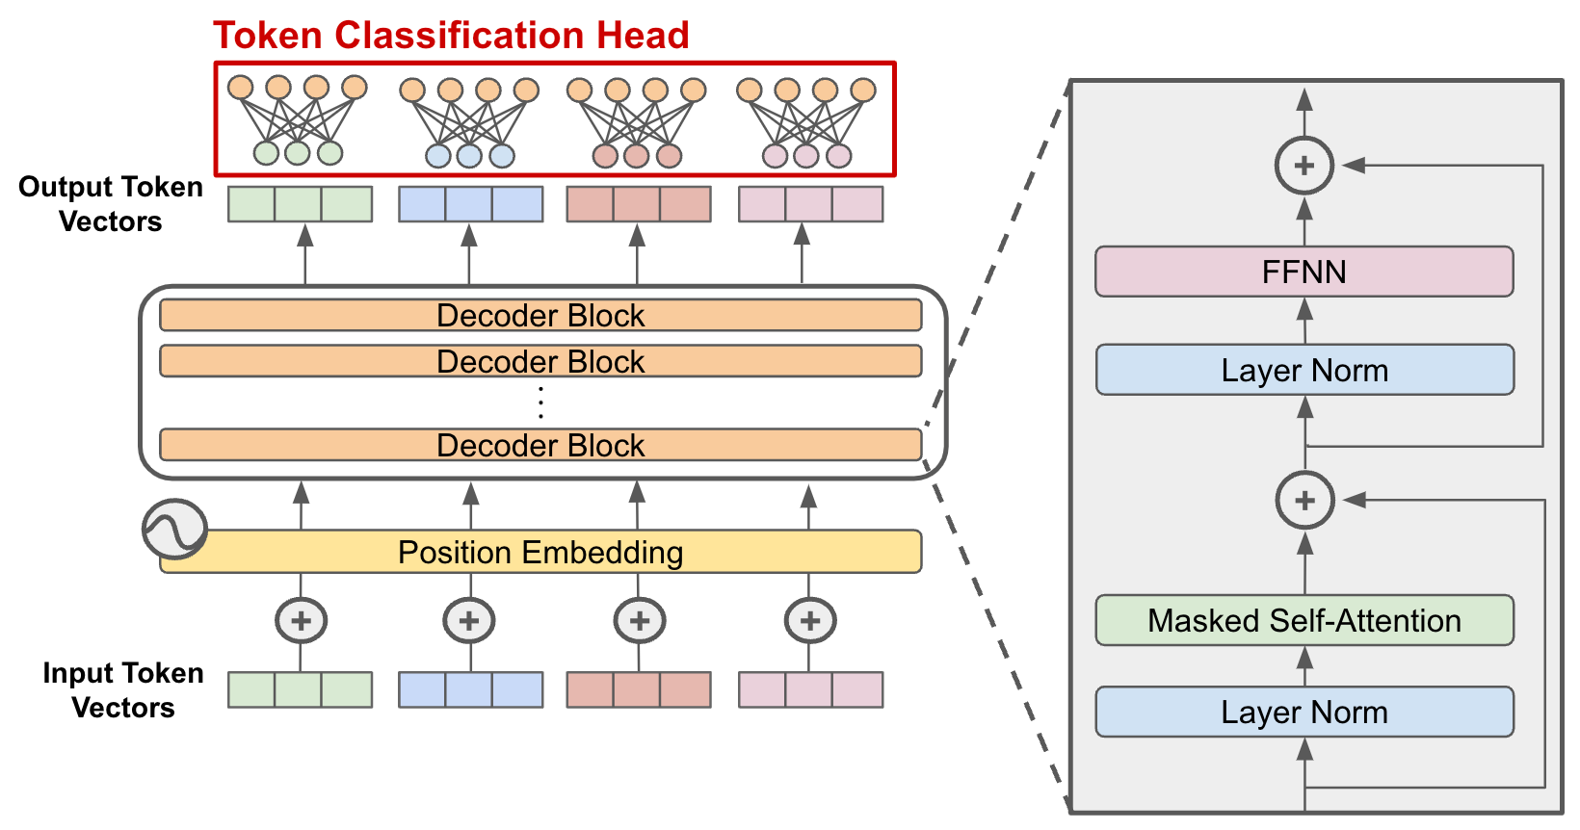
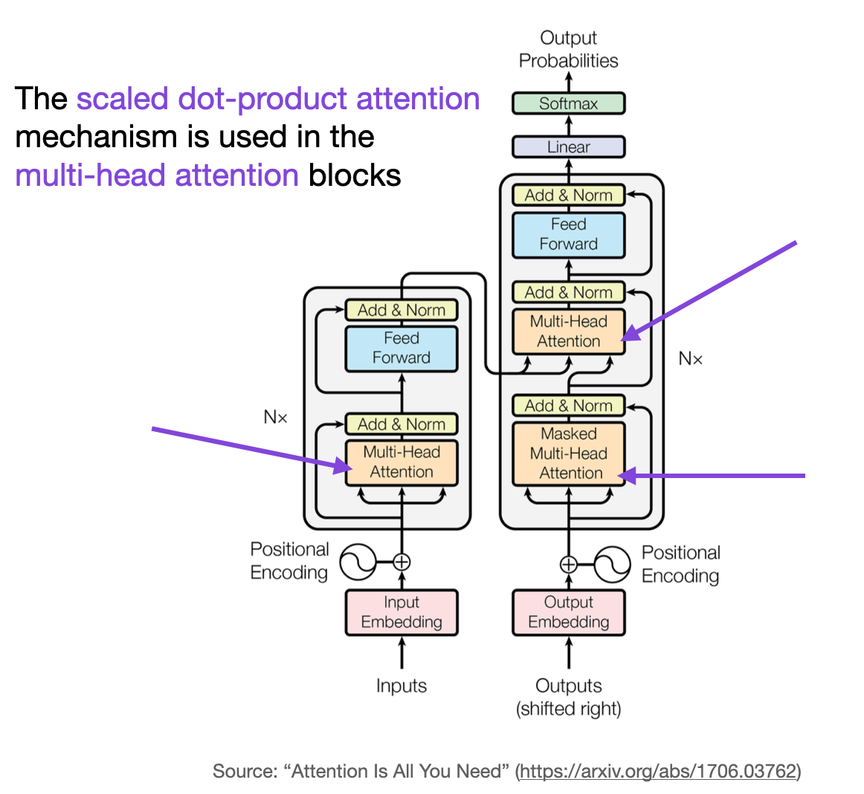
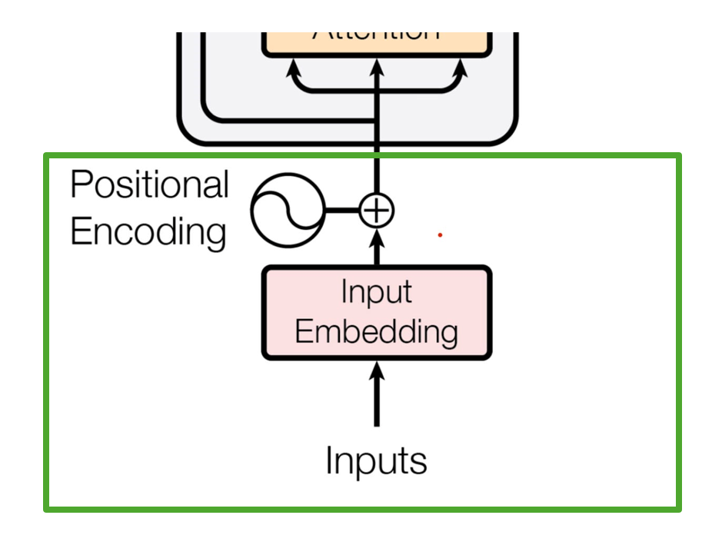
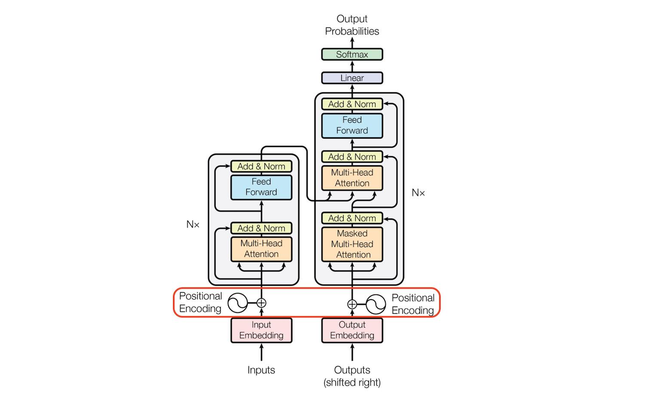
At its core, GPT is a decoder-only Transformer based on the original paper
👉 Transformer Architecture

Core components:
- Tokenizer
- Embedding layer
- Positional encoding
- Stacked Transformer blocks
- Linear + Softmax output

🔄 2. End-to-End Flow (Simple View)
Input Text → Tokenization → Embeddings → Transformer Layers → Logits → Softmax → Next Token

🧩 3. Step-by-Step Architecture Flow

(1) Tokenization
- Input text → split into tokens
- Example:
- "ChatGPT is powerful"
- → ["Chat", "G", "PT", " is", " powerful"]
- Uses:
  - BPE (Byte Pair Encoding)
  - SentencePiece

(2) Token Embedding + Positional Encoding
Each token becomes a vector:
token → embedding vector (e.g., 768 / 4096 dims)
Add position info:
Final input = Token Embedding + Positional Encoding
👉 Without position, model doesn’t understand order.

(3) Transformer Blocks (Core Engine)
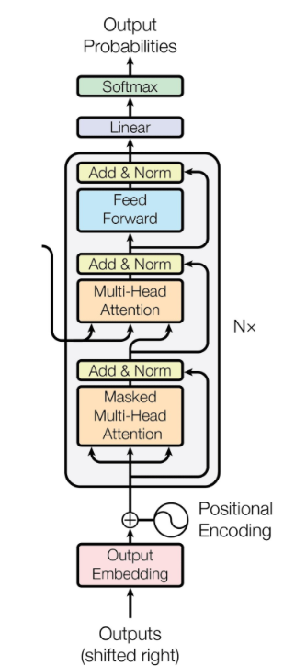
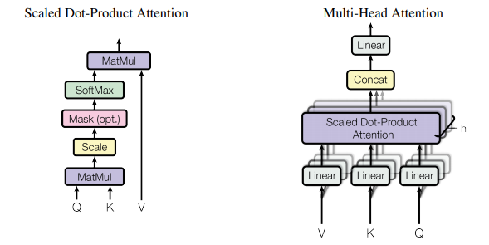
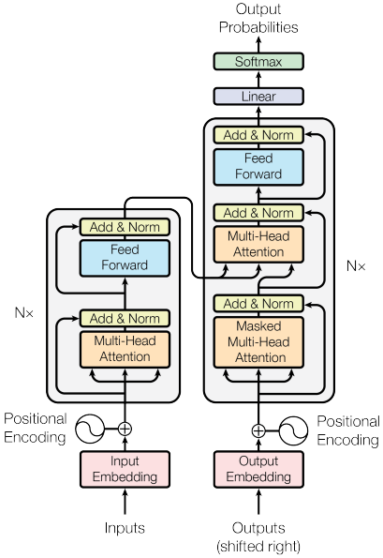

Each block contains:

🔹 (a) Masked Self-Attention
- Every token looks at previous tokens only
- Uses:
  - Query (Q)
  - Key (K)
  - Value (V)

Attention formula:
[
Attention(Q,K,V) = softmax\left(\frac{QK^T}{\sqrt{d_k}}\right)V
]
👉 This is where context understanding happens

🔹 (b) Multi-Head Attention
- Multiple attention heads in parallel
- Each learns different relationships:
  - grammar
  - meaning
  - dependencies

🔹 (c) Feed Forward Network (FFN)
- Simple MLP applied per token:
FFN(x) = max(0, xW1 + b1)W2 + b2

🔹 (d) Residual + LayerNorm
- Stabilizes training
- Enables deep networks (100+ layers)

(4) Stacking Layers
- GPT = stack of Transformer blocks
Examples:
- GPT-2: 12–48 layers
- GPT-4+: 100+ layers (approx, not public)

(5) Output Layer (Logits)
Final vector → linear layer → vocabulary scores
Hidden State → Linear → Logits (size = vocab)

(6) Softmax → Next Token Prediction
Convert logits → probabilities:
[
P(token) = softmax(logits)
]
Then:
- pick highest (greedy)
- or sample (temperature, top-k, top-p)

🏋️ 4. Training Flow (VERY IMPORTANT)
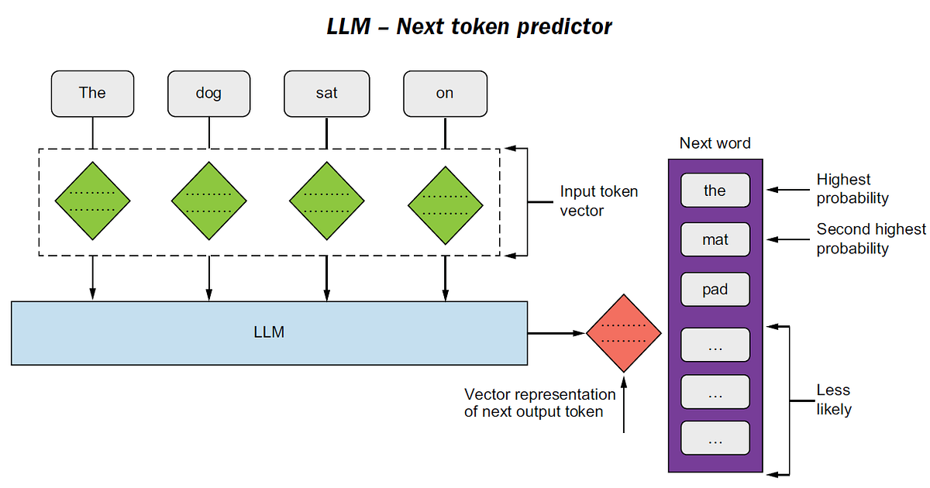
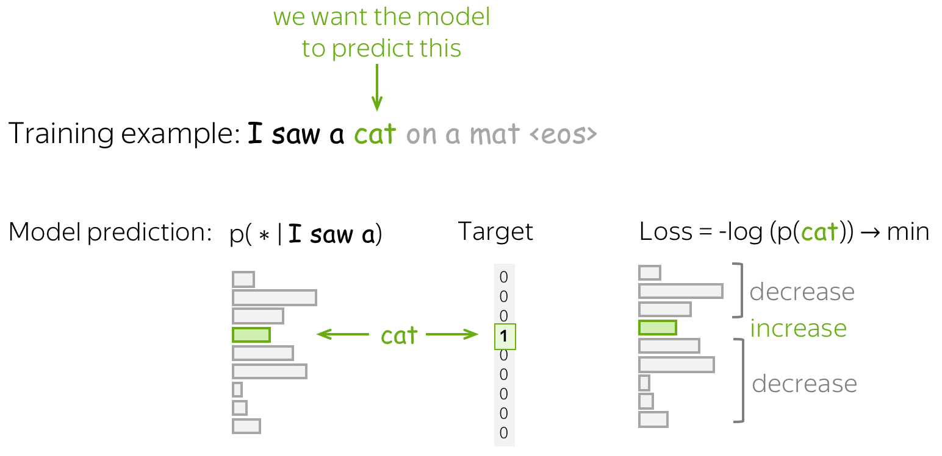

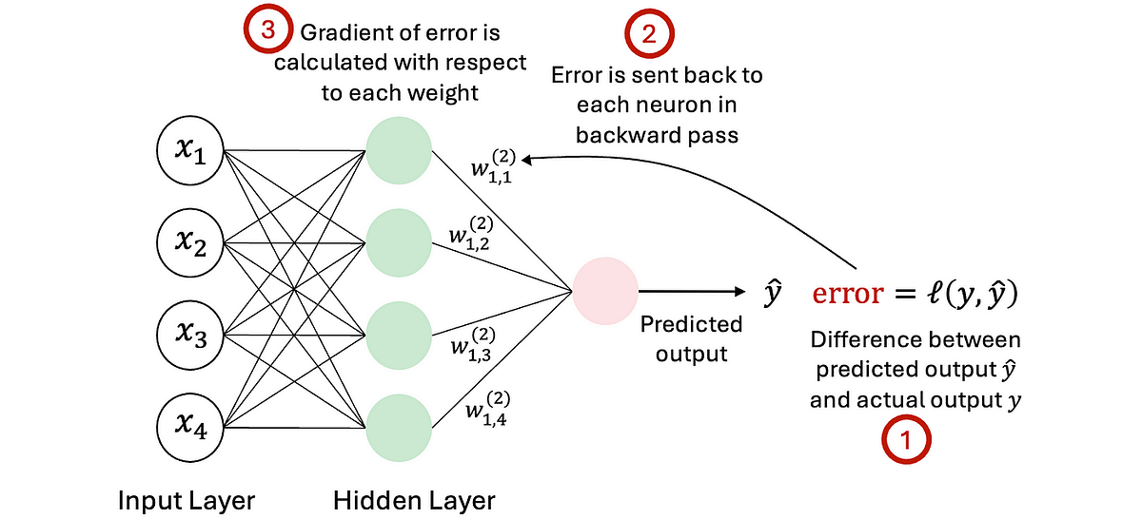

Objective:
Predict next token
Input: "The cat sat on"
Target: "the"

Training Steps:

1. Forward Pass
- Compute predictions

2. Loss Calculation
- Uses:
👉 Cross Entropy Loss

3. Backpropagation
- Compute gradients

4. Weight Update
- Using:
  - Adam optimizer
  - SGD variants

🔑 Key Insight:
👉 Weights update ONLY during training, NOT during inference

⚡ 5. Inference Flow (What Happens in ChatGPT)
When you type:
"Explain AI"

Step-by-step:
- Tokenize input
- Pass through model
- Predict next token
- Append token
- Repeat (autoregressive loop)
Input → Predict → Append → Predict → Append → ...

🧠 6. Key Concepts That Drive GPT

🔹 Autoregressive Modeling
- Predict next token sequentially

🔹 Self-Attention
- Understand relationships:
  - long-range dependencies
  - context

🔹 Scaling Laws
- More:
  - data
  - parameters
  - compute
→ better performance

🏗️ 7. Full Architecture Summary (Mental Model)
Think of GPT as:
Tokenizer → Vectorizer → Context Engine → Probability Machine → Text Generator
Or more technically:
Text
→ Tokens
→ Embeddings
→ [Attention + FFN] × N layers
→ Logits
→ Softmax
→ Next token

🚀 8. Mapping to Your Background (Important for You)
Since you’re a software architect, map it like:
System Concept | LLM Equivalent
Input API | Prompt
Encoding layer | Tokenizer
Processing engine | Transformer stack
Decision logic | Attention
Output service | Decoder (softmax sampling)
Training pipeline | CI/CD + optimization loop

🔥 If you want next level
I can go deeper into:
- Q/K/V numerical example
- Full matrix math walkthrough
- How RAG plugs into this architecture
- How to build mini GPT from scratch
- Infra view (GPU, distributed training)
Just tell me 👍

