Got it — this is the exact point where many people get stuck. Let’s simplify it without losing depth.

🧠 What is “Model Type”? (Simple Meaning)
👉 Model Type = the blueprint/design of the neural network
It tells:
- How the model is structured
- How data flows inside it
- What kind of problems it’s built for

⚙️ Think of it like this
Concept | Analogy
Model Type | Car design (SUV, truck, F1)
Model Layers | Engine parts inside the car
Inference | Driving the car

🧩 Common LLM Model Types (VERY IMPORTANT)

1. GPT-style (Decoder-only Transformer)
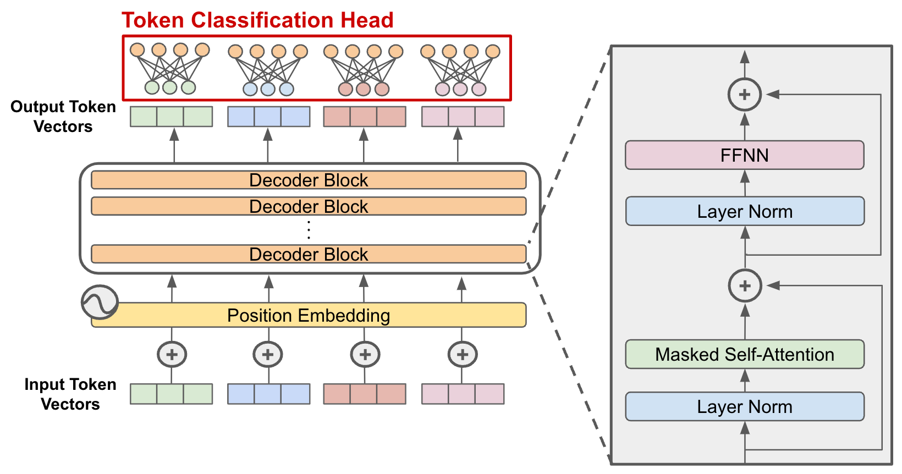

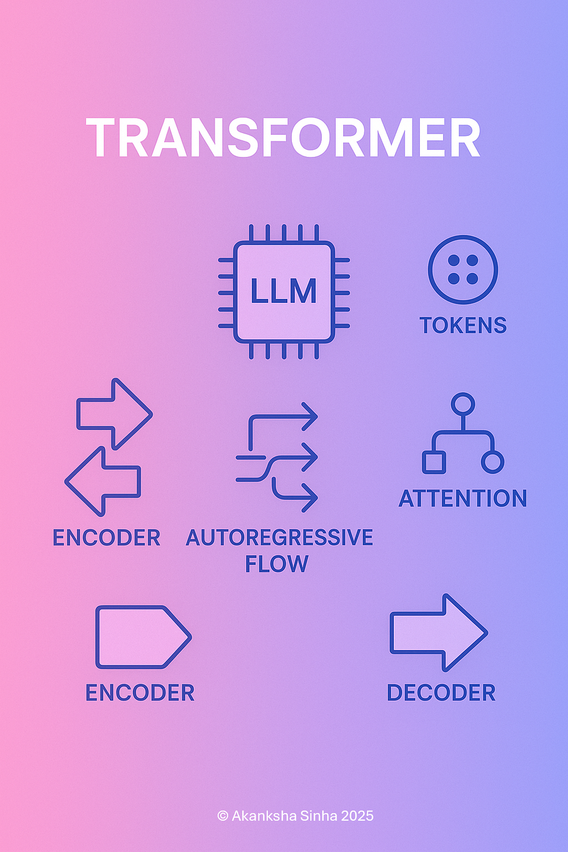
- Used in: ChatGPT, Claude
- Works left → right (predict next token)
- Best for:
  - Chat
  - Text generation
  - Coding
👉 This is what most modern LLM apps use

2. Encoder-Decoder (Seq2Seq like T5)
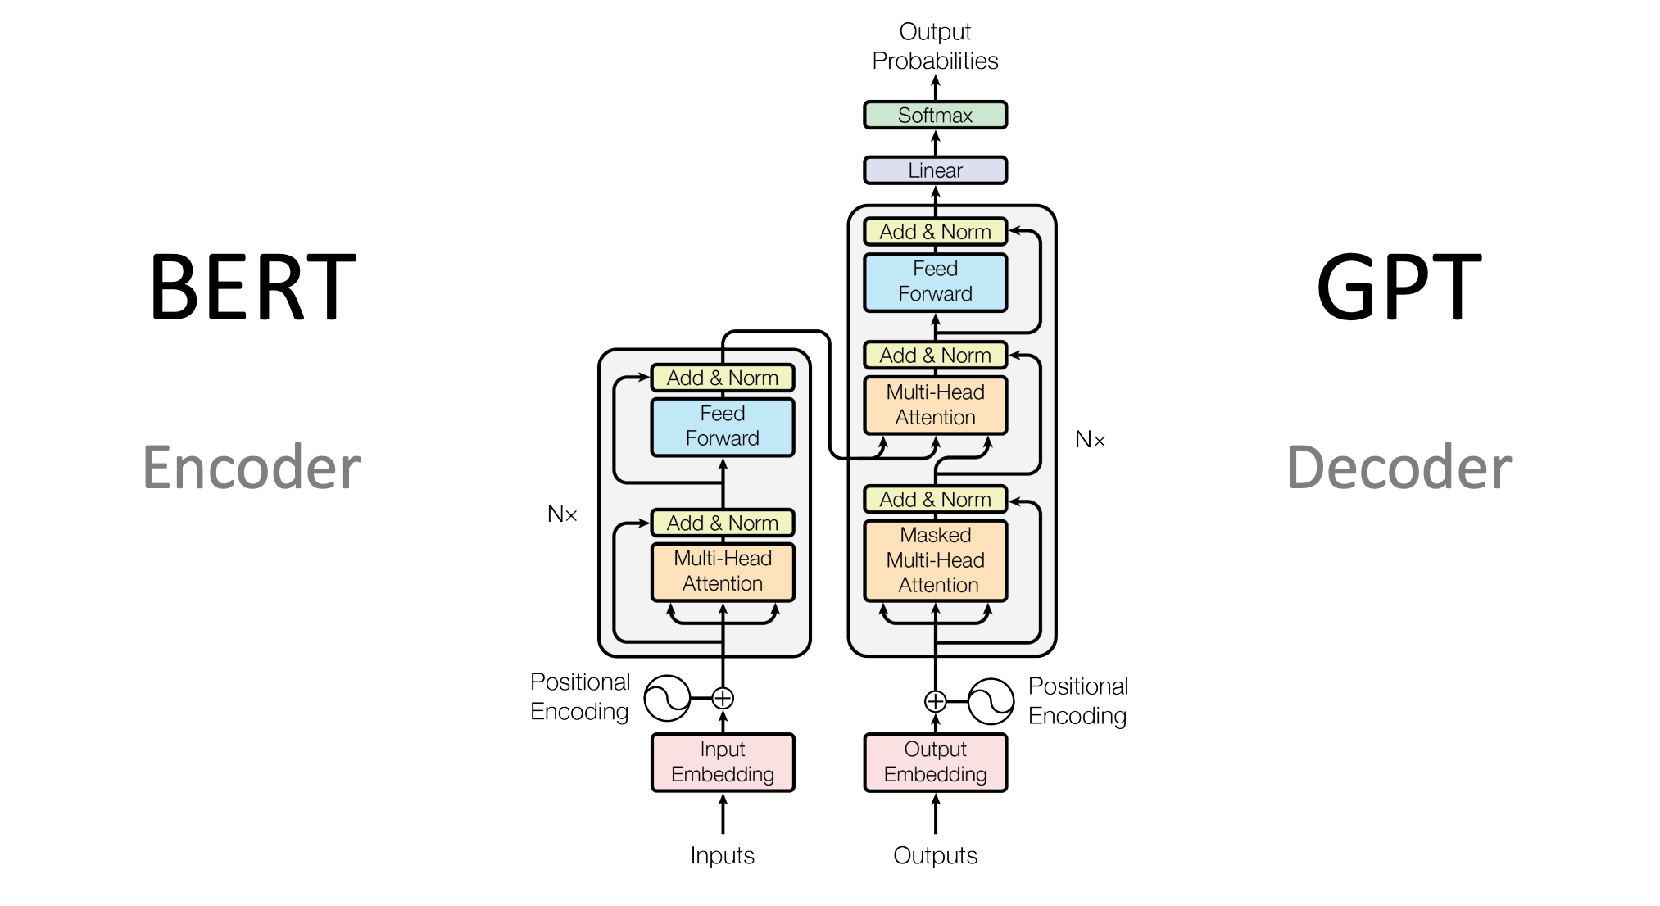
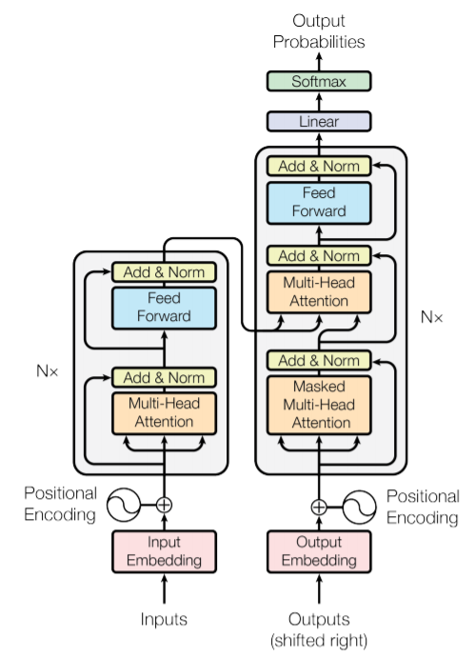
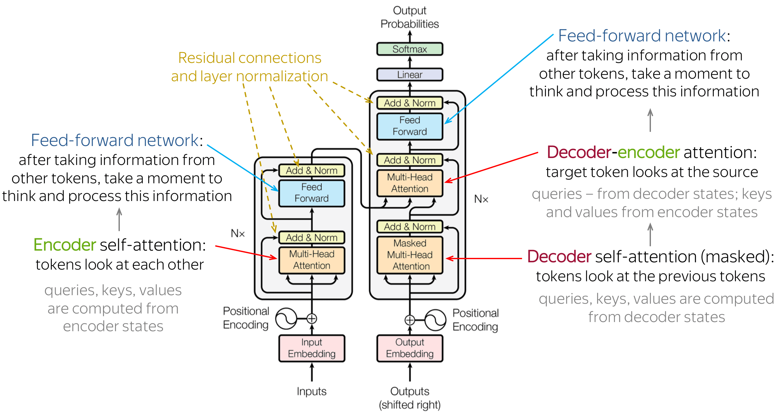
- Two parts:
  - Encoder → understands input
  - Decoder → generates output
- Best for:
  - Translation
  - Summarization

3. Encoder-only (BERT-style)

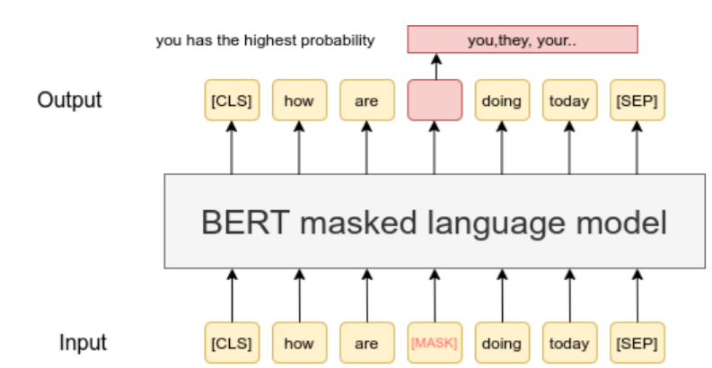

- Reads entire sentence at once (bidirectional)
- Best for:
  - Classification
  - Search
  - Embeddings

4. MoE (Mixture of Experts)
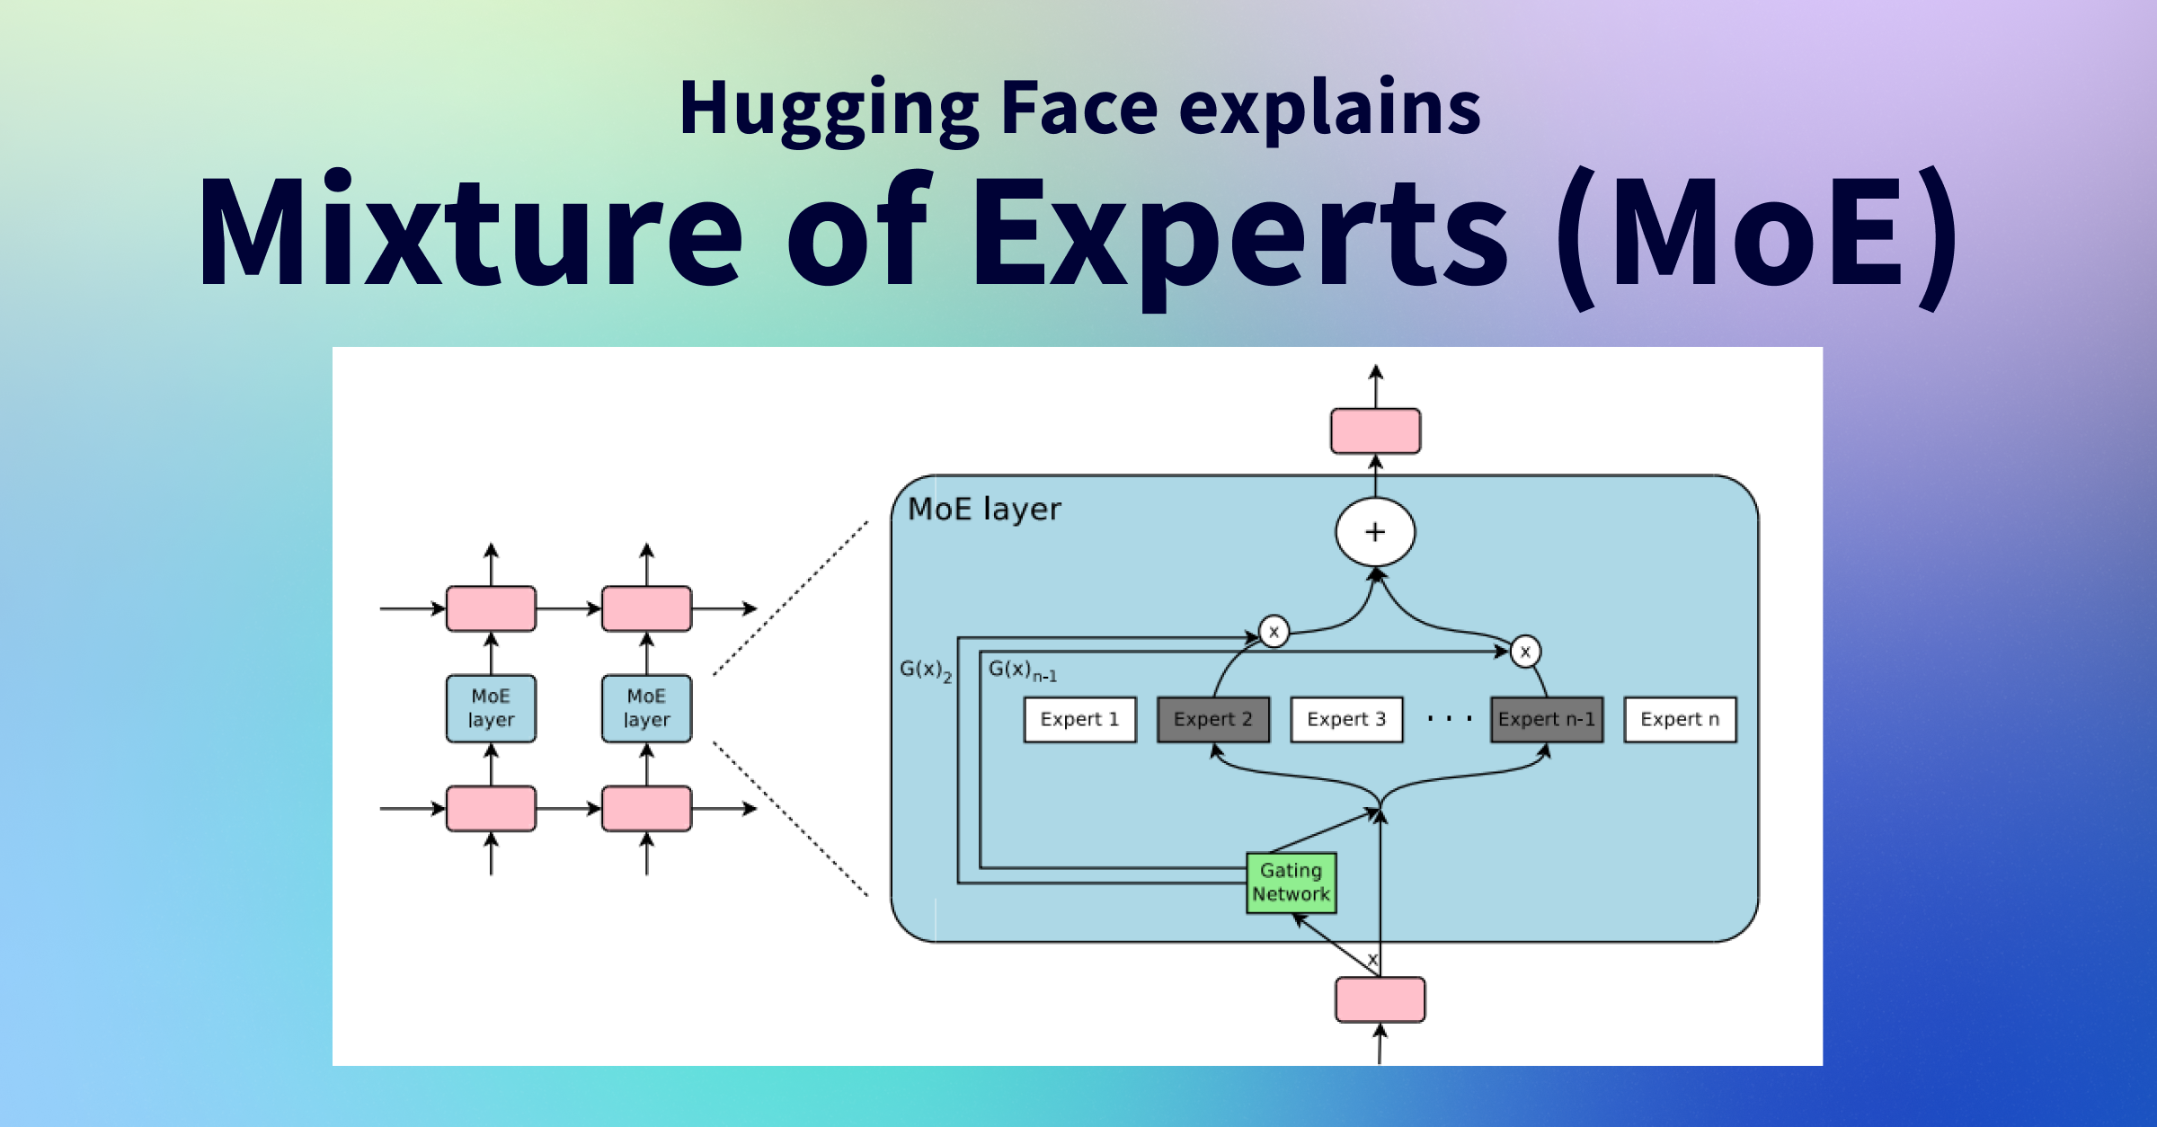
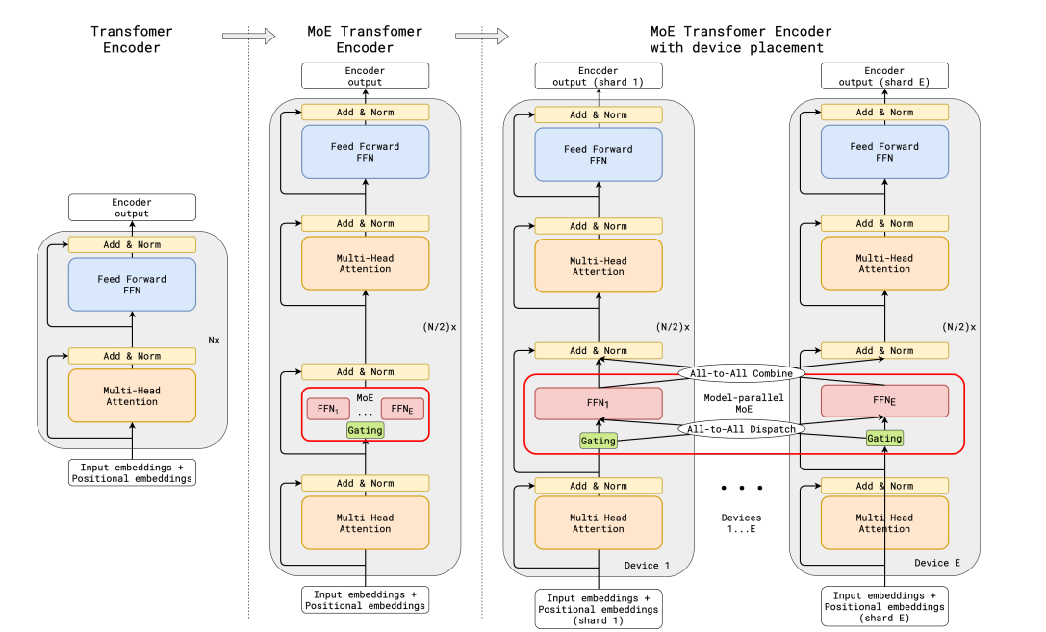
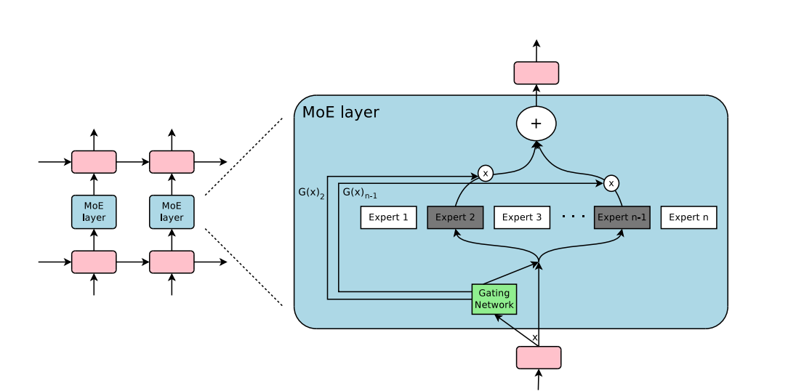
- Many sub-models (experts)
- Only a few activate per token
- Used for:
  - Scaling efficiently

🔁 Where Model Type Fits (Your Main Question)

It does NOT run like decoding

It does NOT happen per token
👉 It defines HOW the forward pass is built

Think in layers:
Level 1: Model Type (design)
↓
Level 2: Model Layers (actual computation)
↓
Level 3: Inference Loop (token generation + decoding)

🔬 Example (Concrete)
Let’s say:
- Model Type = GPT
- Input = "Hello how are"

What happens:
- GPT design says:
  - Use causal attention
  - Only look left
- Then forward pass runs:
  - Through transformer layers
- Output:
  - Probabilities for next word
- Then decoding picks:
  - "you"

🚨 Why this matters (Architect-level insight)
When you choose model type, you are deciding:
Decision | Impact
GPT vs Encoder | Generation vs understanding
MoE vs Dense | Cost vs scale
Multimodal vs text | Capability

💡 Final clarity sentence
👉
Model Type is NOT a step in inference
It is the design of the model that every inference step follows

🧭 If still confusing, here’s the simplest version
- Model Type = What kind of brain it is
- Model Layers = Neurons inside brain
- Decoding = How output is chosen

If you want next step, I can:
✅ Show exact token-by-token inference trace (like debugger view)
✅ Compare GPT vs MoE in production (cost, infra, scaling)
✅ Map this to real serving stack (vLLM / OpenAI API internals)
Just tell 👍

