Here’s a clean, high-level view of GPT architecture — the kind you’d expect in a system design doc or executive technical overview.

🧠 High-Level GPT Architecture (Big Picture)
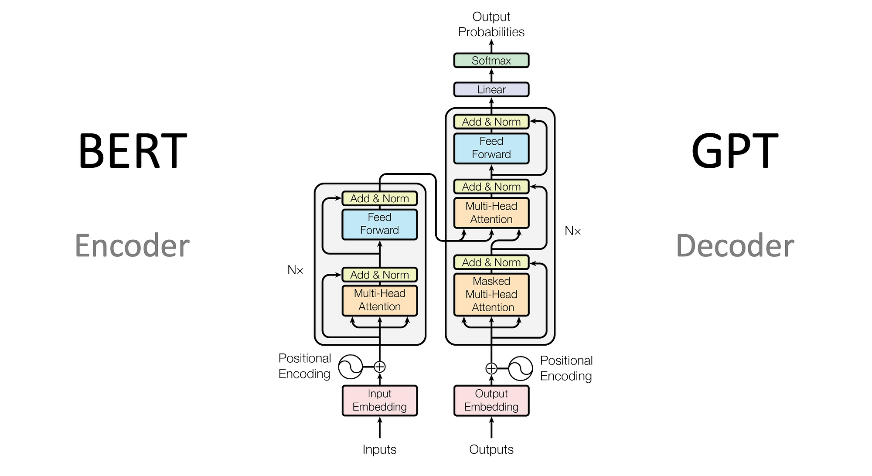
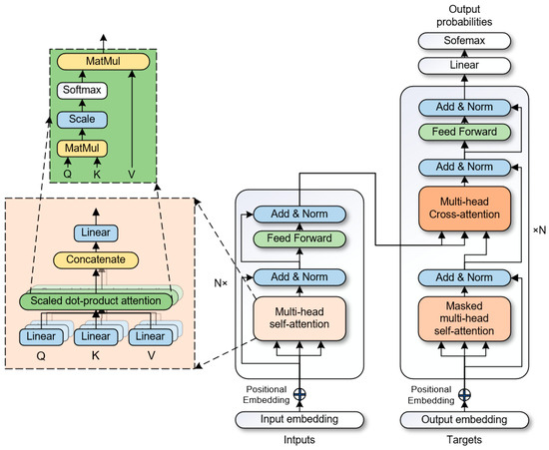
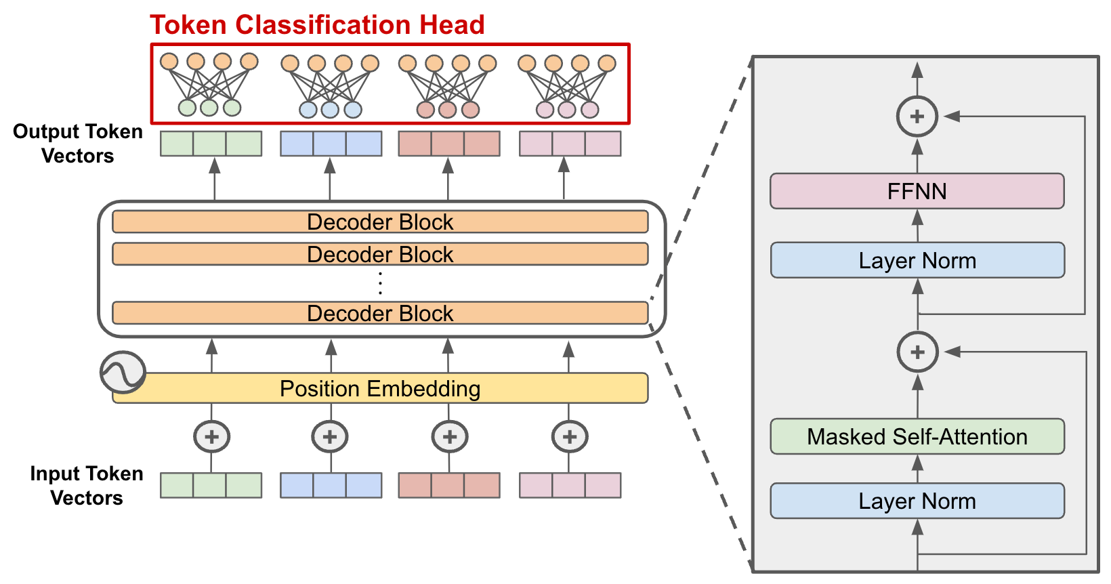

🔷 Core Idea
GPT is a decoder-only Transformer model built on
👉 Transformer Architecture
It converts text → tokens → vectors → probabilities → text

🔄 End-to-End Pipeline
User Input → Tokenizer → Embeddings → Transformer Stack → Output Layer → Next Token

🧩 Main Components (High-Level Blocks)

1. Tokenizer
- Converts raw text → tokens (numbers)
- Handles:
  - words, subwords, punctuation
- Common techniques:
  - BPE (Byte Pair Encoding)
👉 Example:
"Hello world" → [15496, 995]

2. Embedding Layer
- Maps tokens → dense vectors
- Adds:
  - semantic meaning
  - positional encoding (order awareness)
Token ID → Vector (e.g., 4096 dimensions)

3. Transformer Stack (Core Engine)

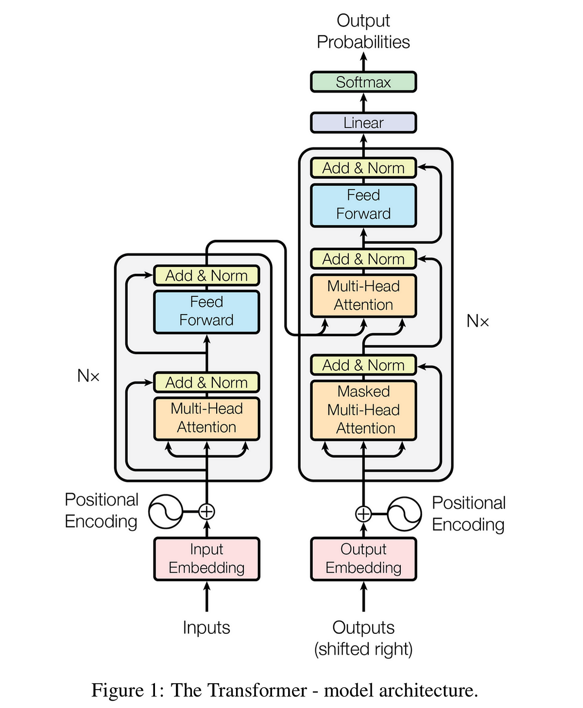

This is the brain of GPT
Each layer includes:
- Masked self-attention
- Multi-head attention
- Feedforward neural network
- Residual connections + normalization
👉 Stacked dozens to hundreds of times

4. Output Layer (Logits)
- Final hidden state → linear projection
- Produces:
- Vector → vocabulary-sized scores

5. Softmax + Sampling
- Converts scores → probabilities
- Selects next token using:
  - greedy
  - temperature
  - top-k / top-p

🔁 Autoregressive Nature
GPT works as:
Predict next token → append → repeat
👉 This is called autoregressive generation

🧠 Key Design Principles

🔹 1. Self-Attention
- Every token attends to previous tokens
- Enables:
  - long-range context understanding

🔹 2. Causal Masking
- Prevents model from seeing future tokens
- Ensures:
- Only past → predict future

🔹 3. Scaling
Performance improves with:
- more parameters
- more data
- more compute

🏗️ System-Level View (Important for You)
Think of GPT as a modular system:
Layer | Role
Input Layer | Tokenizer
Encoding Layer | Embeddings
Processing Layer | Transformer stack
Decision Layer | Linear + Softmax
Control Loop | Autoregressive inference

⚡ Simplified Mental Model
Text
→ Token IDs
→ Vector Space
→ Context Processing (Attention)
→ Probability Distribution
→ Next Word

🔥 One-Line Summary
GPT = Tokenizer + Transformer Engine + Probabilistic Text Generator

🚀 If you want to go deeper
I can extend this into:
- Full training architecture (data + GPUs + pipeline parallelism)
- KV cache + inference optimization
- RAG + Agents layered on top of GPT
- Or map this to a real production system like ChatGPT
Just tell me 👍

