Here’s a full, system-level view of GPT training architecture — from raw data all the way to distributed GPU execution with parallelism. I’ll keep it structured the way a chief architect / AI infra lead would expect.

🧠 1. End-to-End Training Architecture (Big Picture)
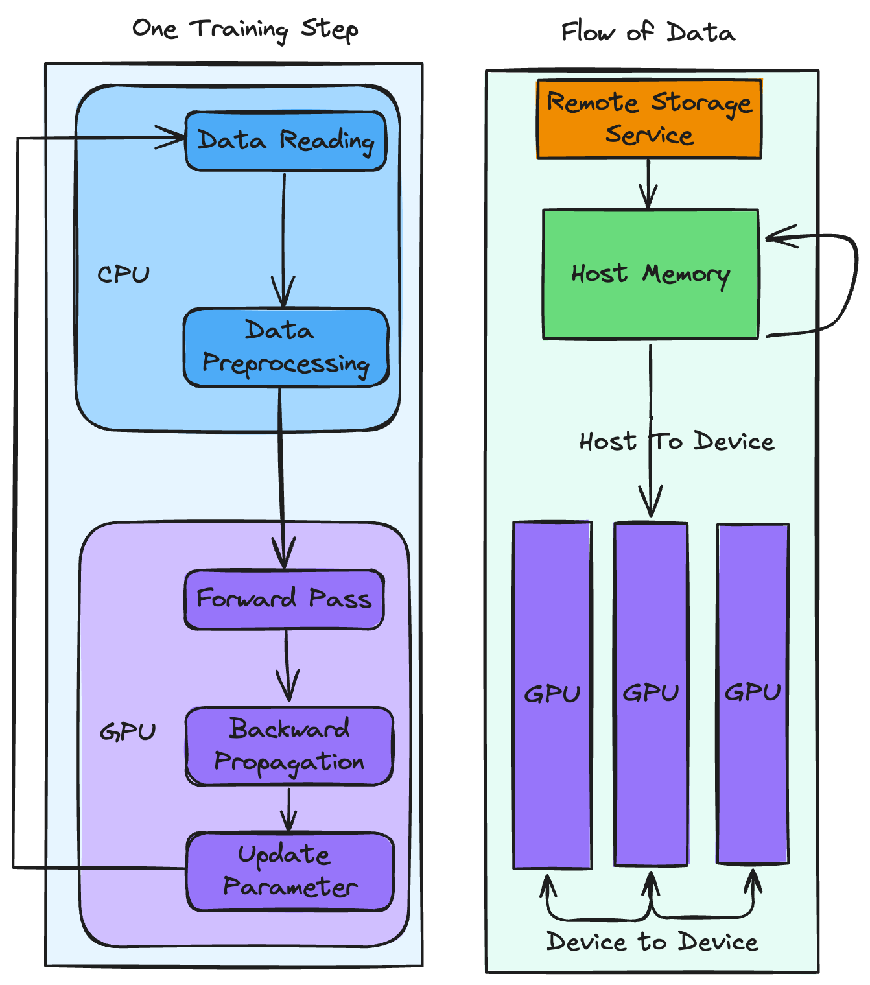
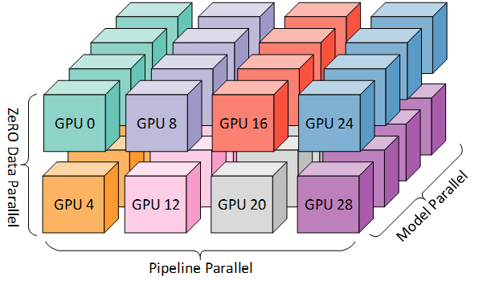
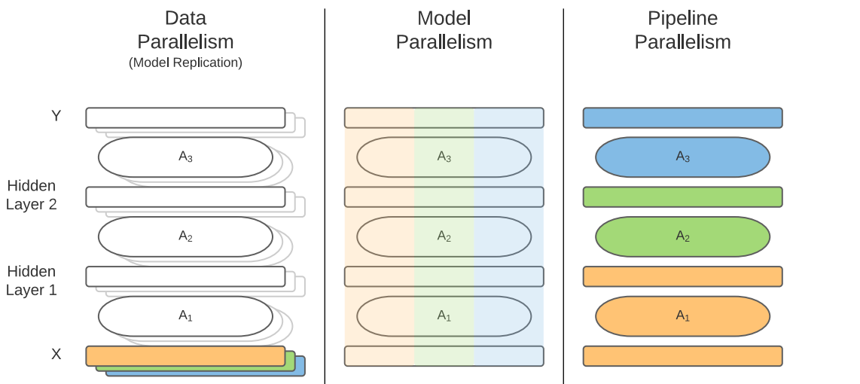
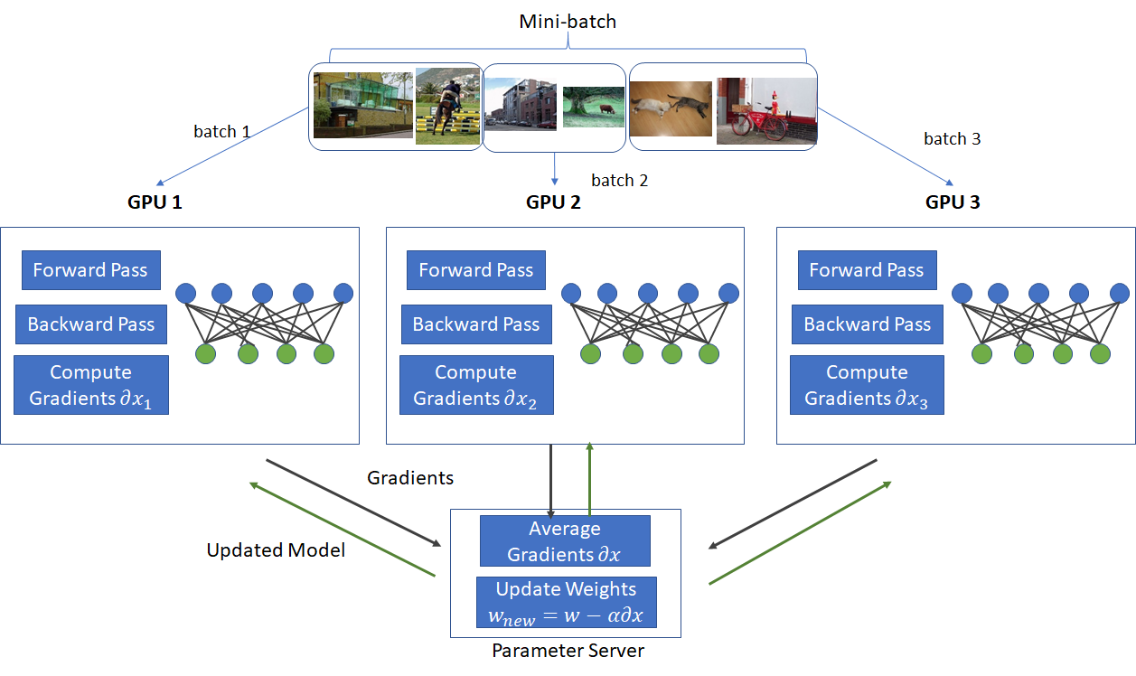
Raw Data → Data Processing → Tokenization → Dataset Sharding → Distributed Training → Model Checkpoints

🧩 2. Data Layer (Foundation)

🔹 Data Sources
- Web (Common Crawl, filtered)
- Books, code, research papers
- Proprietary datasets

🔹 Data Processing Pipeline
Steps:
- Cleaning (remove noise, HTML, duplicates)
- Filtering (quality, toxicity)
- Deduplication
- Formatting
👉 Output:
Clean text corpus (TB–PB scale)

🔹 Tokenization
- Convert text → token IDs
- Stored as:
[token1, token2, token3, ...]

🔹 Dataset Sharding
- Split across nodes:
Shard 1 → GPU Node 1
Shard 2 → GPU Node 2
...
👉 Enables parallel data loading

⚙️ 3. Training Objective

🔹 Next Token Prediction
Input: "AI is transforming"
Target: "the"

🔹 Loss Function
👉 Cross Entropy Loss

🖥️ 4. Compute Layer (GPU/TPU Infrastructure)

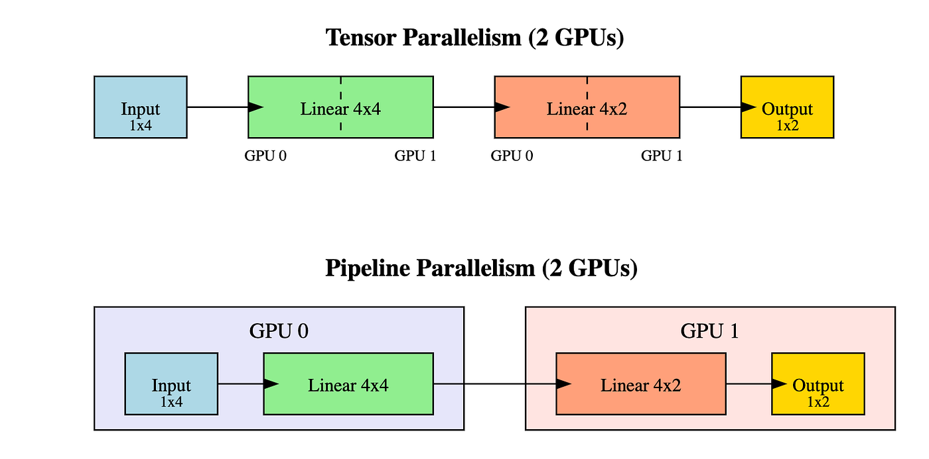

🔹 Hardware
- GPUs (A100, H100)
- High-speed interconnect:
  - NVLink
  - InfiniBand

🔹 Cluster Design
- Thousands of GPUs
- Organized as:
  - Nodes (8 GPUs each typical)
  - Racks → clusters

🔀 5. Parallelism Strategies (CRITICAL)
This is the heart of LLM training scalability.

🔴 5.1 Data Parallelism
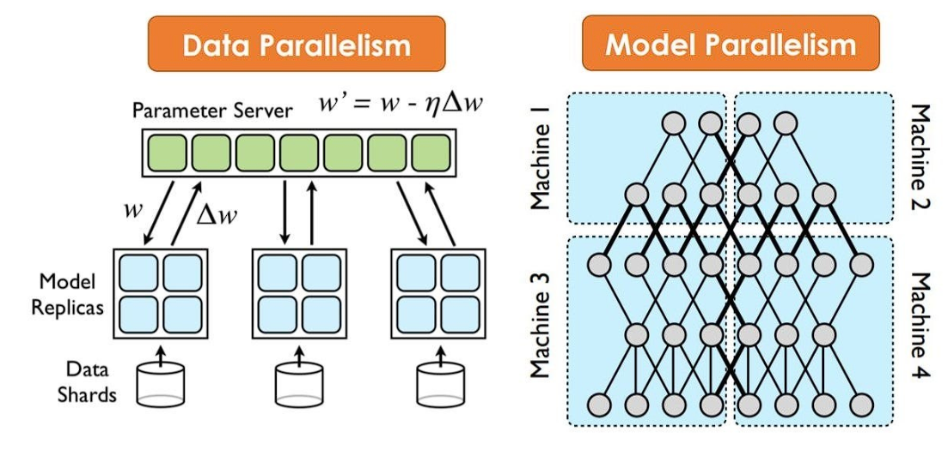
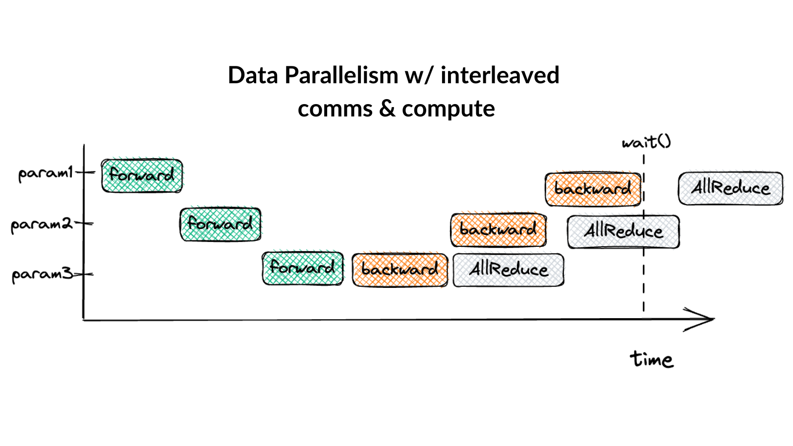
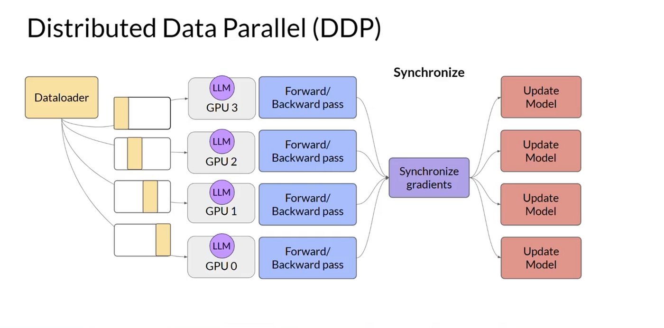

Idea:
- Same model on all GPUs
- Different data on each GPU
GPU1 → Batch A
GPU2 → Batch B
GPU3 → Batch C

Then:
- Gradients synced (All-Reduce)

🔵 5.2 Model Parallelism

Idea:
Split model across GPUs
Layer 1–10 → GPU1
Layer 11–20 → GPU2
👉 Needed when model is too big for one GPU

🟢 5.3 Pipeline Parallelism
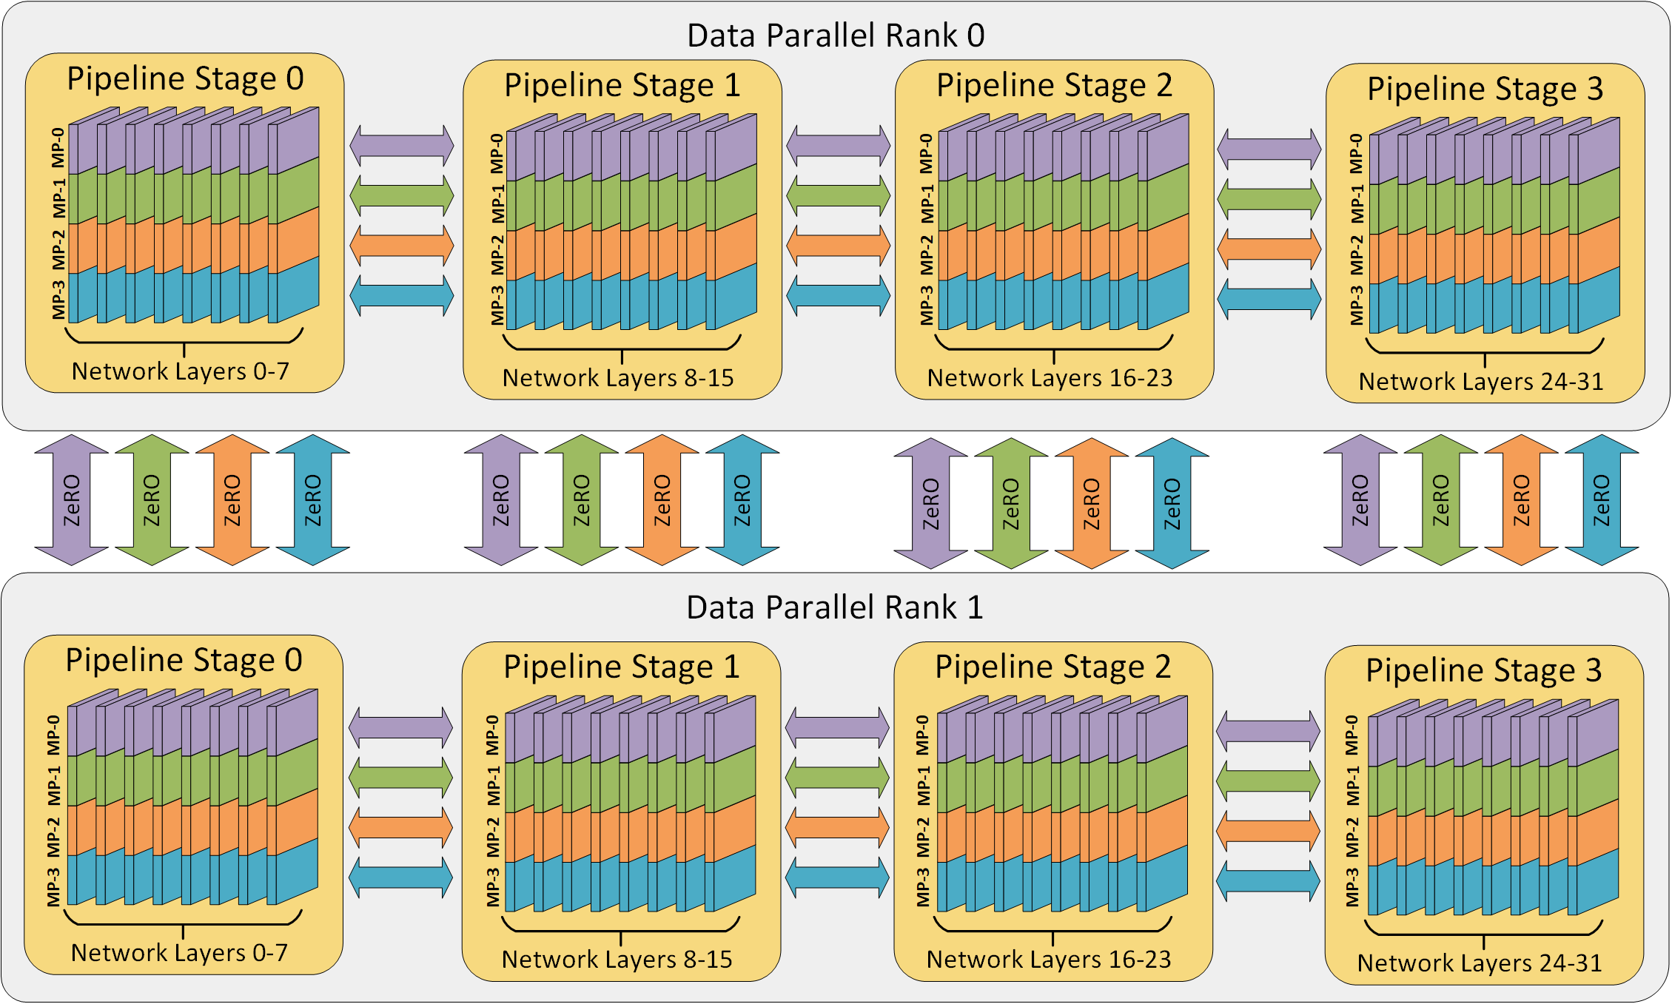
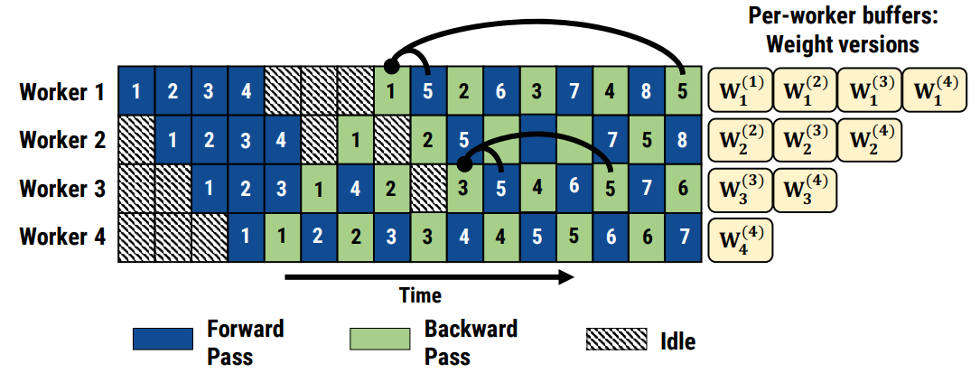
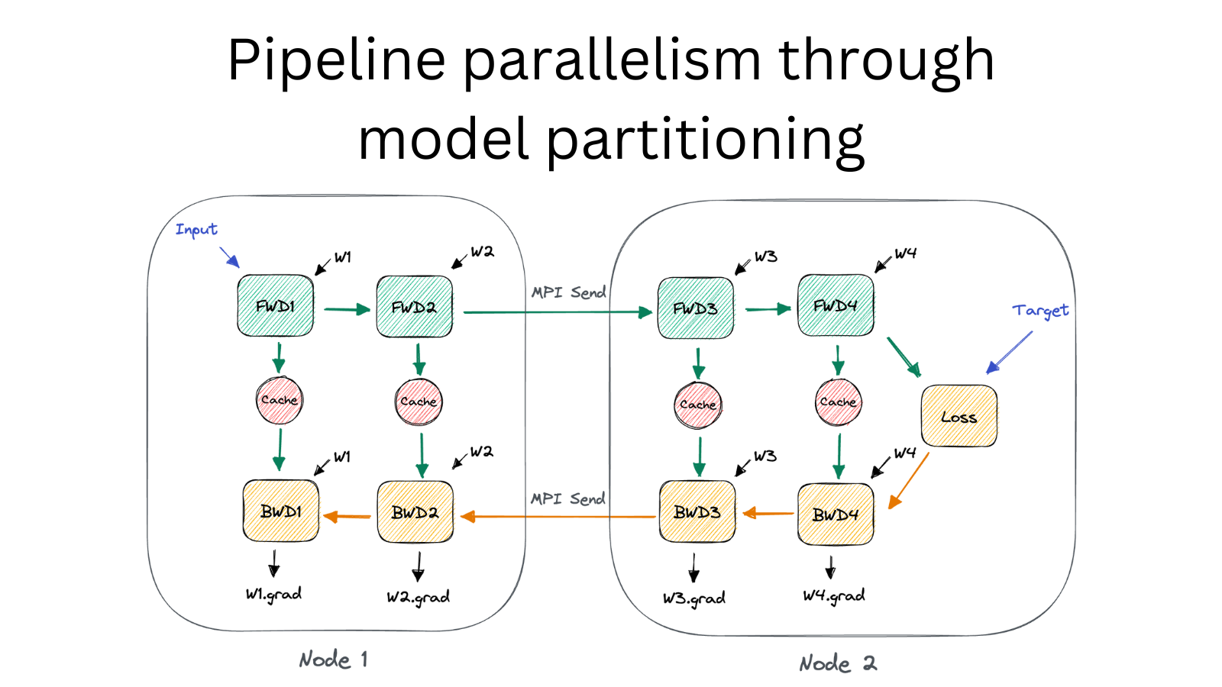

Idea:
- Different GPUs handle different layers
- Data flows like a pipeline
Batch → GPU1 → GPU2 → GPU3 → ...

Uses:
- Micro-batching to keep GPUs busy

🟡 5.4 Tensor Parallelism

Idea:
Split tensors inside a layer
Matrix multiplication split across GPUs
👉 Used in:
- Megatron-LM
- GPT-4 class systems

🧠 6. Training Execution Flow

🔁 Per Training Step:

1. Forward Pass
- Input tokens → predictions

2. Loss Computation
- Compare with target

3. Backward Pass
- Compute gradients

4. Gradient Synchronization
- Across GPUs (AllReduce)

5. Optimizer Step
- Update weights (Adam)

Forward → Loss → Backward → Sync → Update

💾 7. Memory Optimization Techniques

🔹 Gradient Checkpointing
- Save memory by recomputing activations

🔹 Mixed Precision Training
- FP16 / BF16 instead of FP32

🔹 ZeRO (Zero Redundancy Optimizer)
- Splits:
  - optimizer states
  - gradients
  - parameters

🧪 8. Training Phases (Real GPT Systems)

Phase 1: Pretraining
- Massive corpus
- General intelligence

Phase 2: Instruction Tuning
- Fine-tune on instructions

Phase 3: Alignment
- RLHF (Reinforcement Learning from Human Feedback)

🔄 9. Checkpointing & Fault Tolerance
- Save model periodically:
checkpoint_step_10000.pt
- Enables:
  - resume training
  - rollback

🏗️ 10. System Architecture (Your View)
Map this like a distributed system:
Layer | Equivalent
Data pipeline | ETL system
Training loop | Batch processing engine
GPU cluster | Distributed compute
AllReduce | Distributed consensus
Checkpointing | Backup system

⚡ Final Mental Model
Massive Data
↓
Distributed Token Pipeline
↓
Parallel GPU Training (Data + Model + Pipeline + Tensor)
↓
Gradient Sync + Optimization
↓
Trained LLM

🔥 One-Line Summary
LLM training = distributed gradient descent over massive data using multi-dimensional parallelism across thousands of GPUs

🚀 If you want next (highly recommended)
Given your background, I can go deeper into:
- Exact Megatron-LM / DeepSpeed architecture
- Cluster sizing for ₹100–500 Cr AI infra
- How to build your own LLM training pipeline in India
- Cost breakdown (₹ per training run)
Just tell me 👍

