Great — let’s build a clean, CTO-level System Architecture Diagram for an LLM system that clearly separates:
- Model Type (design)
- ONE PASS (core computation)
- Inference Loop (generation)
- System Layer (real-world architecture)

🧠 FULL LLM SYSTEM ARCHITECTURE (PRODUCTION VIEW)

🔷 1. End-to-End Architecture
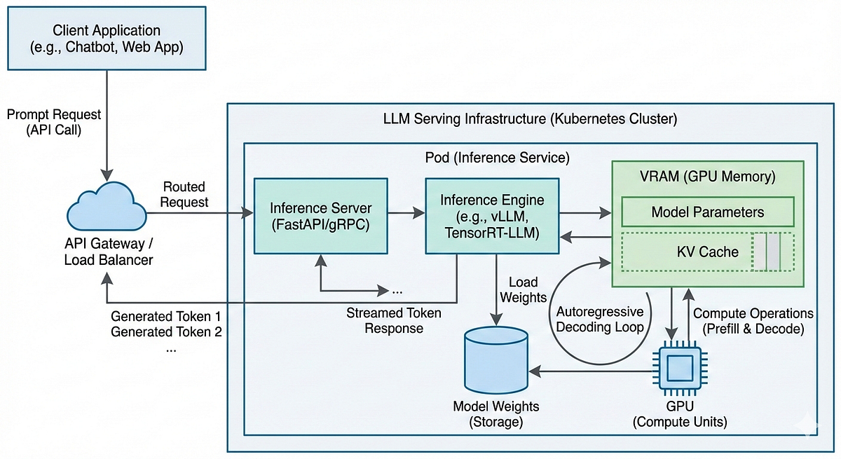
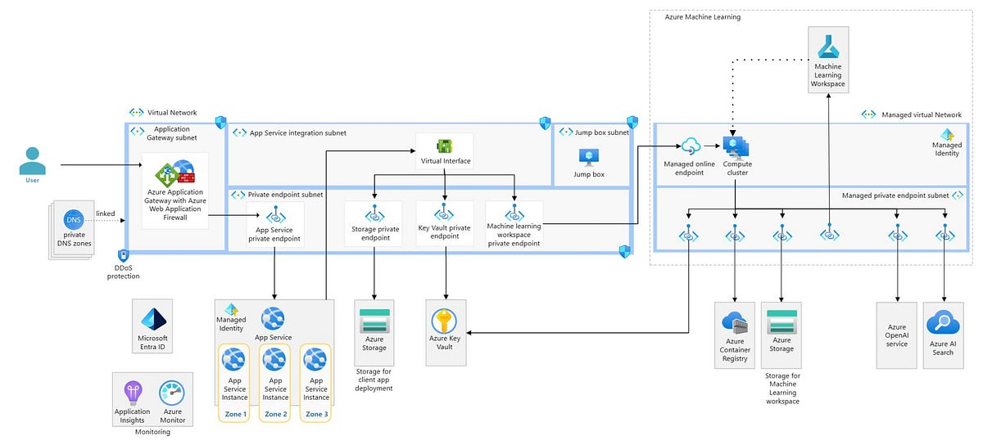

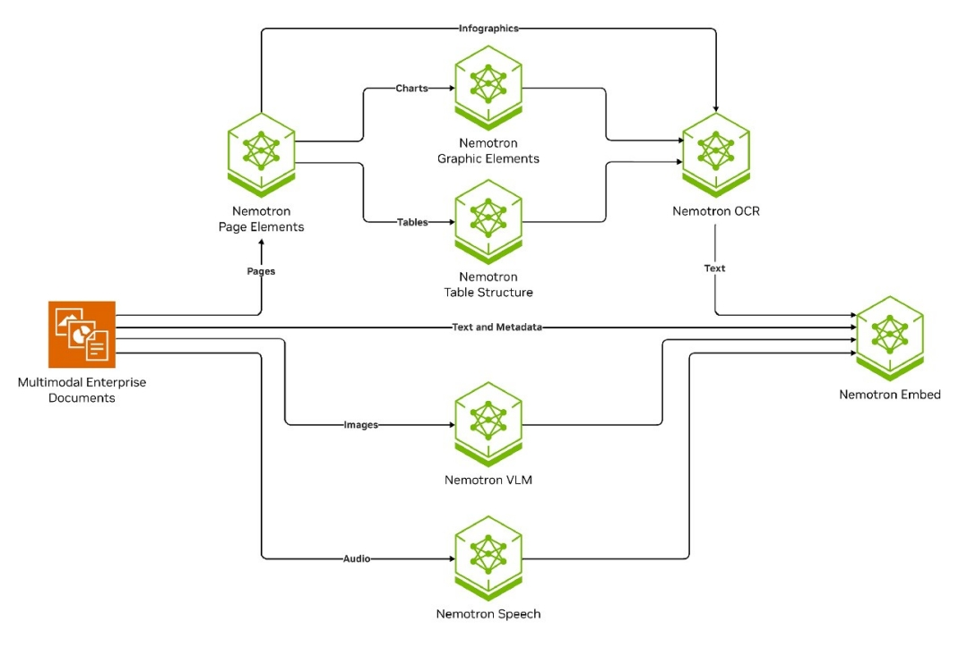

🔗 2. Layered Architecture Breakdown (Your Mental Model)
┌──────────────────────────────────────────────┐
│ CLIENT LAYER │
│ Web / Mobile / API Consumers │
└─────────────────────┬────────────────────────┘
│
▼
┌──────────────────────────────────────────────┐
│ API LAYER │
│ Auth / Rate Limit / Routing │
└─────────────────────┬────────────────────────┘
│
▼
┌──────────────────────────────────────────────┐
│ APPLICATION / ORCHESTRATION │
│ - RAG Pipeline │
│ - Agents / Tools │
│ - Prompt Builder │
└─────────────────────┬────────────────────────┘
│
▼
┌──────────────────────────────────────────────┐
│ INFERENCE SYSTEM (CORE) │
│ │
│ ┌──────────────────────────────────────┐ │
│ │ INFERENCE LOOP │ │
│ │ (token-by-token generation) │ │
│ │ │ │
│ │ ┌────────────────────────────┐ │ │
│ │ │ ONE PASS │ │ │
│ │ │ │ │ │
│ │ │ Embedding │ │ │
│ │ │ Transformer Layers │ │ │
│ │ │ → Logits │ │ │
│ │ └────────────────────────────┘ │ │
│ │ ↓ │ │
│ │ Decoding Strategy │ │
│ │ ↓ │ │
│ │ Next Token │ │
│ └──────────────────────────────────────┘ │
│ │
│ KV Cache / Batching / Scheduler │
└─────────────────────┬────────────────────────┘
│
▼
┌──────────────────────────────────────────────┐
│ MODEL (GPU / TPU) │
│ Model Type: GPT / MoE / Multimodal │
│ (Defines how ONE PASS works) │
└──────────────────────────────────────────────┘

🎯 3. Where Each Concept Fits

✅ Model Type (Design Layer)
- Lives in: Model Definition
- Example:
  - GPT (decoder-only)
  - MoE (mixture of experts)
👉 Defines how Transformer Layers behave

✅ ONE PASS (Core Computation)
- Happens in: GPU execution
- Includes:
  - Embedding
  - Attention
  - Feedforward
  - Logits

✅ Inference Loop (Runtime Engine)
- Happens in: Inference Engine
- Includes:
  - Token generation loop
  - Decoding
  - Streaming

✅ System Layer (Real Production System)
- Includes:
  - API Gateway
  - RAG
  - Agents
  - Vector DB
  - Scaling

🔥 4. Zoom into Inference Core (Most Important)
User Prompt
↓
Tokenizer
↓
┌────────────────────────────┐
│ INFERENCE LOOP │
│ │
│ logits = ONE_PASS(tokens) │
│ next = decode(logits) │
│ tokens += next │
│ │
└────────────────────────────┘
↓
Streaming Response

⚡ 5. Optimization Layer (Critical for Scale)
- KV Cache → avoids recomputation
- Continuous Batching → handles many users
- Tensor Parallelism → multi-GPU
- Streaming Tokens → low latency UX

🧠 Final Mental Model (CTO Summary)
Model Type → defines computation

ONE PASS → computes next-token probabilities

Inference Loop → repeats ONE PASS + decoding

System Layer → makes it usable at scale

🚀 If you want next level
I can:
✅ Convert this into a PPT-ready diagram (clean boxes, arrows, labels)
✅ Map this to real systems like OpenAI / Anthropic / vLLM
✅ Add AWS/GCP deployment architecture (Kubernetes, GPU clusters)
Just tell 👍

