Report

Allsec Technologies Attrition Rate
______________________________________________________________________

Content:

1. Data pre-processing and EDA.

  - Data Loading
  - Load Libraries
  - Summary and dimensionality checking of the data.
  - Missing value Treatment.
  - Martial status
  - Working with date and finding out Age.
  - Managing address field
  - Managing Highest educational qualification
  - Managing Overall experience
  - Managing Length of Service
  - Managing Job Title
  - Defining Target variable
  - Feature Engineering (If any).

2. Visualization.

3. Model.
4. Time Series
5. Continual Service Improvement plan, prescriptive Analytics.

1. Data pre-processing and EDA

1.1 Data Loading

Below is the employee master data set you’ve loaded in R console and that’s showing 10095 data points each having 16 attributes. So dimensionality of the data is (10095*16).

Data Cleaning and Assumption:
Data information across 3 Databases.doc

Code:
Attrition Rate.R

Visualization & Findings (Descriptive Statistics)

Visualization with Power BI

Power BI visualization

1st Dashboard:

- Count of Employee by Job. Title and # Resigned.
Finding: Customer care Executive is the dominant resigned class.

- Count of Employee by Supporting market and # Resigned.
Finding: Customer care Executive is the dominant resigned class.

- Count of Employee ID by Resigned Status, overall Experience and Marital Status
Finding: Overall experience 2 is the most dominant resigned class.

2nd Dashboard:

- Focusing on only Job title = Customer care Executive and Supporting Market.
Since, 2015 is only giving resigned data and not containing any live data we have discarded that year from filter and we see, last two year, i.e 2016-17 most attrition came from Samsung.

Further drilling down gave us most attrition came from sal bin – 0, 1 class.

3rd Dashboard:

- Gender wise Highest Educational qualification:
Finding : Most attrition came from Male Graduation class.

- Number of Employees by Final Age
Finding : 24 is the Age from where most attrition comes.

4th Dashboard:
- Line chart of Gross Average pay by highest education.
- Finding: average pay of Graduated candidate is less than HSC candidate. Post Graduated candidates having highest average pay.

5th Dashboard:
- Attrition Data EDA.
Descriptive Statistics and EDA

> table(Test_Final_1$Gender,Test_Final_1$Marital.Status)

Married Single
F 668 2929
M 599 5326

> table(Test_Final_1$Highest.Educational.Qualification,Test_Final_1$Marital.Status)

Married Single
10th 5 78
Diploma 22 274
Graduation 643 4524
HSC 296 2105
Post Graduate Diploma 8 10
Post Graduation 235 438
Professional 17 15
PUC 41 811

> table(Test_Final_1$Resigned,Test_Final_1$Region_1)

Bangalore Chennai Dallas Hyderabad Manila Mumbai New Delhi Pune Trichy
0 570 3013 0 16 0 204 3546 27 101
1 299 795 0 4 0 117 811 3 16

> table(Test_Final_1$Overall.Experience,Test_Final_1$Resigned.y)

0 1
1Year 298 80
2Year 4674 1424
3Year 61 49

> table(Test_Final_1$Length.of.Service,Test_Final_1$Resigned.y)

0 1
0 0 0
1 1892 1008
10 4 23
11 11 36
12 10 31
13 7 19
14 3 23
15 0 11
16 2 10
17 3 8
18 0 4
2 2548 354
3 2126 177
4 570 101
5 150 61
6 49 42
7 63 73
8 32 38
9 7 26

> table(Test_Final_1$Resigned.y,Test_Final_1$Region_1)

Bangalore Chennai Dallas Hyderabad Manila Mumbai New Delhi Pune Trichy
A 299 795 0 4 0 117 811 3 16
I 570 3013 0 16 0 204 3546 27 101

> table(Test_Final_1$Resigned.y,Test_Final_1$Sal_bin)

0 1 2 3 4 5 6
A 131 232 147 129 118 110 1178
I 2240 1766 1014 712 523 381 841

> table(Test_Final_1$Resigned.y,Test_Final_1$Gender)

F M
A 724 1321
I 2873 4604

> table(Test_Final_1$Resigned.y,Test_Final_1$Marital.Status)

Married Single
A 396 1649
I 871 6606

> table(Test_Final_1$Sal_bin)

0 1 2 3 4 5 6
2371 1998 1161 841 641 491 2019

Density Curve visualization:

About Density Curve:

A density curve is a graph that shows probability. The area under the density curve is equal to 100 percent of all probabilities. ... Density curves can be a skewed distribution. Note that the right- or left-skew doesn't refer to how the graph looks. It refers to whether the data is skewed

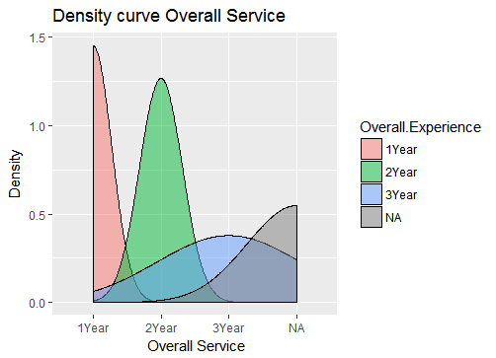

This graph depicts the density plot of the Overall Service of the employees.
For the sake of aesthetics all those with experience greater than 3 years have been put into the NA bin. One can infer the relation between number of people and overall experience.

Age Vs Salary

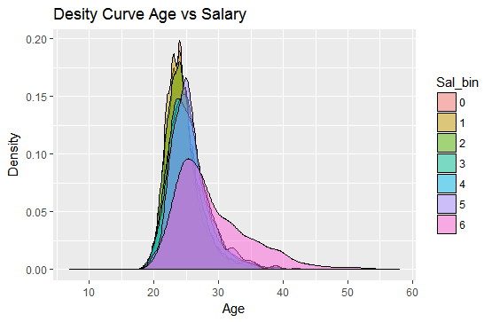

This graph depicts the density plot of the Age of the employees with information of the salary they draw. Here the salary is divided into bins where [0,7] depicts salary from 20k and below to 140K and above. One can infer the relation between number of people belonging to different age groups and salary drawn by them.

Age Vs Marital Status

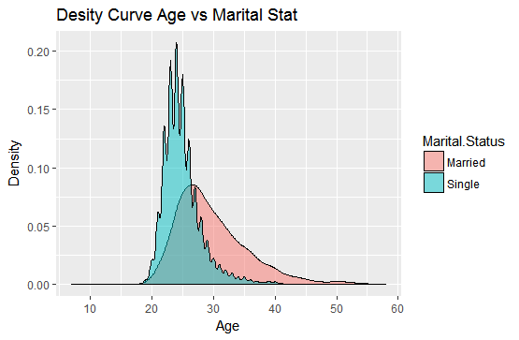

This graph depicts the density plot of the Age of the employees with information of their Marital Status. One can infer the relation between number of people belonging to different age groups and their marital status. As we can see, between ages of 20-30 the number of single people is greater than the number of married people and from age 30 and above the vice versa is true.

Boxplot with 3 Variables:

ABOUT BOXPLOT:
A simple way of representing statistical data on a plot in which a rectangle is drawn to represent the second and third quartiles, usually with a vertical line inside to indicate the median value. The lower and upper quartiles are shown as horizontal lines either side of the rectangle.

gENDER VS AGE

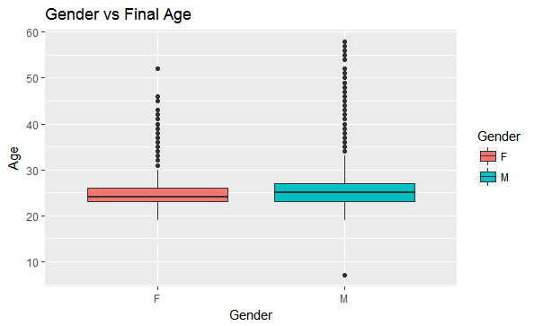

This graph depicts the box plot of the Age of the employees with information of their Gender. One can infer the relation between number of people belonging to different age groups and their gender. As we can see there are a numbers of outliers in both genders.
Average age of both genders is around 25 years.

GENDER VS AGE VS RESIGNED STATUS
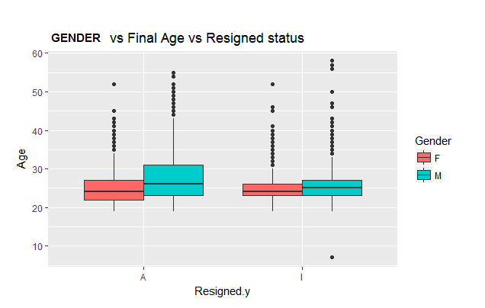

This graph depicts the box plot of the Age of the employees with information of their Gender and the resigned status. One can infer the relation between number of people belonging to different age groups, gender with attrition. As we can see there exist a number of outliers. Average age of both genders in both resigned status classes is around 25 years.

MARITAL STAUS VS FINAL AGE

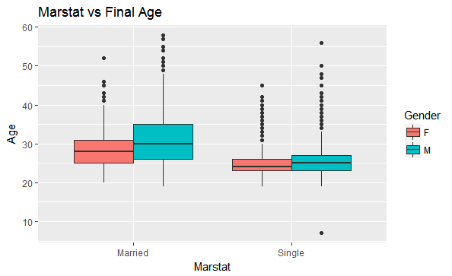

This graph depicts the box plot of the Age of the employees with information of their Gender and the marital status. One can infer the relation between numbers of people belonging to different age groups, gender with marital status. As we can see there exist a number of outliers. Average age of both genders in married classes is around 25 years.

ABOUT SCATTER PLOT:

A scatterplot is a useful summary of a set of bivariate data (two variables), usually drawn before working out a linear correlation coefficient or fitting a regression line. It gives a good visual picture of the relationship between the two variables, and aids the interpretation of the correlation coefficient or regression model.

Region vs Gross pay Distribution

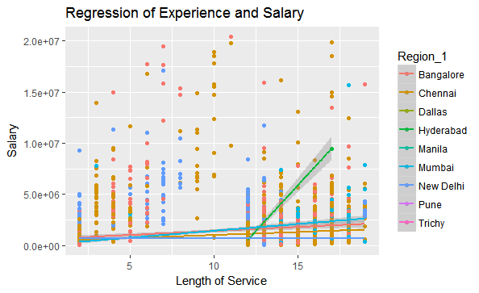

The above graph is a scatter plot between length of service and salary with trend lines which is color coded based on the region the employees work in. From these trend lines we can observe how salary gradually increases as length of service increases. Except for Hyderabad where the increase is abnormal.

REGRESSION OF AGE VS SALARY

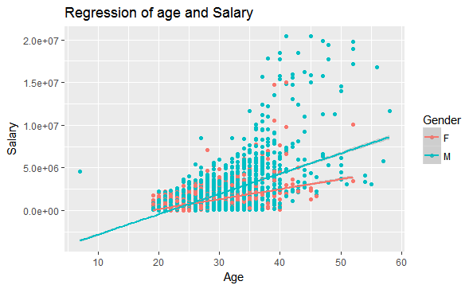

The above graph is a scatter plot between Age and salary with trend lines which is color coded based on the gender of the employees. From these trend lines we can observe how salary gradually increases as Age increases. The rate of increase in salary for men is much more than that of female employees.

ABOUT HISTOGRAM:

A diagram consisting of rectangles whose area is proportional to the frequency of a variable and whose width is equal to the class interval.

Final Age Distribution:

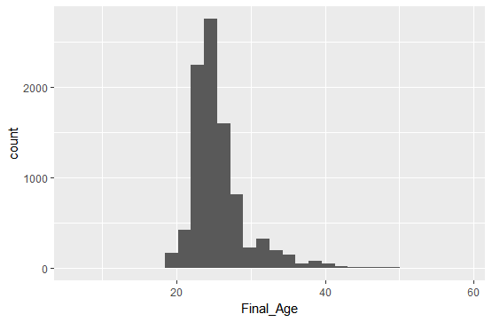

Histogram of Gross Pay

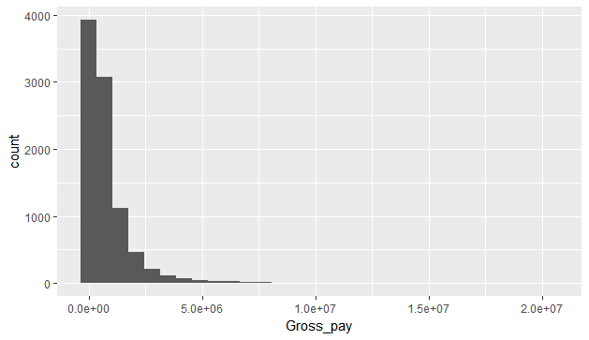
Final age vs gross pay distribution

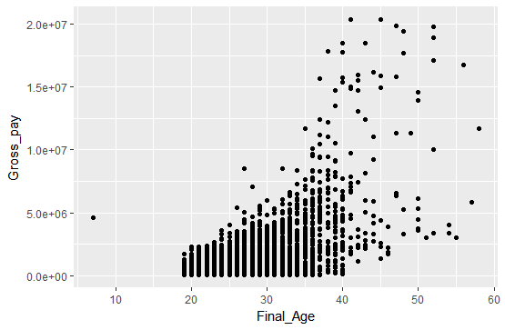

As we can see there are a lot of outliers in the age distribution. And number of outliers increases after the age of 40.

Length of Service vs Gross Pay distribution
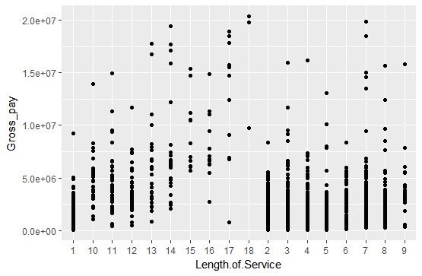
MARITAL STATUS VS GROSS PAY

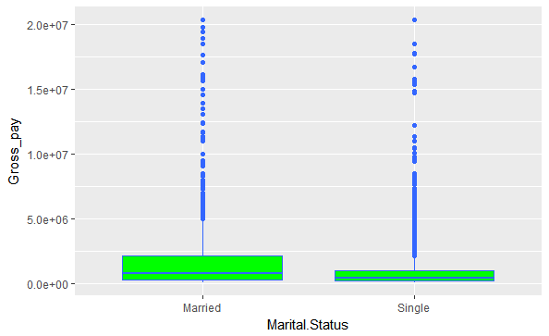

The above is a box plot of marital status versus the gross pay. In both classes there are a number of outliers.

GENDER VS SALARY BIN

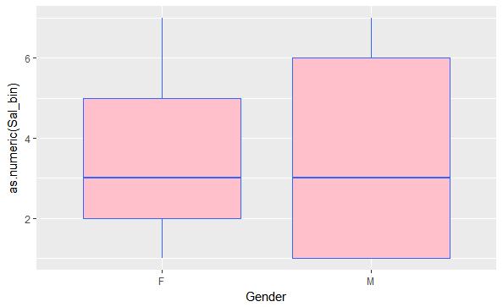
Age Distribution region wise
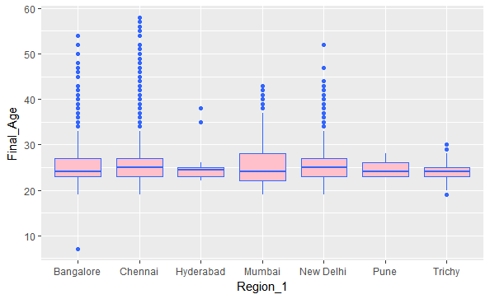

The above is a box plot of region versus age . In all classes there are a number of outliers.

Region wise Salary distribution

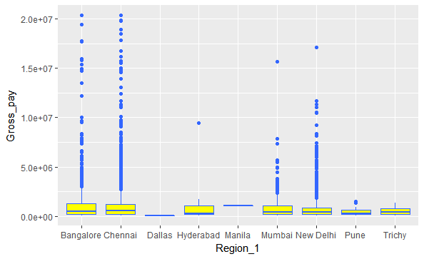

Modification (Limiting Salary value)
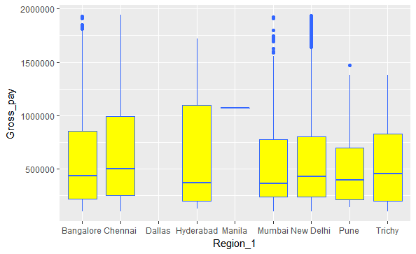

Violin Chart
A Violin Plot is used to visualise the distribution of the data and its probability density.This chart is a combination of a Box Plot and a Density Plot that is rotated and placed on each side, to show the distribution shape of the data. The thick black bar in the centre represents the interquartile range, the thin black line extended from it represents the 95% .
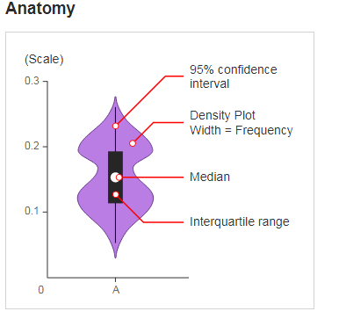
REGION VS GROSS PAY
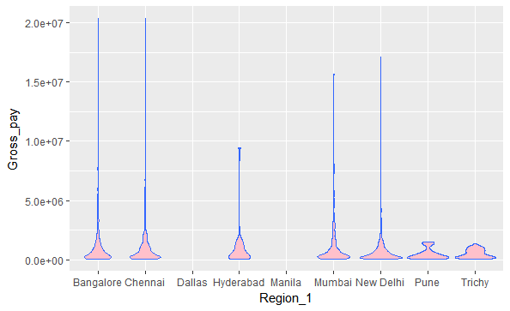
Modified Violin chart
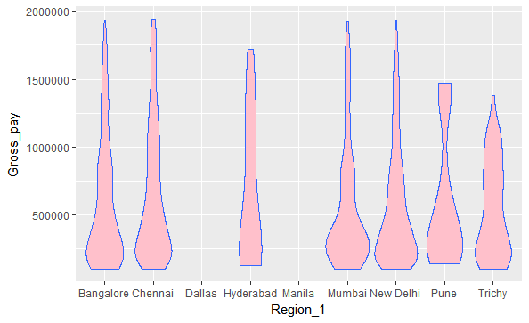
As we can see that from the graph Bangalore, Chennai, Mumbai, New Delhi the distribution is normal whereas for the other cities (Pune , Trichy , Hyderabad) the gross pay is abnormally distributed.

Tree Model: Visualization

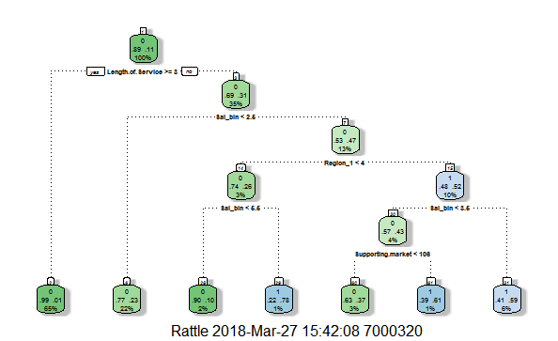
Modification:
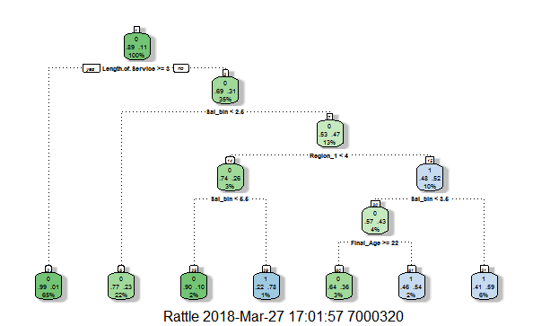

FancyRpartPlot:

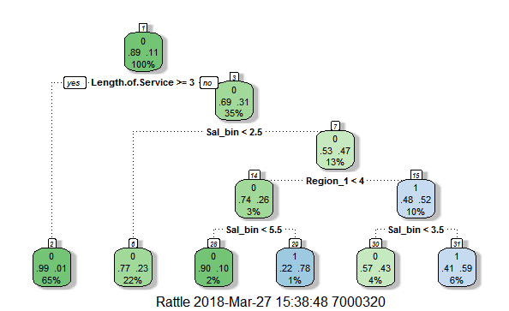

Attrition Pathway:

- Salary bin is the first deciding factor here. Salary bin < 5.5 first attrition. (79%)
- Salary bin < 5.5 and Length of Service >= 1.5 giving pure node of attrition. (51% of previous node)
- Length of Service < 1.5 + Salary bin < 2.5 (21 % of previous node)
- Length of Service < 1.5 + Salary bin > 2.5 – Negative Attrition (7% of previous node)
- Length of Service < 1.5 + Salary bin < 3.5 – 3 % of previous node.
- Length of Service < 1.5 + Salary bin < 3.5 + Gender = Female (2 % of previous node)
- Length of Service < 1.5 + Salary bin < 3.5 + Gender = Male- Negative Attrition (1 % of previous node)
- Length of Service < 1.5 + Salary bin > 3.5 – Negative Attrition (4% of previous node)
- Salary bin > 5.5 – Negative attrition (21%)
- Salary bin > 5.5 + overall. Experience < 1.5 = 8 % of previous node.
- Salary bin > 5.5 + overall. Experience > 1.5 = Negative Attrition 14 % of Previous Node.
- Neural Network Model:

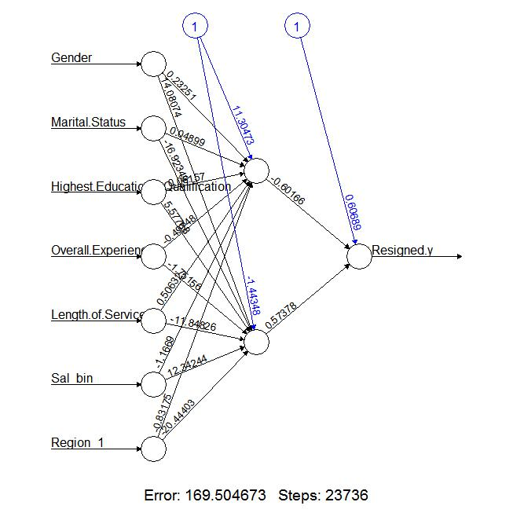

AUC Curve:

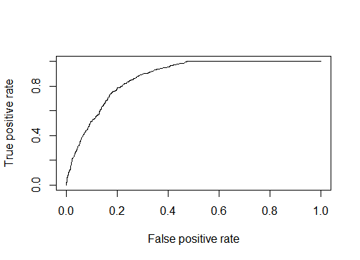

Random Forest

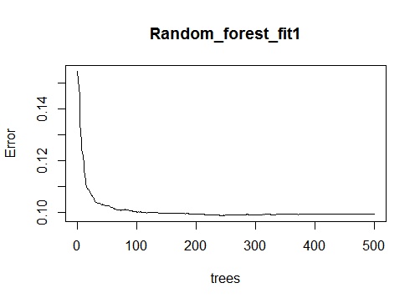
Tree based Model Result

> confusionMatrix(test1_nn_m$Resigned.y,prediction_modified)
Confusion Matrix and Statistics

Reference
Prediction 0 1
0 1808 87
1 149 101

Accuracy : 0.89
95% CI : (0.876, 0.9029)
No Information Rate : 0.9124
P-Value [Acc > NIR] : 0.9998

Kappa : 0.4013
Mcnemar's Test P-Value : 7.164e-05

Sensitivity : 0.9239
Specificity : 0.5372
Pos Pred Value : 0.9541
Neg Pred Value : 0.4040
Prevalence : 0.9124
Detection Rate : 0.8429
Detection Prevalence : 0.8834
Balanced Accuracy : 0.7305

'Positive' Class : 0

Modified Tree:

Confusion Matrix and Statistics

Reference
Prediction 0 1
0 1823 72
1 164 86

Accuracy : 0.89
95% CI : (0.876, 0.9029)
No Information Rate : 0.9263
P-Value [Acc > NIR] : 1

Kappa : 0.3642
Mcnemar's Test P-Value : 3.15e-09

Sensitivity : 0.9175
Specificity : 0.5443
Pos Pred Value : 0.9620
Neg Pred Value : 0.3440
Prevalence : 0.9263
Detection Rate : 0.8499
Detection Prevalence : 0.8834
Balanced Accuracy : 0.7309

'Positive' Class : 0

Regression Model:
1St Iteration: (Full model)

Call:
glm(formula = Resigned.y ~ ., family = binomial(link = "logit"),
data = train_nn, control = list(maxit = 50))

Deviance Residuals:
Min 1Q Median 3Q Max
-2.70271718 -0.55025812 -0.21687409 -0.09463829 2.34219566

Coefficients:
Estimate Std. Error z value Pr(>|z|)
(Intercept) -3.834811821 0.452538533 -8.47400 < 0.000000000000000222 ***
Gender 0.185362421 0.080088864 2.31446 0.02064254 *
Marital.Status 0.016885714 0.116569986 0.14485 0.88482557
Highest.Educational.Qualification 0.070290734 0.025291743 2.77920 0.00544935 **
Overall.Experience 0.092974297 0.011207964 8.29538 < 0.000000000000000222 ***
Department.Technology -0.010169090 0.003531915 -2.87920 0.00398685 **
Length.of.Service -0.221930007 0.009725870 -22.81852 < 0.000000000000000222 ***
Job.title 0.025786262 0.002255520 11.43251 < 0.000000000000000222 ***
Supporting.market 0.005399809 0.001570835 3.43754 0.00058702 ***
Final_Age -0.004705246 0.010597303 -0.44400 0.65703964
Sal_bin 0.692932970 0.023757398 29.16704 < 0.000000000000000222 ***
Region_1 -0.064782231 0.014816641 -4.37226 0.000012297 ***
---
Signif. codes: 0 ‘***’ 0.001 ‘**’ 0.01 ‘*’ 0.05 ‘.’ 0.1 ‘ ’ 1

(Dispersion parameter for binomial family taken to be 1)

Null deviance: 6828.0534 on 6664 degrees of freedom
Residual deviance: 4437.4434 on 6653 degrees of freedom
AIC: 4461.4434

Number of Fisher Scoring iterations: 6

2nd Iteration:

> summary(Regression_fit_1)

Call:
glm(formula = Resigned.y ~ Overall.Experience + Length.of.Service +
Job.title + Sal_bin + Region_1, family = binomial(link = "logit"),
data = train_nn)

Deviance Residuals:
Min 1Q Median 3Q Max
-2.68586157 -0.55236568 -0.22921162 -0.09939932 2.20617495

Coefficients:
Estimate Std. Error z value Pr(>|z|)
(Intercept) -3.295288254 0.164300047 -20.05653 < 0.000000000000000222 ***
Overall.Experience 0.095004291 0.011057142 8.59212 < 0.000000000000000222 ***
Length.of.Service -0.221957470 0.009603360 -23.11248 < 0.000000000000000222 ***
Job.title 0.024492005 0.002103927 11.64109 < 0.000000000000000222 ***
Sal_bin 0.689594884 0.023076028 29.88360 < 0.000000000000000222 ***
Region_1 -0.066094020 0.014770102 -4.47485 0.0000076464 ***
---
Signif. codes: 0 ‘***’ 0.001 ‘**’ 0.01 ‘*’ 0.05 ‘.’ 0.1 ‘ ’ 1

(Dispersion parameter for binomial family taken to be 1)

Null deviance: 6828.0534 on 6664 degrees of freedom
Residual deviance: 4461.2863 on 6659 degrees of freedom
AIC: 4473.2863

Number of Fisher Scoring iterations: 6

ANOVA Test.

> anova(Regression_fit_1, test = "Chisq")
Analysis of Deviance Table

Model: binomial, link: logit

Response: Resigned.y

Terms added sequentially (first to last)

Df Deviance Resid. Df Resid. Dev Pr(>Chi)
NULL 6664 6828.0534
Overall.Experience 1 291.44902 6663 6536.6044 < 0.000000000000000222 ***
Length.of.Service 1 140.84385 6662 6395.7606 < 0.000000000000000222 ***
Job.title 1 575.02627 6661 5820.7343 < 0.000000000000000222 ***
Sal_bin 1 1339.26319 6660 4481.4711 < 0.000000000000000222 ***
Region_1 1 20.18481 6659 4461.2863 0.0000070309 ***
---
Signif. codes: 0 ‘***’ 0.001 ‘**’ 0.01 ‘*’ 0.05 ‘.’ 0.1 ‘ ’ 1

Regression Accuracy:

Confusion Matrix and Statistics

Reference
Prediction 0 1
0 1831 64
1 171 79

Accuracy : 0.8904
95% CI : (0.8765, 0.9034)
No Information Rate : 0.9333
P-Value [Acc > NIR] : 1

Kappa : 0.3466
Mcnemar's Test P-Value : 4.689e-12

Sensitivity : 0.9146
Specificity : 0.5524
Pos Pred Value : 0.9662
Neg Pred Value : 0.3160
Prevalence : 0.9333
Detection Rate : 0.8536
Detection Prevalence : 0.8834
Balanced Accuracy : 0.7335

'Positive' Class : 0

3. Neural Network.

> confusionMatrix(Predict2, test1_nn_m$Resigned.y)
Confusion Matrix and Statistics

Reference
Prediction 0 1
0 1450 20
1 445 230

Accuracy : 0.7832168
95% CI : (0.7651651, 0.8004913)
No Information Rate : 0.8834499
P-Value [Acc > NIR] : 1

Kappa : 0.394261
Mcnemar's Test P-Value : <0.0000000000000002

Sensitivity : 0.7651715
Specificity : 0.9200000
Pos Pred Value : 0.9863946
Neg Pred Value : 0.3407407
Prevalence : 0.8834499
Detection Rate : 0.6759907
Detection Prevalence : 0.6853147
Balanced Accuracy : 0.8425858

'Positive' Class : 0

Random Forest:

Variable Importance.

> importance(Random_forest_fit1, type = 1)
%IncMSE
Gender 10.2921912017
Marital.Status 0.8180246774
Highest.Educational.Qualification 10.4905834686
Overall.Experience 4.2991566900
Department.Technology 27.5576329700
Length.of.Service 69.9562420265
Job.title 19.7097410240
Supporting.market 33.8604598296
Final_Age 23.3033236902
Year_aa 5.0084715867
Sal_bin 48.0078504177
Region_1 30.4631961873

Random Forest Accuracy:

> confusionMatrix(Pred_rf, test1_nn_m$Resigned.y)
Confusion Matrix and Statistics

Reference
Prediction 0 1
0 1795 132
1 100 118

Accuracy : 0.8918415
95% CI : (0.8779257, 0.9046759)
No Information Rate : 0.8834499
P-Value [Acc > NIR] : 0.11878005

Kappa : 0.4438907
Mcnemar's Test P-Value : 0.04182575

Sensitivity : 0.9472296
Specificity : 0.4720000
Pos Pred Value : 0.9314997
Neg Pred Value : 0.5412844
Prevalence : 0.8834499
Detection Rate : 0.8368298
Detection Prevalence : 0.8983683
Balanced Accuracy : 0.7096148

'Positive' Class : 0

`SVM

Parameter tuning of ‘svm’:

- sampling method: fixed training/validation set

- best parameters:
gamma cost
0.5 4

- best performance: 0.08120514246

- Detailed performance results:
gamma cost error dispersion
1 0.5 4 0.08120514246 NA
2 1.0 4 0.08390632239 NA
3 2.0 4 0.08722467421 NA
4 0.5 8 0.08394257390 NA
5 1.0 8 0.08856142621 NA
6 2.0 8 0.09064848188 NA
7 0.5 16 0.08816968407 NA
8 1.0 16 0.09193653967 NA
9 2.0 16 0.09442346754 NA

SVM Accuracy:

> confusionMatrix(train_nn_m$Resigned.y,pred_svm2)
Confusion Matrix and Statistics

Reference
Prediction 0 1
0 4369 59
1 435 140

Accuracy : 0.9012592
95% CI : (0.8926575, 0.9093895)
No Information Rate : 0.9602239
P-Value [Acc > NIR] : 1

Kappa : 0.3216685
Mcnemar's Test P-Value : <0.0000000000000002

Sensitivity : 0.9094505
Specificity : 0.7035176
Pos Pred Value : 0.9866757
Neg Pred Value : 0.2434783
Prevalence : 0.9602239
Detection Rate : 0.8732760
Detection Prevalence : 0.8850690
Balanced Accuracy : 0.8064840

'Positive' Class : 0

control = list(minsplit = 20,
minbucket = 7, cp = 0, maxcompete = 4, maxsurrogate = 5,
usesurrogate = 2, surrogatestyle = 0, maxdepth = 30, xval = 0))
n= 6665

CP nsplit rel error
1 0.19735666 0 1.0000000
2 0.10648622 1 0.8026433
3 0.02551757 2 0.6961571

Variable importance
Sal_bin Length.of.Service Job.title Department.Technology
40 26 9 9
Final_Age Overall.Experience Supporting.market Region_1
7 5 2 1

Node number 1: 6665 observations, complexity param=0.1973567
mean=0.2087022, MSE=0.1651456
left son=2 (5263 obs) right son=3 (1402 obs)
Primary splits:
Sal_bin < 2.865551 to the left, improve=0.19735670, (0 missing)
Job.title < 0.6319673 to the left, improve=0.10401800, (0 missing)
Department.Technology < 0.8052911 to the right, improve=0.09990234, (0 missing)
Supporting.market < 0.4882226 to the right, improve=0.08718747, (0 missing)
Length.of.Service < 2.231977 to the right, improve=0.08041137, (0 missing)
Surrogate splits:
Job.title < 0.6319673 to the left, agree=0.837, adj=0.224, (0 split)
Department.Technology < 0.8052911 to the right, agree=0.830, adj=0.190, (0 split)
Overall.Experience < 2.469979 to the left, agree=0.818, adj=0.136, (0 split)
Final_Age < 7.897639 to the left, agree=0.817, adj=0.132, (0 split)
Length.of.Service < 2.814231 to the left, agree=0.814, adj=0.116, (0 split)

Node number 2: 5263 observations, complexity param=0.1064862
mean=0.1155235, MSE=0.1021778
left son=4 (3405 obs) right son=5 (1858 obs)
Primary splits:
Length.of.Service < 0.4852123 to the right, improve=0.21795690, (0 missing)
Overall.Experience < 1.999507 to the left, improve=0.05376810, (0 missing)
Final_Age < 5.891889 to the right, improve=0.02846568, (0 missing)
Supporting.market < 0.7501957 to the right, improve=0.02396520, (0 missing)
Department.Technology < 3.191339 to the left, improve=0.01720625, (0 missing)
Surrogate splits:
Supporting.market < 0.7501957 to the right, agree=0.681, adj=0.096, (0 split)
Final_Age < 5.641171 to the right, agree=0.677, adj=0.084, (0 split)
Department.Technology < 3.191339 to the left, agree=0.661, adj=0.040, (0 split)
Region_1 < 3.256888 to the left, agree=0.661, adj=0.040, (0 split)
Job.title < 3.821897 to the left, agree=0.650, adj=0.010, (0 split)

Node number 3: 1402 observations
mean=0.5584879, MSE=0.2465792

Node number 4: 3405 observations
mean=0.005286344, MSE=0.005258398

Node number 5: 1858 observations
mean=0.3175457, MSE=0.2167104

Time Series:
R code:
Time Series.R
For Chennai Location:
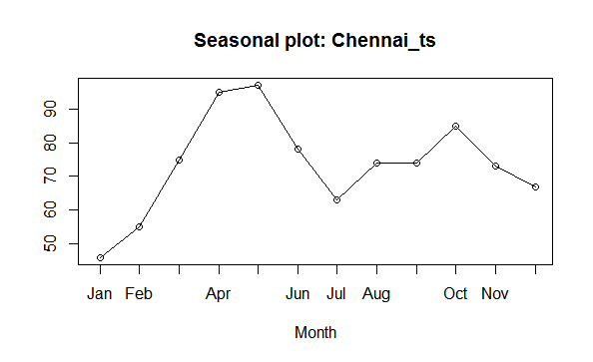
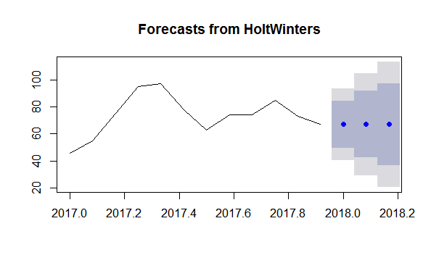
> forecast(fit1, 3)
Point Forecast Lo 80 Hi 80 Lo 95 Hi 95
Jan 2018 67.0004 49.55534 84.44545 40.32049 93.6803
Feb 2018 67.0004 42.33018 91.67061 29.27056 104.7302
Mar 2018 67.0004 36.78601 97.21478 20.79148 113.2093
For Bangalore Location:
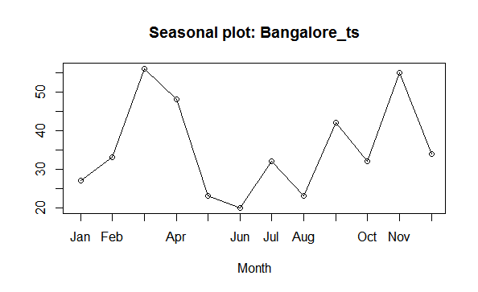

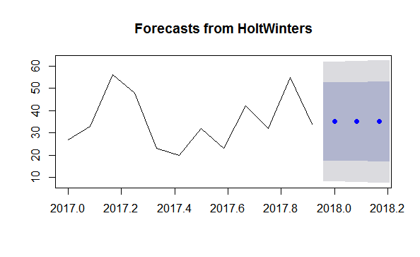
> forecast(fit2, 3)
Point Forecast Lo 80 Hi 80 Lo 95 Hi 95
Jan 2018 35.01909 17.48505 52.55314 8.203086 61.83510
Feb 2018 35.01909 17.28877 52.74942 7.902909 62.13528
Mar 2018 35.01909 17.09465 52.94354 7.606019 62.43217

For Delhi Location:
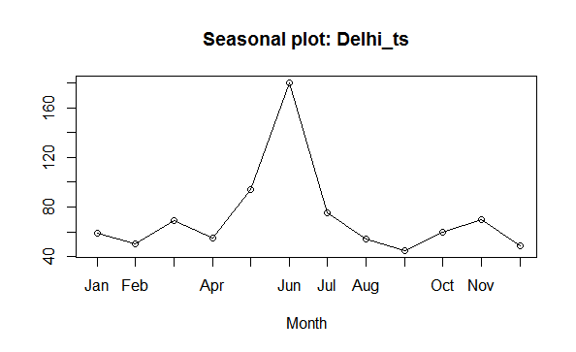

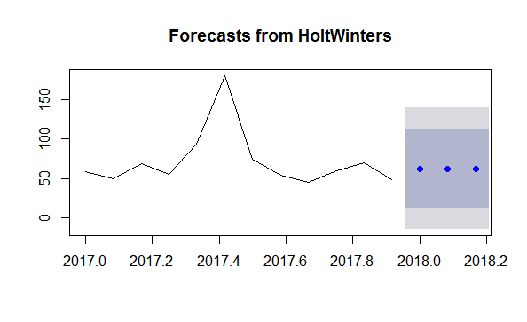
> forecast(fit3, 3)
Point Forecast Lo 80 Hi 80 Lo 95 Hi 95
Jan 2018 62.717 12.67375 112.7602 -13.81755 139.2515
Feb 2018 62.717 12.65174 112.7823 -13.85120 139.2852
Mar 2018 62.717 12.62975 112.8042 -13.88484 139.3188

Allsec Attrition as a whole:

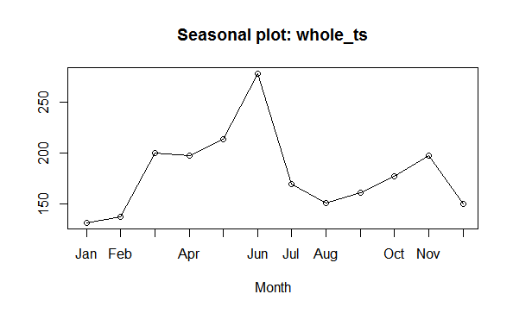

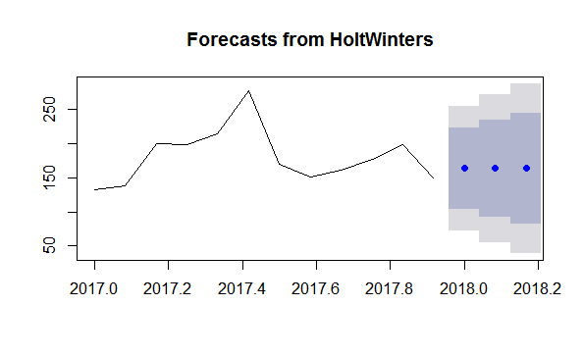

> forecast(fit4, 3)
Point Forecast Lo 80 Hi 80 Lo 95 Hi 95
Jan 2 163.5422 103.91038 223.1739 72.34322 254.7411
Feb 2 163.5422 92.30904 234.7753 54.60050 272.4838
Mar 2 163.5422 82.34877 244.7355 39.36759 287.7167

