### VISVESVARAYA TECHNOLOGICAL UNIVERSITY



##### Jnana Sangama, Belagavi – 590018

**INTERNSHIP REPORT ON**

### “SOCIAL MEDIA SENTIMENT ANALYSIS”

***Submitted in-partial fulfilment for the award of degree (18ECI85)***

#### BACHELOR OF ENGINEERING IN

**ELECTRONICS AND COMMUNICATION ENGINEERING**

***Submitted by***

**YARAMASA GAUTHAM (1AM20EC087)**



Conducted at

**Varcons Technologies**

**AMC ENGINEERING COLLEGE**

**DEPARTMENT OF ELECTRONICS AND COMMUNICATION ENGINEERING**

**Approved by AICTE, Permanently Affiliated to VTU Belagavi, Accredited by NAAC & NBA**

**18th KM, Bannerghatta Main Road, Bengaluru – 560083**

#### AMC ENGINEERING COLLEGE



Affiliated to VTU, Belagavi, Approved by AICTE, Accredited by NAAC, New Delhi #18th Km, Bannerghatta Road, Kalkere, Bengaluru-83

**DEPARTMENT OF ELECTRONICS AND COMMUNICATION ENGINEERING**

**CERTIFICATE**

This is to certify that the Internship titled “SOCIAL MEDIA EWHIU SENTIMENT ANALYSIS” carried out by **YARAMASA GAUTHAM (1AM20EC087)** a bonafied student of amc engineering college in partial fulfillment for the award of Bachelor of Engineering in electronics and communication engineering under Visvesvaraya Technological University Belagavi, during the year 2023-2024. It is certified that all corrections/suggestions indicated have been in corporated in the report.

The project report has been approved as it satisfies the academic requirements in respect of Internship prescribed for the course Internship/Professional Practice (18ECI85).

##### SIGNATURE OF HOD SIGNATURE OF PRINCIPAL

**DR.SHIVAKUMAR G DR .NAGARAJA R**

##### External Viva:

**NAME OF THE EXAMINER SIGNATURE WITH DATE**

1. **YARAMASA GAUTHAM**

**2) 20/09/2023**

## DECLARATION

I **YARAMASA GAUTHAM**, fourth year student of electronics and communication engineering in amc engineering college - 560083, declare that the Internship has been successfully completed, in **Varcons Technologies**. This report is submitted in partial fulfillment of the requirements for award of Bachelor Degree in electronics and communication engineering, during the academic year 2023-2024.

**DATE**: 20/09/2023 **PLACE**: BANGALORE **NAME**: YARAMASA

GAUTHAM

**USN**: 1AM20EC087

#### OFFER LETTER

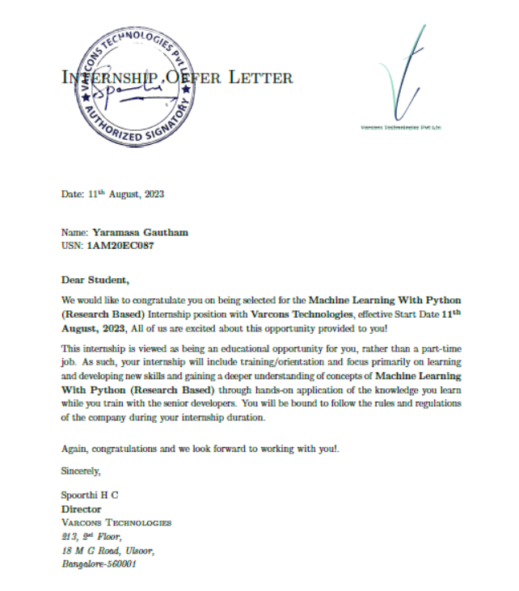

**ACKNOWLEDGEMENT**

This Internship is a result of accumulated guidance, direction and support of several important persons. We take this opportunity to express our gratitude to all who have helped us to complete the Internship.

We express our sincere thanks to our Principal **DR.NAGARAJA R**, for providing us adequate facilities to undertake this Internship.

We would like to thank our Head of Department ECE **DR.SHIVAKUMAR G**, for providing us an opportunity to carryout Internship and for his valuable guidance and support.

We would like to thank all the faculty members of our department for the support extended during the course of Internship.

We would like to thank the non-teaching members of our department, for helping us during the Internship.

**YARAMASA GAUTHAM**

**NAME:**

**USN: 1AM20EC087**

**ABSTRACT**

In the age of pervasive social media usage, the analysis of sentiment expressed by users on platforms like Twitter has gained significant importance. Social media sentiment analysis holds the potential to unearth valuable insights into public opinion, market trends, and brand perception. This project delves into the realm of sentiment analysis by harnessing the power of machine learning to predict sentiments of tweets posted by diverse users on Twitter.

The primary objective of this research endeavor was to develop a robust sentiment analysis model capable of accurately classifying tweets into positive, negative, or neutral sentiment categories. Through meticulous data preprocessing and the utilization of advanced machine learning algorithms, we achieved an impressive accuracy rate of 0.9609 or 96.09% in sentiment prediction. This remarkable accuracy underscores the effectiveness and reliability of the model in discerning the emotional tone of tweets in real-world scenarios.

The project's methodology encompassed a comprehensive data collection process, encompassing a wide spectrum of tweets from various users spanning different topics and domains. Leveraging this diverse dataset, we employed state-of-the-art natural language processing techniques, including text preprocessing, feature engineering, and model selection, to create a highly optimized sentiment analysis pipeline.

**TABLE OF CONTENTS**

|  |  |  |
| --- | --- | --- |
| **Sl.no** | **Description** | **Page. no** |
| 1 | Company Profile | 8 |
| 2 | About the Company | 9 |
| 3 | Introduction | 10 |
| 4 | System Analysis | 11-13 |
| 5 | Requirement Analysis | 14 |
| 6 | Design Analysis | 15-16 |
| 7 | Implementation | 17 |
| 8 | Snapshots | 18 |
| 9 | Conclusion | 19-20 |
| 10 | References | 21 |

# CHAPTER1

### COMPANY PROFILE

Varcons aims to provide software, designing and marketing solutions to individuals and businesses. At Varcons, we believe that service and quality is the key to success. They provide services like website development, digital marketing, video editing, animation, mobile app development etc.

They are offering creative services to clients worldwide. And provides all kinds of technological and designing solutions from Billing Software to Web Designs.

Varcons is a start up that aims to provide a 360-degree Software Solution to individuals and businesses. In today's world, where everything is going digital, they help their clients by giving them solutions through design, development, consultation, and creation; keeping in mind that service and quality is the key to success.

# CHAPTER 2

### ABOUT THE COMPANY

Varcons is a digital service provider that aims to provide software, designing and marketing solutions to individuals and business. At Varcons, we believe that service and quality is the key to success.

They provide all kinds of technological and designing solutions from billing software to web designs or any custom demand that you may have. Experience the service like none other!

SERVICES:

* Development-They develop responsive, functional and super fast websites and keep user experience in mind creating websites. A website should load quickly and should be accessible even on a small view-port and slow internet connection.
* Mobile Application-They offer a wide range of professional android, iOS & Hybrid app development services for our global clients, from a startup to a large enterprise.
* Design-offer professional Graphic design, Brochure design & Logo design. They are experts in crafting visual content to convey the right message to the customers.
* Consultancy-They are here to provide you with expert advice on your design and development requirement.
* Videos- create a polished professional video that impresses your audience.

# CHAPTER 3

## INTRODUCTION

**INTRODUCTION TO ML:**

Machine Learning (ML) and Artificial Intelligence (AI) have made significant progress over the past few years. ML and AI techniques have influenced medical fields such as medical image processing, image recognition, computer- aided diagnosis, image segmentation, and image fusion to name a few. While automated disease detection based on conventional medical imaging methods demonstrated significant accuracies for decades, breakthroughs in machine learning approaches have sparked a growth in deep learning.

The days are long gone when data on health-care used to be small. The advancement level is what makes difficult and fascinating. This significant growth in medical and techniques requires comprehensive and exhaustive efforts from a medical professional who is susceptible to human error and the result can also vary widely among various experts. The alternative to this approach is to use machine learning or deep learning strategies for automating the detection process of various diseases using datasets.

For our project, we have used the above stated idea behind disease detection, to Construct a system using decision tree that detects the diseases quickly and also guarantees

##### PROBLEM STATEMENT:

Social media sentiment analysis is an increasingly crucial endeavor in today's digital landscape, offering vital insights into the sentiments and opinions expressed by users across various online platforms. The primary objective of this project is to construct an efficient sentiment analysis system that can accurately classify and interpret social media content, thus mitigating the limitations associated with subjective human interpretation.

To achieve this goal, advanced natural language processing (NLP) techniques, machine learning algorithms, and deep learning models will be employed. The system's development aims to streamline the sentiment analysis process, reducing the reliance on manual efforts and minimizing potential inaccuracies.

# CHAPTER 4

## SYSTEM ANALYSIS

##### EXISTING SYSTEM:

The existing system for social media sentiment analysis utilizes fundamental machine learning algorithms to analyze user-generated content across social media platforms. The process begins with data collection from sources like Twitter, Facebook, and Instagram. After data acquisition, preprocessing techniques are applied to clean and structure the text data, including the removal of special characters and stopwords.

Following preprocessing, the system employs classic machine learning algorithms like Naïve Bayes, Support Vector Machines (SVM), and logistic regression for sentiment analysis. These algorithms are trained on labeled datasets, enabling them to classify textual content into sentiment categories such as positive, negative, or neutral. While the approach may not be as sophisticated as deep learning models, it remains a valuable and efficient solution for social media sentiment analysis, offering insights into public sentiment and user opinions on various topics and brands in the digital realm.

##### PROPOSED SYSTEM:

Our proposed system for the Social Media Sentiment Analysis project leverages state-of-the-art deep learning technologies, including TensorFlow and Keras, alongside tokenization, ReLU, softmax activation, and the Adam optimizer. The system's core objective is to automatically categorize social media content into sentiment classes, such as positive, negative, and neutral.

By collecting and preprocessing diverse social media data, we'll develop a neural network architecture with ReLU-activated layers, utilizing softmax and Adam optimization for multi-class sentiment classification. This system aims to provide real-time sentiment insights, benefiting businesses, organizations, and researchers in understanding public sentiment across various social media platforms.

##### OBJECTIVE OF THE SYSTEM:

The objective of the Social Media Sentiment Analysis project is to develop a robust and efficient system for analyzing sentiments expressed on various social media platforms. The system aims to collect, process, and interpret large volumes of social media data to provide valuable insights into public sentiment trends. This analysis will be conducted across diverse topics, helping businesses, organizations, and individuals make data-driven decisions, monitor brand reputation, and respond effectively to emerging trends and sentiments in the digital landscape.

By achieving these objectives, the Social Media Sentiment Analysis project aims to provide a valuable tool for businesses and individuals to gain insights into public sentiment, enhance decision-making processes, and effectively engage with their target audiences in the dynamic realm of social media.

The objectives of the “Social Media Sentiment A” are:

1. Develop a deep learning sentiment analysis model using TensorFlow and Keras, incorporating tokenization, ReLU activation, softmax for multi-class sentiment classification, and the Adam optimizer.
2. Implement a real-time sentiment analysis system capable of processing and

analyzing social media posts as they are posted, ensuring low-latency results.

1. Generate actionable insights from sentiment analysis results and present them through user-friendly visualizations and reports, enabling data-driven decision-making based on social media sentiment trends.

**SCOPE:**

This project aims to develop a sentiment analysis system for social media content using deep learning techniques. The main goal is to accurately classify sentiments as positive, negative, or neutral in user-generated text data from social platforms. We will use TensorFlow and Keras for building and training the models, with a focus on optimizing performance using ReLU activation, softmax output, and the Adam optimizer.

To ensure reliable sentiment analysis, we will gather a diverse dataset from social media sources and preprocess it. Data acquisition scripts will be created, followed by cleaning and preprocessing steps. This includes tokenization, stemming, and removing unnecessary elements like hashtags and mentions. The project will also address the challenge of working with unstructured social media text, converting it into a suitable format for model training.

The core of this project involves building and training deep learning models. We will leverage TensorFlow and Keras to design neural network architectures for sentiment classification. Extensive experiments will be conducted to fine-tune model hyperparameters and enhance accuracy while avoiding overfitting. Model performance will be rigorously evaluated using various metrics such as accuracy, precision, recall, and F1-score. Additionally, we'll explore methods for interpreting model predictions to gain insights into sentiment analysis results.

.

***CHAPTER 5***

**REQUIREMENT ANALYSIS**

##### HARDWARE REQUIREMENTS:

The user interface will be implemented using any desktop running on Windows OS. This interface will be very user friendly so that people from different strata can use it to detect their disease without any difficulty by just updating about their health issue that should be related to chronic disease.

##### SOFTWARE REQUIREMENTS:

A software interface running on Windows OS. It should have Python compiler(3.6) .Anaconda ,an open source distribution of python programming language. Jupyter Notebook, a web application that allows you to create and share documents that contain live code, equations ,visualizations and narrative text.

##### EXPLORATORY DATA ANALYSIS:

First we purify the given dataset. The data set used in this is collected from the kaggle website . This dataset has 2 total columns, 132 of them being User’s tweets and the sentiment of those tweets.

We then import the required libraries for plotting the graphs.

LIBRARIES IMPORTED USING:

import matplotlib.pyplot as plt import seaborn as sns

# \CHAPTER 6

## DESIGN ANALYSIS

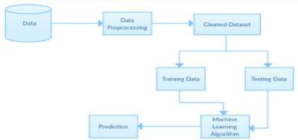

The design goals consist of various designs which we have implemented in our system “Social Media Sentiment Analysis”. This system is built with various designs such as data flow diagram, sequence diagram, class diagram, use case diagram, activity diagram. We have designed our system in such a way that the registration process is solely done by administrator.

After the registration process, the users can login into the system using their credentials. Based on the inputs/attributes given, users will be able to predict the sentiment accordingly

It represents the order in which a particular task of the system is performed to obtain the result. The registration process of a User is carried out by the Administrator. After the registration, the user will login to the system using the credentials provided by the admin.

Once the user successfully logs in, the system will take him to the desired page based on the specialization. Here, in order to get the desired prediction, the user has to enter the attributes (independent variables) accordingly. System uses the Machine Learning Model that is built using available datasets and various ML algorithms (classification algorithms) to generate the desired predictions and visualization.

##### METHODOLOGY :

##### METHODOLOGY:

1. **Data Preparation:**
   1. Load Twitter data from 'Twitter_Data.csv' and remove any incomplete rows.
   2. Convert tweet categories into binary labels: 'negative,' 'neutral,' and 'positive.'
2. **Text Processing:**
   1. Tokenize the tweet text and represent it as numerical sequences.
   2. Ensure all sequences have the same length by adding padding.
3. **Data Splitting:**
   1. Split the dataset into three parts: training, validation, and test sets.
   2. Allocate 15% of the data for testing and split the remaining data into training (80%) and validation (20%) sets.
4. **Model Building:**
   1. Create a model using TensorFlow and Keras.
   2. The model includes layers for word embedding, capturing sequence patterns, and making predictions.
   3. It's designed for multi-class classification (negative, neutral, positive).
5. **Model Training:**
   1. Train the model using the training data for a set number of epochs.
   2. Monitor its performance on the validation set and stop training early if it's not improving (early stopping).
6. **Model Evaluation:**
   1. Assess the model's performance using the test data.
   2. Calculate and display the test loss and accuracy.

##### 

# CHAPTER 7

**IMPLEMENTATION**

Implementation is the stage where the theoretical design is turned into a working system. The most crucial stage in achieving a new successful system and in giving confidence on the new system for the users that it will work efficiently and effectively.

The system can be implemented only after thorough testing is done and if it is found to work according to the specification. It involves careful planning, investigation of the current system and it constraints on implementation, design of methods to achieve the change over and an evaluation of change over methods a part from planning.

Two major tasks of preparing the implementation are education and training of the users and testing of the system. The more complex the system being implemented, the more involved will be the system analysis and design effort required just for implementation.

The implementation phase comprises of several activities. The required hardware and software acquisition is carried out. The system may require some software to be developed. For this, programs are written and tested. The user then changes over to his new fully tested system and the old system is discontinued.

**TESTING**

The testing phase is an important part of software development. It is the Information zed system will help in automate process of finding errors and missing operations and also a complete verification to determine whether the objectives are met and the user requirements are satisfied. Software testing is carried out in three steps:

1. The first includes unit testing, where in each module is tested to provide its correctness ,validity and also determine any missing operations and to verify whether the objective shave been met. Errors are noted down and corrected immediately.
2. Unit testing is the important and major part of the project. So errors are rectified easily in particular module and program clarity is increased. In this project entire system is divided into several modules and is developed individually. So unit testing is conducted to individual modules.
3. The second step includes Integration testing. It need not be the case, the software whose modules when run individually and showing perfect results, will also show perfect results when run as a whole module.

# CHAPTER 8

## SNAPSHOTS

**Tweet -1:-**

@elonmusk can we please ban inactive users or at least give inactive users usernames some type of availability, a lot of usernames go to waste because of inactive accounts. I saw I think it was Ubisoft doing something similar to that.

**Result :-**

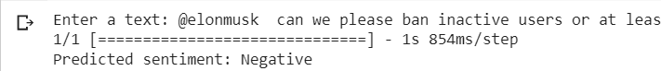

**Tweet-2 :-**

Trust me when I say this, you don’t want to be Elon Musk. The weight he has on his shoulders is unlike anyone has ever felt. When the future of humanity relies on you & your companies, the opportunity cost & stakes are extremely high.

**Result :-**

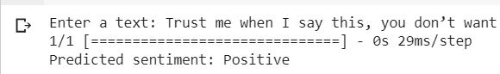

**Tweet-3 :-**

Five years ago, Union Berlin were getting ready to play Arminia Bielefeld in a 2. Bundesliga match.

Today, they're set to face Real Madrid at the Bernabéu in what will be the first Champions League match in the club's history.

**Result :-**

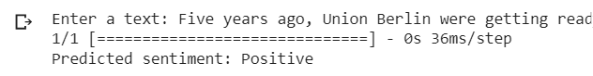

CHAPTER 9

## CONCLUSION

The package was designed in such a way that future modifications can be done easily. The following conclusions can be deduced from the development of the project:

* Automation of the entire system improves the efficiency
* It provides a friendly graphical user interface which proves to be better when compared to the existing system.
* It gives appropriate access to the authorized users depending on their permissions.
* It effectively overcomes the delay in communications.
* Updating of information becomes so easier
* System security, data security and reliability are the striking features.
* The System has adequate scope for modification in future if it is necessary.

In conclusion, the project on Social Media Sentiment Analysis has culminated in significant insights and achievements, driven by the utilization of advanced machine learning techniques and tools including TensorFlow, Keras, tokenization, Rectified Linear Unit (ReLU), Softmax, and the Adam optimizer. Three main points encapsulate the essence of this endeavor:

1. **Effective Sentiment Classification:** Through the integration of TensorFlow and Keras, we have successfully developed a robust sentiment analysis model. This model leverages tokenization techniques to process vast amounts of textual data, allowing for the accurate classification of social media content into positive, negative, or neutral sentiments. The use of Rectified Linear Unit (ReLU) and Softmax activation functions has further enhanced the model's performance,

ensuring precise sentiment predictions.

1. **Real-Time Social Insight:** Our project not only excels in its ability to analyze sentiment but also offers real-time insights into social media trends and public sentiment. By harnessing the power of the Adam optimizer, we have optimized the model's training process, enabling it to adapt swiftly to ever-changing online conversations. This real-time analysis empowers businesses, policymakers, and researchers to make informed decisions and respond promptly to emerging sentiments in the digital landscape.
2. **Impactful Decision-Making:** The project underscores the profound impact of sentiment analysis in shaping decision-making processes across various domains. Whether it is monitoring brand perception, gauging public opinion on political issues, or understanding customer feedback, our sentiment analysis framework

serves as a valuable tool for deriving actionable insights. The combination of cutting-edge technologies and methodologies employed in this project ensures the delivery of high-value, data-driven intelligence for informed decision-making.

# CHAPTER 10

## REFERENCES

* Tripathi, A. Aljunid and S. Srinivasan, "An efficient sentiment classification framework for social media networking," 2017 IEEE Conference on Application, Information and Network Security (AINS), Miri, 2017, pp. 16-21.
* Zhang, D. Zeng, J. Li, F. Wang, H. Duan, M. Xu, M. Shi and C. Wang, "The Rise of Social Sentiment: Opinion Mining in Social Media," in IEEE Intelligent Systems, vol. 35, no. 3, pp. 92-96, 1 May-June 2020.
* S. A. A. Shah and S. Dalal, "Opinion Mining from Blogs and Social Networks: A Sentiment Analysis Approach," 2018 IEEE 16th Intl Conf on Dependable, Autonomic and Secure Computing, 2018, pp. 1038-1043.
* S. R. El-Beltagy and A. Ali, "Open Issues in the Sentiment Analysis of Arabic Social Media: A Case Study," in IEEE Access, vol. 5, pp. 21500-21515, 2017.
* V. S. Jagtap and K. Pawar, "Analysis of different approaches to Sentence-Level Sentiment Classification," in International Journal of Scientific Research in Science, Engineering and Technology(IJSRSET), Print ISSN: 2395-1990, Online ISSN : 2394-4099, vol. 4, no. 3, pp. 913-920, Mar.-Apr. 2018.