**ENSF-381**: **Full Stack Web Development Laboratory**

**Lab04**

**Section: B02**

**Group information: Group 33**

Nicholas Lui (30207036)

Gauthier Appaix (30112909)

GitHub link: <https://github.com/Gauthier7k/ENSF381/tree/main/Lab_4>

**Exercise 1 Note:**

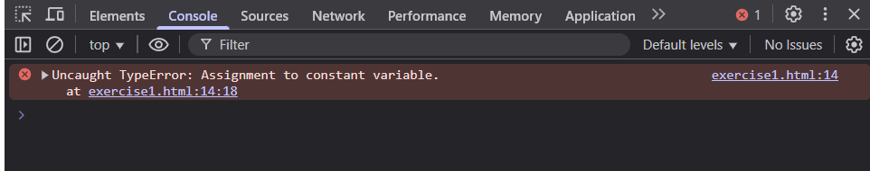

**Exercise 2 Sample Output (calculator function):**

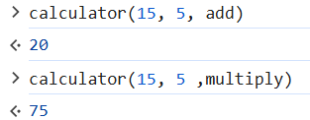

**Exercise 3 Sample Output:**

