Explanations about the supplementary data
The results presented in the manuscript can be reproduced using the RMarckdown script paper_results_v6.rmd. This scripts load “preprocessed” data that are available in the data directory. Some scripts are also provided to document how the “preprocessed” were obtained. The general workflow is shown in the figure below. A brief description of each file is given below.
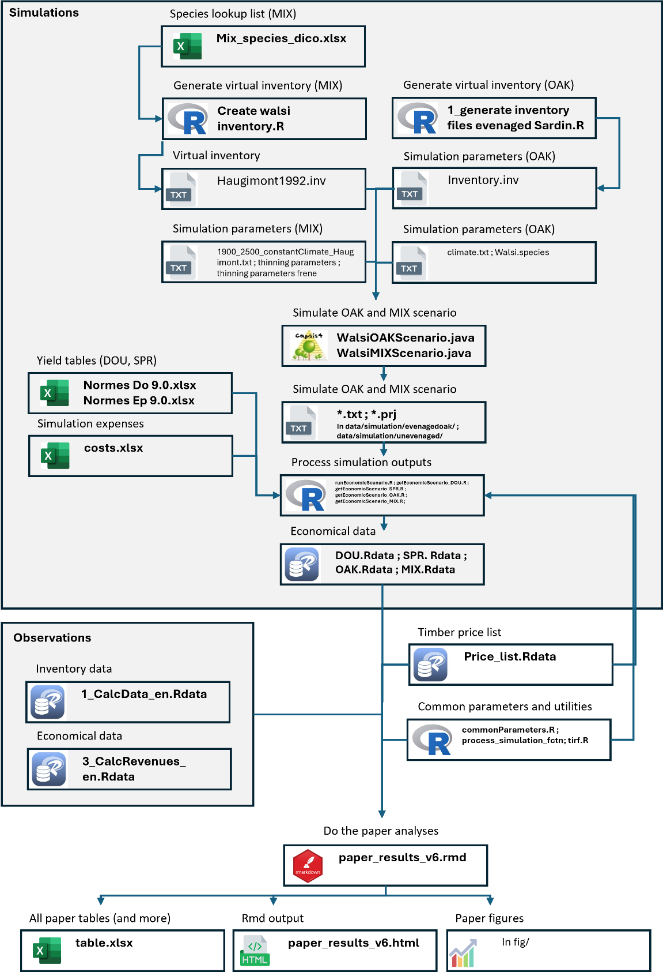
File description
paper_results_v6.rmd
A RMarckdown script that generates all the results (tables, figure, … ) showed in the manuscript.
paper_results_v6.html
The html output of the RMarckdown script paper_results_v6.rmd
tab/tables.xlsx
Tables generated by the script paper_results_v6.Rmd
Fig/
All the figures generated by the script paper_results_v6.Rmd
data/
directory with raw and processed data.
data/1_CalcData_en.Rdata
R data containing the following objects:
- block_sf : spatialized object for each forest block
- dendro_block : Inventory result with one line per block and inventory year
- dendro_zone : Inventory result with one line per zone and inventory year
- inventory_year : list of all inventory years per block
- price_list : the price list with one price per girth class and species group
- struct_block : Inventory result with one line per block, inventory year, species group and girth class
- struct_zone : Inventory result with one line per zone, inventory year, species group and girth class
- zone_sf : spatialized object for each forest zone
the attributes of these object are described in Calcdata_en_metadata.xlsx
data/3_CalcRevenues_en.Rdata
R data containing the following objects:
- cashflows : the list of all expenses and income for the study case
- estate_purchase : year and price of the purchase of each forest block
the attributes of these object are described in CalcRevenues_en_metadata.xlsx
data/simulation/Normes Do 9.0.xlsx
Local Douglas-fir yield table
data/simulation/Normes Ep 9.0.xlsx
Local Norway spruce yield table
data/simulation/cost.xlsx
File use to set the assumptions regarding the expenses of each simulated scenario.
data/simulation/*.rdata
Result for each simulated scenario. The attributes of these object are described in data/simulation/simulation_metadata.xlsx
data/simulation/Mix_species_dico.xlsx
Lookup table for the species names used in the MIX simulation.
data/simulation/evenagedoak/
Directory containing OAK simulation outputs. *.prj files are Capsis project. *.txt contains stand description at each simulated years. These files were generated using script/capsis simulations/java scenario scripts/WalsiOAKScenario.java
data/simulation/unevenaged/
Directory containing MIX simulation outputs. *.prj files are Capsis project. *.txt contains stand description at each simulated years. These files were generated using script/capsis simulations/java scenario scripts/WalsiMIXScenario.java
script/
Directory with the script required to reproduce the analyses.
script/capsis simulation/initial virtual inventories/evenagedoak/ 1_generate inventory files evenaged Sardin.R
R script used to generate the file inventory.inv. OAK simulations were run using the file that are in the same directory (inventory.inv, climate.txt, Walsi.species). These files set model parameters.
script/capsis simulation/initial virtual inventories/unevenaged/ 1900_2500_constantClimate_Haugimont.txt
File with climatic data used for MIX simulations. Climatic data has minor importance in the simulation as they affect only tree mortality.
script/capsis simulation/initial virtual inventories/unevenaged/haugimont1992.inv
Inventory file used to initialized MIX simulations. The file was generated using script/capsis simulation/initial virtual inventories/unevenaged/create walsi inventory.R.
script/capsis simulation/initial virtual inventories/unevenaged/thinning parameters
Parameters of the multicriteria thinning algorithm used in MIX1 and MIX2 simulations.
script/capsis simulation/initial virtual inventories/unevenaged/thinning parameters frene
Parameters of the multicriteria thinning algorithm used in MIX3 simulations.
script/capsis simulation/WalsiMIXScenario.java
Java script used within the Capsis4 plateform to run the MIX simulations.
script/capsis simulation/WalsiOAKScenario.java
Java script used within the Capsis4 plateform to run the OAK simulations.
Script/simulations/
R script used to extract information from the simulation output for each scenario. These scripts are used to produce the files data/simulation/*.rdata.
Script/simulations/tirf.R
A function to compute the internal rate of return.
Script/commonParameters.R
A script that set common economic parameters of this study (soil/land expectation value, management cost, discount rate, …)
Script/myGGplotConfigs.R
A script that set ggplot options.
Script/process_simulation_fctn.R
A script with a set of function used to process simulation outputs.

