**Screenshots of MLOPS assignment**

**Screenshot of mlflow ui**

Screenshot of all the experiments

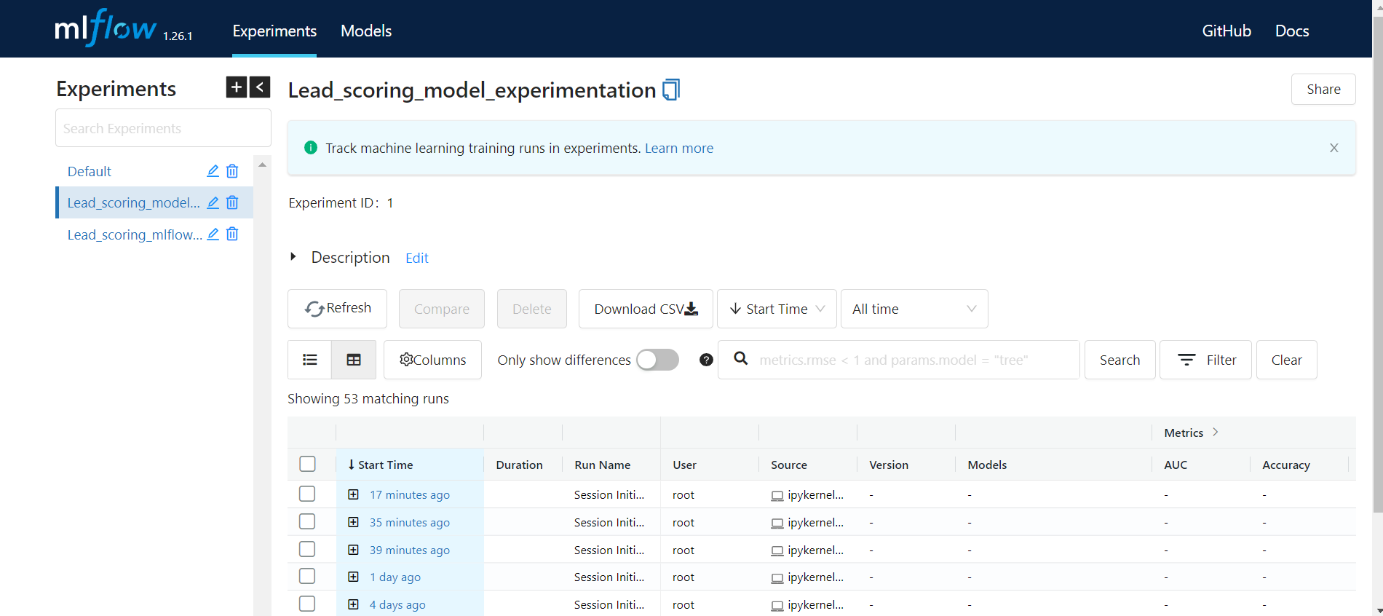

**Screenshot of mlflow ui after dropping features**

screenshot of all the experiments

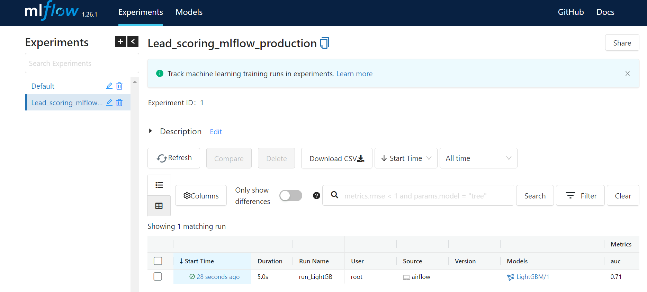

screenshot of one experiments with all the artifacts visible

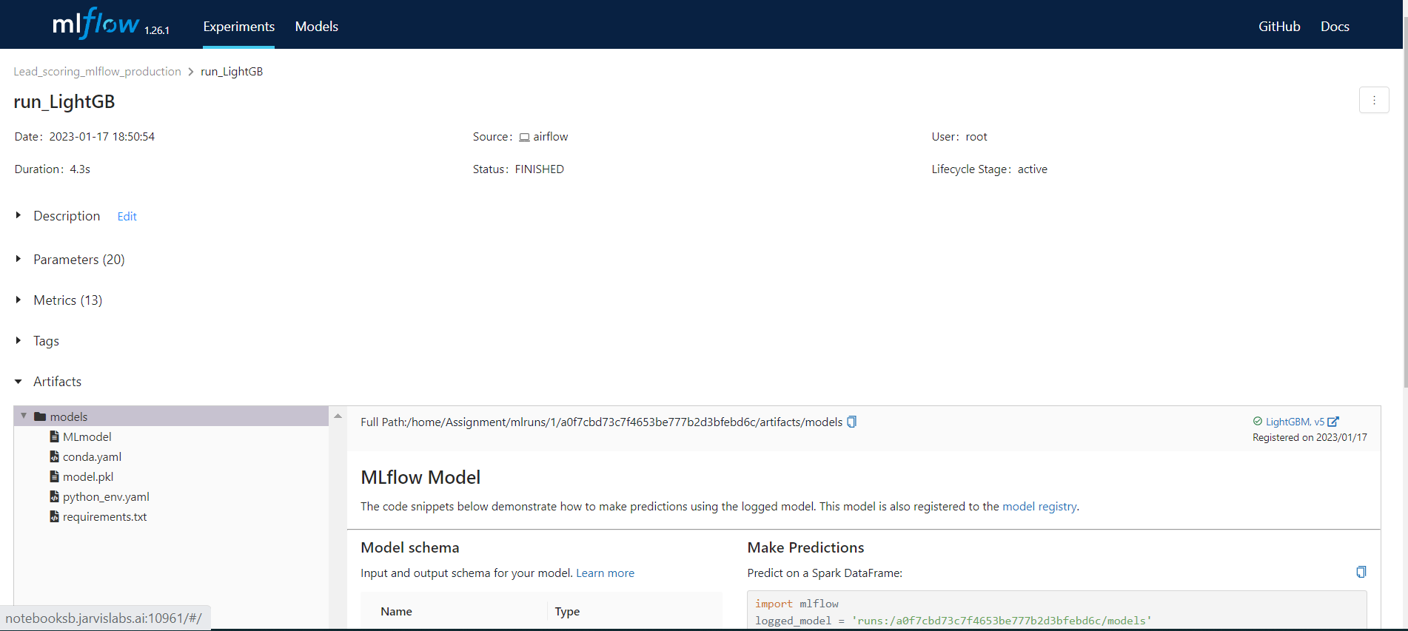

Metrics

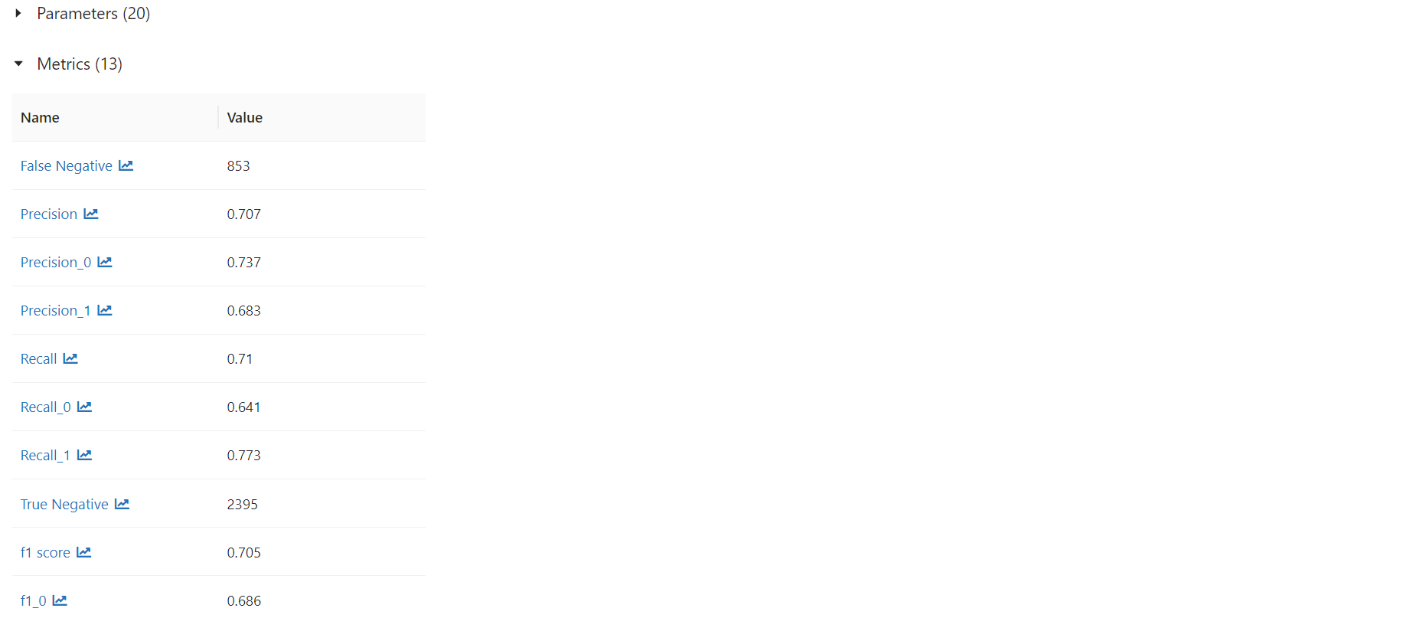

Artifacts

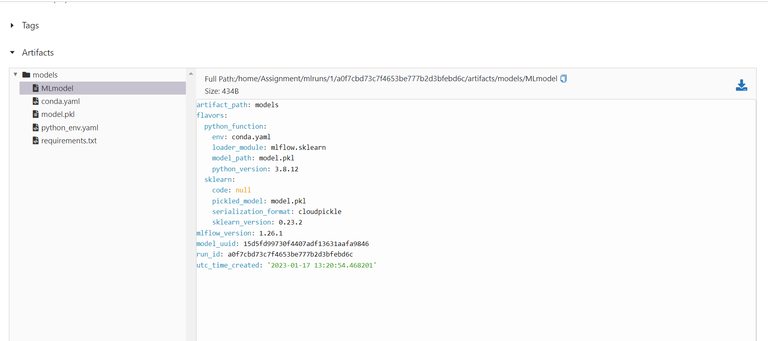

**Create an airflow dag python file for data pipeline**

Screenshot of sucessful execution Airflow DAG in graph

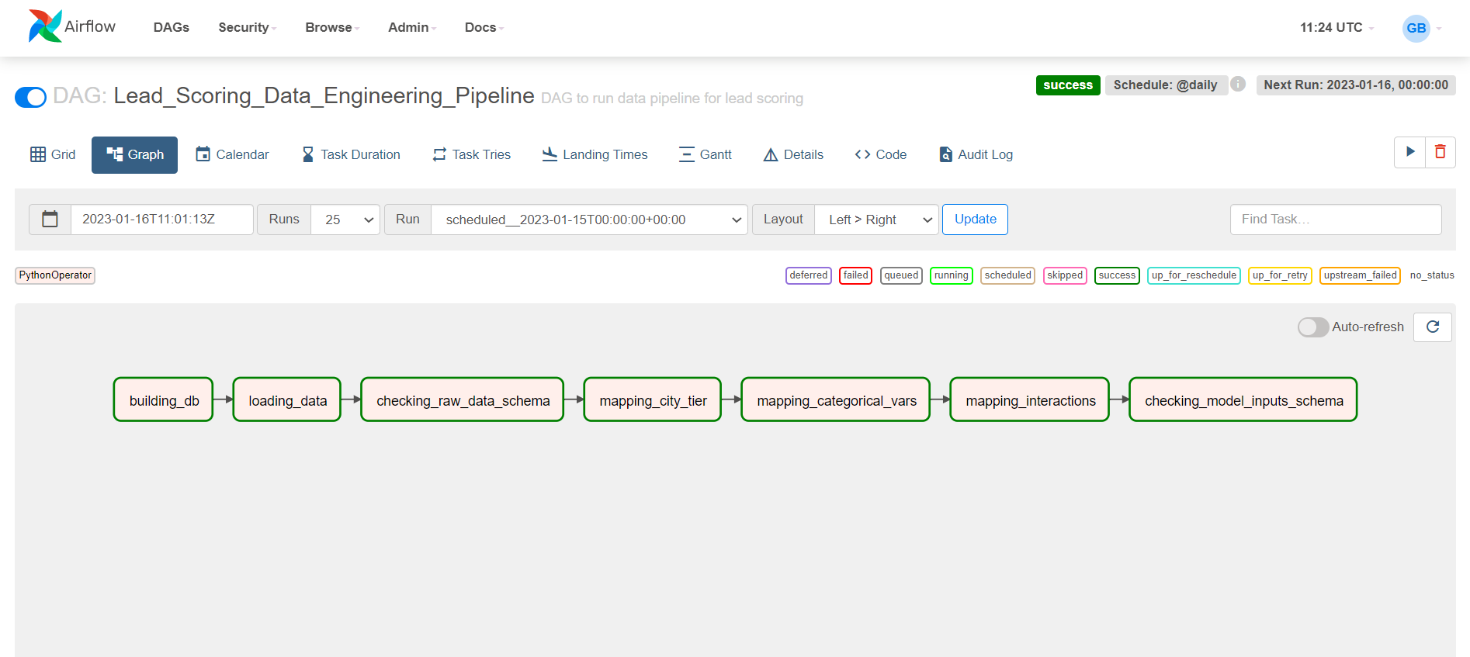

Screenshot of Airflow UI grid

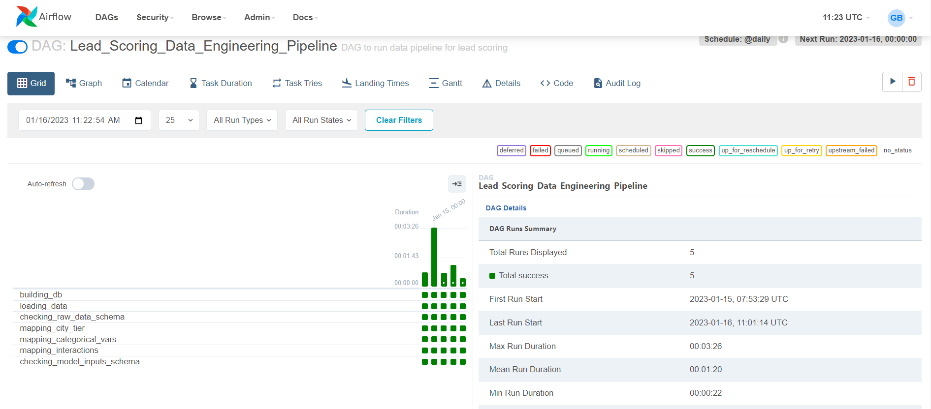

[**Training pipeline**](http://inutils.py/)

screenshot of experiments with all the artifacts visible

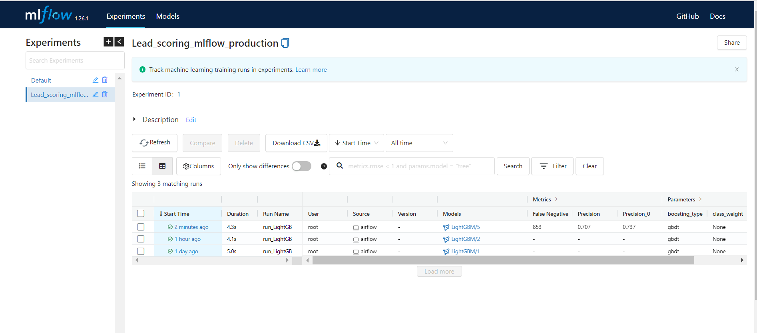



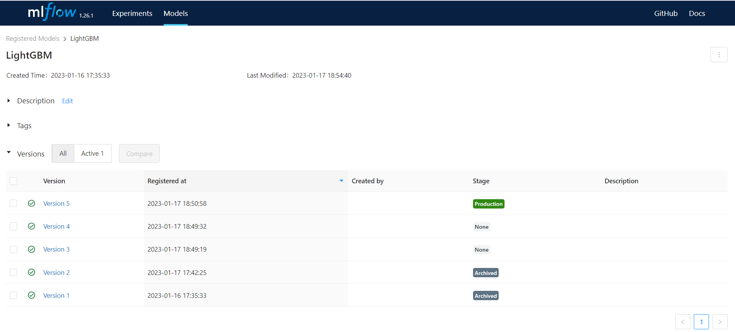

screenshot of model registry with model name and stage as 'production'

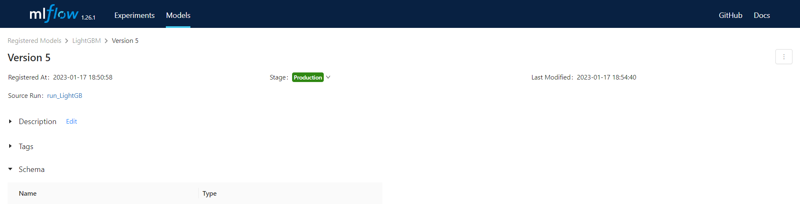

**Successful execution Airflow DAG in graph**

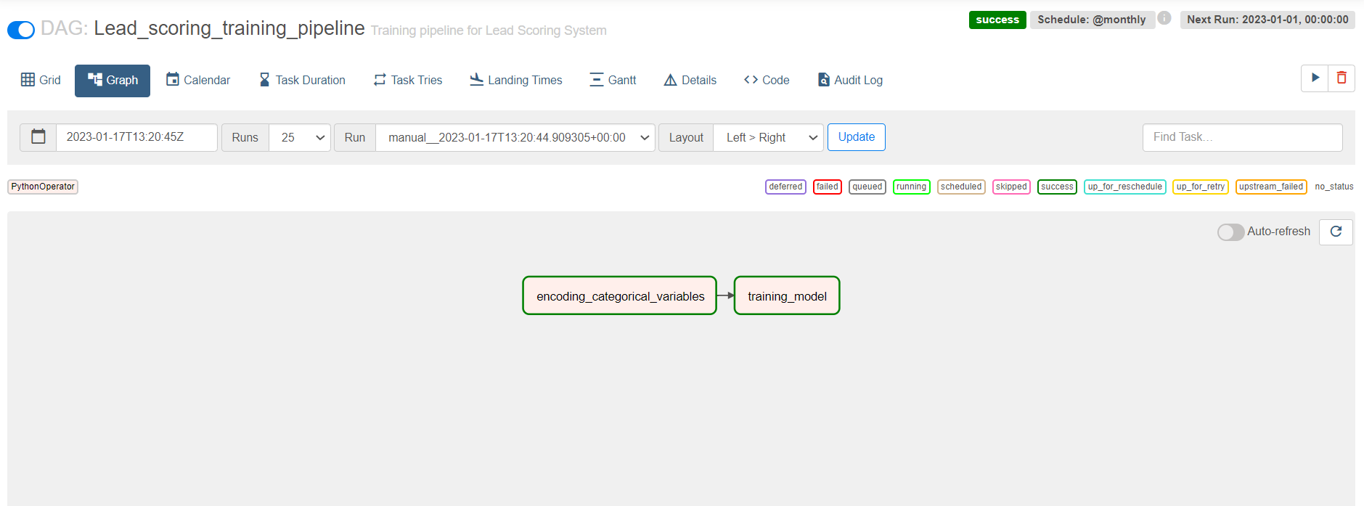

Screenshot of Airflow UI grid

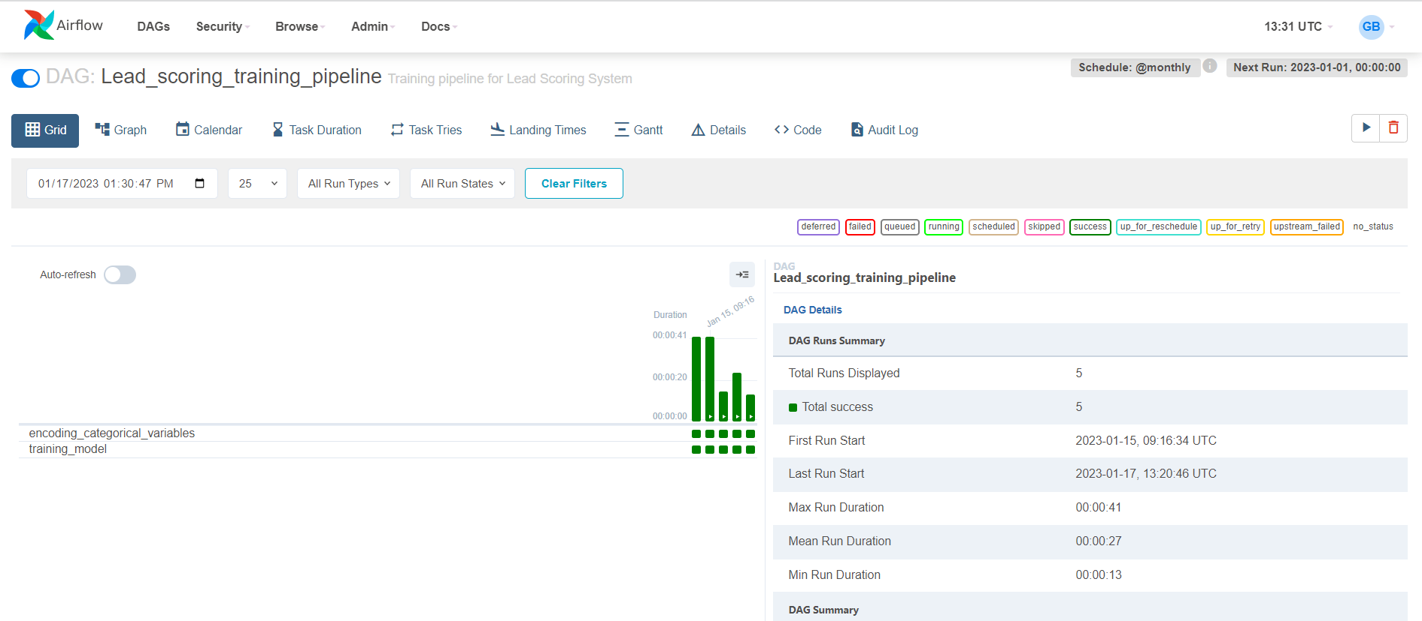

**Create an airflow dag python file for inference pipeline**

Screenshot of Airflow UI grid

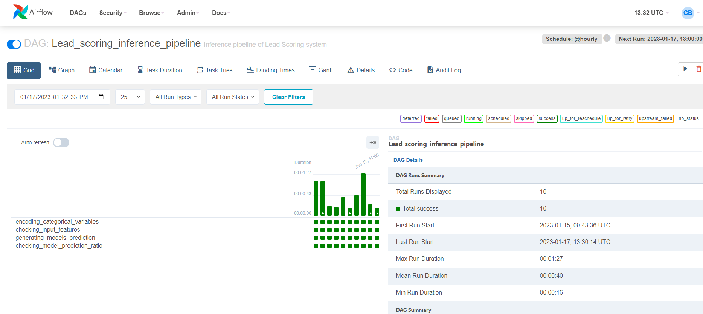

Screenshot of sucessful execution Airflow DAG in graph

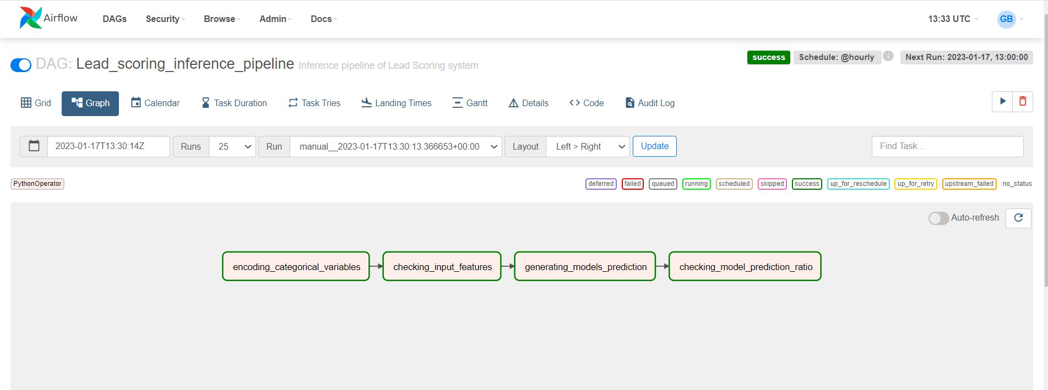

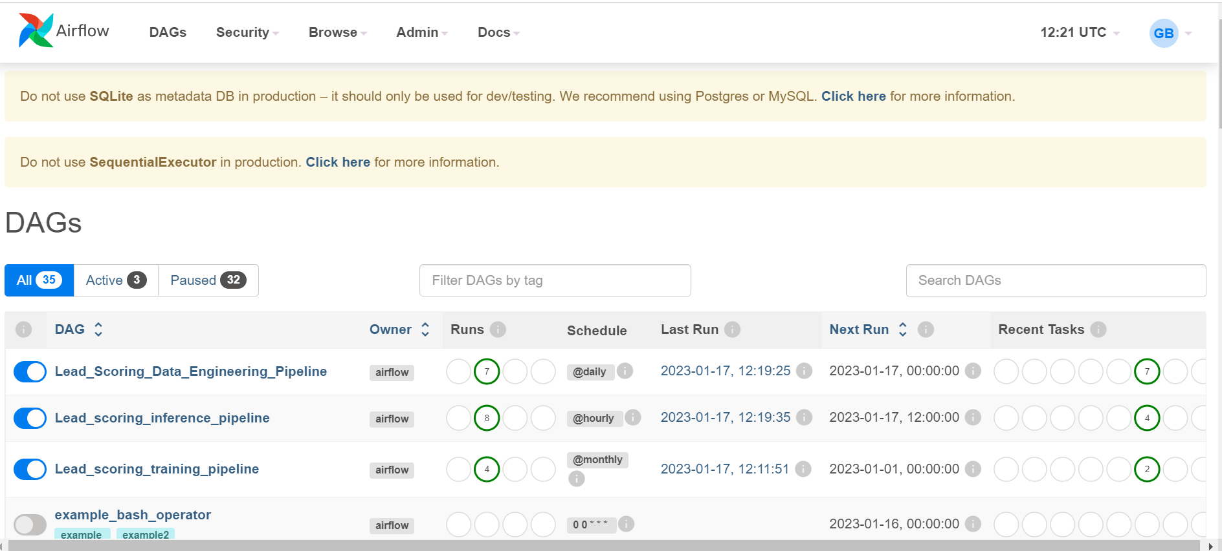

PyTest

