Gautier Lemaitre 22870 <https://github.com/Gautier78/CA2_mern_ReactJS>

**1)Set up the environment**

**On Github:**

First, we clone the repository of Erika.

Then we create a new repository on Github, the mine is named “CA2_mern_ReactJS”

Last, we push all the modifications on the repository.

**On GitPod:**

In my case, I didn’t use GitPod. We can use it if we need help. Just write “gitpod.io/# “ before your repository link. So, anyone that have access can modify your code.

**On MongoDB:**

Once logged, you can create a new project on the top left corner. In this project you must create a new cluster. In this cluster, select AWS Cloud, the Ireland region and choose the free options. You can rename the cluster.

You will have the option to change the ip address. Use 0.0.0.0/0 or your Own ip to allow the connection with the database.

Then choose the second option “Connect your application” and copy/paste the long link in your main JavaScript file of your project.

The link look like this:

mongodb+srv://admin:<password>@clusterbackend.wcefp.mongodb.net/<dbname>?retryWrites=true&w=majority

In yellow, this is the name of the admin, in green you have the password and the database name to replace

**2) Let’s start coding**

**Code**

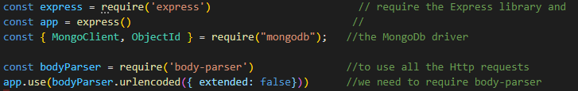

It allows us to use the Express library, the MongoDb driver and Http requests.

**Connection to the Database:**

We can see again the long link. Just under I created an instance of Mongo Client and a function dbName equal to “building” because it’s the name that I’ve given to my database.

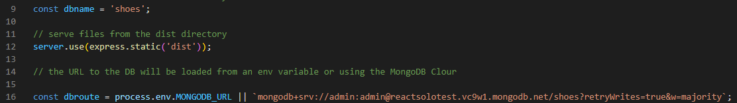

Now press Control + F to search for a specific word, here, search for every Users/User





Change every of them with a new one like, for example, I used “sneakers”.

Replace with your word the name of the files that had the word “User” inside.

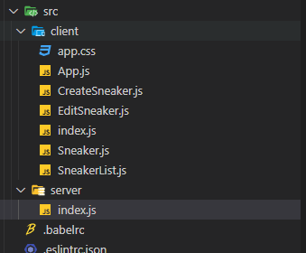

On your files are ready, your website should look like that:

(I’ve already added some shoes)

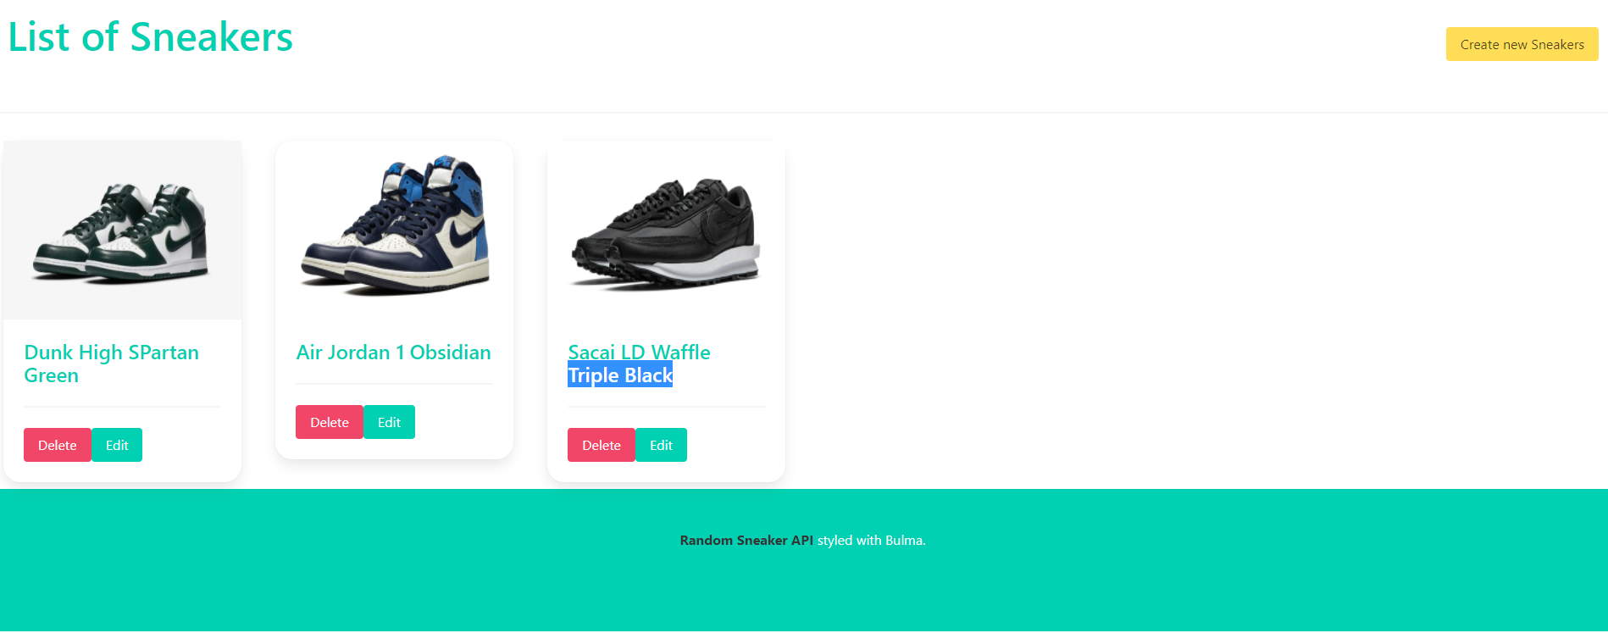

On mongo DB, it looks like that:

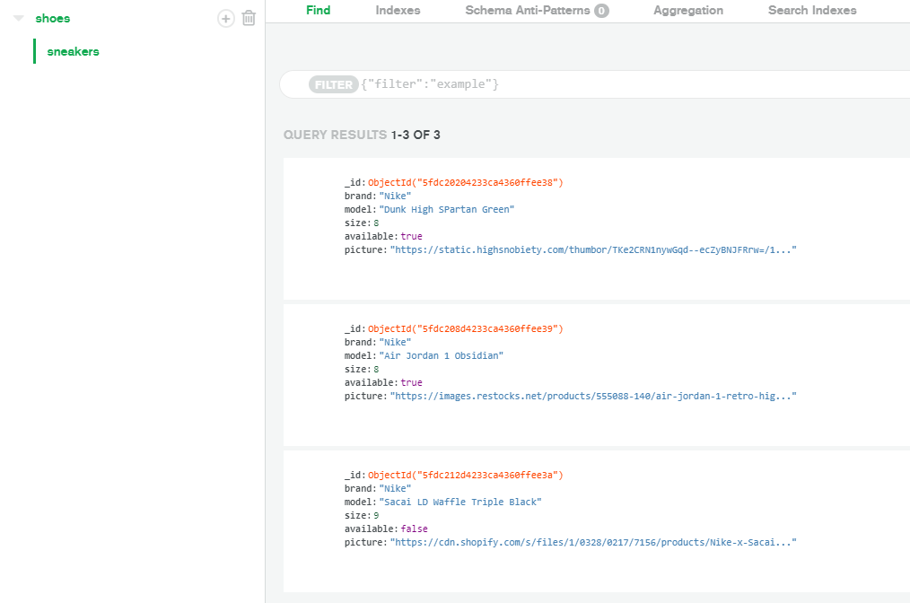

I have integer values, boolean values and strings.

We can now customize the style of the page with bulma or bootstrap. You can use :

npm install react-bootstrap bootstrap

or

npm install bulma

In the file SneakerList.js, import bulma or bootstrap.

