Intelligens beágyazott rendszerek laboratórium

1. mérés

Mérést végezték:
Papp Dániel
Pete Dávid Dorián
Mérésvezető:
Ország Bence

2024. 09. 16.
I. 224

Mérési feladatok

FIR szűrő tervezése és mérése

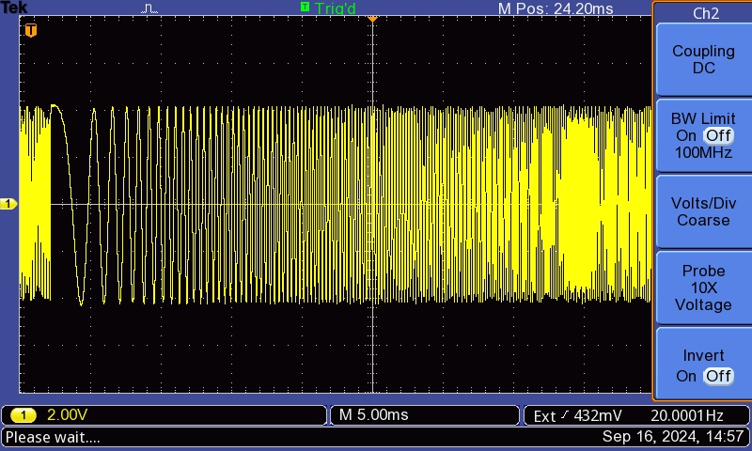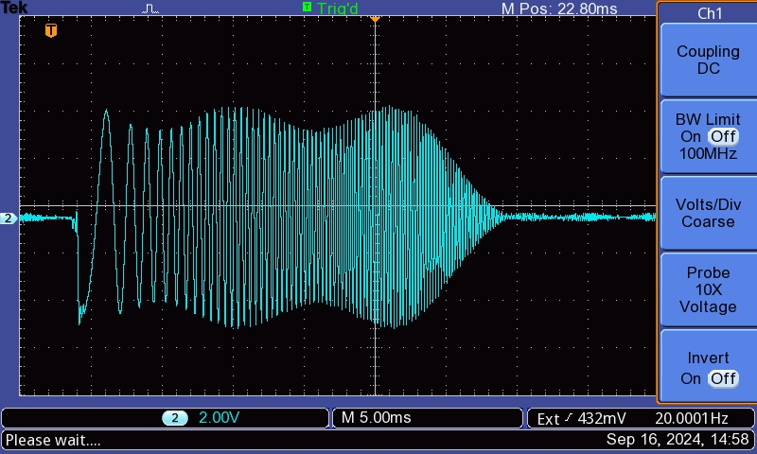
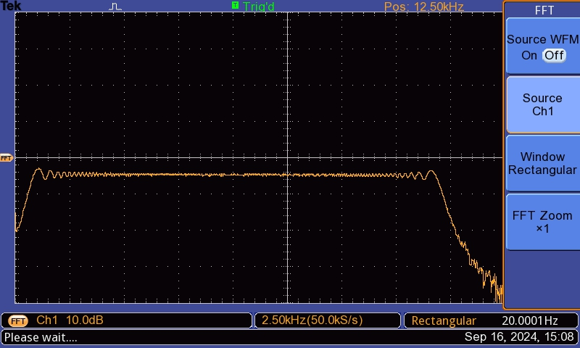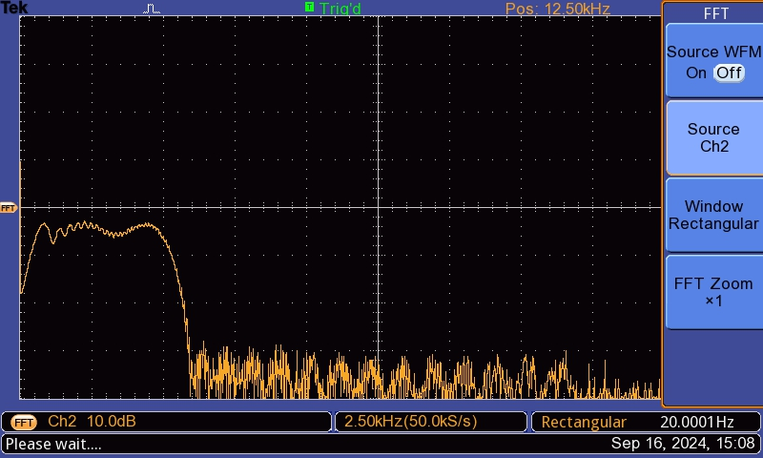

IIR szűrő rutin implementálása

Butterworth IIR szűrő tervezése
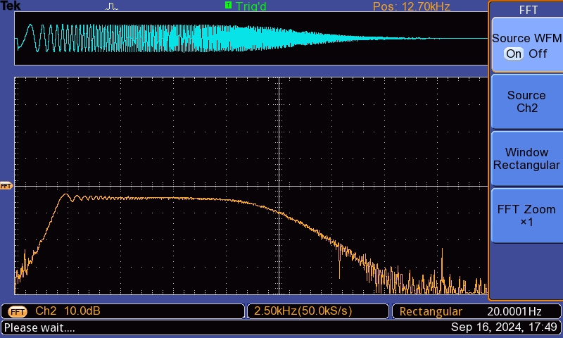
- #include "frame.h"

- #define N 5 // number of filter coefficients
- section("L1_data_b") fract coefsB[N] = {
- //#include "fir_coef.dat"
- 0.093981,
- 0.375923,
- 0.563885,
- 0.375923,
- 0.093981,
- };

- fract coefsA[N] = {
- 0.000000,
- 0.000000,
- 0.486029,
- 0.000000,
- 0.017665,
- };

- fract section("L1_data_a") input[N];
- fract output[N];
- accum outA = 0;
- accum outB = 0;
- accum out = 0;
- volatile fract outVal;
- int i = 0;

- fract konv;
- uint16_t *konvi;
- uint32_t konvi32;

- //--------------------------------------------------------------------------//
- // Function: Process_Data() //
- // //
- // Description: This function is called from inside the SPORT0 ISR every //
- // time a complete audio frame has been received. The new //
- // input samples can be found in the variables iChannel0LeftIn,//
- // iChannel0RightIn, iChannel1LeftIn and iChannel1RightIn //
- // respectively. The processed data should be stored in //
- // iChannel0LeftOut, iChannel0RightOut, iChannel1LeftOut, //
- // iChannel1RightOut, iChannel2LeftOut and iChannel2RightOut //
- // respectively. //
- //--------------------------------------------------------------------------//
- void Process_Data(void)
- {
- if (uart_rx_flag)
- {
- uart_rx_flag = false;
- uart_putch(uart_getch());
- }

- iChannel0LeftOut = iChannel0RightIn;

- input[i] = rbits((iChannel0RightIn>>8));

- int j;
- int ix;

- ix = i;
- outA = 0;
- outB = 0;

- // Filter loop
- for (j=0;j<N;j++)
- {
- outA -= output[(ix)%N]*coefsA[j];

- outB += input[ix%N]*coefsB[j];

- ix++;
- }
- out = outA + outB;
- output[i] = out;

- i--;

- if (i<0)
- {
- i = N-1;
- }

- iChannel0RightOut = bitsr(out) << 8;
- }

Chebysev 1 IIR szűrő tervezése
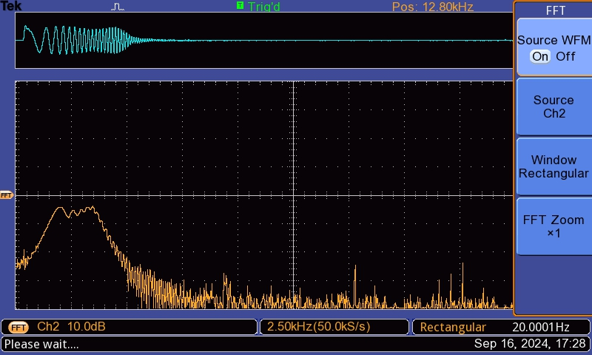
- #include "frame.h"

- #define N 5 // number of filter coefficients
- section("L1_data_b") fract coefsB[N] = {
- //#include "fir_coef.dat"
- 0.000652,
- 0.002606,
- 0.003909,
- 0.002606,
- 0.000652,
- };

- fract coefsA[N] = {
- 0.000000,
- -3.371443/8,
- 4.505325/8,
- -2.808567/8,
- 0.687808/8,
- };

- fract section("L1_data_a") input[N];
- fract output[N];
- accum outA = 0;
- accum outB = 0;
- accum out = 0;
- volatile fract outVal;
- int i = 0;

- fract konv;
- uint16_t *konvi;
- uint32_t konvi32;

- //--------------------------------------------------------------------------//
- // Function: Process_Data() //
- // //
- // Description: This function is called from inside the SPORT0 ISR every //
- // time a complete audio frame has been received. The new //
- // input samples can be found in the variables iChannel0LeftIn,//
- // iChannel0RightIn, iChannel1LeftIn and iChannel1RightIn //
- // respectively. The processed data should be stored in //
- // iChannel0LeftOut, iChannel0RightOut, iChannel1LeftOut, //
- // iChannel1RightOut, iChannel2LeftOut and iChannel2RightOut //
- // respectively. //
- //--------------------------------------------------------------------------//
- void Process_Data(void)
- {
- if (uart_rx_flag)
- {
- uart_rx_flag = false;
- uart_putch(uart_getch());
- }

- iChannel0LeftOut = iChannel0RightIn;

- input[i] = rbits((iChannel0RightIn>>8));

- int j;
- int ix;

- ix = i;
- outA = 0;
- outB = 0;

- // Filter loop
- for (j=0;j<N;j++)
- {
- outA -= output[(ix)%N]*coefsA[j];

- outB += input[ix%N]*coefsB[j];

- ix++;
- }
- out = outA*8 + outB;
- output[i] = out;

- i--;

- if (i<0)
- {
- i = N-1;
- }

- iChannel0RightOut = bitsr(out) << 8;
- }

Kiegészítő feladat

