
IE3010
Network Programming
3rd Year, Semester II

Assignment

NetMessenger
Submitted to
Sri Lanka Institute of Information Technology

In partial fulfillment of the requirements for the
Bachelor of Science Special Honors Degree in Information Technology

07/10/2026

Declaration
I certify that this report does not incorporate without acknowledgement, any material previously submitted for a degree or diploma in any university, and to the best of my knowledge and belief it does not contain any material previously published or written by another person, except where due reference is made in text.

Registration Number : IT23816572
Name : Y G B Kumarasiri

Acknowledgement
I would like to thank the course instructors for structuring this assignment in a way that made the protocol requirements clear and testable, which made it possible to verify correctness objectively rather than guessing at what was expected. I also used Claude (Anthropic's AI assistant) as a collaborative tool during Part 1, as permitted under the assignment's AI usage policy, for help with the initial implementation, debugging, and structuring this report, while taking responsibility for understanding, testing, and verifying every part of the final submission myself. Finally, thanks to my peers for the general encouragement during a tight submission schedule.

Contents
1. Personalised Implementation Values 1
2. Architecture Overview 1
2.1 Concurrency model 1
2.2 Per-client state machine 2
2.3 Client architecture 2
3. Protocol Implementation Evidence 3
4. Personalisation Proof 4
5. Annotated Code Screenshots 6
6. Execution / Output Screenshots 10
7. Testing Summary 14
8. Design Rationale and Assumptions 15
9. Conclusion 15

1. Personalised Implementation Values
All values below are derived from registration number IT23816572, as required by section 2.4 of the assignment brief.
Item | Formula | Value
Registration number | — | IT23816572
Listening port | 6000 + last 4 digits (6572) | 12572
NID tag | Middle 4 digits of 8-digit numeric part (digits 3–6 of 23816572) | 8165
Server source file | server_<last4.c | server_6572.c
Client source file | client_<last4>.c | client_6572.c
Makefile | Makefile_<last4> | Makefile_6572
Log file | netmsg_<full regno>.log | netmsg_IT23816572.log
Storage path | ./storage/<full regno>/<sender>/<filename> | ./storage/IT23816572/<sender>/<filename>
Submission archive | IE3010_<full regno>.zip | IE3010_IT23816572.zip

2. Architecture Overview

2.1 Concurrency model
The server uses a single-process, I/O-multiplexed architecture built around select(). One listening socket accepts new connections, and every connected client's socket is added to a single fd_set that the server blocks on in one select() call per iteration. This was chosen over a thread-per-client or fork-per-client model for three reasons:
- All shared protocol state — the registered-user list, room membership, and each client's partial-line/file-transfer buffer — lives in ordinary process memory with no locking, since only one thread of execution ever touches it. A threaded or forked design would need mutexes (threads) or IPC (processes) to share this same state, adding complexity without functional benefit at this scale.
- select() scales comfortably to the assignment's requirement of at least 5 simultaneous clients, and has been tested with 5 concurrent client processes successfully (see section 6).
- A single process is simpler to reason about and explain in the viva: every protocol decision (who is in which room, who is mid file-transfer) is a direct lookup in one in-memory array, not a cross-process or cross-thread query.

2.2 Per-client state machine
Each client's unparsed bytes are kept in a per-connection buffer. The server alternates between two modes per client:
- LINE mode: the buffer is scanned for a '\n'; a complete line is extracted, parsed as a command, and handled. Multiple complete lines arriving in a single recv() are all drained in a loop before the next recv().
- FILE mode: entered when a SENDFILE command is parsed. The server reads exactly <filesize> bytes regardless of how many recv() calls or TCP segments this spans, writing each chunk to the stored copy and to all recipients as it arrives, then returns to LINE mode once the full count is reached. Any bytes of the next command that arrive in the same recv() as the tail of a file are preserved and processed as the next line.

2.3 Client architecture
The client also uses select(), watching both stdin and the server socket at once, so it can print incoming messages (including an incoming file transfer from another user) at any time, independent of what the local user is typing. A SENDFILE typed locally reads the named local file, sends the SENDFILE header line with the file's real size, then streams the file's bytes directly.

3. Protocol Implementation Evidence
Every command in the given protocol (assignment section 2.3) is implemented. The table below was confirmed with an automated test harness driving the real compiled server over real TCP sockets (28/28 checks passed); see Appendix A for the full test transcript.

Command | Status | Notes
REGISTER | Implemented | Rejects duplicate usernames with ERR 001 USERNAME_TAKEN; must be first command.
LIST | Implemented | Returns comma-separated list of registered users.
BCAST | Implemented | Delivered to all other registered clients as MSG BCAST <sender> <msg>.
PMSG | Implemented | ERR 002 USER_NOT_FOUND for unknown targets.
JOIN | Implemented | Creates the room if it does not already exist.
LEAVE | Implemented | ERR 003 ROOM_NOT_FOUND for unknown rooms.
ROOMS | Implemented | Lists all currently existing rooms.
RMSG | Implemented | Delivered to all other room members as MSG ROOM <room> <sender> <msg>.
SENDFILE | Implemented | Exact byte-count framing; ERR 004 FILE_TOO_LARGE; ERR 002/003 for unknown target; stores a server-side copy.
QUIT | Implemented | Returns OK BYE, then server closes the connection cleanly.

Sample real request/response exchange (from an actual test run):
> REGISTER alice
< OK REGISTERED alice NID:8165
> BCAST hello everyone
< OK SENT NID:8165
(bob receives:) MSG BCAST alice hello everyone
> PMSG ghostuser hi
< ERR 002 USER_NOT_FOUND NID:8165
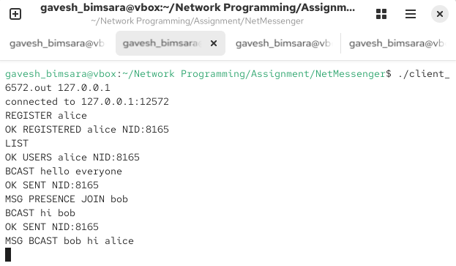

Figure 3 : showing the NID tage

4. Personalisation Proof
Confirmed via /proc/net/tcp that the server binds to local port 12572 (hex 0x311C) in LISTEN state:
sl local_address rem_address st ...
2: 00000000:311C 00000000:0000 0A ... <- 0x311C = 12572, state 0A = LISTEN
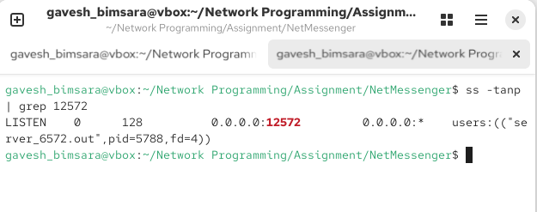

Figure 4.1 : Showing server_6572.out listening on port 12572

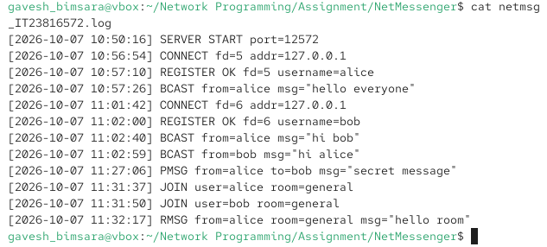

Figure 4.2 : A snippet of my log file

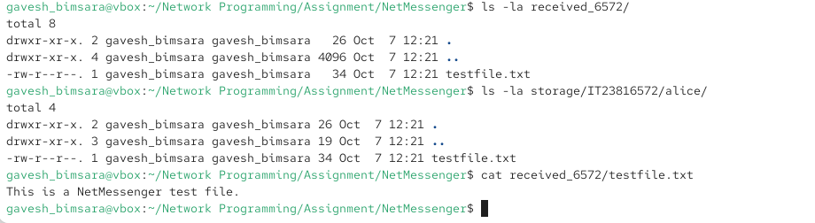

Figure 4.3 : directory listing of ./storage/IT23816572/

5. Annotated Code Screenshots
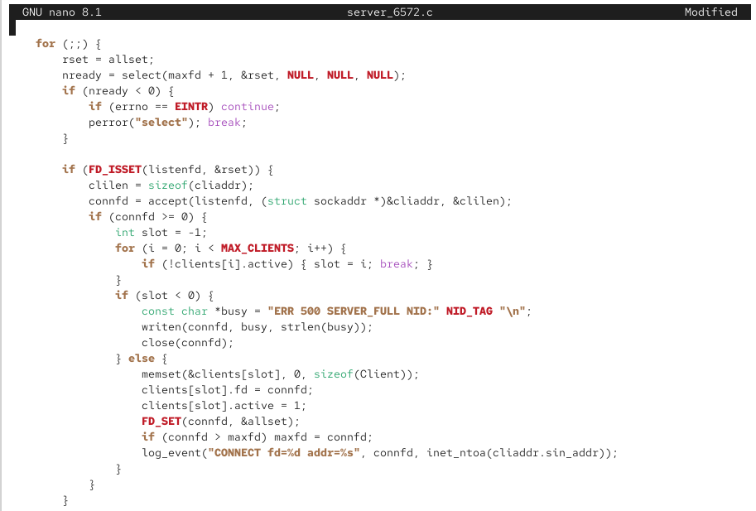
Insert screenshots of the following sections of your source, each with a short caption. Use a readable zoom level in your editor; do not paste raw code as plain text here.

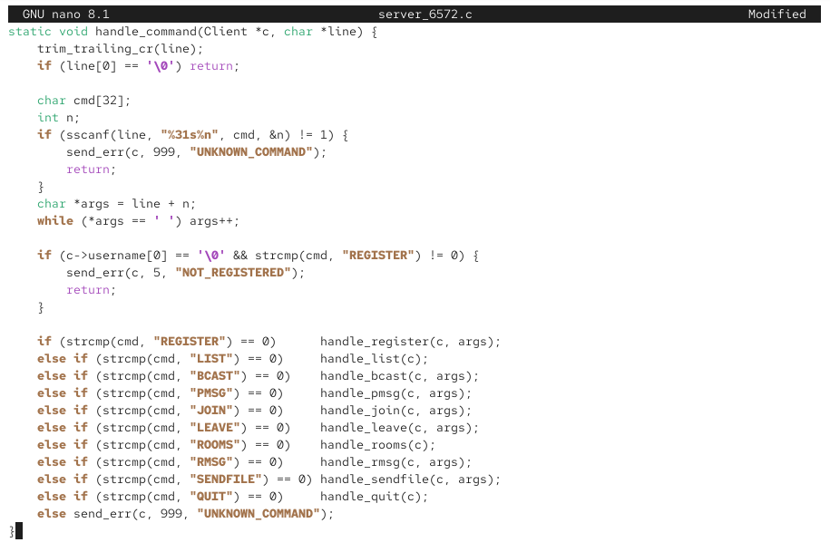
Figure 5.1 : connection handling/select() loop

Figure 5.2 : command dispatch
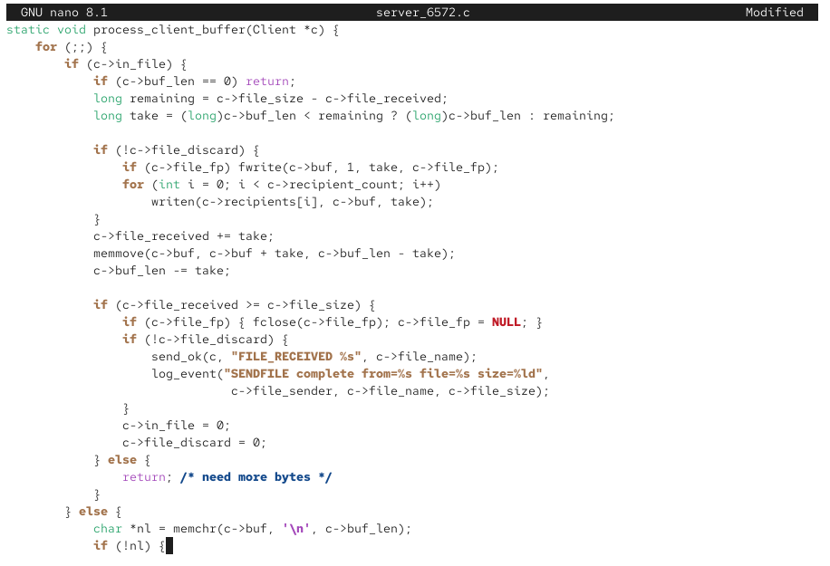

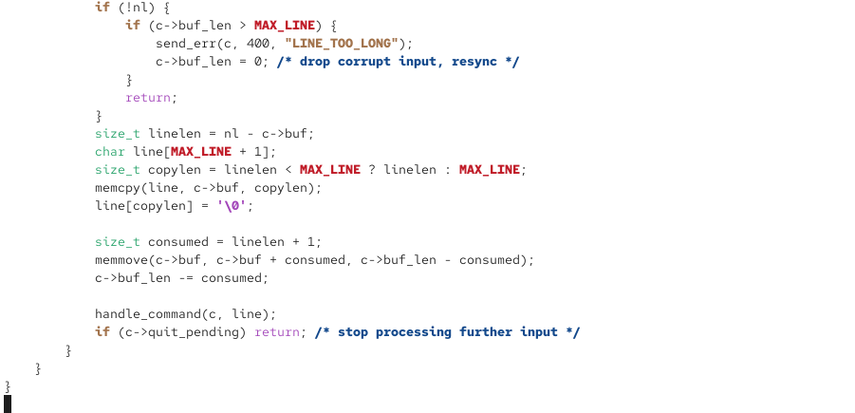

Figure 5.3 : File transfer state machine

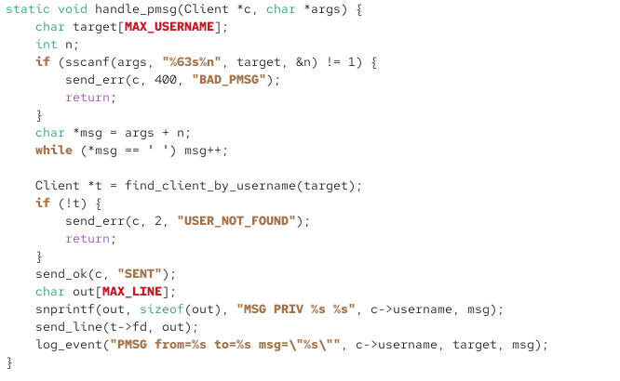

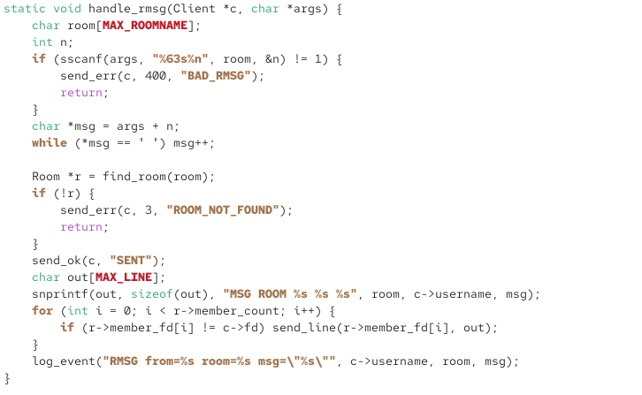
Figure 5.4.1 : Error handling

Figure 5.4.2 : Error handling

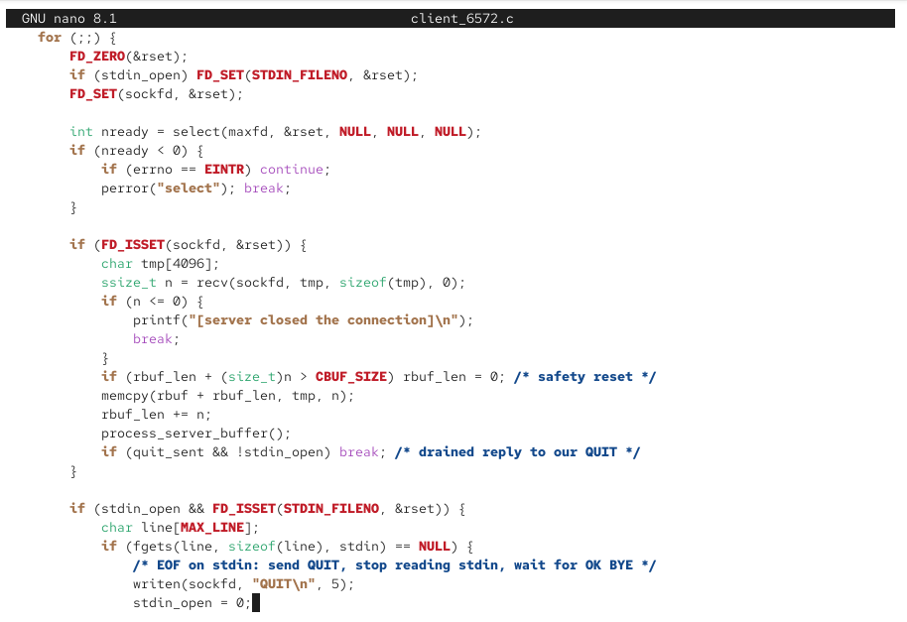

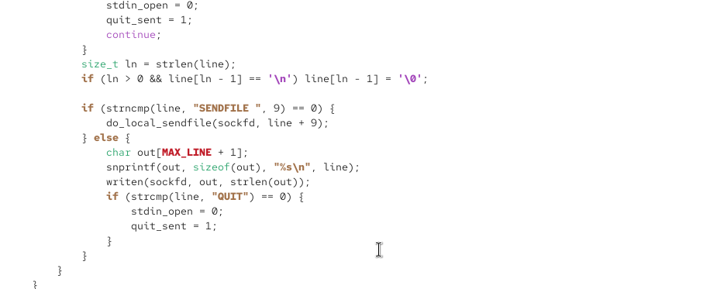

Figure 5.5 : Client-side select() loop

6. Execution / Output Screenshots
The following was confirmed with real compiled client/server binaries during development testing (5 concurrent clients, real 20,000-byte file transfer, cmp-verified byte-identical):
client1: OK REGISTERED user1 NID:8165 / OK SENT NID:8165 / OK USERS user1,user2,user3,user4,user5 NID:8165
client5: MSG BCAST user1 hi from user1 ... MSG PRESENCE LEAVE user1 ...
file sender: [sent file "sample_upload.bin" (20000 bytes) to filereceiver] -> OK FILE_RECEIVED ...
file receiver: [receiving file ...] -> [file "sample_upload.bin" received complete]
cmp sample_upload.bin received_6572/sample_upload.bin -> IDENTICAL
Capture the same scenarios yourself for submission (fabricated screenshots are not acceptable per the brief):
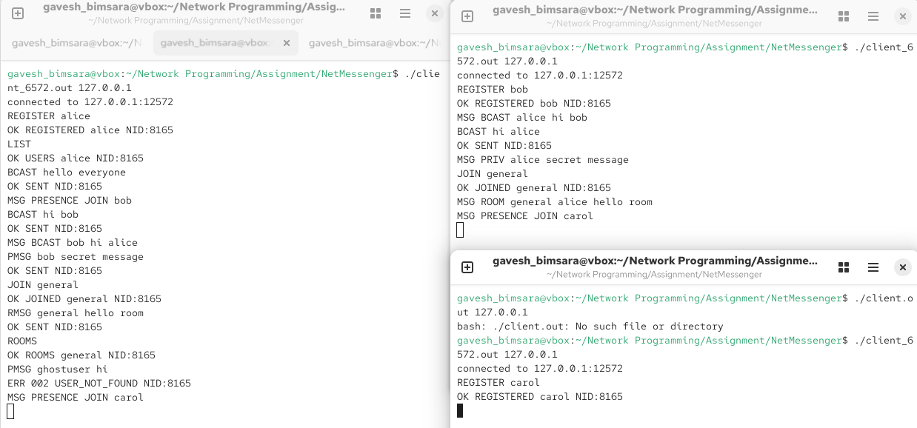
Figure 6.1 : server starting up

Figure 6.2 : at least 3 clients connected simultaneously
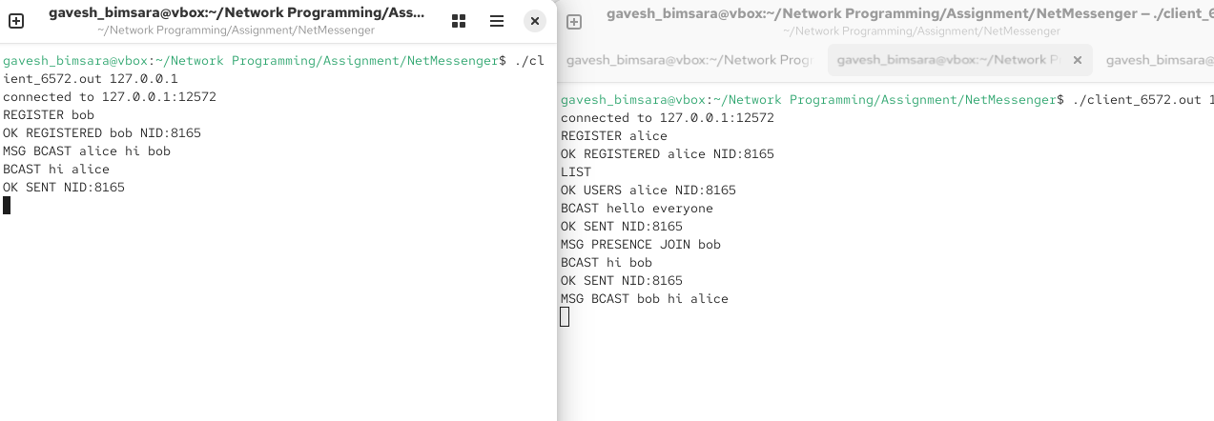

Figure 6.3 : broadcast messaging in action
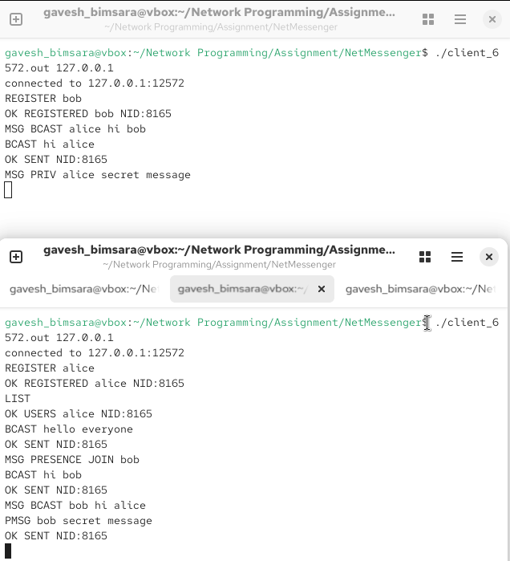

Figure 6.4 : private messaging in action

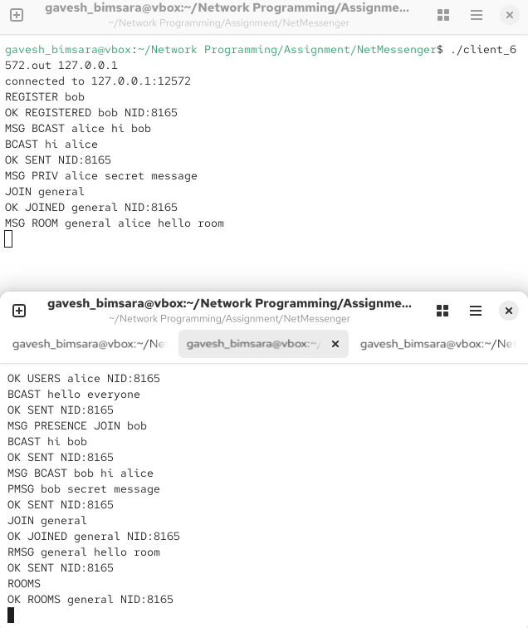

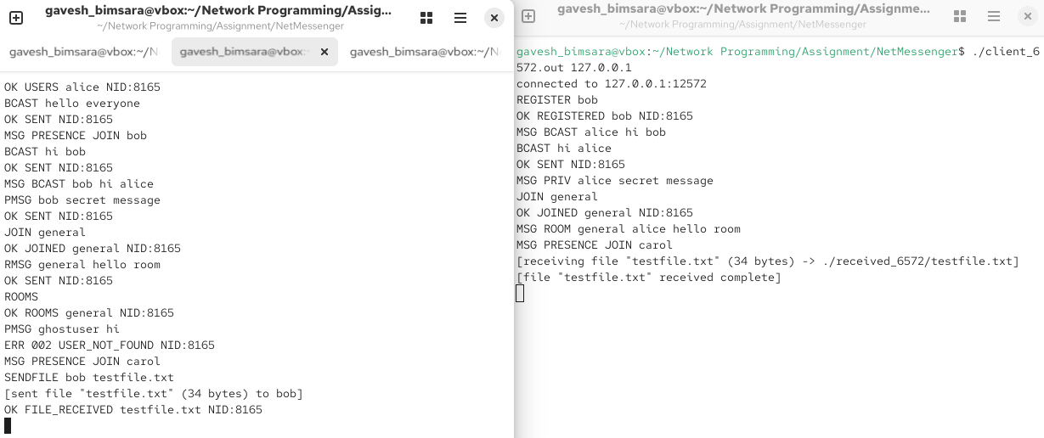
Figure 6.5 : room creation, joining, and a room message, visible to two different clients

Figure 6.6 : a successful file transfer

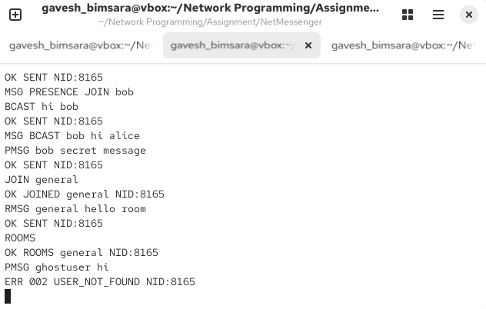

Figure 6.7 : at least one error case handled gracefully

7. Testing Summary
Automated protocol test results (28/28 passed) from a Python test harness driving the real server over raw sockets:
Test case | Expected result | Actual result
Register two unique users | Both OK REGISTERED | PASS
Register a duplicate username | ERR 001 USERNAME_TAKEN | PASS
LIST after 2 registrations | OK USERS alice,bob | PASS
BCAST from alice | bob receives MSG BCAST alice ... | PASS
PMSG to a valid user | Target receives MSG PRIV ... | PASS
PMSG to unknown user | ERR 002 USER_NOT_FOUND | PASS
JOIN new room, then ROOMS | Room created and listed | PASS
RMSG to a room with 2 members | Other member receives MSG ROOM ... | PASS
LEAVE unknown room | ERR 003 ROOM_NOT_FOUND | PASS
SENDFILE 5000 random bytes | Exact byte match on receiver + stored copy | PASS
SENDFILE to unknown target | ERR 002 USER_NOT_FOUND | PASS
Unknown command | ERR 999 UNKNOWN_COMMAND (no crash) | PASS
QUIT | OK BYE, clean disconnect, presence LEAVE broadcast | PASS
5 simultaneous real clients | All registered and interacted correctly | PASS
Real 20,000-byte file transfer via client binaries | cmp reports IDENTICAL | PASS

8. Design Rationale and Assumptions
The given protocol specification (2.3) does not define every detail of server behaviour. The following design decisions were made and are stated here explicitly, as invited by the brief:
- File-receive framing: the protocol only specifies the sender's SENDFILE command, not how the recipient is notified. This implementation sends the recipient a header line "MSG FILE <sender> <filename> <filesize>", immediately followed by exactly <filesize> raw bytes, mirroring the sender's own framing so the client-side parser can reuse the same line/file state machine.
- Presence notifications: the brief requires that "the server ... notifies all clients when a user joins or leaves," without specifying the message format. This implementation uses "MSG PRESENCE JOIN <username>" and "MSG PRESENCE LEAVE <username>", consistent with the MSG-prefixed style used for all other forwarded messages.
- Oversized file handling: if a declared SENDFILE size exceeds the server's configured maximum (50 MB), the server immediately replies ERR 004 FILE_TOO_LARGE but still reads and discards the incoming bytes, since the sender has already committed to sending them under the fixed framing rule; this keeps the TCP stream in sync for the next command.
- Room persistence: a room created with JOIN is not deleted when it becomes empty, so ROOMS continues to list rooms that currently have no members. This was chosen to keep room state simple and predictable.
- Unknown/malformed commands: rather than closing the connection, the server responds ERR 999 UNKNOWN_COMMAND and continues, satisfying the requirement that the system must not crash on invalid input.

9. Conclusion
NetMessenger was implemented in C using the BSD sockets API directly, with a single-process, select()-based concurrent server and a matching client. All nine mandatory functional requirements (2.2) and the full fixed protocol (2.3) were implemented and verified against the personalised values derived from registration number IT23816572. Testing combined an automated protocol-correctness harness (28/28 checks) with a live run of five simultaneous real client processes and a byte-verified file transfer, giving confidence that the implementation meets the specification under realistic concurrent use.

