SUPPLEMENTARY MATERIAL
Effect of 1-year lifestyle intervention with energy-reduced Mediterranean diet and physical activity promotion on the gut metabolome and microbiota
García-Gavilán J, Atzeni A et al.
List of supplementary figures and tables

Supplementary Table 1. Effect of 1-year PREDIMED-Plus interventions on fecal metabolites. 9
Supplementary Table 2. Metabolites selected within each weighted gene co-expression network analysis (WGCNA) identified subnetworks. 11
Supplementary Table 3. Effect of 1-year PREDIMED-Plus interventions on gut microbiota dissimilarity 18
Supplementary Table 4. Effect of 1-year PREDIMED-Plus interventions on fecal microbiota genera abundances. 19
Supplementary Figure 1. Flowchart representing the selection of participants included in the study. 21
Supplementary Figure 2. Pair-wise partial correlations of metabolites included in the Black subnetwork. 22
Supplementary Figure 3. Pair-wise partial correlations of metabolites included in the Midnight blue subnetwork. 23
Supplementary Figure 4. Pair-wise partial correlations of metabolites included in the Pink subnetwork. 24
Supplementary Figure 5. Pair-wise partial correlations of metabolites included in the Salmon subnetwork. 25
Supplementary figure 6. Fecal microbiota distribution among interventions explored through principal coordinate analysis (PCoA) over Bray-Curtis distance. 26
Supplementary Figure 7. Heatmap showing the association between changes in diversity and richness indices and changes in cardiovascular risk factors after one year of follow-up. 27

Supplementary methods
The PREDIMED-Plus clinical trial
The PREDIMED (PREvención con DIeta MEDiterránea)-Plus trial, a 6-year multi-center, parallel-group, randomized, single-blind intervention trial aiming to evaluate the long-term effects of a lifestyle intervention including an energy-reduced Mediterranean diet (erMedDiet), promotion of physical activity (PA), and behavioral support for weight loss (intervention group, IG) versus a control group (CG) following a traditional Mediterranean diet with ad libitum caloric intake on cardiovascular disease and mortality. Participants were recruited by 23 research centers from the Spanish National Health System between September 2013 and December 2016.
The primary outcomes of the trial are a composite of CVD (cardiovascular disease) events (CVD death, nonfatal myocardial infarction, and nonfatal stroke), and long-term weight loss maintenance. Current secondary outcomes comprise: death of any cause, changes in waist circumference, and incidence of acute coronary syndrome (unstable angina), coronary revascularization (percutaneous or surgical), atrial fibrillation, peripheral artery disease, heart failure, venous thrombosis, type 2 diabetes mellitus and its complications, dementia, Parkinson disease, major unipolar depression, osteoporotic fractures, cholelithiasis or cholecystectomy, symptomatic gout, transient ischemic attack, cataract, venous thromboembolism or cancer (breast, prostate, lung, colorectal, or stomach) and serum metabolome changes. Other intermediate outcomes are changes in: blood pressure, fasting blood sugar, Serum lipid profile, markers of inflammation, other intermediate markers of cardiovascular risk, overall diet and nutrient intake, medication use, ECGs, cognitive function, quality of life, and psychological and neuropsychological scores, epigenetic tags (methylation, miRNA, lncRNA), genetic polymorphisms, gene expression, taste and odor perception tests. Gut microbiome is considered an intermediate outcome (as per the clinical trial registration) that was not pre-specified.
Eligible participants were men between 55 to 75 years and women between 60 to 75 years without cardiovascular disease at baseline who had an initial body mass index (BMI) between 27 to 40 kg/m² and met at least 3 criteria for metabolic syndrome [1]. Individuals included in the trial were randomized in a 1:1 ratio to the intervention or control group using a computer-generated random number internet-based system with stratification by center, sex, and age (<65 years, 65-70 years, and >70 years) in batches of 6 participants. The randomization procedure was blinded to all staff members and principal investigators. For participating couples sharing the same household, randomization was done by cluster, with the couple as the unit of randomization [2]. More details about inclusion/exclusion criteria are detailed elsewhere [3]. This trial was approved by the institutional review board of all participating institutions, was registered on the ISRCTN registry (ISRCTN89898870), and can be accessed at https://www.isrctn.com/ISRCTN89898870. All participants provided written informed consent and the procedures were implemented following the ethical standards of the Declaration of Helsinki.
Clinical recorded variables, anthropometry, and general biochemistry
Trained dietitians conducted dietary assessments during face-to-face visits at baseline and every 12 months of follow-up by administering a validated 143-item semi-quantitative food frequency questionnaire to collect information about food habits during the preceding 12 months. Total energy and nutrient intake were derived from Spanish food composition tables [4].
Nondietary variables were also collected at baseline and every 12 months of follow-up. A general questionnaire was administered to collect data on socio-demographics and medical conditions. Leisure time physical activity was measured by the validated Regicor Short Physical Activity Questionnaire [5].
At baseline and after one year of follow-up, nurses measured waist circumference (midway between the lowest rib and the iliac crest using an anthropometric tape), weight (using high-quality electronic calibrated scales), and height (using wall-mounted stadiometer) twice. Blood pressure was measured three times using a validated semiautomatic oscillometer (Omron HEM-705CP, Kyoto, Japan), and the mean value of these measurements was used for the analysis.
Blood samples were collected after overnight fasting. Plasma levels of glucose, total cholesterol, high-density lipoprotein cholesterol (HDL-cholesterol), and triglycerides were measured using standard enzymatic methods. Low-density lipoprotein cholesterol (LDL-cholesterol) was calculated with the Friedewald formula (whenever triglycerides were less than 300 mg/dL). Glycated hemoglobin was measured by a chromatographic method. Fasting serum insulin was measured by an electrochemiluminescence immunoassay by Elecsys immuno-analyzer (Roche Diagnostics, Meylan, France). The lower limit of detection was 0.3 μIU/ml. Insulin resistance was assessed by the homeostatic model assessment of insulin resistance (HOMA-IR) index, calculated as fasting insulin (μIU/ml) multiplied by fasting glucose (mmol/L) divided by 22.5 [6].
Fecal metabolomics analyses
Stool samples (weight range 11.02-94.03 mg) were homogenized in 10 µL of water per milligram stool sample weight using a bead mill (TissueLyser II; Qiagen) and the aqueous homogenates were aliquoted for metabolite profiling analyses using four separate LC-MS methods: 1) hydrophilic interaction liquid chromatography (HILIC) coupled with positive ion mode MS to measure polar metabolites (HILIC-pos), 2) HILIC coupled with negative ion mode MS to measure polar metabolites (HILIC-neg), 3) reversed-phase C8 chromatography coupled with positive ion mode MS to measure polar and nonpolar lipids (C8-pos), and 4) reversed-phase C18 chromatography coupled with negative ion mode MS to measure free fatty acids, bile acids, and metabolites of intermediate polarity (C18-neg). Samples were randomized before analyses. Quality control was evaluated using internal standards that were introduced to samples during each metabolite extraction procedure and repeated analyses of pairs of pooled stool homogenate samples inserted into the analytical queue at intervals of approximately 20 study samples (~10% QC samples overall).
HILIC-positive method
Samples were prepared from stool homogenates (10 µL) via protein precipitation with the addition of nine volumes of 74.9:24.9:0.2 v/v/v acetonitrile/methanol/formic acid containing stable isotope-labeled internal standards [valine-d8 (Isotec) and phenylalanine-d8 (Cambridge Isotope Laboratories; Andover, MA)]. The samples were centrifuged (10 min, 9,000 x g, 4°C). The supernatants were injected directly into a 150 x 2 mm Atlantis HILIC column (Waters; Milford, MA). The column was eluted isocratically at a flow rate of 250 µL/min with 5% mobile phase A (10 mM ammonium formate and 0.1% formic acid in water) for a minute followed by a linear gradient to 40% mobile phase B (acetonitrile with 0.1% formic acid) over 10 minutes. MS analyses were carried out using electrospray ionization in the positive ion mode using full scan analysis over 70-800 m/z at 70,000 resolution and 3 Hz data acquisition rate. Additional MS adjustments were: ion spray voltage = 3.5 kV; capillary temperature = 350°C; probe heater temperature = 300 °C; sheath gas = 40; auxiliary gas = 15; S-lens RF = level 40.
HILIC-negative method
Samples were prepared from stool homogenates (30 µL) by protein precipitation with the addition of inosine-15N4, thymine-d4, and glycocholated4 internal standards in four volumes of 80% methanol (Cambridge Isotope Laboratories; Andover, MA). The samples were centrifuged (10 min, 9,000 x g, 4°C). The supernatants were injected directly into a 150 x 2.0 mm Luna NH2 column (Phenomenex; Torrance, CA). The column was eluted at a flow rate of 400 µL/min with initial conditions of 10% mobile phase A (20 mM ammonium acetate and 20 mM ammonium hydroxide in water) and 90% mobile phase B (10 mM ammonium hydroxide in 75:25 v/v acetonitrile/methanol) followed by a 10 min linear gradient to 100% mobile phase A. MS analyses were carried out using electrospray ionization in the negative ion mode using full scan analysis over 60-750 m/z at 70,000 resolution and 3 Hz data acquisition rate. Additional MS settings were: ion spray voltage = -3.0 kV; capillary temperature = 350°C; probe heater temperature = 325 °C; sheath gas = 55; auxiliary gas = 10; S-lens RF = level 40.
C8-positive method
Lipids (polar and nonpolar) were extracted from stool homogenates (10 µl) using 190 µl isopropanol containing 12:0 - 12:0 PC as an internal standard (Avanti Polar Lipids; Alabaster, AL). After centrifugation (10 min, 9,000g, ambient temperature), supernatants (10 µl) were injected directly into a 100 × 2.1-mm ACQUITY BEH C8 column (1.7 µm; Waters). The column was eluted at a flow rate of 450 µl/min isocratically for 1 min at 80% mobile phase A (95:5:0.1 v/v/vl 10 mM ammonium acetate/methanol/acetic acid), followed by a linear gradient to 80% mobile phase B (99.9:0.1 v/v methanol/acetic acid) over 2 min, a linear gradient to 100% mobile phase B over 7 min, and then 3 min at 100% mobile phase B. MS analyses were carried out using electrospray ionization in the positive ion mode using full scan analysis over 200–1,100 m/z at 70,000 resolution and 3 Hz data acquisition rate. Additional MS adjustments were: ion spray voltage = 3.0 kV; capillary temperature = 300 °C; probe heater temperature = 300 °C; sheath gas = 50; auxiliary gas = 15; S-lens RF = level 60.
C18-negative method
Stool homogenates (30 µl) were extracted using 90 µl methanol containing PGE2-d4 as internal standard (Cayman Chemical Co.) and centrifuged (10 min, 9000 g, 4°C). Supernatants (10 µl) were injected into a 150 × 2.1 mm ACQUITY BEH C18 column (Waters). The column was eluted isocratically at a flow rate of 450 µL/min with 20% mobile phase A (0.01% formic acid in water) for 3 min followed by a linear gradient to 100% mobile phase B (0 0.01% acetic acid in acetonitrile) over 12 min. MS analyses were performed using electrospray ionization in negative ion mode using complete scan analysis over 70-850 m/z at 70,000 resolution and 3 Hz data acquisition rate. Additional settings from MS are ion sputter voltage, –3.5 kV; capillary temperature, 320 °C; probe heater temperature, 300 °C; surround gas, 45; auxiliary gas, 10; and S-lens RF level 60.
The number of identified fecal metabolites was n=330 with the HILIC-positive platform, n=132 with the HILIC-negative platform, n=108 with the C8-positive platform, and n = 86 with the C18-negative platform.
Fecal bacterial DNA extraction and 16S amplicon sequencing
Microbial DNA extraction was performed using the QIAmp PowerFecal DNA kit (Qiagen, Hilden, Germany) following the manufacturer’s instructions. A 5 min lysis step was performed using FastPrep-24TM 5G Homogenizer (MP Biomedicals, Santa Ana, CA, USA). Extracted bacterial DNA was stored at −20°C until further processing. DNA concentration and purity were assessed with the Qubit 2.0 Fluorometer-dsDNA Broad Range (BR) Assay Kit (Thermo Fisher Scientific, Waltham, MA, USA). The V4 region (515F-806R) of the prokaryotic 16S ribosomal RNA (rRNA) gene was amplified in triplicate PCR reactions. PCR was performed in a total reaction volume of 35 µl. The master mix contained 0.7 µl of a unique barcoded primer, 515F-n and 806R-n (10µM each per reaction), 0.7 µl dNTPs mixture, 0.35 µl Phusion Green Hot Start II High-Fidelity DNA Polymerase (2 U/µl; Thermo Scientific, Landsmeer, The Netherlands), 7 µl 5× Phusion Green HF Buffer, and 25.5 µl DNAse- RNAse-free water (Promega, Madison, WI, USA). The amplification program included 30 seconds of initial denaturation step at 98°C, followed by 25 cycles of denaturation at 98°C for 10 seconds, annealing at 50°C for 10 seconds, elongation at 72°C for 10 seconds, and a final extension step at 72°C for 7 minutes. The PCR products were visualized in 1% agarose gel (∼290 bp) and purified with a CleanPCR kit (CleanNA, Alphen Aan den Rijn, The Netherlands). The DNA concentration of the purified PCR products was measured with Qubit dsDNA BR Assay Kit and 200 ng from each purified PCR product was used to construct the sequencing libraries, which were sequenced on an Illumina Novaseq platform. To ensure the quality of the sequencing data, artificial mock communities with known composition [7] were included in each library as positive controls and 7 fecal samples were sequenced in duplicates. Finally, negative control samples were included in each library to control potential contaminant sequences using a DNA template, nuclease-free water, or material from DNA extraction blanks. Raw sequences were processed using the NG-Tax pipeline [7], with a read length of 100 nt. Paired-end libraries were demultiplexed and only read pairs with perfectly matching barcodes were used for downstream steps. Amplicon sequence variants (ASVs) were determined with the default settings. Taxonomy was assigned to each ASV using the USEARCH algorithm [8] and the Silva database (v138.1) [9].
Statistical analyses
Metabolomics statistical analyses
Missing values were imputed for metabolites with less than 20% missing (n = 532) using the random forest imputation approach (“missForest” function from the “missForest” R package) as recommended in previous publications [10–12]. Additionally, the metabolites were centered and scaled using the median scale and log transformation.
Linear regression models were used to assess differences in 1-year changes in stool metabolites (i.e., the change in the metabolite data over time) between study groups adjusted for recruiting center (Alicante, Barcelona, Reus, Valencia), age categories (below the median, ≤ 65 years old; above the median, > 65 years old), sex, smoking status (former smoker, never smoker, smoker), the prevalence of hypertension and type 2 diabetes, BMI categories (overweight, BMI < 30 kg/m²; obesity, BMI ≥ 30 kg/m²), and alcohol intake (g/day). Multiple testing correction was performed using the Benjamini-Hochberg procedure (false discovery rate (FDR)) and reported findings with FDR < 0.05.
Weighted gene co-expression network analysis (WGCNA) [13] was used to identify metabolomic sub-networks based on correlation patterns using baseline stool metabolomics data. The hierarchical clustering considering the high-correlated metabolites was used to detect metabolomic subnetworks and summarized by an eigenvector (based on the first principal component of each subnetwork) for each participant.
The soft threshold parameter for the metabolite dataset chosen was 4 (this value is used to approximate a scale-free topology). Taking consideration of both scale-free topology fit index and mean connectivity, a minimum subnetwork size was assigned to 5 metabolites [14]. Highly correlated subnetworks were merged using a dissimilarity threshold of 0.25. The network membership estimated with baseline metabolomic data was applied to the 1-year metabolomics data. The change (1-year - baseline) in fecal metabolites subnetworks over time was measured by the change in the first principal component over time.
Hubs are the metabolites with the most connections within a subnetwork driving the subnetwork formation. To identify hub metabolites for the network, intramodular connectivity (kWithin) was used. kWithin statistics were estimated using the intramodular Connectivity function from the WGCNA R package. This function calculated the connectivity between metabolites within the same subnetwork using the pair-wise partial correlation matrix between metabolites accounting for the metabolites within the same networks. The hubs were only identified in the subnetworks whose changes were significantly associated with the study groups [15].
Associations between the changes in the subnetworks and the study groups were computed using multivariate linear regression models using delta eigenvectors (1-year - baseline eigenvalues) and adjusted for potential confounders (the same variables described in linear regression models).
In the same way, we assessed the associations between the changes in the four subnetworks that were significantly modified by the intervention and 1-year changes in cardiovascular risk factors (body weight, waist circumference, body mass index (BMI), total cholesterol, high-density lipoprotein (HDL) cholesterol, low-density lipoprotein (LDL) cholesterol, triglycerides, fasting plasma glucose, insulin, glycated hemoglobin, homeostasis model assessment of insulin resistance (HOMA-IR) index using linear regression models adjusted for the same variables considered in previous models. For the optimization of the heatmaps generated, we normalized the coefficients by dividing them by their standard deviation.
Microbiota statistical analyses
To assess the effect of a 1-year PREDIMED-Plus intervention on fecal microbiota α diversity, we performed linear regression models over changes in Chao1, Shannon, and Simpson indexes [16–18] calculated over raw feature counts and adjusted for recruiting center (Alicante, Barcelona, Reus, Valencia), age categories (below the median, ≤65 years old; above the median, >65 years old), sex, smoking status (former smoker, never smoker, smoker), the prevalence of hypertension and type 2 diabetes, BMI categories (overweight, BMI = 25-29.9 kg/m²; obesity, BMI ≥ 30 kg/m²), and alcohol intake (g/day).
Bray-Curtis dissimilarity was calculated over counts at the genus level including only features with total relative abundance ≥ 0.001 in at least 10% of the observations. Principal coordinate analysis (PCoA) was used to depict the between-group and between-time variation onto a 2-dimensional plot. The effect of the intervention on fecal microbiota community dissimilarity was assessed with permutational multivariate analysis of variance (PERMANOVA) on Bray-Curtis distance using the “adonis2” function of the vegan package with 999 permutations. PERMANOVA model was applied with the interaction term of intervention group*time and setting participants’ IDs as groups within which to constrain permutations. The model was also adjusted for potential covariates and p < 0.05 was deemed as significant.
Per-feature analysis was performed using the R package MaAsLin2 [19] (version 1.10.0). To detect the intervention effect on taxonomic feature changes over time, a general linear model (GLM) was performed over centered-log ratio (CLR) transformed counts at the genus level, including the study group, the time between baseline and follow-up, and their product term. Participants’ IDs were specified as a random effect parameter to address the non-independence between samples belonging to the same subject. In addition, the model was adjusted for potential covariates. The analysis included only features with total relative abundance ≥ 0.001 in at least 10% of the observations. We subset the results according to the interaction term and we calculate Benjamini-Hochberg adjusted p-values only performing comparisons for the predictor of interest, while still including covariates in the input so that they can be controlled for. Findings with FDR < 0.25 were reported.
The association between intervention-related fecal microbiota features and fecal metabolites subnetworks was assessed through linear mixed models adjusting for potential confounders and including participants’ IDs as a random effect. In addition, the association between changes in calculated α diversity indexes and changes in fecal metabolites subnetworks was assessed through linear regression models adjusted for potential covariates. In the same way, we assessed the association between features of interest and cardiovascular risk factors (body weight, waist circumference, BMI, total cholesterol, HDL cholesterol, LDL cholesterol, triglycerides, fasting plasma glucose, insulin, glycated hemoglobin, HOMA-IR index) and changes in calculated α diversity indexes and cardiovascular risk factors. For the optimization of the heatmaps generated, we normalized the coefficients by dividing them by their standard deviation.
All the analyses were performed with R (version 4.2.1) (The R Foundation, Vienna, Austria) and R Studio (version 2022.07.1) (Boston, MA, USA).
References
1 Alberti K, Eckel RH, Grundy SM, et al. Harmonizing the Metabolic Syndrome A Joint Interim Statement of the International Diabetes Federation Task Force on Epidemiology and Prevention for the Study of Obesity. Circulation Published Online First: 2009. doi:10.1161/CIRCULATIONAHA.109.192644
2 Sayón-Orea C, Razquin C, Bulló M, et al. Effect of a Nutritional and Behavioral Intervention on Energy-Reduced Mediterranean Diet Adherence Among Patients With Metabolic Syndrome. JAMA 2019;322:1486. doi:10.1001/jama.2019.14630
3 Martínez-González MA, Buil-Cosiales P, Corella D, et al. Cohort Profile: Design and methods of the PREDIMED-Plus randomized trial. Int J Epidemiol 2019;48:387–388o. doi:10.1093/ije/dyy225
4 Moreiras O, Carbajal Á, Cabrera L, et al. Tablas de composición de alimentos. 19a edició. Pirámide 2018.
5 Molina L, Sarmiento M, Peñafiel J, et al. Validation of the Regicor Short Physical Activity Questionnaire for the Adult Population. PLoS One 2017;12:e0168148. doi:10.1371/journal.pone.0168148
6 Matthews DR, Hosker JP, Rudenski AS, et al. Homeostasis model assessment: insulin resistance and β-cell function from fasting plasma glucose and insulin concentrations in man. Diabetologia 1985;28:412–9. doi:10.1007/BF00280883
7 Ramiro-Garcia J, Hermes GDA, Giatsis C, et al. NG-Tax, a highly accurate and validated pipeline for analysis of 16S rRNA amplicons from complex biomes. F1000Res 2018;5:1791. doi:10.12688/f1000research.9227.2
8 Edgar RC. Search and clustering orders of magnitude faster than BLAST. Bioinformatics 2010;26:2460–1. doi:10.1093/bioinformatics/btq461
9 Quast C, Pruesse E, Yilmaz P, et al. The SILVA ribosomal RNA gene database project: improved data processing and web-based tools. Nucleic Acids Res 2012;41:D590–6. doi:10.1093/nar/gks1219
10 Stekhoven DJ, Buhlmann P. MissForest--non-parametric missing value imputation for mixed-type data. Bioinformatics 2012;28:112–8. doi:10.1093/bioinformatics/btr597
11 Gromski P, Xu Y, Kotze H, et al. Influence of Missing Values Substitutes on Multivariate Analysis of Metabolomics Data. Metabolites 2014;4:433–52. doi:10.3390/metabo4020433
12 Wei R, Wang J, Su M, et al. Missing Value Imputation Approach for Mass Spectrometry-based Metabolomics Data. Sci Rep 2018;8:663. doi:10.1038/s41598-017-19120-0
13 Langfelder P, Horvath S. WGCNA: an R package for weighted correlation network analysis. BMC Bioinformatics 2008;9:559. doi:10.1186/1471-2105-9-559
14 Pei G, Chen L, Zhang W. WGCNA Application to Proteomic and Metabolomic Data Analysis. Methods Enzymol 2017;585:135–58. doi:10.1016/BS.MIE.2016.09.016
15 Horvath S, Dong J. Geometric Interpretation of Gene Coexpression Network Analysis. PLoS Comput Biol 2008;4:e1000117. doi:10.1371/journal.pcbi.1000117
16 Chao A. Estimating the Population Size for Capture-Recapture Data with Unequal Catchability. Biometrics 1987;43:783. doi:10.2307/2531532
17 Shannon CE. A Mathematical Theory of Communication. Bell System Technical Journal 1948;27:623–56. doi:10.1002/j.1538-7305.1948.tb00917.x
18 Simpson EH. Measurment of Diversity. Nature 1949;163:688.
19 Mallick H, Rahnavard A, McIver LJ, et al. Multivariable association discovery in population-scale meta-omics studies. PLoS Comput Biol 2021;17:1–27. doi:10.1371/journal.pcbi.1009442

Supplementary Table 1. Effect of 1-year PREDIMED-Plus interventions on fecal metabolites (IG n = 200, CG n = 200).
Metabolites | IG Mean (SD) | CG Mean (SD) | β | p-values | FDR¹ | Method | HMDB ID
2-Hydroxy palmitic acid | -0.08 (0.88) | 0.04 (0.86) | -0.15 | 0.032 | 0.066 | C18-neg | HMDB0031057
2-Hydroxyoctanoic acid | 0.06 (0.92) | -0.05 (0.91) | 0.15 | 0.049 | 0.085 | C18-neg | HMDB0002264
2-Hydroxystearic acid | -0.02 (0.82) | 0.08 (0.78) | -0.14 | 0.037 | 0.071 | C18-neg | HMDB0062549
3-Methyladipic acid | 0.25 (1.11) | 0.02 (1.10) | 0.29 | 0.005 | 0.038 | C18-neg | HMDB0000555
3-Methyladipic acid or Pimelic acid | 0.27 (0.82) | 0.02 (0.84) | 0.23 | 0.002 | 0.054 | HILIC-neg | HMDB0000555
4,7,10,13,16-Docosapentaenoic acid | -0.40 (1.44) | -0.08 (1.61) | -0.42 | 0.002 | 0.026 | C18-neg | HMDB0001976
6,8-Dihydroxypurine | -0.17 (1.16) | 0.12 (1.27) | -0.25 | 0.017 | 0.360 | HILIC-pos | HMDB0001182
Adrenic acid | -0.33 (1.20) | -0.08 (1.33) | -0.30 | 0.004 | 0.037 | C18-neg | HMDB0002226
Agmatine | 0.06 (1.36) | -0.25 (1.40) | 0.25 | 0.036 | 0.360 | HILIC-pos | HMDB0001432
Ala-Phe | -0.24 (0.87) | -0.03 (0.98) | -0.20 | 0.014 | 0.360 | HILIC-pos | HMDB0029010
Allopurinol riboside | -0.49 (2.23) | 0.18 (2.14) | -0.55 | 0.003 | 0.242 | HILIC-pos | HMDB0000481
Arginine | 0.04 (1.28) | -0.23 (1.34) | 0.26 | 0.030 | 0.360 | HILIC-pos | HMDB0000517
Asn-Val | -0.06 (1.07) | -0.18 (0.99) | 0.19 | 0.026 | 0.360 | HILIC-pos | HMDB0028744
C20 Sphinganine | -0.11 (1.04) | 0.11 (0.98) | -0.23 | 0.005 | 0.242 | HILIC-pos
C20 Sphingosine | -0.11 (0.95) | 0.12 (0.93) | -0.24 | 0.002 | 0.242 | HILIC-pos
Cadaverine | -0.26 (1.49) | -0.04 (1.72) | -0.29 | 0.040 | 0.366 | HILIC-pos | HMDB0002322
Cer 18:1;O2/16:0 | -0.13 (0.90) | 0.01 (0.92) | -0.14 | 0.030 | 0.208 | C8-pos | HMDB0004949
Cer 18:1;O2/20:0 | -0.21 (1.53) | 0.08 (1.38) | -0.28 | 0.022 | 0.360 | HILIC-pos | HMDB0004951
Cer 18:1;O2/20:2 | -0.18 (1.85) | 0.12 (1.74) | -0.34 | 0.015 | 0.360 | HILIC-pos
Cer 18:1;O2/22:0 | -0.17 (1.23) | 0.00 (1.28) | -0.21 | 0.038 | 0.208 | C8-pos | HMDB0004952
Cer 18:1;O2/22:1 | -0.28 (1.84) | 0.00 (1.68) | -0.30 | 0.043 | 0.366 | HILIC-pos | HMDB0011775
Cer 18:1;O2/24:0 | -0.19 (1.07) | -0.03 (1.15) | -0.20 | 0.030 | 0.208 | C8-pos | HMDB0004956
Cer 18:1;O2/24:1 | -0.18 (1.10) | -0.04 (1.21) | -0.18 | 0.049 | 0.208 | C8-pos | HMDB0004953
cis-Erucic acid | -0.11 (0.92) | 0.03 (1.04) | -0.16 | 0.039 | 0.071 | C18-neg | HMDB0002068
Citrulline | -0.09 (0.63) | 0.04 (0.67) | -0.11 | 0.043 | 0.366 | HILIC-pos | HMDB0000904
Cryptoxanthin | 0.11 (0.67) | 0.02 (0.65) | 0.13 | 0.018 | 0.360 | HILIC-pos | HMDB0002268
Cyclohexylamine | 0.25 (1.74) | -0.23 (1.75) | 0.35 | 0.029 | 0.360 | HILIC-pos | HMDB0031404
DG 32:0 | -0.02 (0.85) | -0.04 (1.01) | -0.16 | 0.033 | 0.208 | C8-pos | HMDB0007098
DG 36:2 | 0.09 (1.78) | -0.31 (1.90) | 0.30 | 0.040 | 0.208 | C8-pos | HMDB0007218
Eicosadienoic acid | -0.22 (0.91) | -0.10 (1.07) | -0.18 | 0.026 | 0.064 | C18-neg | HMDB0005060
Eicosatrienoic acid | -0.30 (1.11) | -0.16 (1.26) | -0.22 | 0.031 | 0.066 | C18-neg | HMDB0002925
Glycochenodeoxycholic acid | 0.14 (2.28) | -0.31 (1.90) | 0.43 | 0.016 | 0.057 | C18-neg | HMDB0000637
Glycocholic acid | 0.25 (2.77) | -0.31 (2.29) | 0.52 | 0.015 | 0.057 | C18-neg | HMDB0000138
Glycocholic acid | 0.02 (2.82) | -0.37 (2.55) | 0.48 | 0.036 | 0.360 | HILIC-pos | HMDB0000138
Ile-Thr | -0.02 (1.05) | -0.10 (1.21) | 0.19 | 0.049 | 0.387 | HILIC-pos | HMDB0028917
Linoleoyl-EA | -0.13 (1.13) | 0.08 (1.16) | -0.24 | 0.010 | 0.208 | C8-pos | HMDB0012252
Malic acid | -0.09 (0.82) | 0.00 (0.53) | -0.12 | 0.049 | 0.469 | HILIC-neg | HMDB0000156
Metformin | 0.00 (1.13) | 0.31 (1.88) | -0.37 | 0.008 | 0.257 | HILIC-pos | HMDB0001921
Myristoleic acid | 0.16 (0.87) | -0.07 (0.96) | 0.17 | 0.027 | 0.360 | HILIC-pos | HMDB0002000
N(6),N(6)-Dimethyl-lysine | -0.13 (0.68) | 0.01 (0.68) | -0.27 | 0.006 | 0.387 | HILIC-pos | HMDB0013287
N(6)-Methyllysine | -0.27 (1.06) | -0.06 (1.11) | -0.17 | 0.006 | 0.360 | HILIC-pos | HMDB0002038
N-6-Trimethyllysine | -0.19 (1.05) | -0.07 (1.10) | -0.18 | 0.049 | 0.360 | HILIC-pos | HMDB0001325
N-Acetylhistidine | -0.12 (1.10) | 0.05 (0.99) | -0.17 | 0.037 | 0.242 | HILIC-pos | HMDB0032055
N-Acetylserotonin | 0.19 (1.32) | 0.19 (1.40) | 0.24 | 0.030 | 0.242 | HILIC-pos | HMDB0001238
Nonadeca-10Z-enoic acid | 0.10 (1.00) | -0.16 (1.08) | 0.19 | 0.017 | 0.057 | C18-neg | HMDB0013622
Oleic acid | 0.17 (0.94) | -0.10 (1.01) | 0.25 | 0.001 | 0.026 | C18-neg | HMDB0000207
Oxypurinol | -0.01 (0.64) | 0.11 (0.76) | -0.13 | 0.021 | 0.057 | C18-neg | HMDB0000786
Palmitoleoyl-EA | 0.20 (1.20) | -0.02 (1.21) | 0.21 | 0.032 | 0.360 | HILIC-pos | HMDB0013648
Phe-Ile | -0.07 (1.32) | -0.19 (1.19) | 0.21 | 0.036 | 0.360 | HILIC-pos | HMDB0028998
Phenylalanocholic acid | -0.25 (1.01) | -0.03 (1.20) | -0.24 | 0.015 | 0.057 | C18-neg
Sphinganine | -0.14 (0.95) | 0.07 (0.96) | -0.23 | 0.004 | 0.242 | HILIC-pos | HMDB0000269
Stearic acid | 0.09 (0.40) | 0.00 (0.41) | 0.08 | 0.021 | 0.057 | C18-neg | HMDB0000827
Taurochenodeoxycholic acid | 0.11 (2.00) | -0.21 (1.92) | 0.37 | 0.021 | 0.057 | C18-neg | HMDB0000951
TG 53:3 | 0.20 (2.43) | -0.38 (2.67) | 0.51 | 0.012 | 0.208 | C8-pos | HMDB0043058
TG 54:3 | 0.19 (2.18) | -0.22 (2.42) | 0.38 | 0.028 | 0.208 | C8-pos | HMDB0005405
TG 54:4 | 0.09 (2.00) | -0.23 (2.13) | 0.35 | 0.035 | 0.208 | C8-pos | HMDB0005370
Threonine | -0.08 (0.47) | 0.01 (0.47) | -0.09 | 0.035 | 0.360 | HILIC-pos | HMDB0000167
Thymine | -0.15 (0.74) | 0.11 (0.84) | -0.21 | 0.002 | 0.054 | HILIC-neg | HMDB0000262
Tridecylamine | 0.02 (0.69) | -0.08 (0.76) | 0.11 | 0.034 | 0.360 | HILIC-pos
Uracil | -0.03 (0.48) | 0.07 (0.51) | -0.10 | 0.017 | 0.297 | HILIC-neg | HMDB0000300
Multivariable linear regression models adjusted for recruiting center (Alicante, Barcelona, Reus, Valencia), smoking status (former smoker, never smoker, smoker), type 2 diabetes status, sex, BMI categories (overweight, BMI <30 kg/m²; obesity, BMI >= 30 kg/m²); age categories (below the median, <65 years old; above the median, >65 years old), alcohol intake (g/day²), and hypertension status. Abbreviations: IG, intervention group; CG, control group; Ala, alanine; Phe, phenylalanine; Asn, asparagine; Val, valine; Cer, ceramide; DG, diglyceride; Ile, isoleucine; Thr, threonine; TG, triglyceride; C18-neg, reverse chromatography with a T3 ultra-performance liquid chromatography column and MS analyses in the negative ion mode; C8-pos, the reversed-phase method to profile positive ion lipids; HILIC, hydrophilic interaction liquid chromatography.¹ FDR <0.05

Supplementary Table 2. Metabolites selected within each weighted gene co-expression network analysis (WGCNA) identified subnetworks (n = 400).
Subnetwork | Metabolite | Subnetwork | Metabolite
black | C16 Sphinganine | blue | α-Linolenic acid
black | C16 Sphingosine | blue | Deoxyadenosine
black | C20 Sphinganine | blue | DG 32:1
black | C20 Sphingosine | blue | DG 32:2
black | Cer 18:1;O2/14:0 | blue | DG 34:1
black | Cer 18:1;O2/16:0 | blue | DG 34:2
black | Cer 18:1;O2/16:1 | blue | DG 34:3
black | Cer 18:1;O2/17:0 | blue | DG 36:1
black | Cer 18:1;O2/17:1 | blue | DG 36:2
black | Cer 18:1;O2/18:0 | blue | DG 36:3
black | Cer 18:1;O2/18:1 | blue | DG 36:4
black | Cer 18:1;O2/19:0 | blue | DG 38:4
black | Cer 18:1;O2/20:0 | blue | Eicosenoic acid
black | Cer 18:1;O2/20:1 | blue | glycidyl linoleate
black | Cer 18:1;O2/20:2 | blue | Linoleic acid
black | Cer 18:1;O2/22:0 | blue | MG 18:0
black | Cer 18:1;O2/22:1 | blue | Nonadeca-10Z-enoic acid
black | Cer 18:1;O2/24:0 | blue | Oleic acid
black | Cer 18:1;O2/24:1 | blue | Palmitic acid
black | Cer 18:1;O2/24:2 | blue | Palmitoleic acid
black | Eicosadienoic acid | blue | PC 32:1
black | Linoleoyl-EA | blue | PC 34:1
black | Sphinganine | blue | PC 34:2
brown | Acesulfame | blue | PC 36:1
brown | Acetaminophen | blue | PC 36:2
brown | Acetylcholine | blue | PC 36:3
brown | Acisoga | blue | PC 36:4
brown | Adenine | blue | PC 36:4_A
brown | Adenosine | blue | sn-Glycero-3-phosphate
brown | Adonitol or Arabitol | blue | TG 50:1
brown | Agmatine | blue | TG 50:2
brown | Ala-Ala | blue | TG 50:3
brown | Ala-Lys | blue | TG 50:4
brown | Ala-Phe | blue | TG 51:2
brown | Alloisoleucine | blue | TG 52:2
brown | α-N-Phenylacetylglutamine | blue | TG 52:3
brown | α-Tocopherol | blue | TG 52:4
brown | Aminoadipic acid | blue | TG 52:5
brown | Androsterone 3-glucuronide | blue | TG 52:6
brown | Anserine | blue | TG 53:2
brown | Arg-Pro | blue | TG 53:3
brown | Asp-Val | blue | TG 54:1
brown | Asparagine | blue | TG 54:2
brown | Atenolol | blue | TG 54:3
brown | Benzoic acid | blue | TG 54:4
brown | Betaine | blue | TG 54:5
brown | Bilirubin | blue | TG 54:6
brown | Biliverdin | blue | TG 54:7
brown | Butyric acid | blue | TG 54:8
brown | C17 Sphinganine | blue | TG 54:9
brown | Cadaverine | blue | TG 55:3
brown | Caffeine | blue | TG 56:1
brown | Capric acid | blue | TG 56:2
brown | Caprylic acid | blue | TG 56:3
brown | CAR 14:0 | blue | TG 56:4
brown | CAR 2:0 | blue | TG 56:5
brown | CAR 20:4 | blue | TG 56:6
brown | CAR 26:0 | blue | 10Z-Heptadecenoic acid
brown | CAR 3:0 | blue | 13-HODE
brown | CAR 4:0 | cyan | LPE 15:0
brown | CAR 7:0 | cyan | LPE 16:0
brown | CAR DC3:0;2Me | cyan | LPE 17:0
brown | Carboxyibuprofen | cyan | LPE 18:1
brown | Carnitine | cyan | LPE 18:3
brown | Carnosol | cyan | MG 16:1
brown | CE 18:2 | green | Ala-Ile
brown | CE 18:3 | green | Arginine
brown | CE 20:3 | green | Asn-Val
brown | CE 20:4 | green | Gln-Ile
brown | CE 22:4 | green | Gly-Arg
brown | Cer 18:1;O2/16:2 | green | Gly-Val
brown | Cer 18:1;O2/4:0 | green | His-Ile
brown | Cholestenone | green | His-Val
brown | Cholic acid | green | Ile-Glu
brown | Cinnamoylglycine | green | Ile-Ile
brown | Citric acid or Isocitric acid | green | Ile-Lys
brown | Cotinine N-oxide | green | Ile-Thr
brown | Creatine | green | Ile-Trp
brown | Creatinine | green | Ile-Val
brown | Cyclohexylamine | green | Leu-Gly
brown | Cytidine | green | Leu-Phe
brown | Cytosine | green | Lys-Ile
brown | D-α-tocopherylquinone | green | Phe-Ile
brown | D-Urobilinogen | green | Phe-Phe
brown | Daidzein | green | Phe-Tyr
brown | delta-Tocopherol | green | Ser-Ala
brown | Deoxycholic acid | green | Thr-Ile
brown | Deoxycytidine | green | Trp-Val
brown | Deoxyguanosine | green | Tyr-Pro
brown | Desloratadine | green | Val-Arg
brown | DG 32:0 | green | Val-Asp
brown | DG 34:0 | green | Val-Glu
brown | DG 36:0 | greenyellow | DG 30:0
brown | Didanosine | greenyellow | PC 30:0
brown | Diethanolamine | greenyellow | PC 36:4_B
brown | Dimethylarginine | greenyellow | PE 32:1
brown | Ecgonine | greenyellow | PE 34:0
brown | Ectoine | greenyellow | PE 34:1
brown | Erythronic acid or Threonic acid | greenyellow | PE 34:2
brown | Gabapentin | greenyellow | PE 36:2
brown | gamma-Aminobutyric acid | greenyellow | PE P-34:1 or PE O-34:2
brown | Genistein | greenyellow | PE P-34:2 or PE O-34:3
brown | Gentisic acid | grey60 | C22 Sphingosine
brown | Glu-Ala | grey60 | Cer 18:1;O2/15:0
brown | Glu-Gln | grey60 | Isovaleric acid or Valeric acid
brown | Glucosan or 3-Hydroxymethylglutaric acid | grey60 | Phenylacetic acid
brown | Glucuronic acid | grey60 | 11-Methyllauric acid
brown | Glyceric acid | lightcyan | Arachidic acid
brown | Glycitein | lightcyan | Margaric acid
brown | Guanine | lightcyan | Nonadecylic acid
brown | Guanosine | lightcyan | Stearic acid
brown | Harman | lightcyan | 2-Hydroxystearic acid
brown | Heme | lightcyan | Xi-17-Methyloctadecanoic acid
brown | Hexadecanedioic acid | magenta | Choline
brown | Hexose | magenta | LPC 16:0
brown | Hexose | magenta | LPC 18:0
brown | His-Pro | magenta | LPC 18:1
brown | Histamine | magenta | LPC 18:2
brown | Histidine | magenta | LPC 20:0
brown | Hydrocinnamic acid | magenta | LPC 20:1
brown | Hydroxyproline | magenta | LPC 24:0
brown | Ile-Pro | magenta | LPE 18:0
brown | Imidazoleacetic acid | magenta | LPE 18:2
brown | Imidazolepropionic acid | magenta | LPE 22:0
brown | Indole | magenta | PC 32:0
brown | Indolelactic acid | magenta | PC 34:0
brown | Inosine | midnightblue | Allopurinol riboside
brown | isoquinoline-1,5-diol | midnightblue | Fumaric acid or Maleic acid
brown | Kynurenic acid | midnightblue | Hypoxanthine
brown | L-Histidinol | midnightblue | Malic acid
brown | Lactic acid | midnightblue | Pseudouridine
brown | Lauric acid | midnightblue | 6,8-Dihydroxypurine
brown | Lenticin | nColores | names
brown | Leucocholic acid | pink | Adrenic acid
brown | Lisinopril | pink | Arachidonic acid
brown | LPE 20:0 | pink | CAR 16:0
brown | LPE 20:1 | pink | CAR 18:0
brown | Lys-Gly | pink | CAR 18:0;OH
brown | Malonic acid | pink | CAR 18:1
brown | Maslinic acid | pink | CAR 20:0
brown | Metformin | pink | CE 16:0
brown | Methyl N-methylanthranilate | pink | CE 16:1
brown | Monoethylglycinexylidide | pink | CE 20:5
brown | Myristoleic acid | pink | CE 22:6
brown | N(6)-Methyllysine | pink | Cholesterol
brown | N(6),N(6)-Dimethyl-lysine | pink | cis-Erucic acid
brown | N-6-Trimethyllysine | pink | Docosahexaenoic acid
brown | N-Acetyl-D-galactosamine | pink | Eicosapentaenoic acid
brown | N-Acetylaspartic acid | pink | Eicosatrienoic acid
brown | N-Acetylcadaverine | pink | Myristic acid
brown | N-Acetylglutamine | pink | Nervonic acid
brown | N-Acetylhistamine | pink | PE P-36:2 or PE O-36:3
brown | N-Acetylisoputreanine | pink | 4,7,10,13,16-Docosapentaenoic acid
brown | N-Acetylornithine | purple | Biotin
brown | N-Acetylputrescine | purple | Cryptoxanthin
brown | N-Acetylputrescine | purple | Isolithocholic acid
brown | N-Acetylserotonin | purple | Ketoisovaleric acid
brown | N-Acetylvaline | purple | Levulinic acid
brown | N-Methyl-proline | purple | Lithocholic acid
brown | N-Methylserotonin | purple | N-Acetylleucine
brown | N,N-dimethylhexadecylamine | purple | PE P-36:1 or PE O-36:2
brown | N-Oleoyl glycine | purple | Pyroglutamic acid
brown | N1-Acetylspermidine | purple | Uric acid
brown | N1-Methyl-2-pyridone-5-carboxamide | purple | 3-Methyl-2-oxovaleric acid or Ketoleucine
brown | N1,N12-Diacetylspermine | purple | 5-(2-Hydroxyethyl)-4-methylthiazole
brown | Niacinamide | red | Adipic acid or Methylglutaric acid
brown | Nicotinic acid | red | Azelaic acid
brown | Nor-psi-tropine | red | CE 18:0
brown | O-Desmethyltramadol | red | CE 18:1
brown | Oleoyl-EA | red | Cer 18:1;O2/14:1
brown | Olmesartan | red | Dehydrolithocholic acid
brown | Orotic acid | red | Dihydrocholesterol
brown | Oxalic acid | red | DOPA
brown | Oxoglutaric acid | red | Dopamine
brown | p-Hydroxyphenylacetic acid | red | Eicosanedioic acid
brown | Palmitoleoyl-EA | red | Ethyl-N-ethylanthranilic acid
brown | Palmitoyl-EA | red | Indolin-2-one
brown | Palmitoyl-EA | red | L-Metanephrine
brown | Pantothenol | red | L-Urobilin
brown | Paraxanthine or Theobromine | red | Methylimidazoleacetic acid
brown | PE 30:0 | red | N-Acetylglutamic acid
brown | PE 36:4 | red | Oleanolic acid
brown | Pentose 5-phosphate | red | Pro-Phe
brown | Phe-Glu | red | Sebacic acid
brown | Phenylalanocholic acid | red | Suberic acid
brown | Phenyllactic acid | red | Undecanedioic acid
brown | Phytanic acid | red | Val-Tyr
brown | Phytosphingosine | red | Venlafaxine
brown | Pipecolic acid | red | 20-Carboxy-LTB4
brown | Piperine | red | 3-Methyladipic acid
brown | Porphobilinogen | red | 3-Methyladipic acid or Pimelic acid
brown | Pro-Ala | salmon | Glycochenodeoxycholic acid
brown | Pro-hydroxyPro | salmon | Glycocholic acid
brown | Pro-Lys | salmon | Glycocholic acid
brown | Pro-Pro | salmon | Glycodeoxycholic acid
brown | Proline betaine | salmon | Glycodeoxycholic acid or Glycochenodeoxycholic acid
brown | Propionic acid | salmon | Taurochenodeoxycholic acid
brown | Protoporphyrin | salmon | Taurocholic acid
brown | Pterin | tan | LPC O-16:0
brown | Putrescine | tan | LPC P-18:0 or LPC O-18:1
brown | Pyridoxal | tan | LPE P-18:0 or LPE O-18:1
brown | Pyridoxamine | tan | SM 18:1;O2/16:0
brown | Pyridoxine | tan | SM 18:1;O2/18:0
brown | Quinic acid | tan | SM 18:1;O2/18:3
brown | Retinol | tan | SM 18:1;O2/24:0
brown | Ribothymidine | tan | SM 18:1;O2/24:1
brown | S-Methylcysteine S-oxide | yellow | Alanine
brown | Saccharin | yellow | Aminoisobutyric acid
brown | Ser-Pro | yellow | Aspartic acid
brown | Simvastatin | yellow | Citrulline
brown | Sitosterol | yellow | Deoxyinosine
brown | sn-Glycero-3-phosphocholine | yellow | Glu-Pro
brown | Solanidine | yellow | Glutamic acid
brown | Sorbitol | yellow | Glutamine
brown | Sphingosine | yellow | Gly-Pro
brown | Stearamide | yellow | Glycine
brown | Succinic acid | yellow | indole-4-carboxaldehyde
brown | Sucrose or Lactose or Trehalose | yellow | Isoleucine
brown | Symmetric dimethyl-arginine | yellow | Leucine
brown | Tartaric acid | yellow | Lysine
brown | Taurine | yellow | Methionine
brown | Tetradecanedioic acid | yellow | Methionine sulfoxide
brown | Tetradecylamine | yellow | Methylguanidine
brown | Tetrahydroharman-3-carboxylic acid | yellow | N-Acetylarginine
brown | TG 45:0 | yellow | N-Acetylhistidine
brown | TG 48:0 | yellow | N-Acetyltyrosine
brown | TG 50:0 | yellow | N6-Acetyllysine
brown | TG 52:0 | yellow | Oxypurinol
brown | Theophylline | yellow | Pantothenic acid
brown | Thiamine | yellow | Phenylalanine
brown | Thr-Glu | yellow | Proline
brown | Thr-Pro | yellow | Serine
brown | trans-3-Hydroxycotinine | yellow | Targinine
brown | Tridecylamine | yellow | Threonine
brown | Triethanolamine | yellow | Thymine
brown | Triisopropanolamine | yellow | Tryptophan
brown | Tryptamine | yellow | Tyrosine
brown | Tyr-Lys | yellow | Uracil
brown | Tyramine | yellow | Urocanic acid
brown | Tyrosocholic acid | yellow | Valine
brown | Ureidopropionic acid | yellow | 2-Aminobutyric acid
brown | Uridine | yellow | 2-Hydroxy-3-methyl-pentanoic acid or 2-Hydroxyisocaproic acid
brown | Val-Lys | yellow | 2-Hydroxy-3-methylbutyric acid or 3-Hydroxyisovaleric acid
brown | Val-Pro | yellow | 4-Hydroxybenzaldehyde
brown | (E,E)-Trichostachine | yellow | Xanthine
brown | 1,3-Dimethyluric acid
brown | 1,7-Dimethyluric acid
brown | 1-Methyl nicotinamide
brown | 1-Methyladenosine
brown | 1-Methylguanine
brown | 1-Methylguanosine
brown | 1-Methylhistamine
brown | 1-Methylxanthine
brown | 12-HETE
brown | 13-cis-Retinoic acid
brown | 2'-O-Methyladenosine or 3'-O-Methyladenosine
brown | 2-amino-6-hydroxyhexanoic acid
brown | 2-Hydroxy palmitic acid
brown | 2-Hydroxyglutaric acid
brown | 2-Hydroxymyristic acid
brown | 2-Hydroxyoctanoic acid
brown | 2-Oxindole-3-acetate
brown | 3-(3-Hydroxyphenyl)propanoic acid
brown | 3-(N-Acetyl-L-cystein-S-yl) acetaminophen
brown | 3-Dehydroxycarnitine
brown | 3-Guanidinopropanoic acid
brown | 3-Hydroxyanthranilic acid
brown | 3-hydroxynorvaline
brown | 3-Indolepropionic acid
brown | 3-Methoxytyramine
brown | 3-Methylhistidine
brown | 3-Methylxanthine
brown | 4-Acetamidobutanoic acid
brown | 4-Guanidinobutanoic acid
brown | 4-hydroxybenzeneacetonitrile
brown | 4-Hydroxymandelic acid or Homogentisic acid
brown | 4-Pyridoxic acid
brown | 5-Acetylamino-6-amino-3-methyluracil
brown | 5-Hydroxymethyl-4-methyluracil
brown | 5-Methylcytidine
brown | 7-Dehydro-desmosterol
brown | 7-Ketodeoxycholic acid
brown | 7-Methyladenine
brown | 7-Methylguanine
brown | 7-Methylxanthine
brown | 7α-Hydroxy-4-cholesten-3-one
brown | 9-cis-Retinoic acid
brown | Xanthosine
Weighted gene co-expression network analysis (WGCNA) was used to identify metabolomic sub-networks based on correlation patterns using baseline stool metabolomics data. The hierarchical clustering considering the high-correlated metabolites was used to detect metabolomic subnetworks.

Supplementary Table 3. Effect of 1-year PREDIMED-Plus interventions on gut microbiota dissimilarity (CG n = 200, IG n = 200).
 | Df | Sum of sqs | R2 | F | Pr(>F)
Intervention*time | 1 | 0.160 | 0.00093 | 0.7817 | 0.092
Study group | 1 | 0.243 | 0.00142 | 1.1870 | 0.001
Time | 1 | 0.337 | 0.00197 | 1.6476 | 0.001
Recruiting center | 3 | 6.091 | 0.03558 | 9.9373 | 0.001
Smoke status | 2 | 1.102 | 0.00644 | 2.6974 | 0.001
Type 2 diabetes status | 1 | 0.886 | 0.00517 | 4.3345 | 0.001
Sex | 1 | 0.375 | 0.00219 | 1.8338 | 0.001
BMI categories | 1 | 0.559 | 0.00326 | 2.7350 | 0.001
Age categories | 1 | 0.305 | 0.00178 | 1.4904 | 0.001
Alcohol intake (g/day²) | 1 | 0.536 | 0.00313 | 2.6255 | 0.001
Hypertension status | 1 | 0.191 | 0.00112 | 0.9346 | 0.001
Residual | 785 | 160.388 | 0.93700
Total | 799 | 171.171 | 1.00000
BMI, body mass index; Df, degrees of freedom. Effects of intervention on Bray-Curtis distance assessed with PERMANOVA test adjusted for recruiting center (Alicante, Barcelona, Reus, Valencia), smoking status (former smoker, never smoker, smoker), type 2 diabetes status, sex, BMI categories (overweight, BMI <30 kg/m²; obesity, BMI > 30 kg/m²); age categories (below median, <65 years old; above median, >65 years old), alcohol intake (g/day²), hypertension status. Participants’ IDs set as groups in which constrain permutations (999). Pr(>F)<0.05 deemed as significant.

Supplementary Table 4. Effect of 1-year PREDIMED-Plus interventions on fecal microbiota genera abundances (CG n = 200, IG n = 200).
feature | value | coef | stderr | pval | FDR
Eubacterium_hallii_group | IG 1-Y | -0.3656 | 0.1056 | 0.0006 | 0.0458
Dorea | IG 1-Y | -0.3458 | 0.1207 | 0.0044 | 0.1686
NK4A214_group | IG 1-Y | 0.2687 | 0.1080 | 0.0133 | 0.3408
Fusicatenibacter | IG 1-Y | -0.2555 | 0.1235 | 0.0393 | 0.6418
Phascolarctobacterium | IG 1-Y | 0.2557 | 0.1251 | 0.0417 | 0.6418
Acidaminococcus | IG 1-Y | -0.1454 | 0.0795 | 0.0680 | 0.8118
Blautia | IG 1-Y | -0.1672 | 0.0972 | 0.0862 | 0.8118
Barnesiella | IG 1-Y | 0.1842 | 0.1100 | 0.0948 | 0.8118
Parabacteroides | IG 1-Y | 0.2414 | 0.1451 | 0.0968 | 0.8118
Streptococcus | IG 1-Y | -0.2061 | 0.1270 | 0.1054 | 0.8118
Coprococcus | IG 1-Y | -0.2039 | 0.1345 | 0.1302 | 0.8794
Romboutsia | IG 1-Y | -0.1799 | 0.1213 | 0.1387 | 0.8794
Oscillospiraceae_uncultured | IG 1-Y | -0.0863 | 0.0596 | 0.1485 | 0.8794
Eubacterium_siraeum_group | IG 1-Y | 0.1410 | 0.1037 | 0.1746 | 0.8830
Catenibacterium | IG 1-Y | -0.1171 | 0.0882 | 0.1851 | 0.8830
UCG.005 | IG 1-Y | 0.1494 | 0.1124 | 0.1843 | 0.8830
Roseburia | IG 1-Y | 0.1925 | 0.1566 | 0.2198 | 0.8830
Parasutterella | IG 1-Y | 0.1393 | 0.1150 | 0.2268 | 0.8830
Bacteroides | IG 1-Y | 0.1571 | 0.1319 | 0.2342 | 0.8830
Christensenellaceae_R.7_group | IG 1-Y | 0.1591 | 0.1432 | 0.2672 | 0.8830
Paraprevotella | IG 1-Y | 0.1346 | 0.1253 | 0.2833 | 0.8830
Desulfovibrio | IG 1-Y | -0.0840 | 0.0801 | 0.2951 | 0.8830
X__ | IG 1-Y | 0.1488 | 0.1419 | 0.2951 | 0.8830
Clostridium_sensu_stricto_1 | IG 1-Y | -0.1324 | 0.1240 | 0.2863 | 0.8830
Enterobacterales_Enterobacteriaceae_ | IG 1-Y | 0.1584 | 0.1504 | 0.2927 | 0.8830
Muribaculaceae_uncultured_bacterium | IG 1-Y | 0.1025 | 0.1049 | 0.3295 | 0.8830
Terrisporobacter | IG 1-Y | -0.0820 | 0.0858 | 0.3401 | 0.8830
Faecalibacterium | IG 1-Y | 0.1233 | 0.1344 | 0.3597 | 0.8830
Senegalimassilia | IG 1-Y | -0.0633 | 0.0729 | 0.3857 | 0.8830
Alistipes | IG 1-Y | 0.1225 | 0.1405 | 0.3840 | 0.8830
Ruminococcus_torques_group | IG 1-Y | -0.1110 | 0.1335 | 0.4061 | 0.8830
Anaerostipes | IG 1-Y | -0.1047 | 0.1368 | 0.4446 | 0.8830
Eubacterium_eligens_group | IG 1-Y | 0.1170 | 0.1556 | 0.4523 | 0.8830
Butyricicoccus | IG 1-Y | 0.0668 | 0.0884 | 0.4503 | 0.8830
Akkermansia | IG 1-Y | 0.1519 | 0.2024 | 0.4535 | 0.8830
Bifidobacterium | IG 1-Y | 0.1264 | 0.1696 | 0.4563 | 0.8830
Adlercreutzia | IG 1-Y | -0.0496 | 0.0701 | 0.4801 | 0.8830
Agathobacter | IG 1-Y | -0.0539 | 0.0742 | 0.4682 | 0.8830
CAG.56 | IG 1-Y | -0.0674 | 0.0954 | 0.4801 | 0.8830
Ruminococcus | IG 1-Y | -0.1130 | 0.1582 | 0.4755 | 0.8830
Eggerthellaceae_uncultured | IG 1-Y | -0.0566 | 0.0808 | 0.4844 | 0.8830
Lachnospiraceae_UCG.001 | IG 1-Y | 0.0588 | 0.0865 | 0.4968 | 0.8830
Eubacterium_coprostanoligenes_group_uncultured_bacterium | IG 1-Y | -0.1105 | 0.1638 | 0.5004 | 0.8830
Eubacterium_ventriosum_group | IG 1-Y | 0.0417 | 0.0624 | 0.5046 | 0.8830
Negativibacillus | IG 1-Y | -0.0441 | 0.0696 | 0.5265 | 0.8877
Intestinibacter | IG 1-Y | 0.0725 | 0.1164 | 0.5339 | 0.8877
Lachnospiraceae_ | IG 1-Y | -0.0925 | 0.1560 | 0.5533 | 0.8877
Lachnoclostridium | IG 1-Y | 0.0631 | 0.1040 | 0.5447 | 0.8877
Holdemanella | IG 1-Y | -0.0612 | 0.1089 | 0.5743 | 0.8996
Dialister | IG 1-Y | -0.0708 | 0.1293 | 0.5842 | 0.8996
Erysipelotrichaceae_UCG.003 | IG 1-Y | -0.0699 | 0.1420 | 0.6228 | 0.9396
Eubacterium_coprostanoligenes_group_ | IG 1-Y | 0.0487 | 0.1037 | 0.6387 | 0.9396
Odoribacter | IG 1-Y | -0.0333 | 0.0734 | 0.6502 | 0.9396
Mogibacterium | IG 1-Y | -0.0305 | 0.0689 | 0.6589 | 0.9396
UCG.003 | IG 1-Y | 0.0338 | 0.0800 | 0.6727 | 0.9418
Collinsella | IG 1-Y | 0.0554 | 0.1373 | 0.6868 | 0.9444
UCG.002 | IG 1-Y | 0.0521 | 0.1376 | 0.7050 | 0.9523
Prevotellaceae_NK3B31_group | IG 1-Y | 0.0290 | 0.0964 | 0.7636 | 0.9553
Ruminococcaceae_uncultured | IG 1-Y | -0.0324 | 0.1008 | 0.7479 | 0.9553
Monoglobus | IG 1-Y | -0.0244 | 0.0912 | 0.7893 | 0.9553
Subdoligranulum | IG 1-Y | -0.0310 | 0.1203 | 0.7969 | 0.9553
Lachnospira | IG 1-Y | 0.0336 | 0.1426 | 0.8139 | 0.9553
Lachnospiraceae_uncultured | IG 1-Y | -0.0198 | 0.0849 | 0.8154 | 0.9553
Methanobrevibacter | IG 1-Y | -0.0238 | 0.1135 | 0.8339 | 0.9553
Butyricimonas | IG 1-Y | -0.0177 | 0.0803 | 0.8255 | 0.9553
Turicibacter | IG 1-Y | -0.0187 | 0.0838 | 0.8235 | 0.9553
Eubacterium_ruminantium_group | IG 1-Y | 0.0279 | 0.1344 | 0.8354 | 0.9553
Butyrivibrio | IG 1-Y | 0.0193 | 0.0978 | 0.8437 | 0.9553
Eubacterium_xylanophilum_group | IG 1-Y | 0.0119 | 0.0862 | 0.8898 | 0.9678
Prevotella_9 | IG 1-Y | -0.0228 | 0.1764 | 0.8971 | 0.9678
Bilophila | IG 1-Y | 0.0099 | 0.0825 | 0.9042 | 0.9678
Lachnospiraceae_NK4A136_group | IG 1-Y | -0.0155 | 0.1452 | 0.9150 | 0.9678
Ruminococcus_gauvreauii_group | IG 1-Y | 0.0111 | 0.1068 | 0.9175 | 0.9678
Lachnospiraceae_ND3007_group | IG 1-Y | -0.0080 | 0.1015 | 0.9370 | 0.9682
Haemophilus | IG 1-Y | 0.0079 | 0.1111 | 0.9431 | 0.9682
Sutterella | IG 1-Y | -0.0047 | 0.0910 | 0.9586 | 0.9713
Escherichia.Shigella | IG 1-Y | -0.0008 | 0.1645 | 0.9961 | 0.9961
Multivariable association between interaction term intervention*time (IG 1-Y) and fecal microbiota taxonomic features tested with generalized linear models adjusted for recruiting center (Alicante, Barcelona, Reus, Valencia), smoking status (former smoker, never smoker, smoker), type 2 diabetes status, sex, body mass index (BMI) categories (overweight, BMI=25-29.9 kg/m²; obesity, BMI > 30 kg/m²); age categories (below median, <65 years old; above median, >65 years old), alcohol intake (g/day²), hypertension status. Participants’ IDs are set as random effect parameters. Multiple testing corrections were performed with the Benjamini-Hochberg procedure.

Supplementary Figure 1. Flowchart representing the selection of participants included in the study.
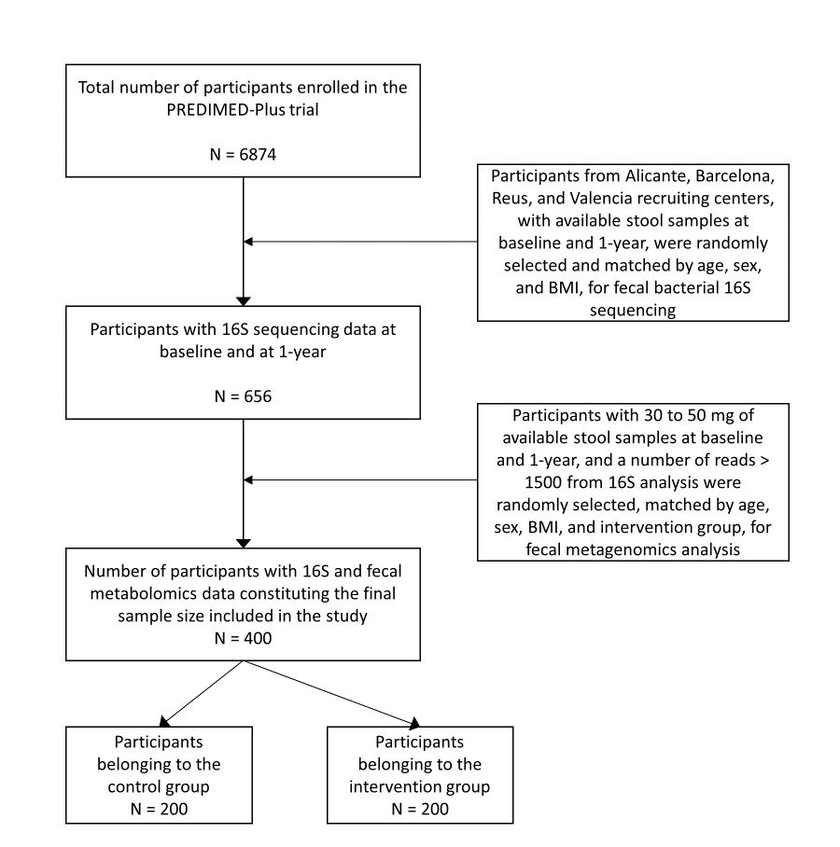

Supplementary Figure 2. Pair-wise partial correlations of metabolites included in the Black subnetwork. A) Baseline metabolites (n = 400). B) 1-year metabolites (n = 400).
A B
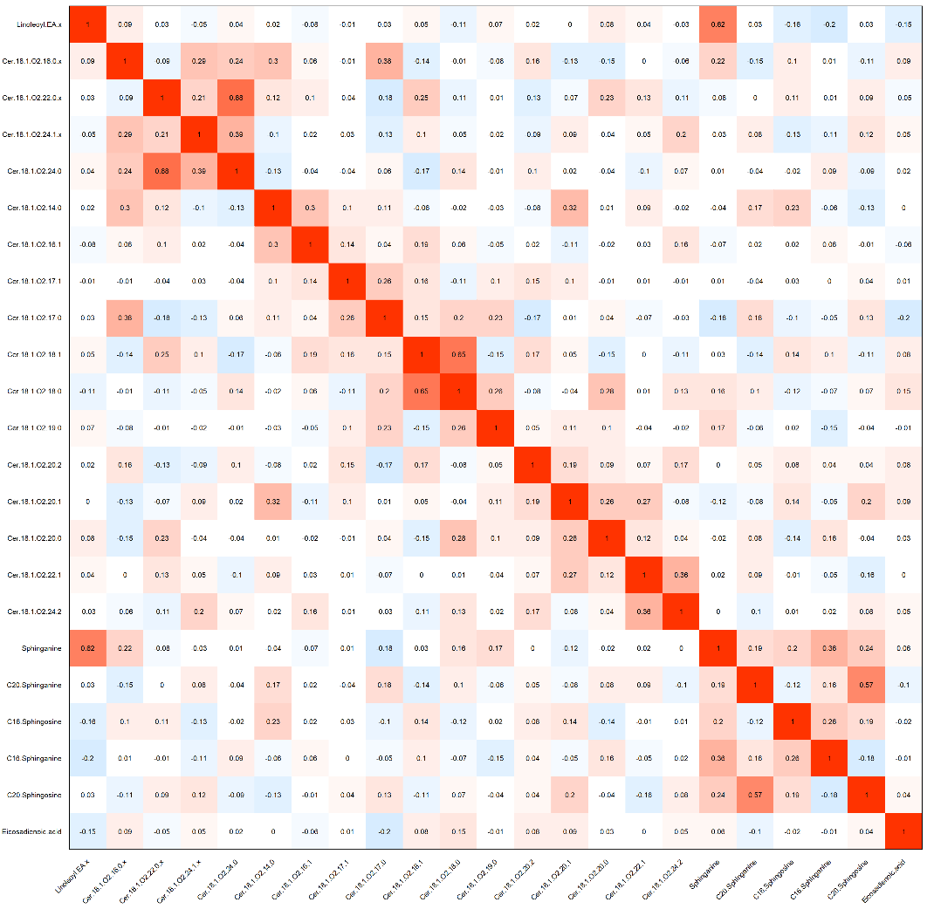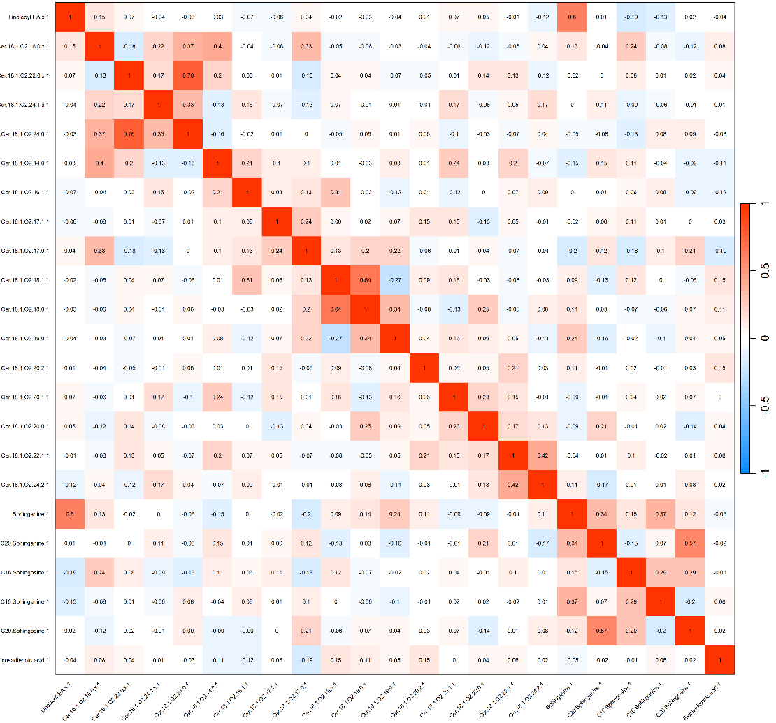

Supplementary Figure 3. Pair-wise partial correlations of metabolites included in the Midnight blue subnetwork. A) Baseline metabolites (n = 400). B) 1-year metabolites (n = 400).
A B
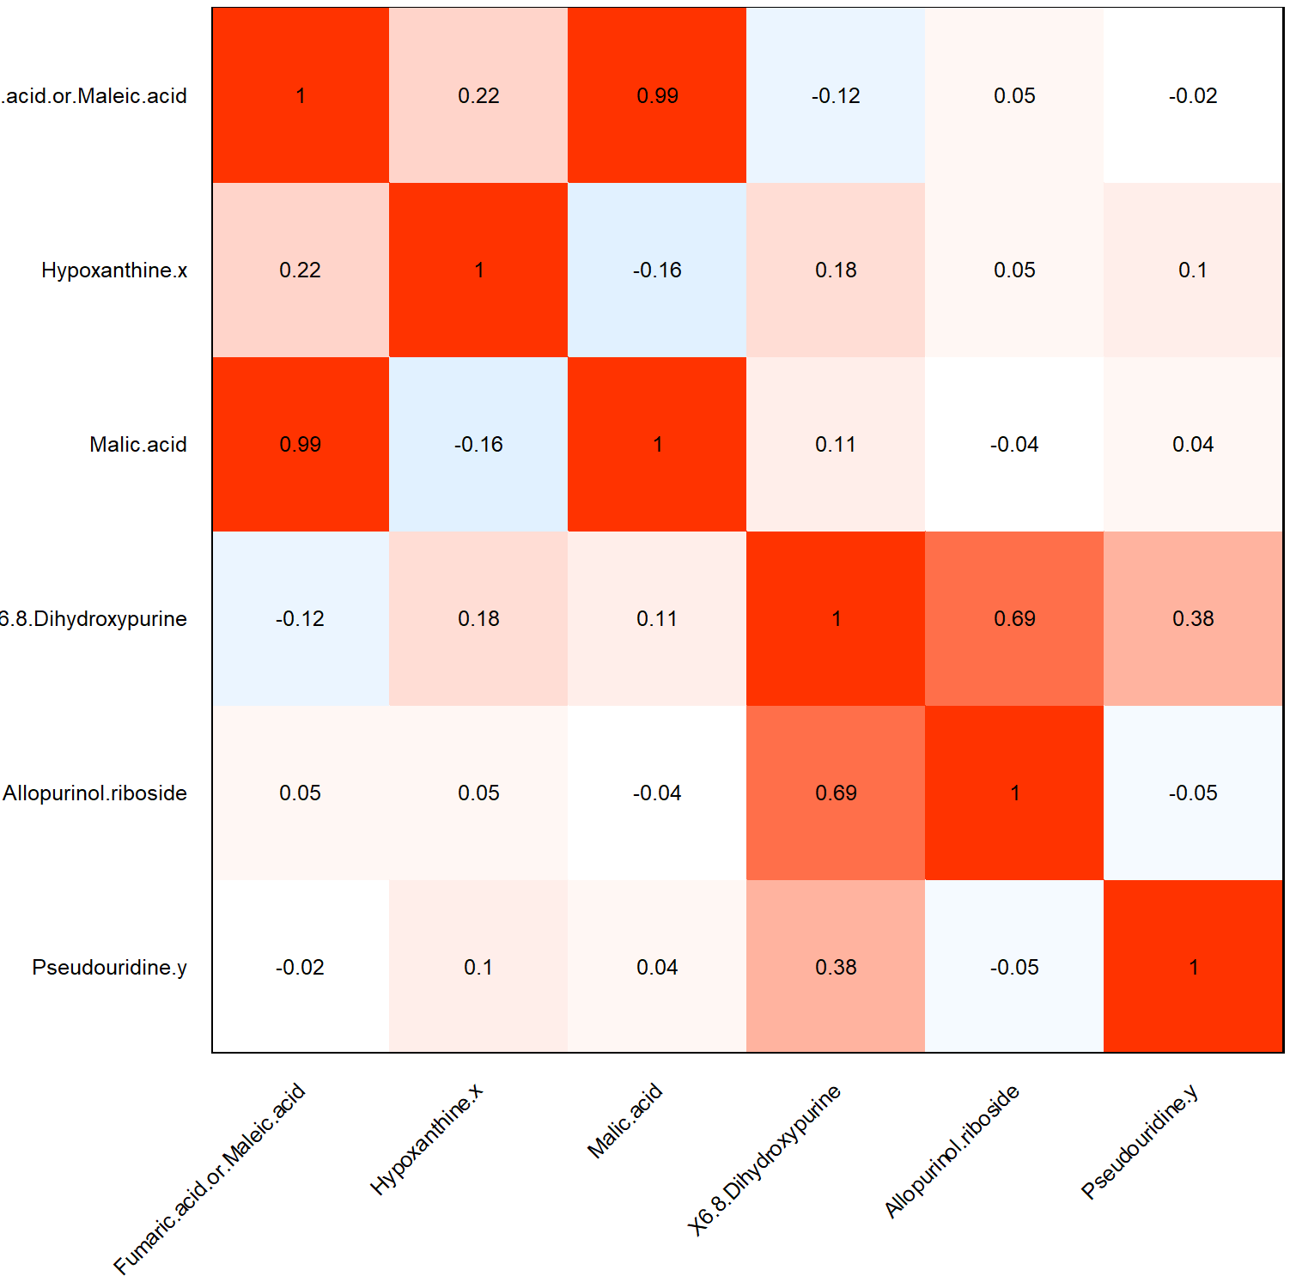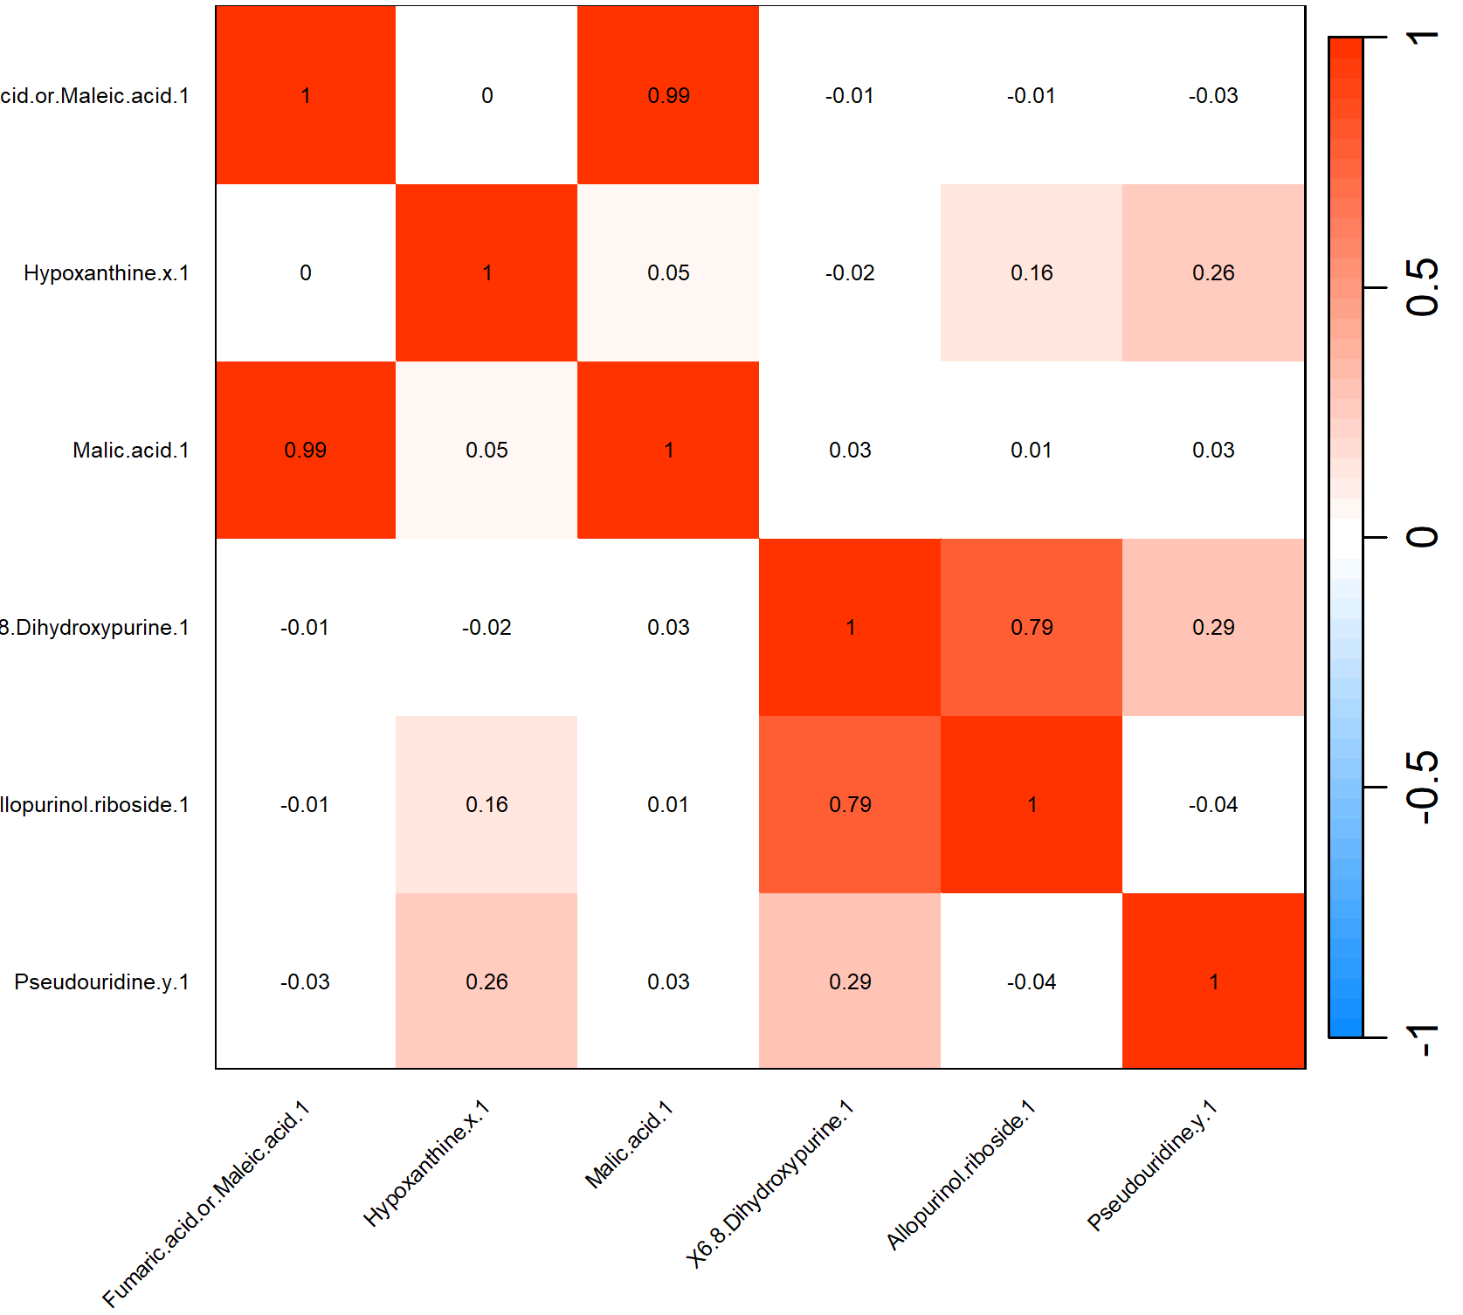

Supplementary Figure 4. Pair-wise partial correlations of metabolites included in the Pink subnetwork. A) Baseline metabolites (n = 400). B) 1-year metabolites (n = 400).
A B
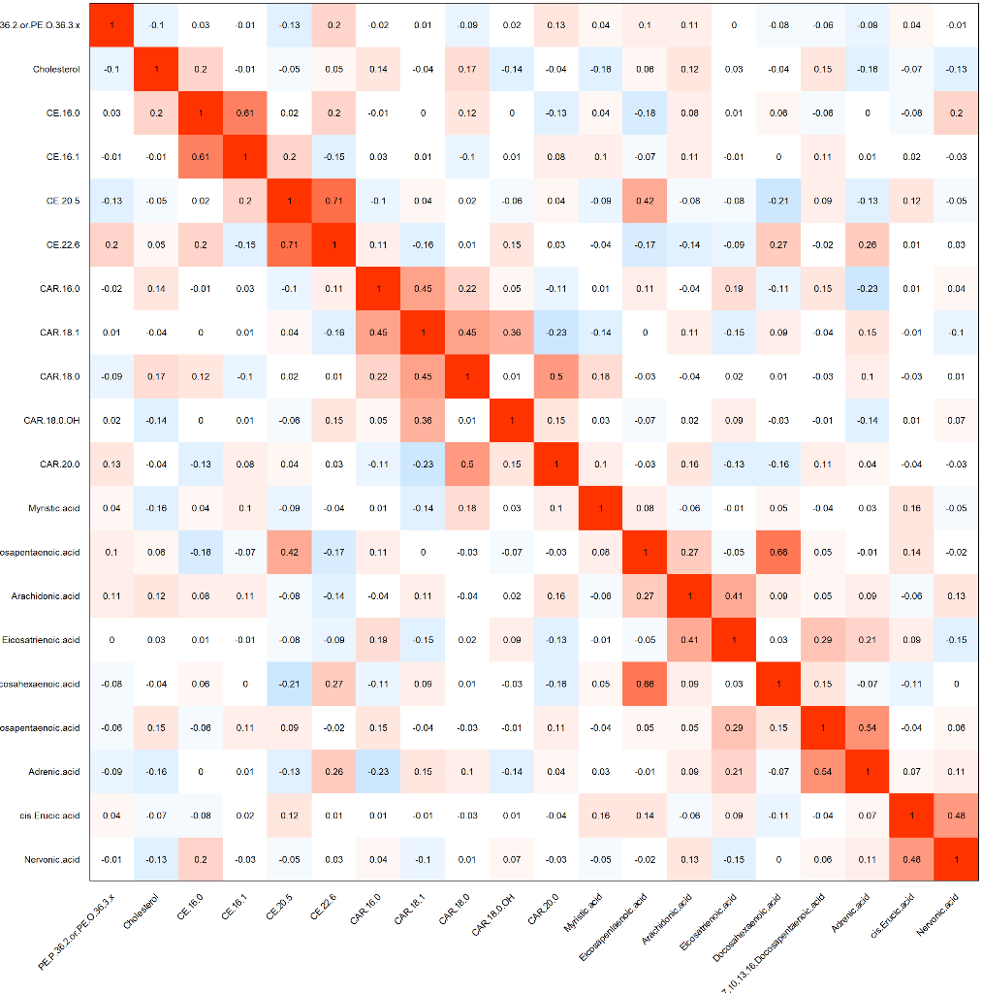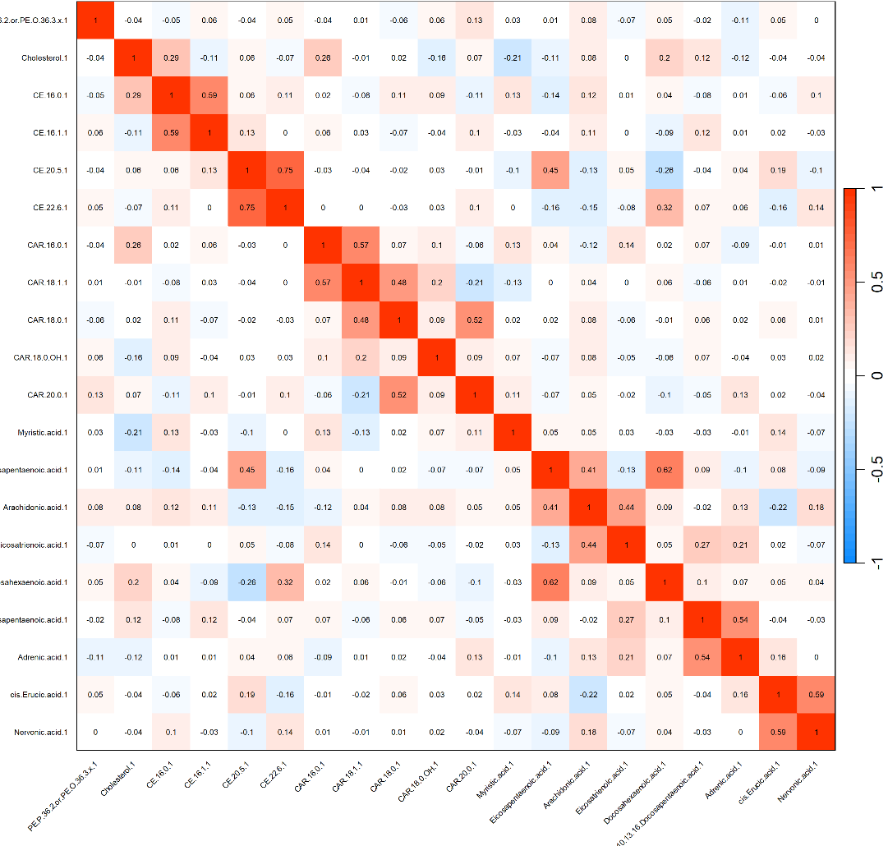

Supplementary Figure 5. Pair-wise partial correlations of metabolites included in the Salmon subnetwork. A) Baseline metabolites (n = 400). B) 1-year metabolites (n = 400).
A B
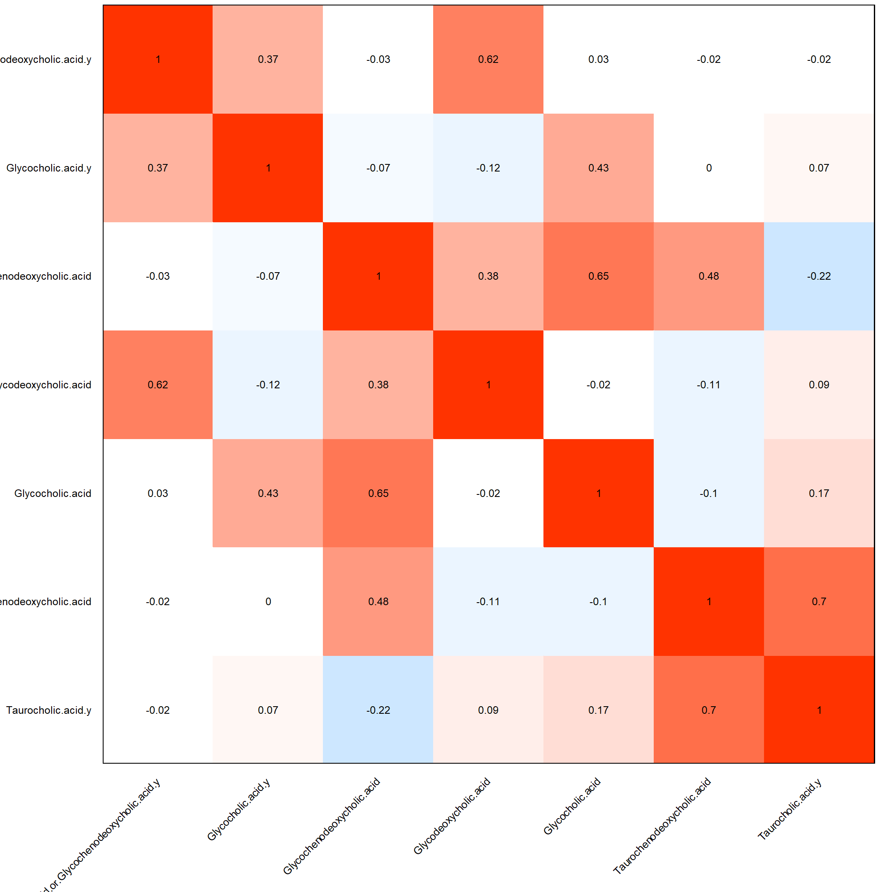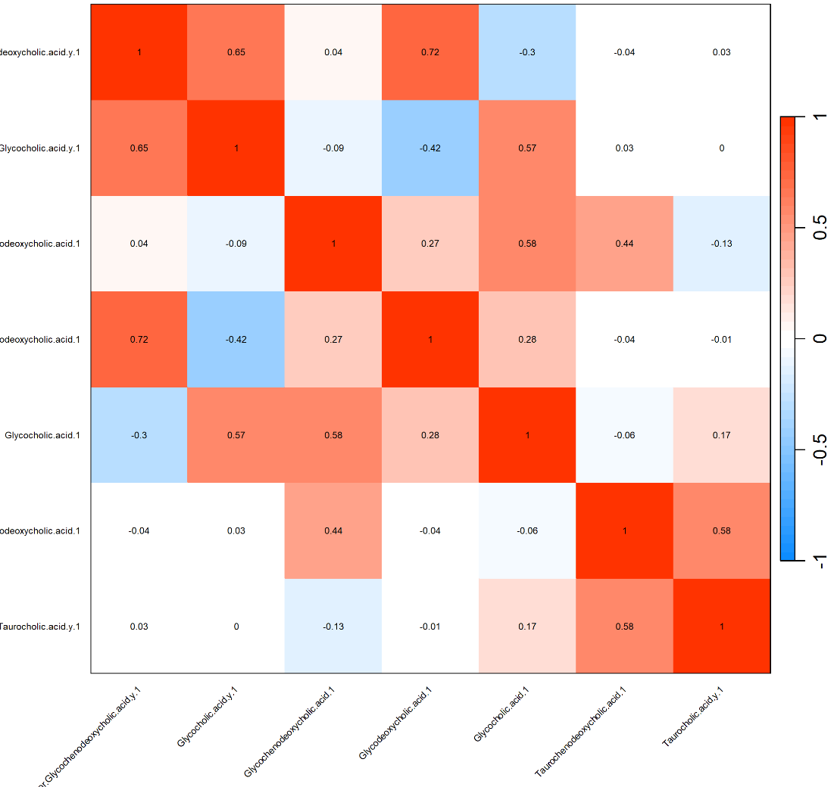

Supplementary figure 6. Fecal microbiota distribution among interventions explored through principal coordinate analysis (PCoA) over Bray-Curtis distance. CG, control group; IG, intervention group; A, after (1-year); B, baseline.

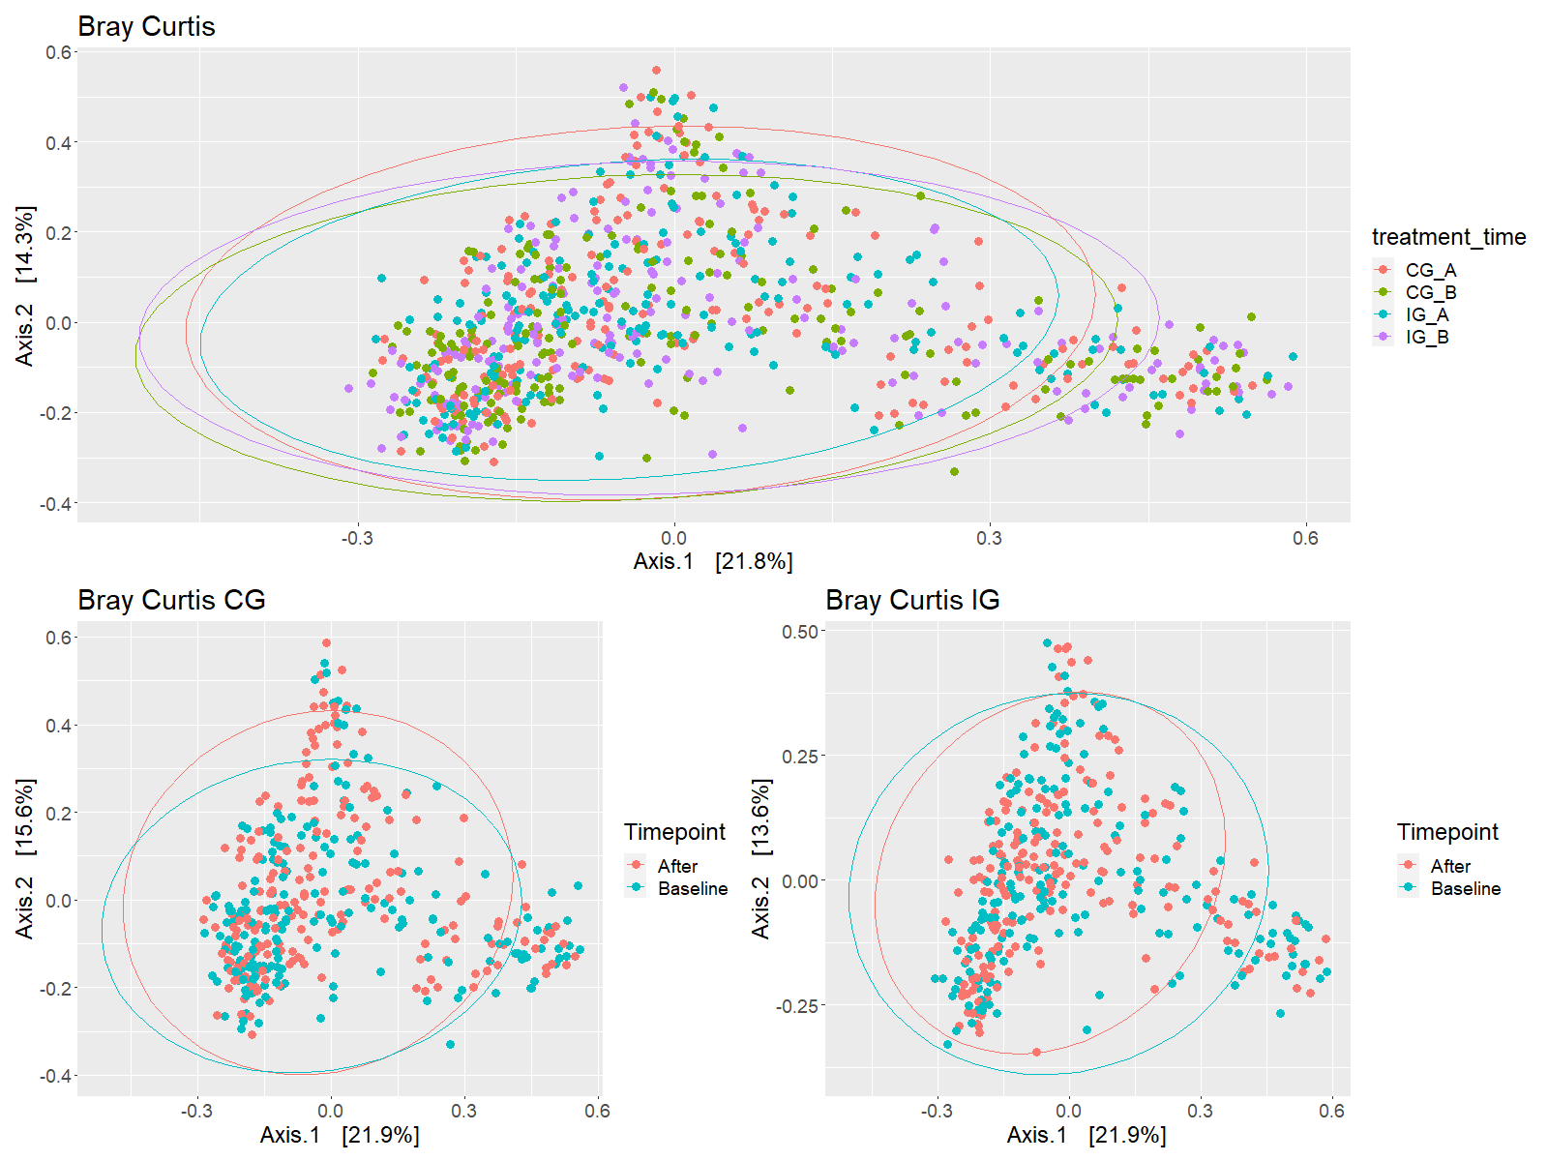

Supplementary Figure 7. Heatmap showing the association between changes in diversity and richness indices and changes in cardiovascular risk factors after one year of follow-up. Association tested with linear regression models adjusted for the Study group, recruiting center (Alicante, Barcelona, Reus, Valencia), smoking status (former smoker, never smoker, smoker), type 2 diabetes status, sex, body mass index (BMI) categories (overweight, BMI <30 kg/m2; obesity, BMI >= 30 kg/m2); age categories (below the median, <65 years old; above median, >65 years old), alcohol intake (g/day2), hypertension status. For each cell, colors indicate the association coefficient with cardiovascular risk factors. HDL, high-density lipoprotein; LDL, low-density lipoprotein; FPG, fasting, plasma glucose; HbA1c, glycated hemoglobin; HOMA-IR, homeostatic model assessment of insulin resistance (n = 400).
