ThermalScout-Net
A custom computer-vision model for human and wildlife detection in thermal drone footage
Project owner: Student research project | Course: COSC 2345 | Instructor: Dr. Kushal Vangara | Status date: October 28, 2026

1. Class-oriented project summary
In COSC 2345, we study how artificial intelligence represents problems, learns from examples, and selects effective approaches. My project applies supervised machine learning and artificial neural networks to a real conservation problem: finding humans and animals in nighttime thermal drone imagery. Rather than treating a pretrained model as a black box, I am developing my own convolutional neural-network detector, training it from scratch, and evaluating it against transfer-learning and YOLO11n alternatives.
The system takes a grayscale thermal frame as input and predicts a class (animal or human) and a bounding box for each object. Its intended purpose is to assist conservation monitoring and footage review, not to determine whether a detected person is involved in poaching.

2. Verified progress and evidence
Stage | What is complete | Evidence
Synthetic CNN | 29,635-parameter PyTorch CNN trained from random initialization over 8 epochs | Loss 0.9574 → 0.0220; 3 of 3 targets located in one illustrated synthetic scene
BIRDSAI inspection | 32 real training videos and 40,661 images loaded; annotation-frame matches checked | 74,668 animal and 12,531 human annotation rows
Development export | 26 train videos and 6 validation videos selected without sharing sequences | 2,001 training images; 334 validation images; official TestReal excluded
Real detector experiment | Next: train custom real-image CNN and inspect held-out validation predictions | Not yet trained; no real-data mAP or accuracy reported

3. Prepared BIRDSAI dataset
Split | Images | Animal labels | Human labels
Development training | 2,001 | 6,691 | 1,090
Development validation | 334 | 954 | 62
Official test | Not loaded | Not loaded | Not loaded
The development sample is strongly class-imbalanced, and the validation partition has only 62 human annotations. Splitting by video helps avoid nearly identical adjacent frames appearing in both training and validation. Final, unbiased evaluation must remain separate from model tuning.

4. Visual evidence collected
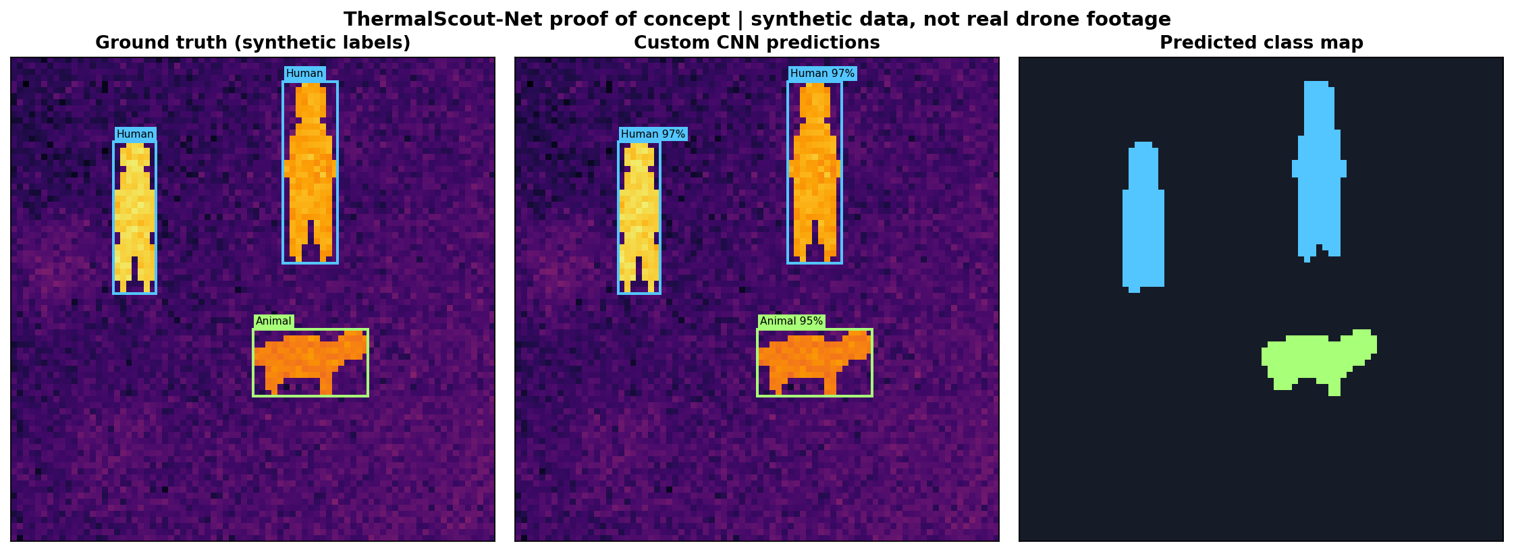  Figure 1. Synthetic CNN demonstration | 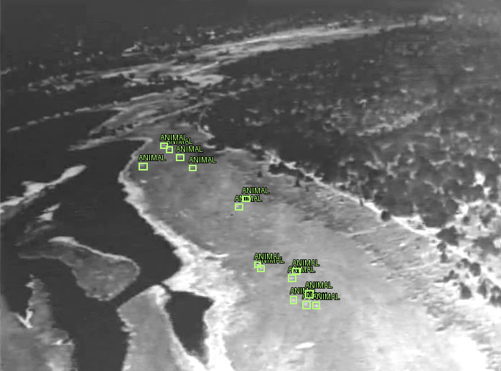  Figure 2. BIRDSAI ground-truth boxes

5. Technical model design and comparison
The first real-image ThermalScout prototype will use PyTorch convolutional layers, multi-resolution feature fusion, and an anchor-free detection head that predicts objectness, box coordinates, and the two classes. Because this version predicts at most one target per output grid cell, overlapping and tiny objects are a recognized limitation.
Experiment | Initialization | Purpose | Current result
Custom synthetic CNN | Random weights | Verify learning pipeline | Loss and single-scene demonstration only
ThermalScout real detector | Random weights | Measure custom design performance on BIRDSAI | Not yet trained
ThermalScout transfer learning | Pretrained feature extractor | Test effect of transferred visual representations | Not yet trained
YOLO11n fine-tuning | Pretrained detector | Benchmark against standard object detection | Not yet trained

6. What counts as accuracy?
A falling training loss shows optimization progress, not reliable accuracy. Since each frame can contain several objects, the main evaluation measures will be detection precision, detection recall (especially for humans), mAP@0.50, mAP@0.50:0.95, and frames processed per second (FPS). Scores must use matching data partitions and defined confidence/IoU evaluation settings. Per-class metrics will be recorded where possible.
Current measured real-image precision: NOT AVAILABLE. Current measured real-image recall: NOT AVAILABLE. Current measured real-image mAP: NOT AVAILABLE. No percentages are invented for the planned models.

7. Next actions and research controls
- Run a quick CPU-friendly training smoke test for the custom real-image detector; verify that image-label pairs and loss computation work.
- Train the scratch model on the exported development sample; save weights, training/validation losses, parameters and example predictions.
- Implement a correct object-detection evaluation using class-specific box matching at IoU thresholds; avoid using only validation loss as accuracy.
- Run a controlled transfer-learning experiment and a YOLO11n fine-tuning experiment using the same video-separated partitions.
- Make a comparison table with actual measured precision, recall, mAP and FPS; evaluate on untouched TestReal only after model selection.

8. Connection to COSC 2345 learning objectives
This project uses AI problem formulation (states and observations as thermal frames; goal as correct object localization/classification), supervised machine learning, neural-network training, model comparison, and responsible AI. Course search algorithms such as BFS and A* are different from neural-network object detection; hyperparameter search is used only to choose effective model settings. The report will emphasize algorithmic trade-offs, experimental evidence, limitations and reproducibility.

9. Report maintenance and reproducibility
The companion local project manager maintains a dated milestone log, experiment-run records, measured-score records and an updated HTML/Markdown report. After each experiment, run "python3.13 project_manager.py update"; a "train" command can run the scratch detector and register its loss CSV. The report is not updated in the background or automatically across unrelated ChatGPT conversations. This PDF and Word document are dated snapshots; the HTML report is the living version.

