**Product Backlog**

|  |  |  |  |  |  |
| --- | --- | --- | --- | --- | --- |
| **Priority** | **Item #** | **Description** | **Estimate** | **Remaining Hours By Sprint Start** | |
| **1** | **2** |
| Very High | 1 | Learning Stack Technologies | 60 | 60 | 20 |
| 2 | Product Vision | 30 | 30 | 10 |
| 3 | Weighted Suggestion Algorithms | 20 | 20 | 15 |
| 4 | Data Collection and Review Mining | 30 | 30 | 20 |
| 5 | UI and Front End | 50 | 50 | 30 |
| High | 6 | Search Queries | 5 | 5 | 0 |
| 7 | Use Case Details | 30 | 30 | 20 |
| 8 | Website Server | 30 | 30 | 10 |
| 9 | Media Databasing | 20 | 20 | 15 |
| 10 | Account Creation and Databasing | 15 | 15 | 10 |
| Medium | 11 | Follow System | 10 | 10 | 10 |
| 12 | Covering Various Forms of Media | 20 | 20 | 20 |
| TOTAL |  |  |  | 320 | 180 |

**Product Burndown Chart**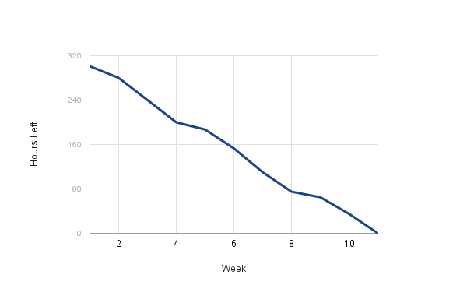

**Sprint Backlog: Sprint 1**

|  |  |  |  |  |  |  |  |  |
| --- | --- | --- | --- | --- | --- | --- | --- | --- |
| Days left | | | 35 | 28 | 21 | 14 | 7 | 0 |
| Item # | Description | Status | 10/1  Sprint Starts | 10/08 | 10/15 | 10/22 | 10/29 | 11/5 |
| 1 | Learning Stack Technologies | In Progress | 60 | 40 | 30 | 26 | 24 | 20 |
| 2 | Product Vision | In Progress | 30 | 20 | 15 | 10 | 10 | 10 |
| 3 | Weighted Suggestions Algorithm | Not Started | 20 | 20 | 20 | 17 | 15 | 15 |
| 4 | Data Collection and Mining | Not Started | 30 | 30 | 30 | 27 | 23 | 20 |
| 5 | UI and Front End | Not Started | 50 | 50 | 45 | 40 | 35 | 30 |
| 6 | Search Queries | Not Started | 5 | 5 | 5 | 5 | 2 | 0 |
| 7 | Use Case Details | Not Started | 30 | 30 | 30 | 30 | 25 | 20 |
| 8 | Website Server | Not Started | 30 | 30 | 25 | 15 | 10 | 10 |
| 9 | Media Databasing | Not Started | 20 | 20 | 20 | 17 | 15 | 15 |
| 10 | Account Creation and Databasing | Not Started | 15 | 15 | 15 | 15 | 15 | 10 |
| 11 | Follow System | Not Started | 10 | 10 | 10 | 10 | 10 | 10 |
| 12 | Covering Various Forms of Media | Not Started | 20 | 20 | 20 | 20 | 20 | 20 |
| Total Estimated Hours Remaining | |  | 320 | 290 | 265 | 232 | 204 | 180 |

**Sprint Backlog: Sprint 2**

|  |  |  |  |  |  |  |  |  |
| --- | --- | --- | --- | --- | --- | --- | --- | --- |
| Days left | | | 35 | 28 | 21 | 14 | 7 | 0 |
| Item # | Description | Status | 11/5  Sprint Start | 11/12 | 11/19 | 11/26 | 12/03 | 12/10 |
| 1 | Learning Stack Technologies | Completed | 20 | 15 | 10 | 5 | 0 | 0 |
| 2 | Product Vision | In Progress | 10 | 7 | 4 | 0 | 0 | 0 |
| 3 | Weighted Suggestions Algorithm | Completed | 15 | 13 | 8 | 5 | 3 | 0 |
| 4 | Data Collection and Mining | In Progress | 20 | 15 | 11 | 7 | 3 | 0 |
| 5 | UI and Front End | In Progress | 30 | 25 | 20 | 15 | 5 | 0 |
| 6 | Search Queries | Completed | 0 | 0 | 0 | 0 | 0 | 0 |
| 7 | Use Case Details | In Progress | 20 | 20 | 20 | 15 | 5 | 0 |
| 8 | Website Server | In Progress | 10 | 5 | 0 | 0 | 0 | 0 |
| 9 | Media Databasing | Completed | 15 | 10 | 6 | 2 | 0 | 0 |
| 10 | Account Creation and Databasing | Not Started | 10 | 8 | 4 | 2 | 0 | 0 |
| 11 | Follow System | Not Started | 10 | 10 | 10 | 7 | 4 | 0 |
| 12 | Covering Various Forms of Media | Not Started | 20 | 20 | 20 | 15 | 10 | 0 |
| Total Estimated Hours Remaining | |  | 180 | 148 | 113 | 73 | 30 | 0 |