***Gavin Johnson – 12/08/23***

**Proposal:**

* This project idea is very roughly based around the idea of an item stock system for let's say a store. Items can be added to the Database file and the number of available items (stock) can be viewed and modified using the GUI. Viewed items can be sorted by highest or lowest stock.

**Time:**

* **Day 1:** Created the basics of the Database tables.
* **Day 2:** Created the basic layout of the GUI.
* **Day 3:** Modified the Database and GUI to work with the new addition to display the Database items in the format of image, name, and stock, in a grid like fashion.
* **Day 4:** Added the sorting option/button and item lookup with the ability to enter a new value for items stock/availability.
* **Day 5 (today):** Added finishing touches, such as GUI alerts for some invalid inputs. Also did more testing.

**Lessons Learned:**

* Nothing really changed with my project’s idea. Although, there is more I wanted to add such as the ability to add/remove your own items. I felt I couldn’t add many visuals into the GUI to make it more pleasing to look at as to me the lib used (tkinter) is rather old and limited in many ways. I didn't figure anything out for this issue though so my only "solution" was to keep the GUI basic and bland.

**Michelle’s Principles:**

* Programs should be efficient in memory and be low on time usage. code should be written in a top-down design and utilizing classes and encapsulation when possible/suited. The programmer should be aware of user-friendly designs based on others’ opinions, not just their own. A program should not break, however bug-free code doesn't exist so we must handle errors or exit peacefully. Code should be simple, clean, easy to read (elegant), and commented. Algorithms should be easy to read and efficient.

**Conclusion:**

* The project can be summarized easily as I wanted to keep it simple and easy to use and understand, items are added to a database via a list and viewed in the GUI. the number of items in stock for that "product" can be modified using the GUI and sorted to view which items have low stock. If I was to remake this, I'd use some other lib for the GUI, maybe something that consists of HTML & CSS linked with Python (using API?). This would allow me to make virtually any GUI design much more easily with more flexibility as I'm more familiar with that type of stuff. I'd also improve the way you search items and add a way to add or remove items from the database during runtime. Possibly create a login page for normal users and admin users, in general a bunch of improvements would be made in future versions.

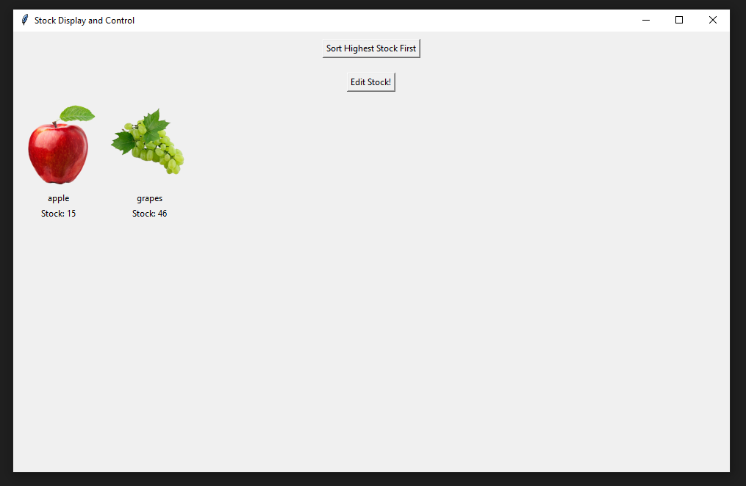

* This is the main GUI. It’s not visually pleasing. Sorted by lowest stock.

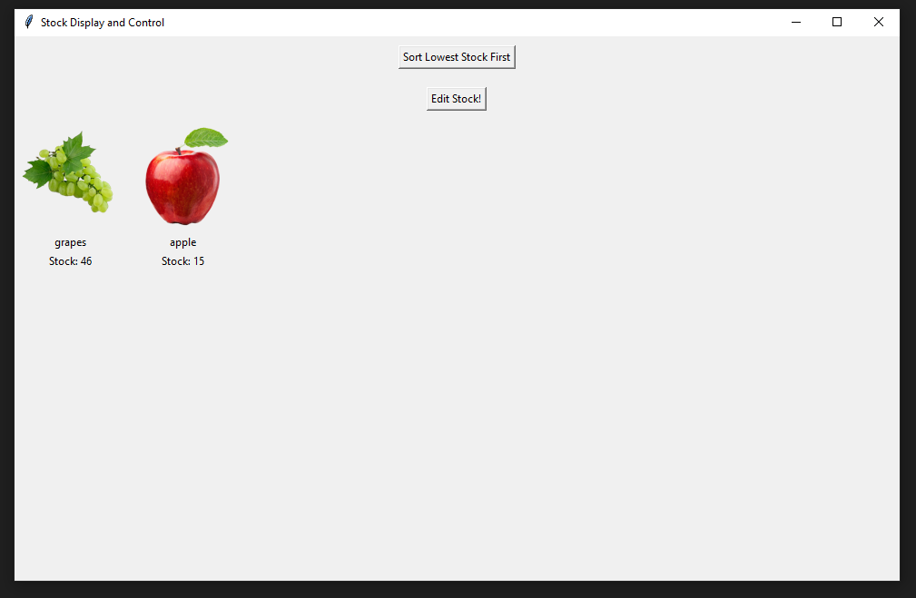

* List sorted by highest stock.

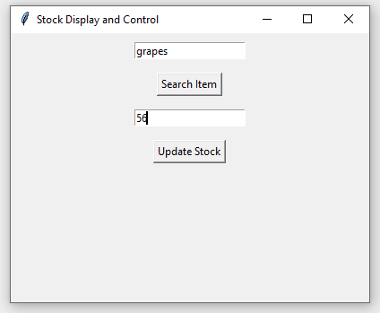

* Menu to search for item and update its’ stock.

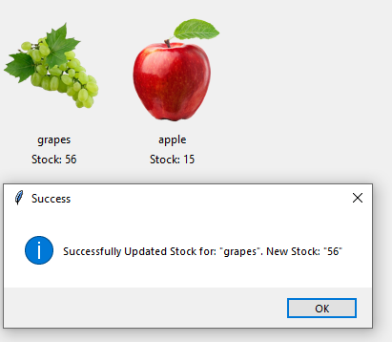

* Successfully updated items stock. GUI is updated with a new number.