Supplementary Materials
Equity, Diversity, Inclusion, and Accessibility Reporting in Canadian Mental Health Pharmacotherapy Randomized Controlled Trials (2016–2026): A Scoping Review Using the PROGRESS-Plus Framework
This document accompanies the main manuscript and contains: the PRISMA-ScR checklist, full database search strategies, the data extraction codebook, per-study extracted data, the Pass 2 inter-rater reliability results, the list of records excluded after eligibility criterion refinement, and the six supplementary figures. Item numbering matches the in-text callouts in the main manuscript.

Contents
• Supplementary Table S1 — PRISMA-ScR Checklist
• Supplementary Table S2 — Full Search Strategies (PubMed, Europe PMC, Scopus, OpenAlex)
• Supplementary File S3 — Data Extraction Codebook
• Supplementary Table S4 — Per-Study Extracted Data (63 trials)
• Supplementary Table S5 — Pass 2 Inter-Rater Reliability
• Supplementary Table S6 — Records Excluded after Canadian-Site Criterion Refinement
• Supplementary Figure S1 — Race / Ethnicity Reporting Over Time
• Supplementary Figure S2 — Race / Ethnicity Reporting by Funder Type
• Supplementary Figure S3 — Indigenous Participation and Governance Indicators
• Supplementary Figure S4 — Sex vs. Gender Reporting
• Supplementary Figure S5 — CONSORT-Equity Compliance
• Supplementary Figure S6 — PROGRESS-Plus Completeness by Year and Sample Size

Supplementary Table S1 — PRISMA-ScR Checklist
Reporting guideline: PRISMA Extension for Scoping Reviews (PRISMA-ScR). Tricco AC, Lillie E, Zarin W, et al. Ann Intern Med. 2018;169(7):467–473. doi:10.7326/M18-0850. Item wording reproduced verbatim from Tricco et al. 2018.
# | Section / Item | PRISMA-ScR item (Tricco et al. 2018) | Compliance status
1 | Title | Identify the report as a scoping review. | Reported
2 | Structured summary | Provide a structured summary that includes, as applicable, background, objectives, eligibility criteria, sources of evidence, charting methods, results, and conclusions relating to the review questions and objectives. | Partially reported — Results section contains placeholder text pending final manuscript drafting; all structural elements are present in the outline
3 | Rationale | Describe the rationale for the review in the context of what is already known and what the review adds to existing knowledge. | Partially reported — Rationale points are outlined; full narrative prose not yet drafted
4 | Objectives | Provide an explicit statement of the questions and objectives being addressed with reference to their key elements (e.g., population or participants, concepts, and context) or other relevant key elements used to conceptualize the review questions and/or objectives. | Reported — 3 primary and 4 secondary objectives stated; population (Canadian mental health pharmacotherapy RCTs), concept (EDIA reporting per PROGRESS-Plus), and context (2016–2026, post-CIHR SGBA+ era) are explicit
5 | Protocol and registration | Indicate whether a review protocol exists; state if and where it can be accessed (e.g., a Web address); and if available, provide registration information including the registration number. | Reported — Not pre-registered; transparency statement with full rationale and compensating measures documented in `PROTOCOL_REGISTRATION.md`; protocol accessible via public GitHub repository
6 | Eligibility criteria | Specify characteristics of the sources of evidence used as eligibility criteria (e.g., years considered, language, and publication status), and provide a rationale for the decisions made. | Reported — Inclusion (RCT, DSM-5/ICD-10 mental disorder, pharmacological intervention, verified Canadian recruitment site, 2016–2026, English) and exclusion criteria with rationale and documented criterion revision (2026-04-11)
7 | Information sources | Describe all information sources in the search (e.g., databases with dates of coverage and contact with authors of studies) and date last searched. | Reported — 4 databases (PubMed, Europe PMC, Scopus, OpenAlex), all searched 2026-03-30; API types and per-database record counts documented
8 | Search | Present the full search strategy for at least one database, including any limits used, such that it could be repeated. | Reported — Full search strategies for all 4 databases in `Search_Strategies_Canadian_MH_RCTs.md`; complete reproducible Python scripts in `04_database_search/`; to be formatted as Supplementary Table S2 in the manuscript
9 | Selection of sources of evidence | State the process for selecting sources of evidence (i.e., screening and eligibility) included in the scoping review. | Reported — Dual independent title/abstract screening (10,904 records), Cohen's κ = 0.39 with base-rate caveat; Codex GPT-5.4 false-negative validation; full-text screening process; all decision rules documented
10 | Data charting process | Describe the methods of charting data from the included sources of evidence (e.g., calibrated forms or forms that have been tested by the team before their use, and whether data charting was done independently or in duplicate) and any processes for obtaining and confirming data from investigators. | Reported — PROGRESS-Plus framework, 50+ variables per study; AI-assisted extraction with human QA; Pass 2 QC on 30% of records (20/66); Cohen's κ 0.86–1.00 for 4 key fields; extraction codebook in Supplementary File S3
11 | Data items | List and define all variables for which data were sought and any assumptions made. | Partially reported — Variable categories listed in manuscript outline (trial-level covariates, PROGRESS-Plus variables, Indigenous-specific variables, CONSORT-Equity compliance); full definitions and decision rules in extraction codebook — to be published as Supplementary File S3
12 | Critical appraisal of individual sources of evidence | If done, provide a rationale for conducting a critical appraisal of included sources of evidence; describe the methods used and how this information was used in any data synthesis (if applicable). | Not applicable — Consistent with scoping review methodology, formal risk-of-bias or quality appraisal of individual studies was not conducted; the manuscript will state this explicitly per PRISMA-ScR guidance
13 | Selection of sources of evidence | Give numbers of sources of evidence screened, assessed for eligibility, and included in the review, with reasons for exclusions at each stage, ideally using a flow diagram. | Reported — PRISMA flow diagram drafted: 54,483 identified → 39,986 unique → 10,904 screened → 134 full-text → 63 included (flow diagram) / 66 included (final extraction, per 2026-04-13 third correction; see footnote §); exclusion reasons at each stage documented
14 | Characteristics of sources of evidence | For each source of evidence, present characteristics for which data were charted and provide the citations. | Partially reported — Trial characteristics summarized in `extraction_summary.md` (66 trials, N=9,598, multisite/international proportions, disorder categories, median sample size); Table 1 to be formatted in manuscript
15 | Critical appraisal within sources of evidence | If done, present data on critical appraisal of included sources of evidence (see item 12). | Not applicable — No critical appraisal conducted (see item 12)
16 | Results of individual sources of evidence | For each included source of evidence, present the relevant data that were charted that relate to the review questions and objectives. | Partially reported — Per-study extraction data in `extracted_data.csv` (66 rows × 75 columns); summarized in `extraction_summary.md`; per-study table to be formatted in manuscript and published as Supplementary File S4
17 | Synthesis of results | Summarize and/or present the charting results as they relate to the review questions and objectives. | Partially reported — Analysis plan specified (descriptive statistics, temporal comparison pre/post-2020, Census benchmarking); key findings documented in `extraction_summary.md`; full narrative synthesis and tables not yet drafted
18 | Summary of evidence | Summarize the main results (including an overview of concepts, themes, and types of evidence available), link to the review questions and objectives, and consider the relevance to key groups. | Partially reported — Summary points outlined (race/ethnicity gap, sex/gender conflation, intersectionality absent, Indigenous governance absent); comparison with US/global literature planned in §4.2; full narrative not yet drafted
19 | Limitations | Discuss the limitations of the scoping review process. | Reported — 6 limitations explicitly enumerated: English-language only, 4-database API-only search, AI-assisted screening/extraction, not pre-registered, Cohen's κ = 0.39, unequal temporal comparison windows
20 | Conclusions | Provide a general interpretation of the results with respect to the review questions and objectives, as well as potential implications and/or next steps for research, practice, or policy. | Partially reported — Conclusions and policy implications outlined (CIHR mandatory PROGRESS-Plus reporting, Indigenous governance); full narrative not yet drafted
21 | Funding | Describe sources of funding for the included sources of evidence, as well as sources of funding for the scoping review. Describe the role of the funders of the scoping review. | Partially reported — Funder patterns of *included trials* described in §3.8 (CIHR, NIH, industry, etc.); funding of *this review*: self-funded, no institutional sponsor — to be stated explicitly in the manuscript funding statement
22 | Competing interests | Provide a statement of any competing interests, or a statement that there are none. | Reported — Conflicts of interest: none declared; independent student-led review with no faculty PI, no institutional sponsor, no industry ties; to be included in manuscript declarations

Supplementary Table S2 — Full Search Strategies
All searches executed 2026-03-30. Database selection was restricted to sources with programmatic (API) access. PsycINFO and CINAHL were not executed (acknowledged as a limitation).
Database yields
Database | Platform / API | Date searched | Records retrieved
PubMed | NCBI E-utilities REST API | 2026-03-30 | 9,964
Europe PMC | Europe PMC REST API | 2026-03-30 | 15,772
Scopus | Elsevier Scopus Search API | 2026-03-30 | 27,983
OpenAlex | OpenAlex REST API | 2026-03-30 | 764
Combined (raw) | — | — | 54,483
After deduplication | — | — | 39,986
After automated filtering | — | — | 10,904
Search concept blocks (combined with Boolean AND)
Concept 1 — Mental disorders: MeSH terms and free-text synonyms covering depressive disorders, bipolar and related disorders, psychotic disorders (schizophrenia and schizoaffective disorder), anxiety disorders, trauma- and stressor-related disorders (including PTSD), obsessive-compulsive and related disorders, substance-related and addictive disorders, neurocognitive disorders (including Alzheimer’s dementia and related dementias), neurodevelopmental disorders (ADHD, autism spectrum disorder), and feeding and eating disorders, using DSM-5 and ICD-10 terminology.
Concept 2 — Randomized controlled trial design: Cochrane Highly Sensitive Search Strategy (sensitivity-maximizing version, 2008 revision) adapted to each platform, supplemented by design-specific terms ("parallel-group", "crossover", "factorial design", "double-blind").
Concept 3 — Canadian context: geographic terms (Canada, Canadian), provincial / territorial names, and institutional affiliation keywords (e.g., major Canadian university / hospital terms).
EDIA-specific terms were intentionally excluded from the search strategy to avoid preferentially retrieving trials that already report diversity data, which would have biased the primary outcome.
Representative query strings
PubMed
((("Depressive Disorder"[MeSH] OR "Bipolar Disorder"[MeSH] OR "Schizophrenia"[MeSH] OR "Anxiety Disorders"[MeSH] OR "Stress Disorders, Traumatic"[MeSH] OR "Obsessive-Compulsive Disorder"[MeSH] OR "Substance-Related Disorders"[MeSH] OR "Neurocognitive Disorders"[MeSH] OR "Attention Deficit Disorder with Hyperactivity"[MeSH] OR "Autism Spectrum Disorder"[MeSH] OR "Feeding and Eating Disorders"[MeSH] OR depressi*[tiab] OR bipolar[tiab] OR schizophren*[tiab] OR psychot*[tiab] OR anxiet*[tiab] OR PTSD[tiab] OR "obsessive compulsive"[tiab] OR "substance use"[tiab] OR dementia*[tiab] OR Alzheimer*[tiab] OR ADHD[tiab] OR autism[tiab] OR "eating disorder*"[tiab])) AND (randomized controlled trial[pt] OR controlled clinical trial[pt] OR randomized[tiab] OR placebo[tiab] OR "randomly"[tiab] OR trial[tiab]) AND (Canada[MeSH] OR Canad*[tiab] OR Ontario[tiab] OR Quebec[tiab] OR "British Columbia"[tiab] OR Alberta[tiab] OR Manitoba[tiab] OR Saskatchewan[tiab] OR "Nova Scotia"[tiab] OR "New Brunswick"[tiab] OR "Newfoundland"[tiab] OR "Prince Edward Island"[tiab] OR Yukon[tiab] OR Nunavut[tiab] OR "Northwest Territories"[tiab])) AND (2000:3000[dp])
Europe PMC
(MESH:"Depressive Disorder" OR MESH:"Bipolar Disorder" OR MESH:"Schizophrenia" OR MESH:"Anxiety Disorders" OR MESH:"Substance-Related Disorders" OR MESH:"Neurocognitive Disorders" OR depressi* OR bipolar OR schizophren* OR anxiet* OR PTSD OR "substance use" OR dementia* OR ADHD OR autism OR "eating disorder*") AND (randomized OR randomised OR RCT OR placebo OR "clinical trial") AND (Canada OR Canadian OR Ontario OR Quebec OR "British Columbia" OR Alberta OR Manitoba OR Saskatchewan OR "Nova Scotia" OR "New Brunswick" OR Newfoundland OR Yukon OR Nunavut) AND (SRC:MED OR SRC:PMC) AND PUB_YEAR:[2000 TO 3000]
Scopus
TITLE-ABS-KEY((depressi* OR bipolar OR schizophren* OR psychot* OR anxiet* OR PTSD OR "obsessive compulsive" OR "substance use" OR dementia* OR Alzheimer* OR ADHD OR autism OR "eating disorder*")) AND TITLE-ABS-KEY((randomized OR randomised OR RCT OR placebo OR "clinical trial")) AND AFFILCOUNTRY(Canada) AND PUBYEAR > 1999 AND (LIMIT-TO(DOCTYPE,"ar") OR LIMIT-TO(DOCTYPE,"re"))
OpenAlex
(title_and_abstract.search:"depressive disorder" OR "bipolar" OR "schizophrenia" OR "anxiety disorder" OR "PTSD" OR "substance use disorder" OR "dementia" OR "ADHD" OR "autism spectrum" OR "eating disorder") AND (title_and_abstract.search:"randomized controlled trial" OR "randomised controlled trial" OR "placebo-controlled") AND (authorships.institutions.country_code:CA) AND (publication_year:2000-2026)
The complete, line-numbered search strategies including concept tables, syntax notes, and reproducible Python API scripts are available at: https://github.com/gavinshadlou/edia-racialized → 04_database_search/

Supplementary File S3 — Data Extraction Codebook
The codebook below was used for all extraction passes. Variable definitions, decision rules, and allowable values are reproduced verbatim from the project repository (06_data_extraction/extraction_codebook.md).
EDIA Reporting in Canadian Mental Health Pharmacotherapy RCTs
Purpose
This codebook operationalizes the PROGRESS-Plus framework for extracting equity, diversity, inclusion, and accessibility (EDIA) reporting data from included randomized controlled trials. It provides decision rules for coding completeness, granularity, and quality of reporting for each variable.
---
Key Definitions
Racialized Groups
In this review, "racialized groups" refers to people who experience racialization — the social process by which racial meaning is ascribed to groups, creating hierarchies of difference. Race is understood as a social construct reflecting systems of power and categorization, not a biological variable.
In the Canadian context:
- **Racialized persons** includes those identified as visible minorities under the *Employment Equity Act* (i.e., non-Caucasian in race or non-white in colour, excluding Indigenous peoples)
- **Indigenous peoples** (First Nations, Inuit, and Metis) are discussed under a **distinct framework** of self-determination, sovereignty, and reconciliation — not subsumed under "racialized"
- This review extracts data on both racialized groups and Indigenous peoples, but analyzes them separately, consistent with CIHR and TCPS2 guidance
Terminology note — "visible minority": This term is used in extraction fields where it preserves fidelity to (a) trial-reported categories and (b) Statistics Canada benchmarking definitions under the *Employment Equity Act*. The term is contested: Statistics Canada (2022 consultation with the Commission on Official Languages) has proposed replacing "visible minority" with "racialized person" or "racialized group" in future census instruments. This review uses "racialized groups" as its primary term throughout, reserving "visible minority" only where Canadian legal/statistical definitions are directly invoked. When trials themselves use "visible minority," code `race_categories` verbatim and note this in `race_notes`.
Adequate Reporting
A trial is coded as having "adequate" EDIA reporting for a given variable when:
1. The variable is explicitly named and defined
2. Participant-level data are presented (counts or proportions)
3. Categories are sufficiently granular (not just "White/non-White")
Partial Reporting
A trial reports a variable partially when data are mentioned but:
- Only in aggregate (e.g., "diverse sample" without numbers)
- Using overly broad categories
- Reported at baseline but not in results
---
PROGRESS-Plus Variables
P — Place of Residence
Field | Description
`place_reported` | Yes / Partial / No
`place_detail` | Categories used (urban/rural/remote/Northern, province, postal code, etc.)
`place_notes` | Free text
Decision rules:
- "Yes" = geographic distribution of participants reported with counts
- "Partial" = general statement (e.g., "urban academic centre") without participant-level data
- "No" = no geographic information about participants
R — Race/Ethnicity/Racialization
Field | Description
`race_reported` | Yes / Partial / No
`race_categories` | Exact categories used (copy verbatim from paper)
`race_n_groups` | Number of racial/ethnic categories reported
`race_framework` | US-derived / Canadian Census / Self-identified / Other / Not stated
`race_granularity` | Granular (14+ groups, matching Statistics Canada visible minority taxonomy) / Moderate (5–13 groups) / Coarse (2–4 groups) / Binary (White/non-White) / Aggregate only
`race_subgroup_analysis` | Yes / No — were racial/ethnic subgroups analyzed for treatment effects?
`race_as_variable` | Covariate / Stratification / Subgroup / Descriptive only / Not used
`race_social_construct` | Yes / No — does the paper acknowledge race as a social construct?
`race_crosswalk` | Free text — mapping of trial-reported categories to Statistics Canada visible minority taxonomy for benchmarking (e.g., "Asian → South Asian + East Asian + Southeast Asian")
`race_notes` | Free text
Decision rules:
- "Yes" = participant race/ethnicity reported with counts per category
- "Partial" = mentioned but no counts (e.g., "predominantly White") or only % without n
- "No" = no mention of race, ethnicity, or racialization
- Record **exact categories** as stated in the paper (do not reclassify)
Granularity reference — Statistics Canada visible minority taxonomy (Census 2021):
South Asian, Chinese, Black, Filipino, Arab, Latin American, Southeast Asian, West Asian, Korean, Japanese, Visible minority n.i.e., Multiple visible minorities. These 12 named groups + "Not a visible minority" + "Total" = 14 categories. Trials that report all named groups (or an equivalent level of specificity) are coded "Granular". See Statistics Canada Table 98-10-0347-01 for the full taxonomy.
Note on US vs. Canadian frameworks: Many included trials will report race/ethnicity using US OMB categories (White / Black or African American / Asian / American Indian or Alaska Native / Native Hawaiian or Pacific Islander / Other). Code `race_framework = "US-derived"` for these. Add a `race_crosswalk` free-text field noting which Statistics Canada categories the reported groups map to, to enable benchmarking.
O — Occupation/Employment
Field | Description
`occupation_reported` | Yes / Partial / No
`occupation_detail` | Categories used
G — Gender/Sex
Field | Description
`sex_reported` | Yes / Partial / No
`sex_categories` | Categories used (Male/Female, M/F/Other, etc.)
`gender_reported` | Yes / Partial / No
`gender_categories` | Categories used (Man/Woman/Non-binary, etc.)
`sex_gender_distinguished` | Yes / No — does the paper distinguish sex from gender?
`sex_subgroup_analysis` | Yes / No
Decision rules:
- Code sex and gender separately
- "Yes" for sex = biological sex reported with counts
- "Yes" for gender = gender identity reported with counts
- If paper uses "gender" but reports M/F only, code sex=Yes, gender=No, sex_gender_distinguished=No
R — Religion/Culture
Field | Description
`religion_reported` | Yes / Partial / No
`religion_detail` | Categories used
E — Education
Field | Description
`education_reported` | Yes / Partial / No
`education_detail` | Categories used
S — Socioeconomic Status (SES)
Field | Description
`ses_reported` | Yes / Partial / No
`ses_indicators` | Income / Insurance / Housing / Deprivation index / Other
`ses_detail` | Categories used
S — Social Capital/Support
Field | Description
`social_capital_reported` | Yes / Partial / No
`social_capital_detail` | Measures used
---
PROGRESS "Plus" Variables
Age
Field | Description
`age_reported` | Yes / Partial / No
`age_detail` | Mean/SD, range, categories
`age_subgroup_analysis` | Yes / No
Disability
Field | Description
`disability_reported` | Yes / Partial / No
`disability_type` | Physical / Intellectual / Sensory / Other
`disability_notes` | Free text
Sexual Orientation and Gender Identity (SOGI)
Field | Description
`sogi_reported` | Yes / Partial / No
`sogi_categories` | Categories used (2SLGBTQ+, heterosexual/homosexual/bisexual, etc.)
`sogi_notes` | Free text
Intersectionality
Field | Description
`intersectional_analysis` | Yes / No
`intersectional_detail` | Which variables were cross-tabulated (e.g., race x gender x SES)
---
Indigenous-Specific Variables
Consistent with TCPS2 Chapter 9 and OCAP (Ownership, Control, Access, Possession) principles. These fields are coded for ALL included trials, not just those with Indigenous participants. "Not reported" means Indigenous participation status is unknown (distinct from "No" = explicitly stated as none).
Participation and Design
Field | Description
`indigenous_participation` | Yes / No / Not reported
`indigenous_groups_named` | First Nations / Inuit / Metis / Multiple / Not specified (select all that apply)
`indigenous_specific_trial` | Yes / No — was the trial designed specifically for/with Indigenous communities?
`indigenous_separate_reporting` | Yes / No — were Indigenous participant outcomes reported separately from racialized group data?
OCAP Principles — Control & Access
Field | Description
`indigenous_partnership` | Yes / No — explicit evidence of community partnership, community advisory board, or CBPR/CPAR approach
`indigenous_partnership_detail` | Free text — name the community body, council, or organization involved if stated
OCAP Principles — Ownership & Possession
Field | Description
`indigenous_data_ownership` | Yes / No — was the data ownership structure explicitly described (i.e., who holds rights to the data)?
`indigenous_governance_body` | Yes / No — was a named Indigenous governance body involved in data oversight or protocol approval?
Data Sovereignty (4-level ordinal)
Field | Description
`indigenous_data_sovereignty` | 0 = No mention / 1 = Statement only (e.g., brief data-sharing note) / 2 = Protocol referenced (e.g., OCAP, FNIGC data governance cited) / 3 = Full governance described (band council approval, data governance agreement, community benefit agreement documented)
`indigenous_data_sovereignty_detail` | Free text — describe the specific governance arrangement if coded 2 or 3
General
Field | Description
`indigenous_notes` | Free text — any additional observations about Indigenous participation or data practices
---
Trial-Level Covariates
Field | Description
`pmid` | PubMed ID
`doi` | Digital Object Identifier
`first_author` | Last name of first author
`year` | Publication year
`journal` | Journal name
`disorder_category` | Depression / Anxiety-Trauma-OCD / Psychotic / Bipolar-Mood / Substance Use / ADHD / Dementia / Eating Disorder / Other
`intervention` | Drug name(s) and class
`comparator` | Placebo / Active comparator / Usual care
`sample_size` | Total N randomized
`trial_design` | Parallel / Crossover / Factorial / Adaptive / Other
`multisite` | Yes / No
`international` | Yes / No — sites in countries other than Canada
`canadian_sites_n` | Number of Canadian sites (if reported)
`canadian_sites_named` | City/province of Canadian sites
`funder` | Industry / CIHR / NIH / Other government / Foundation / Not reported
`registration` | ClinicalTrials.gov ID or other registry
`consent_language` | Languages of consent/study materials (if reported)
`cited_by_count` | Scopus citation count at time of search
`citations_per_year` | Normalized citation rate
---
Benchmarking Framework
Trial demographics will be compared to Canadian population benchmarks:
Benchmark Source | Variables | Level
Statistics Canada Census 2021 (Table 98-10-0347-01) | Visible minority status | National + provincial
Statistics Canada Census 2021 (Table 98-10-0266-01) | Indigenous identity | National + provincial
CCHS Mental Health Component | Mental health service utilization by demographic group | National
CIHI Hospital Mental Health Database | Inpatient mental health demographics | Provincial
Benchmarking approach:
- Compare at the **field level** (aggregate across all included trials), not per-trial pass/fail
- Use **provincial-level** benchmarks matched to trial site locations where possible
- Adjust for **disease-specific prevalence** using CCHS data where available
- Develop a **crosswalk table** mapping trial-reported categories to Census categories
---
Coding Process
1. Two independent reviewers extract data from each included trial
2. Pilot calibration on first 30 trials (increased from 20; per CONSORT-Equity recommendation, Welch et al., *BMJ* 2017); calculate inter-rater agreement for key fields listed below
3. Resolve disagreements by consensus; involve third reviewer if unresolved
4. Target kappa > 0.80 before proceeding to full extraction
Kappa reporting requirements:
Field | Reporting requirement
`race_reported` | Overall kappa + category-specific agreement (% for Yes / Partial / No separately)
`race_granularity` | Overall kappa
`race_framework` | Overall kappa
`gender_reported` | Overall kappa
`sex_gender_distinguished` | Overall kappa
`indigenous_participation` | Overall kappa + category-specific for Yes / No / Not reported
`indigenous_data_sovereignty` | Weighted kappa (ordinal 0–3 scale)
Rationale: Race/ethnicity and Indigenous participation fields have highly skewed marginal distributions (most trials will score "No" or "Partial"). Chance agreement inflates overall kappa in such cases; category-specific agreement prevents this artefact (Viera & Garrett, *American Family Physician* 2005).
CONSORT-Equity alignment:
This review uses CONSORT-Equity (Welch et al., *BMJ* 2017) as a supplementary reporting quality benchmark. For each included trial, code `consort_equity_compliant` (Yes / Partial / No) based on whether the trial reports:
- Sociodemographic characteristics of randomized participants (Item 15 extension)
- Equity-relevant subgroup analyses (Item 18 extension)
- Generalizability discussion with reference to equity (Item 21 extension)
Field | Description
`consort_equity_compliant` | Yes (all 3 items) / Partial (1–2 items) / No (0 items)
`consort_equity_notes` | Which specific items were present
---
Date Range Justification (2016-2026)
The 10-year window was selected based on the following policy milestones:
- **2015**: NIH Policy on Inclusion of Women and Minorities revised, strengthening requirements for demographic reporting in clinical trials
- **2016**: CONSORT 2010 extensions widely adopted; CONSORT-Equity extension in development
- **2017**: ClinicalTrials.gov began requiring race/ethnicity in results reporting
- **2018**: TCPS2 (Tri-Council Policy Statement) revised with strengthened Chapter 9 on Indigenous research and Chapter 4 on equity
- **2019**: CIHR Sex and Gender-Based Analysis Plus (SGBA+) requirements implemented for all funded research
- **2020+**: Heightened global attention to racial equity in health research following anti-Black racism reckoning
- **2022**: CIHR EDI requirements for grant applications strengthened
This window captures the period of most significant policy change in Canadian and international equity reporting standards. It ensures findings reflect current practice rather than historical norms.

Supplementary Table S4 — Per-Study Extracted Data (n = 63 trials)
Key PROGRESS-Plus and Indigenous-specific extraction fields. Additional columns (70+ variables per study) are available in the project repository (06_data_extraction/extracted_data.csv). Codes: Y = Yes, P = Partial, N = No, — = field not applicable.
Rec # | First author | Year | Disorder | N | Race | Sex | Gender | S/G dist. | Indig. | CONSORT-Eq
1 | Stein | 2018 | Anx/OCD | 523 | N | Y | N | N | Not reported | None
2 | Cipriani | 2026 | Depr. | 520 | Y | Y | N | N | Not reported | Partial
3 | Herrmann | 2016 | Dementia | 40 | N | Y | N | N | Not reported | None
4 | McIntyre | 2024 | Depr. | 489 | Y | Y | N | N | Not reported | None
5 | Quilty | 2019 | Eating | 49 | Y | Y | N | N | Not reported | Partial
6 | Cha | 2017 | Depr. | 35 | Y | Y | N | N | Not reported | None
7 | Yatham | 2016 | Bipolar | 344 | N | Y | N | N | Not reported | None
8 | Malla | 2013 | Psych. | 85 | Y | P | P | N | Y | Partial
9 | Tannock | 2016 | ADHD | 65 | Y | Y | N | N | Not reported | None
10 | Yatham | 2023 | Bipolar | 177 | Y | Y | N | N | Not reported | Partial
11 | Mintzer | 2021 | Dementia | 200 | Y | Y | N | N | Not reported | Partial
12 | Morin | 2023 | Other | 211 | Y | Y | N | N | Not reported | Partial
13 | Morin | 2020 | Other | 211 | Y | Y | N | N | Not reported | Partial
14 | Jacob | 2022 | Other | 321 | Y | Y | N | N | Y | Partial
16 | McIntyre | 2019 | Bipolar | 60 | Y | Y | N | N | Not reported | None
17 | Lam | 2016 | Depr. | 122 | N | Y | N | N | Not reported | None
19 | Korthuis | 2017 | SUD | 51 | Y | Y | P | N | Not reported | Partial
21 | Oviedo-Joekes | 2016 | SUD | 202 | Y | Y | N | N | Y | None
23 | Coleman | 2025 | Dementia | 94 | Y | Y | N | N | Not reported | Partial
24 | Woolsey | 2022 | Depr. | 45 | N | Y | N | N | Not reported | None
25 | Yatham | 2017 | Bipolar | 34 | Y | Y | N | N | Not reported | None
26 | Alda | 2016 | Bipolar | 37 | N | Y | N | N | Not reported | None
27 | Yatham | 2016 | Bipolar | 159 | Y | Y | N | N | Not reported | None
28 | Rosenblat | 2024 | Depr. | 31 | N | Y | P | Y | Not reported | None
29 | Herrmann | 2019 | Dementia | 39 | N | Y | N | N | Not reported | None
30 | Zawertailo | 2020 | SUD | 31 | N | Y | N | N | Not reported | None
31 | Phillips | 2019 | Depr. | 41 | N | Y | N | N | Not reported | None
33 | Ladha | 2025 | Depr. | 40 | N | Y | Y | Y | Not reported | Partial
36 | Calkin | 2022 | Bipolar | 45 | Y | Y | N | N | Not reported | None
38 | McDonald | 2018 | Dementia | 27 | N | Y | N | N | Not reported | None
40 | Fallu | 2016 | ADHD | 20 | N | Y | N | N | Not reported | None
41 | Walsh | 2023 | Anx/OCD | 6 | N | Y | N | N | Not reported | None
44 | Silveira | 2025 | Dementia | 55 | Y | Y | N | N | N | Partial
45 | Pettey | 2022 | Other | 61 | N | Y | N | N | Not reported | None
47 | Choueiry | 2023 | Psych. | 24 | N | Y | N | N | Not reported | None
49 | Benrimoh | 2025 | Depr. | 61 | Y | Y | N | N | Not reported | Partial
54 | Lissemore | 2018 | Anx/OCD | 16 | N | Y | N | N | Not reported | None
57 | Carney | 2017 | Depr. | 107 | Y | Y | N | N | Not reported | None
59 | Papakostas | 2024 | Depr. | 278 | Y | Y | N | N | Not reported | None
61 | Shiwach | 2025 | SUD | 435 | Y | Y | N | N | Y | Partial
65 | Montero-Odasso | 2019 | Dementia | 60 | N | Y | N | N | Not reported | None
66 | Flint | 2019 | Psych. | 126 | Y | Y | N | N | Not reported | None
71 | Florian | 2016 | Dementia | 434 | Y | Y | N | N | Not reported | None
72 | Zhand | 2026 | Psych. | 35 | N | Y | N | N | Not reported | None
75 | Rajji | 2025 | Dementia | 173 | Y | N | Y | N | Not reported | None
76 | Edwards | 2023 | Dementia | 46 | N | Y | N | N | Not reported | None
79 | Jutras-Aswad | 2022 | SUD | 272 | Y | Y | Y | Y | Y | Partial
80 | Tulloch | 2016 | SUD | 737 | N | Y | N | N | Not reported | None
81 | Gray | 2020 | SUD | 312 | Y | Y | N | N | Not reported | None
96 | Gendy | 2020 | SUD | 60 | Y | Y | N | N | Not reported | None
98 | Johnstone | 2022 | ADHD | 135 | Y | Y | N | N | Not reported | None
102 | Papastergiou | 2021 | Depr. | 213 | N | Y | N | N | Not reported | None
107 | Kim | 2023 | Bipolar | 25 | Y | Y | N | N | Not reported | None
109 | Ravindran | 2022 | Depr. | 76 | N | Y | N | N | Not reported | None
110 | Shiwach | 2025 | SUD | 785 | Y | Y | N | N | Y | Partial
116 | Takeuchi | 2017 | Psych. | 33 | N | Y | N | N | Not reported | None
117 | Aidelbaum | 2022 | Psych. | 19 | N | Y | N | N | Not reported | None
118 | Greenway | 2025 | Depr. | 32 | Y | Y | N | N | Not reported | Partial
119 | Chinna Meyyappan | 2025 | Depr. | 29 | Y | N | Y | N | Not reported | None
120 | Shekarriz | 2026 | Bipolar | 35 | N | Y | N | N | Not reported | None
124 | Corkum | 2020 | ADHD | 26 | Y | Y | N | N | Y | None
130 | Aidelbaum | 2018 | Psych. | 20 | N | Y | N | N | Not reported | None
131 | Lee | 2022 | Depr. | 85 | Y | Y | N | N | Not reported | None
132 | Weiss | 2021 | ADHD | 354 | N | N | Y | N | Not reported | None
133 | Nguyen | 2025 | Other | 60 | Y | Y | Y | Y | Not reported | Partial
134 | Ellenbogen | 2024 | Depr. | 25 | Y | Y | N | N | Not reported | None

Supplementary Table S5 — Pass 2 Inter-Rater Reliability (Independent Re-Extraction, n = 20 trials / 32%)
A random sample of 20 / 63 records (32%) was independently re-extracted by separate LLM agents operating blind to Pass 1 values. Cohen’s κ is reported for dichotomous / categorical fields. All four fields exceeded the pre-specified reliability threshold of κ ≥ 0.80. Two cell-level discordances (2.5%) were resolved by consensus review.
Field | n agreed | n total | Cohen’s κ | Interpretation
race_reported | 20 | 20 | 1.00 | Perfect agreement
sex_gender_distinguished | 20 | 20 | 1.00 | Perfect agreement
indigenous_participation | 19 | 20 | 0.86 | Almost perfect (Landis & Koch 1977)
education_reported | 19 | 20 | 0.89 | Almost perfect (Landis & Koch 1977)
Pre-specified reliability threshold: κ ≥ 0.80 for all fields. Fields not independently re-extracted in Pass 2 (indigenous_data_sovereignty, ses_reported, consort_equity_compliant) are acknowledged as a limitation in the main manuscript.

Supplementary Table S6 — Records Excluded after Canadian-Site Criterion Refinement (2026-04-11)
The eligibility criterion was simplified from “Canadian principal investigator or institutional affiliation” to “verified Canadian recruitment site,” verified via ClinicalTrials.gov and published methods. The three records below were retroactively reclassified as EXCLUDED at full-text review. Full PDFs remain on disk in the project repository as audit-trail evidence.
Record # | PMID | Study | Canadian author affiliation | Actual recruitment sites
20 | 37227402 | McIntyre et al. 2023 — VIVRE: vortioxetine vs. desvenlafaxine for MDD | McIntyre (University of Toronto) — lead author, not a site PI | 80 sites / 12 countries (Russia, Argentina, Ukraine, and others); no Canadian site
42 | 39144112 | Husain et al. 2024 — Sodium benzoate + N-acetylcysteine feasibility study in schizophrenia | CAMH authors — design contribution only, no recruitment | 5 sites, all in Pakistan
95 | 28044255 | Rutrick et al. 2017 — Mavoglurant for OCD | Gomez-Mancilla (McGill secondary, Novartis Basel primary) | 15 sites in Bulgaria / Germany / USA / Czechia / Switzerland

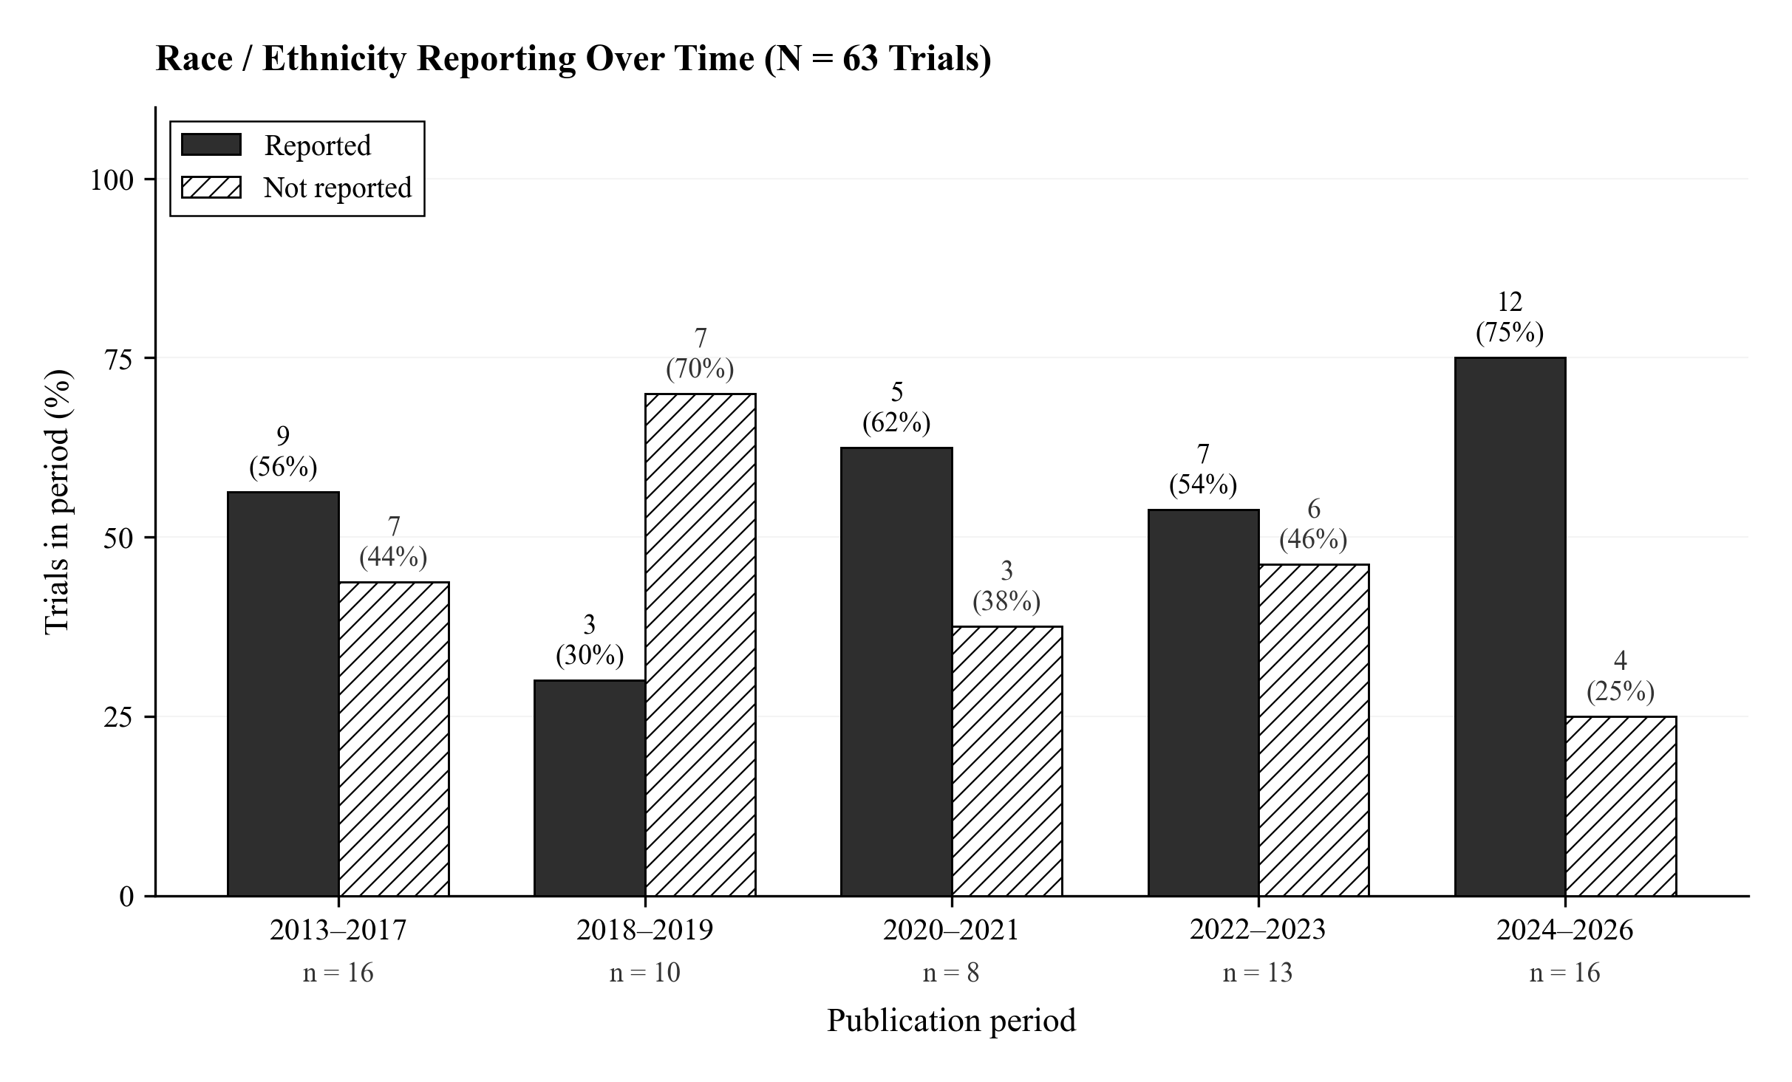
Supplementary Figure S1. Race / ethnicity reporting across five publication periods (N = 63 trials). Solid bars indicate trials reporting race / ethnicity; hatched bars indicate non-reporting. Period denominators (n) are shown below each group; percentages are within-period.

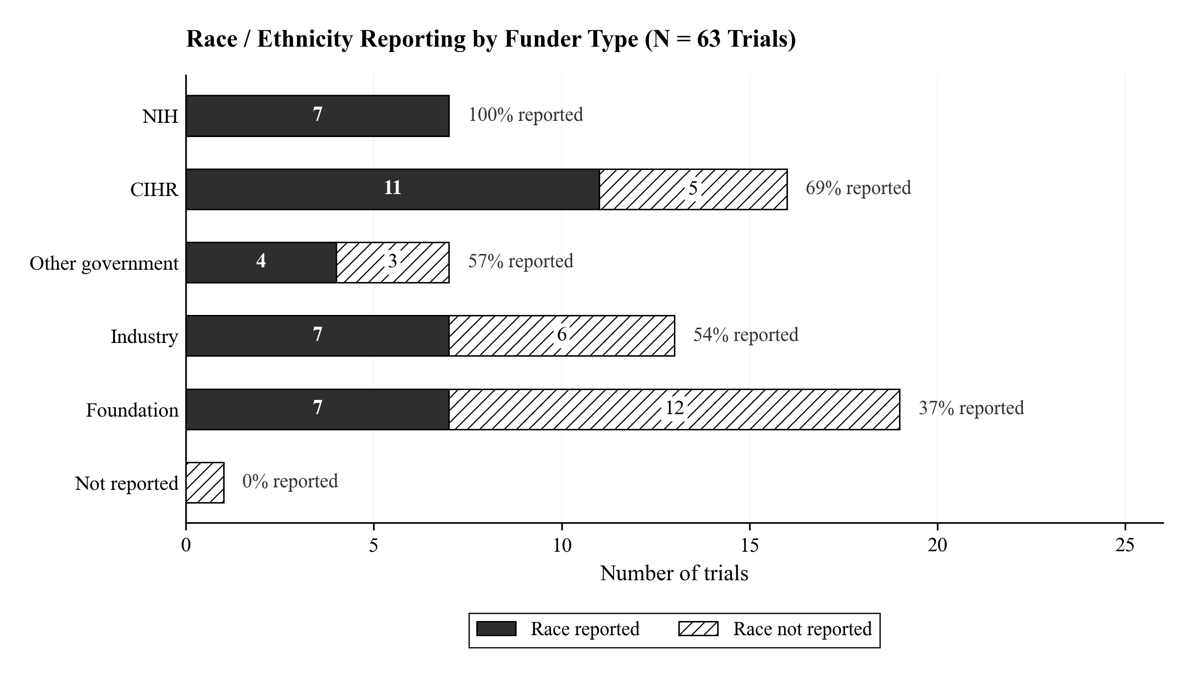
Supplementary Figure S2. Race / ethnicity reporting by funder type (N = 63 trials). Solid segments indicate trials reporting race / ethnicity; hatched segments indicate non-reporting. Counts inside segments, with percent-reporting annotated at right.

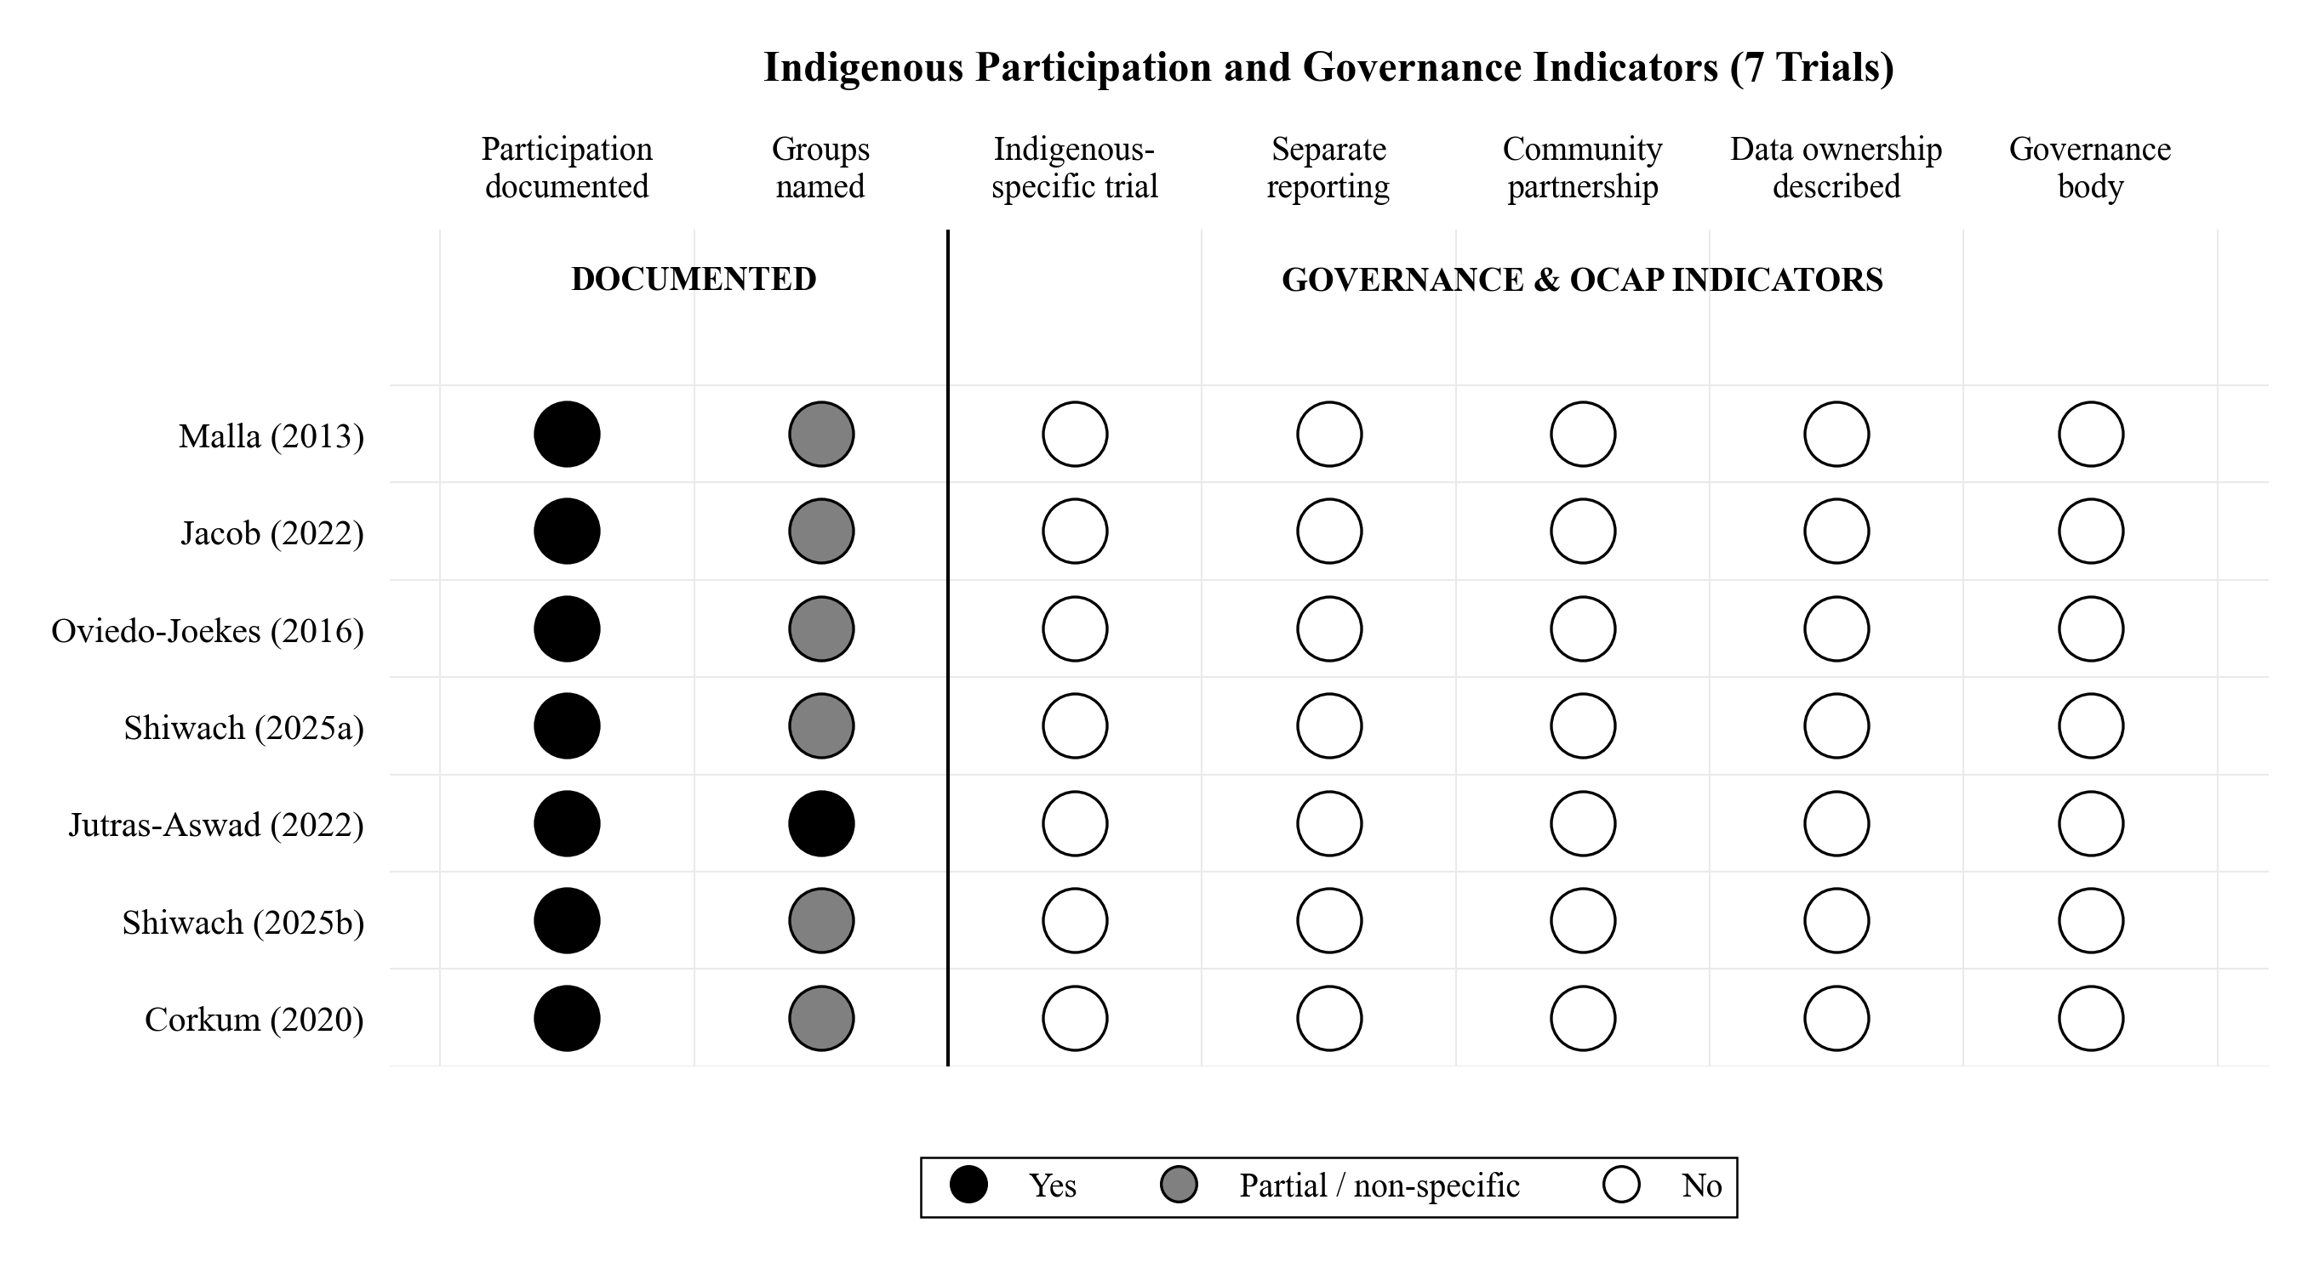
Supplementary Figure S3. Indigenous participation and OCAP / governance indicators across the seven trials that documented Indigenous participation. Solid circle = Yes; half-filled = Partial or non-specific; open = No.

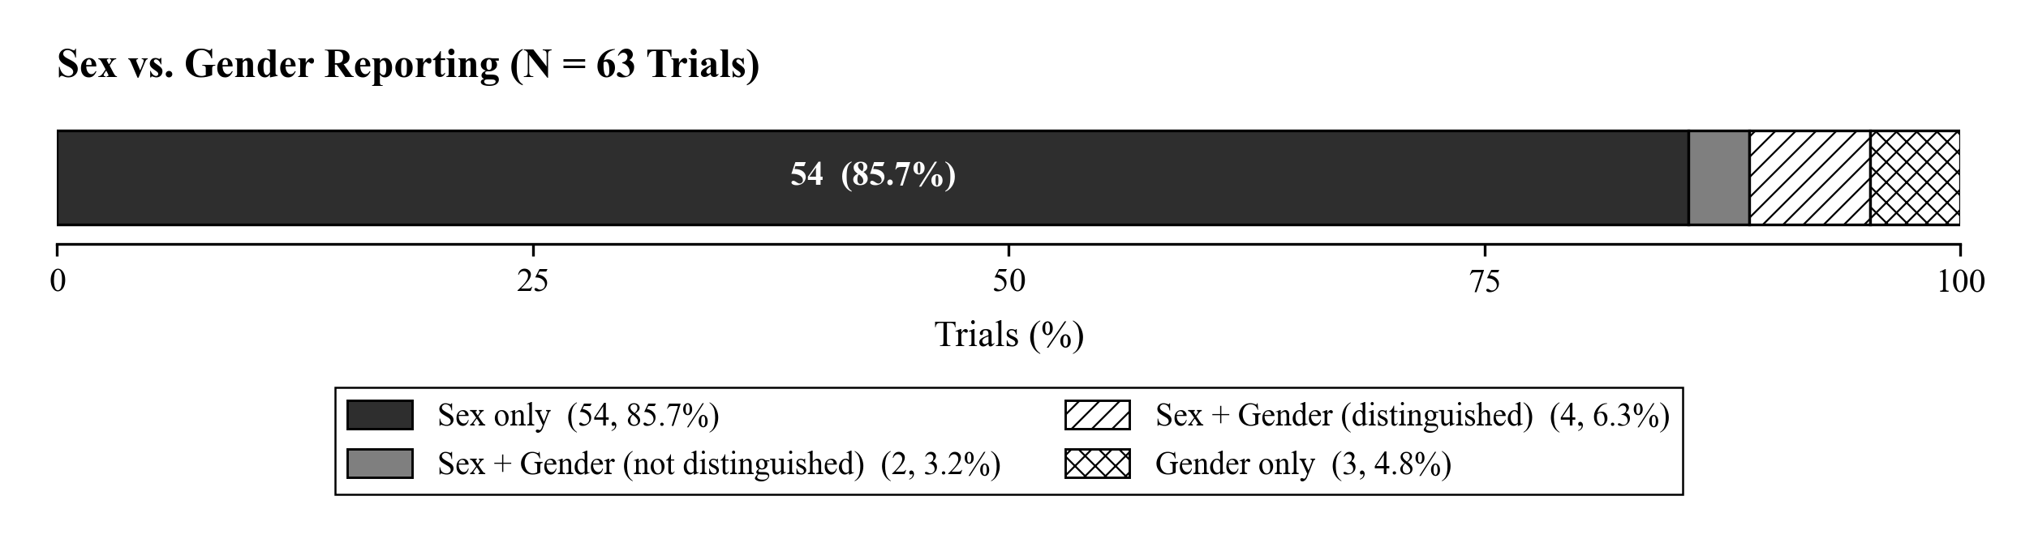
Supplementary Figure S4. Sex vs. gender reporting in 63 trials. Sex only = 54 (85.7%); Sex + Gender (not distinguished) = 2 (3.2%); Sex + Gender (distinguished) = 4 (6.3%); Gender only = 3 (4.8%).

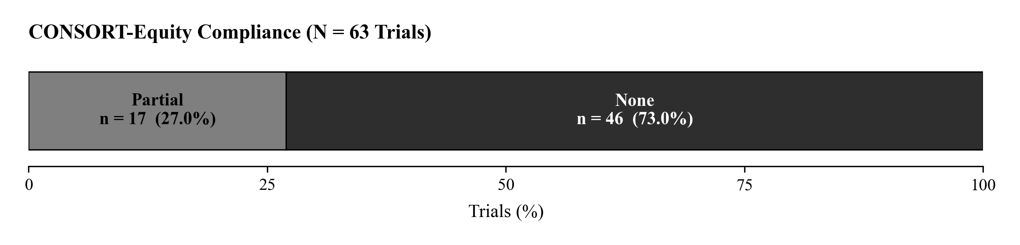
Supplementary Figure S5. CONSORT-Equity compliance. Full compliance was not achieved by any trial (0 / 63). Partial = 17 (27.0%); None = 46 (73.0%).

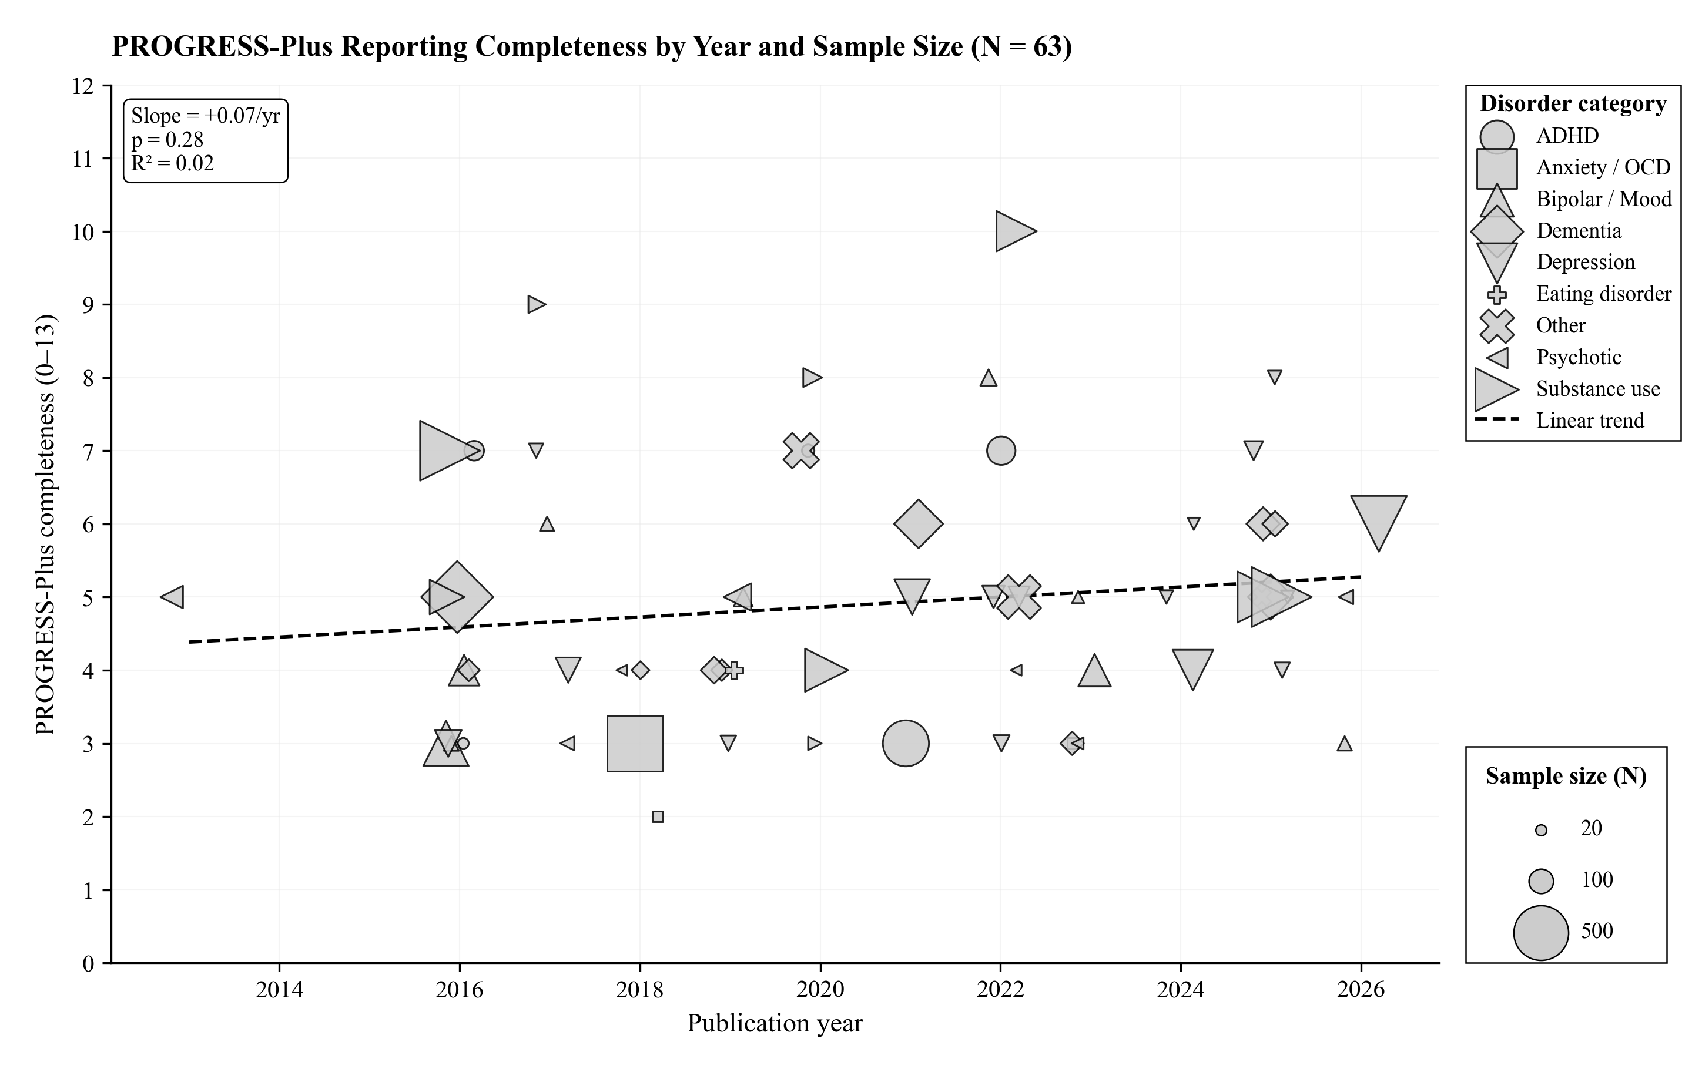
Supplementary Figure S6. PROGRESS-Plus reporting completeness (0–13 fields reported) by publication year and sample size. Marker shape encodes disorder category; marker area scales with sample size. The dashed line is the linear trend across all 63 trials (slope +0.07 / yr; p = 0.28; R² = 0.02).

