Tables and Figures
EDIA Reporting in Canadian Mental Health Pharmacotherapy RCTs (2016–2026):
A Scoping Review Using the PROGRESS-Plus Framework

Figure 1
PRISMA-ScR Flow Diagram for Study Selection
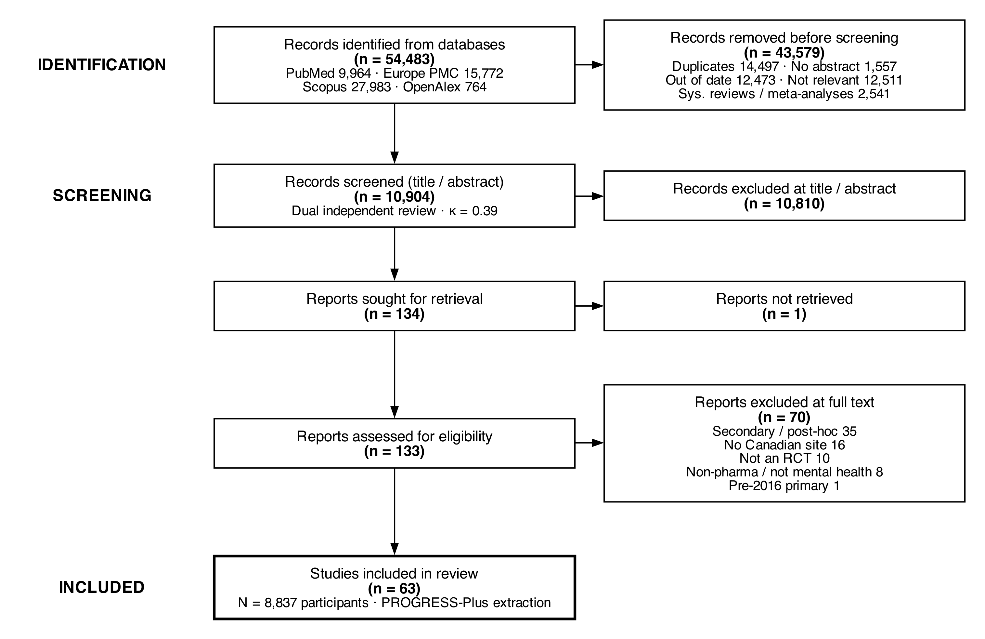
Note. Flow diagram follows the PRISMA-ScR (2020) reporting guidance. N = 63 studies were retained after excluding three records (#4, #12, #45) on post-extraction review.

Table 1
Characteristics of Included Trials (N = 63)
Characteristic | n (%) or Median [IQR]
Year of publication
2013–2017 | 16 (25.4)
2018–2020 | 15 (23.8)
2021–2023 | 16 (25.4)
2024–2026 | 16 (25.4)
Disorder category
Depression | 16 (25.4)
Dementia | 10 (15.9)
Bipolar-Mood | 9 (14.3)
Substance Use | 9 (14.3)
Psychotic | 7 (11.1)
ADHD | 5 (7.9)
Anxiety-Trauma-OCD | 3 (4.8)
Eating Disorder | 1 (1.6)
Other | 3 (4.8)
Trial design
Parallel | 48 (76.2)
Crossover | 12 (19.0)
Other | 3 (4.8)
Setting
Multisite | 38 (60.3)
Single-site | 25 (39.7)
International | 26 (41.3)
All-Canadian | 37 (58.7)
Sample size
Median [IQR] | 60 [34–188]
Range | 6–785
Funder type
Industry | 13 (20.6)
CIHR | 16 (25.4)
NIH | 7 (11.1)
Other government | 7 (11.1)
Foundation | 19 (30.2)
Not reported | 1 (1.6)
Note. Values are n (%) unless otherwise specified. IQR = interquartile range. CIHR = Canadian Institutes of Health Research. NIH = National Institutes of Health. Record #8 (Malla 2013) was published before 2016 but met all other inclusion criteria.

Figure 2
PROGRESS-Plus Variable Reporting Rates (N = 63 Trials)
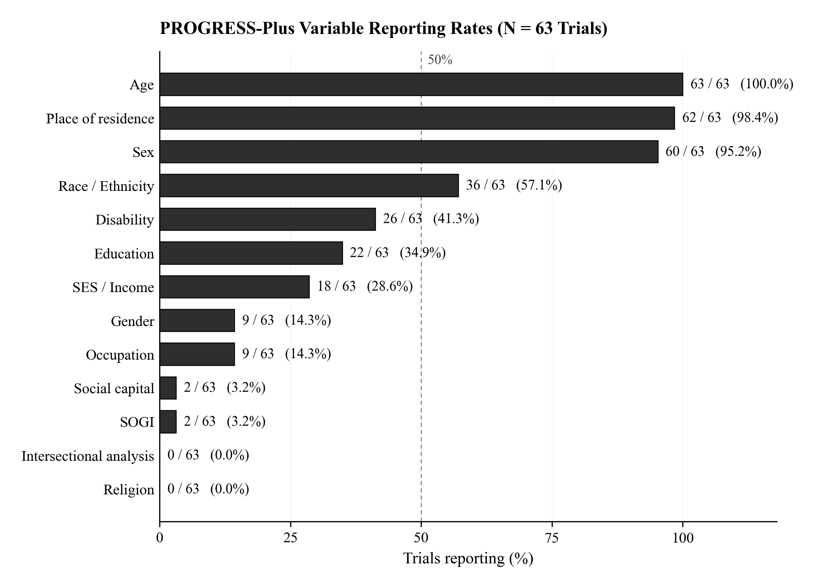
Note. Bars show the proportion of trials reporting each PROGRESS-Plus variable. Race/ethnicity counts strict "Yes" responses only; all other variables count "Yes" + "Partial". The dashed reference line marks the 50% threshold.

Figure 3
Race / Ethnicity Reporting Over Time
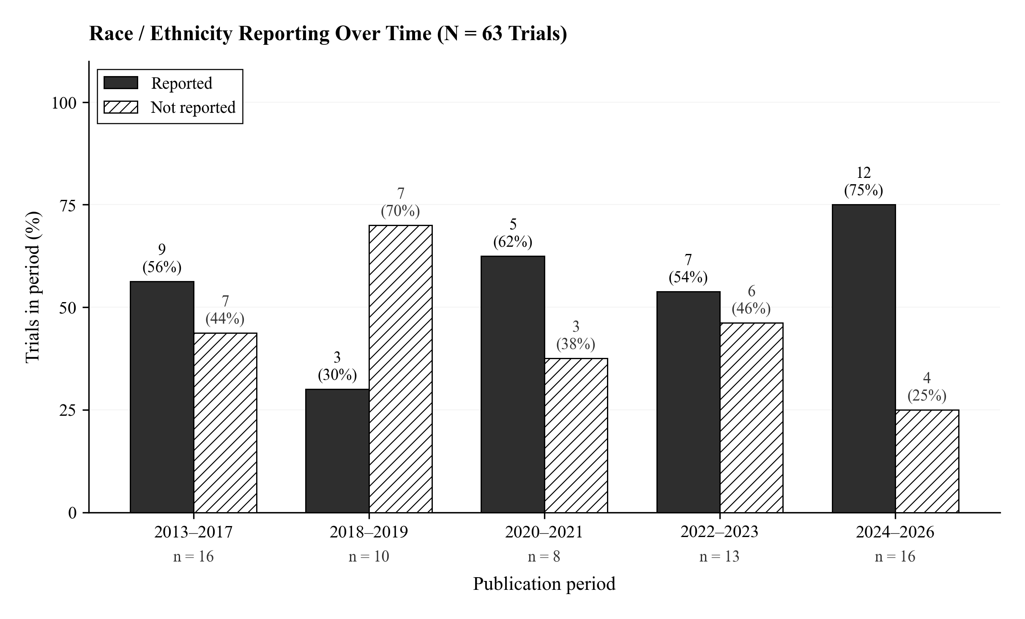
Note. Years are binned to accommodate small per-year sample sizes. Bar labels show count and percent of trials in each period. Per-period denominators (n) appear below the x-axis. The 2018-2019 period is the lowest-reporting bin (30%, with 0 of 4 trials in 2018 reporting race/ethnicity).

Table 2
PROGRESS-Plus Reporting Rates With 95% Confidence Intervals (N = 63)
Variable | n/N | % | 95% CI
PROGRESS-Plus Core
Place of residence (P) | 62/63 | 98.4 | 91.5–99.7
Race/ethnicity (R) | 36/63 | 57.1 | 44.9–68.6
Framework (among reporters)
US-derived | 10/36 | 27.8 | —
Canadian Census | 1/36 | 2.8 | —
Self-identified | 2/36 | 5.6 | —
Other | 5/36 | 13.9 | —
Not stated | 18/36 | 50.0 | —
Granularity (among reporters)
Granular | 1/36 | 2.8 | —
Moderate | 7/36 | 19.4 | —
Coarse | 22/36 | 61.1 | —
Binary | 6/36 | 16.7 | —
Subgroup analysis conducted | 3/63 | 4.8 | 1.6–13.1
Used as covariate/subgroup | 4/63 | 6.3 | 2.5–15.2
Acknowledged as social construct | 0/63 | 0.0 | 0.0–5.7
Occupation (O) | 9/63 | 14.3 | 7.7–25.0
Sex (G) | 60/63 | 95.2 | 86.9–98.4
Gender (G) | 9/63 | 14.3 | 7.7–25.0
Sex/gender distinguished | 4/63 | 6.3 | 2.5–15.2
Religion (R) | 0/63 | 0.0 | 0.0–5.7
Education (E) | 22/63 | 34.9 | 24.3–47.2
SES / income (S) | 18/63 | 28.6 | 18.9–40.7
Social capital (S) | 2/63 | 3.2 | 0.9–10.9
PROGRESS "Plus" Variables
Age | 63/63 | 100.0 | 94.3–100.0
Disability | 26/63 | 41.3 | 30.0–53.6
SOGI | 2/63 | 3.2 | 0.9–10.9
Intersectional analysis | 0/63 | 0.0 | 0.0–5.7
Note. 95% CI computed using Wilson score interval. — indicates CI not applicable for sub-category breakdowns. Race/ethnicity sub-rows use the 36-study reporter denominator. SOGI = sexual orientation and gender identity.

Figure 4
Race / Ethnicity Reporting by Funder Type
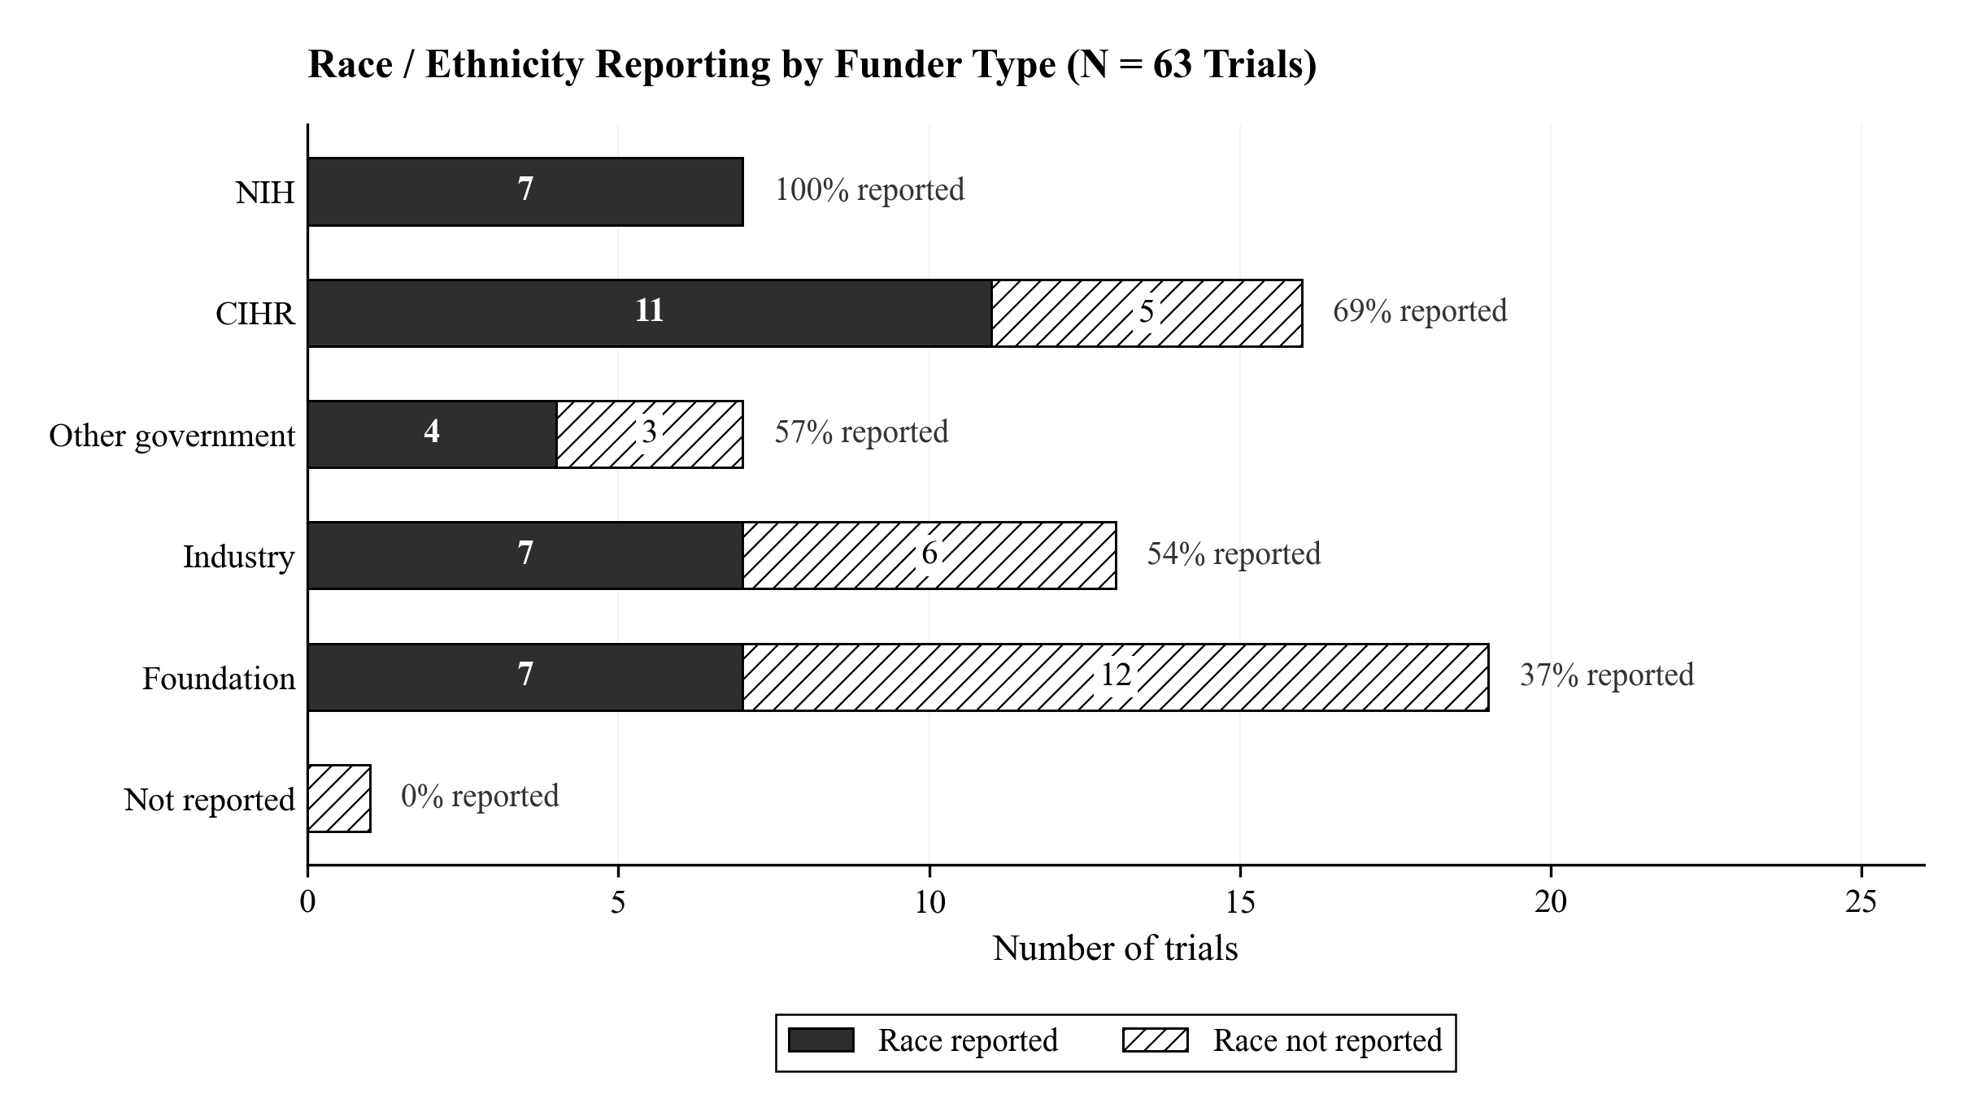
Note. Stacked horizontal bars show the number of trials reporting versus not reporting race/ethnicity within each funder category. The right-side label gives the percent of each funder group that reported race/ethnicity. CIHR-funded trials had the highest absolute count of non-reporting (5/16, 31%).

Table 3
Race / Ethnicity Reporting by Funder Type: Cross-Tabulation
Funder Type | Yes | Partial | No | Total | % Reported
Industry | 7 | 0 | 6 | 13 | 53.8
CIHR | 11 | 0 | 5 | 16 | 68.8
NIH | 7 | 0 | 0 | 7 | 100.0
Other government | 4 | 0 | 3 | 7 | 57.1
Foundation | 7 | 0 | 12 | 19 | 36.8
Not reported | 0 | 0 | 1 | 1 | 0.0
Note. Chi-square = 10.72, df = 5, p = 0.057. "% Reported" counts strict "Yes" responses only. CIHR = Canadian Institutes of Health Research. NIH = National Institutes of Health.

Figure 5
Indigenous Participation and Governance Indicators (7 Trials)
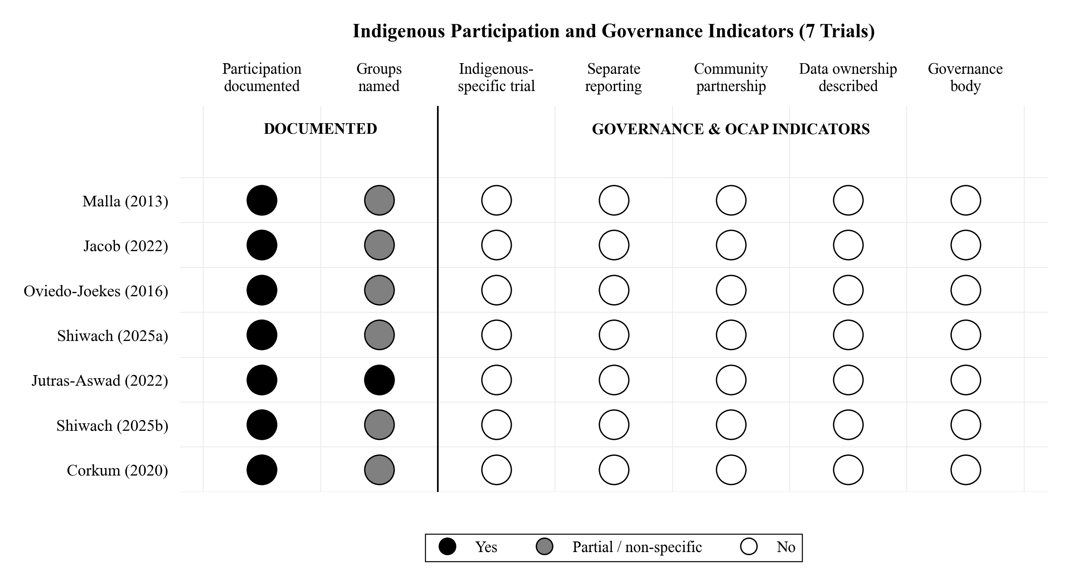
Note. Filled circles indicate Yes; gray circles indicate partial or non-specific reporting; open circles indicate No. The vertical rule separates "Documented" from "Governance & OCAP" indicators. OCAP = Ownership, Control, Access, Possession (First Nations principles). No trial referenced OCAP principles or any Indigenous data governance framework.

Table 4
Detailed Indigenous Participation Characteristics (7 Trials)
Rec # | Study | Disorder | N | Groups | Partnership | Sov. | Notes
8 | Malla (2013) | Psychotic | 85 | Aboriginal (not further specified) | No | 0 | Aboriginal participants (n=2, 2.6%) reported in Table 2 as a race category. No Indigenous-specific recruitment, analysis, or governance described. Ter…
14 | Jacob (2022) | Other | 321 | American Indian or Alaska Native (US context, not Canadian Indigenous) | No | 0 | 2 participants identified as American Indian or Alaska Native (both in placebo group). US-context Indigenous category, not Canadian First Nations/Inui…
21 | Oviedo-Joekes (2016) | Substance Use | 202 | Aboriginal ancestry (not further specified) | No | 0 | ~30% Aboriginal ancestry — highest Indigenous rate in dataset. DTES Vancouver population. No OCAP or Indigenous governance described despite high part…
61 | Shiwach (2025a) | Substance Use | 435 | American Indian or Alaska Native (US context, n=6, 1.4%); Native Hawaiian/Other Pacific Islander (n=3, 0.7%) | No | 0 | American Indian/Alaska Native n=6 (1.4%) and Native Hawaiian/PI n=3 (0.7%). US Indigenous context, not Canadian First Nations/Inuit/Metis. Aggregated …
79 | Jutras-Aswad (2022) | Substance Use | 272 | First Nations; Metis | No | 0 | First Nations 16.9% + Metis 4.8% = 21.7% Indigenous. HIGHEST Indigenous rate with SPECIFIC groups named (First Nations vs Metis). CIHR-funded all-Cana…
110 | Shiwach (2025b) | Substance Use | 785 | American Indian/Alaska Native (US context, n~6, 0.8%) | No | 0 | American Indian/Alaska Native 0.8%, Native Hawaiian/PI 0.7%. US Indigenous context.
124 | Corkum (2020) | ADHD | 26 | Aboriginal (unspecified, n=2, 7.7%) | No | 0 | Aboriginal 7.7% (n=2). Nova Scotia has significant Mi'kmaq population. No OCAP or Indigenous governance.
Note. Sov. = Indigenous Data Sovereignty Score (0 = no mention; 1 = statement only; 2 = protocol referenced; 3 = full governance). All seven trials scored 0. OCAP = Ownership, Control, Access, Possession.

Figure 6
Sex vs. Gender Reporting (N = 63)
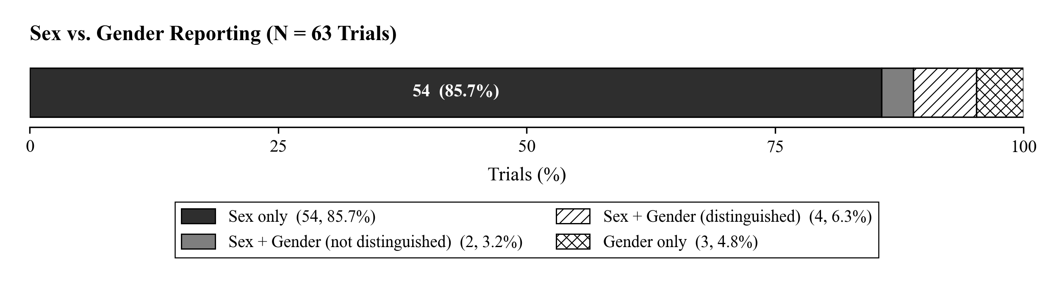
Note. Stacked horizontal bar showing the four mutually exclusive categories. All four trials that distinguished sex from gender were published 2022–2025. "Gender only" comprises three trials reporting gender identity but not biological sex.

Figure 7
CONSORT-Equity Compliance (N = 63)
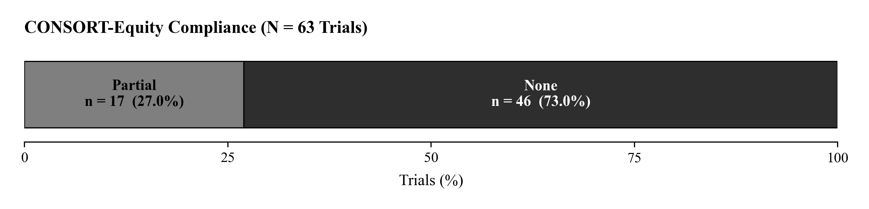
Note. CONSORT-Equity compliance assessed against Welch et al. (2017): sociodemographic characteristics reported, equity-relevant subgroup analyses, and generalizability discussion with explicit equity reference. No trial achieved full compliance on all three criteria (0 / 63, 0%).

Figure 8
PROGRESS-Plus Reporting Completeness by Publication Year and Sample Size
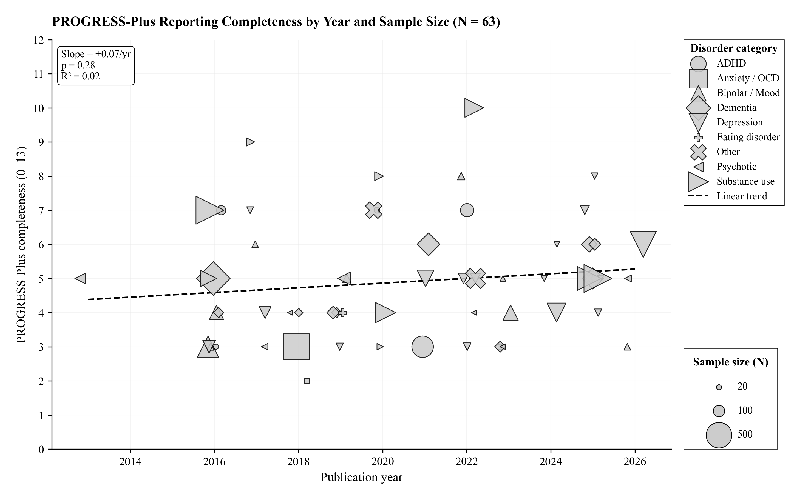
Note. Completeness score = count of PROGRESS-Plus variables reported (0–13). Marker area is proportional to total sample size. Marker shape indicates disorder category. The dashed line is the ordinary least-squares trend (slope and significance shown in the legend).

