**CS 273P Project: determine whether a person makes over 50K a year**

Student Name: Jing Tang ID: 86729684

Student Name: Jiada Ye ID: 32964504

**Introduction:**

We use the dataset Adult to predict whether a person makes over 50K a year through several machine learning algorithms. We first use all the features and take feature selection to improve the prediction accuracy. The we tuned the model of KNN, random forest and … and have the prediction accuracy around 0.84.

**Data Analysis and Processing:**

Firstly, we load the dataset and test dataset and split the dataset into training data and validation data with the provided code.

The dataset contains 14 features, seven of them are numeric features: age, fnlwgt, education-num, capital-gain, capital-loss and hours-per-week, income; and seven of them are not numeric features: workclass, education, marital.status, occupation, relationship, race, sex, native. We convert the non-numeric features into numeric ones, i.e replace male with 0 and replace female with 1. For the target ‘income’ we will predict, we use 0 to represent ‘<=50K’ and use 1 to represent ‘>50k’.

Secondly, we processed some features and data. For feature ‘marital.status’, we combined ‘Never-married',' Divorced',' Separated',' Widowed’ to ‘Single’ and combined ‘Married-civ-spouse',' Married-spouse-absent',' Married-AF-spouse’ to ‘Married’.

**Feature Engineering and Model Comparison:**

Since the meaning of some features are overlapped, we drop ‘relationship’ and ‘education’ and keep ‘marital.status’ and ‘education.num’. Then we explored the relationship of education and marital status with income by catplot, the figure shows that married adults have higher probability to have over 50K income, and the probability of making over 50K income increases with the increase of education.num:

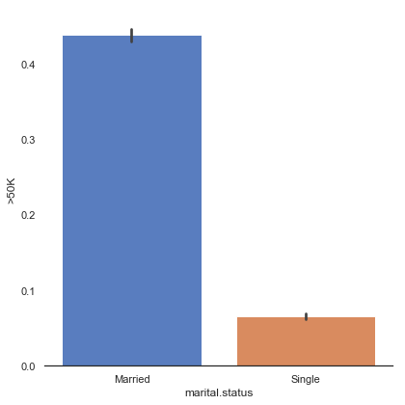

Figure 1. The Possibility Distribution of Marital Status to Income > 50k

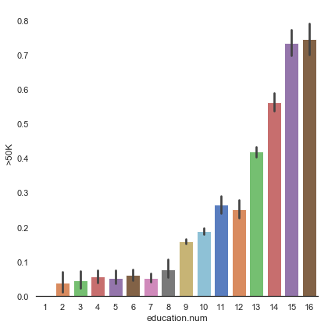

Figure 2. The Possibility Distribution of Education Num to Income > 50k

From the quantity graph of native.country, we can observe that most of the adults are from United States, so the feature is not so meaningful for the prediction and we dropped the feature.

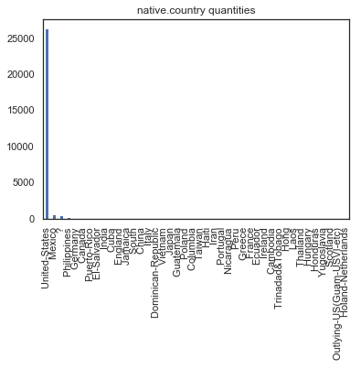

Figure 3. The Country Distribution of Dataset

We convert all other non-numeric features into numeric features and we use the data dropped “education","relationship","native.country” to train 5 models: KNN, Decision Tree, Gaussian Naive Bayes, Random Forest and SVM and use cross-validation to get the mean accuracy score of them.

KNN: 0.665087

DecisionTree: 0.717551

GaussianNB: 0.669418

RandomForest: 0.761794

SVM: 0.666484

The accuracy is not satisfying so we decided to select the features most related to ‘income’ to do the prediction. Then, we use heatmap to observe the correlation between features.

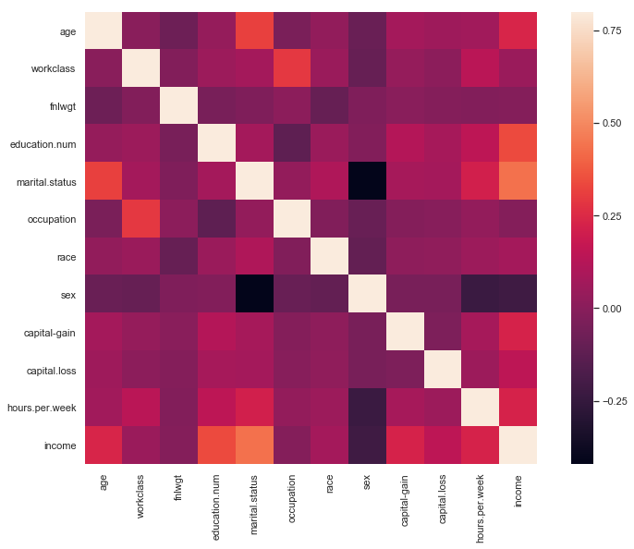

Figure 4. The Heatmap About the Relevance of Income to Different Features

From the heatmap we can observe that some features are not strongly related to income, such as ‘sex’ and ‘fnlwgt’. We shoud find the features most related to ‘income’. We use ‘nlargest’ to list the top ten income-related features and we can see that the features ‘marital.status’, ‘education.num’, ‘age’ have the strongest relationship with ‘income’.

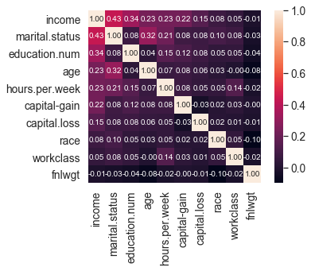

Figure 5. The 10-largest Heatmap of Relevance of Income to Features

Then we drop the features with weakest relationship with ‘income’, which are ‘sex’, ‘occupation’,’fnlwgt’, and ’workclass’.

We use the train dataset to train the 5 models: KNN, Decision Tree, Gaussian Naive Bayes, Random Forest and SVM and use the validation dataset to calculate the accuracy of the 5 models.

KNN: 0.838428

DecisionTree: 0.829945

GaussianNB: 0.801602

RandomForest: 0.840727

SVM: 0.829636

All the results from selected features seem improved significantly compared to those from the original features.

**Model Tuning:**

We choose three algorithms (KNN, SVM and Random Forest) from the five algorithms above to take some tuning and comparison.

***KNN:***

KNN can be used for both classification and regression predictive problems.  At K=1, we were overfitting the boundaries. Hence, accuracy initially increases and reaches a maximum. By varying the k from 1 to 30, we found the k that results in the best accuracy is 12 with accuracy 0.8508934072704868.

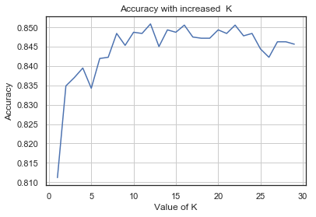

Figure 6. KNN Accuracy with increased K

And we test the model on test dataset, the accuracy of the model is 0.8484122596892083.

***Random Forest:***

Random forests are an ensemble learning method for classification, regression and other tasks

that operates by constructing a multitude of decision trees at training time and outputting the

class that is the mode of the classes (classification) or mean prediction (regression) of the

individual trees.

n_estimators represents the number of trees in the forest. Usually the higher the number of trees the better to learn the data. However, adding a lot of trees can slow down the training process considerably. max_features represent the number of features to consider when looking for the best split.

By varying the n_estimator in the range [50,100,150,200,250], we got the best accuracy 0.8450

When n_estimator= 150.

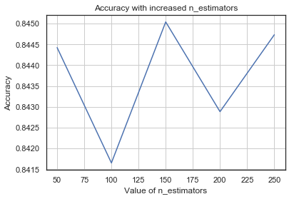

Figure 7. Random Forest Accuracy with increased n_estimators

By varying the max_feature int [1,2,3,4,5,6,7], we got the best accuracy 0.8435 when max_feature = 5

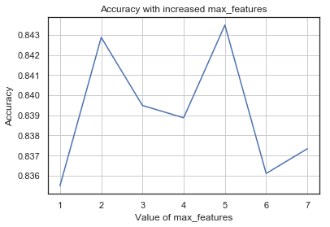

Figure 8. Random Forest Accuracy with increased max_features

and we test the model on test dataset, the accuracy of the model is 0.8427615011362939

***SVM:***

We use different kernels of support vectors: linear, rbf and sigmoid to train the model and got accuracy:

Linear ACC: 0.7735674676524954

rbf ACC: 0.8296364756623537

sigmoid ACC: 0.7578558225508318

Then we tuned the parameter gamma of SVM with RBF kernel. The gamma parameter controls the distance of a single training example can influence. For lower gamma, its influences can reach far and for higher values its influence can reach close. The gamma parameters can be seen as the inverse of the radius of influence of samples selected by the model as support vectors.

First we varied the gamma in the range [1.0e-08,1.0e-07,1.0e-06,1.0e-05,1.0e-04,1.0e-03,1.0e-02,1.0e-01], SVM got the highest accuracy 0.8539741219963032 when gamma = 1.0e-03.

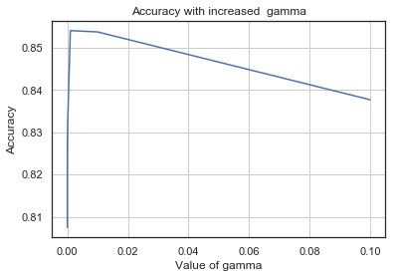

Figure 9. SVM Accuracy with increased Gamma

Then, we test the model on test dataset, the accuracy of the model is 0.8572569252502917.

**Conclusion**

In this project, we analyzed the dataset and the features and make a feature selection according to their relevance with the prediction target, the we use the five models to do the prediction on the selected features. Among the five models, knn, random forest and SVM have higher accuracies, therefore, we choose them to do the parameter tuning. For KNN, the model gets the highest accuracy 0.8484 with k=12. For random forest, the model gets the highest accuracy 0.8428 with the parameter: {n_estimators = 150, max_features= 5}. For SVM, first we made a kernel selection, and tuned the parameter gamma with RBF kernel, the model gets the highest accuracy 0.8573 with gamma = 1.0e-03.

We choose SVM with RBF kernel and gamma = 1.0e-03 as our best model.

Reference:

1. <https://en.wikipedia.org/wiki/Random_forest>

2. <https://www.kaggle.com/iranneto/a-simple-knn-application>

3. <https://www.kaggle.com/ipbyrne/income-prediction-84-369-accuracy>

4. https://scikit-learn.org/stable/auto_examples/svm/plot_rbf_parameters.html

Appendix

The code of the project is in the jupyter notebook file project.ipynb submitted to the EEE dropbox. The dataset files and data_loader.py should be put in the same path with project.ipynb.