Deep Restore

Here with DeepRestore web App we look to implement state of the art Deep Neural Network architectures to enhance corrupted images. The model descriptions are described as below:

DeepDenoise:We look to perform denoise images beyond the existing excellent methods such as Gaussian denoising .However this method only works on grayscale images till now.For testing, We take an image ,add some noise to it additionally and it gives us the denoised image.

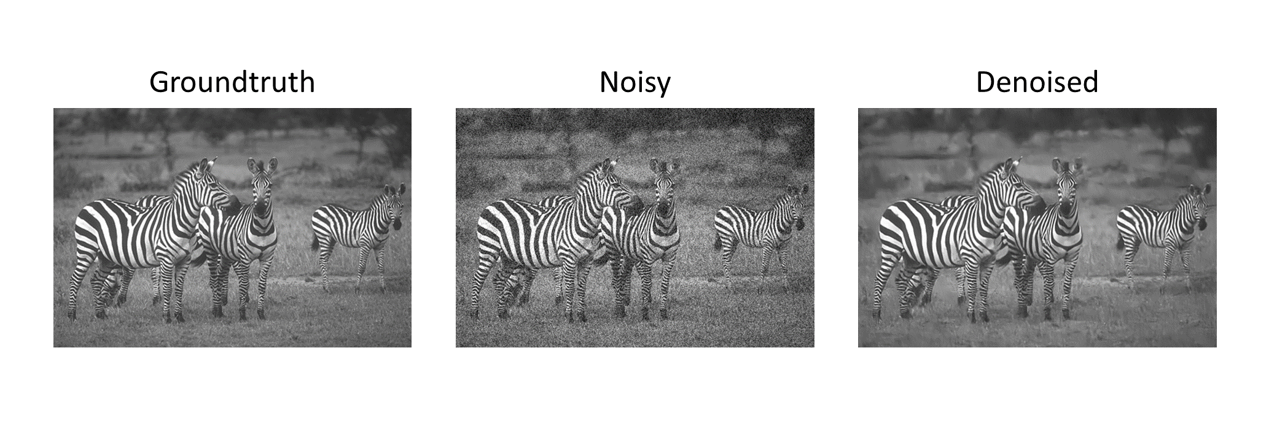

SuperResolution:This method looks to increase the resolution of images without compromising the quality of the image.

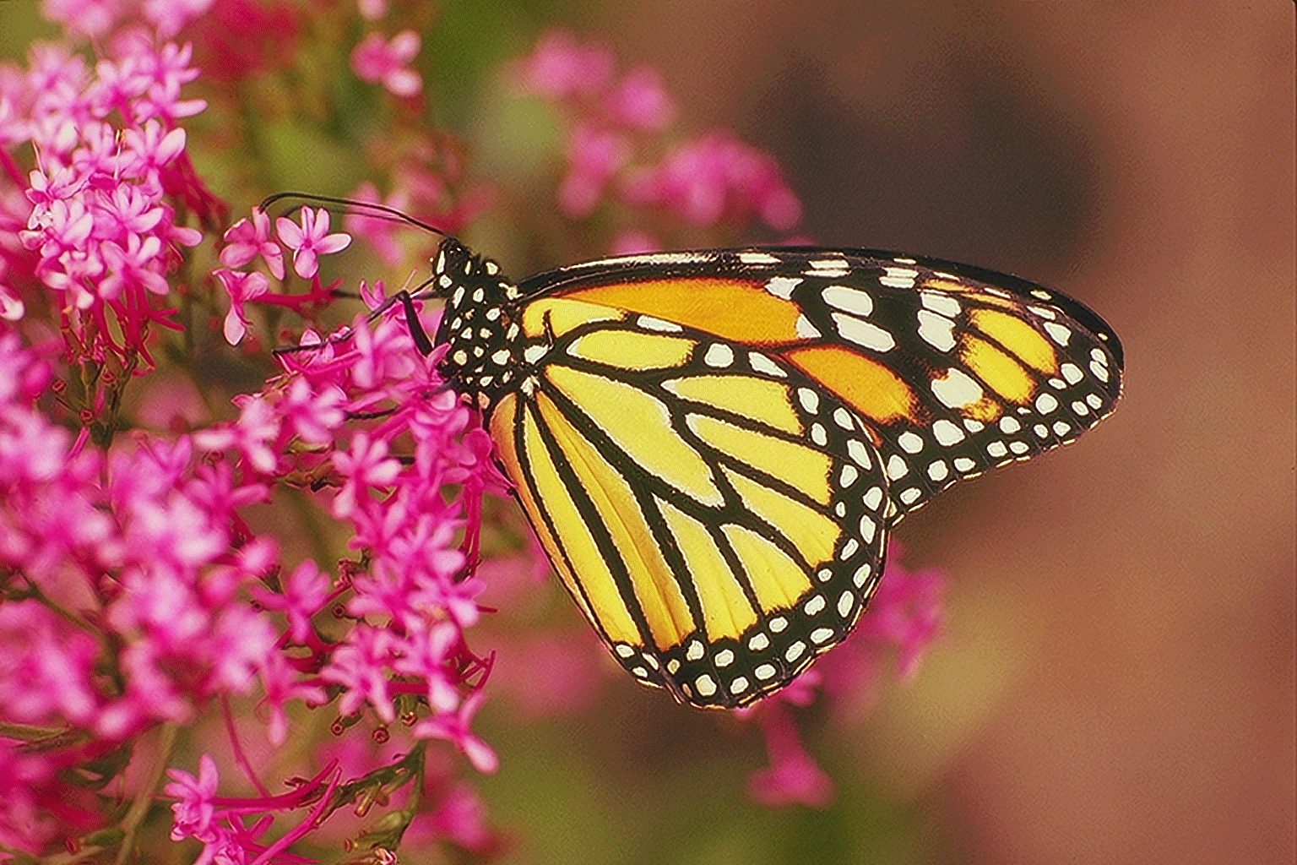

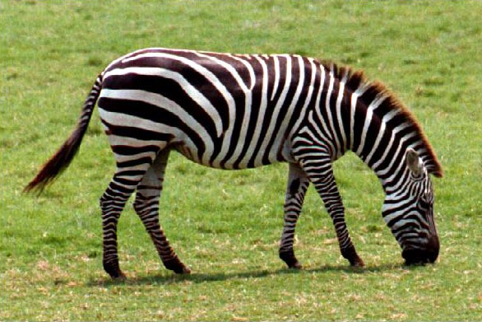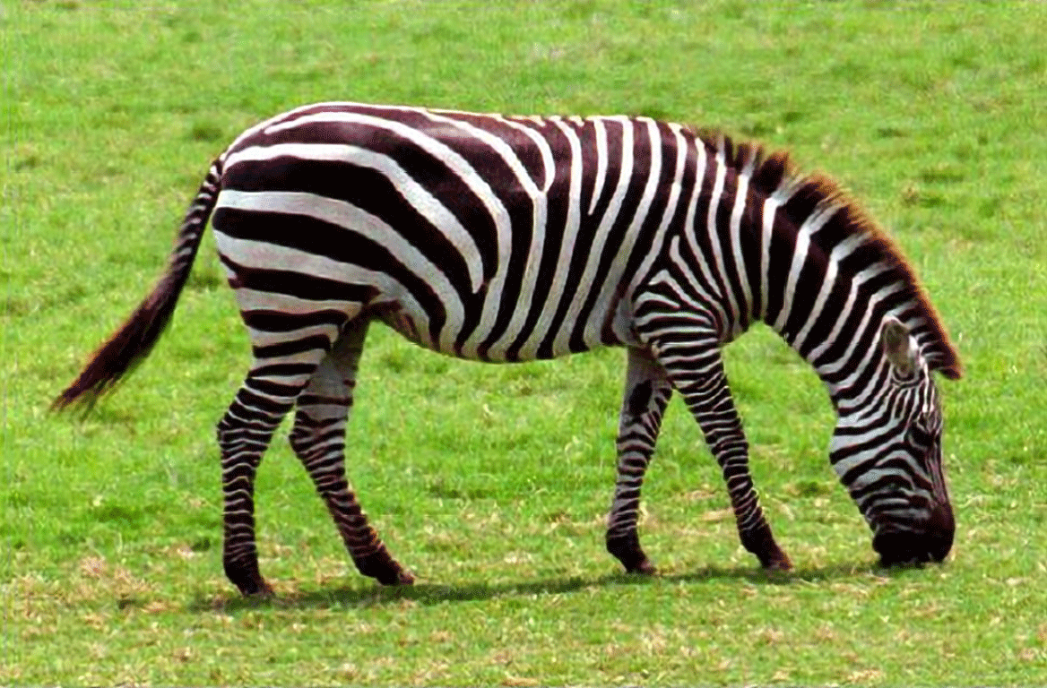

Inpainting:In real life we final many images to have some missing parts .Here in this method we look forward to fill those missing parts using Deep Learning Model that automatically learns those missing parts .Generally people use Adobe photoshop for these purposes ,but with these deep models it can be done fairly easy .However ,there are still areas of improvement in this method.

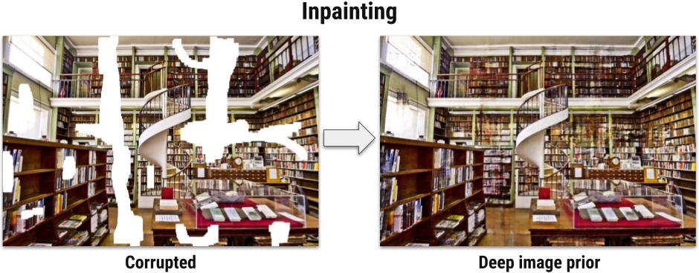

We tried to deployed these model on a web app(DeepRestore) but due to lack of resources on Microsoft Azure such as lack of support for Various open source Deep learning frameworks and also time ,we weren’t able successfully deploy these model using Azure services provided to us.