**Dear new ROMulan OMNI 23xx owner**,

You are now the proud owner of a replacement device designed specifically for discerning owners of the Commodore PETs that use 2332/2316 ROM devices.

The ROMulan OMNI 23xx provides 4K of ROM (2332) or 2K of ROM (2316) and has been configured with the ROM image that you requested in your order.

As a discerning customer you will have selected the image you would like to have in the device and this has been configured for you. A label has been affixed to the underside and will have been verified before shipment.

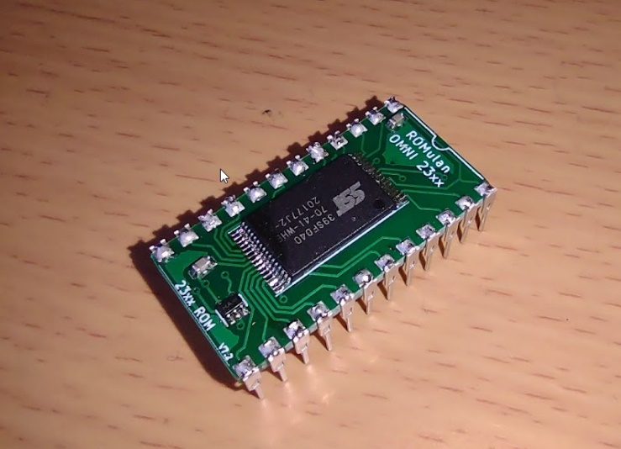

To install…

REMOVE EXISTING 23xx device and insert in the correct orientation. Pin 1 at the top left is next to the “ROMulan” text; the silkscreen shows a ‘notch‘ which indicates the top of the device.

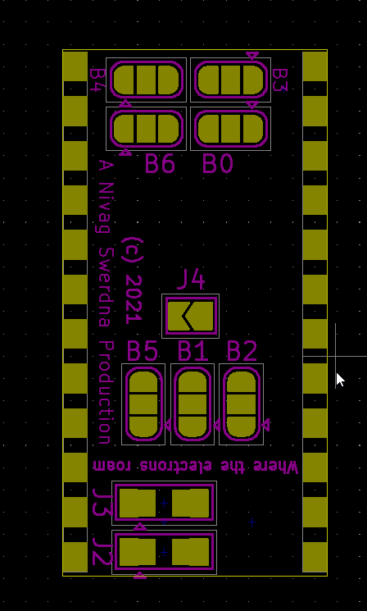What you might not be aware of is that this device actually contains almost any image you might need for a PET and can be reconfigured should your requirements change via the solder jumpers on the underside.

Firstly, the device can either act as a 4K device (i.e. like a 2332) by shorting the J4 jumper. Closed is 4K, Open is 2K.

J2 should be normally be shorted between the first position (shown by triangle and the middle; this connects pin 18 as A11)

J3 should be totally open in 4K mode. In 2K mode J3 should be shorted between the first position and the middle for positioning in the low 2K of the 4K range (normal for an edit ROM) or between the middle and last position to put the ROM in the High 2K range.

Bank selects the image to be read when the device is accessed. This is made up of 7 binary digits from B6 (most significant) down to B0 (least significant). The triangle indicates HI, so middle to triangle is a 1 and middle to the other end is a 0. Pay attention to the labels as the bits are not in physical order on the board.

Any questions… [GavinAndrews@yahoo.com](mailto:GavinAndrews@yahoo.com)   
Share & Enjoy

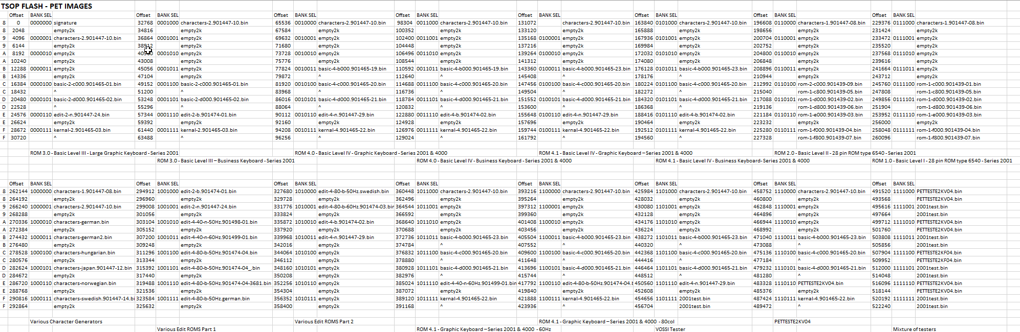

If that is unreadable since it is so small you can also find the table at…

<https://github.com/GavinAndrews/hardware/blob/master/23nnReplacement/documentation/tsop_flash_contents.pdf>

e.g.

Bank Select: 0000111 is kernal-2.901465-03.bin

i.e. B6 B5 B4 B3 B2 B1 B0 are 0000111 respectively; it is 4K so J4 is closed and J2 should be Triangle to Middle to allow p18 as A11;   
J3 should be completely OPEN.

ONLY SOLDER ONE SIDE OF A SOLDER JUMPER! i.e. Two Blobs on the same jumper will create a VCC to GND short and ruin your day. If in doubt check with a meter.