Dear new ROMulan OMNI owner,

You are now the owner of a Omni ROM (aka ROMulan OMNI) device configured with the MultiROM ROMSet designed specifically for discerning owners of original Commodore PET 2001-8 (and similar) machines.

The device has been pre-configured as PETTESTE2KV04.bin

PETTESTE2K – Version 04. Copyright © 2020 David E. Roberts (daver2 at VCF) is an original work of David Roberts and is herby acknowledged., please use his post and links as the definitive source for information…

http://www.vcfed.org/forum/showthread.php?69999-Commoodore-Pet-Cbm-

3016&p=573822#post573822

<https://drive.google.com/drive/folders/1fyLbr1kcG98a2FDOMo1H5pj9lIdJpHcx>

As configured the ROMulan OMNI will present itself as a 2K ROM suitable for placing in location **H3** (i.e. the Editor ROM position) of a PET 2001-8. H3 is designed for a 6540 ROM decoded as $E000-$E7FFF, specifically pin3 is nSELE & pin4 is BA11 at this position.

Insert the ROMulan OMNI in the correct location H3 and the correct orientation (6540s appear upside down when viewed from the front of the case). There is a notch symbol on the silkscreen of the ROMulan OMNI to help orientation.

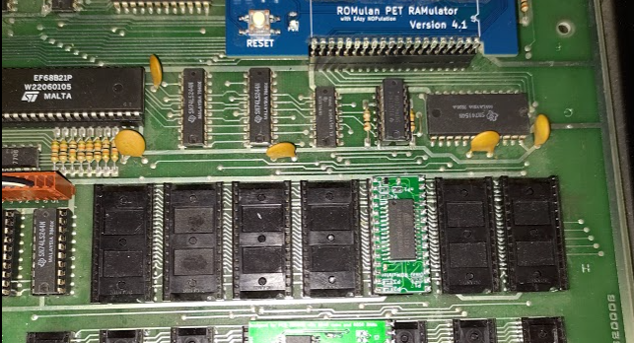

Please note that the PETTESTER requires that at least a Kernel High ROM i.e. H7 ($F800-$FFFF) is present since this contains the $FFFC reset vector required to jump into the editor. Either install a real Kernel ROM in F7 or use a RAM/ROM emulator to emulate one (as in the photo above where a ROMulan PET RAMulator is present). On original PET Series 2001 the 6540 H7 ROM is Part#6540-018 marked 901439-07, later PETs with Basic 3 have H7 being Part#6520-026 marked as 901439-19 in this position.

**Other images on the ROMulan OMNI**

This device is configured with the Multi1 ROMset specifically designed for owners of very early PET 2001-8 computers, it contains Basic 1 images, two testers and the character generator ROM image organized into eight banks of 4K.

|  |
| --- |
| Bank 00 rom-1-c000.901439-01.bin & rom-1-c800.901439-05.bin Bank 01 rom-1-d000.901439-02.bin & rom-1-d800.901439-06.bin Bank 02 rom-1-e000.901439-03.bin & 2001test13.bin (VOSSI Tester) Bank 03 rom-1-f000.901439-04.bin & rom-1-f800.901439-07.bin Bank 04 rom-2-c000.901439-09.bin & rom-1-c800.901439-05.bin **Bank 05 PETTESTE2KV04.bin &** empty Bank 06 empty & empty Bank 07 901439-08.bin & 901439-08.bin    Banks are selected via the solder jumpers M2, M1 and M0.  LEFT-MIDDLE is zero and MIDDLE-RIGHT is one; (Never connect both LEFT-MIDDLE and MIDDLE-RIGHT simultaneously as this will create a power rail short!)  Bank 05 is 101 in binary so M2 HI, M1 LO, M0 HI, gives M2 MIDDLE-RIGHT, M1 LEFT-MIDDLE and M0 MIDDLE-RIGHT as shown above. This selects the **PETTESTE2KV04.bin & empty** bank. |

Advanced Mapping

Jumpers J1, J2, J3 and J4 are used for additional configuration to allow the ROMulan OMNI to be used in any socket and to present itself as either a 2K or a 4K ROM. When operating as a 4K ROM the ROMulan OMNI provides a contiguous 4K ROM and will replace two original 6540 ROMs.

**J1 Address Select**

LEFT-MIDDLE pin17 of 6540 (CS1) used for A11  
RIGHT-MIDDLE pin4 of 6540 (nCS3) used for A11

**J2 A11 Inverse**

LEFT-MIDDLE Invert A11 source  
RIGHT-MIDDLE Use A11 source

**J3 (aka 2KLH) 2K Bank Enable**

LEFT-MIDDLE Invert A11 source as nOE (i.e. Swap 2K pages in Bank)  
RIGHT-MIDDLE Use A11 source as nOE (i.e. Normal 2K operation)

**J4 4K Bank Enable**

OPEN 2K Operation  
CLOSED 4K Operation

**How to use these fancy options**

It rapidly becomes quite complex as each 6540 socket on the PET 2001-8 has the chip select lines wired according to the ROM that is expected in that location.

|  |  |  |  |  |
| --- | --- | --- | --- | --- |
|  | 17 | 27 | 4 | 3 |
|  | CS1 | CS2 | nCS3 | nCS4 |
| H7 | BA11 | VDD | GND | nSELF |
| H4 | VDD | VDD | BA11 | nSELF |
| H3 | VDD | VDD | BA11 | nSELE |
| H6 | BA11 | VDD | GND | nSELD |
| H2 | VDD | VDD | BA11 | nSELD |
| H5 | BA11 | VDD | GND | nSELC |
| H1 | VDD | VDD | BA11 | nSELC |

The table shows which signals are available on which pins. By setting the J1 jumper the A11 align can be selected from either pin 4 or pin 17 so this selection should match the socket being targeted.

J2 and J3 can be used for swapping addresses and can normally be ignored.

J4 is used for enabling 4K mode. When J4 is CLOSED the jumper J3 MUST be OPEN/OPEN.

**Example 1 : Editor ROM**

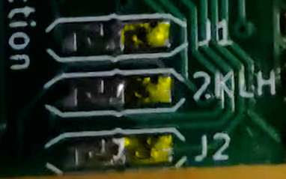The editor ROM is $E000-$E7FF (i.e. 2K). J4 must be OPEN as it is 2K. Now given the address is $Exxx the nSELE line must be available so this pre-determines that Socket H3 must be used as pin3 on that socket is nSELE. Targeting socket H3 we see BA11 is available on pin4 so we set J1 to MIDDLE-RIGHT. We can leave J2 and J3 at their defaults RIGHT-MIDDLE and RIGHT-MIDDLE. This gives us 2K at $E000.

The Bank is selected to give the correct image, Bank 2 is 901439-03.bin or Bank 5 is PETTESTER.

**Example 2: 4K ROM replacing 901439-01 & 901439-05**

The -01 and -05 ROMs are $C000-$C7FFF and $C800-$CFFF i.e. a significant proportion of the BASIC ROM set and it is possible replace both with a single OMNI ROM in 4K mode.

H1 is the obvious target for the replacement (although H5 is possible with inversion) so we pick H1 as the socket of choice. nSELC is available at pin 3. Firstly we chose 4K mode by making J4 CLOSED and we make sure J3 (aka 2KLH) is OPEN/OPEN. For J1 we have RIGHT-MIDDLE to source A11 from pin 4 and finally we have J2 as RIGHT-MIDDLE to use A11 as is.

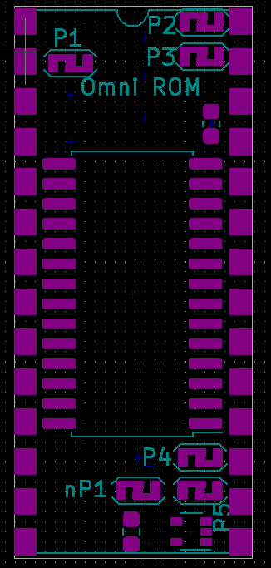 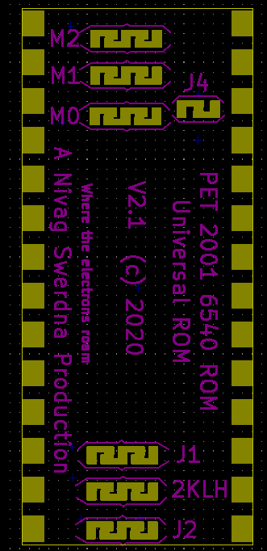

All the P jumpers should be left OPEN with the exception of the nP1 which should be CLOSED. These jumpers are used for programming. Specifically when all jumpers are OPEN except the P jumpers it is possible to program the onboard EEPROM via the pins only; but that’s a super advanced topic.

Any question…

[GavinAndrews@yahoo.com](mailto:GavinAndrews@yahoo.com)

Share & Enjoy,

FYI

I changed the name from OMNI ROMulator to ROMulan OMNI to avoid any confusion with bitfixer’s ROMulator product which was designed at the same time and resulted in a name clash; great minds think alike. The ROMulan OMNI is a 6540 Replacement, the ROMulator… well check out bitfixer’s pages)