**Dear new 8kRAM owner**,

You are now the proud owner of a 8K RAM replacement device designed specifically for discerning owners of original Commodore PET 2001-8 PCB which uses 6550 RAM devices.

The 8kRAM provides 8K of RAM as this is the maximum addressable from the RAM slots (although the device on the PCB is actually much larger capacity).

To install…

REMOVE ALL EXISTING 6550 devices in the I and J rows.

Carefully connect the PCB to the J5 slot (both sides and I3 slot (one side).

There is not much tolerance so do this carefully and don’t panic.

The best approach is to make sure you are straight on and to worry about either J5 or I3 first depending on your approach. Personally, I aim for I3 and then worry about J5 as it is closer to the front but your mileage may vary. Try not to miss out a pin and find it horribly bent; they can be bent back but will only take a certain amount of abuse.

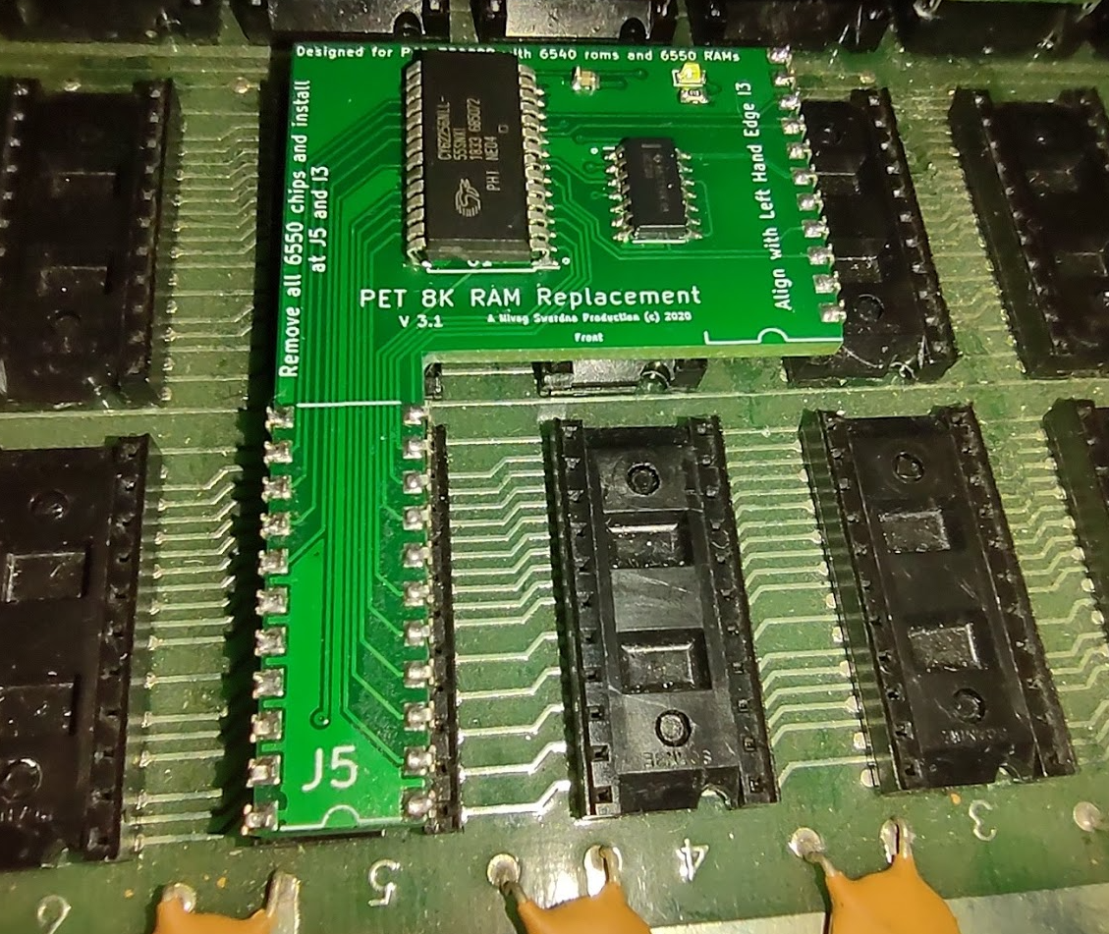

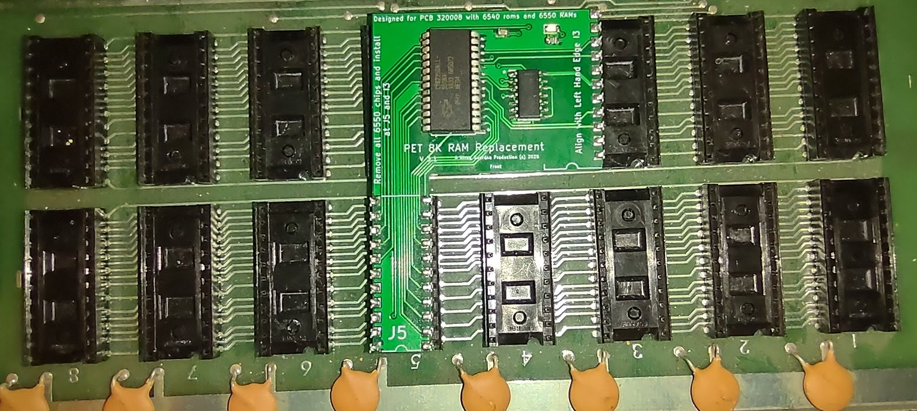

If you asked for the Green LED option then it should glow serenely in the top right corner when power has been supplied. It only glows dimly (1K resistor), that’s intentional. (It is enabled via a solder link on the back; remove the blob to disable).

Any questions…

[GavinAndrews@yahoo.com](mailto:GavinAndrews@yahoo.com)

Share & Enjoy