**Dear ROMulan RAMulator owner**,

The RAMulator uses Batten and Allen Edge pins for maximum compatibility with existing DIP sockets, it maintains the original profile of a DIP integrated circuit pin which is blade shaped. Because the ROMulan RAMulator requires quite long legs as it has to stand above neighboring components to allow the PCB to float above. I have been a little frustrated with the performance of the pins since they are made of reasonably soft material (probably good for the sockets) but these can bend if mis aligned during installation of the RAMulator. To this end I have created a small PCB which can guide the pins as you install.

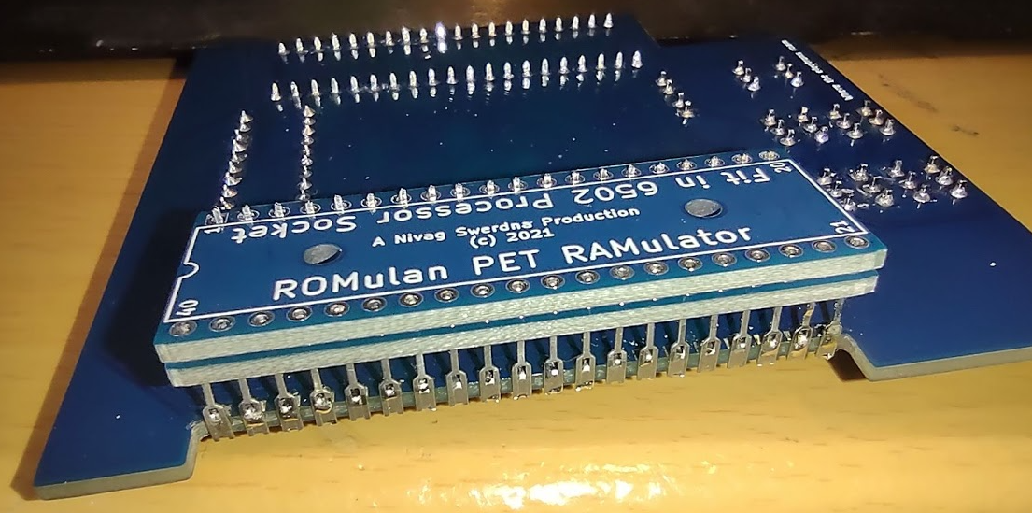

The PCBs can be stacked on the protruding pins for the CPU socket (OK it’s a reasonable challenge getting them on the first time but once they are fitted, they stay happily there); only a single PCB is required to align the Pins but a pair works nicely. Make sure to get the orientation as shown in the diagram (there are electrical connections on the board and putting it the wrong way around would cause a short). Pin 40 (and pin 21) is indicated in the corner near the edge of the board this should be as above.

**Using the “Chip and Slide”**

Prior to installation slide the PCBs to the end so only the end of the pins is showing.

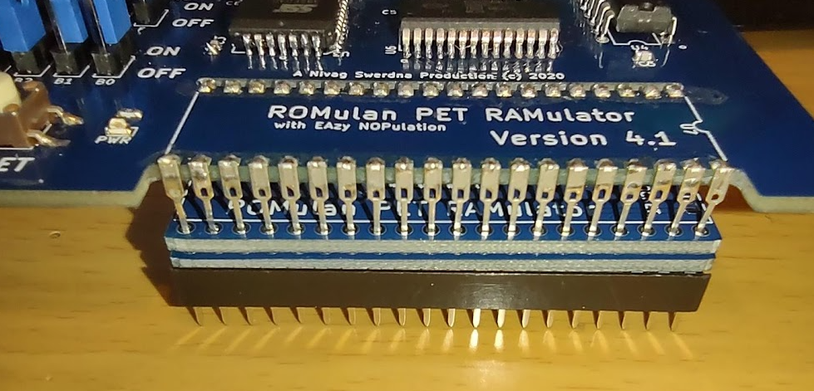

Press downward as you install…

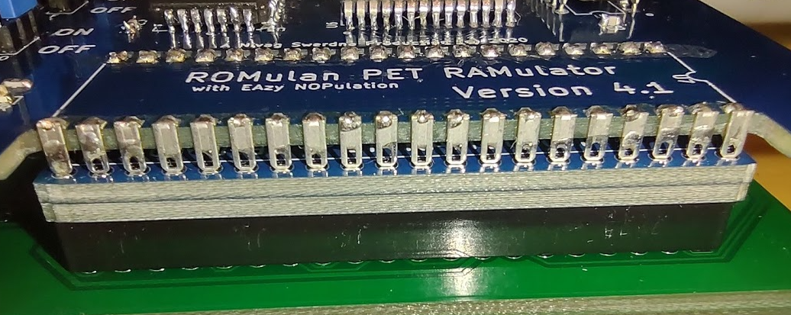

.. the PCBs should slide along the pins and the ends protrude into the DIP socket.

During experimentation it seems that the best combination is to have pins which are four PCBs thickness and have two sliding PCBs so that when fully retracted two PCBs worth of pin are exposed into the DIP socket. Some tweaking may be required. Removing a slider is easy and you can use the remaining slider to help fit/refit it. Hopefully two will work well.

Feedback appreciated!

Any questions…

[GavinAndrews@yahoo.com](mailto:GavinAndrews@yahoo.com)

Share & Enjoy