**Dear new 6502 NOPPer owner**,

You are now the proud owner of a 6502 NOPPer device designed specifically for discerning owners of 6502 microprocessor-based systems.

To install…

REMOVE the existing 6502 microprocessor from the PCB under test

Install the 6502 into the NOPPER making sure of the alignment. The top of the 6502 should be next to the 5-pin header and the Activity LED. There is a marking on the white silkscreen under the socket but it’s a bit tricky to see

Install the assembly back into the main board. It should be noted that the board uses turned pins which should mount into a DIP socket but if you are concerned that round things don’t go into square/rectangular things then consider adding a sacrificial 40pin DIP socket between the NOPPER and the device under test.

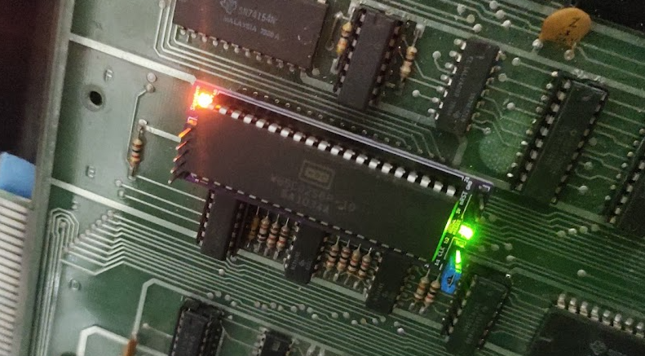

Be careful, there are many pins to line up and Don’t Panic!

The best approach is to check the pins are dead straight as you start and then make sure you are straight on and to worry about all the pins simultaneously! Make sure you have good lighting and appropriate magnification if it looks tricky. Try not to miss out a pin and then find it becomes horribly bent; they can be bent back but will only take a certain amount of abuse.

Once installed, apply power to the main board. The Green Power LED should be illuminated.

If RESET is asserted then the RED LED will be illuminated. Normal reset circuits will hold the board in reset for a fraction of a second and then go high to let the processor function. In normal operation you should therefore expect the RED LED to be on for a fraction of a second and then go out. Flashing RED suggests that the board is in a reset loop (perhaps due to a watchdog reset function) and will require investigation.

Theory of operation

At start-up the microprocessor will fetch a reset vector by reading the bytes $FFFC and $FFFD. Control then passes to that address.

With a 6502 NOPPer installed the databus pins (p26-p33) are forced to adopt the value $EA.

Therefore, the Program Counter is loaded with EAEA and control starts from that location.

The processor then reads the opcode, and since the databus is hardwired to EA, an EA instruction is read.

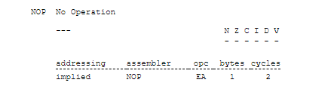

EA is a NOP (No Operation) instruction that takes 2 cycles and has no effect on the registers or flags. Once completed the PC is incremented to EAEB and then next instruction is read. The PC increases by one for each two cycles until it reaches FFFF at which point an increment causes the PC to overflow to 0000, this process then continues indefinitely.

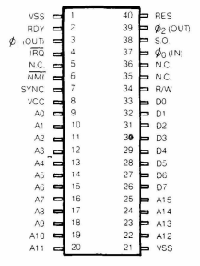

The upshot of all this is that the address bus (16bits A0..A15) continuously increments every two cycles. The frequency of each bit is half that of the previous bit. E.g. A1 changes at half the frequency of A0 since the counting sequence is 00, 01, 10, 11, etc.

The most significant bit A15 is set at $8000 and cleared at $0000 (after roll-over from $FFFF); it therefore changes very slowly compared to A0. By measuring the various address line frequencies it is possible to determine which line is which.

E.g. With a 2MHz clock, A0 changes at 1MHz, A1 at 500kHz, A2 at 250kHz, A3 at 125kHz etc.

Detailed operation

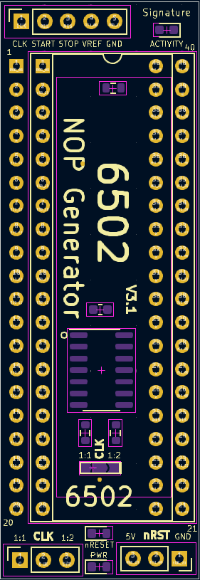

At the top of the adapter is a five pin header with CLK, START, STOP, VREF and GND. These pins are intended for use with a Digital Signal Analyser e.g. HP 5004 A.

CLK is the adjusted clock, START is A15, STOP is A15, VREF is VCC, GND is GND.

The orange activity LED is attached to A15 and will glow when A15 is high. It should be pulsing rapidly when NOPPing at a rate determined by the system clock / 32768.

At the bottom left is a three pin header. A jumper should be installed between left and middle OR middle and right. LEFT is a 1:1 clock, RIGHT is a 1:2 clock (default). Given an EA (NOP instruction takes 2 cycles) it is useful to generate a divide by 2 clock since that is the rate at which the address bus will increment. This is useful for digital signatures.

In the middle are two LEDs; the RED one is illuminated when nRESET is LOW indicating the CPU is in RESET. It should be OFF in normal operation; with a brief period of ON during power-on reset.

The Green Power LED should glow serenely to indicate power is applied.

The bottom right pins are 5V, nRESET and GND respectively; these can be used for sensing current levels or if your mainboard circuit is compatible, you can use these to generate reset by pulling nRST LOW. (Do that part at your own risk!)

Any questions…

[GavinAndrews@yahoo.com](mailto:GavinAndrews@yahoo.com)

Share & Enjoy

PS

Pin 1 on Socket and Pin 1 on CPU adapter wired together; pin 21 used for GND.