**Dear new videoRAM owner**,

You are now the proud owner of a Video RAM replacement device designed specifically for discerning owners of the original Commodore PET 2001-8 PCB which uses 6550 RAM devices.

The videoRAM provides 1K bytes of RAM to replace the pair of 6550s (1k x4) which drive the video circuitry. These RAMs work really hard as sixty times per second they provide their contents to a latch to drive the character ROM and ultimately render as pixels.

To install…

REMOVE the two 6550 chips at C3 and C4.

Carefully connect the PCB to the C3 and C4 slots, taking extra special care to align the four pins that are hidden under the board.

There is not much tolerance so do this carefully and Don’t Panic!

The best approach is to check the pins are dead straight as you start and then make sure you are straight on and to worry about all the pins simultaneously! Make sure you have good lighting and appropriate magnification if it looks tricky. Try not to miss out a pin and then find it becomes horribly bent; they can be bent back but will only take a certain amount of abuse.

[If you are struggling but have empty 6550 sockets at the front of the machine (e.g. if you are using the 8kRAM replacement or the ROMulan RAMulator), then make sure the PET is turned OFF and then you can use these sockets for a dry-run since because the pin pitch and spacing of the 6550s for system RAM matches that of the video RAM.

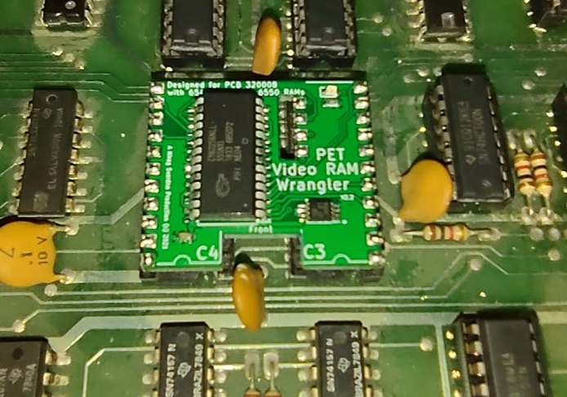

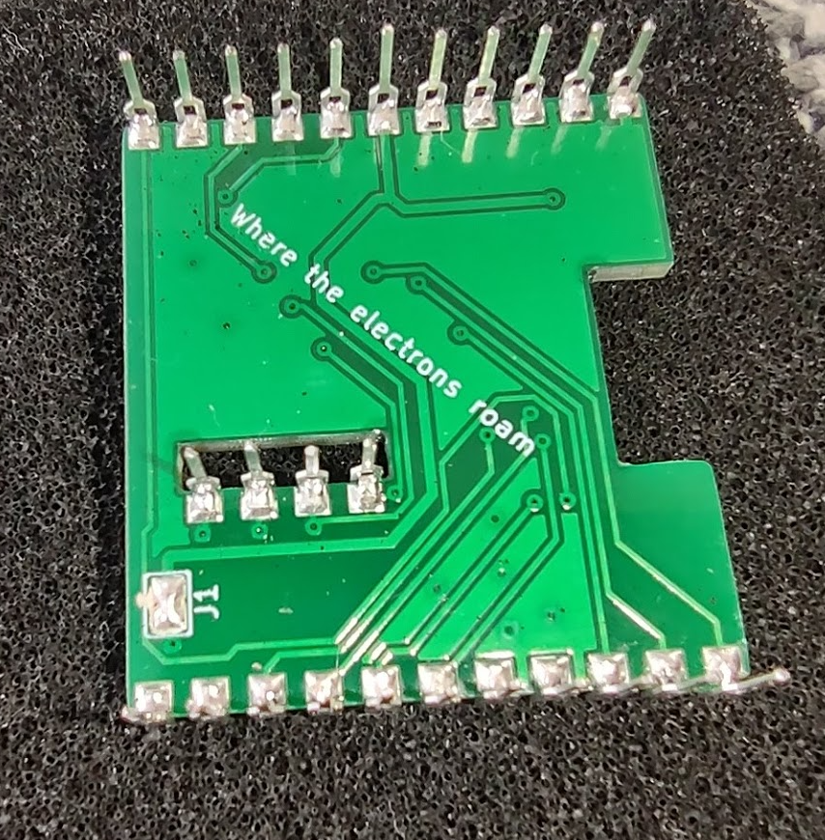

If you asked for the Green LED option then it should glow serenely in the top right corner when power has been supplied. It only glows dimly (1K resistor), that’s intentional. (It is enabled via a solder link on the back; remove the blob to disable).

Any questions…

[GavinAndrews@yahoo.com](mailto:GavinAndrews@yahoo.com)

Share & Enjoy