**Project Benson - Business Proposal**

By Emmanuele, Frederik and Gavin

Summary

The following document constitutes a proposal tendered by Metis Data Science Consulting Firm (“Metis”) to assist the New York Red Bulls soccer team (the “Client”) in the research and optimization of its street team marketing activities using information repositories including the MTA transit ridership database. The team at Metis has made an assessment of the Client’s request and we now outline the results of our preliminary analysis below:

* Statistics show that youth participation in playing soccer continues to trend upwards and may represent an ideal demographic group (i.e. school children under 18 years of age) for targeted marketing efforts.

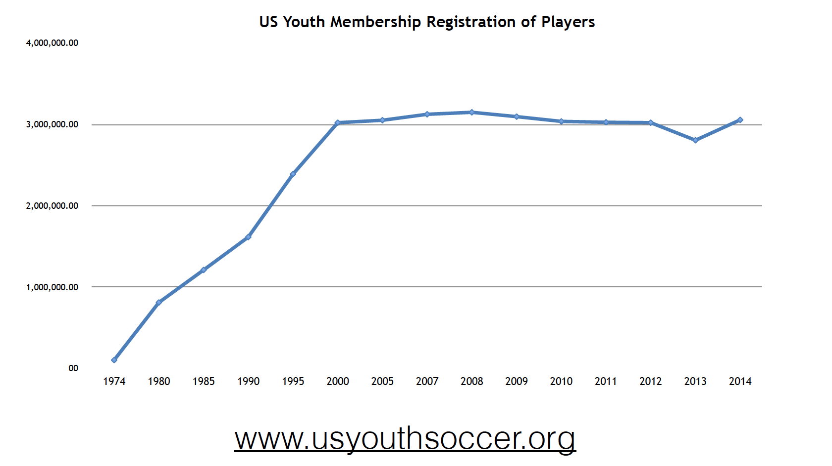

* Ridership varies over time and further analysis will reveal the optimal dates and times, based on both seasonal and daily fluctuations.

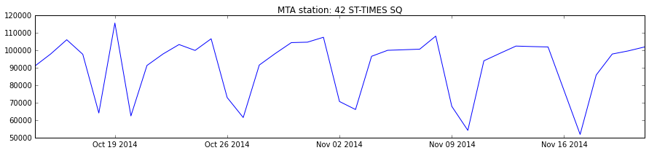

* The volume of ridership activity varies widely at each station.

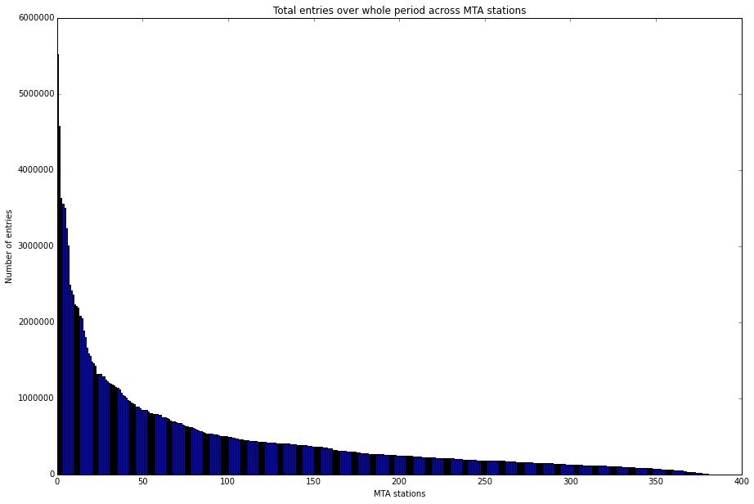

* Geographical location of schools (red icon) versus subway stations (blue icon) illustrates that the population density of the youth is not consistent across different locations in the city.

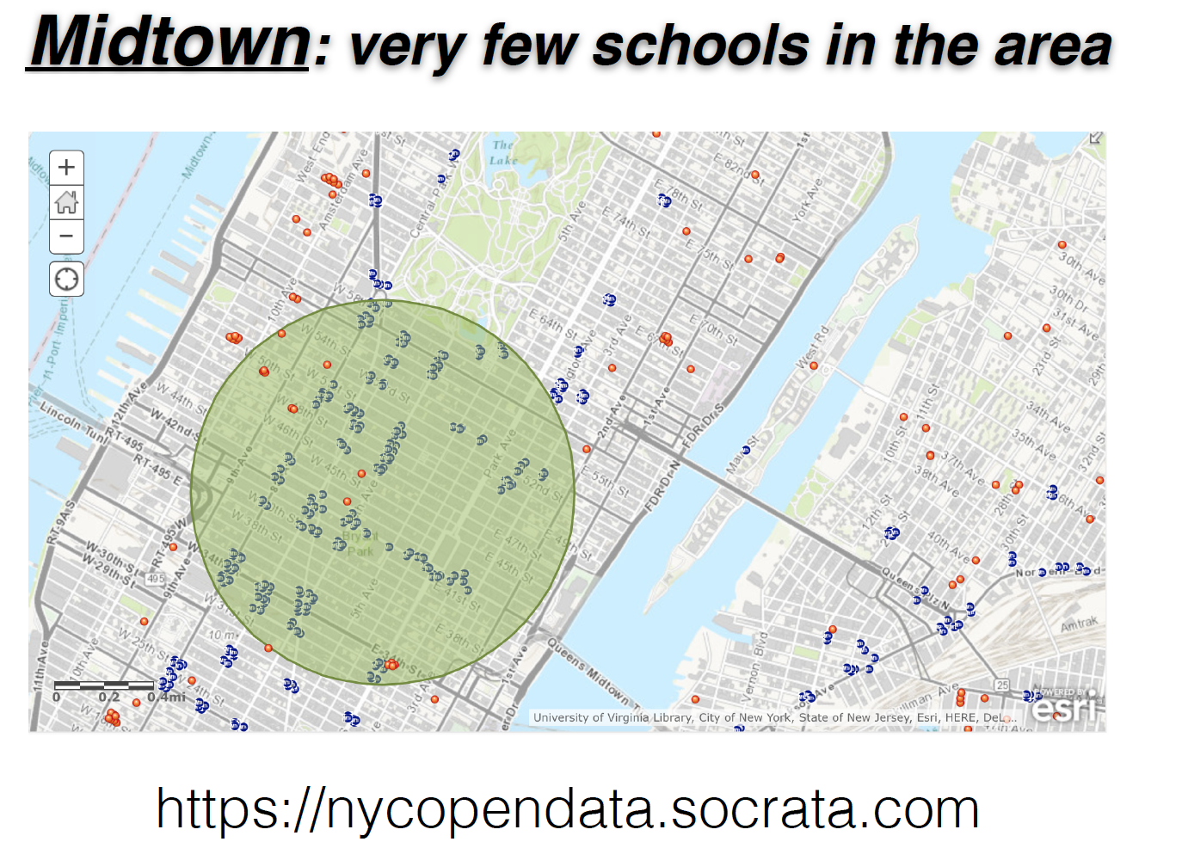 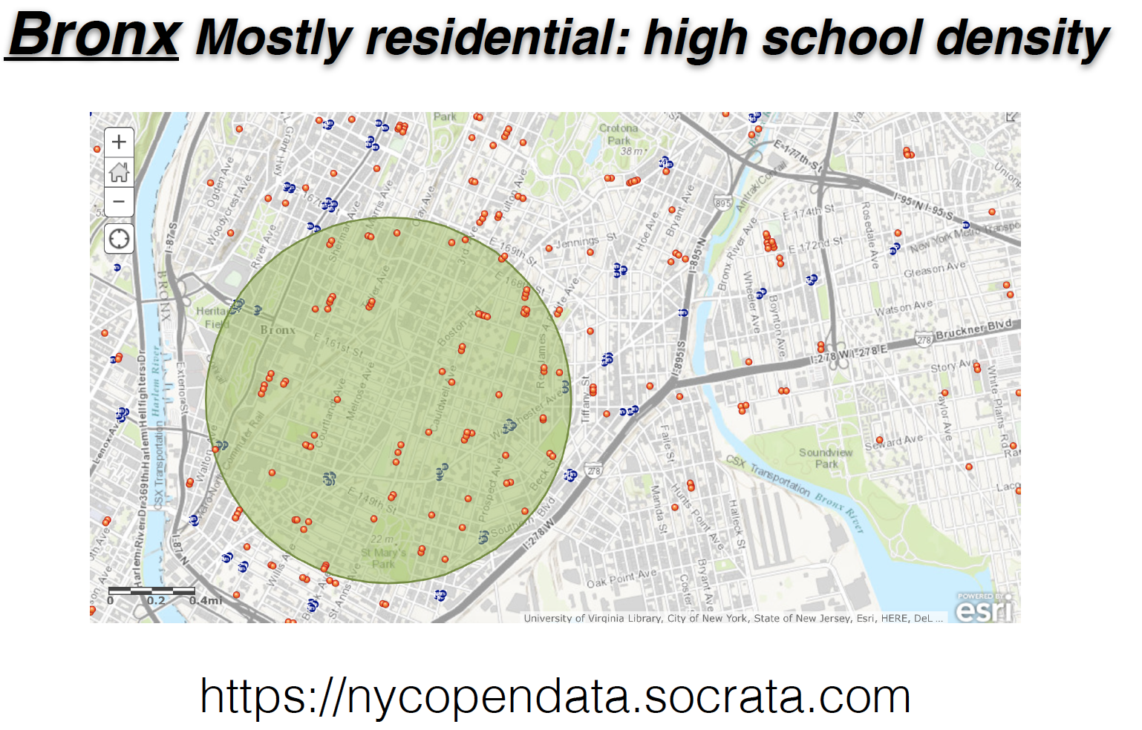

Our Approach

* Metis employs an iterative process management approach to all of its client engagements. For this engagement we intend to:
  + Perform our analysis to the client’s specifications;
  + Provide a prototype to the client for review;
  + Incorporate client feedback from the review session and;
  + Produce the final deliverable.
* Our team will utilize cutting edge data science techniques and tools to infer key insights on MTA ridership per the client’s request.
* To enhance the analysis we propose the use of other data sources including:
  + Publicly available data on the dispersion of school districts in the city. (e.g. nycopendata.socrata.com);
  + Player participation statistics produced by leading youth soccer associations, leagues and public sector athletic oversight organizations. (e.g. www.usyouthsoccer.org);

Deliverable

* At the conclusion of the project, Metis will provide the Client with a written recommendation including a list of subway stations ranked by a combination of ridership and proximity to schools, and a summarized version of the data and statistical analysis used to support our conclusions.

Fees

* We estimate the total price for our services to be 10,000 Metis dollars.

Acceptance

The signatures below indicate acceptance of this proposal and its terms, and forms an agreement between the Client and Metis for the work and deliverables described above.

____________________________________________ ___________________________________________________

CEO Date

Metis Data Science Consulting Firm

_____________________________________________ ___________________________________________________

Director of Marketing Date

New York Red Bulls