**COMP3322B Modern Technologies on World Wide Web**

**Lab 6: RESTful Web Service Using Express.js, MongoDB and Pug**

# Introduction

In this lab exercise, we will use Node.js to implement a RESTful Web service and the HTML content to access the Web service. In particular, we will use the Express.js web framework based on Node.js, together with the Pug template engine and MongoDB. The Web service allows retrieving, adding, updating and deleting contacts from a MongoDB database. The HTML page provides an interface for displaying contact information, adding, updating and deleting contacts.

# Set Up Runtime Environment and Install MongoDB

Follow the instructions (Steps 1 to 3) in **setup_nodejs_runtime_and_examples.docx** to set up Node.js runtime environment and create an Express project named “**lab6**”. Remember to replace app.set('view engine', 'jade'); in the generated **app.js** by app.set('view engine', 'pug'); .

In addition, we will need a MongoDB database to store reports information. We install the database as follows.

**Step 1**: In the “lab6” project directory, create a new directory “data”. This directory will be used to store database files.

cd lab6 mkdir data

**Step 2**: Go to <https://www.mongodb.com/download-center/community> and download the latest version of MongoDB (choose the latest “Community Server” release to download). Install MongoDB to a directory at your choice.

**Step 3**: **Launch the 2nd terminal** (besides the one you use for running NPM commands), and switch to the directory where MongoDB is installed. Start MongoDB server using the “data” directory of “lab6” project as the database location, as follows: (replace “**YourPath**” by the actual path on your computer that leads to “lab6” directory)

If you use a 64-bit MongoDB on your own computer, please use the following command：

./bin/mongod --dbpath **YourPath**/lab6/data

After starting the database server successfully, you should see some prompt in the terminal like “…2019-03-30T11:14:10.896+0800 I NETWORK [initandlisten] waiting for connections on port 27017”. This means that the database server is up running now and listening on the default port 27017. **Then leave this terminal open and do not close it during your entire lab practice session,** in order to allow connections to the database from your Express app.

**Step 4**: **Launch the 3rd terminal**, switch to the directory where mongodb is installed, and execute the following commands:

./bin/mongo use lab6

db.contactList.insert({'name':'Jim', 'email':'jim@gmail.com', 'tel':'1234567'})

The “use lab6” command creates a database named “lab6”. The next command followed by “use lab6” inserts a new record into the “contactList” collection of the database.

After you run the insert command, you should see “WriteResult({ "nInserted" : 1 })” on the terminal. You can insert more records into the database collection to facilitate testing of your program.

**Step 5**: Now switch to the “lab6” project folder. Open **package.json** using a text editor. Add dependencies for MongoDB. The complete file should look like this (you do not need to worry if the version of other modules included in the **package.json** thatyou have generated is lower):

{

"name": "lab6",

"version": "0.0.0", "private": true, "scripts": {

"start": "node ./bin/www"

},

"dependencies": {

"cookie-parser": "~1.4.3",

"debug": "~2.6.9",

"express": "~4.16.0",

"http-errors": "~1.6.2",

"jade": "~1.11.0",

"morgan": "~1.9.0",

"pug": "^2.0.3",

"mongodb": "^3.2.2",

"monk": "^6.0.6",

"body-parser": "~1.18.3"

}

}

Then install the dependencies using the terminal as follows: cd lab6

npm install

After this, we have added 3 more Node.js packages to “lab6” project, which are **mongodb**

and **monk** (used to interact with the MongoDB database), and **body-parser** (used for parsing body of HTTP request message).

# Lab Exercise 1: Create the Home Page Using Pug

We next modify the Pug templates in the “./views” directory of “lab6”, in order to render the homepage of our Express app.

**Step 1**: Replace **index.pug** with the index.pug which we provide in **lab6_materials.zip**. Open it using a text editor. Please refer to [https://pugjs.org/api/getting-started.html](https://pugjs.org/api/getting-started.htmlf) for explanations of the code in the file.

**Step 2**: Open **layout.pug** using a text editor and modify it to contain the following content:

|  |
| --- |
| doctype html  html  head  title= title  link(rel='stylesheet', href='/stylesheets/style.css')  body  block content  script(src='https://ajax.googleapis.com/ajax/libs/jquery/3.3.1/jquery.min.js')  script(src='/javascripts/externalJS.js') |

The first line of code in **index.pug** indicates that **index.pug** extends **layout.pug**. By modifying **layout.pug** as above, the web page rendered links to a **style.css** file under ./public/stylesheets for styling (use the style.css file we provide to you in **lab6_materials.zip** to replace the default style.css file under ./public/stylesheets), the jQuery library on Google server, and an **externalJS.js** file under ./public/javascripts containing client-side JavaScript (which we will create under that directory in Lab Exercise 2). Note that the ./public directory has been declared to hold static files which can be directly retrieved by a client browser, using the line of code “app.use(express.static(path.join(__dirname, 'public')));” in app.js (note there are two underscores “_” before dirname in the code). In this way, the render web page can directly load files under the ./public directory.

**Step 3**: Open **index.js** under the directory ./routes, and replace “Express” in the line “res.render('index', { title: 'Express' });” by “Lab 6”.

**Step 4:** Now let’s check out the web page rendered using the new Pug files. In the terminal, type “**npm start**” to start the Express app (**you should always use control+C to kill an already running app before you start the app again after making modifications**). Check out the rendered page again at http://localhost:3000 on your browser. You should see a page like the following:

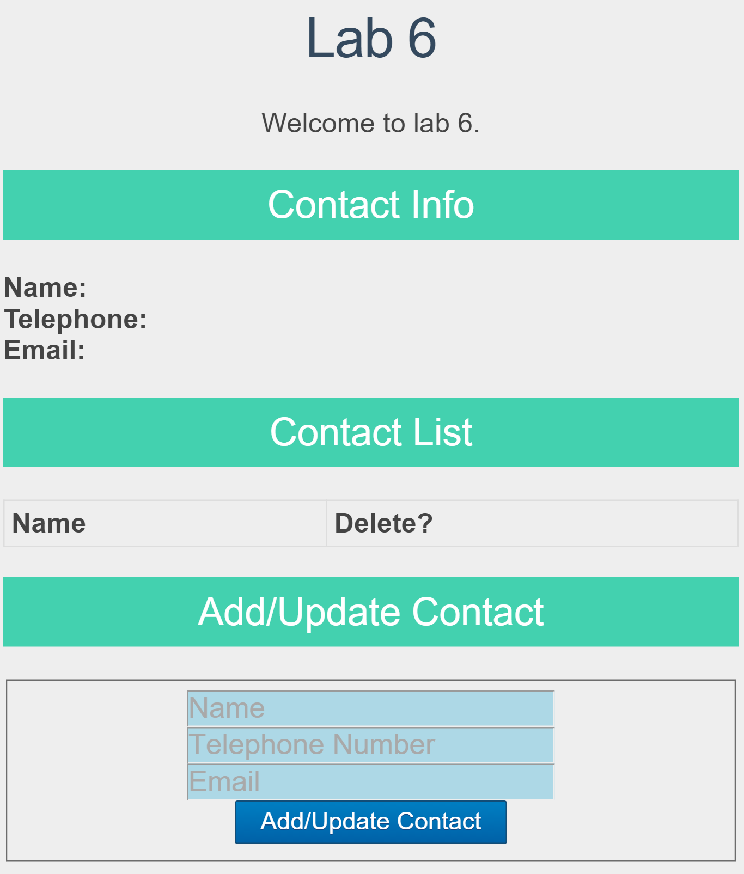

Fig. 1

# Lab Exercise 2: List Contacts

We next modify our Express app to connect to the database, retrieve and display the commodity list.

**Step 1**: Open **app.js** and add the following line ***below*** “var logger = require('morgan');”.

var bodyParser = require('body-parser');

and replace the following two lines:

app.use(express.json());

app.use(express.urlencoded({ extended: false });

by

app.use(bodyParser.json());

app.use(bodyParser.urlencoded({ extended: false }));

Note: the latest version of Express.js has included the body parser functionalities as built-in middlewares (express.json and express.urlencoded). But to be consistent with lecture slides, we still use the 'body-parser' module in this lab.

**Step 2**: Open **app.js** and add the following lines ***below*** “var bodyParser = require('body- parser');”. By doing so, we establish a connection with the database “lab6” that we created.

// Database

var mongo = require('mongodb'); var monk = require('monk');

var db = monk('localhost:27017/lab6');

Then we need to enable subsequent router modules to access the database. To achieve this, add the following code ***before*** the line of “app.use('/', indexRouter);”.

// Make our db accessible to routers app.use(function(req,res,next){

req.db = db; next();

});

By assigning the **db** object to **req.db**, subsequent router modules can use **req.db** to communicate with the database.

**Step 3**: Now open **users.js** in the directory ./routes and modify the file such that it contains the following content:

|  |
| --- |
| var express = require('express');  var router = express.Router();  /*  * GET contactList.  */  router.get('/contactList', function(req, res) {  var db = req.db;  var collection = db.get('contactList');  collection.find({},{},function(err,docs){  if (err === null)  res.json(docs);  else res.send({msg: err});  });  });    module.exports = router; |

The middleware in this **users.js** controls how the server responds to the HTTP GET requests for “http://localhost:3000/users/contactList”. The middleware will first retrieve the database connection. Then it will retrieve the ‘contactList’ collection, encode everything in this collection as a JSON message and send it back to the client.

**Step 4**: Restart your Express app with “npm start” in your first terminal. Test if your server- side code works by browsing http://localhost:3000/users/contactList on your browser. The browser should display a JSON response text like this:

[{"_id":"582e741ac1f51204644fb50e","name":"Jim","email":"jim@gmail.com","tel":"1234567"}]

We can see that a "_id" attribute was added by the database server into each contact record that we inserted earlier, which is used to uniquely identify the record in a collection. When a contact record is retrieved from the database, this "_id" attribute and its value are also included.

**Step 5**: Now we add client-side code for displaying the contact list. Recall that in Step 2 of Lab Exercise 1, we link the rendered HTML page to **externalJS.js**. Create an **externalJS.js** file under the directory ./public/javascripts. Put the following jQuery code into **externalJS.js**:

|  |
| --- |
| // contact data array for filling in info box  var contactListData = [];  // DOM Ready =============================================================  $(document).ready(function() {  // Populate the contact list on initial page load  populateContactList();  });  // Functions =============================================================  // Fill contact list with actual data.  function populateContactList() {  // Empty content string  var tableContent = '';  // jQuery AJAX call for JSON  $.getJSON( '/users/contactList', function( data ) {  contactListData = data;    // For each item in our JSON, add a table row and cells to the content string  $.each(data, function(){  tableContent += '<tr>';  tableContent += '<td><a href="#" class="linkShowContact" rel="' + this.name + '">' + this.name + '</a></td>';  tableContent += '<td><a href="#" class="linkDeleteContact" rel="' + this._id + '">delete</a></td>';  tableContent += '</tr>';  });  // Inject the whole content string into our existing HTML table  $('#contactList table tbody').html(tableContent);  });  }; |

**Step 6**: Now browse the home page at http://localhost:3000/. The request is handled by the middleware in router **index.js**, which renders the web page using **index.pug** and **layout.pug**. The rendered page links to **externalJS.js**. The jQuery code in **externalJS.js** is executed when the page has been loaded by the browser ($(document).ready()), which adds retrieved document(s) into the contact list. You should see that the contact record that we inserted into the database earlier is now displayed on the web page:

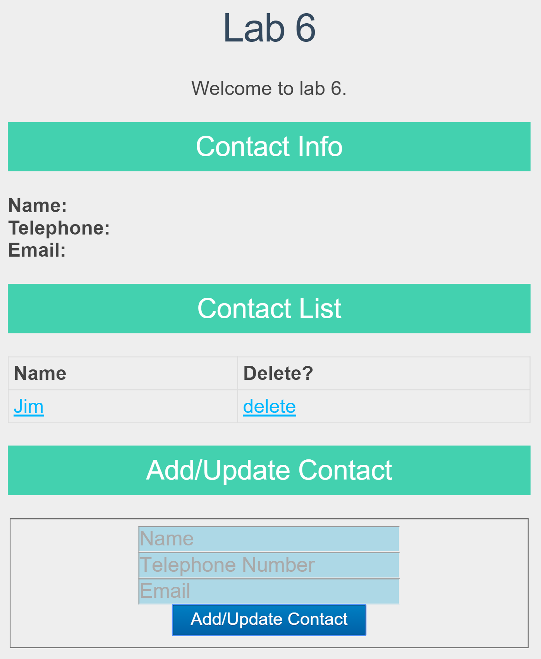

Fig. 2

# Lab Exercise 3: Show Detailed Contact Information

We next implement the client-side code for displaying a contact’s detailed information in the “Contact Info” part of the page, when a contact name in the contact list is clicked.

**Step 1**: In the code we added into **externalJS.js** in Step 5 of Lab Exercise 2, we saved contact record(s) retrieved from the database into an array ***contactListData*.** We now retrieve the respective contact’s record from array **contactListData** and display the detailed information. Open **externalJS.js** and add the following content at the end of the file.

|  |
| --- |
| // Show Contact Info  function showContactInfo(event) {  // Prevent Link from Firing  event.preventDefault();  // Retrieve contact name from link rel attribute  var thisContactName = $(this).attr('rel');  // Get Index of object based on id value  var arrayPosition = contactListData.map(function(arrayItem) { return arrayItem.name; }).indexOf(thisContactName);  // Get our contact Object  var thisContactObject = contactListData[arrayPosition];  //Populate Info Box  $('#contactInfoName').text(thisContactObject.name);  $('#contactInfoTel').text(thisContactObject.tel);  $('#contactInfoEmail').text(thisContactObject.email);  //record id in “rel” attribute of the contactInfoName field  $('#contactInfoName').attr({'rel': thisContactObject._id});  };  // contact name link click  $('#contactList table tbody').on('click', 'td a.linkShowContact', showContactInfo); |

**Step 2**: Browse <http://localhost:3000/> in your browser: refresh the page and click **Jim** in the Contact List. You should see that the detailed information of the contact is displayed in the Contact Info part:

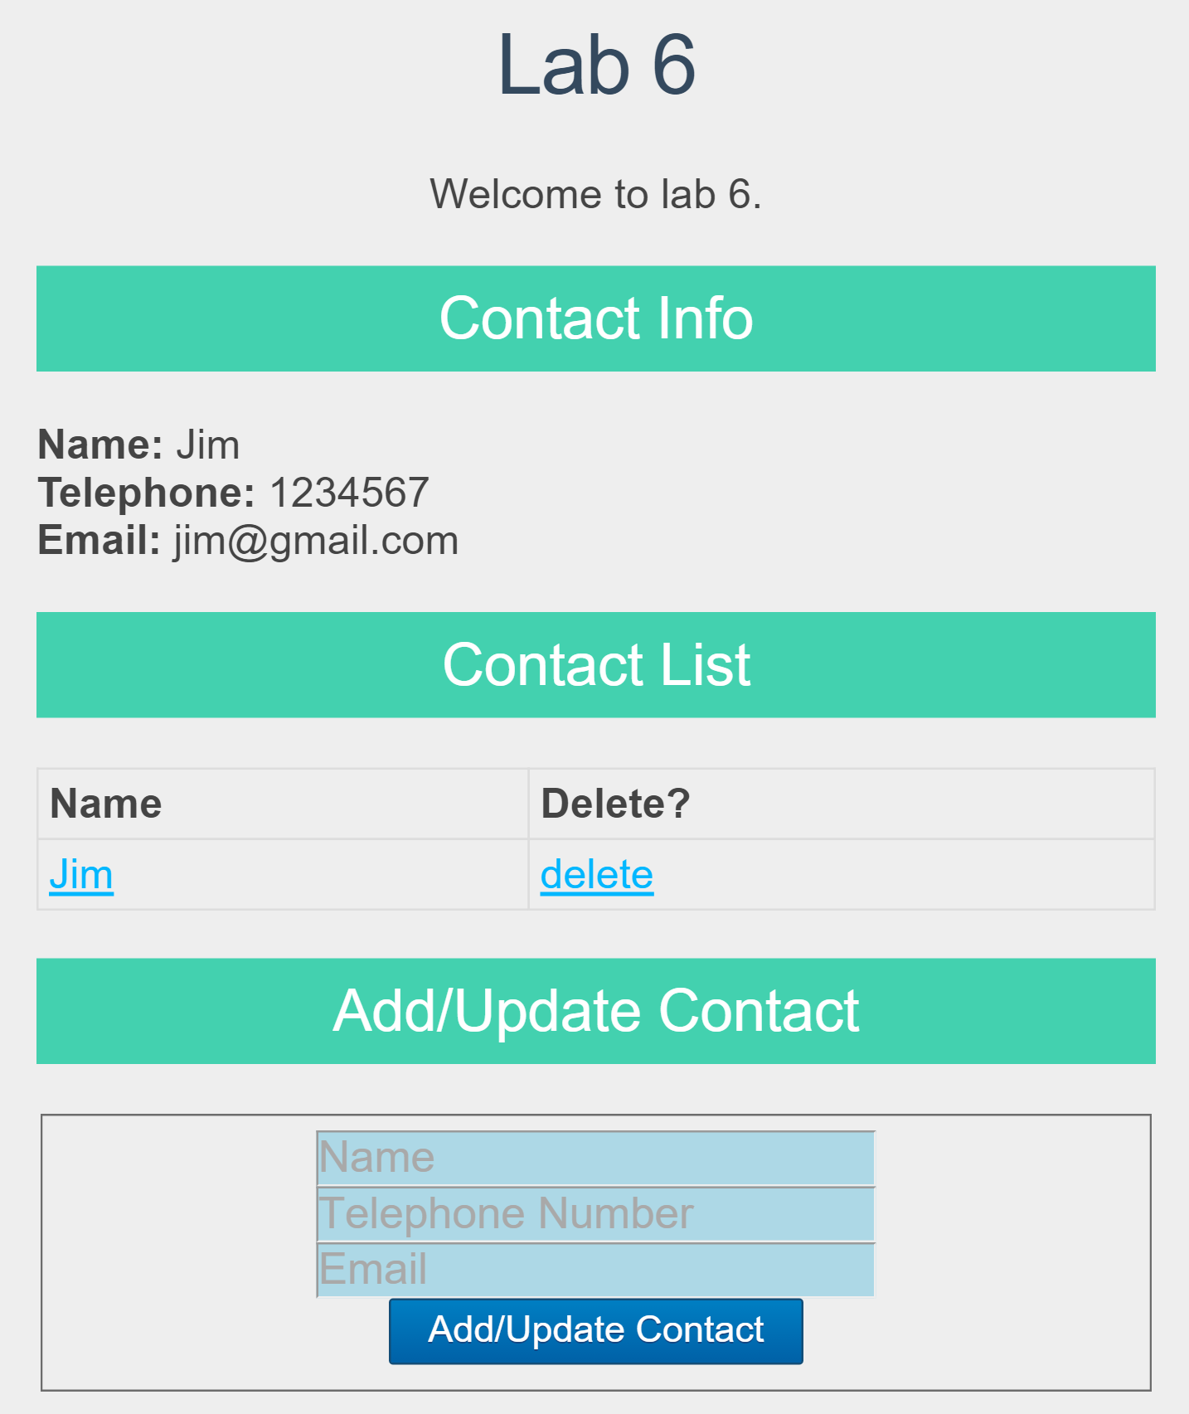

# Fig. 3

# Lab Exercise 4: Add a New Contact

We next implement the server-side and client-side code for adding a new contact record into the database.

**Step 1**: Open **users.js** in the ./routes directory and add the following middleware into this file, which handles HTTP POST requests sent for [http://localhost:3000/users/addContact](http://localhost:3000/users/addcommodity) .

|  |
| --- |
| /*  * POST to addContact.  */  router.post('/addContact', function(req, res) {  var db = req.db;  var collection = db.get('contactList');  collection.insert(req.body, function(err, result){  res.send(  (err === null) ? { msg: '' } : { msg: err }  );  });  }); |

Make sure names of the contacts you add are different, as we are going to make use of the name to distinguish a new or existing contact in the “Add/Update Contact” part.

**Step 2**: Open **externalJS.js** in the ./public/javascripts directory and add the following code at the end of the file. What the code achieves is as follows: when the “Add/Update Contact” button is clicked, the **addOrUpdateContact** function will be invoked. **addOrUpdateContact** first checks if all fields in the “**#addOrUpdateContact**” division have been filled: if not, it prompts 'Please fill in all fields' and return; otherwise, it further checks if the entered name exists among names of all contacts displayed on the page. If the name does not exist, it sends an AJAX HTTP POST request to http://localhost:3000/users/addContact, carrying a JSON string containing the input information of the new contact inside its body. Upon receiving a success HTTP response, the client clears all the fields in the “**#addOrUpdateContact**” division, and updates the contact list by calling **populateContactList ()***.*

|  |
| --- |
| // Add or update contact  function addOrUpdateContact(event) {  event.preventDefault();  // Super basic validation - increase errorCount variable if any fields are blank  var errorCount = 0;  $('#addOrUpdateContact input').each(function(index, val) {  if($(this).val() === '') { errorCount++; }  });  // Check and make sure errorCount's still at zero  if(errorCount === 0) {  // check if the input contact exists already  var name = $('#addOrUpdateContact fieldset input#inputContactName').val();  var existContactIndex = -1;  for (var i = 0; i < contactListData.length; i++){  if(contactListData[i].name == name){  existContactIndex = i;  break;  }  }  if(existContactIndex >= 0){  //the contact exists  var existingContact = {  '_id': contactListData[existContactIndex]._id,  'name': $('#addOrUpdateContact fieldset input#inputContactName').val(),  'tel': $('#addOrUpdateContact fieldset input#inputContactTel').val(),  'email': $('#addOrUpdateContact fieldset input#inputContactEmail').val()  }  updateContact(existingContact);  } else{  // the contact is new  var newContact = {  'name': $('#addOrUpdateContact fieldset input#inputContactName').val(),  'tel': $('#addOrUpdateContact fieldset input#inputContactTel').val(),  'email': $('#addOrUpdateContact fieldset input#inputContactEmail').val()  }  // Use AJAX to post the object to our addContact service  $.ajax({  type: 'POST',  data: newContact,  url: '/users/addContact',  dataType: 'JSON'  }).done(function( response ) {  // Check for successful (blank) response  if (response.msg === '') {  // Clear the form inputs  $('#addOrUpdateContact fieldset input').val('');  // Update the table  populateContactList();  }  else {  // If something goes wrong, alert the error message that our service returned  alert('Error: ' + response.msg);  }  });  }  }  else {  // If errorCount is more than 0, error out  alert('Please fill in all fields');  return false;  }  };  // Add/Update Contact button click  $('#btnAddUpdateContact').on('click', addOrUpdateContact); |

**Step 3**: Restart your Express app and browse http://localhost:3000 again. Add information of a new contact as Fig. 3 below. After clicking the “Add Contact” button, you should see a page as shown in Fig. 4.

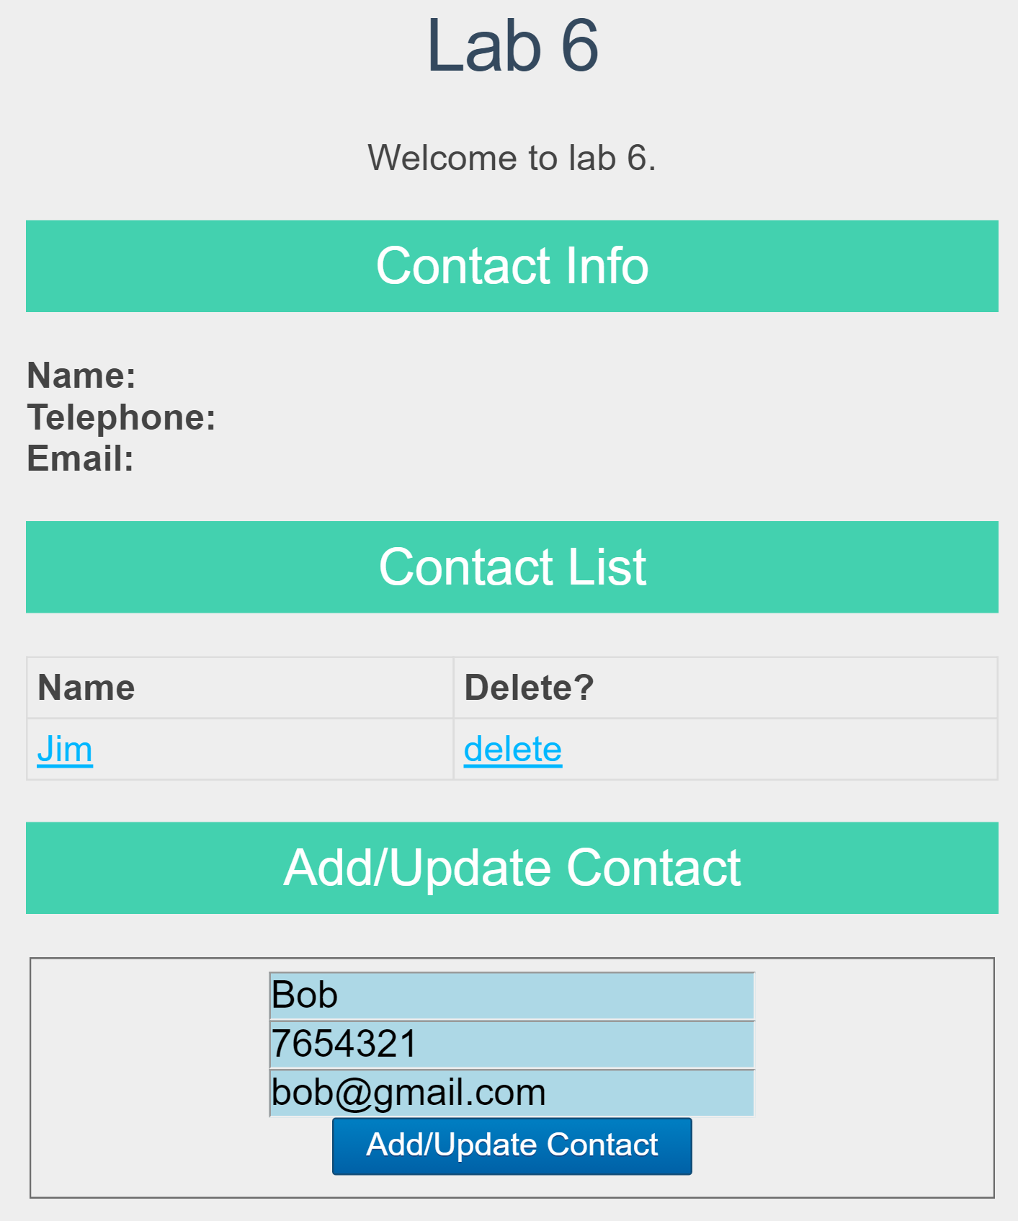

Fig. 4

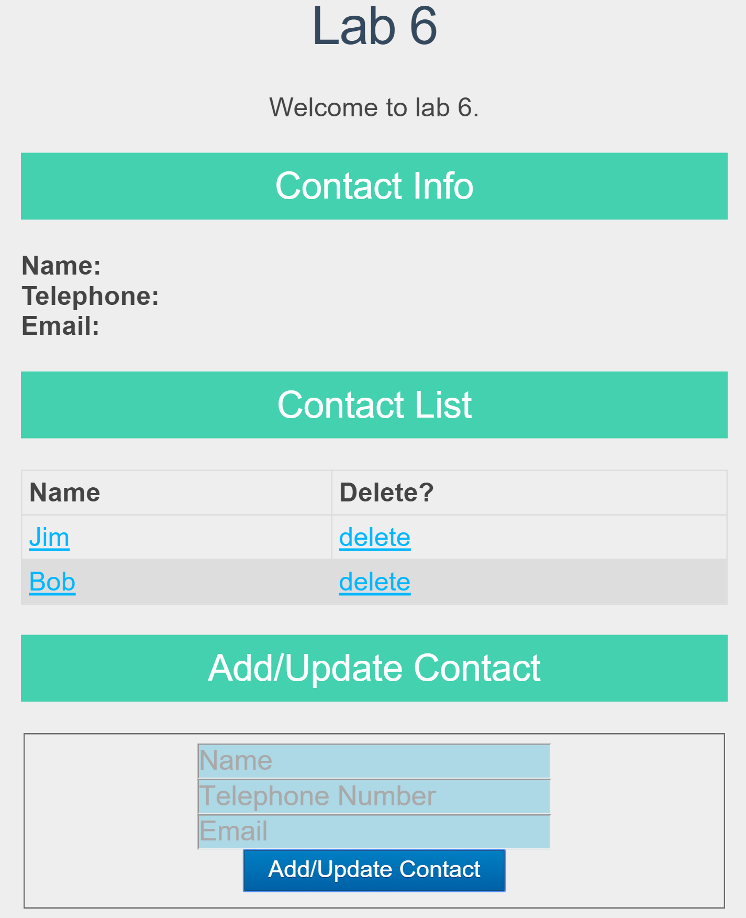

Fig. 5

# Lab Exercise 5: Update a Contact

In this part, we implement the server-side and client-side code for updating an existing contact record in the database.

**Step 1**: Open **users.js** in the ./routes directory and add the following middleware:

|  |
| --- |
| /*  * PUT to updateContact  */  router.put('/updateContact/:id', function (req, res) {  var db = req.db;  var collection = db.get('contactList');  var contactToUpdate = req.params.id;    //TO DO: update the contact record in contactList collection, according to contactToUpdate and data included in the body of the HTTP request  }); |

Implement the code in the above middleware, for updating an existing contact record in the contactList collection, whose “_id” is carried in the URL of the PUT request, and new contact information carried in request body. **Hint**: use **collection.update()** (https://automattic.github.io/monk/docs/collection/update.html). Upon successful update, the server should send a response message back to the client with an empty body; otherwise, it sends the error message back to the client.

**Step 2**: Open **externalJS.js** in the ./public/javascripts/ directory and add the following code at the end of the file.

|  |
| --- |
| // Update Contact  function updateContact(existingContact) {  var id = existingContact._id;  $.ajax({  type: ?,  url: ?,  data: ?,  dataType: 'JSON'  }).done(function (response) {  if (response.msg === '') {  // Clear the form inputs  ?  // Update the table  populateContactList();  //Update detailed info if the updated contact's detailed info is displayed  ?  }  else {  ?  }  });  }; |

Replace “?” with correct code to finish the client-side code for sending an AJAX HTTP PUT request and handling the response. Upon successful update, you should clear the form input on the web page; and if the detailed contact information of the updated contact is being displayed under “Contact Info”, update the contact info there. If an error message is carried in the response, prompt the error message using alert().

**Step 3**: Restart your Express app, browse http://localhost:3000 again, and test the update function as follows:

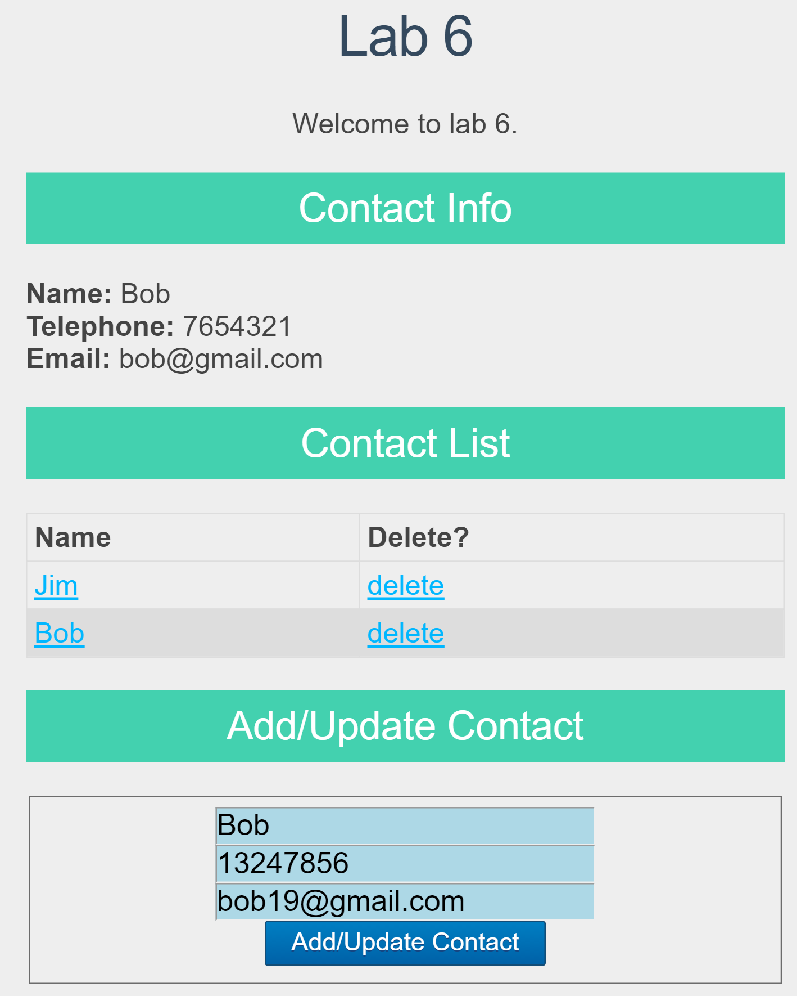

Fig. 6 Input new information of an existing contact

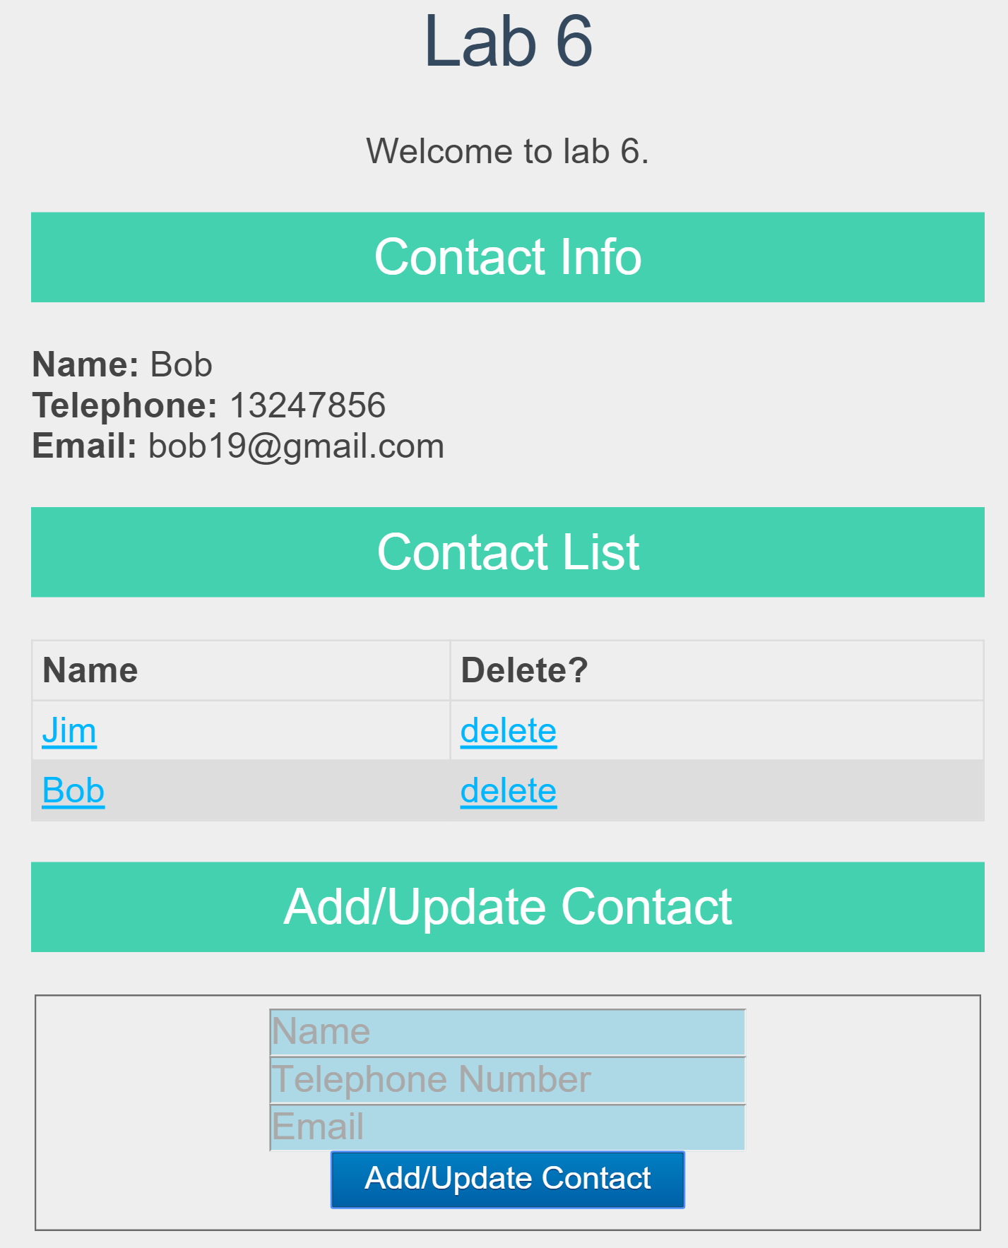

Fig. 7 After clicking “Add/Update Contact” on the Fig. 10 view

# Lab Exercise 6: Delete a Contact

In this part, we implement the server-side and client-side code for deleting a contact record from the database, when a respective “delete” button in the contact list is clicked.

**Step 1**: Open **users.js** in the ./routes directory and add the following middleware:

|  |
| --- |
| /*  * DELETE to delete a contact.  */  router.delete(?, function(req, res) {  ?  }); |

You should replace “?” with correct code for handling a delete request, by following the hints below:

1. Among the code we added in Step 5 of Lab Exercise 2, the **“_id”** attribute of a contact record is saved to the **“rel”** attribute of a **“<a>”** element of class **“linkDeleteContact”**, i.e., the “**delete**” link shown in the screenshots. The client will send an AJAX HTTP DELETE request to the following URL once you click the “**delete”** button:

http://localhost:3000/users/deleteContact/xx

(replace xx by the value of “_id” attribute of a contact record to be deleted).

1. The middleware should handle HTTP DELETE requests for path **/deleteContact/:id,** and retrieve the **“_id”** attribute carried in a DELETE request through **req.params.id**.
2. Use **remove()** method on a MongoDB collection for deleting the respective contact record from the collection in the database. Upon successful deletion, the server should send an empty response message back to the client; otherwise, it sends the error message back to the client.

**Step 2**: Open **externalJS.js** in the ./public/javascripts/ directory and add the following code at the end of the file.

|  |
| --- |
| // Delete contact link click  $('#contactList table tbody').on('click', 'td a.linkDeleteContact', deleteContact);  // Delete Contact  function deleteContact(event) {  event.preventDefault();  // Pop up a confirmation dialog  var confirmation = confirm('Are you sure you want to delete this contact?');    // Check and make sure the contact confirmed  if (confirmation === true) {  // If confirmed, do our delete  var id = $(this).attr('rel');  $.ajax({  type: ?,  url: ?  }).done(function( response ) {  ?  });  }  else {  // If saying no to the confirm, do nothing  return false;  }  }; |

Replace “?” with correct code to finish the client-side code for sending an AJAX HTTP DELETE request and handling the response. You should follow these hints:

1. **$('#contactList table tbody').on('click', 'td a.linkDeleteContact', deleteContact);** captures the click event on the **delete** link. This event will be processed by the **deleteContact** function.

2. You should fill in correct type and url of the HTTP DELETE request in the **$.ajax** method call.

3. Upon successful deletion, you should refresh the “Contact List” display on the web page. If the detailed information of the contact deleted is displayed in the “Contact Info” part, empty the detailed information there. If the deletion failed on the server side, display the error message carried in the response using alert().

**Step 3**: Restart your Express app, browse http://localhost:3000 again, and test the delete function as follows:

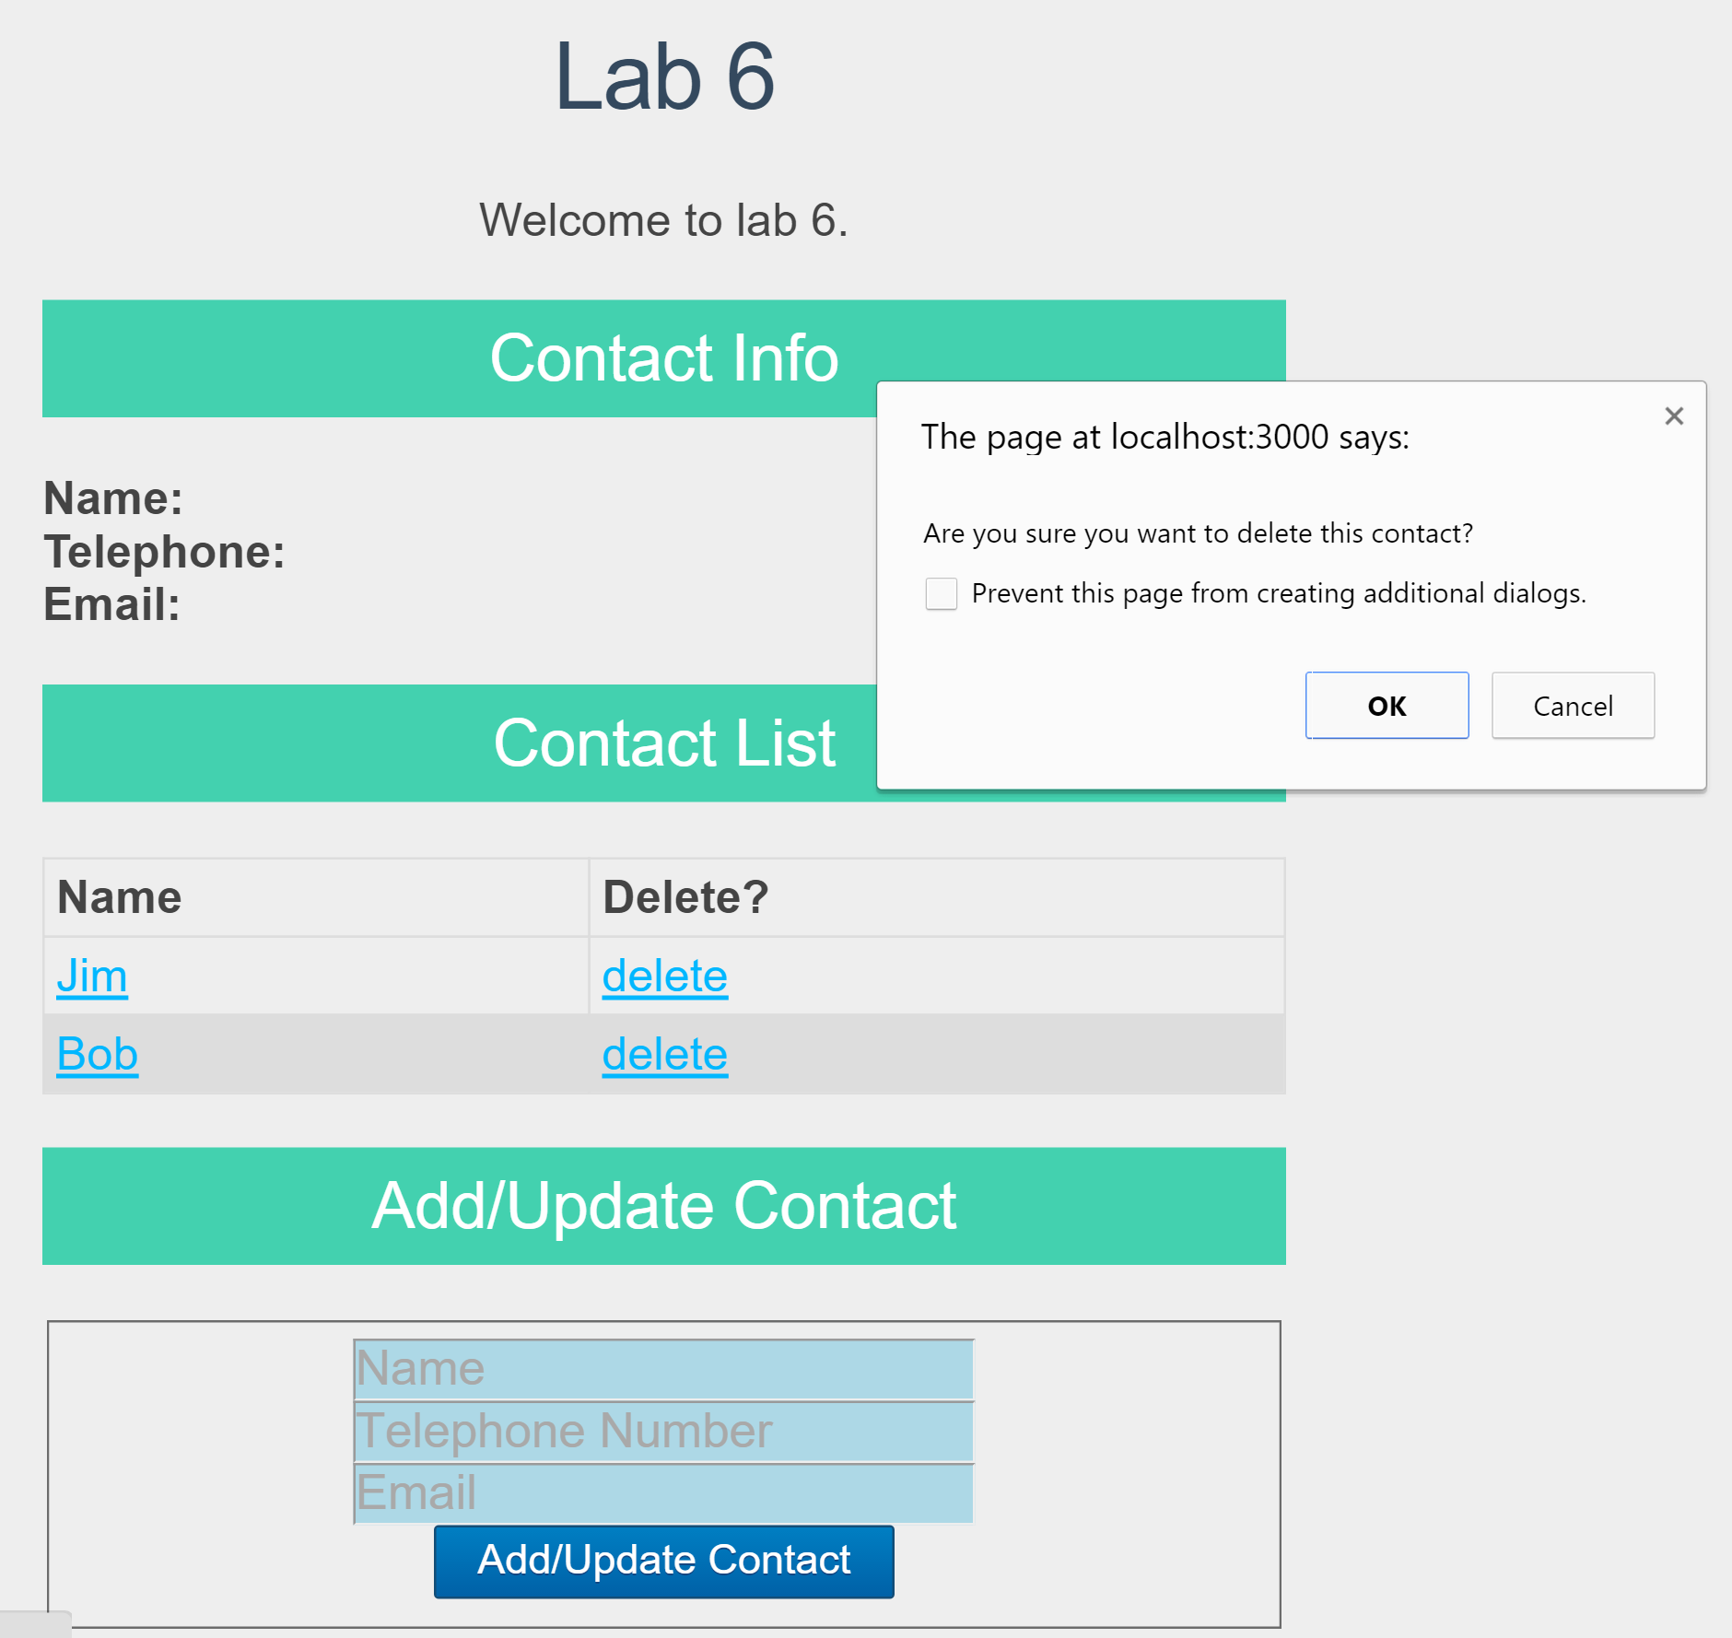

Fig. 8 After clicking “delete” in the row of “Jim”

(when Jim’s detailed info is not displayed in “Contact Info”)

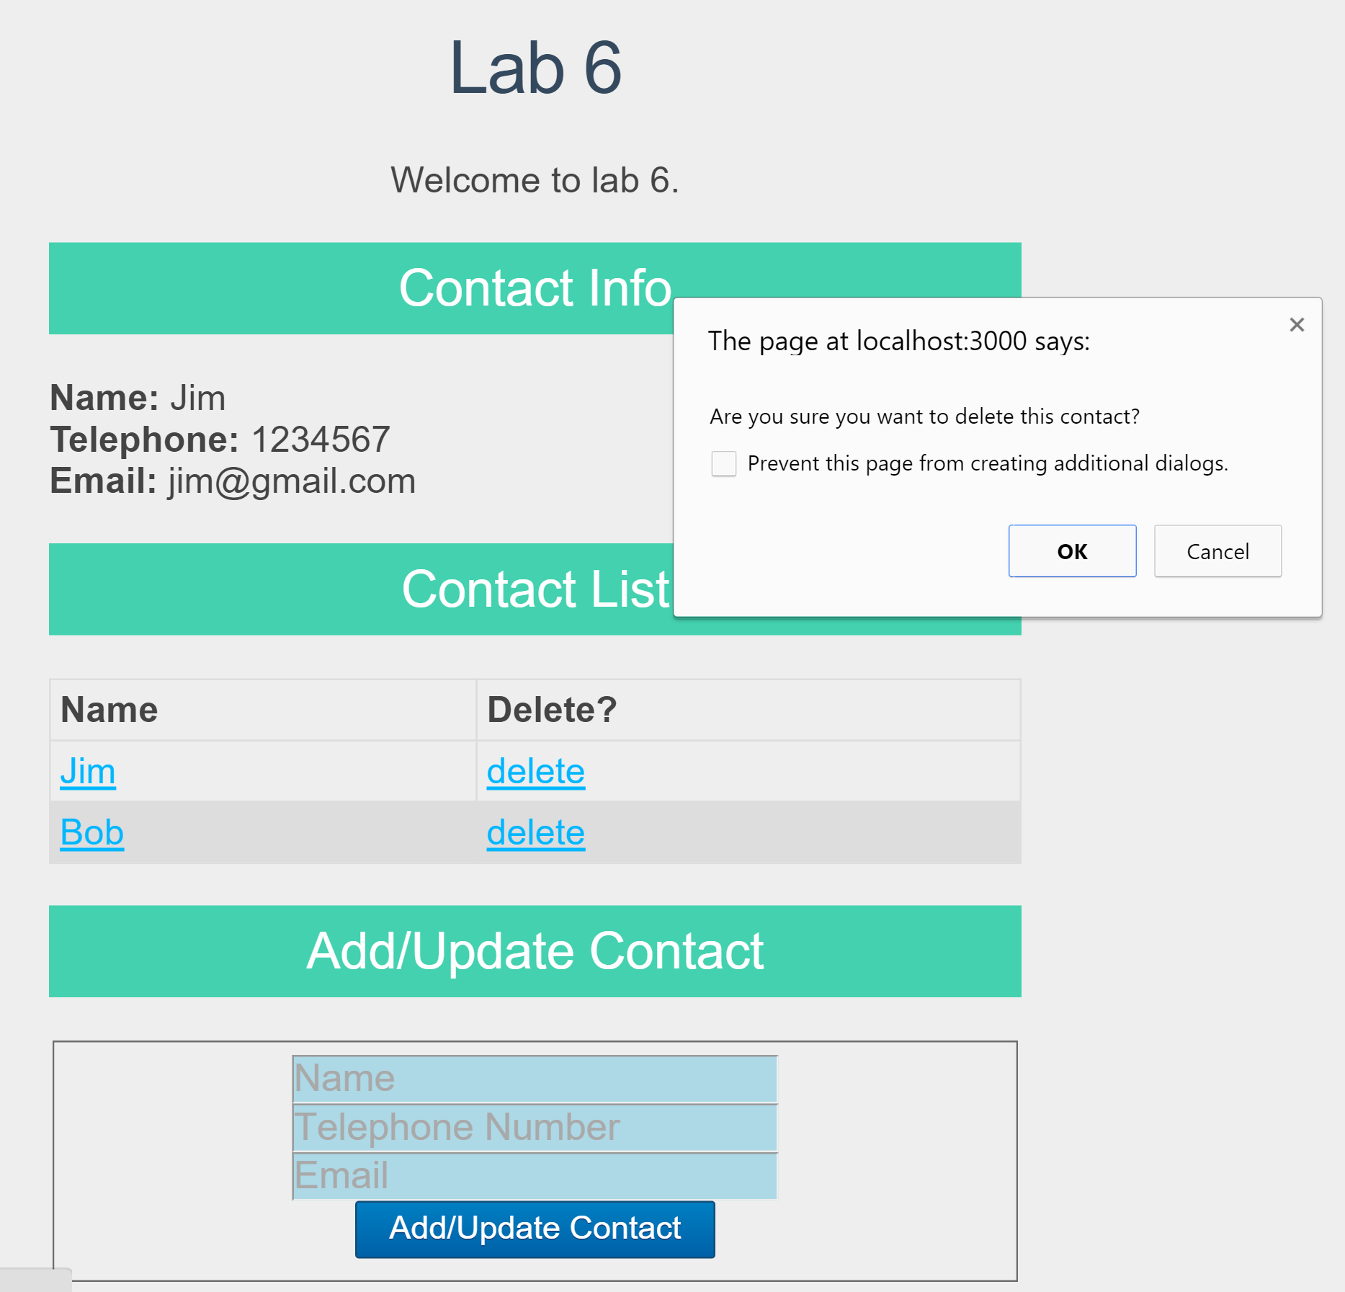

Fig.9 After clicking “delete” in the row of “Jim”

(when Jim’s detailed info is displayed in “Contact Info”)

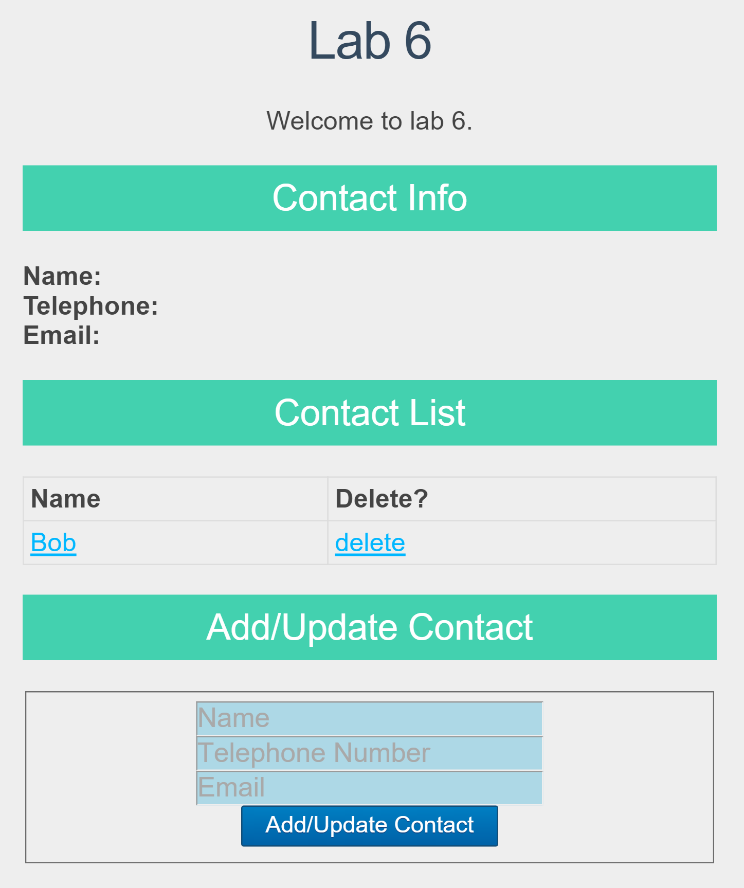

Fig. 10 After confirming deletion by clicking “OK” in both case (1) and case (2) above

# Submission:

Create a .zip file named **lab6.zip** which should contain **app.js**, **package.json**, **the “public” folder**, **the “routes” folder** and **the “views” folder (including all files in these folders)**. Please upload lab6.zip to i.cs.hku.hk web server before **23:59 Sunday April 7, 2019**. The URL to access your submission should be [**http://i.cs.hku.hk/~[your_CSID]/lab6.zip**](http://i.cs.hku.hk/~%5byour_CSID%5d/lab6.zip). We will check your files for lab 6 marking.