21.3

见21.10

21.8

import java.util.Map;

import java.util.Set;

import java.util.TreeMap;

public class Exercise21_8 {

public static void main(String[] args){

String text = "Good morning teacher, I do have gone to your class today!";

Map<String, Integer> map = new TreeMap<>();

String[] words = text.split("[ ,;.:?'\"()]!");

for(String word : words){

word = word.toLowerCase();

if(word.length() > 0){

if(map.containsKey(word)){

map.put(word, map.get(word) + 1);

}

else {

map.put(word, 1);

}

}

}

Set<Map.Entry<String, Integer>> entrySet = map.entrySet();

for(Map.Entry<String, Integer> each : entrySet){

System.out.println(each.getValue() + " " + each.getKey());

}

}

}

运行结果：

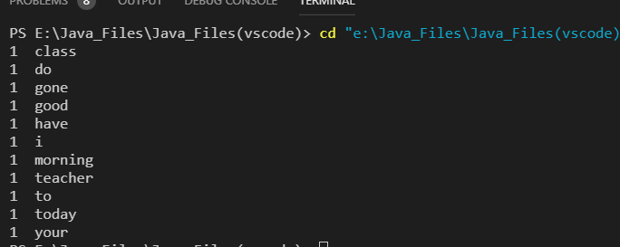

21.10

import java.io.File;

import java.io.FileNotFoundException;

import java.util.Map;

import java.util.Scanner;

import java.util.Set;

import java.util.TreeMap;

public class Exercise21_10{

public static void main(String[] args) throws FileNotFoundException {

Map<String, Integer> map = new TreeMap<>();

String word = "abstract\tassert\tboolean\tbreak\tbyte\n" +

"String\tint\tInteger\t"+

"case\tcatch\tchar\tclass\tconst\n" +

"continue\tdefault\tdo\tdouble\telse\n" +

"enum\textends\tfinal\tfinally\tint\tfloat\n" +

"for\tgoto\tif\timplements\timport\n" +

"instanceof\tint\tinterface\tlong\tnative\n" +

"new\tpackage\tprivate\tprotected\tpublic\n" +

"return\tstrictfp\tshort\tstatic\tsuper\n" +

"switch\tsynchronized\tthis\tthrow\tthrows\n" +

"transient\ttry\tvoid\tvolatile\twhile";

String words[] = word.split("[ \t\n+]");

String filename = "Exercise21_8.java";

File file = new File(filename);

Scanner get_words = new Scanner(file);

while(get_words.hasNext()){

String temp = get_words.nextLine();

if(temp.length() == 0)

continue;

// System.out.println(temp);

String sentence = temp;

String[] get = sentence.split("[ ,;/:?><(){}|&%!=+'\t\n\\.\\-]");

for(int i = 0; i < get.length; i++) {

if(get[i].length() == 0)

continue;

if(get[i].equals("\\\\"))

break;

if(get[i] == "\""){

i++;

while(get[i] != "\"")

i++;

}

if (judgeContains(words, get[i])) {

if(map.containsKey((get[i])))

map.put(get[i], map.get(get[i]) + 1);

else

map.put(get[i], 1);

}

}

}

Set<Map.Entry<String, Integer>> set = map.entrySet();

for(Map.Entry<String, Integer> print : set){

System.out.println(print.getValue() + " " + print.getKey());

}

}

public static boolean judgeContains(String[] words, String word){

for(String temp : words){

if(temp.equals(word))

return true;

}

return false;

}

}

运行结果：

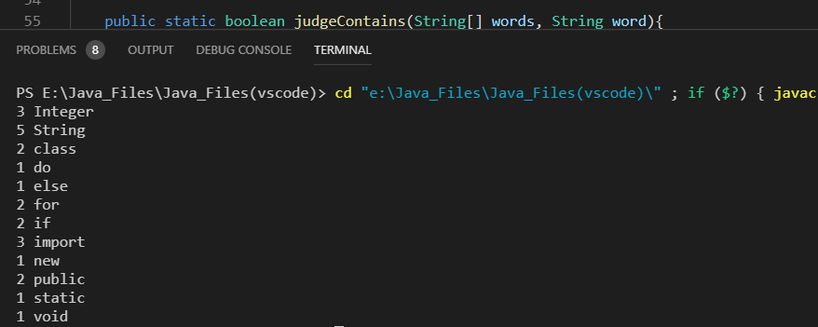

21.12

import java.io.File;

import java.util.Map;

import java.io.FileNotFoundException;

import java.util.Scanner;

import java.util.Set;

import java.util.TreeSet;

public class Exercise21_12{

public static void main(String[] args) throws FileNotFoundException{

Scanner in = new Scanner(System.in);

String[] names = new String[5];

String[] read;

Set<String> boys = new TreeSet<>();

Set<String> girls = new TreeSet<>();

Set<String> equal = new TreeSet<>();

int number = 0;

String filename = in.nextLine();

File file = new File(filename);

Scanner get_words = new Scanner(file);

while(get_words.hasNext()){

int i = 0;

read = get_words.nextLine().split("[ \t\n]");

for(String name : read){

if(name.length() != 0){

names[i] = name;

i++;

}

}

boys.add(names[1]);

girls.add(names[3]);

}

for(String boy_temp : boys){

for(String girl_temp : girls){

if(boy_temp.contains(girl_temp)){

equal.add(girl_temp);

number++;

}

}

}

System.out.println(number + " " + equal);

}

}

运行结果：

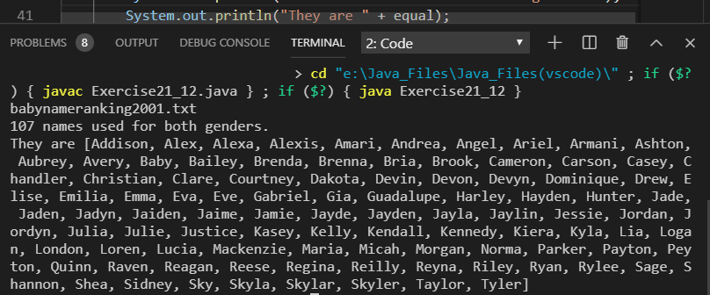

21.13

import java.io.FileNotFoundException;

import java.io.File;

import java.util.Scanner;

public class Exercise21_13{

public static void main(String[] args) throws FileNotFoundException{

Scanner in = new Scanner(System.in);

String[] names = new String[5];

while(true){

System.out.print("Enter the year: ");

String year = in.nextLine();

System.out.print("Enter the gender: ");

String gender = in.nextLine();

System.out.print("Enter the name: ");

String name = in.nextLine();

String filename = "..//Document//babynameranking" + year + ".txt";

File file = new File(filename);

Scanner scan = new Scanner(file);

while(scan.hasNext()){

int i = 0;

String[] read = scan.nextLine().split("[ \t\n]");

for(String temp : read){

if(temp.length() != 0){

names[i++] = temp;

}

}

if(gender.equals("M")){

if(names[1].equals(name)){

System.out.println("Boy name " + name +" is ranked #" +

names[2] + " in year " + year);

break;

}

}

if(gender.equals("F")){

if(names[3].equals(name)){

System.out.println("Girl name " + name +" is ranked #" +

names[4] + " in year " + year);

break;

}

}

}

System.out.println("Enter another inquiry?");

String judge = in.nextLine();

while(judge.charAt(0) != 'Y' && judge.charAt(0) != 'y' &&

judge.charAt(0) != 'N' && judge.charAt(0) != 'n'){

System.out.println(judge.charAt(0) + " " +"Please Enter Y/y or N/n");

judge = in.nextLine();

in.nextLine();

}

if(judge.charAt(0) == 'N' || judge.charAt(0) == 'n')

break;

}

}

}

运行结果：

