**Design:**

Approach: using list with 8/15 elements to build the blocks. In calculation replace the “ “ with 0, when showing results, change back to “ “.

Object: board[ ] :this is the list for calculation and playing

Move: for collecting the user input for movement

Random: for creating a random list

Gametype: for choosing 8 or 15 blocks

Program flow: first show rules and sample results, then define all the function , the use loop structure to make sure the game can be restart. In main loop, first create random list and show it to players, than load defined functions for game running, judge the game status-finished or not. If finished, let players choose whether to restart; if not, keep running and add “1 step” into counting.

Logic: create a list with 8 or 15 elements, then use “random” to make a random list, than print with 3/5 elements each line.

**Functions:**

Onestep_8: for process a single move in 8 blocks game. Including judge user inputs ,blank blocks position and act by input.

Onestep_15: same logic as 8, but use for 15 blocks.

Startgame8: contain the initialize of the game, the judgement for if players win. Also provides step count. Onestep_8 will be loaded in this function

Startgame15: same logic as 8, but use for 15 blocks

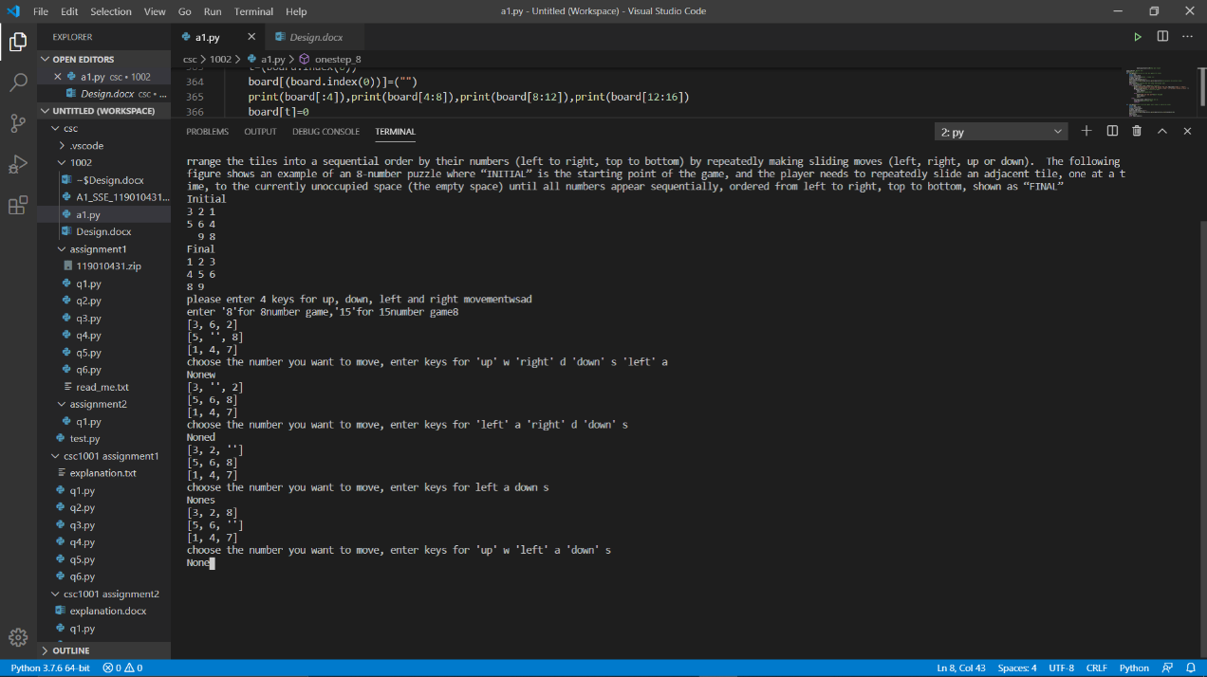**Sample outputs**

8 blocks:

[2, '', 5]

[6, 3, 1]

[4, 8, 7]

15 blocks:

[3, 11, 13, 15]

[6, '', 5, 10]

[4, 1, 14, 7]

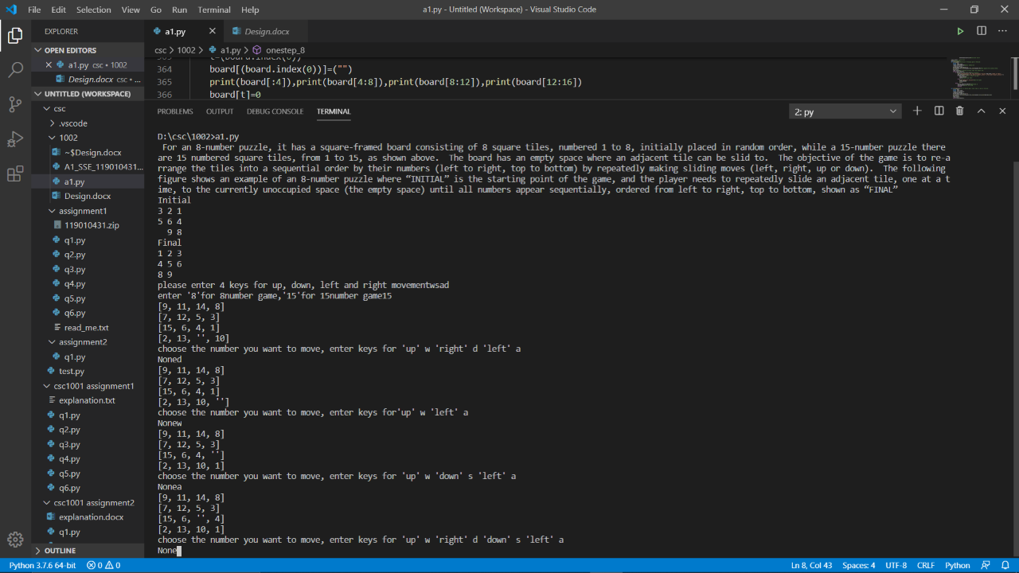[9, 12, 2, 8]